LEGUMINOSAE CAESALPINIOIDEAE Hymenaea verrucosa (MSANDARUSI)
Synonym: LEGUMINOSAE CAESALPINIOIDEAE Trachylobium verrucosum
Specimen:
Uw 15656 - LEGUMINOSAE CAESALPINIOIDEAE Hymenaea verrucosa
 | 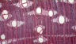 |  |  | 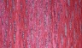
  tls
  lens: unknown
  M.E. Bakker
  Inst: NHN
  xs
  lens: unknown
  M.E. Bakker
  Inst: NHN

Features:

1v | Growth ring boundaries distinct
2v | Growth ring boundaries indistinct or absent
5 | Wood diffuse-porous
13 | Simple perforation plates
22 | Intervessel pits alternate
23 | Shape of alternate pits polygonal
26 | Medium - 7 - 10 µm
27v | Large - >= 10 µm
29 | Vestured pits
30 | Vessel-ray pits with distinct borders; similar to intervessel pits in size and shape throughout the ray cell
42 | 100 - 200 µm
43 | >= 200 µm
46 | <= 5 vessels per square millimetre
47v | 5 - 20 vessels per square millimetre
52? | <= 350 µm
53? | 350 - 800 µm
58 | Gums and other deposits in heartwood vessels
61 | Fibres with simple to minutely bordered pits
66 | Non-septate fibres present
69 | Fibres thin- to thick-walled
71? | <= 900 µm
72? | 900-1600 µm
73? | >= 1600 µm
80 | Axial parenchyma aliform
81 | Axial parenchyma lozenge-aliform
82 | Axial parenchyma winged-aliform
83 | Axial parenchyma confluent
89 | Axial parenchyma in marginal or in seemingly marginal bands
92 | Four (3-4) cells per parenchyma strand
93 | Eight (5-8) cells per parenchyma strand
98 | Larger rays commonly 4 - to 10 seriate
104 | All ray cells procumbent
106 | Body ray cells procumbent with one row of upright and / or square marginal cells
115 | 4-12 / mm
136 | Prismatic crystals present
142 | Prismatic crystals in chambered axial parenchyma cells
178 | Tropical mainland Africa and adjacent islands (Brazier and Franklin region 78)
179 | Tropical Africa
180 | Madagascar & Mauritius, Réunion & Comores
189 | Tree
192 | Wood of commercial importance
194? | Basic specific gravity medium, 0.40-0.75
195? | Basic specific gravity high, >= 0.75
196? | Heartwood colour darker than sapwood colour
197 | Heartwood basically brown or shades of brown

Anatomical Note: PROTA description by D. Louppe, P. Détienne, E.A. Wheeler
Habitat: Zanzibar-Inhambane regional transition zone forest; Transition woodland (ILDIS)
Region: Native to East Africa, Madagascar and Seychelles | ILDIS

Reference: PROTA, 2002-- . Protabase. Plant Resources of Tropical Africa / Ressources végétales de l'Afrique tropicale, Wageningen, Netherland

Source : http://insidewood.lib.ncsu.edu/description?descid=1442

Hymenaea

Hymenaea verrucosa
In English this tree is called gum or Zanzibar copal, or amber tree, and its local names are mnangu and mtandarusi. Formerly scientists knew it by the name Trachylobium verrucosum. Beware that the Byrsocarpus boivinianus tree is also called mnangu.
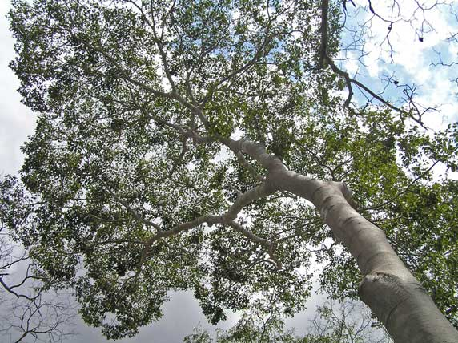
Gum copal is found in dry coastal forest and tall damp miombo in southern Tanzania. It is native to the Indian Ocean rim, and is widely planted in botanic gardens in the tropics. The leaves of this tree are highly distinctive, being divided symmetrically into two leaflets although this is only evident close-up. However, it is not always easy to spot these leaflets as the tree is tall and seldom has low-hanging branches. Dependent on soil moisture levels, the tree sheds most of its leaves in the dry season. The trunk is smooth and grey, and frequently has a cleft or is hollow as a result of damage from tapping the resin. Slashing the bark reveals red coloured wood underneath. The flowers are pale, open and about 4cm across. They are followed by the species' unique fruit. These are small and hard, dotted on the exterior with bubbles of resin that set when the fruit drops. They are reddish-green when ripe, but turn brown on the ground. Parts of the fruit case are usually visible under gum copal trees, the black seeds are quickly eaten by animals.
In the eighteenth and nineteenth century the yellow resin was an important product in world commerce. It was exported from Kilwa to Europe and the Arabian Peninsula where it was used to make varnish but these uses were superseded by synthetic chemicals. In recent years there has been a small resurgence in the use of gum copal in floor sealant. These days there is more demand for the tree's timber.
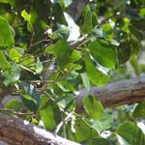  H. verrucosa leaves |  | 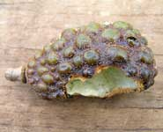  H. verrucosa fruit |  | 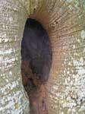  H. verrucosa tr

Source : http://www.mpingoconservation.org/tax_hymenaea.html

Hymenaea verrucosa Gaertn.
East African copal
  Symbol: |  | HYVE8
  Group: |  | Dicot
  Family: |  | Fabaceae
  Duration:
  Growth Habit:
  Native Status:
    None
  Distribution: |  | Not in PFA
  More Information:
  - Classification
  - Data Source and Documentation

Images:
Hymenaea verrucosa Gaertn.
See all the Hymenaea thumbnails at the PLANTS Gallery
Synonyms:
Hymenaea verrucosa Gaertn.
 | TRVE5 | Trachylobium verrucosum (Gaertn.) Oliv.

Related Taxa:
Hymenaea verrucosa Gaertn.
View 236 genera in Fabaceae, 2 species in Hymenaea
Classification:
Hymenaea verrucosa Gaertn.
Click on a scientific name below to expand it in the PLANTS Classification Report.
Kingdom | Plantae – Plants
Subkingdom | Tracheobionta – Vascular plants
Superdivision | Spermatophyta – Seed plants
Division | Magnoliophyta – Flowering plants
Class | Magnoliopsida – Dicotyledons
Subclass | Rosidae
Order | Fabales
Family | Fabaceae – Pea family
Genus | Hymenaea L. – hymenaea
Species | Hymenaea verrucosa Gaertn. – East African copal

More Accounts and Images:
Hymenaea verrucosa Gaertn.
View species account from ARS Germplasm Resources Information Network (GRIN).
View taxonomic account from Integrated Taxonomic Information System (ITIS) for ITIS Taxonomic Serial Number 506321.
Source : http://plants.usda.gov/java/profile?symbol=HYVE8

Mandrorofy Hymenaea verrucosa
Famille des Fabaceae

Arbre de grande taille fournissant un bois pour la construction légère et le bois de chauffe. Sa résine est à l'origine du copal de madagascar "jeune ambre" que l'on trouve dans le nord est de madagascar.

http://generation-masoala.com/mandrorofy.aspx

