Antimicrobial Prenylated Anthracene Derivatives from the Leaves of Harungana madagascariensis

Simeon F. Kouam,*†‡ Diane B. Yapna,† Karsten Krohn,‡ Bonaventure T. Ngadjui,§ Joseph Ngoupayo,§ Mohamed I. Choudhary, and Barbara Schulz#
Department of Chemistry, Higher Teachers' Training College, University of Yaounde 1, BP 47, Yaounde, Cameroon, Department of Chemistry, University of Paderborn, Warburger Strasse 100, D-33098 Paderborn, Germany, Department of Organic Chemistry, Faculty of Science, University of Yaounde 1, BP 812, Yaounde, Cameroon, H.E.J. Research Institute of Chemistry, International Center for Chemical Sciences, University of Karachi, Karachi 75270, Pakistan, and Institute of Microbiology, Technical University of Braunschweig, D-38106 Braunschweig, Germany
J. Nat. Prod., 2007, 70 (4), pp 600–603
DOI: 10.1021/np060556l
Publication Date (Web): March 13, 2007
Copyright © 2007 American Chemical Society and American Society of Pharmacognosy

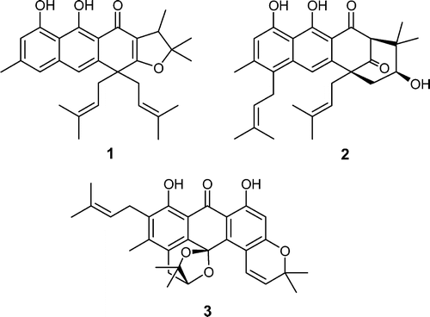
Three new prenylated anthranoids, harunmadagascarins C (1) and D (2) and kenganthranol D (3), together with three known compounds (4−6) were isolated from the leaves of Harungana madagascariensis. Their structures were assigned by spectroscopic methods and by comparison with literature data. In the three new natural products 1−3, one or two prenyl groups are incorporated in furan, pyran, or cyclohexane rings in four different modes of annulation. Compounds 2, 4, and 6 were strongly active against the Gram-positive Bacillus megaterium.
Source : http://pubs.acs.org/doi/abs/10.1021/np060556l

