Scientific Name
Dalbergia baronii
Trade Name
Madagascar rosewood
Family Name
Leguminosae
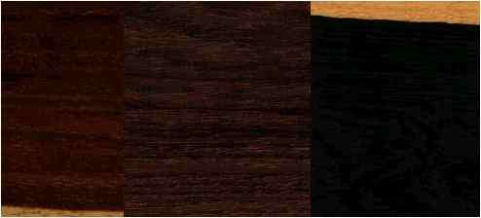
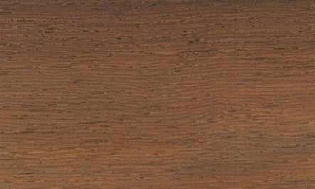
Common Names
Madagascar rosewood, Palissandre voamboana
Regions of Distribution
Africa
Countries of Distribution [VIEW MAP]
Madagascar
Common Uses
Building materials, Carvings, Chairs, Chests, Concealed parts (Furniture), Core Stock, Decorative veneer, Desks, Dining-room furniture, Domestic flooring, Dowell pins, Dowells, Drawer sides, Drum sticks, Excelsior, Factory flooring, Figured veneer, Fine furniture, Floor lamps, Flooring, Furniture , Furniture components, Furniture squares or stock, Hatracks, Interior construction, Interior trim, Joinery, Kitchen cabinets, Living-room suites, Millwork, Moldings, Musical instruments , Office furniture, Organ pipes, Parquet flooring, Piano keys, Pianos , Precision instruments, Shipbuilding, Turnery, Veneer
Environmental Profile
Status has not been officially assessed
Distribution Overview
Madagascar. The species is mainly found in evergreen humid rainforest �at low altitudes, along streams, rivers, in marshy areas and the back of mangrove stands.
Heartwood Color
Brown
Yellow
Orange
Black
Gray buff
Sapwood Color
White
Yellow
Brown
Red
Grain
Even
Straight

Straight
Texture
Coarse
Medium
Fine
Luster
Low
Natural Durability
Very durable
Durable
Moderately durable
Resistant to termites
The heartwood has very low natural resistance to decay, and should not be used under conditions that promote decay
Drying Defects
Splitting
Checking
Ease of Drying
Fairly Easy
Thick Stock Requires Care
Rapidly
Slowly
Little degrade
Little degrade if dried properly
Easy
Kiln Drying Rate
Naturally dries slowly
Naturally dries quickly
Drying rate is fairly rapid to fast
Tree Size
Tree height is 20-30 m
Trunk diameter is 200-250 cm
Blunting Effect
High to severe
Boring
Fair to good results
Fairly difficult to very difficult
Carving
Very Good to Excellent Results
Fairly Difficult to Very Difficult
Cutting Resistance
Easy to saw
Fairly Difficult to Very Difficult to saw
Cutting resistance is small
Gluing
Fairly Easy to Very Easy
Fair to Good Results
Fairly Difficult to Very Difficult
Variable gluing properties
Mortising
Fair to Good Results
Fairly Difficult to Very Difficult
Moulding
Fair to Good Results
Fairly Difficult to Very Difficult
Movement in Service
Fair to Good Stability - Medium Movement
Excellent Stability - Small Movement
Shape retention after manufacture is usually good
Dimensional stability is generally very good
Nailing
Poor to Very Poor Results
Fairly Difficult to Very Difficult
Satisfactory nailing properties
Pre-boring recommended
Planing
Fair to Good Results
Fairly Difficult to Very Difficult
Generally easy to use hand tools
Easy to use machine tools
Resistance to Impregnation
Resistant heartwood
Resistant sapwood
Permeable sapwood
Resistant
Response to Hand Tools
Easy to Work
Fairly Difficult to Difficult to Work
Routing & Recessing
Fair to Good Results
Fairly Difficult to Very Difficult
Screwing
Poor to Very Poor Results
Fairly Difficult to Very Difficult
Possible if prebored
Turning
Fairly Easy to Very Easy
Fair to Good Results
Fairly Difficult to Very Difficult
Veneering Qualities
Veneers easily
Suitable for peeling
Suitable for slicing
Veneers moderately easy
Steam Bending
Fair to Good Results
Fairly Easy to Very Easy
Painting
Takes oil-based paints with some difficulty
Polishing
Fair to Good Results
Very Good to Excellent Results
Excellent results
Numerical Data
Item | Green | Dry | English
Bending Strength |  | 16961 | psi
Maximum Crushing Strength |  | 8663 | psi
Stiffness |  | 1742 | 1000 psi
Specific Gravity |  | 0.47
Item | Green | Dry | Metric
Bending Strength |  | 1192 | kg/cm2
Maximum Crushing Strength |  | 609 | kg/cm2
Stiffness |  | 122 | 1000 kg/cm2
References
Bolza, E., Keating, W.G.,1972,African Timbers - the Properties, Uses and Characteristics of 700 Species,C.S.I.R.O. Div. of Building Research

Source : http://www.thewoodexplorer.com/maindata/we372.html

