Tabebuia rosea (Bertol.) DC.
roble, May flower, apamate Bignoniaceae

LOCAL NAMES
T. rosea, tree in flower in pasture, Guanacaste, Costa Rica. (David Boshier)
T. rosea, tree in mass flower, Choluteca, Honduras. (David Boshier)

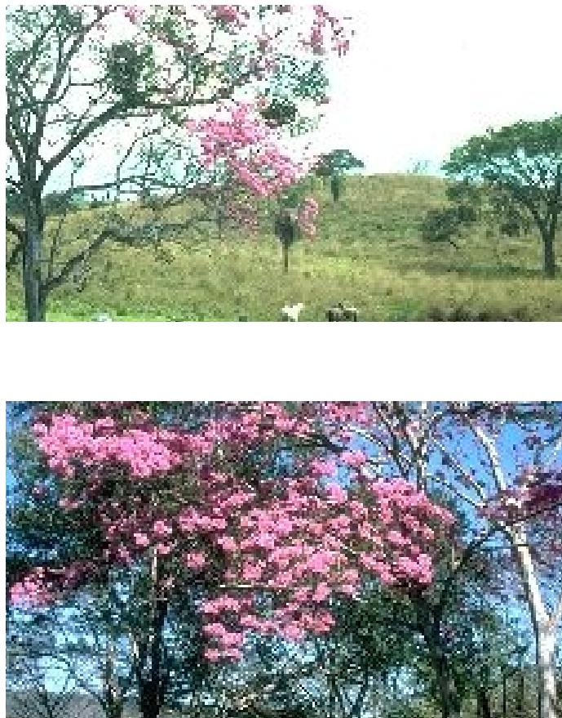
English (rosy trumpet tree,pink poui); Spanish
(roble,ocobo,macuelizo,Gauyacan rosado,flormorado); Trade name (roble,May flower,apamate)
BOTANIC DESCRIPTION
Tabebuia rosea is a medium to large-sized deciduous tree up to 25 m high.
Flowers purplish-pink to nearly white, up to 8 cm long.
Fruit a linear dehiscent capsule containing many winged seeds.
The generic name is after the Brazilian local name for Tabebuia serratifolia.
BIOLOGY
The principal flush of shoot growth takes place during the early rainy season and is completed within 2-3 months. The small, terminal flower buds of new shoots remain dormant for several months. When leaves begin to abscise during the dry season, flower buds swell and the large, pink flowers open. Frequently, leaves in the upper part of the tree crown fall earlier than those in the lower part, and flowers open 1st on the bare upper branches. Fruits develop during the months following anthesis, often simultaneously with the emergence of new shoots.

Agroforestry Database 4.0 (Orwa et al.2009) Page 1 of 5

Tabebuia rosea (Bertol.) DC.
Agroforestry Database 4.0 (Orwa et al.2009) Page 2 of 5
roble, May flower, apamate Bignoniaceae
ECOLOGY
In Sri Lanka it does not thrive in dry districts at sea level. The branches are easily broken by strong winds.
BIOPHYSICAL LIMITS
Altitude: Up to 1 200 m; Mean annual rainfall: 1 250- 2 500 mm; Mean annual temperature: 22-27 deg C.
Soil type: T. rosea grows well in deep rich soil.
DOCUMENTED SPECIES DISTRIBUTION
Native: Belize, Colombia, Costa Rica, El Salvador, Guadeloupe, Honduras, Mexico, Nicaragua, Panama,
Venezuela
Exotic: Ghana, Sri Lanka, Trinidad and Tobago, Uganda
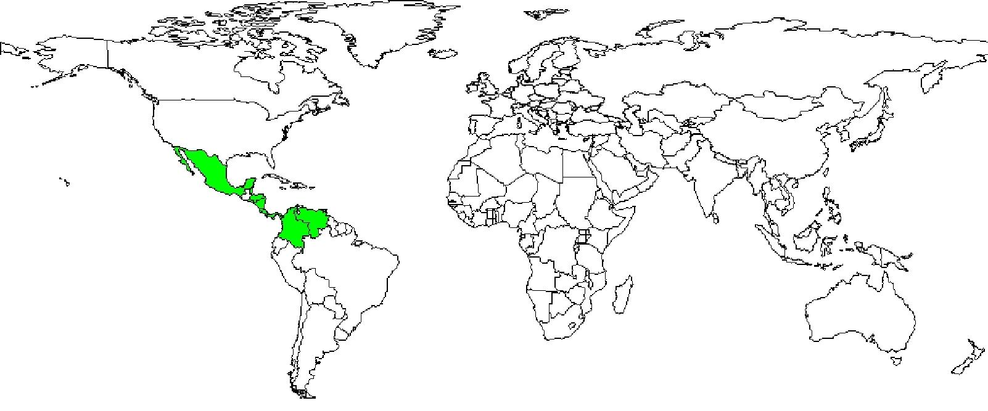

The map above shows countries where the species has been planted. It does neither suggest that the species can be planted in every ecological zone within that country, nor that the species can not be planted in other countries than those depicted. Since some tree species are invasive, you need to follow biosafety procedures that apply to your planting site.

Native range
Exotic range
Agroforestry Database 4.0 (Orwa et al.2009) Page 3 of 5
Tabebuia rosea  some  roble, May flower, apamate | (Bertol.) DC.  Bignoniaceae

PRODUCTS
Timber: T. rosea yields an excellent timber.
SERVICES
Ornamental: This is one of the most common and showy of the flowering trees of the New World tropics and subtropics.
Tabebuia rosea (Bertol.) DC.
Agroforestry Database 4.0 (Orwa et al.2009) Page 4 of 5
roble, May flower, apamate Bignoniaceae
TREE MANAGEMENT
T. rosea is fast growing, especially when young. Trees withstand a limited amount of pruning but not pollarding. In Sri Lanka, early growth is faster than that of any other ornamental tree used in the country, reaching a height of over 9 m in about 3 years at Colombo. Where conditions are not favourable, bark-burst has been observed. The lifespan is about 50 years.
GERMPLASM MANAGEMENT
Seed storage behaviour is intermediate; seeds tolerate desiccation to 7.1% mc (99% germination), storage temperature of 5 deg. C; viability is maintained for 30 months in hermetic air-dry storage at 10 deg. C. There are about 42 000 seeds/kg.
Tabebuia rosea (Bertol.) DC.
roble, May flower, apamate Bignoniaceae
FURTHER READNG
Borchert R. 1983. Phenology and control of flowering tropical trees. Biotropica. 15(2): 81-89.
Burkill HM. 1994. Useful plants of West Tropical Africa. Vol. 2. Families E-I. Royal Botanical Gardens, Kew.
Hong TD, Linington S, Ellis RH. 1996. Seed storage behaviour: a compendium. Handbooks for Genebanks: No. 4. IPGRI.
Katende AB et al. 1995. Useful trees and shrubs for Uganda. Identification, Propagation and Management for Agricultural and Pastoral Communities. Regional Soil Conservation Unit (RSCU), Swedish International Development Authority (SIDA).
Streets RJ. 1962. Exotic forest trees in the British Commonwealth. Clarendon Press, Oxford.
Young JA, Young CG. 1992. Seeds of woody plants in North America. Dioscorides Press, Oregon, USA.
SUGGESTED CITATION
Orwa C, Mutua A , Kindt R , Jamnadass R, Simons A. 2009. Agroforestree Database:a tree reference and selection guide version 4.0 (http://www.worldagroforestry.org/af/treedb/)
Agroforestry Database 4.0 (Orwa et al.2009) Page 5 of 5

