Morus nigra

tut

LOCAL NAMES
Creole (mi); English (mulberry,small fruited mulberry,black mulberry,black
Persian); French (Murier noir,mûres); German (Schwarzer Maulbeerßaum); Hindi (tut,shah-tut); Indonesian (murbei); Italian (gelso nero); Javanese (besaran); Spanish (mora negra,morero,morera negra); Swahili (mforsadi); Trade name (tut); Vietnamese (dâu tam)

BOTANIC DESCRIPTION
Morus nigra is a deciduous tree, slender but with numerous branches. Grows to 6-9 m in height, but it tends to be a bush if not trained when young.

Leaves rough on upper surfaces and pubescent underneath, 7-12.5 cm long, often producing leaves of several different shapes, with 1 or more lobes, multilobed leaves often appearing on the same branches as lobeless ones; abnormally shaped leaves usually produced from stem
shoots or sucker growths, and frequently by very vigorous young branches.

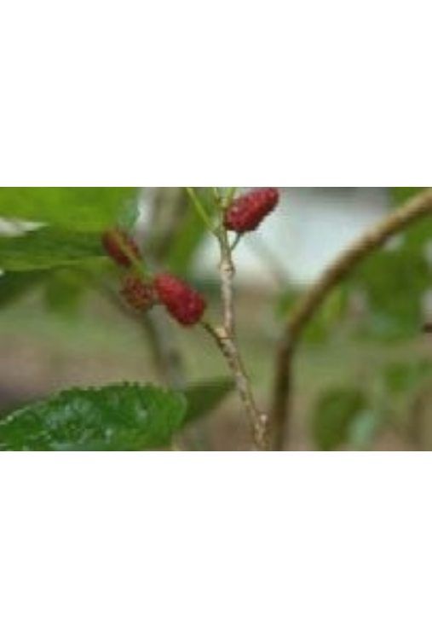
Flowers held on short, green, pendulous, nondescript catkins that appear

. Moraceae

ulberry fruit (French B.)
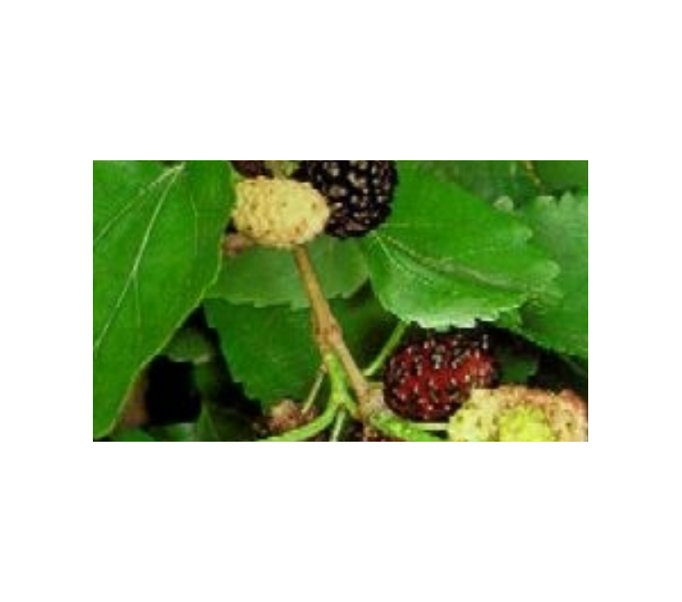

in the axils of the current season’s growth and on spurs on older wood. The flowers appear in 1.3 cm scaly clusters, female flowers ripening quickly into 1.3-2.5 cm blackberry-shaped edible fruits.

Botanically, the fruit is not a berry but a collective fruit; the fleshy bases of pollinated flowers begin to swell and ultimately become completely altered in texture and colour, becoming succulent, fat and full of juice. In appearance, each tiny swollen flower roughly resembles the individual drupe of a blackberry. The colour of the fruit does not identify the mulberry species.

It has been suggested that the generic name of the mulberry, Morus, was derived from the Latin ‘mora’ (delay), from the tardy expansion of the buds. An alternative explanation is that it comes from the Celtic ‘mor’ (black), referring to the colour of the fruit. The specific name refers to the dark colour of the fruit.

BIOLOGY
Trees are either dioecious or monoecious, and sometimes will change from one sex to the other. M. nigra trees do not begin to bear much fruit before 15 years of age. They are wind pollinated, and some cultivars will set fruit without any pollination, for example in California, USA. The self- fertile trees commonly produce 2 crops a year.

M. nigra trees have been known to bear fruit for hundreds of years, and it is commonly said that the fruit of the oldest mulberry trees is the best.

Leaves and fruits. (Arnoldo Mondadori
Editore SpA)

ECOLOGY
M. nigra trees are highly favoured in areas with long hot summers or extended droughts. A rugged species, M. nigra is fairly resistant to cold but grows best at lower altitudes when sheltered from wind and in coastal areas.

BIOPHYSICAL LIMITS Altitude: 0-2 000 m

Soil type: M. nigra like a warm, well-drained soil, preferably a deep loam. Shallow soils such as those frequently found on chalk or gravel are not recommended.

DOCUMENTED SPECIES DISTRIBUTION

Native: Exotic:

Iran
Canada, China, Cuba, Dominican Republic, Germany, Greece, Haiti, India, Italy, Japan, Pakistan, Puerto Rico, Spain, Sweden, Tanzania, United Kingdom, US

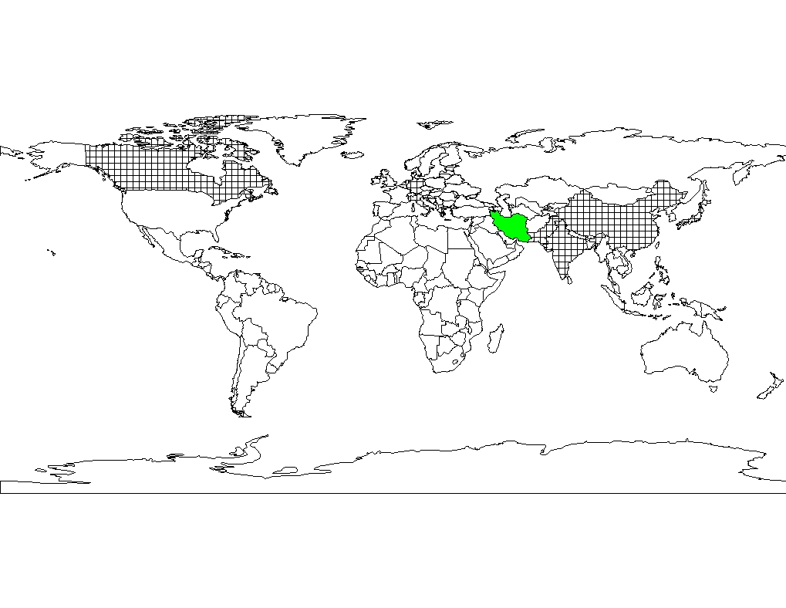
Native range


Exotic range

The map above shows countries where the species has been planted. It does neither
suggest that the species can be planted in every ecological zone within that country, nor that the species can not be planted in other countries than those depicted. Since some tree species are invasive, you need to follow biosafety procedures that apply to your planting site.

PRODUCTS
Food: The purple-black berries are large and juicy, with a good balance of sweetness and tartness that makes them the best-flavoured species of the genus. The ripe fruit contains about 9% sugar, with malic and citric acid. Berries can be eaten raw or dried, or used in pies, tarts, puddings, conserves, jams, or sweetened and pureed as a sauce; slightly unripe fruit is best for pies and tarts. Mulberries blend well with other fruit, especially pears and apples. The fruit is sometimes pounded to a fine powder and mixed with the flour for bread.

Fodder: Although inferior to those of M. alba, the leaves of M. nigra are also used for raising silkworms and have been used as a feed for domestic rabbits. Both cattle and goats browse the leaves and shoots; therefore, young saplings need protection.

Fuel: Pruned and dead branches are suitable for firewood. Fibre: In Japan, a textile fibre is extracted from the bark.
Timber: The wood is a rich yellow that darkens over time to a rich golden brown. The wood is not affected by water and, because of its hardness, is used in joinery for articles subject to wear, for lathe work, and in the manufacture of barrels, caskets, snuffboxes and cups.

Tannin or dyestuff: The leaves yield a yellow dye, used mainly for heightening the sheen on silk.

Alcohol: Fruits produce an alcoholic drink; for example, in Greece they are fermented for this purpose. In Devonshire, UK, they are sometimes mixed with cider during fermentation, giving the drink a pleasant taste and deep red colour.

Medicine: The main use of M. nigra in modern medicine is for the preparation of a syrup obtained from the ripe fruit employed to flavour or colour other medicines. It is a dark violet or purple liquid, with a faint odour and a refreshing, sweet-acid taste. M. nigra leaves are used in pharmacy for their astringent properties. M. nigra has laxative and antipyretic properties. The bark is a reputed anthelmintic, used to expel tapeworms. A leaf, flower or root decoction can be gargled for diabetes; fever, sore throat and swollen vocal chords are treated with fruit juice. A parasitic fungus, known locally as ‘meshimakobu’, brown on the outside and yellow inside, grows on the old stems of mulberry trees on the island of Meshima, Japan, and is used medicinally there.

Other products: A milky juice found in all parts of the plant coagulates into a kind of Indian rubber; it has been thought to give tenacity to the filament spun by the silkworm.

SERVICES
Shade or shelter: The trees are fairly wind resistant with some cultivars being used as windbreaks.

Ornamental: M. nigra is especially worth growing for its luxuriant foliage and picturesque form. Fruitless male trees are the ones most often planted near paved areas, as the fruit of female trees drops and can cause permanent stains. Pot cultivation for small indoor plants and bonsai trees is also popular.

Boundary/barrier/support: When spaced correctly, the species can be planted as a live fence.

Other services: Birds are so fond of the fruit that M. nigra is sometimes planted near more valuable fruit trees, such as cherries, to lure the birds away from the choice crop.

TREE MANAGEMENT
The tree can be grown in various forms: as a tall standard with 1.8 m stem, as a low standard on a 0.9 m stem, as a bush, or as a pyramid-shaped tree. It can also be fan-trailed against a wall and is a good subject for pot cultivation. Standard trees require no pruning except for removing dead wood and thinning branches. Most forms, especially pyramid trees, need to have the lateral growth shortened to about 6 leaves to form spurs. Wall trees need to have their branches trained 30 cm apart. It is not advisable to prune the trees heavily due to the plant’s inclination to bleed—cuts of more than 5 cm in diameter generally do not heal and should be avoided. The bleeding will be less severe if the tree is pruned while it is dormant.

Trees grow very rapidly, need full sun, adequate space (at least 4.5 m between each tree) and generally thrive with minimal fertilization. Although somewhat drought resistant, they need to be watered in the dry season; if the roots become too dry, the fruit are likely to drop before being fully ripened. Pot trees need repotting each year before new growth commences.

They are not easily killed, and careful pruning and cultivation have rejuvenated old specimens. Broken, undetached branches usually take root if they touch the ground.

GERMPLASM MANAGEMENT
Seed storage behaviour is orthodox; storage in airtight hermetic storage at -20 deg. C is recommended.

PESTS AND DISEASES
M. nigra is generally free of pests and diseases, although cankers and die-back can occur. A white powdery coating on the lower leaf surface is a symptom of mildew spread by the pathogens Phyllactinia corylea and Uncinula geniculata. It can be treated with sulphur dust, copper oxychloride, karathane and imazalil. In some areas, ‘popcorn disease’, in which the fruit swells to resemble popped corn, is an occasional problem. The disease carries over from one season to the next, so collecting and burning infected fruit help control it.

FURTHER READNG
Anon. 1986. The useful plants of India. Publications & Information Directorate, CSIR, New Delhi, India.
Crane E, Walker P. 1984. Pollination directory for world crops. International Bee Research Association, London, UK. Hong TD, Linington S, Ellis RH. 1996. Seed storage behaviour: a compendium. Handbooks for Genebanks: No. 4.
IPGRI.

Lanzara P. and Pizzetti M. 1978. Simon & Schuster's Guide to Trees. New York: Simon and Schuster

Mbuya LP et al. 1994. Useful trees and shrubs for Tanzania: Identification, Propagation and Management for Agricultural and Pastoral Communities. Regional Soil Conservation Unit (RSCU), Swedish International Development Authority (SIDA).

Nicholson B.E, Harrison S.G, Masefield G.B & Wallis M. 1969. The Oxford Book of Food Plants. Oxford University Press

Simmons AF. 1972. Growing unusual fruit. David and Charles Limited. Newton Abbot Devon.

Timyan J. 1996. Bwa Yo: important trees of Haiti. South-East Consortium for International Development. Washington
D.C.

SUGGESTED CITATION
Orwa C, Mutua A , Kindt R , Jamnadass R, Simons A. 2009. Agroforestree Database:a tree reference and selection guide
version 4.0 (http://www.worldagroforestry.org/af/treedb/)

