GLIRICIDIA SEPIUM
1 Forests | 

Action Sheet 54
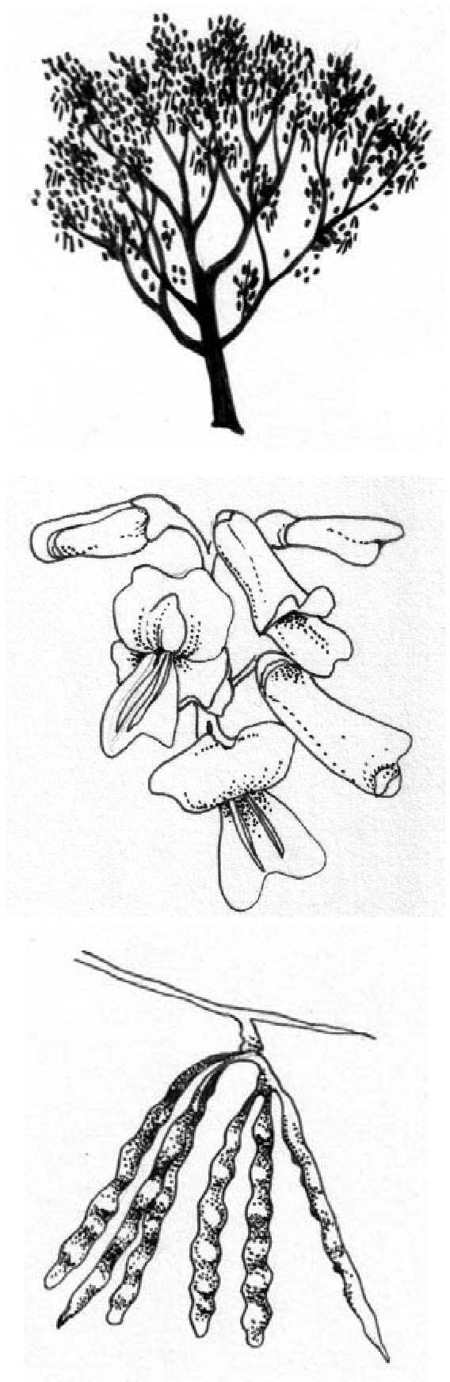
What is this Action Sheet about?
This Action Sheet is about how to plant and use Gliricidia sepium (Mother of cocoa or quickstick) in agroforestry. Gliricidia sepium is a South American nitrogen-fixing tree with many uses on the farm.
What can Gliricidia sepium be used for? Food: Flowers can be fried and eaten.
Fodder: Leaves are rich in protein and highly digestible for ruminants like goat and cattle, as they are low in fibre and tannin. There is evidence of improved animal production (both milk and meat) in large and small ruminants when Gliricidia is used as a supplement to fodder. However, non-ruminants fed on Gliricidia sepium have shown clear signs of poisoning.
Apiculture: The flowers attract honeybees (Apis spp.), hence it is an important species for honey production.
Fuel: Good for firewood and charcoal production. The wood burns slowly without sparking and with little smoke.
Timber: Very durable and termite resistant; used for railway sleepers, farm implements, furniture, house construction and as mother posts in live-fence establishment.
Poison: The leaves, seeds or powdered bark are poisonous to humans when mixed with cooked rice or maize and fermented. It has been used as a poison for pests like rats and mice.
Medicine: A traditional remedy for hair loss, boils, bruises, burns, colds,
cough, debility, eruptions, erysipelas, fever, fractures, gangrene, headache, itch, prickly heat, rheumatism, skin tumours, ulcers, urticaria and wounds.
Erosion control: Hedgerows in alley cropping control soil erosion.
Shade and shelter: Often grown as shade for tea, coffee and cocoa. It is also used as a nurse tree for shade-loving species. Its fine, feathery foliage gives a light shade.
Reclamation: Can be planted to reclaim denuded land or land infested with Imperata cylindrica (Cogon grass)
Soil improver: Capable of fixing atmospheric nitrogen, and can be used to improve soil fertility. Used as a green manure, G. sepium increases soil organic matter and helps to recycle soil nutrients because it produces much leaf litter. It also improves soil aeration and reduces soil temperature. It is a drought-resistant and valuable water-conserving species, because in the dry season it sheds most of its leaves, hence reducing water loss through transpiration.
Boundary/barrier/support: Can be used for live fencing around cattle pastures and for delineating boundaries. Its fast growth, ease of propagation, nitrogen fixing ability and light canopy makes it ideal as live support for black pepper, vanilla and yam.
Alley-cropping: Hedgerows in alley cropping slow weed growth and have been shown to reduce the incidence of disease in groundnut crops.
Where does it grow Africa and is it a safe exotic species?
2 Forests

Countries in Africa where Gliricidia is naturalized or grown on farms: Benin, Burkina Faso, Cameroon, Chad, Cote d’Ivoire, Gambia, Ghana, Grenada, Guadeloupe, Guinea, Guinea-Bissau, Kenya, Liberia, Mali, Martinique, Mauritania, Niger, Nigeria, Senegal, Sierra Leone, Tanzania, Uganda, Zambia.
When species are introduced from another continent, they often start to grow in the wild, and may compete with native vegetation. In West Africa, the Global Invasive Species Programme lists Gliricidia sepium as invasive alien species, as it has become wild in many areas. However, due to its many uses, it is not so far considered a pest.
Where will it grow?
Gliricidia sepium grows between 0-1200m, and can survive where the mean annual temperature is between 15-30°C with no frost. It needs a mean annual rainfall of between 600-3500 mm. It can therefore grow from the semi-arid subtropics to the wet tropics. It can be grown on a wide range of soils from pure sand to deep lake-bed deposits. If you are obtaining seed, it is worth seeking seed from plants that have been tested and shown to grow well on the soil in your area (See Action Sheet 56: Where to get tree seeds). In areas where Gliricidia seeds well, you can collect pods when they begin to turn yellow/brown, and then dry in the sun to extract the seeds.
How do you plant Gliricidia seeds?
G. sepium can be planted directly in the field or grown in a nursery before transplanting to the field after 6 to 8 weeks. Direct sowing of seeds requires good land preparation and regular weeding. It is not necessary to treat fresh seeds before planting. However, when seeds are not fresh, they need to be soaked overnight in hot water and planted immediately. Nearly all the seeds will germinate within a week.
Seed or seedling inoculation with suitable strains of rhizobium is necessary where G. sepium is not naturalized (See Action Sheet 36: Planting Nitrogen-Fixing Trees). In countries where Gliricidia is native or naturalized, local bacteria will already live in association with the roots of Gliricidia. In this case, using local soils in the nursery will automatically provide the right bacteria.
In the nursery, almost any type of seedling container can be used, although an open-ended container allowing regular root pruning will help avoid spiral growth of the seedling root as it becomes rootbound in the container. A rich soil mixture is recommended for the nursery, with added organic matter to enrich poor soils.
Transplanting Guide
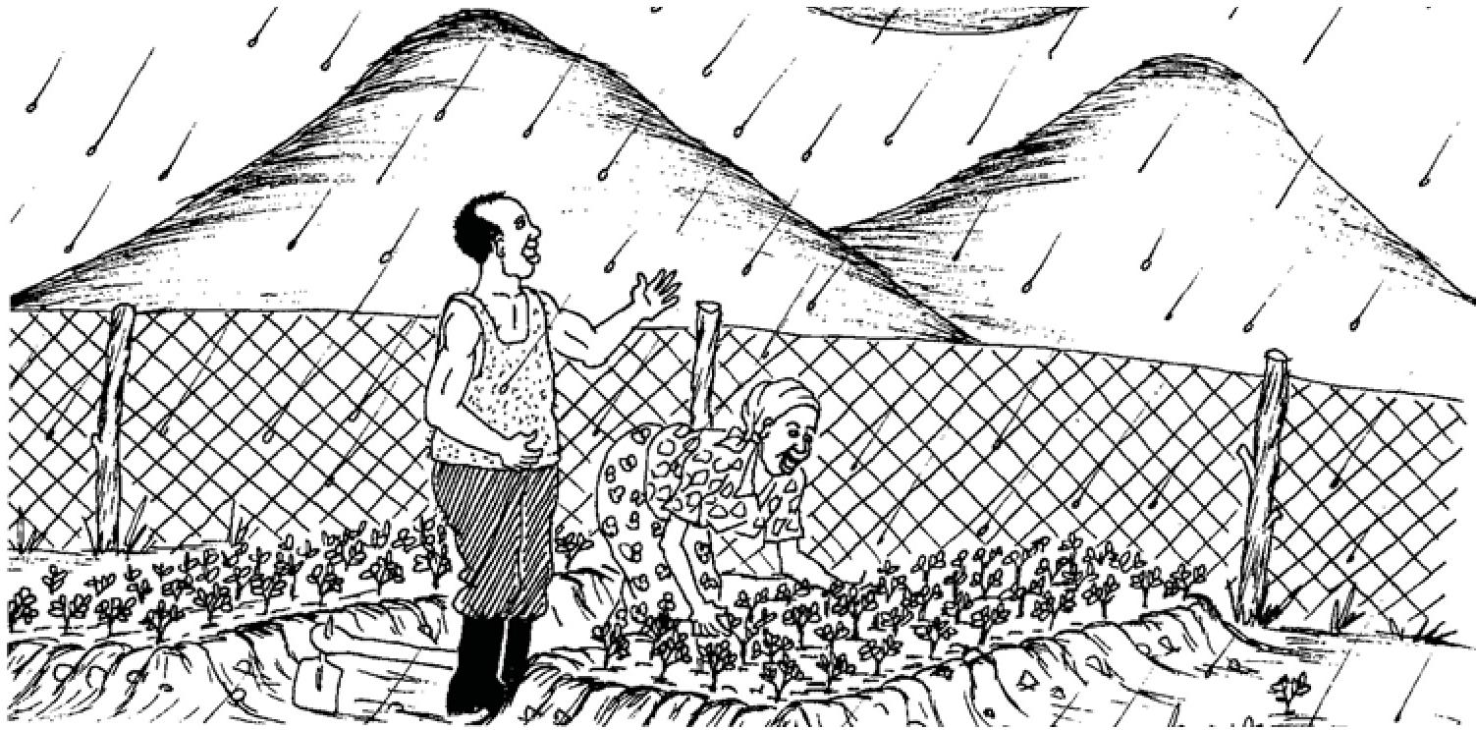
- Transplant on a rainy day, or when there is enough moisture in the soil
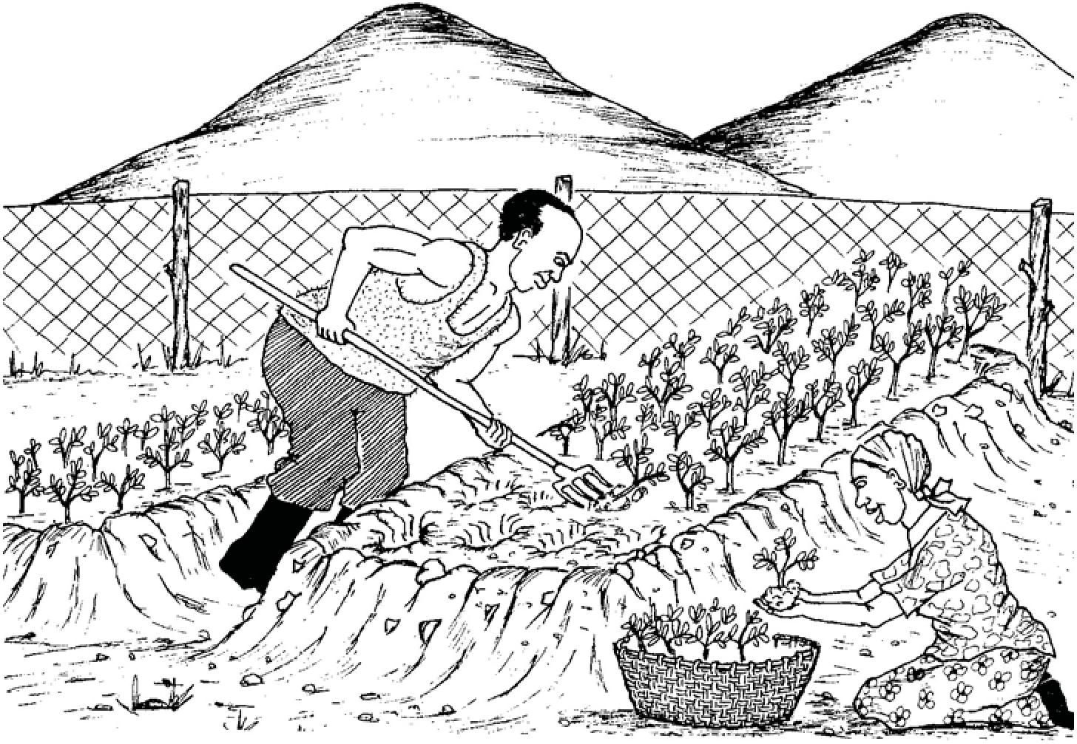
- Uproot seedlings with soil lumps on the roots and put in well-ventilated containers
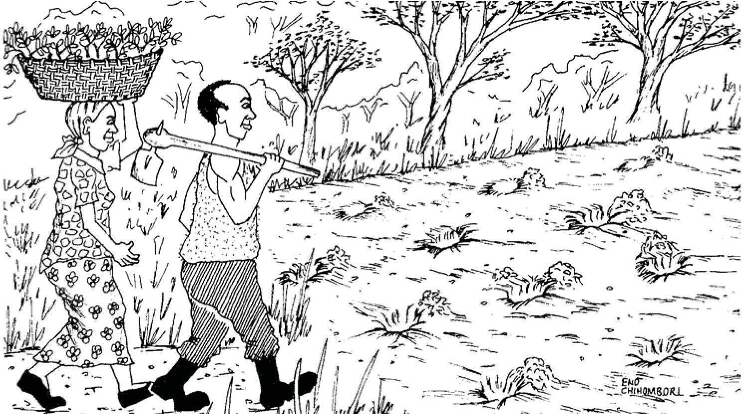
- Carry to the field where you plan to plant out. Carry carefully to avoid exposure
of the roots and any damage to the plants
3 Forests

Can Gliricidia be grown from cuttings?
G. sepium is commonly grown from cuttings, although for establishment in poor soils, growing from seed will lead to better root development. Cut pieces with 2-6cm diameter and 30-100cm length and make wounds with a knife on the first 20cm of the stake. Plant with at least 20cm below the ground as soon as possible after harvesting, and do not allow to dry out. The cutting will need to be watered regularly until they are well-established.
The use of stump cuttings from nursery grown plants can also be successful. Grow seedlings to at least a 1cm diameter stem, then cut the root at 15cm, the shoot at 25cm, and roll in mud, or otherwise keep wet, until they are planted out to the field.
How do you manage Gliricidia in the field?
That depends what you plan to use it for. If you are growing for firewood, then you can coppice it – cut it close to the base so it resprouts new growth. If you are growing for fodder or green manure, pruning at 0.3 – 1.5 m will make more leaves grow.
These pictures show how Gliricidia can be used to fertilize maize fields in an improved fallows system, using green manure for biomass transfer from the gliricidia trees to the soil. The months given are relevant for Southern Africa. It is always worthwhile talking to farmers and extension workers with experience of a technique you are interested in applying on your farm for the first time.

Free the plants from all materials that might catch fire and create a firebreak around the field
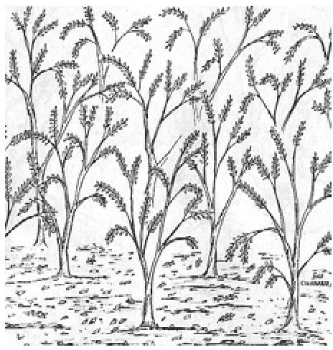
After 18 – 24 months of growth, the field of Gliricidia is often ready for cutting.
Plant 6-8 week-old seedlings from the nursery at a spacing of 1m x 1m, in between rwhere you plan to plant rows of maize.
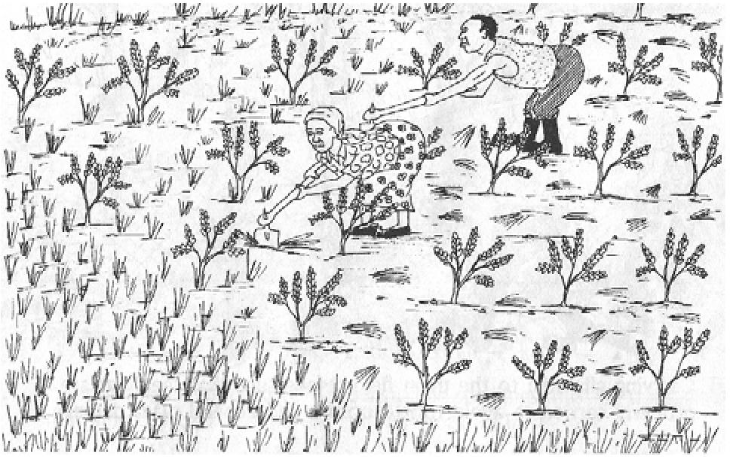
Weed all unwanted plants which might interrupt the growth of the young Gliricidia plants.
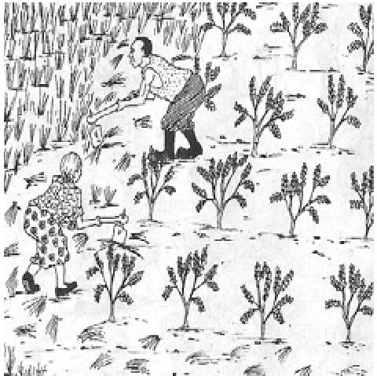

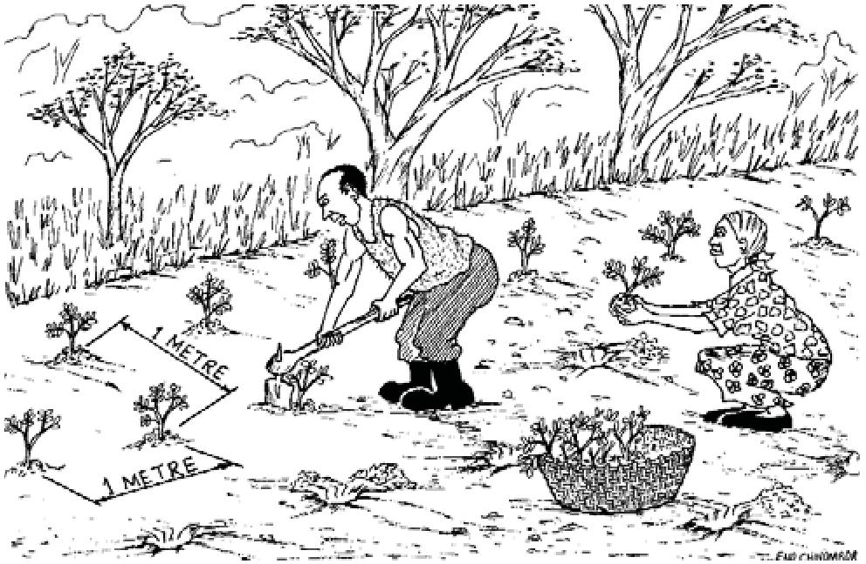

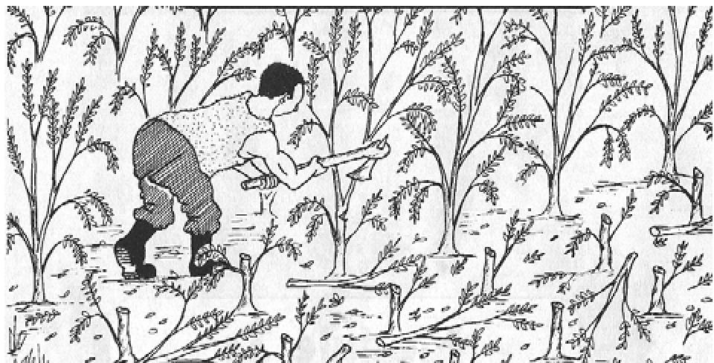 | In early September, cut the trees when they reach 30cm in height. Leave the cuttings in the field for 2 weeks until they drop leaves. Two weeks after cutting, the Gliricidia biomass is ready to be mixed into the soil.
  4 Forests

In late September, collect up the dry poles and sticks for firewood or other uses. The leaves will have dropped off.
In early October, make ridges or dig in the Gliricidia leaves and soft twigs.
In October, plant maize at normal planting spacing
By December, you see the maize growing between the coppiced Gliricidia trees.
In January, coppices are cut back again and the leaves and soft twigs are applied between the maize plants as a top dressing or mulch.
5 Forests
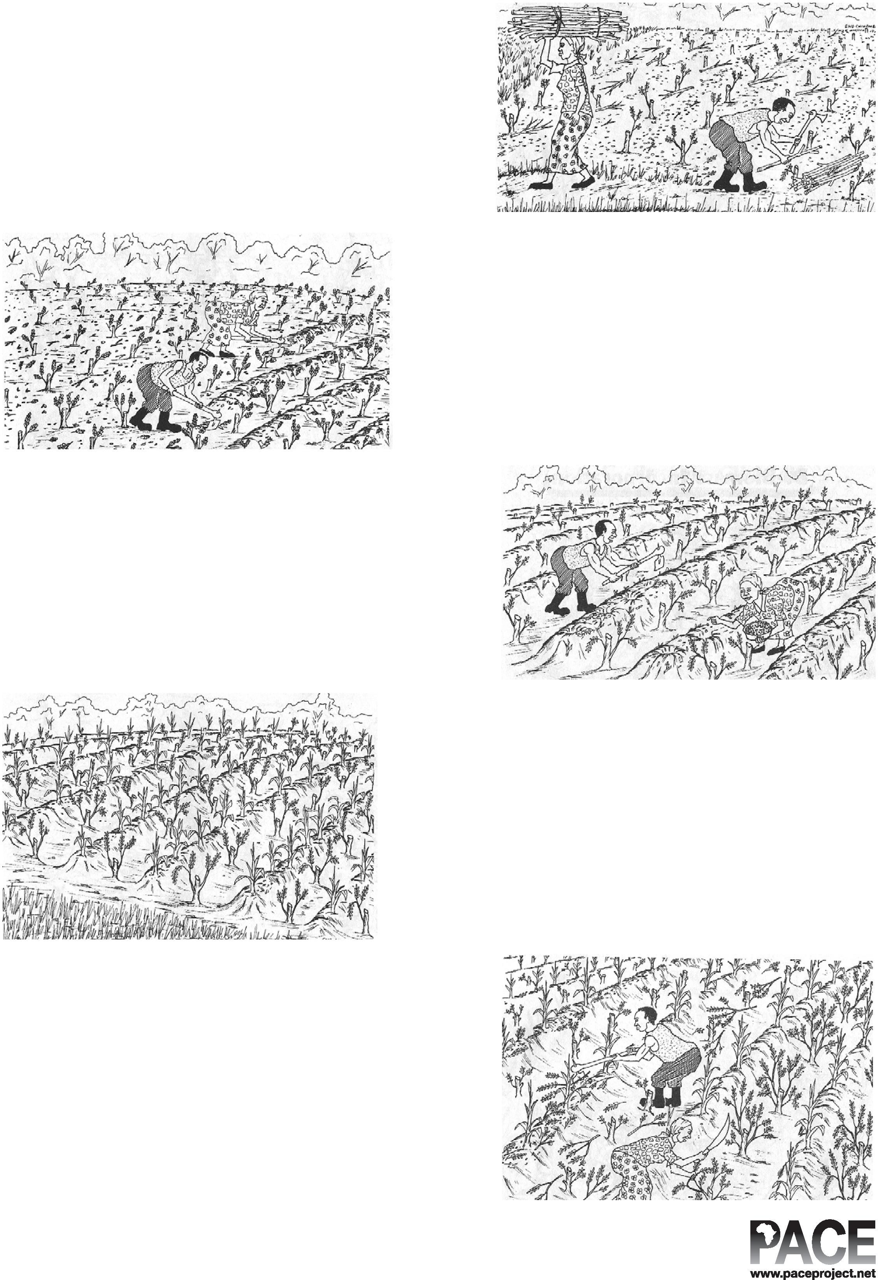
ACKNOWLEDGEMENTS: This Action Sheet was compiled by Nancy Gladstone, based on the following sources:
6 Forests

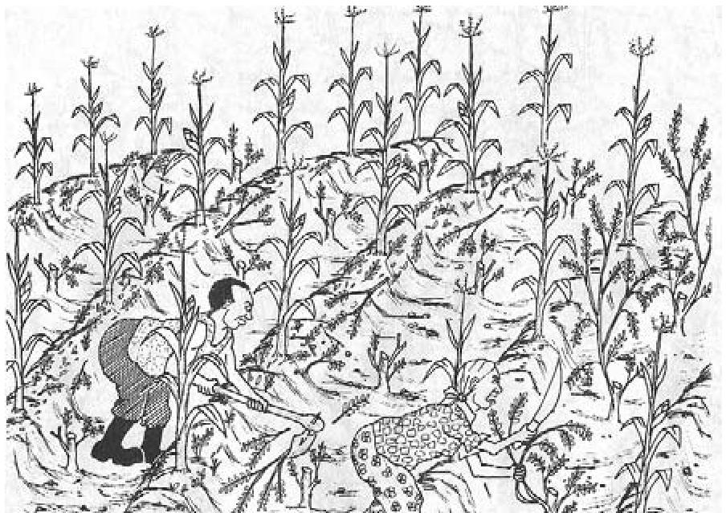 | In late February, it is time to cut the Gliricidia coppices again and apply between the maize plants as a top dressing or mulch.
 | 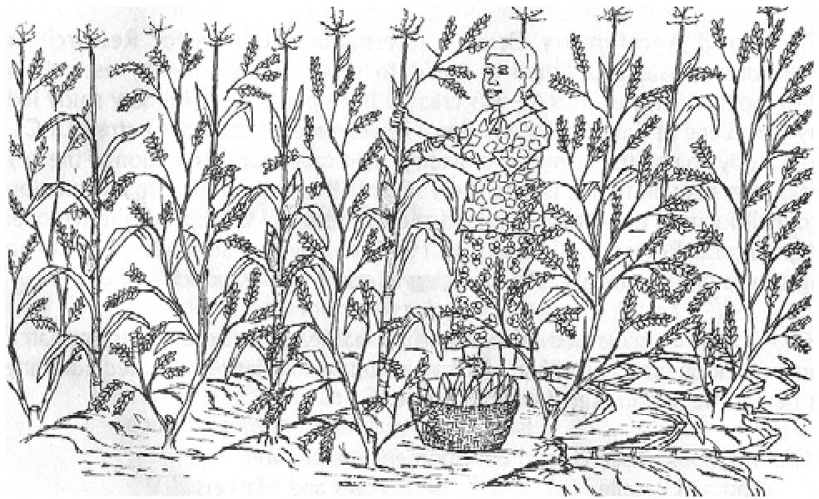
In April and May, the maize will be ready for harvesting. Leave the Gliricidia to grow as a fallows from May to September. In September you can prune to 30cm, leave for 2 weeks, dig the twigs and soft leaves in, and plant again on naturally fertilized soil.

Establishing and managing a gliricidia fallow: from transplanting to harvest of tree biomass, World Agroforestry Centre (International Centre for Research in Agroforestry) 2004, compiled by World Agroforestry Center Zambia Saff, Edited by Parkie Mbozi and Roza Katanga, Cartoons by Enock Chihombori (cartoons reproduced with permission above).
World Agroforestry Centre Agroforestree Database entry on Gliricidia sepium
Growing Gliricidia, NFT Highlights - A quick guide to useful nitrogen fixing trees from around the world, A publication of the Forest, Farm, and Community Tree Network (FACT Net), Winrock International.
Prevention and Management of Alien Invasive Species: Forging Cooperation throughout West Africa. CAB International (2004) - Proceedings of a workshop held in Accra, Ghana, 9-11 March, 2004
Illustrations by Alexi Francis
FOR MORE INFORMATION
CONTACT
World Agroforestry Centre

