ERYTHRINA ABYSSINICA*
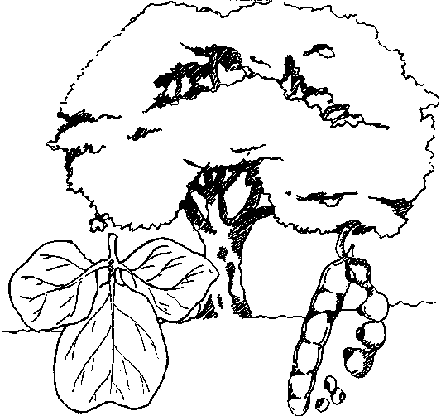
DISTRIBUTION
A deciduous savannah species suitable for a wide range of conditions. It is widespread in Tanzania in various habitats including open woodlands, forest clearings, grasslands, and lowland woodlands to 2000 m except in very dry or high altitude areas (RSCU 1992). E. abyssinica is found in Mbeya, Rukwa, Morogoro, Tabora, Arusha, the Coast and Kagera (Rulangaranga 1989).
Minimum Altitude (m): | 60
Maximum Altitude (m): | 2290
Minimum Rainfall (mm): | 500
Maximum Rainfall (mm): | 1500
Minimum Temperature (C): | 15
Maximum Temperature (C): | 25
REQUIREMENTS
Soil requirements: Occurs on a variety of soils from loams to clay loams. The tree prefers deep well-drained soils on plateaus and slopes (Egli and Kalinganire 1988).
Light Requirements: Moderately light demanding.
Influential Factors: Fairly fire and termite resistant (RSCU 1992). E. abyssinica can be grown only on frost free sites.
PROPAGATION
Means of Propagation: Seedlings, cuttings, direct sowing, coppice, suckers and truncheons, or, suckers and truncheons, or stems.
Seeds per kg: | 6800
Germination Rate (%): | 82
Seed Sources: | 800 TSH per kg - Tanzania National Seed Centre 1991.
Seed Treatments: Pods are 15 to 25 cm in length and should be collected as ripe fruits while still on the tree. Seeds are red with a black spot, and are contained in woody black pods. Seeds retain their viability for a long period, and may be stored indefinitely in cool, dry, insect free conditions. Seed does not require pretreatment. The seed of all Erythrina is poisonous.
Seedling Management: Low germination rates have been reported (RSCU 1992) but Egli reports a germination rate of 90% with fresh seeds (Egli and Kalinganire 1988). Direct sowing, seedlings and transplants have equal success. It has been noted that old trees coppice readily. Trees are easily propagated from large cuttings which is the most common method of reproduction (Teel 1984). Cuttings are stripped of leaves and planted directly at the beginning of the rainy season.
SILVICULTURE
Planting Types: Recommended for planting in higher areas as single shade trees, in rows, or to mark boundaries in cultivated areas. It can be planted near dwellings, by fields, swamps, roads, and watercourses. It is also recommended for live hedges.
Growth Factors: Moderately fast growing.
Management Systems: The tree is easily cultivated and tolerates pollarding and coppicing.
IMPORTANT USES
Use #1: MEDICINE
The bark of young stems is used to treat trachoma. It is also roasted and applied to burns and swellings. Powdered root is used for syphilis, anthrax, and snakebites (Rulangaranga 1989).
Use #2: GENERAL PURPOSE WOOD The wood is light (495 kg per m³), easy to work, but is not durable and is liable to attack by insects and fungi (Egli and Kalinganire 1988). It was reported that beehives, drums, crafts, toys, necklaces, and domestic items such as spoons are made from the wood.
Use #3: LAND IMPROVEMENT
It is widely recognized as an ornamental and shade tree. It is nitrogen fixing, its leaves are used for mulch, and it is known for conserving soil.
OTHER USES: Honey bees are also attracted by the flowers.
NOTES
It is protected by farmers and left standing when land is cleared for agriculture, indicating that it is highly valued.

Source : http://www.fao.org/docrep/X5327e/x5327e11.htm
Erythrina abyssinica Lam. ex DC.
Protologue  Prodr. 2: 413 (1825).  Family  Papilionaceae (Leguminosae - Papilionoideae, Fabaceae)  Chromosome number  2n = 42  Synonyms  Erythrina tomentosa R.Br. ex A.Rich. (1847).  Vernacular names  Red-hot-poker tree, lucky bean tree, flame tree, Abyssinian coral tree (En). Arbre de corail d’Abyssinie (Fr). Mjafari, mlungu, mbamba ngoma, mwamba ngoma (Sw).  Origin and geographic distribution  Erythrina abyssinica is widespread from Sudan and Ethiopia south to Angola, Zimbabwe and Mozambique. It has been introduced as an ornamental in Mauritius and various places in tropical Asia and Central America.  Uses  Erythrina abyssinica is a veritable multipurpose tree. The wood is commonly used for making carvings, stools, drums, mortars, beehives, tool handles, brake blocks and floats for fishing nets, and sometimes also in house construction; wood from the roots is used for making walking sticks. The wood serves as firewood; it smoulders readily without flaming and keeps smouldering for long periods.  The tree is recommended for soil conservation programmes, for erosion control, and for use as green manure. It is the main planted shade tree for coffee in Ethiopia. It is extensively used as a live fence around homesteads, and is also planted as an ornamental. The flowers provide nectar and pollen for bees at the end of the dry season, strengthening bee colonies in this difficult period. The bark is sometimes used as a brown dye for textiles and the sap gives a red colour. Cork from the bark is used as floats for fishing nets. The leaves are eaten by sheep and goats. The seeds are locally popular for making curios and necklaces.  Erythrina abyssinica is well known as a medicinal plant. The bark is most commonly used in traditional medicine, to treat snakebites, malaria, sexually transmittable diseases such as syphilis and gonorrhoea, amoebiasis, cough, liver inflammation, stomach-ache, colic and measles. Roasted and powdered bark is applied to burns, ulcers and swellings. The liquid from crushed bark of green stems is used to cure conjunctivitis caused by Chlamydia trachomatis (trachoma), whereas bark sap is also drunk as an anthelmintic. The bark is also applied against vomiting. Pounded flowers serve to treat dysentery. A maceration of the flower is drunk as an abortifacient, and applied externally to treat earache. Roots are taken to treat peptic ulcers, epilepsy, malaria, blennorrhagia and schistosomiasis. Leaves are taken to treat peptic ulcers; they are also used for treatment of diarrhoea. A leaf decoction serves as an emetic. Leaves are applied externally to wounds and painful joints; they are also applied to treat skin diseases in cattle. Fruit extracts are taken to treat asthma and meningitis.  Properties  The wood is lightweight and soft. It is greyish white, sometimes with shades of red. The grain is usually straight, texture coarse. The wood is easy to work, but planed surfaces may be woolly. It does not split when nailed, but the nail-holding capacity is poor. It is not durable and is prone to fungal and wood-borer attacks; however, it is moderately resistant to termites.  In a test in Ethiopia it was concluded that leafy twigs can effectively serve as a cheap source of protein supplement for low-quality diets during the dry season for resource-poor farmers with stall-fed sheep and goats. As a general-purpose fodder it is less suitable, as the palatability of the leaves to sheep is rather poor.  Several compounds exhibiting a broad spectrum antimicrobial activity have been isolated from the root bark. A crude extract of the root bark showed antiplasmodial activity against Plasmodium falciparum; flavonoids and isoflavonoids are the active compounds. Stem bark extracts also showed antiplasmodial activity, including activity against chloroquine-resistant strains of Plasmodium falciparum, and flavonoids have been isolated as active ingredients. Seeds contain a curare-like poison.  Description  Deciduous, small tree up to 12(–15) m tall; bole usually short, stout, up to 60 cm in diameter, usually armed with woody knobs; bark thick, corky, deeply fissured, yellowish brown, exuding a brown, gummy sap; crown rounded, with thick, spreading, somewhat twisted branches; twigs armed with strong curved prickles, initially densely hairy, glabrescent. Leaves alternate, 3-foliolate; stipules lanceolate, caducous; petiole 6–20 cm long, often prickly, rachis 3–8 cm long, petiolules 0.5–1 cm long; leaflets broadly ovate to rhombic or almost circular, 2.5–20 cm × 2.5–21 cm, cordate to rounded or truncate at base, obtuse to notched at apex, densely hairy especially below, 3-veined from the base, veins sometimes with prickles. Inflorescence an axillary or terminal, pyramidal, dense, erect false raceme up to 20 cm long; peduncle 2–20 cm long; bracts up to 9 mm long, soon caducous. Flowers bisexual, papilionaceous; pedicel 2–6 mm long; calyx cylindrical to spindle-shaped, split at one side, tube 0.5–2 cm long, densely hairy, lobes elliptical to linear, 0.5–6 cm long; corolla orange-red to scarlet red, standard elliptical to obovate, 3–5 cm × 1–1.5 cm, wings 7–11 mm × 4–6 mm, keel petals free, 5–6 mm × 3–4 mm; stamens 10, fused but 1 almost free; ovary superior, narrowly cylindrical-oblong, stiped, 1-celled, style long, incurved. Fruit a linear-oblong pod 4–16 cm × 1–2.5 cm, markedly constricted between the seeds, brown to black, usually hairy, opening by 2 valves, 1–10-seeded. Seeds ellipsoid, 6–12 mm long, bright red with area around the hilum black.  Other botanical information  Erythrina comprises approximately 120 species: about 30 in continental Africa, 6 in Madagascar, 70 in tropical America and 12 in tropical Asia and Australia.  Erythrina latissima E.Mey. from Botswana, Zimbabwe, Mozambique, eastern South Africa and Swaziland closely resembles Erythrina abyssinica, but has larger leaflets, flowers and seeds. Its wood is undoubtedly used for similar purposes. In traditional medicine the powdered bark of Erythrina latissima is applied to wounds. The effectiveness is supported by pharmacological research, which showed the presence of antimicrobial flavonoids.  Erythrina burttii Baker f. is a small tree up to 15 m tall restricted to Kenya and Tanzania. Its wood is used for stools and camel bells and as fuelwood. The leaves are used for making a tea. The seeds are used in traditional medicine to treat throat pain, and in veterinary medicine to treat cough in camels. Stem bark extracts showed in-vitro antifungal and antibacterial activities, with flavonoids as the active principles.  Erythrina melanacantha Harms is a small to medium-sized tree up to 20 m tall, occurring in Ethiopia, Somalia, Kenya, Tanzania and Socotra (Yemen). The wood is used to make headrests, stools, jugs, cups and pots. In Ethiopia the roots have been used as famine food and they are a source of potable water. Erythrina melanacantha is browsed by livestock and is occasionally planted as ornamental. Its fruits are eaten in Ethiopia.  Erythrina sacleuxii Hua is a small to medium-sized tree up to 25 m tall, known from Kenya and Tanzania. The wood is used for making headrests and mortars. It also serves as fuelwood and for charcoal making. The tree is planted as an amenity and roadside tree. A root decoction is used to treat gonorrhoea and leprosy. Antiplasmodial flavonoids have been isolated from the bark.  Anatomy  Wood-anatomical description (IAWA hardwood codes):  Growth rings: 2: growth ring boundaries indistinct or absent. Vessels: 5: wood diffuse-porous; 13: simple perforation plates; 22: intervessel pits alternate; 23: shape of alternate pits polygonal; 26: intervessel pits medium (7–10 μm); 29: vestured pits; 30: vessel-ray pits with distinct borders; similar to intervessel pits in size and shape throughout the ray cell; 43: mean tangential diameter of vessel lumina ≥ 200 μm; (45: vessels of two distinct diameter classes, wood not ring-porous); 46: ≤ 5 vessels per square millimetre. Tracheids and fibres: 61: fibres with simple to minutely bordered pits; 66: non-septate fibres present; 69: fibres thin- to thick-walled. Axial parenchyma: 85: axial parenchyma bands more than three cells wide; (90: fusiform parenchyma cells); 91: two cells per parenchyma strand. Rays: 98: larger rays commonly 4- to 10-seriate; (99: larger rays commonly > 10-seriate); 109: rays with procumbent, square and upright cells mixed throughout the ray; 110: sheath cells present; 114: ≤ 4 rays per mm. Storied structure: 120: axial parenchyma and/or vessel elements storied. Mineral inclusions: 136: prismatic crystals present; 142: prismatic crystals in chambered axial parenchyma cells.  (E. Ebanyenle, A.A. Oteng-Amoako & P. Baas)  Growth and development  Seedlings develop a deep root system before stem growth starts. Trees grow moderately fast, but growth rates vary widely depending on soil conditions. They are deciduous and flower when leafless. In this period they are conspicuous and decorative. Flowering is erratic, but occurs over a long period: September to April in Ethiopia, January to March in Kenya and July to November in southern Africa. The flowers are mainly pollinated by birds, often sunbirds. Seeds are ripe about 2 months after flowering. Erythrina abyssinica is a nitrogen fixing tree.  Ecology  Erythrina abyssinica occurs in woodland and wooded grassland, also in secondary scrub vegetation, in regions with (500–)800–1500(–2000) mm annual rainfall. Its optimal temperature range is 15–25°C. In Sudan it is found up to 2000 m altitude, in Tanzania up to 2300 m. It can be found on loamy to clayey soils, and prefers deep well-drained soils on plateaus and slopes, with a pH of 3.5–5.5. Trees are fire resistant, and even seedlings resprout after fires, due to their deep root system. Erythrina abyssinica does not tolerate frost.  Propagation and planting  Erythrina abyssinica can be propagated by seed. The 1000-seed weight is about 150 g. Seeds should be collected from ripe pods still on the tree; they are widely available. They are sun dried for one day before storage. Seeds can be stored for long periods if they are kept in a cool and dry place and kept free from insects, e.g. by adding ash. The germination rate of seeds is generally low: 10–30%. Pre-treatment with hot water or concentrated sulphuric acid may increase the germination rate up to 90%. Scarification of seeds is also beneficial for germination; this can be done by rubbing with sandpaper or nicking with a knife, after which the seeds should be immersed in water for some hours until they begin to swell. To obtain optimal growth, seeds are inoculated with appropriate Rhizobium bacteria immediately before sowing. Seeds can be sown in seed beds of sterile sand or in polythene bags with a mixture of soil, sand and compost (2:1:1). They should be sown with the hilum facing downward and covered with a thin layer of potting medium. Seedlings can be transplanted when 20–30 cm tall. Direct sowing in the field is also possible.  Propagation by cuttings is often successful when these are planted in the rainy season. Cuttings are stripped of leaves and planted directly. Air-layering is also possible.  Management  Trees can be managed by pollarding and coppicing. Seedlings should not be pruned before they are one year old. Planting large stakes of 2.5 m long and 8–10 cm in diameter is sometimes practised for its use as shade tree; these stakes can produce a canopy of 3–4 m in diameter in 6 months. Truncheons are commonly used to make living fences.  Genetic resources  Erythrina abyssinica is widespread in various habitats and currently not under threat. It is included in several germplasm collections, e.g. in the ILRI genetic resources collection (12 samples collected from the wild in Ethiopia) and the USDA/ARS NGRL desert legume program (seed collected from the wild in Zimbabwe).  Prospects  Although Erythrina abyssinica is not a very important timber tree, it is an outstanding multipurpose tree that provides not only wood, but also serves as shade tree and for soil improvement. It is also very useful for living fences and as an ornamental. Moreover, it has interesting applications in traditional medicine that deserve more research attention.  Major references  • Chilufya, H. & Tengnäs, B., 1996. Agroforestry extension manual for northern Zambia. Regional Soil Conservation Unit, Nairobi, Kenya. 120 + 124 pp.  • Coates Palgrave, O.H., 1957. Trees of Central Africa. National Publications Trust, Rhodesia and Nyasaland, Salisbury, Southern Rhodesia. 466 pp.  • Hines, D.A. & Eckman, K., 1993. Indigenous multipurpose trees of Tanzania: Uses and economic benefits for people. [Internet] Cultural Survival Canada, Ottawa, Canada. http://www.fao.org/ documents/show_cdr.asp?url_file=/docrep/X5327e/ x5327e11.htm. Accessed March 2007.  • Kibungu Kembelo, A.O., 2004. Quelques plantes medicinales du Bas-Congo et leurs usages. DFID, London, United Kingdom. 197 pp.  • Latham, P., 2004. Useful plants of Bas-Congo province, Democratic Republic of the Congo. DFID, London, United Kingdom. 320 pp.  • Mackinder, B., Pasquet, R., Polhill, R. & Verdcourt, B., 2001. Leguminosae (Papilionoideae: Phaseoleae). In: Pope, G.V. & Polhill, R.M. (Editors). Flora Zambesiaca. Volume 3, part 5. Royal Botanic Gardens, Kew, Richmond, United Kingdom. 261 pp.  • Maundu, P. & Tengnäs, B. (Editors), 2005. Useful trees and shrubs for Kenya. World Agroforestry Centre - East and Central Africa Regional Programme (ICRAF-ECA), Technical Handbook 35, Nairobi, Kenya. 484 pp.  • SEPASAL, 2007. Erythrina abyssinica. [Internet] Survey of Economic Plants for Arid and Semi-Arid Lands (SEPASAL) database. Royal Botanic Gardens, Kew, Richmond, United Kingdom. http://www.kew.org/ ceb/sepasal/. Accessed February 2007.  • World Agroforestry Centre, undated. Agroforestree Database. [Internet] World Agroforestry Centre (ICRAF), Nairobi, Kenya. http://www.worldagroforestry.org/ resources/databases/ agroforestree. Accessed March 2007.  • Yenesew, A., Induli, M., Derese, S., Midiwo, J.O., Heydenreich, M., Peter, M.G., Akala, H., Wangui, J., Liyala, P. & Waters, N.C., 2004. Anti-plasmodial flavonoids from the stem bark of Erythrina abyssinica. Phytochemistry 65(22): 3029–3032.  Other references  • Ali, H., König, G.M., Khalid, S.A., Wright, A.D. & Kaminsky, R., 2002. Evaluation of selected Sudanese medicinal plants for their in vitro activity against hemoflagellates, selected bacteria, HIV-1 RT and tyrosine kinase inhibitory, and for cytotoxicity. Journal of Ethnopharmacology 83: 219–228.  • Bekele-Tesemma, A., Birnie, A. & Tengnäs, B., 1993. Useful trees and shrubs for Ethiopia: identification, propagation and management for agricultural and pastoral communities. Technical Handbook No 5. Regional Soil Conservation Unit/SIDA, Nairobi, Kenya. 474 pp.  • Centre d’Echange de la République du Burundi, 2002. Stratégie nationale et plan d’actions en matière de la diversité biologique. [Internet] http://bch-cbd.naturalsciences.be/ burundi/contribution/strategie/ chapii-1.htm. Accessed September 2007.  • Dharani, N., 2002. Field guide to common trees and shrubs of East Africa. Struik Publishers, Cape Town, South Africa. 320 pp.  • Gelfand, M., Mavi, S., Drummond, R.B. & Ndemera, B., 1985. The traditional medical practitioner in Zimbabwe: his principles of practice and pharmacopoeia. Mambo Press, Gweru, Zimbabwe. 411 pp.  • InsideWood, undated. [Internet] http://insidewood.lib.ncsu.edu/search/. Accessed May 2007.  • Kaitho, R.J., Umunna, N.N., Nsahlai, I.V., Tamminga, S., van Bruchem, J., Hanson, J. & van de Wouw, M., 1996. Palatability of multipurpose tree species: effect of species and length of study on intake and relative palatability by sheep. Agroforestry Systems 33(3): 249–261.  • Katende, A.B., Birnie, A. & Tengnäs, B., 1995. Useful trees and shrubs for Uganda: identification, propagation and management for agricultural and pastoral communities. Technical Handbook 10. Regional Soil Conservation Unit, Nairobi, Kenya. 710 pp.  • Kokwaro, J.O., 1993. Medicinal plants of East Africa. 2nd Edition. Kenya Literature Bureau, Nairobi, Kenya. 401 pp.  • Larbi, A., Thomas, D. & Hanson, J., 1993. Forage potential of Erythrina abyssinica: intake, digestibility and growth rates for stall-fed sheep and goats in southern Ethiopia. Agroforestry Systems 21(3): 263–270.  • Laurent, N. & Chamshama, S.A.O., 1987. Studies on the germination of Erythrina abyssinica and Juniperus procera. International Tree Crops Journal 4(4): 291–298.  • Lovett, J.C., Ruffo, C.K., Gereau, R.E. & Taplin, J.R.D., 2006. Field guide to the moist forest trees of Tanzania. [Internet] Centre for Ecology Law and Policy, Environment Department, University of York, York, United Kingdom. http://celp.org.uk/ projects/ tzforeco/. Accessed September 2007.  • Maundu, P., Berger, D., Saitabau, C., Nasieku, J., Kipelian, M., Mathenge, S., Morimoto, Y. & Höft, R., 2001. Ethnobotany of the Loita Maasai. Towards community management of the forest of the Lost Child. Experiences from the Loita Ethnobotany Project. UNESCO People and Plants Working Paper 8, Paris, France. 34 pp.  • Neuwinger, H.D., 2000. African traditional medicine: a dictionary of plant use and applications. Medpharm Scientific, Stuttgart, Germany. 589 pp.  • Powell, M.H. & Westley, S.B., 1993. Erythrina production and use: a field manual. Nitrogen Fixing Tree Association, Hawaii, United States. 56 pp.  • Sommerlatte, H. & Sommerlatte, M., 1990. A field guide to the trees and shrubs of the Imatong Mountains, southern Sudan. Deutsche Gesellschaft fur Technische Zusammmenarbeit (GTZ), Nairobi, Kenya. 372 pp.  • Tabuti, J.R.S., Lye, K.A. & Dhillion, S.S., 2003. Traditional herbal drugs of Bulamogi, Uganda: plants, use and administration. Journal of Ethnopharmacology 88: 19–44.  • Taniguchi, M. & Kubo, I., 1993. Ethnobotanical drug discovery based on medicine men’s trials in the African savanna: screening of East African plants for antimicrobial activity II. Journal of Natural Products 56(9): 1539–1546.  • van Wyk, B. & van Wyk, P., 1997. Field guide to trees of southern Africa. Struik Publishers, Cape Town, South Africa. 536 pp.  • Williamson, J., 1955. Useful plants of Nyasaland. The Government Printer, Zomba, Nyasaland. 168 pp.  • Yenesew, A., Derese, S., Irungu, B., Midiwo, J.O., Waters, N.C., Liyala, P., Akala, H., Heydenreich, M. & Peter, M.G., 2003. Flavonoids and isoflavonoids with antiplasmodial activities from the root bark of Erythrina abyssinica. Planta Medica 69(7): 658–661.  Sources of illustration  • Coates Palgrave, K., 1983. Trees of southern Africa. 2nd Edition. Struik Publishers, Cape Town, South Africa. 959 pp.  • Coates Palgrave, O.H., 1957. Trees of Central Africa. National Publications Trust, Rhodesia and Nyasaland, Salisbury, Southern Rhodesia. 466 pp.  • Noad, T. & Birnie, A., 1989. Trees of Kenya. A fully illustrated field guide. Nairobi, Kenya. 281 pp.  • Troupin, G., 1982. Flore des plantes ligneuses du Rwanda. Publication No 21. Institut National de Recherche Scientifique, Butare, Rwanda. 747 pp.  Author(s)  Editors  General editors  Photo editor  Correct citation of this article:  Aerts, R., 2008. Erythrina abyssinica Lam. ex DC. In: Louppe, D., Oteng-Amoako, A.A. & Brink, M. (Editors). Prota 7(1): Timbers/Bois d’œuvre 1. [CD-Rom]. PROTA, Wageningen, Netherlands. |  | 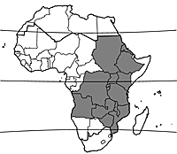wild  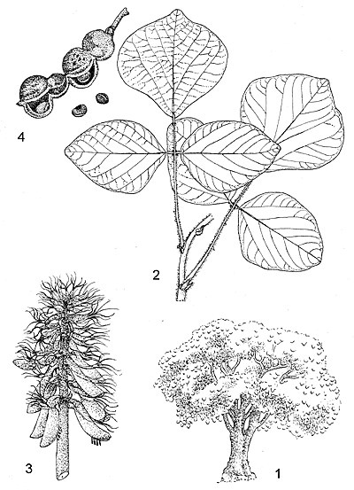1, tree habit; 2, part of leafy twig; 3, inflorescence; 4, fruit and seeds.  Redrawn and adapted by Iskak Syamsudin  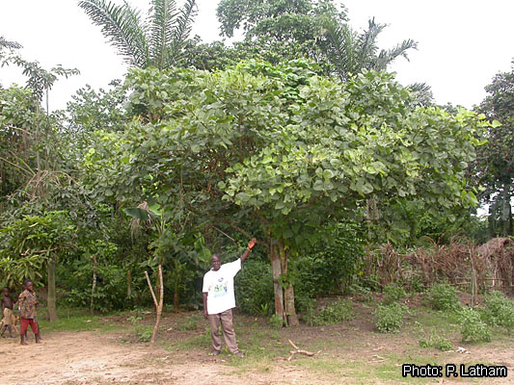tree habit  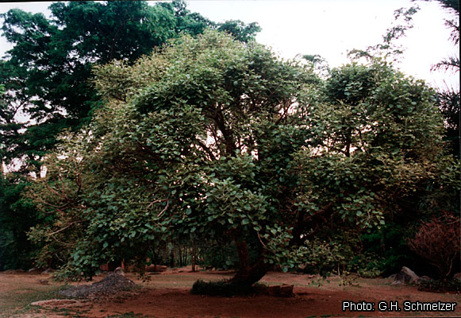tree habit  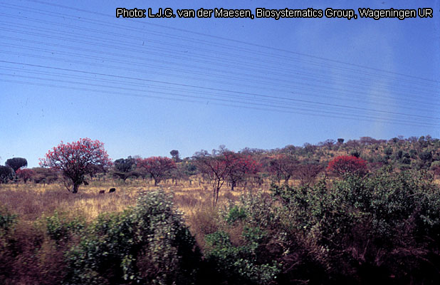flowering trees  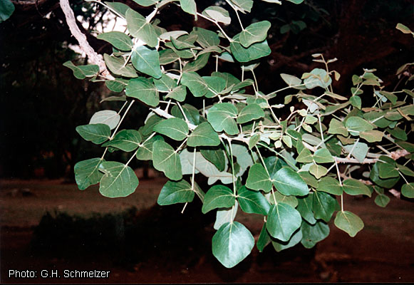leafy branch  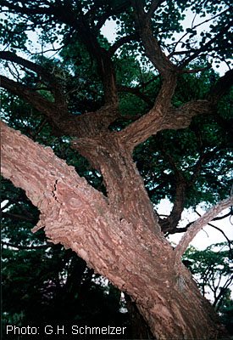crown  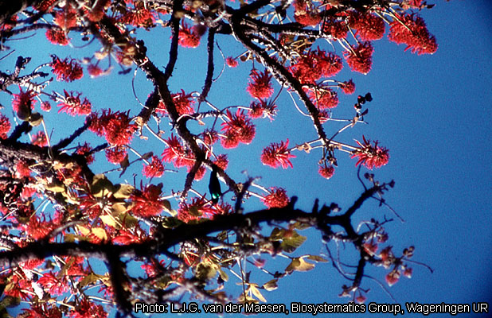flowering branches  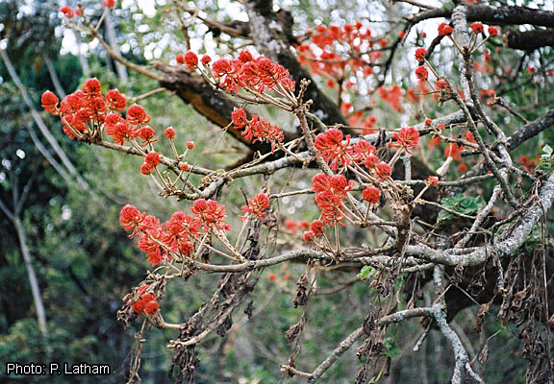flowering branches  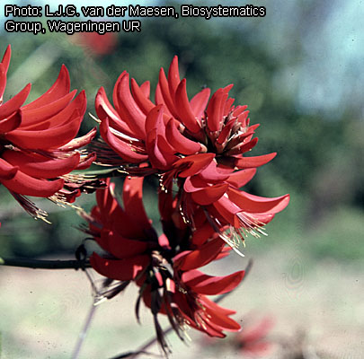inflorescences  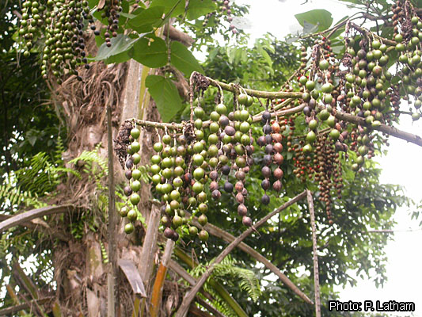infructescences  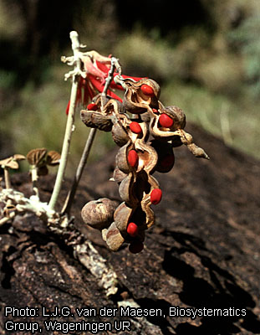infructescences showing seeds  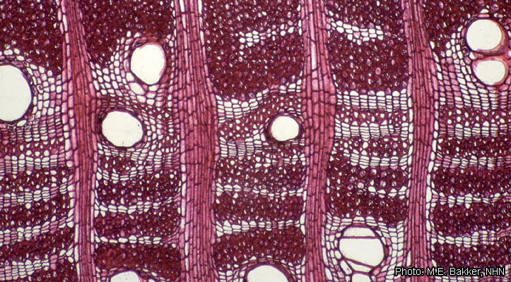wood in transverse section  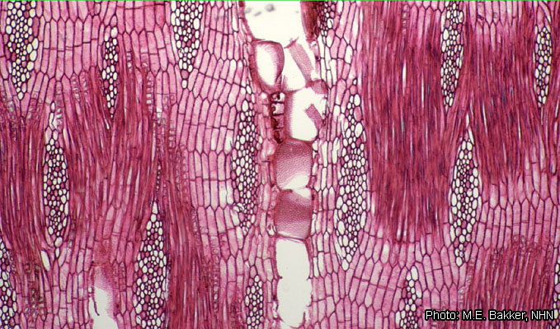wood in tangential section
  • | R. Aerts  Division Forest, Nature and Landscape, Katholieke Universiteit Leuven, Celestijnenlaan 200E, Box 2411, BE-3001, Leuven, Belgium
  • | D. Louppe  CIRAD, Département Environnements et Sociétés, Cirad es-dir, Campus international de Baillarguet, TA C-DIR / B (Bât. C, Bur. 113), 34398 Montpellier Cedex 5, France
  • | A.A. Oteng-Amoako  Forestry Research Institute of Ghana (FORIG), University P.O. Box 63, KNUST, Kumasi, Ghana
  • | M. Brink  PROTA Network Office Europe, Wageningen University, P.O. Box 341, 6700 AH Wageningen, Netherlands
  • | R.H.M.J. Lemmens  PROTA Network Office Europe, Wageningen University, P.O. Box 341, 6700 AH Wageningen, Netherlands
  • | L.P.A. Oyen  PROTA Network Office Europe, Wageningen University, P.O. Box 341, 6700 AH Wageningen, Netherlands
  • | J.R. Cobbinah  Forestry Research Institute of Ghana (FORIG), University P.O. Box 63, KNUST, Kumasi, Ghana
  • | G.H. Schmelzer  PROTA Network Office Europe, Wageningen University, P.O. Box 341, 6700 AH Wageningen, Netherlands

Source : http://database.prota.org/PROTAhtml/Erythrina%20abyssinica_En.htm

