Rosewood
From Wikipedia, the free encyclopedia
This article is about rosewood timber. For other uses, see Rosewood (disambiguation).
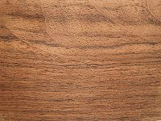
A classic rosewood surface
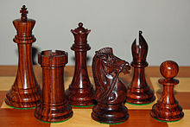
Chess pieces in Dalbergia latifoliarosewood
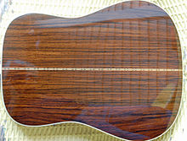
Back of guitar made with East Indian rosewood
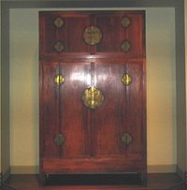
A Chinese Ming Dynasty compoundwardrobe made of 'huanghuali' rosewood, latter half of the 16th century.
Rosewood refers to any of a number of richly hued timbers, often brownish with darker veining, but found in many different hues. All rosewoods are strong and heavy, taking an excellent polish, being suitable for guitars, marimbas, turnery (billiard cues, the black pieces inchess sets, etc), handles, furniture, luxury flooring, etc.
In general, supplies are poor through overexploitation. Some species become canopy trees (up to 30 m high), and large pieces can occasionally be found in the trade.

Contents
[hide]
- 1 True rosewoods
- 2 Other "rosewoods"
- 3 Madagascar rosewood logging controversy
- 4 References

[edit]True rosewoods
All genuine rosewoods belong to the genus Dalbergia. The pre-eminent rosewood appreciated in the western world is the wood of Dalbergia nigra which is now a CITES – listed endangered species. It is best known as Brazilian Rosewood, but also as "Rio Rosewood" or "Bahia Rosewood." This wood has a strong sweet smell, which persists over the years, explaining the name "rosewood".
Another classic rosewood is that yielded by Dalbergia latifolia known as (East) Indian Rosewood or sonokeling. It can be found in tropical America, Southeast Asia, and Madagascar.
Not all species in the large genus Dalbergia yield rosewoods; only about a dozen species do. The woods of some other species in the genusDalbergia are notable—even famous—woods in their own right: African Blackwood, Cocobolo, Kingwood, and Tulipwood. The Indian souvenir trade tries to sell objects made of Dalbergia sissoo (sometimes stained purple) as if they were rosewood. The wood of some other species is usable for tool handles at best.

[edit]Other "rosewoods"
The timber trade will sell many timbers under the name "rosewood" (usually with an adjective) due to some (outward) similarities. A fair number of these timbers come from other legume genera; one such species that is often mentioned is Machaerium scleroxylon. Another that may be found in advertisements from Asia is Pterocarpus indicus (and related species).
An exception is the Australian Rose Mahogany (Dysoxylum fraserianum), a highly regarded rainforest tree in eastern Australia which is sometimes also called "Rosewood", although its wood bears no resemblance whatsoever to the true rosewoods.

[edit]Madagascar rosewood logging controversy
Main article: Illegal logging in Madagascar
In 2009 controversy arose surrounding the intensification of rosewood logging in Madagascar's national parks.^{[1]} Logging was linked to criminal syndicates that laundered rosewood logs through Reunion and Mauritius before transporting timber to China for processing.^{[2]} Finished wood and furniture was then shipped to Europe and the United States. In November 2009 Gibson Guitar Corporation in Nashville was raided by federal authorities for its alleged use of illegally sourced rosewood.^{[3]} ^{[4]} The investigation is ongoing as of January 2010. In March 2010 the Malagasy government finally announced a ban of the rosewood export for a period between 2 and 5 years.^{[citation needed]}

[edit]References
  - ^ "Investigation into the Illegal Felling, Transport and Export of Precious Wood in Sava Region, Madagascar" (PDF). Environmental Investigation Agency. August 2009. Retrieved 5 November 2010.
  - ^ Gerety, Rowan Moore (16 December 2009). "Major international banks, shipping companies, and consumers play key role in Madagascar's logging crisis". MongaBay.com News. MongaBay.com. Retrieved 5 November 2010.
  - ^ Lind, J.R. (17 November 2009). "Feds raid Gibson offices". Nashville Post. Retrieved 5 November 2010.
  - ^ Wood, E. Thomas (12 August 2010). "What the feds found at Gibson". Nashville Post. Retrieved 2 May 2011.
View page ratings
Rate this page
What's this?
Trustworthy
Objective
Complete
Well-written
I am highly knowledgeable about this topic (optional)
Submit ratings
Categories:
- Wood
- Furniture

Source : http://en.wikipedia.org/wiki/Rosewood

