Canarium madagascariensis
Famille des Burséracées
Un arbre de 40 à 50 m de haut servant d'enrichissement des sols et de reforestation.
Grand arbre, fruits, toutes l’année, servant d'alimentation des lémuriens.
La résine de son écorce a une odeur particulière, bois utilisé pour la construction de pirogue, graines comestibles

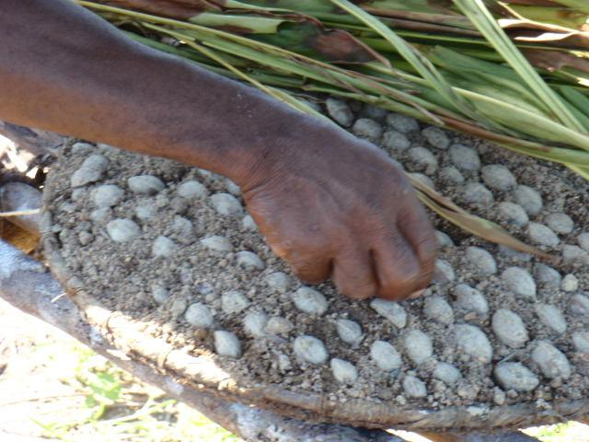  Graines de canarium | 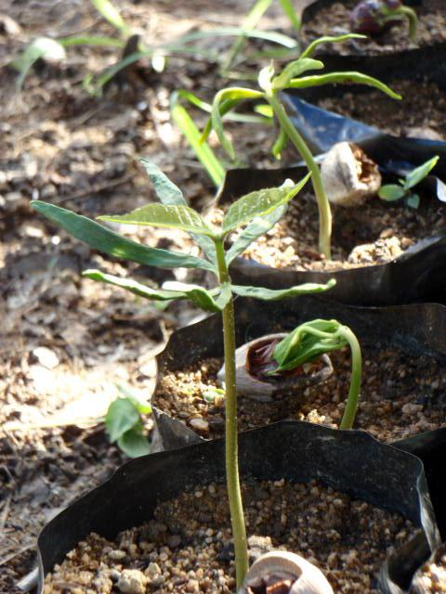  plant de canarium
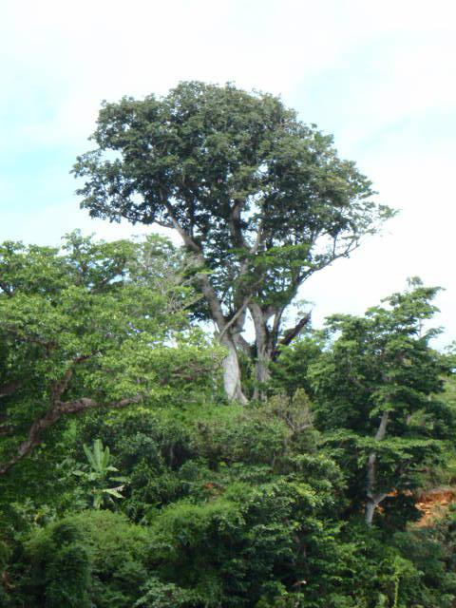  canarium adulte ramy be | 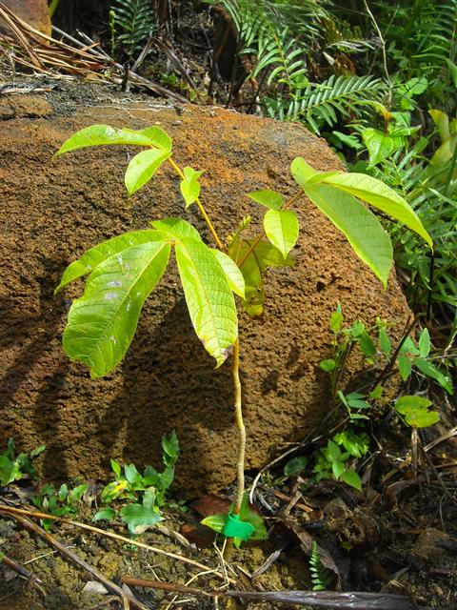  Canarium ou Ramy be

Source : http://generation-masoala.com/canarium.aspx

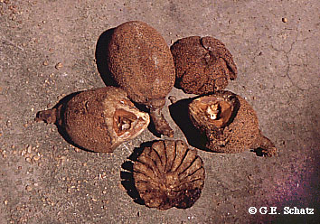
Canarium "madagascariense" fruit after being handled and parasitized by Daubentonia madagascariensis, the Aye-aye.

Notes diverses :
The revision of Canarium (Burseraceae) by Leenhouts (1959) identifies a group of related species ("denticulatum Group") that include: endemic species on the Andamans (C. manii), Sri Lanka (C. zeylanicum), Mauritius (C. paniculatum), as well as C. madagascariense in Madagascar and E. Africa (further taxonomic work is needed in Madagascar to delimit additional species within highly variable "madagascariense"), and C. schweinfurthii in C. and W. Africa. A combination of both primitive and advanced features in C. schweinfurthii suggest long isolation from the rest of the group. On 7.8 MY Mauritius, C. paniculatum probably represents a recent dispersal from Madagascar.
Source : http://www.mobot.org/mobot/madagasc/biomad11.html

