Calophyllum parviflorum Bojer ex Baker, 1877 (Famille :Clusiaceae ou Guttiferae ?) - Vintanina

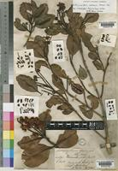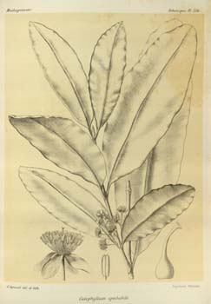
(à gauche, photo de la base JSTOR Plant Science, à droite, photo de la base www.plantgenera.org ).

Calophyllum («belle feuille », en grec kalos, "beau" et phullon, «feuille») est un genre d' arbres de plus de 200 espèces d' tropicales à feuillage persistant de la famille Clusiaceae , communément appelé Palo Maria. Espèces autochtones ( ?) de Madagascar, l'Afrique de l’est et du sud et sud-est de l'Asie (Est du Pakistan, Vietnam, Indonésie), des îles du Pacifique, des Antilles, d'Amérique du Sud. Les noms communs et des échanges pour ces arbres sont les suivants:
- teitai (en Kiribati)
- Arbre arbre Bintangor (en malais)
- arbre de Poon (en Inde).
Pour la résine, parfois utilisé en médecine, voir Tacamahaca. En Europe centrale et en Amérique du Sud, pousse Calophyllum brasiliensis: guanandi, Jacareúba, Arbre et Feuille de Santa Maria Bonita brésilien.
Ils vivent dans un large éventail de milieux, de falaises marécages côtiers, les forêts de plaine. Ils atteignent 30 m de hauteur et de 8 dm de diamètre. Les feuilles sont brillantes et coriaces. L'écorce est gris ou blanc et zestes dans de grandes lanières. Le bois est léger, le bois de coeur rose-rouge, ou parfois brun, tandis que l'aubier varie spp., parfois jaune, brun (avec le rose intérieur) à l'orange.
Beaucoup contiennent de la Calanolide en quantités variables.
Les sangles de bois sont utilisées dans les mâts et les rames.
(Produit l’huile de Tamanu).

Sources :
http://es.wikipedia.org/wiki/Calophyllum (tiré de http://mashpedia.es/Calophyllum ).
http://tropix.cirad.fr/asi/BINTANGOR.pdf
Alfred Grandidier, Histoire physique, naturelle et politique de Madagascar, Atlas, vol. 3, t. 357 (1890).
Sur son bois, http://www.fratelliparisi.it/qualita/enciclopediadellegno/bintangor.htm
The Old World species of Calophyllum (Guttiferae), 1. The Mascarene species, P F Stevens, Journal of the Arnold Arboretum 57:167-184 (1976) http://biostor.org/reference/62022

Note : Le Calophyllum parviflorum est originaire de l’Asie du sud-est. Source : https://www.konsum.admin.ch/holzdeklaration/suche/index.html?lang=fr&page=15&stichwort=&id=146

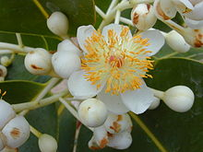  Calophyllum inophyllum  (wikipedia) | 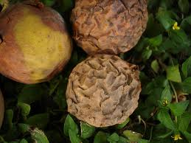  fruits de Calophyllum inophyllum  (source: http://mashpedia.es/Calophyllum) | 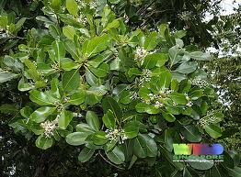  Calophyllum inophyllum  (source: http://mashpedia.es/Calophyllum)
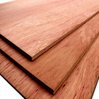  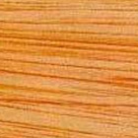  www.fsc.dk/index.php?id=272 | 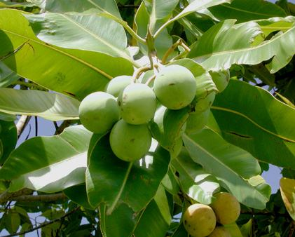  Calophyllum inophyllum  http://www.911balsam.com/wp-content/gallery/rasteniya/tamanu.jpg |   Bois de Calophyllum parviflorum.  Source : Falegnameria Fratelli Parisi, Enciclopedia del legno, Bintangor  www.fratelliparisi.it/qualita/enciclopediadellegno/bintangor.htm

Calophyllum parviflorum

Family Clusiaceae
Trees , shrubs , or sometimes herbs containing resin or oil in schizogenous spaces or canals and sometimes black or red glands containing hypericin or pseudohypericin. Leaves simple , entire or rarely gland-fringed,opposite or sometimes whorled , nearly always estipulate. Flowers bisexual or unisexual , regular, hypogynous, solitary or in cymes or thyrses ; bracteoles often inserted just beneath calyx and then not always easily distinguishable from sepals. Sepals (2-) 4 or 5(or 6), imbricate or decussate or rarely wholly united in bud, inner ones sometimes petaloid . Petals [3 or]4 or 5[or 6], free , imbricate or contorted in bud. Stamens many to rarely few (9), in [3 or]4 or 5 bundles (fascicles) that are free and antipetalous or variously connate , with filaments variously united or apparently free and then sometimes sterile (staminodes) ; anther dehiscence longitudinal . Staminode bundles (fasciclodes) 3-5, free and antisepalous or variously connate or absent. Ovary superior, with 2-5(-12) connate carpels, 1-12-loculed, with axile to parietal or basal placentation ; ovules 1 to many on each placenta, erect to pendulous; styles 1-5[-12], free or Â± united or absent; stigmas 1-12, punctiform to peltate or, when sessile, radiate , surface papillate or smooth . Fruit a septicidal or septifragal, rarely loculicidal, capsule,berry, or drupe; seeds 1 to many, without or almost without endosperm [sometimes arillate ].
About 40 genera and 1200 species: mainly in tropical regions , except Hypericum and Triadenum, which are both mainly temperate in distribution; eight genera (one endemic) and 95 species (48 endemic, one introduced ) in China.
The Clusiaceae are a rather economically important family . Many species, such as Mesua ferrea and Garcinia paucinervis, have hard wood . Numerous species in Calophyllum, Clusia Linnaeus, and Garcinia producevaluable commercial resin or gum. Gamboge is produced from Garcinia morella Desrousseaux and other species. Garcinia mangostana and Mammea americana Linnaeus produce well-known edible fruits. Other species, such as Calophyllum inophyllum and Garcinia indica Choisy, have oily seeds. Hypericum is important in horticulture and medicine.
^{[1]}

Genus Calophyllum
Trees or shrubs , with clear [or milky or yellow] latex. Apical buds rarely abortive ; buds lacking (or with) scales . Leaves opposite, petiolate [or rarely sessile], leathery, usually glabrous ; secondary veins many, almost perpendicular to midvein , ± prominent above; tertiary venation absent; translucent glandular canals present between veins. Inflorescence cymose or thyrsiform, terminal or axillary . Flowers bisexual [or rarely unisexual ].Sepals and petals together 4-12 (usually 4 + 4 in Chinese species), 2- or 3-whorled, not always differentiated, outer (sepals) decussate, inner (petals) imbricate. Stamens many, not obviously fascicled; filaments scarcelyunited or all free , slender; anthers erect , basifixed ; fasciclodes absent. Ovary 1-loculed, glabrous [tomentose ], with a single erect ovule; style elongate , slender; stigma often peltate. Drupelike berry with thin exocarp ("skin"), thin fleshy mesocarp and thin endocarp sometimes adherent to seed. Seed 1, large, with thin [or thick] testa ("stone") ; embryo with broad fleshy cotyledons.
About 187 species: tropical regions , mainly in Asia, but also in E Africa, tropical America, Madagascar, the Mascarenes, and Australasia; four species in China.^{[2]}

Habitat
Typically found at an altitude of 0 to 2,400 meters (0 to 7,874 feet).^{[3]}

Taxonomy
[ Back to top ]
- Domain: Eukaryota () - Whittaker & Margulis,1978 - eukaryotes
  - Kingdom: Plantae () - Haeckel, 1866 - Plants
    - Subkingdom: Viridaeplantae () - Cavalier-Smith, 1981
      - Phylum: Tracheophyta () - Sinnott, 1935 Ex Cavalier-Smith, 1998 - Vascular Plants
        - Subphylum: Euphyllophytina ()
          - Infraphylum: Radiatopses () - Kenrick & Crane, 1997
            - Class: Magnoliopsida () - Brongniart, 1843 - Dicotyledons
              - Subclass: Dilleniidae () - Takhtajan, 1967
- Superorder: Theanae () - Thorne Ex Reveal, 1993
  - Order: Hypericales () - Dumortier, 1829
    - Family: Clusiaceae () - Lindley, 1836 - Mangosteen Family
      - Subfamily: Calophylloideae ()
        - Genus: Calophyllum () - Linnaeus, Sp. Pl. 1: 513. 1753. - Camas
          - Specific epithet: parviflorum - Bojer ex Baker
            - Botanical name: - Calophyllum parviflorum Bojer ex Baker

Notes
Publishing author : Boj. ex Baker Publication : Fl. Mauritius 16. 1877 [2 Aug 1877]

Similar Species
[ Back to top ]

Members of the genus Calophyllum
ZipcodeZoo has pages for 267 species, subspecies, varieties, forms, and cultivars in this genus. Here are just 100 of them:
C. acidus · C. acuminatum · C. acutiputamen · C. aerarium · C. akara · C. alboramulum · C. amalloides · C. amblyphyllum · C. amoenum · C. amplexicaule · C. andersonii · C. angulare · C. angustifolium · C. angustum · C. antillanum (Antilles Calophyllum) · C. apetalum · C. archipelagi · C. ardens · C. arestanosans · C. articulatum · C. augia · C. aurantiacum · C. auriculatum · C. australianum · C. austrocoriaceum · C. austroindicum · C. balansae· C. bancanum · C. banyengii · C. benjamina · C. bicolor · C. biflorum · C. bifurcatum · C. bingator · C. blancoi · C. blumei · C. bonii · C. borneense · C. brachyphyllum · C. bracteatum · C. brasiliense · C. brasiliense var. rekoi ·C. brasiliensis · C. brasilinse · C. brassii · C. burmanni · C. bursiculum · C. calaba · C. calabra · C. calcicola · C. caledonicum · C. canum · C. carrii · C. carrii var. carrii · C. carrii var. longigemmatum · C. castaneum · C. caudatum · C. celebicum · C. cerasiferum · C. ceriferum · C. changii · C. chapelieri · C. chiapense · C. chinense · C. cholobtaches (Calophyllum) · C. clemensorum · C. collinum · C. comorense · C. complanatum · C. confertum· C. confusum · C. congestiflorum · C. cordato-oblongum · C. coriaceum · C. costatum · C. costulatum · C. cucullatum · C. cumingii · C. cuneatum · C. cuneifolium · C. cupi · C. curtisii · C. cussi · C. cymosum · C. decipiens · C. depressinervosum · C. dioscurii · C. dispar · C. dongnaiense · C. drouhardi · C. drouhardii · C. dryobalanoides · C. dubium · C. dunkani · C. echinatum · C. edule · C. elatum · C. elegans · C. ellipticum · C. enervosum

More Info
[ Back to top ]
- Search for Pictures: images.google.com
- Search for Scholarly Articles: Google Scholar
- Search using Scientific Name and Vernacular Names: All the Web | AltaVista Canada | AltaVista | Excite | Google | HotBot | Lycos
- Search using Specialized Databases: GenBank | Medline | Scirus | CISTI/CAL | Agricola Periodicals | Agricola Books

Further Reading
[ Back to top ]
- Li Xiwen & Li Yan-hui. 1990. Guttiferae. In: Li Hsiwen [Xiwen], ed., Fl. Reipubl. Popularis Sin. 50(2): 1-112.

Notes
[ Back to top ]

Contributors
- Brands, S.J. (comp.) 1989-2007. Systema Naturae 2000. The Taxonomicon. Universal Taxonomic Services, Amsterdam, The Netherlands. Accessed March 24, 2007.
- Global Biodiversity Information Facility. Accessed February 28, 2008. http://www.gbif.org Mediated distribution data from 2 providers.

Data Sources
Accessed through GBIF Data Portal February 28, 2008:
- Australian National Herbarium (CANB)
- Missouri Botanical Garden

Identifiers
- Biodiversity Heritage Library NamebankID: 9204315
- Globally Unique Identifier: urn:lsid:ipni.org:names:427254-1
- International Plant Names Index (IPNI) ID: 427254-1
- Zipcode Zoo Species Identifier: 1232801

Footnotes
- Xi-wen Li, Jie Li, Norman K. B. Robson & Peter Stevens "Clusiaceae". in Flora of China Vol. 13 Page 1. Published by Science Press (Beijing) and Missouri Botanical Garden Press. Online at EFloras.org. [back]
- Xi-wen Li, Jie Li & Peter Stevens "Calophyllum". in Flora of China Vol. 13 Page 1, 38. Published by Science Press (Beijing) and Missouri Botanical Garden Press. Online at EFloras.org. [back]
- Mean = 1,044.800 meters (3,427.822 feet), Standard Deviation = 998.420 based on 5 observations. Altitude information for each observation from British Oceanographic Data Centre. [back]
Last Revised: 7/3/2009

Source : http://zipcodezoo.com/Plants/C/Calophyllum_parviflorum/

Calanolide A : est un nouvel et expérimental inhibiteur non nucléosidique de la transcriptase inverse (INNTI) d'abord tiré de l’arbre Calophyllum lanigerum en Malaisie. Il lui a été trouvé une activité anti- VIH puissante. Source : http://en.wikipedia.org/wiki/Calanolide_A

