BREONADIA SALICINA
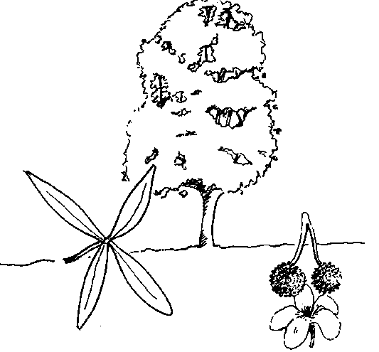
DISTRIBUTION
Grows in moist valleys, riparian woodlands, along streams and rivers, and in swampy areas (Palgrave 1988).
PROPAGATION
Means of Propagation: Easily grown from seedlings. Cuttings placed in mud and wildlings are frequently used methods.
Seedling Management: Germination is more successful in moist conditions. In Ruvuma region, cuttings are placed in mud. Wildlings appear to have a higher survival rate than nursery seedlings, which need to be at least 1 m high to survive transplanting.
SILVICULTURE
Planting Types: Very high potential for agroforestry in valleys with coffee and other agricultural crops in southern Tanzania (RSCU 1992). It is also planted on hill sides for erosion control.
Growth Cycle: Fairly fast growing.
Management Systems: Can be planted successfully in mixed woodlots in single lines and in rows at 2×2.5 m in southern Tanzania. It appears susceptible to weed competition. However it may be more resistant to dry periods than the common fast growing trees of the area.
IMPORTANT USES
Use #1: TIMBER
Wood is yellowish, hard, heavy, very durable, and oily to the touch (Palgrave 1988). It is also termite resistant. It makes an excellent timber which is highly valued for furniture and house construction. It is heavily exploited.
Use #2: MEDICINE
Bark is soaked in water to prevent influenza fever. It is also used to cure stomach ailments.
Use #3: FIREWOOD
It is a well-known firewood in southern Tanzania.
Source : http://www.fao.org/docrep/X5327e/x5327e0p.htm

