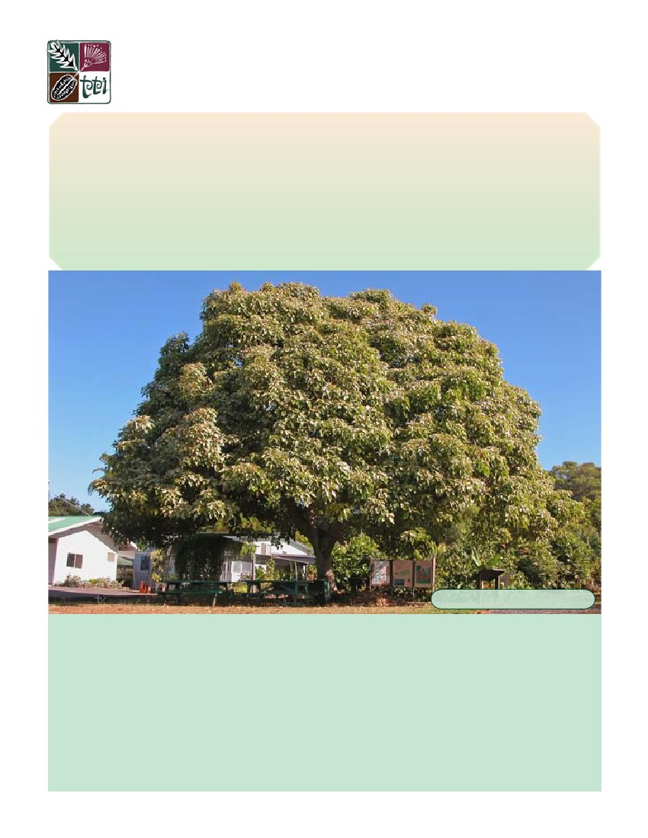
Species Profiles for Pacific Island Agroforestry
www.traditionaltree.org
April 2006
ver. 2.1
Aleurites moluccana (kukui)
Euphorbiaceae (spurge family)
‘ama (Marquesas); candlenut, candleberry, varnish tree, Indian or Belgaum walnut (English); kukui, kuikui (Hawai‘i);
lama (Samoa); lauci, nggerenggere, sikeci, sikeli, sikethi, toto, tuitui, tutui, waiwai (Fiji); lumbang (Guam); raguar (Car-
oline Islands); rama (Mangareva); sakan (Palau); sakan, shakan (Pohnpei); tahii, tahiri, tiairi, ti‘a‘iri, tutui (Moorea
[French Polynesia]); tuitui (Mangaia [Cook Islands], Futuna, Makatea, Niue, Tonga, Tubuai, Uvea); tutu‘i, ti‘a‘iri
(Society Islands); tutui (Rimatara, Rurutu, Tahiti)
Craig R. Elevitch and Harley I. Manner
photo: C. ElEvitCh
A gathering place under kukui.
IN BRIEF
Distribution Widespread throughout the tropics.
Growth rate Moderately fast growing in favorable condi-
Size Typically reaches 10–15 m (33–50 ft), with similar tions, growing 0.5–1.5 m (1.6–5 ft) per year.
crown diameter.Main agroforestry uses Windbreak, screen/hedge, soil
Habitat Subtropical dry to wet and tropical very dry to stabilization, homegardens.
wet forest climates. Typically 0–700 m (0–2300 ft) with Main products Oil from seed, nut shells for leis.
rainfall of 640–4290 mm (25–170 in).
Yields 80 kg (176 lb) seeds per tree/year in cultivation.
Vegetation Associated with a wide variety of cultivated Intercropping Planted as a boundary or windbreak tree.
plants.
Invasive potential Moderate, has naturalized in many ar-
Soils Prefers light and medium textured soils; grows even on eas. Rarely considered a pest.
basalt, red loams, stony clay ground, sand, and limestone.
INTRODUCTION
Kukui is one of the great domesticated multipurpose trees
of the world. It is one of the most useful trees introduced by
the aboriginal people of the Pacific islands. A tall, spread-
ing tree in open areas, it commonly attains heights of 10 m
(33 ft) and a canopy diameter about as wide as the tree
is tall. Kukui grows in homegardens, in and around farms,
and naturalized along streams, gulches, and valley slopes. It
is easily recognized by its characteristic silvery gray-green
foliage, which is particularly ornamental.
Kukui is native to the Indo-Malaysia region and was in-
troduced in ancient times throughout the Pacific islands. It
can grow in a wide range of dry to wet tropical and sub-
tropical habitats but is most at home in the moist tropics
with annual rainfall of 2000 mm (80 in) or greater. Kukui
tolerates drought and wind and grows readily on poor soils
as well as steep slopes. Due to its many traditional uses and
its role in ecosystems, kukui is recognized as the official
state tree of Hawai‘i.
Elsewhere in the Pacific, it is primarily found in cultivation
in villages and plantations or in secondary growth follow-
ing cultivation or along stream banks. The tree is also found
in Puerto Rico, the Virgin Islands, Malagasy, Sri Lanka,
southern India, Bangladesh, Brazil, the West Indies, and
the Gulf Coast of the United States.
m (2300 ft). In Hawai‘i, kukui has naturalized in forests
on all the main islands and is commonly found in cultiva-
tion. It is particularly at home in moderately moist valleys,
where it has become a conspicuous part of the landscape.
BOTANICAL DESCRIPTION
Aleurites moluccana (L.) Willd.
Preferred scientific name
Family Euphorbiaceae (spurge family)
The traditional uses of kukui are extensive. Throughout
Polynesia kukui is known in local languages by names
whose root means “light,” referring to the traditional use
of seeds and oil which were burned for illumination. Many
parts of the plant including the seeds, leaves, flowers, and
bark were used in traditional medicine. Caution is advised
in using the plant medicinally or for consumption, as all
parts of the tree are toxic. Dyes extracted from various
plant parts were used to color tapa cloth and canoes, as
well as in tattooing. Today, in addition to its traditional
uses, kukui has found commercial uses, particularly in the
cosmetics industry.
Non-preferred scientific names
Synonyms no longer in use include:
Aleurites javanica Gand.
Aleurites remyi Sherff
Aleurites triloba Forster & Forster f.
Camirium moluccanum (L.) Ktze.
Croton moluccanus L.
Jatropha moluccana L.
Common names
In urban areas, kukui makes a lovely shade tree or visual
screen. In agricultural systems it can be integrated for use
in windbreaks, shade, soil stabilization, and improved fal-
low. Kukui can regenerate and naturalize where planted,
and it has been described as a moderate invader in certain
areas. However, it is rarely considered invasive or problem-
atic.
DISTRIBUTION
Native range
Kukui is native to Indo-Malaysia. It thrives in moist tropi-
cal regions up to 1200 m (3940 ft) elevation.
Kukui is today widespread throughout the tropics. It was
introduced aboriginally throughout the Pacific islands and
is now a common tree of the Pacific at elevations up to 700
‘ama (Marquesas)
kukui, kuikui (Hawai‘i)
lama (Samoa)
rama (Mangareva)
tahii, tahiri, tiairi, ti‘a‘iri, tutui (Moorea, French Polynesia)
tuitui (Mangaia [Cook Islands], Futuna, Makatea, Niue,
Tonga, Tubuai, Uvea)
tutu‘i, ti‘a‘iri (Society Islands)
tutui (Rimatara, Rurutu, Tahiti)
Other common names from the Pacific include:
lauci, nggerenggere, sikeci, sikeli, sikethi, toto, tuitui, tutui,
waiwai (Fiji)
lumbang (Guam)
raguar (Caroline Islands)
sakan (Palau)
sakan, shakan (Pohnpei)
The roots of the Polynesian names below mean “light,” re-
ferring to the ancient use of burning the nuts or oil ex-
tracted from the nuts to provide illumination:
Candlenut, candleberry, varnish tree, Indian or Belgaum
walnut (English)
Current distribution
Names from other world regions include:
Aleurites moluccana (kukui)
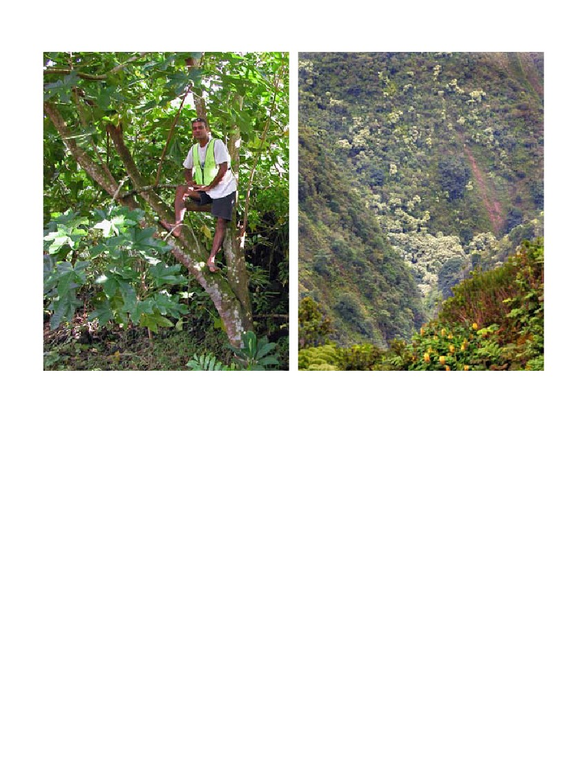
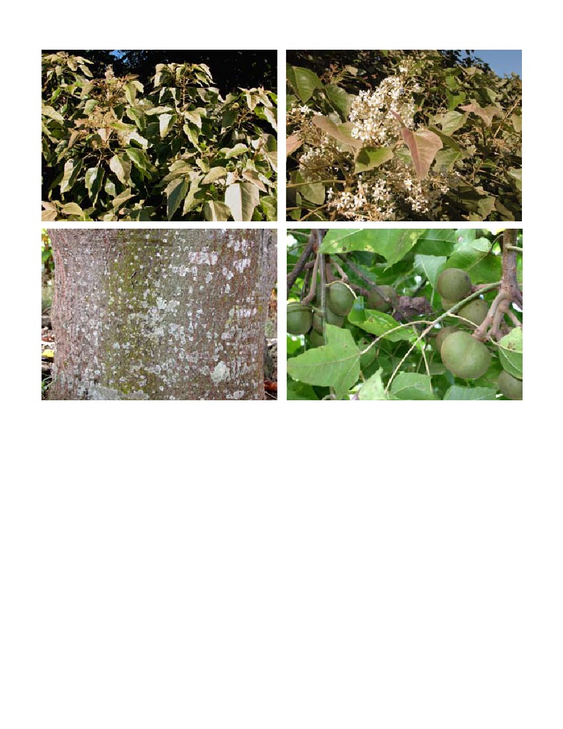
Left: Kukui often is found in the regrowth of abandoned agricultural sites, such as here in American Samoa. (pictured: Tui-
puavai Tago) Right: The distinctive canopy often stands out in the landscape, such as here on the slopes of Waipi‘o Valley,
Hawai‘i. photos: C. ElEvitCh
arbol llorón, avellano, avellano criollo, nogal de la India, nuez
(Spanish)
bancoulier, noyer de bancoul, noyer des Moluques, aleurites,
noisette, noix, noyer, noyer des Indes (French)
calumbàn, noz da India (Portuguese)
kamiri (Indonesian)
kandeltri (Bislama, Vanuatu)
Kerzennussbaum, Lichtnussbaum (German)
le noix de Bancoul (French, Vanuatu)
lèrit, nwa, nwazèt (Creole)
ragaur (Carolinian)
tung (trade name)
Kukui is a large spreading tree that can reach 20 m (66 ft)
in height and 0.9 m (3 ft) trunk diameter, although it typi-
cally reaches 10–15 m (33–50 ft) when growing in the open.
Crooked trunks and irregular, wide, spreading or pendu-
lous side branches are typical. In narrow valleys kukui usu-
ally has a branchless trunk and achieves its greatest height.
Dense clusters of kukui are often seen in areas favorable
to its growth, with the inner trees having tall trunks with
relatively few side branches and trees on the edge having
outer side branches and foliage often down to the ground.
Kukui is monoecious (having both male and female flow-
ers on the same plant). The greenish-white, fragrant flow-
ers are arranged in a 10–15 cm (4–6 in) terminal panicled
cyme, with many small male flowers surrounding the fe-
male flowers. The corolla is whitish with five free petals,
dingy white to creamy in color, oblong in shape and up to
1.3 cm (0.5 in) in length. The ovary is pubescent, superior,
and two-celled, each with one ovule. Staminate flowers are
longer and thinner than pistillate flowers.
Flowers
Size and form
The plant typically flowers in the spring, although flowers
can be found nearly any time of year in many areas.
This tree is easily discernible by its very distinctive leaves,
which are three- to five-nerved from the base, alternate, and
simple, with entire, wavy margins. The leaf blades are 10–20
cm (4–8 in) long with two glands at the junction of the
Leaves
Species Profiles for Pacific Island Agroforestry (www.traditionaltree.org)

Upper left: The scientific name for kukui, Aleurites, comes from the Greek word for “floury,” referring to the dusted-flour ap-
pearance of young leaves and flower buds. Upper right: Trees often flower nearly continuously. Lower right: Ripe fruit in tree.
Lower left: Bark is smooth and light gray in color, often with lichen growth in moist areas. photos: C. ElEvitCh
leaf base and petiole that secrete a sweetish sap. Leaves of
young plants and those of the lower branches are three- to
five-lobed with a rounded, heart-shaped base (subcordate),
while the apex is acute (sharp). Younger leaves are usually
simple and deltoid to ovate in shape. The upper surface of
young leaves is whitish with a silvery gloss, becoming dark
green with age. The underside is rusty stellate-pubescent
when young (having a hairy glossy indument).
The green to brownish fruit is a laterally compressed, ovoid
to globose indehiscent drupe 5–6 cm (2–2.4 in) long by
5–7 cm (2–2.8 in) wide. It has also been described as being
“round, hard apple-shaped” with fleshy to leathery husks.
The nuts contain an oil similar to tung oil from Aleurites
fordii.
The seeds are contained within a hard, black, rough shell
elliptical in shape and about 2.5–3.5 (1–1.4 in) cm long. The
shells are similar in shape and texture to walnuts, although
smaller and thicker. There are about 100–120 seeds (with
shells on, but with husks removed) per kilogram (45–55
seeds/lb).
Aleurites trisperma Blanco is a small tree similar to kukui (A.
moluccana). Unlike kukui, A. trisperma has unlobed leaves
and prominently ridged three-seeded fruits.
Seeds
Fruit
Similar species
GENETICS
Variability
There is great variability in kukui, particularly in the leaves,
Aleurites moluccana (kukui)
which can vary tremendously in size, shape, color, and tex-
ture, even on a single tree. For example, leaves of young
plants and of the lower branches are three- to five-lobed
while older leaves and those of the upper branches are usu-
ally simple and deltoid to ovate in shape. Fruits can range
in size up to 4 cm (1.6 in) in diameter.
The variety aulanii is named for small-fruited plants from
Waipi‘o Valley, Hawai‘i (Wagner et al. 1999). The variety
katoi (mango-leafed kukui) has “narrow, lanceolate leaves
with lateral lobes obscure or absent” (Stuppy et al. undated).
The remyi variety, also the probable result of aboriginal Ha-
waiian selection, has “lengthened, simple lanceolate leaves
(with or without obscure lobes) or deeply lobed leaves with
the lateral lobes very narrow and the terminal lobe much
elongated,” while a cultivar from New Caledonia has or-
bicular leaves (Stuppy et al. undated). A variety found in
Vanuatu (Maewo) has seeds which can be eaten without
any apparent toxic effect (Walter and Sam 2002).
In China, tung oil is produced from Aleurites fordii (Stone
1970). In Japan, A. cordata is used for the same purpose,
while other related species are A. montana and A. trisperma
(Anon. undated [2]).
Hawaiian sayings (Pukui 1983)
He kumu kukui i he‘e ka pīlali.
“A kukui tree oozing with gum.”
(A prosperous person.)
Ka malu hālau loa o ke kukui.
“The long shelter of the kukui trees.”
(A kukui grove shelters like a house.)
Pupuhi kukui—malino ke kai.
“Spewed kukui nuts—calm sea.”
(Pour oil on troubled waters.)
Fosberg 1998).
Known varieties
Culturally important related species
On Moorea (Fr. Polynesia), kukui, Hibiscus tiliaceus, Rhus
taitensis, and other trees are found on the sides of val-
leys. On rocky slopes, kukui is found in association with
indigenous species such as Pisonia umbellifera, Boehmeria
virgata, Pandanus sp., Freycinetia impavida, Hernandia sp.,
Cyclophyllum barbatum, Macaranga sp., Weinmannia parvi-
flora, Glocihdion sp., Neonauclea forsteri, Ixora moorensis, and
Tarenna sambucina (Mueller-Dombois and Fosberg 1998).
ASSOCIATED PLANT SPECIES
As kukui is an aboriginal introduction to the Pacific islands,
it is generally found in disturbed mesic (moderately moist)
forest habitats. In Hawai‘i, it is very conspicuous along
stream valleys and ravines. However, it can also be found
in association with native species. It is found in cultivated
forest remnants in the Marquesas and other high volcanic
islands of the Pacific.
Associated native species commonly found
In Pahole Gulch, O‘ahu, Hawai‘i, kukui is a dominant
species in a forest composed of Diospyros hillebrandii, D.
sandwicensis, Pisonia umbellifera, and P. brunoniana (Muel-
ler-Dombois and Fosberg 1998). Kukui is also a domi-
nant in non-native forests of the Pahole Gulch Natural
Area, composed of Syzygium cumini, Psidium spp., Schinus
terebinthifolius, and Eucalyptus (Mueller-Dombois and
On Mangaia (Cook Islands), kukui is found in “disturbed
native” mixed-species forest dominated by the native tree
species Elaeocarpus floridanus and Hernandia moerenhoutia-
na (Merlin 1991). Introduced species associated with kukui
include Cocos nucifera, Morinda citrifolia, Hibiscus tiliaceus,
and Psidium guajava.
In the Marquesas, this species is found in formerly cul-
tivated valley bottomlands. The vegetation here has been
described as a mesophytic (medium moisture) forest
composed largely of food and other useful plants such as
Artocarpus, Annona, Ceiba, Cocos, Citrus, Coffea, Syzygium,
Inga, Inocarpus, Mangifera, Pandanus, Persea, Psidium,
Pometia, and Spondias (Mueller-Dombois and Fosberg
1998, Decker 1992). On Eiao Island (Marquesas), kukui is
found in the gulches with Pisonia grandis, Hibiscus tiliaceus,
Thespesia populnea, Dodonea viscosa, and Annona squamosa
(Mueller-Dombois and Fosberg 1998).
In Tahiti, kukui is found in the submontane rain and valley
forests in association with native species along with bread-
fruit (Artocarpus altilis), mango (Mangifera indica), and
coconut (Cocos nucifera) (Mueller-Dombois and Fosberg
1998).
Species commonly associated as aboriginal intro-
duction in Pacific islands
ENVIRONMENTAL PREFERENCES
AND TOLERANCES
This species has a large geographical distribution. Climati-
Climate
Species Profiles for Pacific Island Agroforestry (www.traditionaltree.org)
cally it is found in subtropical dry and wet climates and
tropical very dry to wet forest climates. In Hawai‘i, the
species is found between 0 and 700 m (0–2300 ft) (Wag-
ner et al. 1999). Near the equator, the tree is reported to
grow on a variety of soils up to 2000 m (6560 ft), although
it is more likely that it has an upper limit of about 1200 m
(3940 ft).
Soil drainage
It requires free drainage.
Soil acidity
It grows in lightly acidic to alkaline soils (pH 5–8).
Special soil tolerances
Kukui tolerates infertile soils.
Elevation range
0–700 m (0–2300 ft) (Hawai‘i), but can grow up to 1200 m
(3940 ft) closer to equator.
Mean annual rainfall
640–4290 mm (25–170 in) (mean of 14 cases, 1940 mm [76
in]) (Duke 1983)
Rainfall pattern
Kukui grows in climates with summer, winter, bimodal,
and uniform rainfall patterns.
Dry season duration (consecutive months with <0
mm [1. in] rainfall)
3–5 months or longer, as the species is often found along
streams that may have subsurface water even after longer
dry spells
Mean annual temperature
19–27°C (66–81°F)
Mean maximum temperature of hottest month
26–30°C (79–86°F)
Mean minimum temperature of coldest month
8–13°C (46–55°F)
Minimum temperature tolerated
8°C (46°F) (estimate)
Said to occur on a variety of soils, including red loams,
stony clay ground, sand, and limestone. As evidenced by
its relative absence in Northern Guam (which is underlain
by limestone), kukui does not seem to prefer alkaline soils.
However, its presence on Mangaia, which has Makatea
soils with some limestone, suggests a tolerance of neutral
to slightly alkaline soils. The species is dominant on moist,
well drained acidic soils (perhaps Inceptisols and Ando-
sols) of the high volcanic islands of the Pacific Basin.
Tolerances
Drought
Kukui is quite drought tolerant once well established.
However, it flourishes in moist environments.
Full sun
The tree prefers full sun and can grow as a pioneer species
in open areas with suitable rainfall.
Shade
Kukui can grow in a modest amount of shade, up to 25%.
Fire
The species is probably intolerant of fire.
Frost
It is probably intolerant of frost, as it is generally confined
to the lower slopes of pali (steep slopes) that do not experi-
ence frost (up to about 700 m [2300 ft] in Hawai‘i).
Waterlogging
Although the species is an indicator of stream courses, it
favors well drained, moist soils.
Salt spray
Kukui tolerates a modest amount of salt spray and is oc-
casionally found growing near the coast.
Wind
It tolerates both steady and storm winds and makes a suit-
able windbreak tree, especially in a multi-row windbreak.
Soils
Abilities
Regenerate rapidly
The tree can grow well even on relatively poor sites, pro-
vided ample soil moisture is available, particularly during
establishment.
Coppice
Kukui regrows very well even after severe pruning, al-
though it has a tendency to die after two or more prunings
Soil texture
The tree prefers light and medium texture soils (sands, san-
dy loams, loams, and sandy clay loams).
Aleurites moluccana (kukui)
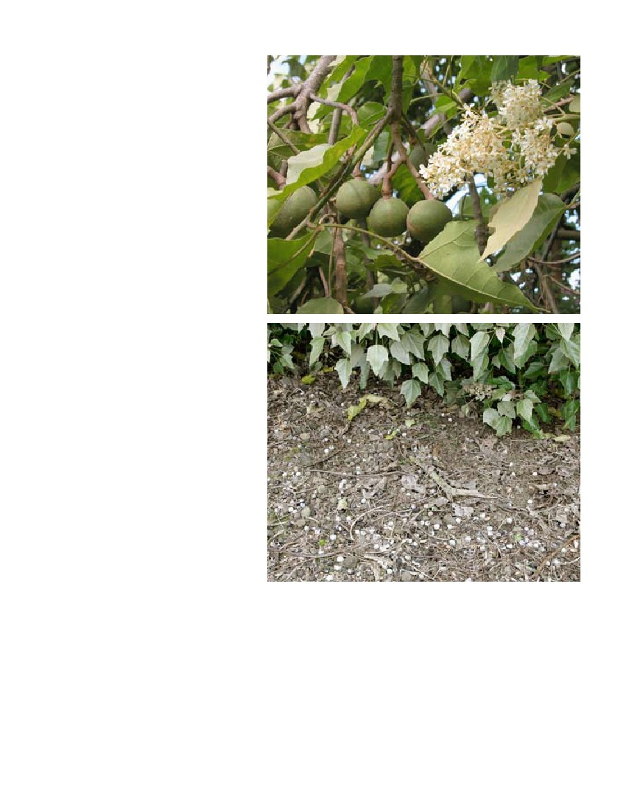
in quick succession.
Other
Kukui is known for its ability to grow well on
slopes, even steep gulches and cliffs.
GROWTH AND
DEVELOPMENT
There is little direct information on the growth
and development of kukui. It is said that the
tree is quick growing and readily colonizes dis-
turbed gaps and forest margins. Given these
characteristics, kukui probably has growth rates
comparable to other common secondary forest
tree species. The tree requires little attention
once it is established.
Flowering and fruiting
Flowering and fruiting begins at 3–4 years old.
In many places flowering and fruiting take place
almost continuously, frequently with flowers
and fruits of all stages of ripeness occurring on
each tree.
Kukui can hold its own even in the presence of
grasses and other herbaceous weeds.
Reaction to competition
PROPAGATION
Propagation of kukui seedlings is easily done
by seed. Although the seeds can take up to 3–4
months to germinate, they are large and quickly
grow into strong, stout seedlings ready for field
planting. Seedlings are not finicky about grow-
ing location (tolerating sun or partial shade),
nor do they require special growing medium
or watering regimes. Due to the quick growth
of germinating seeds into seedlings, seeds lend Ripe fruit can often be collected from underneath the lower canopy (top),
themselves to either being direct-seeded in the or seeds can be collected from the ground under trees with the husk already
field or pregerminated in the nursery, then di- deteriorated (bottom). photos: C. ElEvitCh
rect-seeded. Kukui can also be propagated by
cuttings, but this is uncommon and may not Seed processing
yield a plant that grows as vigorously as a seedling.
If the fruits are fresh, they are allowed to decay a few
Kukui flowers and fruits intermittently throughout the
year. Mature fruits can be picked from the tree or collected
from the ground.
Seed collection
days in a moist area, which facilitates peeling off the thick,
leathery outer husk. This exposes the hard shell that en-
closes the seed. There are about 100–120 seeds per kg (45–55
seeds/lb) with husk removed and shells on. Typically, ger-
mination is about 80% over the course of several months.
Species Profiles for Pacific Island Agroforestry (www.traditionaltree.org)
To improve the germination rate, bad seeds can be floated
off in water.
Seeds can be stored for several months when dried to
10–12% moisture content. Often seeds lying on the ground
under trees are viable and can be used successfully.
Seed storage
It has been reported that 200–300 seedlings are planted
per hectare for oil seed production. In windbreaks, kukui
can be planted 3–4 m (10–13 ft) apart in the row.
Guidelines for outplanting
DISADVANTAGES
There are very few disadvantages to planting the widely
adapted and multipurpose kukui tree. Perhaps the biggest
commercial disadvantage is that no large markets exist for
any kukui products. Also, it is so easy to grow in many
environments that there is no clear commercial advantage
to growing it in any specific place. For example, any kukui
product that can be produced in Hawai‘i can be easily re-
produced in other tropical regions where the costs of land
and labor are cheaper.
Pre-planting treatments
Untreated seeds germinate in about 4 months. Sun warm-
ing of a moist medium is thought to hasten and improve
germination. Cracking the seed coat (shell) and soaking
overnight in water may also hasten germination. Fungi
growing on the seed coat may become a problem for ger-
minating seeds, so treating the seeds with a fungicide prior
to sowing may be helpful in reducing fungal problems.
Seed scarification with acid does not benefit germination.
Kukui seeds can grow in moderate shade, but full sun also
works and may hasten germination.
Growing area
Potential for invasiveness
Germination
Kukui has naturalized in several Pacific islands, particular-
ly in Hawai‘i, and has the potential to become established
outside of cultivation. Despite this, kukui is rarely consid-
ered a harmful invasive or pest species.
Seeds can be direct-seeded in containers or pregerminated
in beds. When seeds are pregerminated in a bed, it is best to
transplant the seeds just as they begin to germinate when
the seed cracks open. Pregerminated seeds can either be
planted in nursery containers or direct-sown in the field.
Because kukui germinants have a large, thick taproot, it is
recommended that seedlings are grown in 2–4 liter (1/2–1
gallon) root-training containers. Use a well drained pot-
ting medium such as 50% peat moss, 25% perlite, and 25%
vermiculite, amended with a little compost, dolomite lime,
gypsum, and 14–14–14 slow-release fertilizer. Potting me-
dia should also be inoculated with mycorrhizal fungi from
a reputable commercial source, particularly if the trees will
be planted in degraded soils.
After germination, plants are ready to be transplanted into
the field after about 3–4 months.
Media
The following fungi are known to attack kukui: Cephalospo-
rium sp., Clitocybe tabescens, Fomes hawaiensis, Gloeosporium
aleuriticum, Physalospora rhodina, Polyporus gilvus, Pythium
ultimum, Sclerotium rolfsii, Sphaeronema reinkingii, Tram-
etes corrugata, Xylaria curta, Ustulina deusta. Nematodes
include Meloidogyne sp. (Duke 1983).
Susceptibility to pests/pathogens
AGROFORESTRY/ENVIRONMENTAL
PRACTICES
Mulch/organic matter
Kukui leaves make a good mulch. To preserve the health
of the tree and encourage rapid regrowth, only a small per-
centage of the leaves (less than 20%) should be removed at
any one time.
Soil stabilization
Kukui grows well on steep slopes and in gulches. Along
with koa (Acacia koa), kukui was one of the first trees
planted by the Hawai‘i Division of Forestry for watershed
rehabilitation.
Crop shade/overstory
Although not considered overly competitive with other
plants, kukui’s dense shade limits its use as shade for light-
demanding crops.
Time to outplanting
Approximate size for outplanting
Trees are ready to outplant when they have attained a
height of about 25 cm (10 in) and stem diameter of 12 mm
(0.5 in).
Aleurites moluccana (kukui)
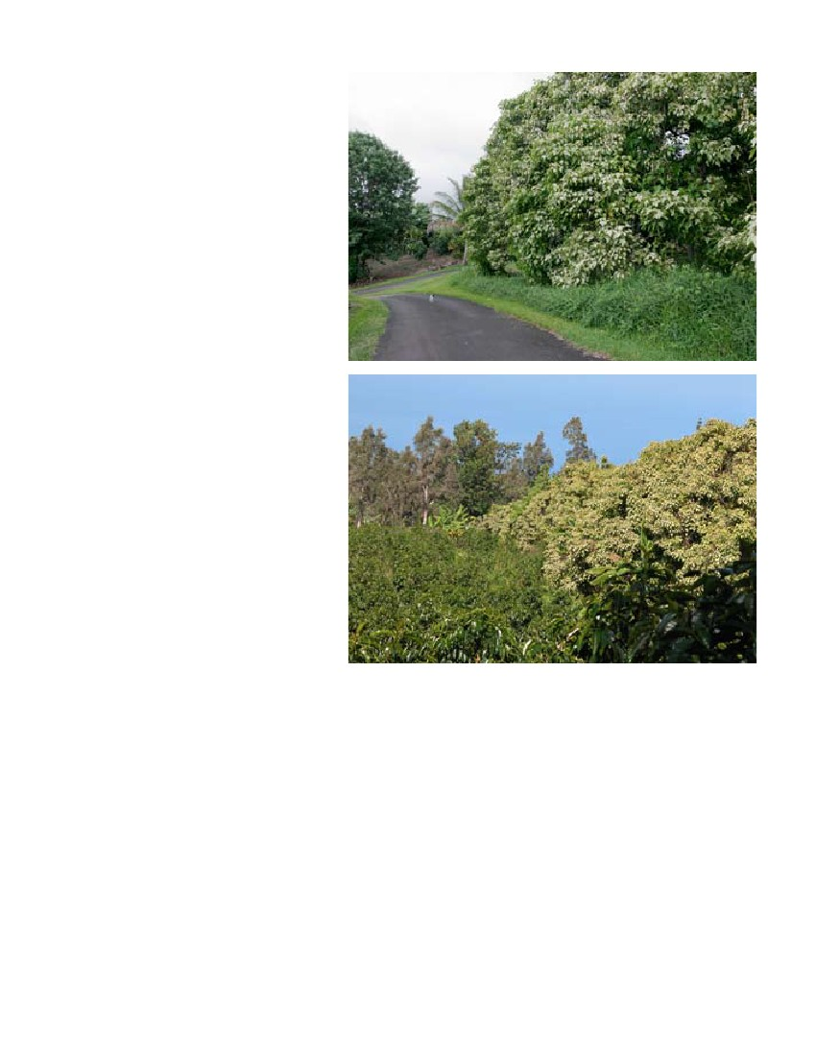
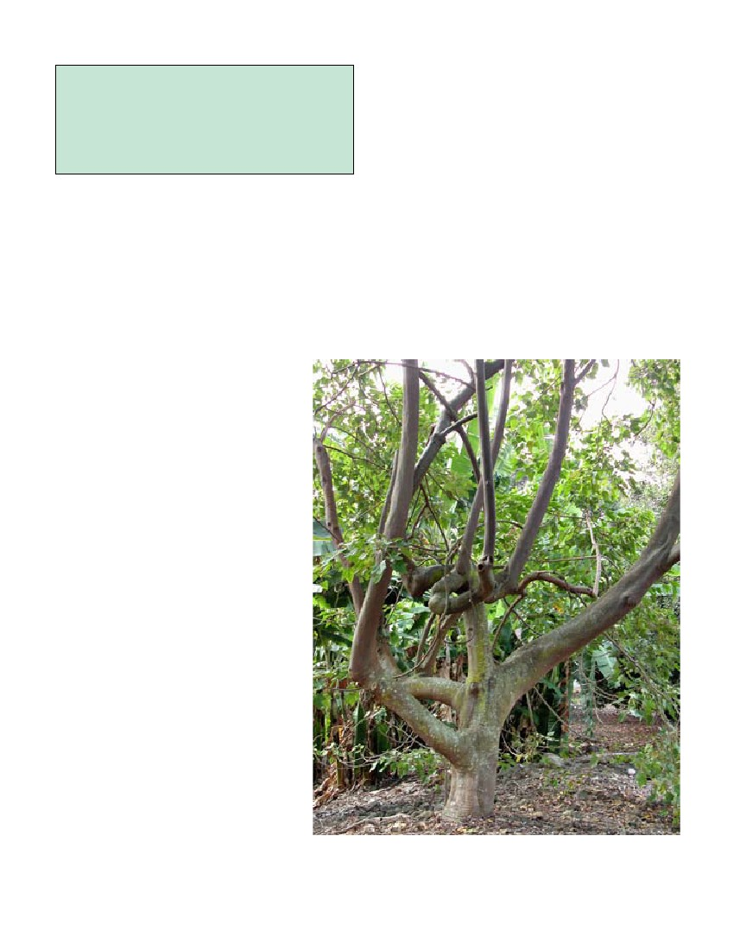
Alley cropping
Although kukui will regrow after severe prun-
ing, its moderate growth rate makes it unsuit-
able for frequent pruning for mulch in an alley
cropping system.
Homegardens
Because of its usefulness and beauty, kukui is
grown in homegardens throughout the Pacific
and elsewhere in the tropics.
Living fences/visual screen/boundary
markers
It is often used as a living fence or bound-
ary marker in Tonga, Hawai‘i, and elsewhere.
Planted densely as a double row on 2 x 2 m (6.5
x 6.5 ft) or 3 x 3 m (10 x 10 ft) spacing, kukui
makes a wonderful visual screen.
Windbreaks
Kukui makes a good windbreak component,
particularly in a multi-row windbreak.
Ornamental
Kukui is widely used as an ornamental tree for
its thick silvery-green foliage. This is perhaps
its most common use in cultivation.
USES AND PRODUCTS
With its innumerable uses, kukui was dis-
seminated aboriginally throughout the Pacific
islands. Virtually all parts of the tree—leaves,
fruits, bark, wood, roots, sap, flowers, etc.—
were useful for medicine, illumination, housing, Kukui makes an excellent screen along roads and boundaries. Top: Privacy
dyes, food, ornamentation, and many other uses. hedge along driveway. Bottom: Boundary hedge next to coffee plantation.
Even today, many of kukui’s traditional appli- photos: C. ElEvitCh
cations are still in use. During the 19th century
kukui oil was a commercial export of Hawai‘i,
stomach or bowel disorder in children, asthma, bad breath,
and it has recently been revitalized as a commercial prod-
skin sores or ulcers, “swollen womb,” and rejuvenating
uct there and elsewhere in the Pacific.
the body after poisoning (Kaaiakamanu and Akina 1922).
Kukui nut oil makes a strong laxative and is sometimes
Nut/seed
used like castor oil. The leaves have been used for poultices
The raw seeds are toxic and have a strong purgative ef-
for deep contusions and swellings.
fect, but cooked seeds can be eaten sparingly, especially as
a condiment. Some varieties, such one found in Vanuatu
Flavoring/spice
(Maewo), have no apparent toxic effect (Walter and Sam
Hawaiians have traditionally used the roasted, pounded
2002).
kukui seed kernel mixed with salt and seaweed or chili
peppers as a condiment called ‘inamona.
Medicinal
Folk remedies are reported for general weakness due to
Species Profiles for Pacific Island Agroforestry (www.traditionaltree.org)
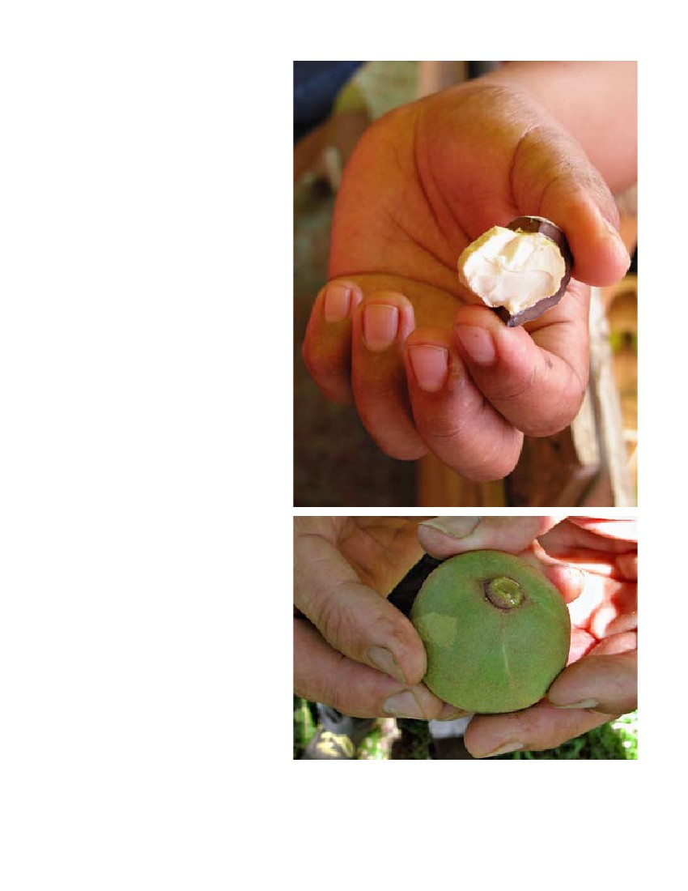
Kukui is the official tree of the State of Hawai‘i be-
cause of “the multiplicity of its uses to the ancient Ha-
waiians for light, fuel, medicine, dye, and ornament, as
well as the distinctive beauty of its light-green foliage
which embellishes many of the slopes of our beloved
mountains.” (Neal 1965)
kernels (traditionally used for illumination) is used for an
indelible black dye in tattooing and tapa cloth, particularly
in Samoa and Tonga (Whistler 1991).
Toxin/insecticide/fish poison
Kukui oil can protect cotton bolls from the boll weevil and
prevent feeding by the striped cucumber beetle.
Cosmetic/soap/perfume
Oil extracted from the seed can be made into soap. Chewed
seeds are used as a soap substitute. Refined kukui oil is to-
day widely sold in the cosmetic industry and may currently
be kukui’s primary commercial product.
Fertilizer
After removal of the oil, the remaining seed cake has been
used for fertilizer.
Animal fodder
After removal of the oil, the remaining seed cake has been
used for cattle fodder.
Timber
The wood is straw colored and very light weight (sp. gr.
0.35). Because it is not resistant to decay or insect attack, it
is rarely utilized for timber. The wood is readily colonized
by fungi and has been used successfully as a substrate for
growing mushrooms, particularly the ear fungus (Auricu-
laria sp.) known in Hawai‘i as pepeiao. After
heavy rains, deadwood under kukui trees often
has large quantities of edible fungus.
Fuelwood
The wood can be burned as a low-quality fuel.
Canoe/boat/raft making
The Hawaiians used the easily worked wood
for short-lived, light-weight canoes and fishnet
floats.
Rope/cordage/string
A bark infusion with water was used by Hawai-
ians to preserve fishnets.
Resin/gum/glue/latex
The whitish sap was painted on tapa cloth to
make it more durable and waterproof.
Body ornamentation/garlands
The empty shells are strung to make a popular
lei. The mature black seeds and immature white
to brown seeds are commonly used in lei mak-
ing, polished and unpolished. The shells, which
can be polished to a high luster, are fashioned
into earrings and other costume jewelry. The
leaves with or without the flower clusters are
woven into impressive leis.
Tannin/dye
Hawaiians used the seed husk to make a black
dye for tattooing and the root bark to make a Due to its light weight, poor durability, and crooked form, the wood is
dye to paint canoes. The soot from burned seed rarely used for timber. photo: C. ElEvitCh
10 Aleurites moluccana (kukui)
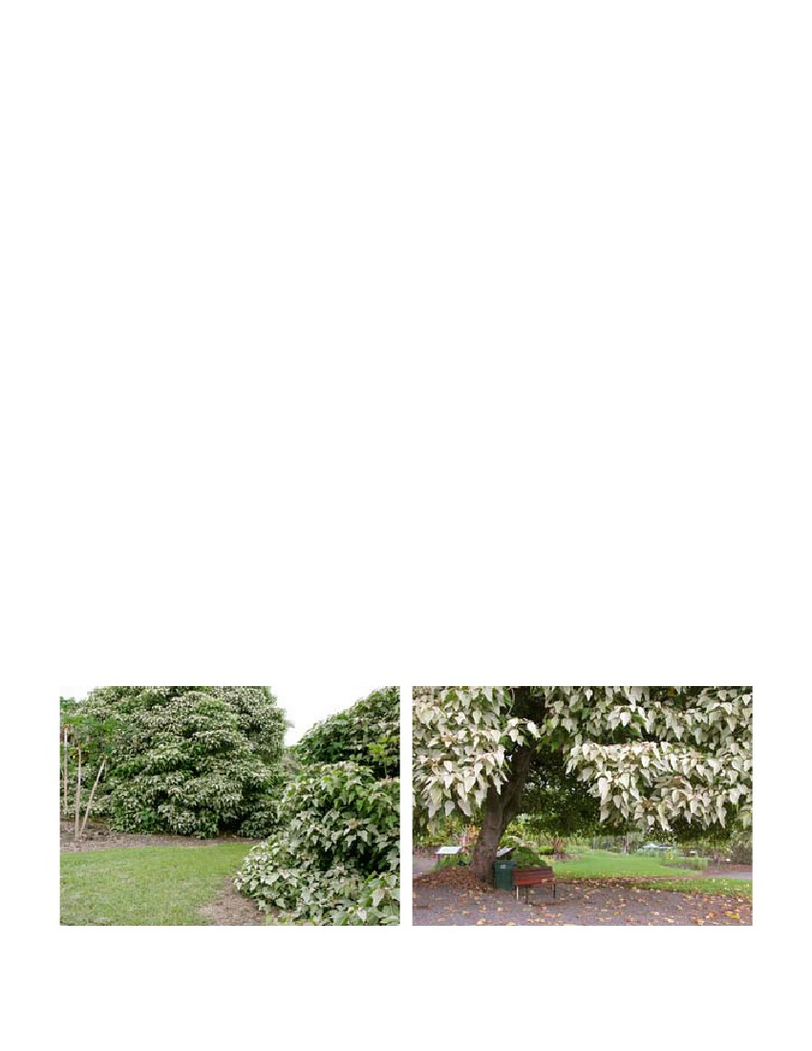
Oil/lubricant
Oil extracted from the seeds was traditionally
used by Hawaiians as a preservative for surf-
boards. The oil can also be used as a basis for
paint or varnish, burned as an illuminant, made
into soap, and used for waterproofing paper. To-
day kukui nut oil is marketed as a skin moistur-
izer and protectant. With chemical modification
the oil can also be burned as fuel in diesel en-
gines.
Illumination/torches
The oily kernels are dried and strung on a skewer
such as a coconut leaf midrib. Each nut in the
string burns for about 3 minutes and emits a
somewhat fragrant smoke.
Ceremonial/religious importance
The likeness of a pig’s head carved from kukui
wood is set on an altar for the Hawaiian festival
of Makahiki (Kamehameha Schools 1994).
Other
The seeds have been used as toys such as mar-
bles and tops. The crushed seeds have been used
mixed with other ingredients as fish bait (Abbot
1992).
URBAN AND COMMUNITY
FORESTRY
Kukui is found in homegardens and community
areas throughout the tropics. It has many tradi-
tional products for home use such as a condi-
ment, medicines, dye, and utility wood. The tree
is also highly prized for its amenity services in-
cluding shade, living fence, and ornament.
Kukui typically reaches 10–15 m (33–50 ft) tall
with a broad canopy when grown in the open,
with dense foliage often growing down to the
ground. When grown in the shade of nearby
trees, kukui grows more upright, with a domi-
nant main stem and little side foliage. Trunk di-
ameter at maturity can reach 1.5 m (5 ft). The tree
tolerates pruning very well and can be controlled
in size and shape as desired.
Size in an urban environment
Top: The kukui kernel has numerous uses including medicine, condiment,
and a basis for oil and soap. Bottom: The sap which wells up at the stem
Rate of growth in a landscape
attachment just after harvesting young kukui fruits is used traditionally by
In favorable conditions young trees can grow 1–2 Hawaiians to treat cuts and skin sores. photos: C. ElEvitCh
Species Profiles for Pacific Island Agroforestry (www.traditionaltree.org) 11
m/yr (3.3–6.6 ft) in height. As trees grow older, the rate of
growth declines.
There is no indication of the root system interfering with
other plants, pipes, or structures.
Water/soil requirements
Root system
The tree grows in a wide variety of soils, including infertile
soils. It requires free drainage.
There is no data available, but kukui trees are estimated to
live 40–60 years.
Life span
Various parts of the plants are used in traditional medicine
throughout Oceania (Thaman and Whistler 1996, Whis-
tler 2000, Walter and Sam 2002). A black dye used to dye
tapa cloth is made from the fruit, bark, or roots. Leaves,
flowers, and seeds are used in making leis in Hawai‘i. The
leaves and young branches are considered to be an excel-
lent mulch material and were formerly used to mulch taro
in Hawai‘i. Many more uses are listed in “Uses and prod-
ucts” above.
The flavorful but somewhat toxic kernels are consumed
to varying degrees throughout the Pacific. In Hawai‘i
the seeds are traditionally roasted and crushed together
with sea salt to prepare a condiment called ‘inamona. The
crushed, roasted kernel is frequently used in small quanti-
ties in Indonesian and Malaysian cuisine. In Samoa the
kernels are eaten by children, although more than 2–3 ker-
nels can cause nausea, vomiting, abdominal pains, or diar-
rhea.
Products commonly used in a Pacific island
household
Varieties favored for use in homegardens or public
areas
There are many forms found regionally (see “Variability”
above). These selections would be favored for home and
village gardens.
In optimal conditions with ample moisture available, leaf
flush, flowering, and fruiting are nearly continuous.
The silver-gray foliage stands out in the landscape. Kukui
is also recognizable by its domed and dense canopy. Trees
are often in flower; the white to cream-colored flowers are
attractive and slightly fragrant.
Given ample sunlight and space, kukui’s dense crown
makes a very good visual barrier, particularly since foliage
tends to extend down to the ground. A row of trees planted
3–5 m (10–16 ft) apart forms a solid canopy.
Seasonality of leaf flush, flowering, fruiting
Exceptional ornamental values
Use as living fence, hedge or visual/noise barrier
Light requirements
Kukui prefers full sun and grows more upright and spindly
in partial shade.
Birds/wildlife
Many types of birds find shelter in the kukui canopy.
Left: In open areas, the foliage usually extends down to the ground. Right: When pruned up, the area under the canopy makes
a wonderful sitting area. photos: C. ElEvitCh
1 Aleurites moluccana (kukui)
Young seedlings benefit from regular weeding and irri-
gation if necessary. Once established, trees require little
care. Kukui does not require fertilizer except in the most
infertile soils. It tolerates drought but will grow best in
consistently moist conditions. The dense canopy tends to
suppress weed growth within the drip line. The tree re-
grows well after pruning. If desired, lower branches can be
pruned up along the perimeter to open a view underneath
the canopy. The tree can also be pollarded to control the
height and canopy diameter (Salim et al. nd). In pollarding,
a framework of several stems is formed at a desired height
by pruning the tree during its early development. These
stems are then pruned back heavily every 2–3 years.
Maintenance requirements
A suggested spacing for oil production is 200 trees/ha,
which can be achieved with a spacing of about 7 x 7 m (23
x 23 ft) or 6 x 8 m (20 x 26 ft).
Spacing
Management objectives and design consider-
ations
Kukui holds its branches very well in normal conditions
and even in storms. The ground beneath the trees is often
covered with fruits and seeds.
Special considerations regarding leaf, branch, and
fruit drop
Seeds can be harvested from the ground, although the
heavy leaf mulch usually found under kukui trees hinders
harvesting the fallen seeds. Picking seeds from the trees
is often impractical due to the height and the difficulty of
judging maturity of the ripening fruit. The propensity of
kukui to grow well on steep slopes may be used to some
advantage, as the large spherical fruits can roll to collection
areas if designed properly.
Yields
Nuisance issues
None.
Hazards
Newly fallen fruits are hard and round, about the size of
golf balls. They present a real danger on streets or side-
walks where people could easy slip on them.
Pests or diseases rarely seriously affect kukui. There are no
pests of economic importance (Siemonsma 1999).
Common pest problems
For tropical plantations with trees spaced at 200 trees/ha
(81 trees/acre), nut yields were reported as 80 kg/tree (176
lb/tree), or 16 mt/ha/yr (7.1 t/ac/yr), of which 3 mt (3.3 t)
would be oil Given a spacing of 200 trees/ha and an ex-
pected yield of approximately 80 kg of seeds per tree per
year, about 16 mt/ha/yr can be produced. About 20% of
this yield can be extracted as oil, which is equivalent to
3.2 mt/ha (1.5 t/ac) of unrefined oil per year. The current
retail value (year end 2003) of kukui nut oil is about $43/kg
($19.50/lb). This represents a considerable potential retail
value per hectare for the processed oil, and an incentive to
investigate value-added processing methods. The residues
can be converted to alcohol. Fruit yields range between 4
and 20 mt/ha/yr (1.8–8.9 t/ac/yr) and an oil yield of 3100
kg/ha (2760 lb/ac) has been reported (suitable, with modi-
fication, for diesel uses) (Duke 1983).
Removing the outer husk and drying to ca. 12–15% mois-
ture should be carried out on-farm. This stabilizes the
seeds (prevents fungal growth and insect infestation) and
prepares them for pressing.
Kukui nut oil is marketed widely through health food stores
and on the Internet. Market volumes are not known.
COMMERCIAL CULTIVATION
The widespread cultivation of kukui has traditionally been
for its many non-commercial uses. At one time the seed oil
was used as a basis for varnishes and paint, although the
oil derived from tung (Aleurites fordii) is superior for these
uses. In more recent times, the primary commercial prod-
uct derived from kukui is the oil extracted from the seed
for the cosmetic industry. The oil is rich in polyunsaturated
oils (linolenic, oleic, and various linoleic acids), and is said
to have a high penetrability and soothing effect on dry or
sunburned skin and other skin maladies such as psoriasis,
acne, and eczema. Most oil produced in India, Sri Lanka,
and other places is consumed locally and does not find its
way into international trade.
On-farm processing methods
Markets
INTERPLANTING/FARM
APPLICATIONS
Some interplanting systems include:
Species Profiles for Pacific Island Agroforestry (www.traditionaltree.org) 1
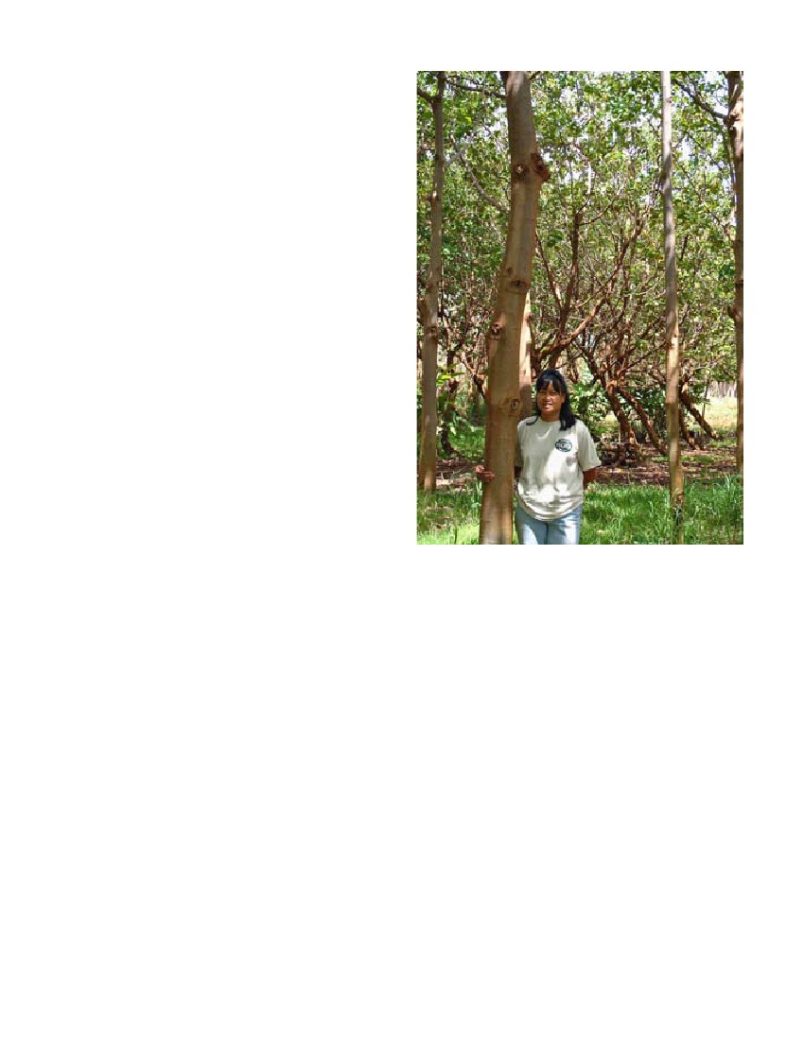
Example 1
Location
Keauhou, North Kona, Hawai‘i.
Description
This project is a 2.4 ha (6 ac) orchard planted in 1993. The
elevation is 230 m (700 ft) and rainfall ca. 1040 mm (45 in)
annually. The purpose is a visual screen.
Crop/tree interactions
The interior of the property was planted with avocados,
mango, and sapodilla trees. The kukui afforded modest
protection from the periodic storm winds.
Spacing/density of species
The outer boundary was planted with a double row of
kukui trees 2.6 m (8 ft) apart within rows and 2.6 m (8 ft)
between rows.
Example 2
Location
Located at the Moloka‘i Research and Demonstration
Farm in the Ho‘olehua Ag Park, Moloka‘i, Hawai‘i. The
project is planted on 0.15 ha (0.36 ac).
Description
This project is called, “A Demonstration of a Multi-Crop-
ping System in Establishing and Producing Native Trees”
(Arce 2003). Five rows of trees were planted in a north-
south orientation with six kukui trees in each row. There is
4.6 m (15 ft) between rows to accommodate the tractor for
mowing the area between rows. In addition to the growth
rate of the kukui and other trees, the project measured the
performance of understory crops such as alfalfa, ginger and
anthuriums for cut flowers, kava, edible fungus, and cacao.
Alfalfa was successfully grown during the early years, be-
fore the kukui trees shaded the surrounding area too much.
Kukui’s natural habit of dropping its branches and many
falling nuts posed a hazard to understory crops such as the
flowers. Ear fungus, a popular edible fungus known in Ha-
waiian as pepeiao, was introduced to kukui logs which were
set in piles between the trees. Small amounts of edible fun-
gus were produced, which could probably be increased by
improved mycoculture techniques.
Trees were planted at 3 m (10 ft) between trees, 4.6 m (15
ft) between rows.
Kali Arce shows her kukui trees in an agroforestry demon-
stration project in Ho‘olehua, Moloka‘i, Hawai‘i. photo: J. B.
Friday
PUBLIC ASSISTANCE AND
AGROFORESTRY EXTENSION
Extension offices for agroforestry and forestry in the
Pacific: http://www.traditionaltree.org/extension.html
BIBLIOGRAPHY
(☛ indicates recommended reading)
Abbott, I.A. 1992. Lā‘au Hawai‘i—Traditional Hawaiian
Uses of Plants. Bishop Museum Press, Honolulu.
Anonymous. Undated [1]. Aleurites moluccana. <http://
hk.geocites.com/tkp_tree/Aleurites_moluccana.htm>.
Anonymous. Undated [2]. Tung oil. <http://www.geocites.
com/hattiesburg_history/tung_oil.html>.
Arce, K.M. 2003. A Demonstration of a Multi-Cropping
System in Establishing and Producing Native Trees. Un-
published research results. CTAHR Cooperative Exten-
sion, University of Hawai‘i, Ho‘olehua, Hawai‘i.
Spacing
1 Aleurites moluccana (kukui)
Bonner, F.T. Undated. Aleurites moluccana (L.) Willd. In:
USDA. Woody Plant Seed Manual, rev. ed. <http://wpsm.
net/Aleurites.pdf>.
CAB International. 2003. Forestry Compendium. CAB In-
ternational, Wallingford, UK.
Clarke, W.C., and R.R. Thaman (eds.). 1993. Agroforestry in
the Pacific Islands: Systems for Sustainability. The United
Nations University, Tokyo, Japan.
Cox, P.A. 1991. Polynesian Herbal Medicine. In: Cox, P.A.,
and S.A. Banack. 1991. Islands, Plants, and Polynesians—
An Introduction to Polynesian Ethnobotany. Dioscorides
Press, Portland, Oregon.
Decker, B.G. 1992. Secondary plant cover of upland slopes,
Marquesan Islands, French Polynesia. Atoll Research
Bulletin 363: 1–36.
☛ Duke, James A. 1983. Handbook of Energy Crops.
<http://www.hort.purdue.edu/newcrop/duke_energy/
Aleurites_moluccana.html>.
Elevitch, C.R., and K.M. Wilkinson (eds.). 2000. Agro-
forestry Guides for Pacific Islands. Permanent Agricul-
ture Resources, Holualoa, Hawai‘i.
Elevitch, C.R., and K.M. Wilkinson. 2003. Propagation
protocol for production of container Aleurites moluccana
(L.) Willd. In: Native Plant Network. University of Idaho,
College of Natural Resources, Forest Research Nursery,
Moscow, Idaho. <http://www.nativeplantnetwork.org>.
Kaaiakamanu, D.M., and J.K. Akina. 1922. Hawaiian Herbs
of Medicinal Value. Charles E. Tuttle Company, Rutland,
Vermont.
Kamehameha Schools Bernice Pauahi Bishop Estate. 1994.
The Ahupua‘a—Life in Early Hawai‘i. Kamehameha
Schools Press, Honolulu.
Kepler, A.K. 1984. Hawaiian Heritage Plants. The Oriental
Publishing Company, Honolulu.
Krauss, B.H. 1974. Ethnobotany of Hawaii (course com-
pendium). University of Hawai‘i, Department of Botany,
Honolulu.
Lamb, S.H. 1987. Native Trees and Shrubs of the Hawaiian
Islands. Sunstone Press, Santa Fe, New Mexico.
☛ Little, E.L., and R.G. Skolmen. 1989. Common Forest
Trees of Hawai‘i (Native and Introduced). Agriculture
Handbook 679. U.S. Department of Agriculture Forest
Service, Washington, DC.
McDonald, M.A. 2003. Nā Lei Makame: The Treasured Lei.
University of Hawai‘i Press, Honolulu.
Merlin, M. 1991. Woody vegetation on the raised coral lime-
stone of Mangaia, southern Cook Islands. Pacific Science
45: 131–151.
Merlin, M., D. Jano, W. Raynor, T. Keene, J. Juvik, and B.
Sebastian. 1992. Tuhke en Pohnpei: Plants of Pohnpei.
East-West Center, Honolulu.
Mueller-Dombois, D., and F.R. Fosberg, 1998. Vegetation of
the Tropical Pacific Islands. Springer Verlag, New York.
☛ Neal, M.C. 1965. In Gardens of Hawaii, new and rev. ed.
Special publication 50. Bishop Museum Press, Honolulu.
Pacific Island Ecosystems at Risk (PIER). 2004. Aleurites
moluccana. <http://www.hear.org>.
Pukui, M.K. 1983. ‘Ōlelo No‘eau: Hawaiian Proverbs & Po-
etical Sayings. Bishop Museum Press, Honolulu.
Salim, A.S., A.J. Simons, C. Orwas, J. Chege, B. Owuor, and A.
Mutua. 2002. Agroforestree database.World Agroforestry
Centre, Nairobi, Kenya. <http://www.worldagroforestry-
centre.org/Sites/TreeDBS/Aft/>.
Siemonsma, J.S. 1999. Aleurites moluccana (L.) Willd. In: de
Guzman, C.C., and J.S. Siemonsma (eds.). Plant Resourc-
es of South-East Asia No 13. Spices. Backhuys Publishers,
Leiden, the Netherlands.
Smith, S.C. 1981. Flora Vitiensis Nova: A New Flora of Fiji.
Volume 2. National Tropical Botanical Garden, Lāwa‘i,
Hawai‘i.
Stone, B.C. 1970. The Flora of Guam. Micronesica 6:1–659.
Stuppy, W., P.C. van Welzen, P. Klinratana, and M.C.T.
Posa. Undated. Malesian Euphorbiaceae Descriptions 5.
Aleurites. National Herbarium Nederland. <http://www.
nationaalherbarium.nl/euphorbs/home.htm>.
Thaman, R.R., and W.A. Whistler. 1996. A Review of Uses
and Status of Trees and Forests in Land-use Systems in
Samoa, Tonga, Kiribati and Tuvalu with Recommenda-
tions for Future Action. South Pacific Forestry Develop-
ment Programme, Suva, Fiji.
USDA. 1974. Seeds of Woody Plants in the United States.
USDA Agricultural Handbook 450. <http://wpsm.net/
Genera.htm>.
Wagner, W.L., D.R. Herbst, and S.H. Sohmer. 1999. Manual
of the Flowering Plants of Hawai‘i, rev. ed. University of
Hawai‘i Press, Honolulu.
Walter, A., and C. Sam. 2002. Fruits of Oceania. ACIAR
Monograph 85. Australian Center for Agricultural Re-
search. Canberra, Australia.
Whistler, W.A. 1991. Polynesian Plant Introductions. In:
Cox, P.A., and S.A. Banack. Islands, Plants, and Polyne-
sians—An Introduction to Polynesian Ethnobotany. Di-
oscorides Press, Portland, Oregon.
Whistler, W.A. 1992. Tongan Herbal Medicine. Isle Botanica.
Honolulu.
Whistler, W.A. 1996. Samoan Herbal Medicine. Isle
Botanica. Honolulu.
Whistler, W.A. 2000. Plants in Samoan Culture: The
Ethnobotany of Samoa. Isle Botanica. Honolulu.
Species Profiles for Pacific Island Agroforestry (www.traditionaltree.org) 1
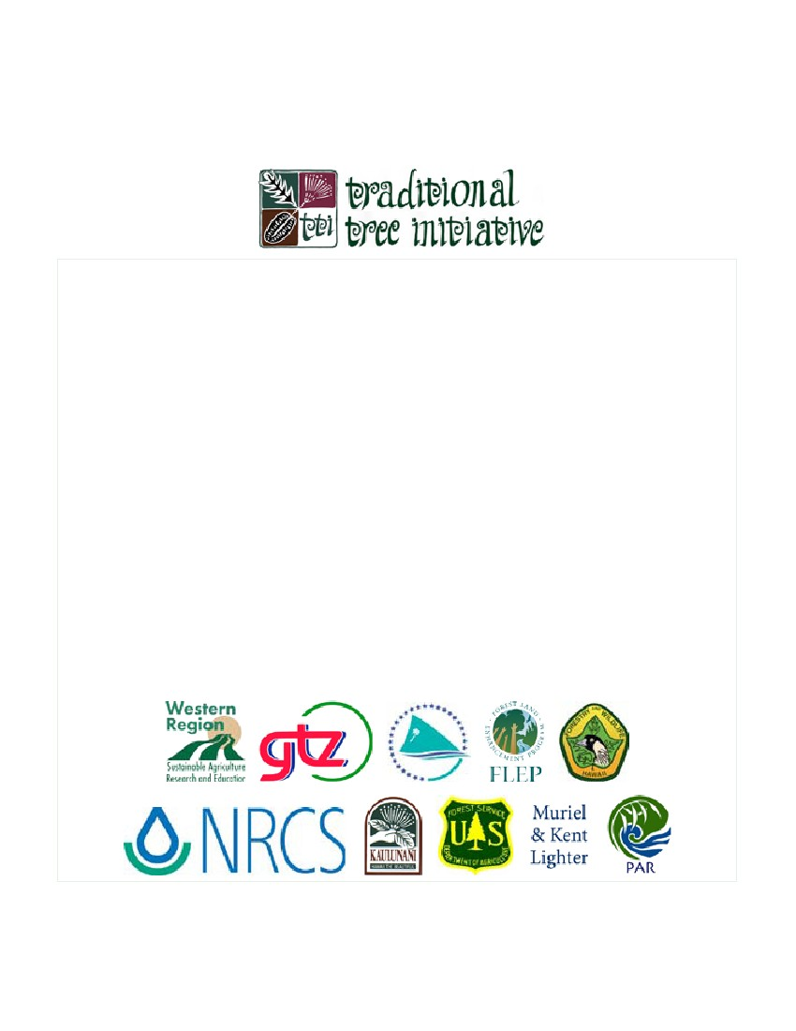
Traditional Tree Initiative—Species Profiles for Pacific Island Agroforestry (www.traditionaltree.org)
Aleurites moluccana (kukui)
Authors: Craig R. Elevitch1 and Harley I. Manner2
1. Permanent Agriculture Resources (PAR), PO Box 428, Hōlualoa, Hawai‘i 96725, USA; Tel: 808-324-4427; Fax: 808-324-4129; E-
mail: par@agroforestry.net; Web: <http://www.agroforestry.net>.
2. University of Guam, College of Arts and Sciences, UOG Station, Mangilao, GU 96923 USA; Tel: 671-735-2874; Fax: 671-734-5255;
E-mail: hmanner@uog9.uog.edu
Acknowledgments: The authors and publisher thank Kali Arce, Dale Evans, Heidi Johansen, Scott Peterson, Diane Ragone, Art
Whistler, and Kim Wilkinson for their input. The photo contribution by J. B. Friday is greatly appreciated.
Recommended citation: Elevitch, C.R., and H.I. Manner. 2006. Aleurites moluccana (kukui), ver. 2.1. In: Elevitch, C.R. (ed.). Species
Profiles for Pacific Island Agroforestry. Permanent Agriculture Resources (PAR), Hōlualoa, Hawai‘i. <http://www.traditionaltree.
org>.
Sponsors: Publication was made possible by generous support of the United States Department of Agriculture Western Region Sus-
tainable Agriculture Research and Education (USDA-WSARE) Program; SPC/GTZ Pacific-German Regional Forestry Project;
USDA Natural Resources Conservation Service (USDA NRCS); Kaulunani, an Urban Forestry Program of the DLNR Division
of Forestry and Wildlife and the USDA Forest Service; State of Hawai‘i Department of Land & Natural Resources Division of
Forestry & Wildlife; USDA Forest Service Forest Lands Enhancement Program; and Muriel and Kent Lighter. This material is
based upon work supported by the Cooperative State Research, Education, and Extension Service, U.S. Department of Agriculture,
and Agricultural Experiment Station, Utah State University, under Cooperative Agreement 2002-47001-01327.
Series editor: Craig R. Elevitch
Publisher: Permanent Agriculture Resources (PAR), PO Box 428, Hōlualoa, Hawai‘i 96725, USA; Tel: 808-324-4427; Fax: 808-324-
4129; E-mail: par@agroforestry.net; Web: <http://www.agroforestry.net>. This institution is an equal opportunity provider.
Reproduction: Copies of this publication can be downloaded from <http://www.traditionaltree.org>. This publication may be repro-
duced for noncommercial educational purposes only, with credit given to the source. © 2006 Permanent Agriculture Resources. All
rights reserved.

1 Aleurites moluccana (kukui)

