REVIEW REPORT ON FOCUS ON VISION SPECS (FOCUSSPECS) INTRODUCTIONS
FIG. 1
After five month, a review was undertaken to determine whether respondents were still using the FOV focusspecs; the problem they encounter whilst still using it and take suggestion from them on what kind of improvement should be made.
REVIEW RESULT GENDER
TABLE 1
GENDER | NUMBER OF RESPONDENTS | PERCENTAGE OF RESPONDENTS
MALE | 67 | 70%
FEMALE | 29 | 30%
TOTAL | 96 | 100%

OCCUPATION OF RESPONDENTS
OCCUPATIONS OF RESPONDENTS
40 37
35
31
28
30
25
20
15
10
5
0
TEACHERS STUDENT OTHERS

COMPLIANCE
FIG. 3
CHART OF RESPONDENTS WHO WERE STILL USING

THE SPECS
STILL IN USE NOT IN USE
32
70
60
50
40
30
20
10
0
64

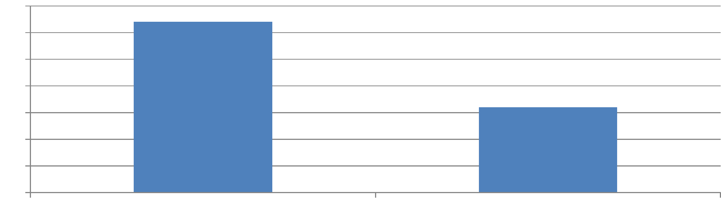
FIG.2
ORIGINALLY PREFERRED COLOURS
PREFERRED COLOUR OF FOCUSSPECS

60
50 | 49
40
30
 |  |  |  |  |  | 21
20  10 |  |  |  | 15
0 |  |  |  |  | 3 |  | 6
 | BLACK BROWN PINK GREY GOLD

REASONS FOR USAGE
REASON FOR USAGE OF FOCUSSPECS

90
90 |  | 81
80 |  | 81
70
60
50
40
30
20 |  |  |  | 14
10
0
NEAR VISION DISTANCE VISION
FIG. 4
Sefwi-Wiawso District
At this district, all the respondent who took the Focusspecs were available for the review making 100% review response rate. Of this eighteen (18) were males whilst four(4) were females. Four(4) had refractive errors and 18 were presbyopic,
Sixty eight percent (68%) of them were still using the focus specs and the most preferred color was black. The predominant reason for rejecting the focus specs was that, it looks more like a toy and therefore they suggested that future design of the focus specs should look more serious.
BLACK BROWN BLUE PINK GREY

PREFFERRED COLOUR-SEFWI

18 16 14 12 10
8
6
4
2
0
18 16 14 12 10  8  6  4  2  0 | 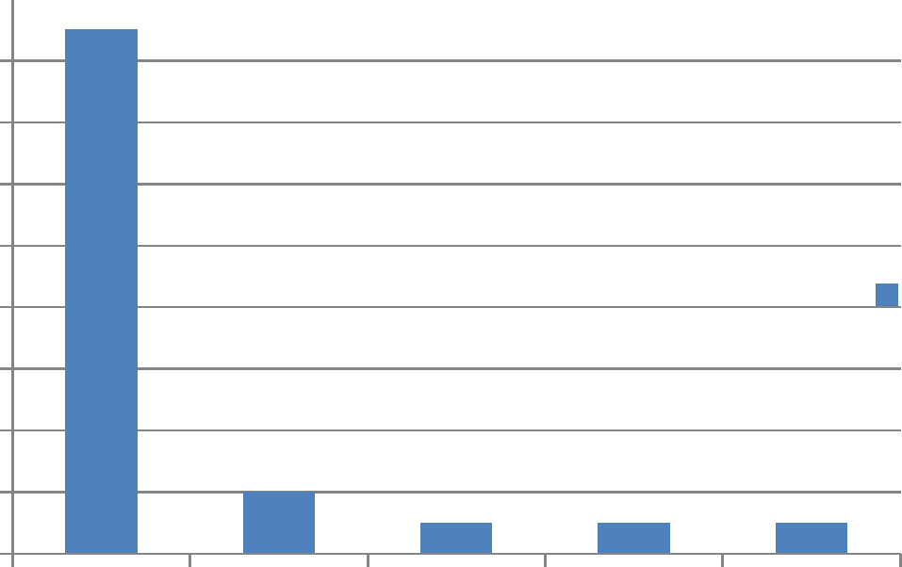 |  | PREFFERRED COLOURSEFWI

FIG 5

USAGE- SEFWI

12

10
8
6

USAGE- SEFWI

4
2
0

NEAR VISION DISTANCE VISION NO RESPONSE

FIG 6
FIG 7

PERCENTAGE OF FOCUSSPECS STILL
IN USE-SEFWI
PERCENTAGE OF
FOCUSSPECS STILL IN USESEFWI
80% 70% 60% 50% 40% 30% 20% 10%
0%
80% 70% 60% 50% 40% 30% 20% 10%  0% | 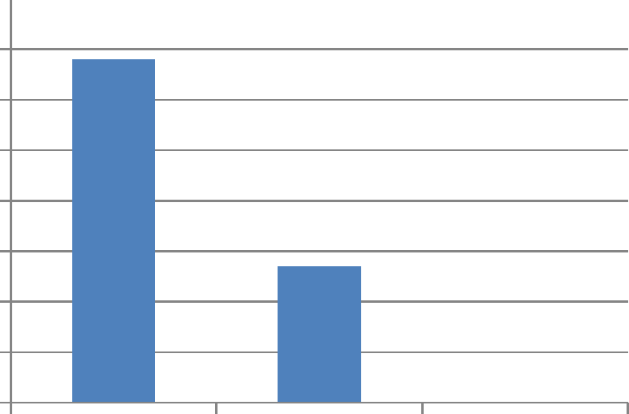
 | USING NOT USING NO RESPONSE

AKYEMANSA DISTRICT
All 26 respondent (19 males and 7 female) who were giving the focus specs were available for the review.
Four(4) had refractive errors and 22 were presbyopic and 24 Focusspecs were given. Fifty eight percent (58%) of them were still using the Focusspec. The preferred colour was black and most people here do not have much complain.
JUASO DISTRICT
Only fifteen (15) respondents were available for the review making forty percent (40%) of those who were giving the focus specs. Out of these four(4) were female and eleven (11) males.
Seven of them had refractive error and eight were presbyopic. Fifty three percent (53%) were still using the focus specs and most of them suggested future focus specs should have improve design should and be should be lighter in weight.
Nkwanta District
Most of the issues raised with the focus specs in the other districts were the same for that of Nkwanta district. However, the grey coloured frames were the most preferred as shown in the chart below.
CONCLUSION
BLACK BROWN BLUE PINK GREY GOLD
0
0
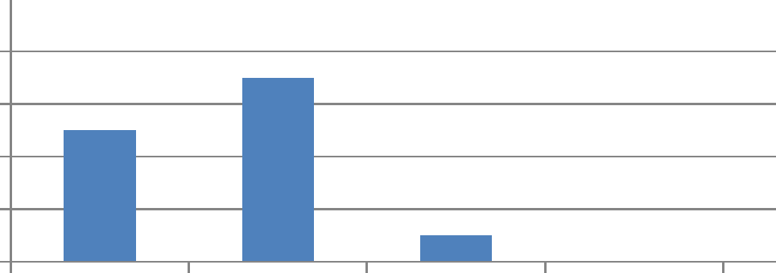

PREFERRED COLOUR- NKWANTA
18
17
16
14
12
10
8
6
7
4
5
3
2
1

Based on the five(5) month review report in the four district of Ghana, the most preferred colour of focus specs is grey and most people who use it are presbyopes.

