safe needle disposal
November 26, 2010 at 10:37 am (cool green technology, health & safety, hospital waste mgt)
Tags: Biohazardous Materials, environment, Hypodermic needle, Medical waste, Syringe, Waste Management
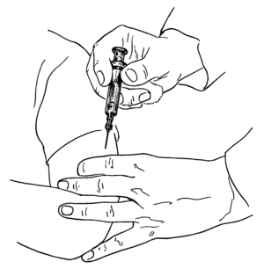
Image via Wikipedia
i just received a snail mail package of one dozen Yellowone Needle Cap (Antivirus) from ms. han pham (d designer/inventor) herself!
Yellowone Needle Cap is a non-reusable sharps container for disposal of hypodermic needles. It is designed for syringes with luer-slip. The cap fits over 90 percent of all beverage cans in the world.
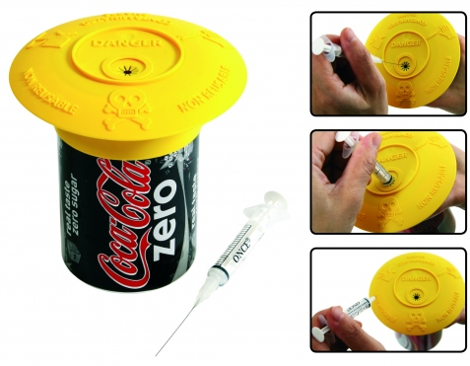
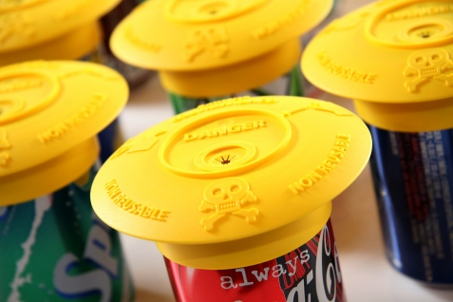
will now start to work on how poor clinics in the philippines can safely disposed off their sharps to protect d health workers, patients, communities as well as d environment!
sharp wastes can be minimized by 90% by segregating d needles fr d syringes after each use….infectious waste disposal is an expensive activity so reducing its volume mean savings in disposal costs!
best practices in health care recommend the segregation of needles/sharps at point of use. Source: WHO. it is the needle that is dangerous. It sticks deep – it goes straight into the muscle or the vein. The syringe itself does no harm, because it cannot cut or stick deep through the skin. Therefore, it can be disposed according to local regulations. Source: Annelie Ginzel, MSF.
for those who are not in compliance w/ republic act 6969 (toxic & hazardous waste law), e.g. they don’t have a proper treatment facility nearby. probably a sharp pit (or burial pit) can be a safer alternative. it is very interesting to note that many needles end up in open dumpsites that r accessible to scavengers that recycles them w/o proper treatment.

Related Articles
- Environmental Sticking Point – Used Needle and Syringe Disposal (planetsave.com)
- Put Medical Waste in the Mail – Not in Your Landfill (ecolocalizer.com)
- Bemis Health Care Names QuickMedical as National Distributor (prweb.com)
- A Green Processing System for Medical Waste (cleantechnica.com)
Source : http://resourceefficiency.wordpress.com/category/health-safety/

