Appendix 2 - Design Calculations for Latrine Pits
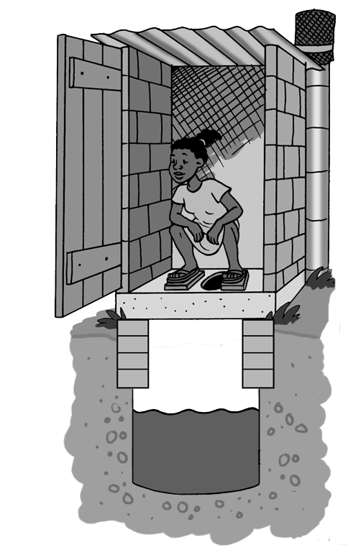

Introduction
This Appendix will explain how to design different types of latrine pits. It contains the following information:

- Design tables for latrine pits based on families of 4, 6 and 8 people
- Explanations of the equations used for latrine pit calculations
- Step-by-step sample calculations with full solutions
- Practice questions with full solutions

Latrine Pit Calculations Using Tables
There are five pieces of information that must be considered to design a pit latrine:



Key Information Needed for Latrine Pit Calculations

- Number of users (N): The number of people that will use the pit on a regular basis.

- Lifetime (Y): The number of years the pit should last before having to dig a new pit or empty the existing one.

- Pit dimensions:

  - Length (L) and width (W) for a rectangular or square pit.

  - Diameter (d) (the distance from one side of the circle to the opposite through the middle) for a circular pit.

- Pit depth (D): How deep the pit is (this includes the 0.5 metres needed for left unfilled to allow for soil cover).

- Sludge accumulation rate (R): How quickly the pit fills. This depends on the moisture conditions in the pit and the type of anal cleaning material used.

Pit Shape
Choose the shape of the pit before starting any calculations or using the tables. When choosing, remember the following:

- Circular pits are less likely to collapse because the pressure from the surrounding soil is evenly spread.
- Rectangular pits tend to collapse more often because pressure is placed on the four walls. This leaves the corners to absorb the stress.

Pressure from surrounding ground
Pressure from surrounding ground
(Lifewater International, 2009)

Pit Dimensions

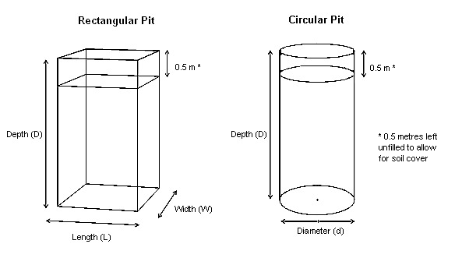
Rectangular Pit Variables |  |  | Circular Pit Variables
D = | Depth (Metres) |  | d = | Diameter (Metres)
L = | Length (Metres) |  | D = | Depth (Metres)
W = | Width (Metres) |  | N = | Number of Users (Person)
N = | Number of Users (Person) |  | R = | Sludge Accumulation Rate (Litres/Person-Year)
R = | Sludge Accumulation Rate (Litres/Person-Year) |  | Y = | Lifetime (Years)
Y = | Lifetime (Years)

Latrine Pit Design Tables
The tables can be used to design the following latrine types:

- Simple Pit Latrine
- Ventilated Improved Pit Latrine (VIP)
- Pour flush latrine,
- Twin Pit (Simple, VIP and Pour flush)
- Offset Pour flush Latrine (single or twin)
- Composting Latrine
- Dehydrating Latrine

The tables found below can be used to design latrine pits for 2, 5 and 10 year lifetimes based on the number of regular users. There are calculations for both rectangular and circular shaped pits.

The tables may not be useful in all circumstances. A hand calculation to find the pit dimensions will have to be done if the pit depth taken from the design tables is within 1.5 metres of the water table. See section 3 to do calculations by hand.

Safety Consideration

A pit deeper than 1.2 metres should be supported by pit lining or shoring (a temporary support structure) while digging. This will help prevent it from collapsing on the person digging the pit.

- The bottom of the pit must be 1.5 metres above the water table.

Suggested Maximum Sludge Accumulation Rates
Pit Conditions | Sludge Accumulation Rate (R) (Litres/person/year)
Pit Conditions | Degradable anal cleaning materials (e.g. leaves, paper, cornhusks etc.) | Non-degradable anal cleaning materials (e.g. rocks, trash, plastic)
Water in pit (e.g. Pour Flush Latrine or water used for anal cleaning) | 40 | 60
Dry in pit (e.g. none or small amount of water in pit) | 60 | 90
Note: The numbers in the above table are long term accumulation rates. In short term pits (pits that are used for about two years) these rates are too low. It is suggested that they are increased by 50%. In these calculations R is multiplied by 1.5.
(Harvey, Baghri, & Reed, 2002)

How quickly the pit fills is a sludge accumulation rate. The design tables were calculated using conservative maximum sludge accumulation rates (ie. non-degradable material used for anal cleaning) for a wet pit and a dry pit. These values are found in the bolded boxes in the table above. The sludge accumulation rate used for the two year compost latrine calculations was based on a dry pit and degradable and cleaning material.

Table 2.2.1 - Pit Design for 4 Regular Users
Pit Dimensions | Pit Depth (D) (metres)
Rectangular Pit  width (w) x length (L) (metres) | 2 Year Life** |  | 5 Year Life |  | 10 Year Life |  | 2 Year Life Compost***
Rectangular Pit  width (w) x length (L) (metres) | R=60 | R=90 | R=60 | R=90 | R=60 | R=90 | R=60
1x1 | 1.2 | 1.6 | 1.7 | 2.3 | 2.9 | 4.1* | 2.7
1x1.2 | 1.1 | 1.4 | 1.5 | 2.0 | 2.5 | 3.5* | 2.3
1x1.5 | 1.0 | 1.2 | 1.3 | 1.7 | 2.1 | 2.9 | 1.9
1x2 | 0.9 | 1.0 | 1.1 | 1.4 | 1.7 | 2.3 | 1.6
1.2x1.2 | 1.0 | 1.3 | 1.3 | 1.8 | 2.2 | 3.0* | 2.0
1.2x1.5 | 0.9 | 1.1 | 1.2 | 1.5 | 1.8 | 2.5 | 1.7
1.2x2 | 0.8 | 1.0 | 1.0 | 1.3 | 1.5 | 2.0 | 1.4
Circular Pit
Diameter (d) (metres)
1 | 1.4 | 1.9 | 2.0 | 2.8 | 3.6* | 5.1* | 3.3*
1.1 | 1.3 | 1.6 | 1.8 | 2.4 | 3.0* | 4.3* | 2.8
1.2 | 1.1 | 1.5 | 1.6 | 2.1 | 2.6 | 3.7* | 2.4
1.3 | 1.0 | 1.3 | 1.4 | 1.9 | 2.3 | 3.2* | 2.1
1.4 | 1.0 | 1.2 | 1.3 | 1.7 | 2.1 | 2.8 | 1.9
1.5 | 0.9 | 1.1 | 1.2 | 1.5 | 1.9 | 2.5 | 1.7

Table 2.2.2 - Pit Design for 6 Regular Users
Pit Dimensions | Pit Depth (D) (metres)
Rectangular Pit  width (w) x length (L) (metres) | 2 Year Life** |  | 5 Year Life |  | 10 Year Life |  | 2 Year Life Compost***
Rectangular Pit  width (w) x length (L) (metres) | R=60 | R=90 | R=60 | R=90 | R=60 | R=90 | R=60
1x1 | 1.6 | 2.1 | 2.3 | 3.2* | 4.1* | 5.9* | 3.7*
1x1.2 | 1.4 | 1.9 | 2.0 | 2.8 | 3.5* | 5.0* | 3.2*
1x1.5 | 1.2 | 1.6 | 1.7 | 2.3 | 2.9 | 4.1* | 2.7
1x2 | 1.0 | 1.3 | 1.4 | 1.9 | 2.3 | 3.2* | 2.1
1.2x1.2 | 1.3 | 1.6 | 1.8 | 2.4 | 3.0* | 4.3* | 2.8
1.2x1.5 | 1.1 | 1.4 | 1.5 | 2.0 | 2.5 | 3.5* | 2.3
1.2x2 | 1.0 | 1.2 | 1.3 | 1.6 | 2.0 | 2.8 | 1.9
Circular Pit
Diameter (d) (metres)
1 | 1.9 | 2.6 | 2.8 | 3.9* | 5.1* | 7.4* | 4.6*
1.1 | 1.6 | 2.2 | 2.4 | 3.3* | 4.3* | 6.2* | 3.9*
1.2 | 1.5 | 1.9 | 2.1 | 2.9 | 3.7* | 5.3* | 3.4*
1.3 | 1.3 | 1.7 | 1.9 | 2.5 | 3.2* | 4.6* | 2.9
1.4 | 1.2 | 1.6 | 1.7 | 2.3 | 2.8 | 4.0* | 2.6
1.5 | 1.1 | 1.4 | 1.5 | 2.0 | 2.5 | 3.6* | 2.3

Table 2.2.3 - Pit Design for 8 Regular Users
Pit Dimensions | Pit Depth (D) (metres)
Rectangular Pit  width (w) x length (L) (metres) | 2 Year Life** |  | 5 Year Life |  | 10 Year Life |  | 2 Year Life Compost***
Rectangular Pit  width (w) x length (L) (metres) | R=60 | R=90 | R=60 | R=90 | R=60 | R=90 | R=60
1x1 | 1.9 | 2.7 | 2.9 | 4.1* | 5.3* | 7.7* | 4.8*
1x1.2 | 1.7 | 2.3 | 2.5 | 3.5* | 4.5* | 6.5* | 4.1*
1x1.5 | 1.5 | 1.9 | 2.1 | 2.9 | 3.7* | 5.3* | 3.4*
1x2 | 1.2 | 1.6 | 1.7 | 2.3 | 2.9 | 4.1* | 2.7
1.2x1.2 | 1.5 | 2.0 | 2.2 | 3.0* | 3.8* | 5.5* | 3.5*
1.2x1.5 | 1.3 | 1.7 | 1.8 | 2.5 | 3.2* | 4.5* | 2.9
1.2x2 | 1.1 | 1.4 | 1.5 | 2.0 | 2.5 | 3.5* | 2.3
Circular Pit
Diameter (d) (metres
1 | 2.3 | 3.3* | 3.6* | 5.1* | 6.6* | 9.7* | 6.0*
1.1 | 2.0 | 2.8 | 3.0* | 4.3* | 5.6* | 8.1* | 5.0*
1.2 | 1.8 | 2.4 | 2.6 | 3.7* | 4.7* | 6.9* | 4.3*
1.3 | 1.6 | 2.1 | 2.3 | 3.2* | 4.1* | 5.9* | 3.8*
1.4 | 1.4 | 1.9 | 2.1 | 2.8 | 3.6* | 5.2* | 3.3*
1.5 | 1.3 | 1.7 | 1.9 | 2.5 | 3.2* | 4.6* | 2.9

* 3 metres is considered a deep pit and will take a minimum of six days for one person to dig. Most people are uncomfortable being in a pit that is deeper than 3 metres.

** The sludge accumulation rates for all 2 year life calculations were multiplied by 1.5 to take into account limited volume reduction from decomposition due to the short time frame.

*** These values should be used for composting and dehydrating latrines. The sludge accumulation values for all 2 year life compost calculations were multiplied by a value 1.5 for the short time and by 3 for the addition of materials that help with composting (e.g. Lime, ash, kitchen scraps).

Practice Questions
Use the tables in section 2.2 and the ‘Suggested Maximum Sludge Accumulation Rate Table’ to answer the following questions. Solutions are found at the end of this section.

Question 1

- A family of 4 wants to build a rectangular pit for their simple pit latrine
- They want the pit to have a length of 1.2 metres and a width of 1.0 metres
- They want to be able to use it for 5 years
- They use grass and leaves for anal cleaning

How deep should their pit be?

Question 2

- A family of 4 wants to build a circular pit for their VIP latrine
- They want the pit to have a diameter of 1.2 metres
- They want to be able to use it for 10 years
- They use grass and leaves for anal cleaning

How deep should their pit be?

Question 3

- A family of 8 wants to build a pour flush latrine
- They want to build a circular pit with a diameter of 1.3 metres
- They want to use it for 10 years
- They use paper for anal cleaning

How deep should their pit be? What challenge might you find trying to dig a latrine pit to this depth?

Question 4

- A family of 6 wants to build a VIP latrine
- They use rocks for anal cleaning
- They want to build a rectangular pit with a width of 1.2 metres and a length of 1.5 metres
- The want to use the latrine for 5 years

How deep should their pit be?

Question 5

- A family of 6 wants to build two circular pits for their twin pour flush offset latrine (Hint: not a composting option)
- They want each pit to have a diameter of 1 metre
- They use paper for anal cleaning
- They will empty each pit once the contents are safe to handle (2 years)

How deep should each pit be?

Question 6

- A family of 4 wants to build two rectangular pits for their composting latrine
- They want each pit to have a length of 1.2 metres and width of 1.0 metres
- They use leaves for anal cleaning
- They will empty each pit once the contents are safe to handle and use it as fertilizer

How deep should each pit be?

Question 7

- A family of 6 wants to build a dehydrating latrine with two rectangular pits
- They want each pit to have a length and width of 1.2 metres
- They are very good at not putting any water, urine or wiping materials in the pit
- They will empty the pit contents when they are safe to handle and used as compost

How deep should each pit be?

Question 8 (Challenge Question)

- A family of 5 wants to build a pour flush latrine
- They want to build a rectangular pit with a length of 1.5 metres and width of 1 metre
- They want to use the latrine for 5 years
- They use with soft plastic for anal cleaning

How deep should their pit be?

Question 9 (Challenge Question)

- A family of 6 wants to build a pour flush latrine
- They want to build a rectangular with a length of 1.5 metres and width of 1 metre
- They want to use the latrine for 7 years
- They use with soft plastic for anal cleaning

How deep should their pit be?

Question 10 (Challenge Question)

- A family of 7 want to build a composting latrine with two rectangular pits
- They want each pit to have a length of 1.5 metres and width of 1 metre
- They use paper for anal cleaning
- They will empty the pit contents after 2 years and use it as compost

How deep should each pit be?

Solutions to Practice Questions

Using Table 2.2.1, R = 60, D = 1.5 metres
Using Table 2.2.1, R=60, D = 2.6 metres
Using Table 2.2.3, R = 60, D = 4.1 metres – Any pit deeper than 3 meters is a deep pit. It will take a long time to dig the pit and people may not be comfortable digging that deep. It is also possible that you will dig into the water table.
Using Table 2.2.2, R = 90, D = 2.0 metres
Using Table 2.2.2, R=60, D = 1.9 metres
Using Table 2.2.1, R = COMPOSTING, D = 2.3 metres
Using Table 2.2.2, R = COMPOSTING, D = 2.8 metres
Step 1: Family of 4, Using Table 2.2.1, R = 90, D = 1.7 metres
Step 2: Family of 6, Using Table 2.2.2, R = 90, D = 2.3 metres
Step 3: Family of 5, Halfway between answers of step 1 and step 2, D = 2.0 metres
Step 1: 5 Years, Using Table 2.2.2, R = 90, D = 2.3 metres
Step 2: 10 Years, Using Table 2.2.2, R = 90, D = 4.1 metres
Step 3: 7 Years, Halfway between answers of step 1 and step 2, D = 3.2 metres
Step 1: Family of 6, Using Table 2.2.2, R = COMPOSTING, D = 2.2 metres
Step 2: Family of 8, Using Table 2.2.3, R = COMPOSTING, D = 3.4 metres
Step 3: Family of 7, Halfway between answers of step 1 and step 2, D = 3.0 metres

Latrine Pit Design Calculations by Hand
This section will explain the equations that are used in latrine pit design calculations. It will then lead you through sample and practice questions for long term (greater lifetime than two years) and short term (lifetime of two years or less) latrine types.

Calculating Area and Volume for Pits Based on Dimensions

We will start with the pit shapes and the equations that are needed to figure out area and volume of the pit based on dimensions.

Rectangular Pit

Area and volume for a rectangular pit can be calculated from the three pit dimensions:
- Depth
- Length
- Width

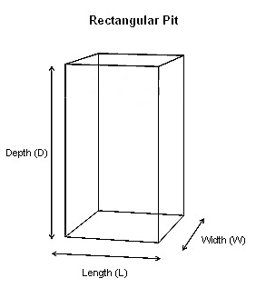

A rectangular pit shape is made of 3 sets of rectangles that have different dimensions.

- Top and bottom are the same
- Front and back are the same
- Side and side are the same
Top and Bottom
Length (L)
Width (W)
This is the shape that you see when you look at the pit from above.

The length and width of the pit are most likely determined by the size of slab you have or can build.

Front and Back
Length (L)
Depth (D)
You create the depth as you dig your pit.

The front and back rectangle shares the length dimension of the top and bottom rectangle.

The dimensions of this rectangle are length (L) and depth (D).

Width (W)
Depth (D)
Side and Side
The side and side rectangle has the same depth (D) as the front and back rectangles.

It also has the same width (W) as the top and bottom rectangles.

Note: All dimensions used in this appendix are measured in metres.

Area
In latrine calculations, area refers to the area of the top and bottom rectangle.

Length (L)
Width (W)
$$\begin{aligned}\text{Area}=\text{Length}×\text{Width} \\ A=L×W\end{aligned}$$

- Length and width are measured in metres (m)
- Area is measured in square metres (m²)

Volume

From the equation above,we know that A = L x W

$\begin{aligned}\text{Volume}=\text{Area}×\text{Depth} \\ V=A×D \\ V=L×W×D\end{aligned}$

In pit calculations, the volume equation is often rearranged to solve for depth.

$\begin{aligned}\text{Depth}=\frac{\text{Volume}}{\text{Area}} \\ D=\frac{V}{A} \\ D=\frac{V}{L×W}\end{aligned}$

            - Depth is measured in metres (m)
            - Area is measured in square metres (m²)
            - Volume is measured in cubic metres (m³)

Circular Pit
Area and volume for a circular pit can be calculated from the two pit dimensions: depth and diameter (the distance across the circle through the middle).

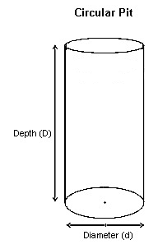

A circular pit shape is called a cylinder. It is made up of two identical circles that are the top and the bottom, and a rectangle that wraps around them. If you were to unroll a cylinder and lay it flat on the ground it would look like this:
Diameter (d)
Depth (D)
Length (L)

Area

$$\begin{aligned}\text{Area}={\text{Diameter}}^{2}×\frac{3\text{.}\text{14}}{4} \\ A=d^{2}×\frac{3\text{.}\text{14}}{4}\end{aligned}$$
Diameter (d)

- Diameter is measured in metres (m)
- Area is measured in square metres (m²)
- 3.14 is a rounded value for the ratio pi (π)

Volume
From the equation above, we know that

$$\begin{aligned}\text{Volume}=\text{Area}×\text{Depth} \\ V=A×D \\ V=d^{2}×\frac{3\text{.}\text{14}}{4}×D\end{aligned}$$

In pit calculations, the volume equation is often rearranged to solve for depth.

$\begin{aligned}\text{Depth}=\frac{\text{Volume}}{\text{Area}} \\ D=\frac{V}{A} \\ D=\frac{V}{(d^{2}×\frac{3\text{.}\text{14}}{4})}\end{aligned}$

- Depth is measured in metres (m)
- Area is measured in square metres (m²)
- The units for volume will be cubic metres (m³)

Calculating Volume Based on Usage
The volume of a latrine pit is calculated based on a combination of its usage and dimensions. The following information is needed to calculate a pit with the correct volume.

Key Information Needed for Latrine Pit Calculations

- Number of users (N): The number of people that will use the pit on a regular basis

- Lifetime (Y): The number of years the pit should last before having to dig a new pit or empty the existing one

- Pit dimensions:

  - Length (L) and width (W) for a rectangular or square pit

  - Diameter (d) (the distance from one side of the circle to the opposite through the middle) for a circular pit

- Pit depth (D): How deep the pit is

- Sludge accumulation rate (R): How quickly the pit fills. This depends on the moisture conditions in the pit and the type of anal cleaning material used.

The following table provides values that should be used for the sludge accumulation rate based on the moisture conditions in the pit and the type of anal cleaning material used.

Suggested Maximum Sludge Accumulation Rates
Pit Conditions | Sludge Accumulation Rate (R) (Litres/person/year)
Pit Conditions | Degradable anal cleaning materials (e.g. leaves, paper, cornhusks etc.) | Non-degradable anal cleaning materials (e.g. rocks, trash, plastic)
Water in pit (e.g. Pour Flush Latrine or water used for anal cleaning) | 40 | 60
Dry in pit (e.g. none or small amount of water in pit) | 60 | 90
(Harvey, Baghri, & Reed, 2002)
The following equation will tell us how much volume the pit needs.

Space needed for soil cover
This part of the equation is accounting for the extra volume at the top needed for the soil cover. Excreta will not fill this space.
This is the equation for geometric volume, where 0.5 metres is the depth of the cover.

Amount of Material Entering the Pit
This part of the equation tells us how much material (e.g. excreta, wiping material) will be entering the pit.
The 1000 is a conversion value to change the units from litres (found in the sludge accumulation rate) to cubic metres.

$$\text{Volume }=\frac{\text{Number of users}×\text{Sludge accumulation rate}×\text{Lifetime}}{\text{1000}}+0\text{.}5×\text{Area}$$

$$V=\frac{N×R×Y}{\text{1000}}+0\text{.}5×A$$

This equation can be rearranged to solve for the number of years that the latrine pit can be used. You may need to use this equation when the pit dimensions are constrained by the depth of the water table. The bottom of your pit must be at least 1.5 metres above the ground water.

$$\begin{aligned}\text{Lifetime}=\frac{(\text{Volume}−0\text{.}5×\text{Area})×\text{1000}}{\text{Number of users}×\text{Sludge accumulation rate}} \\ \\ Y=\frac{(V−0\text{.}5×A)×\text{1000}}{N×R}\end{aligned}$$

Long Term and Short Term Latrine Pits
Latrine designs can be broken into two categories:

- Long term latrine – Any pit that is designed to fill in more than two years.
- Short term latrine – Any pit that is designed to fill in two years or less.

The following table categorizes latrines into their most common lifetime.

Long Term Latrines | Short Term Latrines
- Simple pit latrine  - VIP latrine  - Pour flush latrine  - Pour flush offset latrine  - Twin pit (if the user empties the pits less than once every two years) | - Twin pit  - Simple pit latrine  - VIP latrine  - Pour flush latrine  - Pour flush offset  - Composting latrine  - Dehydrating latrine  - Arborloo

The equations for long term and short term latrines are almost identical. The only difference is found in the usage volume calculation. The following table explains the changes to the usage volume equation based on the latrine purpose and lifetime.

Volume Equations Based on Latrine Lifetime and Purpose
Lifetime and Purpose | Equation | Explanation
Long term latrines | $$V=\frac{N×R×Y}{\text{1000}}+0\text{.}5A$$ | This is the basic volume equation for any latrine that is designed to fill for more than two years.
Short term latrines – no compost being made | $$V=\frac{N×1\text{.}5R×Y}{\text{1000}}+0\text{.}5A$$ | In a short term pit, sludge does not have enough time to naturally decompose and reduce in volume. This natural process of volume reduction over time is normally taken into account in the table value for sludge accumulation. The sludge accumulation rate must be increased by 50% or in other words, multiplied by a factor of 1.5 because there is not enough time for the volume to reduce.
Short term latrines - compost being made | $$V=\frac{N×1\text{.}5R×Y×3}{\text{1000}}+0\text{.}5A$$ | In a short term pit used to create compost, the amount of material entering the pit is actually larger than what the sludge accumulation value accounts for. This is because other materials (e.g. ash, lime, food scraps) are being added to help the process of decomposition. The sludge accumulation factor must therefore also be multiplied by 3 as well as 1.5 due to the short time.

Summary of Latrine Pit Equations
Use the information in this section as a reference to work through the practice questions in section 1.5.

Table of Equations
Dimension | Formula | Variables
Area: Rectangular | $$A=L×W$$ | A: Area (m²)  L: Length (m)  W: Width (m)
Area: Circular | $$A=d^{2}×\frac{3\text{.}\text{14}}{4}$$ | A: Area (m²)  d: Diameter (m)
Depth: Rectangular | $$D=\frac{V}{A}$$ | V: Volume (m³)  A: Area (m²)
Depth: Circular | $$D=\frac{V}{A}$$ | V: Volume (m³)  A: Area (m²)
Geometric Volume: Rectangular | $$V=D×A$$ | D: Depth (m)  A: Area (m²)
Geometric Volume: Circular | $$V=d^{2}×\frac{3\text{.}\text{14}}{4}×D$$ | d: diameter (m)  D: Depth (m)
Usage Volume – Long Term | $$V=\frac{(N×R×Y)}{\text{1000}}+0\text{.}5×A$$ | V: Volume of pit (m³)  N: Number of users  Y: Years in use  A: Area of pit base (m²)  R: Sludge accumulation rate (liters/person/year)
Usage Volume – Short Term, No Compost | $$V=\frac{N×1\text{.}5R×Y}{\text{1000}}+0\text{.}5A$$ | V: Volume of pit (m³)  N: Number of users  Y: Years in use  A: Area of pit base (m²)  R: Sludge accumulation rate (liters/person/year)
Usage Volume – Short Term, Compost | $$V=\frac{N×1\text{.}5R×Y×3}{\text{1000}}+0\text{.}5A$$ | V: Volume of pit (m³)  N: Number of users  Y: Years in use  A: Area of pit base (m²)  R: Sludge accumulation rate (liters/person/year)
Years in Use | $$Y=\frac{(V−0\text{.}5×A)×\text{1000}}{N×R}$$ | V: Volume of pit (m³)  N: Number of users  Y: Years in use (year)  A: Area (m²)  R: Sludge accumulation rate (liters/person/year)

Notes:

- The top of the water table must be at least 1.5 metres below the bottom of the latrine.

- Products from ecosanitation latrines are safe to handle after 2 years.

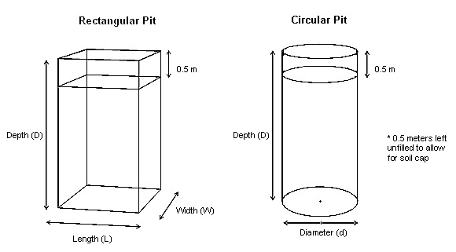

Suggested Maximum Sludge Accumulation Rate
Pit Conditions | Sludge Accumulation Rate (R) (litres/person/year)
Pit Conditions | Degradable anal cleaning materials (leaves, paper, cornhusks etc.) | Non-degradable anal cleaning materials (rocks, trash, plastic)
Water in pit (Pour Flush Latrine or water used for anal cleaning) | 40 | 60
Dry in pit (none or small amount of water in pit) | 60 | 90

Example Questions

Long Term Latrine Calculation – Rectangular, Finding Depth
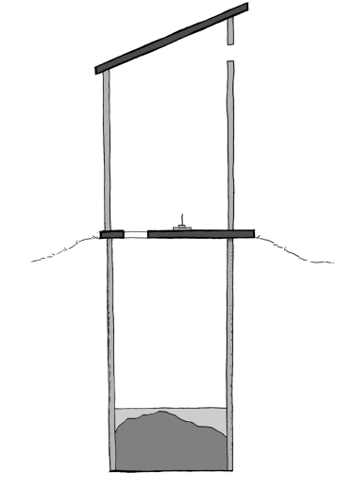
- A family of 4 wants to build a rectangular pit for their simple
pit latrine

- They want the pit to have a length of 1.2 metres and a width of 1.0 metres

- They want to be able to use it for 6 years

- They use grass and leaves for wiping

How deep should their latrine be?

Solution

Step 1: Known information - Write down the variables and their values. Identify the
variable that you need to solve for.
We are using a sludge accumulation rate of 60 (litres/person/year) because it is mostly dry inside the pit and degradable anal cleaning materials are being used (e.g. leaves and grass).

$$\begin{aligned}\text{Shape }=\text{ Rectangular} \\ \text{Number of Users }N=\text{ 4 people} \\ \text{Length }L=\text{ 1}\text{.}\text{2 metres} \\ \text{Width }W=\text{ 1 metre} \\ \text{Lifetime }Y=\text{ 6 years} \\ \text{Sludge Accumulation Rate }R=\text{ 60 }(\text{litres/person/year}) \\ \text{Depth }D=\text{ ?}\end{aligned}$$

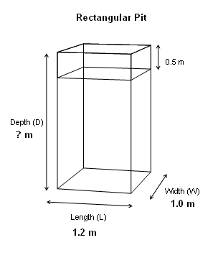
Step 2: Draw and Label Your Diagram – Draw a diagram of the pit and label all dimensions.
We are trying to find the depth (D) of the pit.

Step 3: Formulas - Write down the formula for the variable you are trying to solve
for. Check if you have the value for each variable in it. If values are not given, find an equation to give you the missing value of the variable you want. Be sure that you are using the formula for the right shape and latrine type.

The first equation gives the depth but we don’t know the value of A (area) or V (volume).

The second equation gives the value for V (volume), but we do not know the value for A (area).

The third equation gives the value of A(area) based on length and width, which we have values for.

$D=\frac{V}{A}$ $\begin{aligned}V=? \\ A=?\end{aligned}$

$V=\frac{N×R×Y}{\text{1000}}+0\text{.}5A$ $\begin{aligned}N=4\text{people} \\ R=\text{60}({L/{\text{person}}}/{\text{yr}}) \\ Y=6\text{yrs} \\ A=?\end{aligned}$

$A=L×W$ $\begin{aligned}L=1\text{.}2m \\ W=1\text{.}0m\end{aligned}$

Step 4: Fill in the formula that you know the value of all the variables for.
We are finding the value for A (area) first because we know the values for both L (length) and W (width).

$$\begin{aligned}A=L×W \\ A=1\text{.}2m×1m \\ A=1\text{.}2m^{2}\end{aligned}$$

Step 5: Fill in the formula that you know the value of all the variables for.

From the previous equation we now know the value of A. We can now solve for V.
$$\begin{aligned}V=\frac{N×R×Y}{\text{1000}}+0\text{.}5A \\ \\ V=\frac{4\text{people}×\text{60}({L/{\text{person}}}/{\text{yr}})×6\text{yr}}{\text{1000}(L/{m^{3}})}+0\text{.}5m×1\text{.}2m^{2} \\ \\ V=\frac{\text{1440}\text{ L}}{\text{1000}(L/{m^{3}})}+0\text{.}6m^{3} \\ \\ V=1\text{.}4m^{3}+0\text{.}6m^{3} \\ \\ V=2\text{.}0m^{3}\end{aligned}$$
Fill in all the values for the variables.

Do all the multiplication first.

Divide 1440 by 1000.

Add 1.4 and 0.6

Step 6: Fill in the formula that you know the value of all the variables for.

$$\begin{aligned}D=\frac{V}{A} \\ \\ D=\frac{2\text{.}0m^{3}}{1\text{.}2m^{2}} \\ \\ D=1\text{.}7m\end{aligned}$$
Solve for D (depth) using the values for A and V that were found in the two previous steps.

Step 7: Write out the answer.

The depth must be 1.7 metres for the pit to last six years.

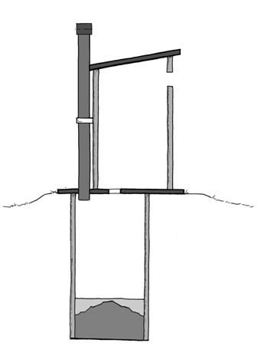
Long Term Latrine – Circular, Finding Depth
- A family of 4 wants to build a circular pit for their VIP latrine

- They want the pit to have a diameter of 1.2 metres

- They want to be able to use it for 6 years

- They use grass and leaves for anal cleaning

How deep should their latrine be?

Step 1: Known information - Write down the variables and their values. Identify the
variable that you need to solve for.
We are using a sludge accumulation rate of 60 (litres/person/year) because it is mostly dry inside the pit and degradable anal cleaning materials are being used (e.g. leaves and grass).

$\begin{aligned}\text{Shape }=\text{ Circular} \\ \text{Number of Users }N=\text{ 4 people} \\ \text{Diameter }d=\text{ 1}\text{.}\text{2 metres} \\ \text{Lifetime }Y=\text{ 6 years} \\ \text{Sludge Accumulation Rate }R=\text{ 60 }(\text{litres/person/year}) \\ \text{Depth }D=\text{ ?}\end{aligned}$

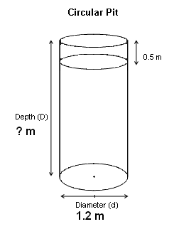
Step 2: Draw and Label Your Diagram - Draw a diagram of the pit and label all
dimensions.
We are trying to find the depth (D) of the pit.

Step 3: Formulas - Write down the formula for the variable you are trying to solve
for. Be sure that you are using the formula for the right shape and latrine type. Check if you have the value for each variable in it. If values are not given, find an equation to give you the missing value of the variable you want.

The first equation gives the depth but we don’t know the value of A (area) or V (volume).

The second equation gives the value for V (volume), but we do notknow the value for A (area).

The third equation gives the value of A (area) based d (diameter), which we know.

$D=\frac{V}{A}$ $\begin{aligned}V=? \\ A=?\end{aligned}$

$V=\frac{N×R×Y}{\text{1000}}+0\text{.}5A$ $\begin{aligned}N=4\text{people} \\ R=\text{60}({L/{\text{person}}}/{\text{yr}}) \\ Y=6\text{yrs} \\ A=?\end{aligned}$

$A=d^{2}×\frac{3\text{.}\text{14}}{4}$ $d=1\text{.}2m$

Step 4: Fill in the formula that you know the value of all the variables for.
We are finding the value for A (area) first because we know the value for d (diameter).

$$\begin{aligned}A=d^{2}×\frac{3\text{.}\text{14}}{4} \\ \\ A=1\text{.}2^{2}×\frac{3\text{.}\text{14}}{4} \\ \\ A=1\text{.}4×0\text{.}8 \\ \\ A=1\text{.}1m^{2}\end{aligned}$$

Step 5: Fill in the formula that you know the value of all the variables for.

From the previous equation we now know the value of A. We can now solve for V.

Fill in all the values for the variables.

Do all the multiplication first.

Divide 1440 by 1000.

Add 1.4 and 0.6
$$\begin{aligned}V=\frac{N×R×Y}{\text{1000}}+0\text{.}5A \\ \\ V=\frac{4\text{people}×\text{60}({L/{\text{person}}}/{\text{yr}})×6\text{yr}}{\text{1000}(L/{m^{3}})}+0\text{.}5m×1\text{.}1m^{2} \\ \\ V=\frac{\text{1440}L}{\text{1000}(L/{m^{3}})}+0\text{.}6m^{3} \\ \\ V=1\text{.}4m^{3}+0\text{.}6m^{3} \\ \\ V=2\text{.}0m^{3}\end{aligned}$$

Step 6: Fill in the formula that you know the value of all the variables for.

$$\begin{aligned}D=\frac{V}{A} \\ \\ D=\frac{2\text{.}0m^{3}}{1\text{.}1m^{2}} \\ \\ D=1\text{.}8m\end{aligned}$$
Solve for D (depth) using the values for A and V that were found in the two previous steps.

Step 7: Write out the answer:

The depth must be 1.8 metres for the pit to last six years.

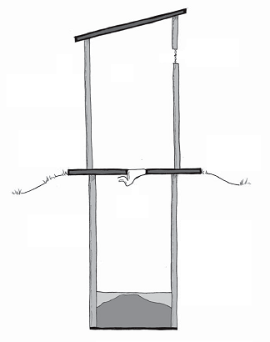
Long Term Latrine – Finding Lifetime

- A family of 8 wants to build a pour flush latrine

- They want to build a circular pit with a diameter of 1.3 metres

- The water table is 3.1 metres under the ground surface

- The groundwater is used for drinking

- They use paper for anal cleaning

What is the deepest they can dig their pit? How long will their pit last?

Step 1: Known information - Write down the variables and their values. Identify the
variable that you need to solve for.
We need to find the values for lifetime and depth!

$$\begin{aligned}\text{Shape }=\text{ Rectangular} \\ \text{Number of Users }N=\text{ 8 people} \\ \text{Diameter }d=\text{ 1}\text{.}\text{3 metres} \\ \text{Lifetime }Y=\text{ ?} \\ \text{Sludge Accumulation Rate }R=\text{ 40 }(\text{litres/person/year}) \\ \text{Depth }D=\text{ ?}\end{aligned}$$
We are using a sludge accumulation rate of 40 (litres/person/year) because it is wet inside the pit and a degradable material is used for anal cleaning (paper).

Step 2: Draw and Label Your Diagram – draw and label a diagram of the latrine
with respect to the groundwater table. 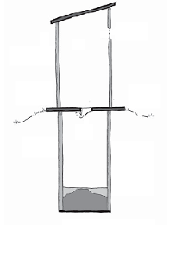
We need to find out how far down we can dig the pit.

We know the bottom of the pit has to be a minimum of 1.5 metres above the water table.
Ground water
3.1m
1.5 m
? m

Step 3: Formulas – Write down the formula for the variable you are trying to solve
for.
The full distance to the water table (3.1m) minus the 1.5m distance needed between the pit and water table gives the depth that the pit can be dug, which is 1.6m.

$$\text{Depth of Pit }=\text{ Depth of Water Table - 1}\text{.}\text{5 m}$$
$$\begin{aligned}D=3\text{.}1m−1\text{.}5m \\ D=1\text{.}6m\end{aligned}$$

The pit can be 1.6 metres deep.

Step 4: Draw and Label your Diagram – Draw a diagram of the pit and label all the
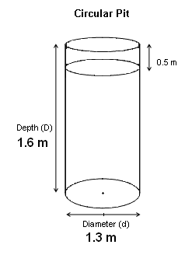
dimensions.

We know all of the dimensions of the pit.

Step 4: Formulas – Write down the formula for the variable you are trying to solve
For. Be sure that you are using the formula for the right shape and latrine type. Check if you have the value for each variable in it. If values are not given, find an equation to give you the missing value of the variable you want.

$Y=\frac{(V−0\text{.}5×A)×\text{1000}}{N×R}$ $\begin{aligned}V=? \\ A=? \\ N=8\text{people} \\ R=\text{40}({L/{\text{person}}}/{\text{yr}})\end{aligned}$
The first equation calculates the lifetime of the pit (Y) but we don’t know V (volume) or A (area).

The second equation gives the value for V (volume), but we do notknow the value for A (area).

The third equation gives the value of A (area) based on d (diameter) of the pit, which we know.

Note: This is the same equation as
$V=\frac{N×R×Y}{\text{1000}}+0\text{.}5$ but has been rearranged
to solve for Y.

$V=D×A$ $\begin{aligned}D=1\text{.}6m \\ A=?\end{aligned}$

$A=d^{2}×\frac{3\text{.}\text{14}}{4}$ $d=1\text{.}3m$

Step 5: Fill in the formula that you know the value of all the variables for.
We are finding the value for A (area) first because we know the value of d (diameter).

$$\begin{aligned}A=d^{2}×\frac{3\text{.}\text{14}}{4} \\ \\ A=1\text{.}3^{2}×\frac{3\text{.}\text{14}}{4} \\ \\ A=1\text{.}7×0\text{.}8 \\ \\ A=1\text{.}4m^{2}\end{aligned}$$

Step 6: Fill in the formula that you know the value of all the variables for.

From the previous equation we now know the value of A. We also know the value of D from step 3.

Multiply the area by the depth to find the volume of the pit.
$$\begin{aligned}V=D×A \\ \\ V=1\text{.}6m×1\text{.}3m^{2} \\ \\ V=2\text{.}1m^{3} \\ \end{aligned}$$

Step 7: Fill in the formula that you know the value of all the variables for.

$$\begin{aligned}V=\frac{N×R×Y}{\text{1000}}+0\text{.}5A \\ \\ Y=\frac{(V−0\text{.}5×A)×\text{1000}}{N×R} \\ \\ Y=\frac{(2\text{.}1m^{3}−0\text{.}5m×1\text{.}3m^{2})×\text{1000}(L/{m^{3}})}{8\text{people}×\text{40}({L/{\text{person}}}/{\text{yr}})} \\ \\ Y=\frac{(2\text{.}1m^{3}−0\text{.}7m^{3})×\text{1000}(L/{m^{3}})}{8\text{people}×\text{40}({L/{\text{person}}}/{\text{yr}})} \\ \\ Y=\frac{1\text{.}4m^{3}×\text{1000}(L/{m^{3}})}{8\text{people}×\text{40}({L/{\text{person}}}/{\text{yr}})} \\ \\ Y=\frac{\text{1400}L}{\text{320}(L/{\text{yr}})} \\ \\ Y=4\text{.}4\text{yr}\end{aligned}$$
This equation has been rearranged to isolate Y.

Fill in the values for all the variables.

Do multiplication inside the brackets first.

Subtract the values in the brackets ie.2.1 minus 0.7.

Multiply the values on top and multiply the values on the bottom.

Divide the top value by the bottom value.

Step 8: Write out the answer.

The deepest the pit can be is 1.6m below the ground. The pit will last 4.6 years at this depth.

Short Term Latrine – Circular
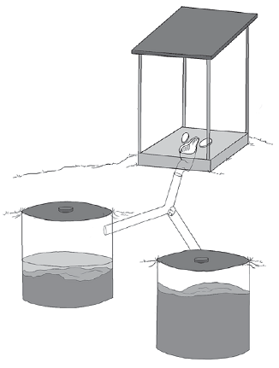

- A family of six wants to build two circular pits for their twin pour flush offset latrine

- They want each pit to have a diameter of 1 metre

- They use paper for anal cleaning

- They will empty each pit once the contents are safe to handle

How deep should each pit be?

Step 1: Known information - Write down the variables and their values. Identify the
variable that you need to solve for.
We know excreta will be safe after two years and can then be emptied.

$$\begin{aligned}\text{Shape }=\text{ Circular} \\ \text{Number of Users }N=\text{ 6 people} \\ \text{Diameter }d=\text{ 1 metre} \\ \text{Lifetime }Y=\text{ 2 years} \\ \text{Sludge Accumulation Rate }R=\text{ 40 }(\text{litres/person/year}) \\ \text{Depth }D=\text{ ?}\end{aligned}$$
We are using a sludge accumulation rate of 40 (litres/person/year) because it is wet inside the pit and a degradable anal cleaning material is being used (paper).

Step 2: Draw and Label Your Diagram - Draw a diagram of the pit and label all
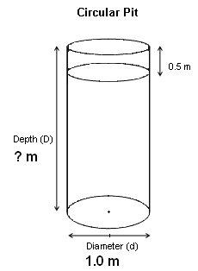
dimensions.
We are trying to find the depth (D) of the pit.

Step 3: Formulas - Write down the formula for the variable you are trying to solve
For. Be sure that you are using the formula for the right shape and latrine type. Check if you have the value for each variable in it. If values are not given, find an equation to give you the missing value of the variable you want.

$D=\frac{V}{A}$ $\begin{aligned}V=? \\ A=?\end{aligned}$
The first equation gives the depth but we don’t know the value of A (area) or V (volume).

The second equation gives the value for V (volume), but we do notknow the value for A (area).

The third equation gives the value of A (area) based d (diameter), which we know.

$V=\frac{N×1\text{.}5R×Y}{\text{1000}}+0\text{.}5A$ $\begin{aligned}N=6\text{people} \\ R=\text{60}({L/{\text{person}}}/{\text{yr}}) \\ Y=2\text{yrs} \\ A=?\end{aligned}$

Note: A factor of 1.5 is included to increase the sludge
accumulation rate due to the short lifetime
of the pit. There is not enough time for the
volume of sludge to decrease from biological
processes, which is taken into account in the
given sludge accumulation rate.

$A=d^{2}×\frac{3\text{.}\text{14}}{4}$ $d=1\text{.}0m$

Step 4: Fill in the formula that you know the value of all the variables for.
We are finding the value for A (area) first because we know the value for d (diameter).
$$\begin{aligned}A=d^{2}×\frac{3\text{.}\text{14}}{4} \\ \\ A=1\text{.}0^{2}×\frac{3\text{.}\text{14}}{4} \\ \\ A=1\text{.}0×0\text{.}\text{785} \\ \\ A=0\text{.}8m^{2}\end{aligned}$$

Step 5: Fill in the formula that you know the value of all the variables for.

From the previous equation we now know the value of A. We can now solve for V.

Fill in all the values for the variables.

Do all the multiplication first.

Divide 1080 by 1000.

Add 1.08 and 0.4
$$\begin{aligned}V=\frac{N×1\text{.}5R×Y}{\text{1000}}+0\text{.}5A \\ \\ V=\frac{6\text{people}×1\text{.}5×\text{60}({L/{\text{person}}}/{\text{yr}})×2\text{yrs}}{\text{1000}(L/{m^{3}})}+0\text{.}5m×0\text{.}8m^{2} \\ \\ V=\frac{\text{1080}L}{\text{1000}(L/{m^{3}})}+0\text{.}4m^{3} \\ \\ V=1\text{.}\text{08}m^{3}+0\text{.}4m^{3} \\ \\ V=1\text{.}5m^{3}\end{aligned}$$

Step 6: Fill in the formula that you know the value of all the variables for.

$$\begin{aligned}D=\frac{V}{A} \\ \\ D=\frac{1\text{.}5m^{3}}{0\text{.}8m^{2}} \\ \\ D=1\text{.}9m\end{aligned}$$
Solve for D (depth) using the values for A and V that were found in the two previous steps.

Step 7: Write out the answer:

For each pit to last two years the depth must be 1.9 metres.

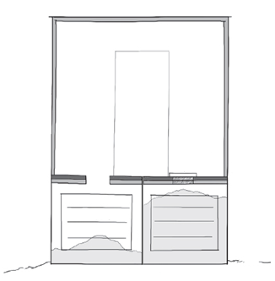
Short Term Latrine– Rectangular, Composting

- A family of five wants to build two rectangular pits for their composting latrine

- They want each pit to have a length of 1.2 metres and width of 1.0 metres

- They use leaves for anal cleaning

- They will empty each pit once the compost is safe to handle

How deep should each pit be?

Step 1: Known information - Write down the variables and their values. Identify the
variable that you need to solve for.
We know excreta will be safe after two years and can then be emptied.

$$\begin{aligned}\text{Shape }=\text{ Rectangular} \\ \text{Number of Users }N=\text{ 5 people} \\ \text{Length }=\text{ 1}\text{.}\text{2m} \\ \text{Width }=\text{ 1}\text{.}\text{0m} \\ \text{Lifetime }Y=\text{ 2 years} \\ \text{Sludge Accumulation Rate }R=\text{ 60 }(\text{litres/person/year}) \\ \text{Depth }D=\text{ ?}\end{aligned}$$
We are using a sludge accumulation rate of 60 (litres/person/year) because it is dry inside the pit and a degradable material is being used (leaves).

Step 2: Draw and Label Your Diagram - Draw a diagram of the pit and label all
dimensions.
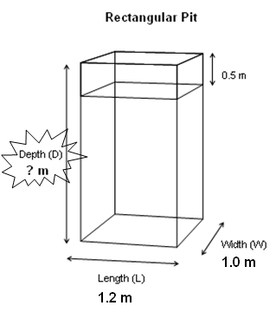

We are trying to find the depth (D) of the pit.

Step 3: Formulas - Write down the formula for the variable you are trying to solve
For. Be sure that you are using the formula for the right shape and latrine type. Check if you have the value for each variable in it. If values are not given, find an equation to give you the missing value of the variable you want.

$D=\frac{V}{A}$ $\begin{aligned}V=? \\ A=?\end{aligned}$
The first equation gives the depth but we don’t know the value of A (area) or V (volume).

The second equation gives the value for V (volume), but we do not know the value for A (area).

The third equation gives the value of A (area) based L (length) and W (width), which we know.

$V=\frac{N×1\text{.}5R×Y×3}{\text{1000}}+0\text{.}5A$ $\begin{aligned}N=5\text{people} \\ R=\text{60}({L/{\text{person}}}/{\text{yr}}) \\ Y=2\text{yrs} \\ A=?\end{aligned}$

Note: A factor of 1.5 is included to increase the sludge
accumulation rate due to the short lifetime
of the pit. There is not enough time for the
volume of sludge to decrease from biological
processes, which is taken into account in the
given sludge accumulation rate.

Note: A factor of 3 is used to account for the added volume
of ash and other organic material added to the pit to
help the composting process.

$A=L×W$ $\begin{aligned}L=1\text{.}2m \\ W=1\text{.}0m\end{aligned}$

Step 4: Fill in the formula that you know the value of all the variables for.
We are finding the value for A (area) first because we know the values for L and W.

$$\begin{aligned}A=L×W \\ \\ A=1\text{.}2m×1\text{.}0m \\ \\ A=1\text{.}2m^{2}\end{aligned}$$

Step 5: Fill in the formula that you know the value of all the variables for.

From the previous equation we now know the value of A. We can now solve for V.

Fill in all the values for the variables.

Do all the multiplication first.

Divide 2700 by 1000.

Add 1.08 and 0.4
$$\begin{aligned}V=\frac{N×1\text{.}5R×Y×3}{\text{1000}}+0\text{.}5A \\ \\ V=\frac{5\text{people}×1\text{.}5×\text{60}({L/{\text{person}}}/{\text{yr}})×2\text{yrs}×3}{\text{1000}(L/{m^{3}})}+0\text{.}5m×1\text{.}2m^{2} \\ \\ V=\frac{\text{2700}L}{\text{1000}(L/{m^{3}})}+0\text{.}6m^{3} \\ \\ V=2\text{.}7m^{3}+0\text{.}6m^{3} \\ \\ V=3\text{.}3m^{3}\end{aligned}$$

Step 6: Fill in the formula that you know the value of all the variables for.

$$\begin{aligned}D=\frac{V}{A} \\ \\ D=\frac{3\text{.}3m^{3}}{1\text{.}2m^{2}} \\ \\ D=2\text{.}8m\end{aligned}$$
Solve for D (depth) using the values for A and V that were found in the two previous steps.

Step 7: Write out the answer:

Each pit must be 2.8 metres deep.

Practice Questions

Long Term Latrine – Rectangular, Finding Depth
- A family of 6 wants to build a VIP latrine

- They use rocks for anal cleaning

- They want to build a rectangular pit with a width of 1.2 metres and a length of 1.5 metres

- The want to use the latrine for 5 years

How deep should their latrine be?

Calculations

Solution

Step 1: Known information - Write down the variables and their values. Identify the
variable that you need to solve for.

$$\begin{aligned}\text{Shape }=\text{ Rectangular} \\ \text{Number of Users }N=\text{ 6 people} \\ \text{Length }L=\text{ 1}\text{.}\text{5 metres} \\ \text{Width }W=\text{ 1}\text{.}\text{2 metre} \\ \text{Lifetime }Y=\text{ 5 years} \\ \text{Sludge Accumulation Rate }R=\text{ 90 }(\text{litres/person/year}) \\ \text{Depth }D=\text{ ?}\end{aligned}$$
We are using a sludge accumulation rate of 90 (litres/person/year) because it is mostly dry inside the pit and a non- degradable material is being used (plastic).

Step 2: Draw and Label Your Diagram - Draw a diagram of the pit and label all
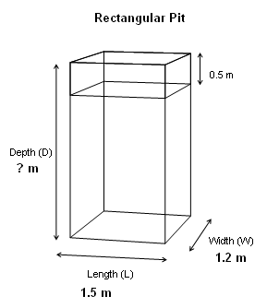
dimensions.

We are trying to find the depth (D) of the pit.

Step 3: Formulas - Write down the formula for the variable you are trying to solve
For. Be sure that you are using the formula for the right shape and latrine type. Check if you have the value for each variable in it. If values are not given, find an equation to give you the missing value of the variable you want.

The first equation calculates the depth but we don’t know the value of A (area) or V (volume).

The second equation gives the value for V (volume), but we do not know the value for A (area) in this equation.

The third equation gives the value of A (area) based on length and width, which we have values for.

$D=\frac{V}{A}$ $\begin{aligned}V=? \\ A=?\end{aligned}$

$V=\frac{N×R×Y}{\text{1000}}+0\text{.}5A$ $\begin{aligned}N=6\text{people} \\ R=\text{90}({L/{\text{person}}}/{\text{yr}}) \\ Y=5\text{yrs} \\ A=?\end{aligned}$

$A=L×W$ $\begin{aligned}L=1\text{.}5m \\ W=1\text{.}2m\end{aligned}$

Step 4: Fill in the formula that you know the value of all the variables for.
We are finding the value for A (area) first because we know the values for both L (length) and W (width).

$$\begin{aligned}A=L×W \\ A=1\text{.}5m×1\text{.}2m \\ A=1\text{.}8m^{2}\end{aligned}$$

Step 5: Fill in the formula that you know the value of all the variables for.
From the previous equation we now know the value of A. We can now solve for V.

Fill in all the values for the variables.

Do all the multiplication first.

Divide 2700 by 1000.

Add 2.7 and 0.9

$$\begin{aligned}V=\frac{N×R×Y}{\text{1000}}+0\text{.}5A \\ \\ V=\frac{6\text{people}×\text{90}({L/{\text{person}}}/{\text{yr}})×5\text{yr}}{\text{1000}(L/{m^{3}})}+0\text{.}5m×1\text{.}8m^{2} \\ \\ V=\frac{\text{2700}m^{3}}{\text{1000}(L/{{\text{ m}}^{3}})}+0\text{.}9m^{3} \\ \\ V=2\text{.}7m^{3}+0\text{.}9m^{3} \\ \\ V=3\text{.}6m^{3}\end{aligned}$$

Step 6: Fill in the formula that you know the value of all the variables for.

$$\begin{aligned}D=\frac{V}{A} \\ \\ D=\frac{3\text{.}6m^{3}}{1\text{.}8m^{2}} \\ \\ D=2m\end{aligned}$$
Solve for D (depth) using the values for A and V that were found in the two previous steps.

Step 7: Write out the answer:

The depth must be 2 metres for the pit to last six years

Long Term Latrine – Finding Lifetime
- A family of 5 wants to build a pour flush latrine

- They want to build a rectangular pit with a length of 1.1metres and width of 1.1 metres

- The water table is 4.2 metres under the ground surface

- The groundwater is used for drinking

- They use soft plastic for anal cleaning

How long will their pit last?

Calculations

Solution

Step 1: Known information - Write down the variables and their values. Identify the
variable that you need to solve for.
We need to find the values for lifetime and depth!!!

$$\begin{aligned}\text{Shape }=\text{ Rectangular} \\ \text{Number of Users }N=\text{ 5 people} \\ \text{Length }=\text{ 1}\text{.}\text{1 metres} \\ \text{Width }=\text{ 1}\text{.}\text{1 metres} \\ \text{Lifetime }Y=\text{ ?} \\ \text{Sludge Accumulation Rate }R=\text{ 60 }(\text{litres/person/year}) \\ \text{Depth }D=\text{ ?}\end{aligned}$$
We are using a sludge accumulation rate of 60 (litres/person/year) because it is wet inside the pit and a non-degradable material is used for wiping (soft plastic).

Step 2: Draw and Label Your Diagram – draw and label a diagram of the latrine
We need to find out how far down we can dig the pit.

We know the bottom of the pit has to be a minimum of 1.5 metres above the water table.
with respect to the groundwater table.
Ground water
4.2 m
1.5 m
? m
Step 3: Formulas – Write down the formula for the variable you are trying to solve
for.
The full distance to the water table (4.2 m) minus the 1.5 m distance needed between the pit and water table gives the depth that the pit can be dug, which is 2.7 m.

$$\text{Depth of Pit }=\text{ Depth of Water Table - 1}\text{.}\text{5 m}$$
$$\begin{aligned}D=4\text{.}2m−1\text{.}5m \\ D=2\text{.}7m\end{aligned}$$

The pit can be 2.7 metres deep.

Step 4: Draw and Label your Diagram – Draw a diagram of the pit and label all the
dimensions.
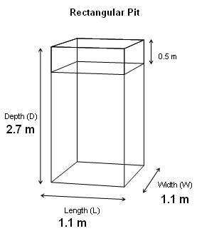

We know all of the dimensions of the pit.

Step 4: Formulas – Write down the formula for the variable you are trying to solve
For. Be sure that you are using the formula for the right shape and latrine type. Check if you have the value for each variable in it. If values are not given, find an equation to give you the missing value of the variable you want.

$Y=\frac{(V−0\text{.}5×A)×\text{1000}}{N×R}$ $\begin{aligned}V=? \\ A=? \\ N=5\text{people} \\ R=\text{60}({L/{\text{person}}}/{\text{yr}})\end{aligned}$
The first equation calculates the lifetime of the pit (Y) but we don’t know V (volume) or A (area).

The second equation gives the value for V (volume), but we do notknow the value for A (area).

The third equation gives the value of A (area) based on d (diameter) of the pit, which we know.

Note: This is the same equation as
$V=\frac{N×R×Y}{\text{1000}}+0\text{.}5$ but has been rearranged
to solve for Y.

$V=D×A$ $\begin{aligned}D=2\text{.}7m \\ A=?\end{aligned}$

$A=L×W$ $\begin{aligned}L=1\text{.}1m \\ W=1\text{.}1m\end{aligned}$

Step 4: Fill in the formula that you know the value of all the variables for.
We are finding the value for A (area) first because we know the values of L (length) and W (width).

$$\begin{aligned}A=L×W \\ \\ A=1\text{.}1m×1\text{.}1m \\ \\ A=1\text{.}2m^{2} \\ \end{aligned}$$

Step 5: Fill in the formula that you know the value of all the variables for.

From the previous equation we now know the value of A. We also know the value of D from step 3.

Multiply the area by the depth to find the volume of the pit.
$$\begin{aligned}V=D×A \\ \\ V=2\text{.}7m×1\text{.}2m^{2} \\ \\ V=3\text{.}2m^{3} \\ \end{aligned}$$

Step 6: Fill in the formula that you know the value of all the variables for.

$$\begin{aligned}V=\frac{N×R×Y}{\text{1000}}+0\text{.}5A \\ \\ Y=\frac{(V−0\text{.}5×A)×\text{1000}}{N×R} \\ \\ Y=\frac{(3\text{.}2m^{3}−0\text{.}5m×1\text{.}2m^{2})×\text{1000}(L/{m^{3}})}{5\text{people}×\text{60}({L/{\text{person}}}/{\text{yr}})} \\ \\ Y=\frac{(3\text{.}2m^{3}−0\text{.}6m^{3})×\text{1000}(L/{m^{3}})}{5\text{people}×\text{60}({L/{\text{person}}}/{\text{yr}})} \\ \\ Y=\frac{2\text{.}6m^{3}×\text{1000}(L/{m^{3}})}{5\text{people}×\text{60}({L/{\text{person}}}/{\text{yr}})} \\ \\ Y=\frac{\text{2600}L}{\text{300}(L/{\text{yr}})} \\ \\ Y=8\text{.}7\text{yr}\end{aligned}$$
This equation has been rearranged to isolate Y.

Fill in the values for all the variables.

Do multiplication inside the brackets first.

Subtract the values in the brackets ie. 3.2 minus 0.6.

Multiply the values on top and multiply the values on the bottom.

Divide the top value by the bottom value.

Step 7: Write out the answer.

The deepest the pit can go is 2.7m below the ground. The pit will last 8.7 years at a depth of 2.7 metres.

Short Term Latrine Question 1 – Finding Depth
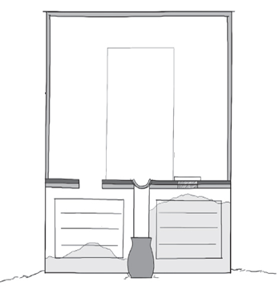
- A family of 4 wants to build a dehydrating latrine with two rectangular pits

- They want each pit to have a length of 1.2m and a width of 1.2 m

- They are very good at not putting any water, urine or wiping materials in the pit

- They will empty once the compost is safe to handle

How deep should each pit be?

Calculations

Solution

Step 1: Known information - Write down the variables and their values. Identify the
variable that you need to solve for.
We know excreta will be safe after two years and can then be emptied.

$$\begin{aligned}\text{Shape }=\text{ Rectangular} \\ \text{Number of Users }N=\text{ 4 people} \\ \text{Length }=\text{ 1}\text{.}\text{2m} \\ \text{Width }=\text{ 1}\text{.}\text{2m} \\ \text{Lifetime }Y=\text{ 2 years} \\ \text{Sludge Accumulation Rate }R=\text{ 60 }(\text{litres/person/year}) \\ \text{Depth }D=\text{ ?}\end{aligned}$$
We are using a sludge accumulation rate of 60 (litres/person/year) because it is dry inside the pit.

Step 2: Draw and Label Your Diagram - Draw a diagram of the pit and label all
dimensions.
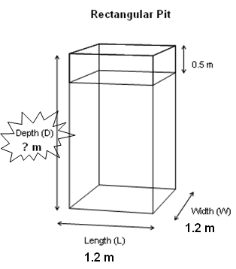
We are trying to find the depth (D) of the pit.

Step 3: Formulas - Write down the formula for the variable you are trying to solve
for. Be sure that you are using the formula for the right shape and latrine type. Check if you have the value for each variable in it. If values are not given, find an equation to give you the missing value of the variable you want.

$D=\frac{V}{A}$ $\begin{aligned}V=? \\ A=?\end{aligned}$
The first equation gives the depth but we don’t know the value of A (area) or V (volume).

The second equation gives the value for V (volume), but we do notknow the value for A (area).

The third equation gives the value of A (area) based on L (length) and W (width), which we know.

$V=\frac{N×1\text{.}5R×Y×3}{\text{1000}}+0\text{.}5A$ $\begin{aligned}N=4\text{people} \\ R=\text{60}({L/{\text{person}}}/{\text{yr}}) \\ Y=2\text{yrs} \\ A=?\end{aligned}$

Note: A factor of 1.5 is included to increase the sludge
accumulation rate due to the short lifetime
of the pit. There is not enough time for the
volume of sludge to decrease from biological
processes, which is taken into account in the
given sludge accumulation rate.

Note: A factor of 3 is used to account for the added volume
of ash and other organic material added to the pit to
help the composting process.

$A=L×W$ $\begin{aligned}L=1\text{.}2m \\ W=1\text{.}0m\end{aligned}$

Step 4: Fill in the formula that you know the value of all the variables for.

We are finding the value for A (area) first because we know the values for L and W.
$$\begin{aligned}A=L×W \\ \\ A=1\text{.}2m×1\text{.}2m \\ \\ A=1\text{.}4m^{2}\end{aligned}$$

Step 5: Fill in the formula that you know the value of all the variables for.

From the previous equation we now know the value of A. We can now solve for V.

Fill in all the values for the variables.

Do all the multiplication first.

Divide 2160 by 1000.

Add 1.08 and 0.4
$$\begin{aligned}V=\frac{N×1\text{.}5R×Y×3}{\text{1000}}+0\text{.}5A \\ \\ V=\frac{4\text{people}×1\text{.}5×\text{60}({L/{\text{person}}}/{\text{yr}})×2\text{yrs}×3}{\text{1000}(L/{m^{3}})}+0\text{.}5m×1\text{.}4m^{2} \\ \\ V=\frac{\text{2160}L}{\text{1000}(L/{m^{3}})}+0\text{.}7m^{3} \\ \\ V=2\text{.}2m^{3}+0\text{.}7m^{3} \\ \\ V=2\text{.}9m^{3}\end{aligned}$$

Step 6: Fill in the formula that you know the value of all the variables for.

$$\begin{aligned}D=\frac{V}{A} \\ \\ D=\frac{2\text{.}9m^{3}}{1\text{.}4m^{2}} \\ \\ D=2\text{.}1m\end{aligned}$$
Solve for D (depth) using the values for A and V that were found in the two previous steps.

Step 7: Write out the answer:

Each pit must be 2.1 metres deep.

Short Term Latrine Question 2 – Finding Depth
- A family of 8 wants to build a twin simple pit latrine

- They want each circular pit to have a diameter of 1.4 metres

- They use water for anal cleaning

- They want the contents to be safe during removal

- They do not plan on using the pit contents as fertilizer

How deep should each pit be?

Calculations

Short Term Latrine Solution 2

Step 1: Known information - Write down the variables and their values. Identify the
variable that you need to solve for.
We know excreta will be safe after two years and can then be emptied.

$$\begin{aligned}\text{Shape }=\text{ Circular} \\ \text{Number of Users }N=\text{ 8 people} \\ \text{Diameter }d=\text{ 1}\text{.}\text{4 metres} \\ \text{Lifetime }Y=\text{ 2 years} \\ \text{Sludge Accumulation Rate }R=\text{ 40 }(\text{litres/person/year}) \\ \text{Depth }D=\text{ ?}\end{aligned}$$
We are using a sludge accumulation rate of 40 (litres/person/year) because it is wet inside due to anal cleaning with water and the rest of the pit contents are degradable.

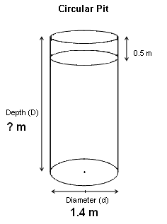
Step 2: Draw and Label Your Diagram - Draw a diagram of the pit and label all
dimensions.
We are trying to find the depth (D) of the pit.

Step 3: Formulas - Write down the formula for the variable you are trying to solve
for. Be sure that you are using the formula for the right shape and latrine type. Check if you have the value for each variable in it. If values are not given, find an equation to give you the missing value of the variable you want.

$D=\frac{V}{A}$
The first equation gives the depth but we don’t know the value of A (area) or V (volume).

The second equation gives the value for V (volume), but we do notknow the value for A (area).

The third equation gives the value of A (area) based d (diameter), which we know.

$V=\frac{N×1\text{.}5R×Y}{\text{1000}}+0\text{.}5A$ $\begin{aligned}N=8\text{people} \\ R=\text{40}({L/{\text{person}}}/{\text{yr}}) \\ Y=2\text{yrs} \\ A=?\end{aligned}$

Note: A factor of 1.5 is included to increase the sludge
accumulation rate due to the short lifetime
of the pit. There is not enough time for the
volume of sludge to decrease from biological
processes, which is taken into account in the
given sludge accumulation rate.

$A=d^{2}×\frac{3\text{.}\text{14}}{4}$ $d=1\text{.}4m$

Step 4: Fill in the formula that you know the value of all the variables for.

We are finding the value for A (area) first because we know the value for d (diameter).
$$\begin{aligned}A=d^{2}×\frac{3\text{.}\text{14}}{4} \\ \\ A=1\text{.}4^{2}×\frac{3\text{.}\text{14}}{4} \\ \\ A=1\text{.}\text{96}×0\text{.}\text{785} \\ \\ A=1\text{.}5m^{2}\end{aligned}$$

Step 5: Fill in the formula that you know the value of all the variables for.

From the previous equation we now know the value of A. We can now solve for V.

Fill in all the values for the variables.

Do all the multiplication first.

Divide 1440 by 1000.

Add 1.44 and 0.75
$$\begin{aligned}V=\frac{N×1\text{.}5R×Y}{\text{1000}}+0\text{.}5A \\ \\ V=\frac{8\text{people}×1\text{.}5×\text{40}({L/{\text{person}}}/{\text{yr}})×2\text{yrs}}{\text{1000}(L/{m^{3}})}+0\text{.}5m×1\text{.}5m^{2} \\ \\ V=\frac{\text{960}L}{\text{1000}(L/{m^{3}})}+0\text{.}8m^{3} \\ \\ V=1\text{.}0m^{3}+0\text{.}8m^{3} \\ \\ V=1\text{.}8m^{3}\end{aligned}$$

Step 6: Fill in the formula that you know the value of all the variables for.

$$\begin{aligned}D=\frac{V}{A} \\ \\ D=\frac{1\text{.}8m^{3}}{1\text{.}5m^{2}} \\ \\ D=1\text{.}2m\end{aligned}$$
Solve for D (depth) using the values for A and V that were found in the two previous steps.

Step 7: Write out the answer:

Each pit must be 1.2 metres deep.

References
Harvey, P., Baghri, S., & Reed, B. (2002). Emergency Sanitation: Assessment and Programme Design. Loughborough, UK: WEDC.

Lifewater International. (2009). Sanitation Latrine Design and Construction. California, USA: Lifewater International.

