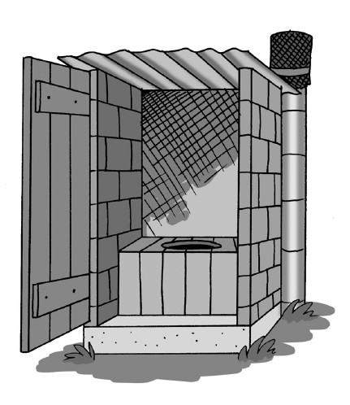
Appendix 1 – Latrine Fact Sheets

