General Information
A composting latrine is an ecosanitation option. It is a twin pit system where the urine and feces go into the same pit. After each use, the excreta is covered with carbon rich materials such as ash, sawdust, earth or vegetable matter to help decomposition (Esray et al.,2001). One pit is used for two years and then covered and left while the other pit is used. This latrine relies on a warm temperature (over 25-30°C), damp conditions, oxygen, and time for pathogen reduction and fertilizer production. It produces fertilizer in batches every two years.

Recommended Areas
- Where use of human excreta as fertilizer/soil conditioner is accepted
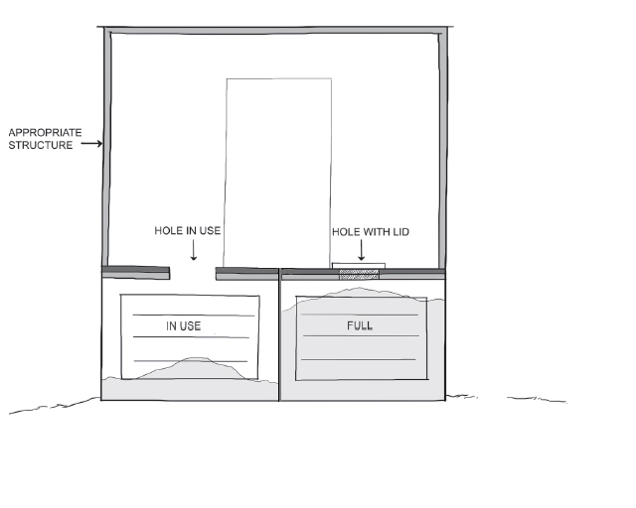
- Where low cost organic fertilizers are desirable
Composting Latrine (Lifewater International, 2009)
- Limited water supply
- Areas with high ground water tables

Materials
- Lining: brick, concrete block, stone, pole, bamboo
- Latrine Slab: wood and mortar/earth, concrete (reinforced)

Design Components
- Two vaults constructed above ground with permeable bottom or fully lined (permeable) pits below ground
- Sealable drop holes
- Ventilation into pit
- Access doors to allow removal of composted excreta
- Drainage layer at the bottom of the pit to absorb moisture (e.g. 5 cm of fine soil or compost)

Design Options
- Can be built as a vault design (above ground) instead of a pit design (below ground) for easier access and to allow better pit ventilation for composting
- Vault design good for areas with high ground water table
- If designed as an above ground vault, a ramp can be used instead of stairs to make it more accessible for elderly and disabled users
- A ventilation pipe in the pit will help reduce odours and gases
- Collecting urine separately from feces will help reduce odours and produce immediately usable fertilizer – see Fact Sheet on Dehydrating Latrines

Operation and Maintenance
- One pit is used for two years and then covered and left while the other pit is used. After two years, the contents of the first pit are safe to handle (WHO, 2006).
- Floor and slab should be kept clean. Wash water and chemicals should not be allowed to enter the pit.
- Anal cleansing water should not be disposed of in the pit. Water should be diverted to a soak pit.
- Soft degradable wiping materials can be added to the latrine. All other wiping materials should be safely disposed (e.g. buried)
- Ash and/or soil must be regularly added to the pit to control flies
- Carbon materials (grass, straw, raw kitchen waste/food scraps, wood chips) should be added regularly.
- Use contents as fertilizer after two years

Advantages | Limitations
- Compost can be used as fertilizer after two years  - No water needed except for cleaning  - Permanent - no need to dig a new pit  - Pit less likely to collapse due to low moisture  - Less possibility of groundwater contamination | - A carbon source and ash/soil must be added regularly  - Expensive construction  - More complex to build  - More maintenance required  - Misunderstanding of the process can lead to incomplete composting, handling of unsafe excreta, and application of unsafe excreta to crops

References
Esray, S, Ingvar Andersson, Astrid Hillers, Ron Sawyer. (2001). Closing the Loop Ecological Sanitation for Food Security. United Nations Development Program, SIDA, Mexico.
Lifewater International (2009). Sanitation Latrine Design and Construction. California, USA.
WHO (2006). WHO Guidelines for the Safe Use of Wastewater, Excreta and Greywater. Geneva, Switzerland.

