General Information
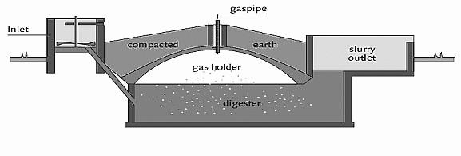
A biogas digester is an ecosanitation option. It uses human and animal feces and organic waste to produce gas that can be used in the home for cooking and lighting. A pour flush latrine can be connected to the biogas digester. The digester uses natural decomposition processes to create methane and carbon dioxide gas. The slurry produced has a high level of pathogens and should be composted and used as fertilizer or safely disposed (e.g. buried). An average family cannot normally produce enough excreta to fuel a biogas digester on their own, and must add the feces of two cattle (or similar quantity livestock manure), or combine with other families.
Source: Unknown

Recommended Areas
- Rural areas for households with livestock
- Compounds/communities with more than one family or household who own at least two cattle who could share a digester
- Areas where fuel for cooking/lighting is expensive or in short supply

Materials
- Requires skilled labour and advice
- Appliances that can be run off biogas: cooking stove, heating, lighting, refrigeration

Design Components
- Masonry or steel digestion chamber
- Inlet port for loading animal excreta
- Connection to water seal / pour flush latrine with inlet port for human excreta (optional)
- Outlet for digested slurry
- Outlet port for generated gas

Design Options
- A single biogas digester can be shared by a group of families to reduce capital costs. The arrangements for the operation and management of the digester and the sharing of the gas produced must be agreed.
- Biogas digesters can be connected to communal latrines where sufficient human excreta can be collected.

Operation and Maintenance
- Operation and maintenance of latrine according to type connected
- The digester should be loaded on a daily basis to operate effectively
- Kitchen and garden waste (organic matter) can be added to the digester
- Non-organic and solid materials should not be put into the digester The slurry produced should be composted to reduce pathogens or safely disposed (e.g. buried)

Advantages | Limitations
- Excreta is used as a resource to produce fuel  - Permanent system  - The slurry can be composted for use on crops  - Can be used by washers and wipers who use soft materials for anal cleansing  - Can be connected to a pour flush latrine  - Reduces potential for groundwater contamination if slurry is properly disposed | - Expensive to build  - Required skilled design and construction labour  - Requires regular maintenance and feeding of the system  - Must have enough excreta for the system to function  - Slurry must be handled carefully and composted as it is not sanitary  - Requires water for flushing  - May be unacceptable to use excreta for this purpose – especially human excreta

