General Information
An arborloo latrine is an ecosanitation option. It uses one shallow pit (1 metre deep) for composting excreta, which is then used to grow a tree when the pit is full. The superstructure, slab and footing are portable, so that when the pit is full (i.e. within 0.5 metres from the top), the structure can be moved to a new pit. The pit typically fills in about six to nine months. The full pit is topped with soil and a fruit bearing or fuel wood tree is planted in the nutrient rich soil.

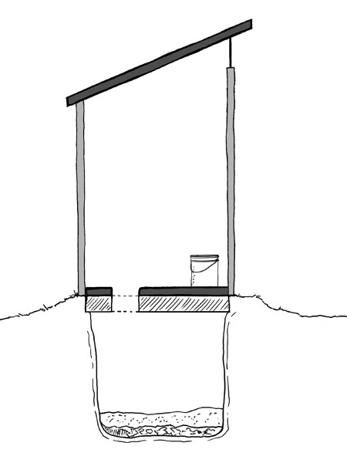
Arborloo (Lifewater International, 2009)

Recommended Areas
- Limited water supply
- Space for an orchard and multiple pits
- Human excreta accepted as fertilizer for fruit or fuel wood trees

Materials
- Footing: cement ring, brick ring
- Latrine Slab: wood and mortar/earth, concrete (reinforced)
- Drop Hole Cover: wood, plastic, concrete

Design Components
- Small excavated pit (approximately 1 metre by 1 metre by 1 metre)
- Footing to support the slab
- Slab or platform spanning the pit
- Drop hole over the pit with tight fitting cover
- Superstructure (preferably light and moveable)

Design Options
- The slab can be a reused concrete slab or a more traditional pole and earth platform
- The arborloo system can also produce compost for use on crops. Three pits can be dug and lined. One pit is used at a time and by the time the third pit is full the contents of the first should be safe to handle and apply to crops.

Operation and Maintenance
- Ash, soil, sawdust or lime should be added to the pit after each use.
- The arborloo is used like a normal latrine, but kitchen and food waste can be added into the pit to provide additional organic matter and nutrients for composting in the pit.
- When the pit contents are within 50 cm of the top, a new pit is excavated and the slab and superstructure are transferred to the new pit. The pit is backfilled with soil, and a tree or shrub (preferably fruiting) is then planted in the full, nutrient rich arborloo pit

Advantages | Limitations
- Inexpensive to construct and most parts are re-usable  - No direct contact with excreta  - No water needed (except for cleaning)  - Can be used by washers and wipers for anal cleansing Pit excavation is small and shallow  - Orchard or fuel wood grove is developed over time | - Ash, lime, sawdust, earth, or vegetable matter must be added regularly  - Space is required for planting trees after pit is full  - Space is required to relocate the latrine on a regular basis  - Frequently need to dig a new pit and reinstall superstructure  - May be culturally unacceptable to use human excreta for this purpose

References
Lifewater International (2009). Sanitation Latrine Design and Construction. California, USA.

