Pit Toilets
These improved facilities include connection to a public sewer, a septic system pour flush latrine, simple pit latrine and ventilated improved pit latrine. Therefore disposal of human excreta in a safe, hygienic and scientific manner is integral part of rural sanitation.
The programme of construction of toilets in this project is linked to making people aware of, sanitation standards and the adverse health impacts of unsanitary conditions. The idea is develop the habit of using toilets.
Scarcity of water has been identified as one of the major factor that has impeded the growth of effective implementation of a rural sanitation programme.
In light of this fact construction of twin pit compost toilet has been planned which would be eco friendly, technically appropriate, socio-culturally acceptable and economically affordable.
These toilets consists of a pan with a steep slope of 250-280 and especially designed trap with 20mm water seal requiring only 1.5-2 litres of water for flushing thus helping conserve water. It is connected to two pits of varying size and capacity depending on the number of users. The capacity of each pit is normally designed for 3 years’ usage. Both pits are used alternately. When one pit is full, the incoming excreta is diverted into the second pit. In about two years, the sludge gets digested and is almost dry and pathogens free thus safe for handling as manure. Digested sludge is odourless, a good manure and soil conditioner
2 pit toilets would be constructed in both, in schools and in each household with community’s contribution
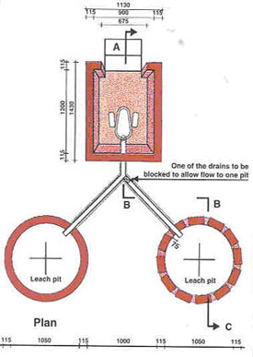
Twin Pit water seal toilets
Source: Sulabh International
Advantages of twin pit compost toilets:
Free from health hazards and does not pollute surface or groundwater
Needs only 1.5-2 litres of water
Design and specifications can be specified
Pit where filled up, gets converted to manure after 1-11/2 Yrs
Can be connected to sewer where available
Different models of compost toilet are available which can be chosen by the community depending upon its affordability and their need. Some of them are:
Model 1: Mud plastered toilet
Substructure: Mud platform plastered in cement mortar1: 4 cement plastered pan, cement trap and brick plastered foot rests, Pit lining: Tar drum, Pit cover-compacted soil over thatch and logs.
Superstructure: Jute all round the toilet on bamboo frame1800mm high and jute purdah on door opening.
Users: 5
Capacity of each pit: 2 Yrs
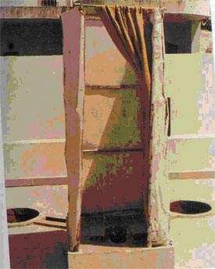
Source: Sulabh International
Bamboo framed toilet
Superstructure: Dry brick ballast in foundation, brick work in mud mortar, flooring of 12mm thick 1:4 cement plaster over 75mm dry brick ballsast, cement mosaic pan, cement trap and brick plastered foot rests.
Pit lining - Brick work 75mm in cement mortar1:6 , Pit cover-50mm thick
Substructure: Thatch wall with thatch roof on bamboo frame and jute purdah on door opening 1800mm high.
Users: 5
Capacity of each pit: 2 Yrs
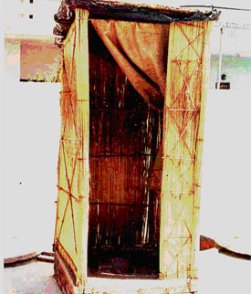
Source: Sulabh International
Open roof brick toilets
Substructure: Dry brick ballast in foundation , brick work in mud mortar, flooring of 12mm thick 1:4 cement plaster over 75mm dry brick ballast, cement mosaic pan, cement and brick plastered foot rests.
Pit lining-Brick work 115mm in cement mortar 1:6, Pit cover-50mm thick
Superstructure: 115mm thick brick work in 1:6 cement mortar 1500mm high and jute curtains on door opening 1800mm high.
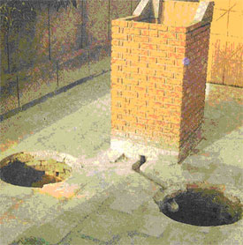
Corrugated roof top brick toilet
Sub structure: Cement concrete 1:6:12 in foundation, brick work in 1:6 cement mortar, flooring in 1:4 cement plaster over 75mm dry brick ballast, cement mosaic pan, cement trap and brick plastered foot rests.
Pit lining-Brick work 75mm in cement mortar 1:6 cement mortar
Superstructure: 115mm thick brick wall in 1:6 cement mortar, Corrugated sheet, holes in brick work for ventilation and jute purdah 1800mm high. Inside whitewash and outside colour wash.
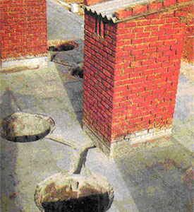

Source : http://www.k4rd.org/ruraltech_pit.htm

