Diversity and Distributions, (Diversity Distrib.) (2011) 17, 788–809
SPECIAL ISSUE: HUMAN-MEDIATED INTRODUCTIONS O F AUSTRALIAN A C A C I A S—A GLOBAL EXPERIMENT I N BIOGEOGRAPHY
DOI:10.1111/j.1472-4642.2011.00782.x
788 http://wileyonlinelibrary.com/journal/ddi ª 2011 Blackwell Publishing Ltd
BIODIVERSITY
REVIEW
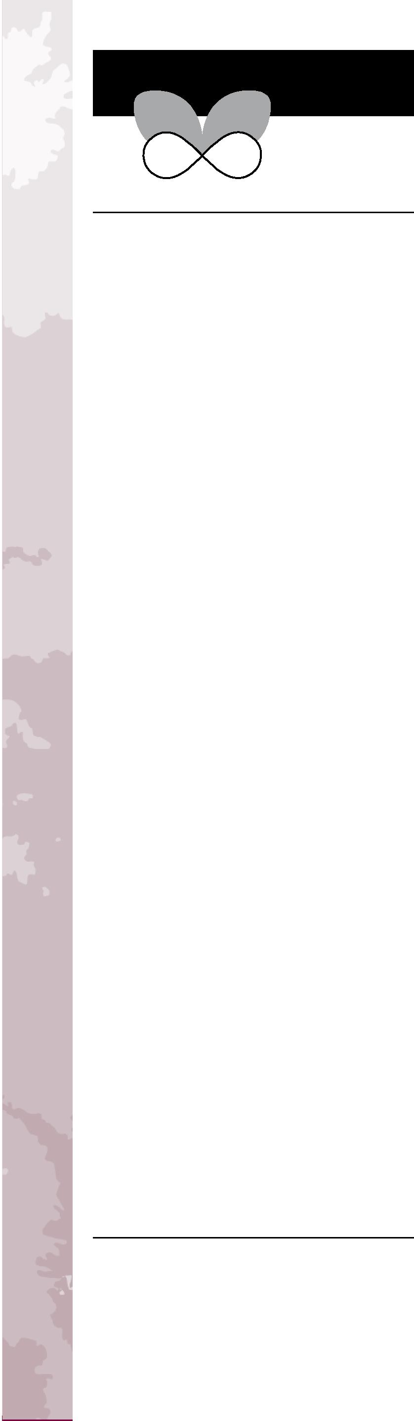
Trees and shrubs as invasive alien species – a global review
A Journal of Conservation Biogeography
David M. Richardson¹* and Marcel Rejmânek²
ABSTRACT
¹Centre for Invasion Biology, Department of Botany and Zoology, Stellenbosch University, Matieland 7602, South Africa, ²Department of Ecology and Evolution, University of California Davis, Davis, CA 95616, USA
*Correspondence: David M. Richardson, Centre for Invasion Biology, Department of Botany & Zoology, Stellenbosch University, Matieland 7602, South Africa.
E-mail: rich@sun.ac.za
Aim Woody plants were not widely considered to be important invasive alien species until fairly recently. Thousands of species of trees and shrubs have, however, been moved around the world. Many species have spread from planting sites, and some are now among the most widespread and damaging of invasive organisms. This article presents a global list of invasive alien trees and shrubs. It discusses taxonomic biases, geographical patterns, modes of dispersal, reasons for introductions and key issues regarding invasions of non-native woody plants around the world.
Location Global.
Methods An exhaustive survey was made of regional and national databases and the literature. Correspondence with botanists and ecologists and our own observations in many parts of the world expanded the list. Presence of invasive species was determined for each of 15 broad geographical regions. The main reasons for introduction and dissemination were determined for each species.
Results The list comprises 622 species (357 trees, 265 shrubs in 29 plant orders, 78 families, 286 genera). Regions with the largest number of woody invasive alien species are: Australia (183); southern Africa (170); North America (163); Pacific Islands (147); and New Zealand (107). Species introduced for horticulture dominated the list (62% of species: 196 trees and 187 shrubs). The next most important reasons for introduction and dissemination were forestry (13%), food (10%) and agroforestry (7%). Three hundred and twenty-three species (52%) are currently known to be invasive in only one region, and another 126 (20%) occur in only two regions. Only 38 species (6%) are very widespread (invasive in six or more regions). Over 40% of invasive tree species and over 60% of invasive shrub species are bird dispersed.
Diversity and Distributions
Main conclusions Only between 0.5% and 0.7% of the world’s tree and shrub species are currently invasive outside their natural range, but woody plant invasions are rapidly increasing in importance around the world. The objectively compiled list of invasive species presented here provides a snapshot of the current dimensions of the phenomenon and will be useful for screening new introductions for invasive potential.
Keywords
Biological invasions, dispersal modes, invasive species, management, natural experiment, reasons for introduction, shrub invasions, tree invasions.

INTRODUCTION
Woody plants were not widely recognized as invasive species of major importance until fairly recently (Holm et al., 1977;
Akobundu & Agyakwa, 1987; Holm et al., 1997; Osada, 1997; Raju, 1998; Everitt et al., 2007). In the past few centuries, humans have moved thousands of woody plant species out of their natural ranges for many purposes, and in recent decades,

Global review of invasive trees & shrubs

many species of trees and shrubs have become naturalized or invasive (Binggeli, 1996; Binggeli et al., 1998; Richardson, 1998; Richardson & Rejma´nek, 2004; Williams & Cameron, 2006; Richardson, 2011a,b). In many parts of the world, these life-forms now feature prominently on the lists of invasive alien plants, and in some areas, non-native woody species are now among the most conspicuous, damaging and, in some cases, best-studied invasive species. Twenty-one woody plant species feature on the widely cited list of ‘100 of the World’s Worst Invaders’ (Lowe et al., 2000), seven woody plants appear on a list of ‘100 of the worst’ invasive species in Europe (http:// www.europe-aliens.org/speciesTheWorst.do), and 20% of the most intensively studied invasive species are woody plants (Pysˇek et al., 2008). Studies of woody plant invasions have shed light on many crucial aspects of plant invasion ecology and invasion ecology in general. For example, the study of alien tree invasions, in particular by comparing their dynamics with those of natural migrations of trees following deglaciation, has elucidated many key aspects of biological invasions (Petit et al., 2004). Pinus, with many species that have been widely planted in many parts of the world, some of which have become invasive, has been suggested as a model group in plant invasion ecology (Richardson, 2006). However, many woody plant species have become naturalized or invasive only recently, and little is known about the invasion ecology of most species. Because many aspects of invasion ecology demand insights into global comparisons of the performance of species in different parts of the world and under a range of situations, an accurate assessment of which species are currently invasive around the world is an important requirement for advancement in the development of general models and for the formulation of sustainable management strategies. One of the best predictors of invasiveness of introduced species is whether they have invaded in other parts of the world, assuming they have been introduced and had time to invade elsewhere (Rejmânek et al., 2005; Gordon et al., 2010). The natural experiment of global introductions of woody plant species around the world thus has much potential for shedding light on many aspects of invasion ecology (Grotkopp et al., 2002, 2010; Richardson et al., 2004a,b, 2011a,b;). We believe that a thorough and objective assessment of woody plant species that have overcome various barriers to become invasive around the world is urgently needed.
This article presents an up-to-date snapshot of the global situation regarding non-native trees and shrubs as invasive species throughout the world. We use this as the basis for discussing a range of issues relating to the ecology and management of invasive woody plants.
METHODS
Defining trees and shrubs
When is a plant a ‘tree’ and when is it a ‘shrub’? We define trees as perennial woody plants with many secondary branches supported clear of the ground on a single main stem or trunk
with clear apical dominance (we added palms which are usually considered trees). Setting a minimum height specification at maturity proved difficult, but we considered species that met the aforementioned criteria and that regularly attain a height of at least 3 m to qualify as trees. Woody plants that do not meet these criteria by having multiple stems or small size were deemed to be shrubs. We included as ‘trees’ and ‘shrubs’ all woody plant species with the exception of woody climbers (lianas), woody grasses (Bambusoidae), woody parasitic plants (Loranthaceae, Santalaceae) and cacti (Cactaceae, although the shrub-like genus Pereskia is included). Several genera have both woody and non-woody members. A notable example is Solanum in which invasive species include tree (e.g. Solanum mauritianum) and shrub (e.g. Solanum torvum) forms, as well as many non-woody species (e.g. Solanum sisymbriifolium). The genus Lonicera includes several invasive species that are shrubs (Lonicera maackii, Lonicera morrowii, Lonicera standishii, Lonicera tatarica and Lonicera · bella) but others, including the widespread invasive Lonicera japonica and other species such as Lonicera confusa, are woody vines. We have excluded species that are sometimes called ‘herbaceous shrubs’ (Aeschynomene spp., Ageratina adenophora and Vinca spp. are good examples of widespread invasive species in this group).
Which species to include?
Diversity and Distributions, 17, 788–809, ª 2011 Blackwell Publishing Ltd 789
There are many sources of information on invasive trees and shrubs, including books and monographs, peer-reviewed articles, sundry reports and articles in the grey literature and countless contributions on the Internet (Appendix S1). Unfortunately, each database uses different criteria for categorizing alien species. Many databases are rather ‘inclusive’ (they include species for which evidence of invasion is tenuous or include ‘potential invaders’ or ‘alert weeds’, based solely on their invasiveness in other areas). These factors complicated the task of producing a single standardized list on which to base a global review. Consequently, a new list was compiled, drawing on all sources listed in Appendix S1 and many others. Our list includes only trees and shrubs that are clearly invasive (sensu Richardson et al., 2000b; Pysˇek et al., 2004), not those that are just naturalized or established only in highly disturbed areas such as roadsides or in heavily human-modified landscapes. This definition specifies that the alien species should (1) have sustained self-replacing populations for at least 10 years without direct intervention by people (or in spite of human intervention) by recruitment from seed or ramets capable of independent growth and (2) recruit reproductive offspring at considerable distances from the parent plants and thus have the potential to spread over a large area. The definition carries no connotation of impact (see Richardson et al., 2011b; p. 415 for discussion). All sources were scrutinized and verified before species were accepted for inclusion on the list. Taxa that form the foundation of our list feature on regional or national lists (including those in Appendix S1), for example as ‘major invaders’ (Nel et al., 2004), ‘transformers’ or ‘category 1b invasive species’ listed in the National Environmental

D. M. Richardson and M. Rejmânek

Management: Biodiversity Act (South Africa), ‘EPPC Category 1’ species (California), ‘FEPPC Category 1 and 2’ (Florida), Weeds of National Significance and species in category ‘5A’ in Randall (2007) [those ‘... recorded as an invasive species...the most serious criterion that can be applied to a plant... generally used for serious high impact environmental and/or agricultural weeds that spread rapidly and often create monocultures.’] (Australia), ‘widespread invaders’, ‘common weeds’ and species subject to Pest Plant Management Strategies or listed on the National Pest Plant Accord (New Zealand; see Roy et al., 2004), ‘noxious weeds’ (Australia); naturalized plants ‘with an invasive behaviour’ (Greece; Arianoutsou et al., 2010), ‘espèces particulièrement invasives’ (Madagascar; Tassin et al., 2009) and lists of ‘worst weeds’ from many other sources (always checked with local experts). Species native in part of a given region but introduced and invasive in other remote regions (outside the range of normal dispersal, i.e. excluding human-mediated movement) were included in our list (e.g. eastern Australian Acacia species that are invasive in Western Australia and vice versa). Species for which only range expansions adjacent to their natural range were evident were not included on the list (see Wilson et al., 2009a for discussion). Searches were also made of articles listed in the ISI Web of Knowledge and thousands of publications in our personal libraries. Species were added from our own experience in many parts of the world and following correspondence with many colleagues. Every effort was made to resolve taxonomic problems in collating a single list.
Despite our best efforts, we have almost certainly overlooked many species that merit inclusion on the list. Nonetheless, we are confident that the list presented here contains most notable invasive alien trees and shrubs and is adequate for describing the current dimensions of the phenomenon. We are satisfied that the geographical and taxonomic coverage of the list provides a sound basis for an overview of the global phenomenon of woody plant invasions. We plan to update the database as new information becomes available and would welcome correspondence on the list.
For each taxon, we noted the regions where it has been clearly recognized as invasive. We used 15 broad regions selected for practical rather than biogeographical reasons: Africa (southern; south of 20°S); Africa (rest; north of 20°S); Australia; New Zealand; Europe (including Russia west of the Ural Mountains); Middle East (south-western Asia); North America; Central America; South America; Asia (including China, India, SE Asia, Hong Kong and Singapore); Pacific Islands (including French Polynesia, Hawaii, Japan and the Bonin [Ogasawara] Islands; Kiribati and Micronesia); Indian Ocean Islands and Madagascar (including the Mascarene Islands and Sri Lanka); Caribbean Islands; Atlantic Islands (Azores, Bermuda, Canary Islands, Falkland Islands; Madeira, Outer Hebrides, St Helena and Tristan da Cunha); and Indonesia. We noted the main reason(s) for the introduction and dissemination of the taxa as aliens [where such information was available; for some species, the reason(s) for introduction could not be determined, and we refrained from
guessing]. Eight broad categories were used: (commercial) forestry; high-quality timber/furniture; horticulture (orna-mental, including hedging); agroforestry (including fodder), fuelwood and charcoal; food (including spice and medicine); stabilization, erosion control and fertility improvement; and ‘other’ (including shade, biofuel and rubber). We determined the principle mode of seed dispersal for each species in the following categories: bird, wind and ‘other’.
The 622 species x 15 areas presence/absence data matrix was subjected to the correspondence analysis (CA) option in the program package cANoco 4.5 (Lepsˇ & S^{ˇ}milauer, 2003; Ter Braak & S^{ˇ}milauer, 2002). Results are presented as ordination diagrams where either centroids (geometric centres) of areas or centroids of species are plotted in the plane of CA axes 1 and 2. Mean latitudes were fitted a posteriori into these diagrams using attribute contour plot procedure GAM in cANoco 4.5.
790 Diversity and Distributions, 17, 788–809, © 2011 Blackwell Publishing Ltd
Interspecific associations were analysed using the program Assoc 2.0 (Microsoft BASIC program written by M. Rejmânek). To eliminate questionable values of low frequencies, only species that occurred in at least six areas were considered. Association index V (Pielou, 1977) was used to quantify the strength of positive associations. Values of this index range from —1 (each of the areas contains only one of the two species) to +1 (two species always occur together). We used V >— 0.6 as a critical value for plotting positive interspecific associations in a constellation diagram (Kershaw & Looney, 1985). In this particular data set, V >— 0.6 corresponds to situations where two species co-occur in at least five areas.
RESULTS
A global list of invasive alien trees and shrubs
The list of invasive trees and shrubs assembled for this article comprises 622 species (357 tree species and 265 shrub species). The full list is provided in Appendix S2, a summary appears in Table Box 1, and examples are shown in Figs 1 and 2. The distribution of taxa in major clades, orders and families and their representation in different regions are summarized in Table 1.
Among the features of the list are the large number of taxa in the clade Pinophyta, order Pinales (4 families, 13 genera, 38 species), and in the angiosperm orders Fabales (2 families, 37 genera, 123 species), Rosales (8 families, 29 genera, 107 species), Myrtales (6 families, 30 genera, 56 species), Malpighiales (7 families, 22 genera, 42 species), Sapindales (5 families, 24 genera, 37 species) and Lamiales (7 families, 23 genera, 47 species). These seven orders make up 73% of the list. Several families and genera stand out as particularly important. For trees, the Fabaceae and in particular the genus Acacia (sensu lato; 32 species), and especially taxa in subgenus Phyllodineae native to Australia (23 species; most widespread is Acacia mearnsii, invasive in at least 12 regions), and Pinaceae, particularly the genus Pinus (22 species; most widespread are Pinus pinaster, Pinus radiata and Pinus elliottii – all invasive in five or more regions), are exceptional. For shrubs, the family Rosaceae contributes 82 taxa

Global review of invasive trees & shrubs
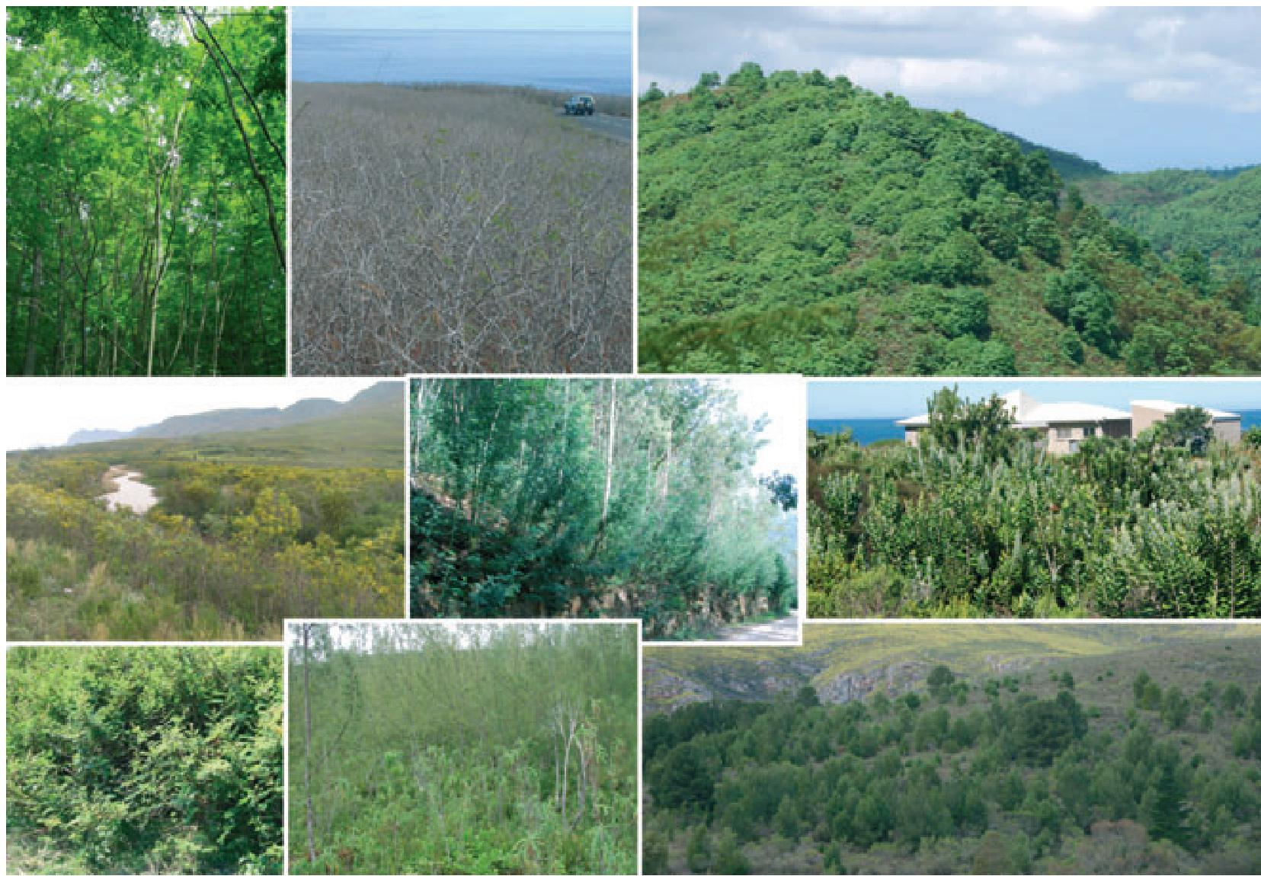
Figure 1 Examples of invasive trees. Clockwise from top left: Ailanthus altissima (Simaroubaceae), USA (Photo: P. Martin); Dichrostachys cinerea (Fabaceae), La Réunion (Photo: D.M. Richardson); Cinchona pubescens (Rubiaceae), Santa Cruz, Galapagos (Photo: R. Atkinson); Metrosideros excelsa (Myrtaceae), Western Cape, South Africa (Photo: D.M. Richardson); Pinus radiata (Pinaceae), Western Cape, South Africa (Photo: D.M. Richardson); Casuarina equisetifolia (Casuarinaceae), La Réunion (Photo: D.M. Richardson); Mimosa pigra (Fabaceae), Lochinvar National Park, Zambia (Photo: G. Shanungu); Acacia saligna (Fabaceae), Western Cape, South Africa (Photo: D.M. Richardson); Acacia dealbata (Fabaceae), Portugal (Photo: D.M. Richardson) [centre image].

to the list (90% of them are shrubs); Rubus (36 species; many more species in this genus are potentially invasive, e.g. Rubus simplex and Rubus xanthocarpus Wharton et al. (2005)), Cotoneaster (10 species), Rosa (8 species) and Pyracantha (6 species) are dominant genera in this group. Other genera with five or more species on the list are Senna (Fabaceae; 15), Salix (Salicaceae;13), Ligustrum (Oleaceae; 7); Eucalyptus (Myrtaceae; 5); and Populus (Salicaceae; 5) (Appendix).
Invasive trees and shrubs in different regions
A striking feature of the list of invasive trees and shrubs of the world is that 325 species (52%) are currently known to us as invasive in only one region and another 128 (20%) occur in only two regions. Only 38 species (6%) are very widespread (known to be invasive in six or more regions) (Table 2). Six species (1%) occur in 10 regions or more: Acacia farnesiana (11), A. mearnsii (12), Ailanthus altissima (11), Lantana camara (12), Leucaena leucocephala (12) and Ricinus communis (14). Regions differ considerably in the number of invasive species listed. Six regions have over 100 species of invasive alien woody plants: Australia (183); southern Africa (170); North America (163); Pacific Islands (147); Europe (107); and New Zealand (107) (Table 1). Regions also differ considerably in terms of the uniqueness of their invasive woody floras. In four regions, over 25% of their invasive woody species are known to
be invasive only in that region: North America (34%), Europe (33%), Asia and the Pacific Islands (both 26%). At the other end of the spectrum, in six regions, < 10% of species in their woody invasive floras are only known to be invasive in that region: New Zealand (2%), southern Africa & Africa (rest) (both 4%), Indian Ocean Islands (5%), Atlantic Ocean Islands (8%) and Central America (9%) (Fig. 3).
Positions of geographical areas in the CA diagram (Fig. 4) reveal several patterns. Ordination scores of areas on the first axis are strongly correlated with latitude. Consequently, positions of areas form a continuum from the tropical to temperate climates. While temperate areas are relatively dissimilar in terms of their invasive woody species composition, there seems to be a compositional convergence of tropical areas. South America, the continent with both temperate and tropical climates, is positioned in the centre, reflecting the fact that alien flora of this continent shares invasive species with many other areas (Europe, North America, Australia, and the Palaeotropics). Somewhat surprisingly, Atlantic Islands and the Middle East are positioned close to southern Africa. This is because invasive woody floras of these areas are, to a large extent, subsets of the exotic woody flora of southern Africa (30 of 57 Atlantic Islands species and 12 of 22 Middle East species are shared with southern Africa).
Diversity and Distributions, 17, 788–809, ª 2011 Blackwell Publishing Ltd 791
Figure 5 presents positions of selected species in the same two-dimensional CA ordination space. Species from eight large

D. M. Richardson and M. Rejmânek
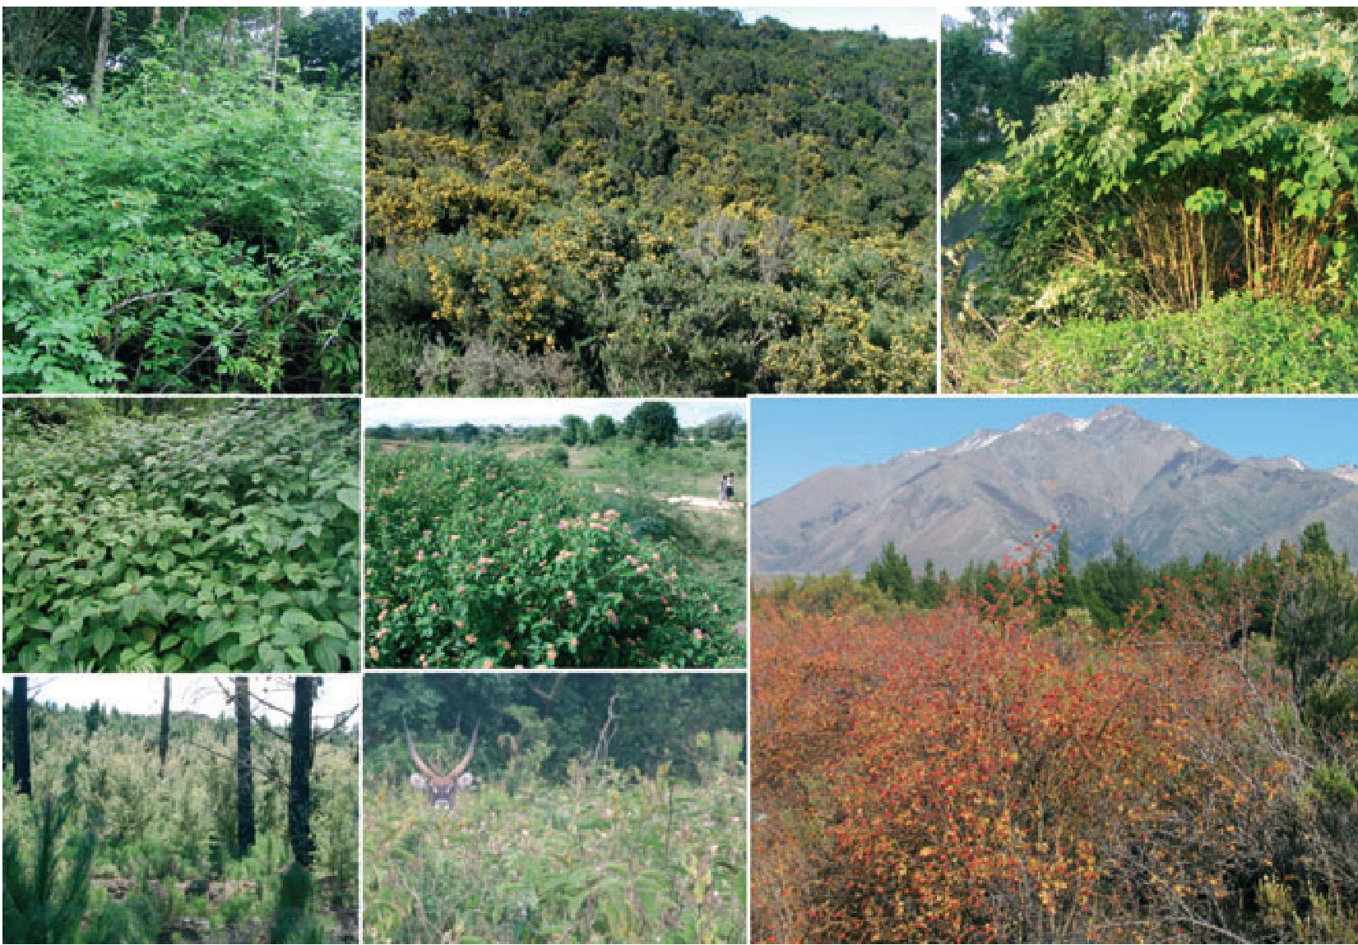
Figure 2 Examples of invasive shrubs. Clockwise from top left: Rubus niveus Santa Cruz, Galapagos (Photo: D.M. Richardson); Ulex europaeus (Fabaceae), La Réunion (Photo: D.M. Richardson); Fallopia japonica (Polygonaceae), Poland (Photo: D.M. Richardson); Rosa rubiginosa (Rosaceae), Argentina (Photo: D.M. Richardson); Solanum incanum (Solanaceae), Aberdares National Park, Kenya (Photo: A. Witt); Hakea sericea (Proteaceae), Western Cape, South Africa (Photo: D.M. Richardson); Clidemia hirta (Melastomataceae), La Réunion (Photo: D.M. Richardson); Lantana camara (Verbenaceae), Mpumalanga, South Africa (Photo: D.M. Richardson).

genera are plotted here in the sequence from the most tropical (Senna), through genera that include both tropical and temperate species (Acacia, Rubus, Pinus), to the most temperate genus (Rosa). Strong positive interspecific associations are visualized via a constelation diagram in Fig. 6. Two distinct noda (groups of species) are immediately apparent: (1) Temperate species cluster around P. pinaster, P. radiata, Robinia pseudoacacia, Ligustrum lucidum and Acacia melanoxylon. (2) Tropical species cluster around Tecoma stans, Spathodea campanulata, Clidemia hirta and Mimosa diplotricha. Species appearing in this diagram are among the most representative invasive trees and shrubs in temperate and tropical areas. This diagram is essentially complementary to CA ordination diagrams in Figs 4 and 5. Composition of invasive woody floras forms a continuum from tropical to temperate. At the same time, however, both floras are, to a large extent, unique.
species). Regions with > 100 species of invasive woody plants showed marked differences in reasons for introduction/dissemination of species. For example, the percentage of species in the invasive floras introduced for horticulture ranged from 52% on Pacific Islands to 77% for North America and for forestry from 13% for North America to 24% for Europe. Horticultural use and forestry together accounted for between 65% (for the Pacific Islands) and 90% (for North America) of invasive tree and shrub species in regions with 100 or more species.
Seed dispersal modes
Birds are the most important agent of dispersal for invasive alien trees (c. 43%) and shrubs (c. 61%) (Table 3). Other modes of dispersal are less often represented (see Discussion) but can be the key factors leading to invasions in particular habitats.

Reasons for introduction and dissemination
The list reveals a marked over-representation of species used for horticulture (387 species; 51% of them are trees) and for ‘forestry’ (79 species, all but one of them are trees). Woody plants introduced for horticulture dominate the invasive floras in all regions (Fig. 7). Other prominent reasons for introduction and dissemination are food (65 species) and agroforestry (46
DISCUSSION
Representation of species on the list and differences between regions
792 Diversity and Distributions, 17, 788–809, ª 2011 Blackwell Publishing Ltd
The list (Appendix S2), comprising 622 species, represents a tiny proportion of the global woody plant flora that comprises probably around 60,000 (current estimates in the literature

Global review of invasive trees & shrubs
Atlantic
Ocean
Islands
Indian
Ocean
Islands
Pacific
Islands New Zealand Australia
Table 1 Summary of invasive trees and shrubs in 15 geographical regions of the world and representation of selected taxonomic groups.
Tree species 90 59 17 36 10 99 52 105 68 117 46 32 63 31 17 357
Shrub species 73 48 5 30 11 50 54 79 28 55 30 25 12 8 6 265
Total 163 107 22 66 21 147 107 183 95 170 76 57 75 39 23 622
Representation of major clades
Polypodiopsida 0 0 0 0 0 1 0 1 1 0 0 0 0 0 0 1
Pinophyta 5 15 1 3 0 7 15 9 2 11 1 4 11 0 0 39
Magnoliidae 5 3 0 2 1 7 1 4 6 3 5 0 2 2 1 19
Commelinidae 4 1 0 0 0 8 1 3 3 0 3 1 7 3 5 21
Eudicotyledoneae 5 7 0 0 0 2 5 2 1 7 1 2 1 0 1 17
Pentapetalae (Core Eudicots) 6 4 1 0 0 0 1 1 2 8 0 2 2 0 0 13
Rosidae 10 3 0 6 3 18 8 13 14 24 8 6 6 3 4 56
Fabidae 69 27 12 37 11 58 51 96 41 85 34 23 31 18 7 283
Mavidae 16 6 6 5 1 13 5 13 13 12 5 5 6 6 3 49
Asteridae 9 6 0 0 0 3 7 7 2 3 0 1 1 1 1 28
Lamiidae 17 8 2 14 2 24 11 29 9 19 18 10 7 4 1 78
Campanulidae (Euasterids II) 4 3 0 1 3 7 2 7 1 4 2 3 1 2 0 18
622
Representation of selected taxa
Pinaceae 5 10 1 2 0 6 14 9 2 8 0 2 10 0 0 30
Pinus 4 7 1 2 0 6 12 9 2 8 0 2 9 0 0 22
Myrtaceae 8 2 0 2 0 12 8 7 5 23 5 5 4 2 3 32
Eucalyptus & Corymbia 2 2 0 1 0 1 1 2 0 5 1 0 2 0 0 8
Fabaceae 28 15 10 28 8 33 20 53 25 47 28 11 19 15 4 122
Acacia (sensu lato) 7 9 6 6 5 8 9 19 8 15 6 6 6 2 1 32
Rosaceae 24 25 0 0 0 6 19 28 4 20 2 5 4 0 1 84
Cotoneaster 2 4 0 0 0 0 5 3 0 5 0 1 0 0 0 10
Pyracantha 0 1 0 0 0 0 0 2 0 6 0 0 1 0 0 6
Rosa 6 1 0 0 0 1 2 1 0 2 0 1 1 0 0 8
Rubus 8 4 0 0 0 3 10 14 2 4 2 2 0 1 0 36
Oleaceae 8 4 0 0 0 2 4 5 1 6 0 1 4 0 0 18
Ligustrum 7 1 0 0 0 0 3 2 1 4 0 1 2 0 0 8
Middle
East Asia Indonesia
Central
America Total
South
America
Africa (rest)
Africa
(southern)
Caribbean Region
North
America Europe
Diversity and Distributions, 17, 788–809, ª 2011 Blackwell Publishing Ltd 793
D. M. Richardson and M. Rejmânek
Number of regions
Central America
Caribaean islands
South
America
Atlantic islands
Africa (rest)
Africa
(southern)
Indian Ocean
islands (incl.
Madagascar)
Pacific
Islands New Zealand Australia
Middle
East Asia Indonesia
North
America Europe
Life form
Genus Species
Table 2 Widespread invasive alien tree and shrub species (those listed in six or more regions).
Acacia dealbata T 1 1 1 1 1 1 1 7
Acacia farnesiana T 1 1 1 1 1 1 1 1 1 1 1 11
Acacia longifolia T 1 1 1 1 1 1 1 7
Acacia mangium T 1 1 1 1 1 1 6
Acacia mearnsii T 1 1 1 1 1 1 1 1 1 1 1 1 12
Acacia melanoxylon T 1 1 1 1 1 1 1 1 1 9
Ailanthus altissima T 1 1 1 1 1 1 1 1 1 1 1 11
Albizia lebbeck T 1 1 1 1 1 1 1 7
Calotropis procera S 1 1 1 1 1 1 6
Casuarina equisetifolia T 1 1 1 1 1 1 1 1 1 9
Chromolaena odorata S 1 1 1 1 1 1 1 7
Clidemia hirta S 1 1 1 1 1 1 6
Cytisus scoparius S 1 1 1 1 1 1 6
Lantana camara S 1 1 1 1 1 1 1 1 1 1 1 1 12
Leucaena leucocephala T 1 1 1 1 1 1 1 1 1 1 1 1 12
Ligustrum lucidum T 1 1 1 1 1 1 6
Melia azederach T 1 1 1 1 1 1 1 7
Mimosa diplotricha T 1 1 1 1 1 1 6
Mimosa pigra T 1 1 1 1 1 1 1 7
Muntingia calabura T 1 1 1 1 1 1 6
Nicotiana glauca S 1 1 1 1 1 1 1 1 1 9
Parkinsonia aculeata T 1 1 1 1 1 1 1 7
Pinus pinaster T 1 1 1 1 1 1 1 1 8
Pinus radiata T 1 1 1 1 1 1 1 7
Pittosporum undulatum T 1 1 1 1 1 1 1 7
Psidium cattleianum T 1 1 1 1 1 1 1 7
Psidium guajava T 1 1 1 1 1 1 1 1 8
Ricinus communis S 1 1 1 1 1 1 1 1 1 1 1 1 1 1 14
Robinia pseudoacacia T 1 1 1 1 1 1 6
Salix fragilis T 1 1 1 1 1 1 1 1 8
Schinus molle T 1 1 1 1 1 1 6
Schinus terebinthifolius T 1 1 1 1 1 1 1 1 8
Senna occidentalis S 1 1 1 1 1 1 6
Solanum mauritianum T 1 1 1 1 1 1 6
Spathodea campanulata T 1 1 1 1 1 1 1 7
Syzygium jambos T 1 1 1 1 1 1 1 1 8
Tecoma stans T 1 1 1 1 1 1 1 7
Ulex europaeus S 1 1 1 1 1 1 1 1 8
794 Diversity and Distributions, 17, 788–809, ª 2011 Blackwell Publishing Ltd
Global review of invasive trees & shrubs

Figure 3 Invasive alien tree and shrub species (622 taxa listed in Appendix S1) have different global ranges: 325 species (52%) are known to be invasive in only one region, whereas six species occur in more than 10 of the 15 geographical regions (see Methods). The figure shows the composition of each invasive alien flora, characterized in terms of the global invasive ranges of component species (occurring in 1–14 regions; no species occurred in all 15 regions).
1 2 3 4 5 6 7 8 9 10 11 12 13 14

Central America
Asia
Middle East
Africa (rest)
Europe
Australia
Indonesia
North America
Indian Ocean Islands
New Zealand
Pacific Islands
South America
Atlantic Ocean Islands
Africa (southern)
Caribbean Region
180
160
140
120
100
40
20
80
60
0
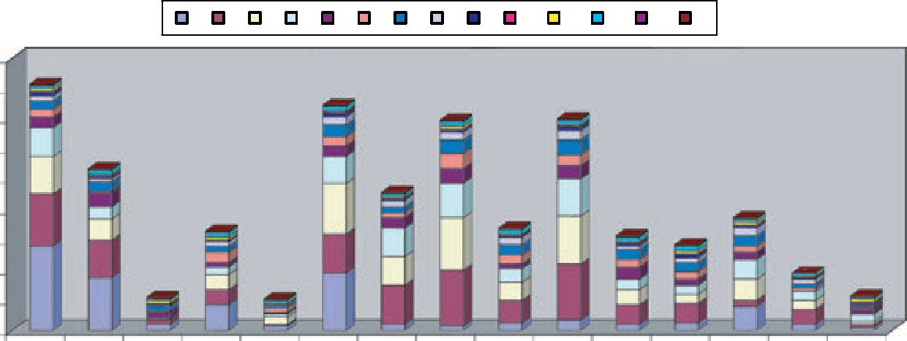

range from 50,000 to 100,000) species of ‘trees’ and approximately the same number of ‘shrubs’ (perhaps only 30,000 species). Using these rough numbers, we suggest that only between 0.5% and 0.7% of the global pool of tree and shrub species are currently clearly invasive outside their natural range.
Diversity and Distributions, 17, 788–809, ª 2011 Blackwell Publishing Ltd 795
Cursory examination of the list reveals a strong bias in favour of temperate species with obvious usefulness to humans and a strong bias against tropical species. Colonial history has played an important part in the dissemination of woody plants around the world (Crosby, 1986; Spongberg, 1990; Taylor, 2009; Laws, 2010). Consequently, the positions of regions in Fig. 4 and the level of similarity between regions are clearly influenced by historical/cultural factors over the past few centuries. More recently, intentional and co-ordinated transfers for specific purposes such as forestry (in the broad sense) and horticulture have dominated invasion pathways, and these are starting to blur the effects of older introductions. Woody plants from Australia (especially species in the families Fabaceae, Myrtaceae and Proteaceae) have been very widely moved around the world (many of them recently) and are fairly well represented on the main list, (c. 8% of species in Appendix S2), and on the list of widespread invaders (7 of 38 species in Table 2; 18%). There has been far less movement of woody plants from some other parts of the world with rich tree and shrub floras, notably China. This trend is, however, very likely to change in the next few decades (Kunming Institute of Botany, 2003; Normile, 2004).
Numbers of invasive alien trees and shrubs vary considerably between regions of the world, although it is difficult to determine whether the patterns reflect the real extent of invasions and to what extent the patterns are affected by different levels of reporting and the availability of accurate data on the status of species in different regions. Most regions with > 100 known invasive trees and shrubs (Table 1) are places with long histories of introductions and where invasions are generally well studied. Regions with < 100 species are places generally under-represented in terms of the intensity of research on biological invasions (Pysˇek et al., 2008). The pattern probably reflects predominantly the magnitude of introductions and plantings (high propagule pressure) and the
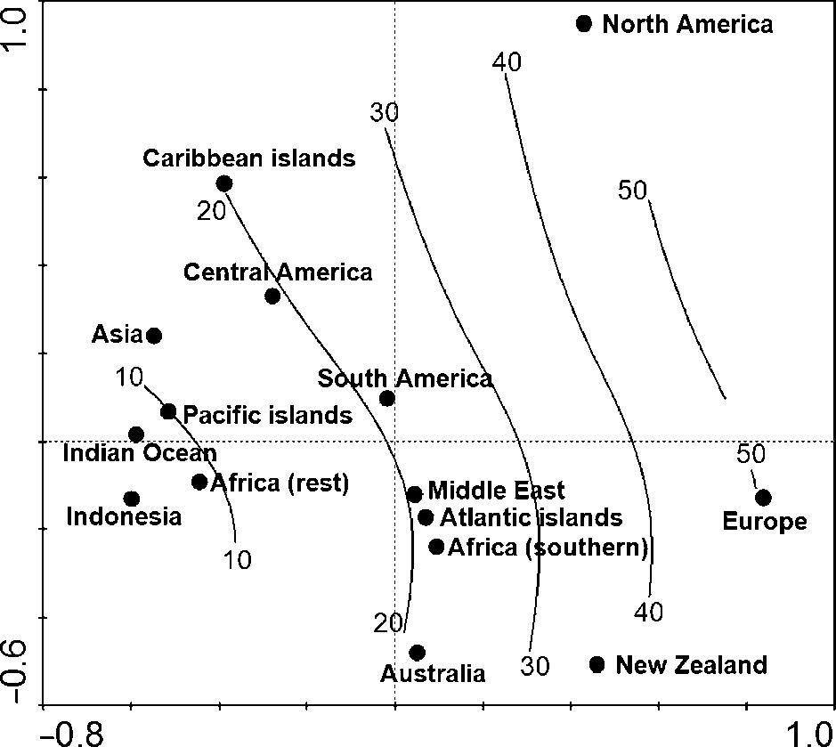
Figure 4 Correspondence analysis ordination diagram of 15 geographical areas based on presence/absence data for 622 invasive tree and shrub species. Closed points represent the positions of individual areas, and contours represent a posteriory fitted mean latitudes irrespective of south or north directions. It is obvious that the first (horizontal) ordination axis is strongly positively correlated with latitude.
level of effort devoted to reporting on invasive species, rather than any real difference between regions in overall invasibility. Introductions that have taken place only in the last few decades (see e.g. Grimshaw & Bayton, 2009; Shulkina, 2004; Wharton et al., 2005) have not had time to generate invasions, and there is undoubtedly a substantial ‘invasion debt’ in all regions, especially more affluent regions.
An important feature of the list is the strong underrepresentation of many well-known families with a large proportion of woody species. Such families that have not (yet) contributed many invasive species include Anacardiaceae [850 species, including c. 200 Rhus sensu lato (including Searsia and Toxicodendron)]; Annonaceae (2100); Betulaceae (140 species, including 35 species in Alnus and 35 in Betula); Burseraceae (640), Chrysobalanaceae (530 species); Combretaceae (525

D. M. Richardson and M. Rejmânek
Figure 5 Correspondence analysis ordination of invasive tree and shrub species in some large genera. Positions of closed points (areas) and contours (mean latitudes) are identical with their positions in Fig. 4. Triangles represent centroids (geometric centres or barycentres) of individual species; these are in many cases identical with particular geographic areas (closed points). Genera are ordered from the most tropical (Senna) to the most temperate (Rosa). (a – Senna) 1, Senna alata; 2, Senna bicapsularis; 3, Senna corymbosa; 4, Senna didymobotrya;
- Senna hirsuta; 6, Senna multiglandulosa; 7, Senna multijuga; 8, Senna obtusifolia; 9, Senna occidentalis; 10, Senna pendula; 11, Senna septentrionalis; 12, Senna siamea; 13, Senna spectabilis; 14, Senna surattensis; 15, Senna tora; (b – Psidium and Syzygium) 1, Psidium cattleianum; 2, Psidium guajava; 3, Psidium guineense; 4, Syzygium cumini; 5, Syzygium jambos; 6, Syzygium malaceense; 7, Syzygium paniculatum; (c – Solanum) 1, Solanum aviculare; 2, Solanum betaceum; 3, Solanum erianthum; 4, Solanum incanum; 5, Solanum linnaeanum;
- Solanum marginatum; 7, Solanum mauritianum; 8. Solanum torvum; 9, Solanum viviparum; (d – Acacia and Acaciella) 1, Acacia auriculiformis; 2, Acacia baileyana; 3, Acacia catechu; 4, Acacia concina; 5, Acacia confuse; 6, Acacia crassicarpa; 7, Acacia cyclops; 8, Acacia dealbata; 9, Acacia decurrens; 10, Acacia elata; 11, Acacia farnesiana; 12, Acacia hockii; 13, Acacia holosericea; 14, Acacia implexa; 15, Acacia iteaphylla; 16, Acacia karroo; 17, Acacia longifolia; 18, Acacia mangium; 19, Acacia mearnsii; 20, Acacia melanoxylon; 21, Acacia nilotica; 22, Acacia paradoxa; 23, Acacia podalyrifolia; 24, Acacia pycnantha; 25, Acacia retinodes; 26, Acacia salicina; 27, Acacia saligna; 28, Acacia stricta; 29, Acacia verticillata; 30, Acacia victoriae; 31, Acaciella angustisima; 32, Acaciella glauca; (e – Rubus) 1, Rubus alceifolius; 2, Rubus anglocandicans; 3, Rubus argutus; 4, Rubus armeniacus; 5, Rubus bifrons; 6, Rubus cissburiensis; 7, Rubus cuneifolius; 8, Rubus echinatus; 9, Rubus ellipticus; 10, Rubus erythrops; 11, Rubus flagellaris; 12, Rubus fruticosus agg.; 13, Rubus idaeus; 14, Rubus illecebrosus; 15, Rubus laciniatus; 16, Rubus laudatus; 17, Rubus leightonii; 18, Rubus leptothyros; 19, Rubus leucostachys; 20, Rubus x loganobaccus; 21, Rubus macrophyllus; 22, Rubus moluccanus; 23, Rubus niveus (Rubus albescens); 24, Rubus ostryifolius; 25, Rubus parvifolius; 26, Rubus phaeocarpus; 27, Rubus phoenicolasius; 28, Rubus pinnatus; 29, Rubus polyanthemus; 30, Rubus riddelsdellii; 31, Rubus rosifolius; 32, Rubus rubritinctus; 33, Rubus rugosus; 34, Rubus spectabilis; 35, Rubus ulmifolius; 36, Rubus vestitus; (f – Pinus) 1, Pinus banksiana; 2, Pinus canariensis; 3, Pinus caribaea; 4, Pinus clausa; 5, Pinus contorta; 6, Pinus elliottii; 7, Pinus halepensis; 8, Pinus kesiya; 9, Pinus koraiensis; 10, Pinus luchuensis; 11, Pinus mugo; 12, Pinus muricata; 13, Pinus nigra; 14, Pinus oocarpa; 15, Pinus patula; 16, Pinus pinaster; 17, Pinus pinea; 18, Pinus ponderosa; 19, Pinus radiata; 20, Pinus strobus; 21, Pinus sylvestris; 22, Pinus taeda; (g – Salix) 1, Salix alba; 2, Salix atrocinerea; 3, Salix babylonica; 4, Salix cinerea; 5, Salix daphnoides; 6, Salix exigua; 7, Salix fragilis; 8, Salix glauca; 9, Salix nigra; 10, Salix purpurea; 11, Salix rubens; 12, Salix x sepulcralis (Salix x chrysocoma); 13, Salix triandra; (h – Rosa) 1, Rosa bracteata; 2, Rosa canina; 3, Rosa eglanteria; 4, Rosa laevigata; 5, Rosa multiflora; 6, Rosa rubiginosa (Rosa eglanteria); 7, Rosa rugosa; 8, Rosa wichuraiana.

species); Dipterocarpaceae (535 species); Ericaceae [3850 species, including c. 1000 Rhododendron (650 in China) and 860 Erica species]; Ebenaceae (575); Euphorbiaceae (6500 species, > 60% are trees and shrubs); Fagaceae (970 species, including 34 in Nothofagus and 530 in Quercus); Lauraceae (2550 species); Lecythidaceae (325); Magnoliaceae (221 species); Malvaceae (including Bombacaceae, Sterculiaceae and Tiliaceae; 5000 species, mostly trees and shrubs); Meliaceae (650); Moraceae (1150 species; 850 Ficus spp.); Myristicaceae (520); Proteaceae (1775 species, including 77 Banksia, 149 Hakea and 103 Protea species); Rubiaceae (11,000 species, > 95% of them are trees and shrubs); Sapindaceae (1450 species, including 114 Acer species); and Sapotaceae (975) (numbers of species from Mabberley, 2008).
Many large, particularly tropical, woody genera are clearly under-represented. Examples (with number of known invasive species/total number of species) are Psychotria (0/1850), Piper (1/1050), Rhododendron (1/1000), Erica (4/860), Ficus (4/850), Eucalyptus (7/750), Schefflera (1/600), Ixora (0/560), Quercus (3/530), Ilex (1/400), Vaccinium (1/450), Baccharis (1/350), Clusia (1/300+), Litsea (0/300+), Inga (1/300), Lithocarpus (0/ 300), Melalaeuca (4/250), Licania (0/220), Magnolia (0/220), Ocotea (0/200), Palicourea (0/200), Persea (1/200), Pouteria (0/ 200), Shorea (0/200), Terminalia (1/200), Zanthoxylum (0/ 200), Casearia (0/180), Homalium (0/180), Rinorea (0/170), Lasianthus (0/170), Commiphora (0/150), Oreaopanax (0/150), Calliandra (1/130), Faramea (0/130), Camellia (0/120), Lonchocrpus (0/120), Coccoloba (0/120), Nectandra (0/120), Hirtella (0/110), Hopea (0/100) and Lindera (0/100). On the other hand, some genera are over-represented in our database. These
are mostly relatively small genera, e.g. Casuarina (3/17), Schinus (3/33), Ligustrum (8/40), Fraxinus (7/42), Prosopis (5/44), Tamarix (4/54) and Pinus (22/110).
Species from many genera and families have not been sufficiently widely transported and disseminated around the world for long enough and in large enough numbers to give them a chance to invade. This clearly complicates the quest to evaluate the ongoing natural experiment to provide ecological reasons for taxonomic biases in the list. Very few woody plant groups have been surveyed in enough detail to assess the levels of invasiveness in relation to the degree of transport and dissemination outside their natural ranges.
796 Diversity and Distributions, 17, 788–809, ª 2011 Blackwell Publishing Ltd
A few taxonomic groups on the list have, however, been sufficiently well disseminated and the determinants of invasiveness well enough studied to allow for at least preliminary judgements to be made regarding the distribution of invasiveness across the whole group. The most notable group in this regard is the clade Pinophyta, for which enough evidence is available to allow for reasonably robust conclusions to be drawn on the determinants of invasiveness, taking into account lifehistory traits, propagule pressure and facets of invasibility. For this group, a syndrome of life-history traits [small seed mass (< 50 mg), short juvenile period (< 10 years) and short intervals between large seed crops] separates the most invasive species from others with less potential to invade (Rejma´nek & Richardson, 1996; Richardson & Rejma´nek, 2004). The discriminant function derived from the life-history traits of invasive and non-invasive pines was later incorporated, together with other biological attributes, into general rules for the detection of invasive woody seed plants (Table 6.1 in Rejma´nek et al., 2005;

Global review of invasive trees & shrubs

(a)
(c)
(e)
(g)
(b)
(d)
(f)
(h)
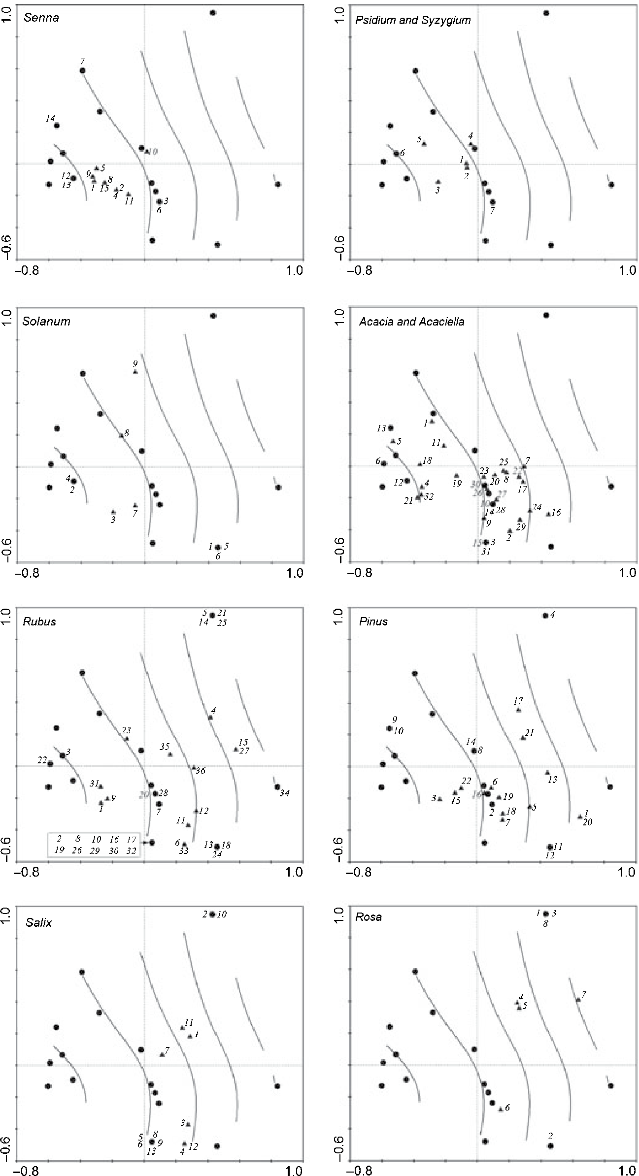

Table 1 in Rejma´nek, 2011). To date, this is the only riskassessment procedure based exclusively on biological attributes of tested woody plant species. Although an ecological syndrome associated with inherent invasiveness clearly exists for this group, good evidence has also emerged that the elucidation of the expression of invasiveness in this taxon must incorporate extrinsic factors such as propagule pressure and residence time
Diversity and Distributions, 17, 788–809, ª 2011 Blackwell Publishing Ltd 797
(Richardson et al., 1994; Proches¸ et al., 2011). Another group for which considerable insights are now available is Acacia (sensu lato) and in particular taxa in Acacia subgenus Phyllodinae native to Australia (‘Australian acacias’) (Box 1). Eucalypts (the genera Angophora, Corymbia and Eucalyptus in the Myrtaceae) have been exceptionally well disseminated and widely planted for well over a century in many parts of the

D. M. Richardson and M. Rejmânek
Figure 6 Species constellation diagram based of species present in at least six geographical areas and co-occurring at least five times (this corresponds to values of association coefficient V ‡ 0.6).
Pittosporum undulatum
Cytisus scoparius
Robinia pseudoacacia
Acacia dealbata
Salix fragilis
Psidium guajava
Tecoma stans
Calotropis
procera
Acacia
mangium
Mimosa pigra
Senna occidentalis
Muntingia calabura
Spathodea Mimosa
campanulata
diplotricha
Albizia lebbeck
Clidemia hirta
Syzigium jambos
Acacia melanoxylon
Nicotiana glauca
Schinus
molle
Pinus
pinaster
Pinus radiata
Psidium cattleianum
Solanum
mauritianum
Parkinsonia aculeata
Casuarina equisetifolia
Leucaena leucocephala
Ulex europaeus
Ligustrum lucidum
Acacia longifolia

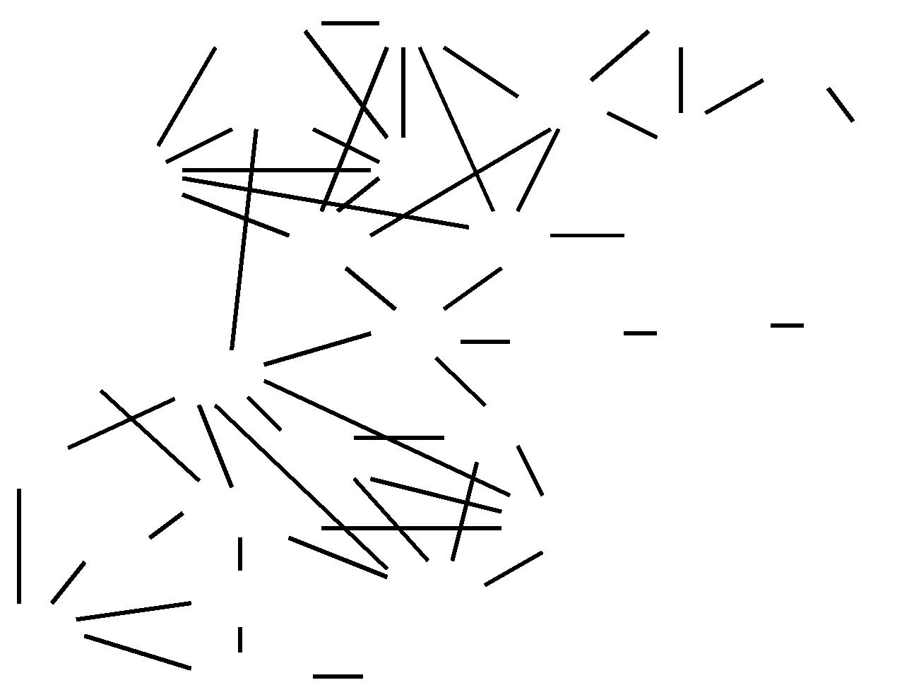

world. No clear ecological syndromes favouring invasiveness have been discovered in this group (Rejmânek & Richardson, 2011), and surprisingly, few species are listed as invasive (only eight species; Appendix S2; Table Box 1). The extent of invasiveness of eucalypts in particular regions is well explained only by metrics that describe the magnitude and duration of plantings (Rejmânek et al., 2005). We suggest that the situation for pines and eucalypts probably represents opposite endpoints on a continuum from ecological/phylogenetic/taxonomic mediation of invasiveness on the one end (exemplified by pines), to mediation driven primarily by factors related to propagule pressure (with eucalypts as exemplar). Other factors relating to the composition of the list, with implications for understanding current invasions and predicting future invasions, are discussed in the following sections.
Reasons for introduction and dissemination
The reasons for introduction and use of non-native plants are important for evaluating the levels and patterns of invasiveness, as cultivation practices fundamentally shape invasion pathways (Wilson et al., 2009b). The use of plants in horticulture provides a very effective means of dissemination, as plants are cultivated and nurtured (protected from effects of disturbance, allowing plants to attain maturity and accumulate large propagule banks), often in large numbers, at scattered foci, often close to a wide range of potentially invasive habitats. Horticultural plants are frequently selected for attributes that are closely associated with invasiveness, such as long-lasting displays of brightly coloured flesh fruits attractive to a wide range of generalist seed dispersers (Reichard, 2011). The large number of species introduced for horticulture in our global list mirrors the dominance of horticultural species in many regional lists of woody invasive plants (Essl et al., 2011).
Species used for forestry are selected for fast growth (one of a package of traits typically associated with species with adaptations for rapid colonization and thus inherent ‘weediness’; Grotkopp et al., 2010) and are typically grown in large plantations, allowing for the accumulation of massive propagule banks. Woody plants most widely used in agroforestry are selected for their tolerance of a wide range of conditions, rapid growth and frequently precocious and prolific fruiting and/or seed production. They are often grown in highly disturbed areas. These criteria define the introduction and dissemination pathways for these species. These, and the role of cultivation methods in mediating invasiveness, are fundamental filters that have resulted in the patterns of occurrence shown in Appendix S2 and Fig. 4. There is a significant rank correlation between number of uses and number of areas occupied by invasive tree species (Kendall’s tau corrected for ties = 0.215; P < 0.001), but not for shrub species (P = 0.87). The mean number of uses is slightly, but significantly higher for trees (1.26) than for shrubs (1.08), Mann–Whitney U-test, P < 0.001. This may also be why the mean number of areas occupied by tree species is somewhat larger (2.35) than for shrub species (1.93), Mann–Whitney U-test; P < 0.001.
Careful consideration must be given to these factors when formulating management strategies, because selection criteria and cultivation practices can be modified potentially to reduce future problems with invasive woody plants (Hughes & Styles, 1987; Richardson et al., 2004a,b; Richardson & Blanchard, 2011).
798 Diversity and Distributions, 17, 788–809, ª 2011 Blackwell Publishing Ltd
Dispersal modes
Efficient propagule dispersal is essential for species to progress from naturalization to invasion (Murray & Phillips, 2010; Rejmânek, 2011). The finding that birds are the prevalent seed

Global review of invasive trees & shrubs
Figure 7 Reasons for introduction and dissemination for invasive alien trees and shrubs in 15 geographical regions. Note that the total numbers in each bar are not the same as the number of species known to be invasive in each region, as some species were introduced/used for more than one reason.
250 Unknown
Other Stabilization Food Fuelwood Agroforestry Horticulture
150 High-quality timber
Forestry
100
200
`
50
0

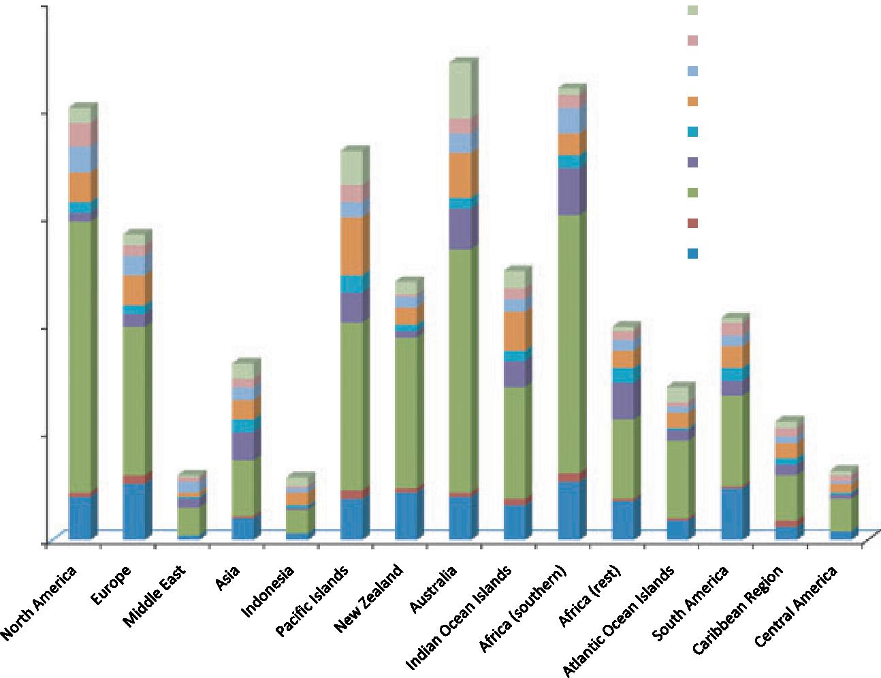

Table 3 Dispersal modes of invasive trees and shrubs and mean number of regions occupied (MN).
 | Trees |  |  | Shrubs |  |  | Trees and shrubs
Dispersal mode | n | % | MN | n | % | MN | n | % | MN
Bird | 154 | 43.1 | 2.44 | 162 | 61.1 | 1.77 | 316 | 50.8 | 2.09
Wind | 91 | 25.5 | 2.25 | 21 | 7.9 | 2.43 | 112 | 18.0 | 2.29
Other | 112 | 31.4 | 2.31 | 82 | 30.1 | 2.12 | 194 | 31.2 | 2.23
Total | 357 | 100 |  | 265 | 100 |  | 622 | 100

dispersal agent for both trees and shrubs (Table 3) is in agreement with earlier analyses (Binggeli, 1996) and is not surprising because birds are among the most efficient long-distance vectors of dispersal (Vittoz & Engler, 2007). Moreover, in the tropics, many bird-dispersed species are also bat-dispersed. The second most important mode of seed dispersal among invasive woody plants seems to be wind. However, percentages of invasive trees and shrubs falling into this category are relatively low (Table 3) compared with Binggeli’s (1996) summary. The likely reason for this discrepancy is that Binggeli included among wind-dispersed species, the so-called censer species (species that slowly release seeds from their fruits by shaking in the wind). This category is very often represented by many naturalized species (e.g. Table 7.3 in Specht & Specht, 1999). For example, dry-fruiting Ericaceae, Melastomataceae, Myrtaceae and Rosaceae belong to this category. If the censer mechanism is included under wind dispersal mode, the percentage of wind-dispersed trees and shrubs would be at least 24%. Besides censer, the ‘other’ modes of dispersal in Table 3 include dispersal by mammals (c. 10–20%), water (5– 10%), ants (c. 5%) and ballistic (< 5%). At least 3% of the 622 species on our list, particularly species in the families Polygonaceae and Salicaceae, exhibit long-distance dispersal by water because of vegetative establishment of their parts or whole
plants. The major conclusion is that bird-dispersed woody invaders always deserve, for many reasons (see Richardson et al., 2000a; Aslan & Rejmânek, 2010), special attention. Dispersal of alien woody species by vertebrates, mainly by birds and bats, is particularly important in the wet tropical forests (Table 8.1 in Rejmânek, 1996; Lobova et al., 2009).
There are no statistically significant differences in the mean numbers of areas occupied by species with different dispersal modes recognized in Table 3. The only significant difference is between bird-dispersed shrubs (1.77 areas on average) and bird-dispersed trees (2.43 areas) (Scheffe test; P < 0.05).
Diversity and Distributions, 17, 788–809, ª 2011 Blackwell Publishing Ltd 799
Key management issues
Management efforts are underway in many parts of the world to reduce problems associated with invasive alien trees and shrubs. These range from ad hoc local-scale efforts to control invasions and mitigate their effects, to national-scale, systematic strategies that integrate all potential options for reducing current problems and reducing the risk of future problems (van Wilgen et al., 2011; Wilson et al., 2011). Details of such operations are available in many publications. Rather than dissecting case studies, we focus on some overarching issues

D. M. Richardson and M. Rejmânek

that complicate management. Background on invaded ecosystems, invasion processes, impacts and determinants of invasibility is provided in Appendix S3.
In devising sustainable strategies for managing problems arising from invasions of introduced trees and shrubs, managers and planners must confront several complex challenges. Most widespread tree and shrub invaders were intentionally introduced to the regions where they now cause problems, and most are still useful in parts of the regions where they occur (Kull et al., 2011). Conflicts of interests abound. Especially for forestry and agroforestry, replacing invasive alien species with native or less invasive non-native alternatives has limited potential. For commercial forestry, eucalypts and pines will remain the foundation of exotic forestry enterprises, and options must be sought to reduce invasiveness and to mitigate negative impacts of the key taxa. There is more scope for finding acceptable alternatives for invasive non-native orna-mental species, but the nursery trade has substantial financial investments in many countries. The demand for popular ornamentals also has strong cultural ties, and the demand is thus difficult to change quickly. There are also other challenges for managing invasiveness in ornamental plants. In many taxa, different cultivars, hybrids or subspecific entities show very different levels of invasiveness, e.g. Buddleja davidii, Lantana spp. (an ‘aggregate species’) and Pyrus calleryana. Well-known invasive plants that have descended from domesticated plants
include Psidium cattleianum, Pyrus calleryana and Coffea arabica. Genera where species identification is problematical resulting in barriers to effective management include Cecropia, Prosopis, Rubus and Ulmus. These factors all complicate the implementation of clear policies. In forestry, invasiveness may change substantially in hybrids and transgenics, with scope for both enhanced and reduced invasiveness. Biotechnology has the potential to reduce the invasiveness of useful trees by producing sterile trees. Although technologically feasible, important barriers exist. For example, the Forestry Stewardship Council prohibits the use of transgenic species (Richardson & Petit, 2005).
Interventions must consider that invasive alien trees and shrubs (other than the economically important taxa discussed above) may serve useful purposes in some situations. For instance, many alien trees and shrubs have strong value as nurse plants for the restoration of degraded natural forests (Lugo, 2004). Increasing land degradation in many parts of the world will increase the need to stabilization and rehabilitation efforts, including the controlled use of non-native species, even those with known or predicted invasive potential. ‘Weediness’ is often welcomed in such cases, and this is difficult to reconcile with biodiversity conservation concerns. Management strategies for invasive trees and shrubs must accommodate such issues. New multidimensional evaluation protocols (Richardson et al., 2009) are needed.

Box 1 Australian Acacia species as invasive alien plants around the world – the emerging story
800 Diversity and Distributions, 17, 788–809, ª 2011 Blackwell Publishing Ltd
Few groups of woody plants provide as many opportunities for gaining insights into the complex interplay of factors that determine which species are introduced, which become established and naturalized (and why), how different species are perceived by humans and have different types of ‘impacts’ (positive and negative) in new environments, as Australian Acacia species (Richardson et al., 2011a,b).
About 1012 species in Acacia subgenus Phyllodineae are native to Australia (see Miller et al., 2011 for discussion on taxonomic issues relating to this clade). These species occur throughout the continent and form the dominant vegetation in many areas. About a third of Australian acacias are trees that reach 5 m or more in height. At least a third of species are grown outside their native ranges, and many species have been widely planted around the world for forestry and other purposes. Australian acacias now dominate landscapes in many parts of the world, either as intentional plantings or as invasive populations (23 species are known to be invasive sensu Pysˇek et al. (2004); Text Box 1). The introduction histories are well known for some regions (e.g. South Africa; Le Roux et al., 2011). Invasive Australian acacias serve many purposes, have many types of impacts on ecosystems in their new ranges (Le Maitre et al., 2011) and are perceived in different ways by different sectors of society (Kull et al., 2011). These factors shape the approaches that have been adopted to manage invasive Australian acacias (van Wilgen et al., 2011; Wilson et al., 2011).
Invasive Australian acacias do not form a monophyletic group but form small clusters throughout the phylogeny. There are no taxonomic characters that separate invasive from non-invasive species (Miller et al., 2011). Castro-Diez et al. (2011) found that ecological, evolutionary and human-use factors interacted to explain invasiveness in this group, with proxies for human usage providing the dominant contribution to models. Size and other features of native ranges are good predictors of invasiveness in foreign environments (Hui et al., 2011b; see also Gallagher et al., 2011). Gibson et al. (2011) examined reproductive syndromes in invasive and non-invasive taxa and found no obvious differences, suggesting that most taxa are well equipped to become invasive. Unlike the situation in Pinus (Grotkopp et al., 2004), there is no difference in genome size between invasive and non-invasive species (Gallagher et al., 2011). Invasions of Australian acacias are contingent on symbiosis between the plants and bacterial strains in the genus Bradyrhizobium (Rodriguez-Echeverria et al., 2011).
Insights from the articles in this issue of Diversity and Distributions will assist in developing improved protocols for screening taxa in this group for invasiveness in particular regions and in formulating improved management strategies for species already at different stages of naturalization/invasion.

Global review of invasive trees & shrubs
Number of regions
Central America
Caribbaean Region
South
America
Atlantic islands
Africa (rest)
Africa
(southern)
Indian
Ocean
islands
New
Zealand Australia
Table Box 1 The geographical distribution of 23 Australian acacias known to be invasive outside their native ranges.
Pacific Islands
Middle
East Asia Indonesia
North
America Europe
Acacia species
A. auriculiformis 1 1 1 1 2
A. baileyana 1 1 1 2
A. crassicarpa 1 1
A. cyclops 1 1 1 1 1 2
A. dealbata 1 1 1 1 1 1 1 4
A. decurrens 1 1 1 1 3
A. elata 1 1
A. holosericea 1 0
A. iteaphylla 1 1
A. implexa 1 1
A.longifolia 1 1 1 1 1 1 1 3
A. mangium 1 1 1 1 1 1 3
A. mearnsii 1 1 1 1 1 1 1 1 1 1 1 1 7
A. melanoxylon 1 1 1 1 1 1 1 1 1 5
A. paradoxa 1 1 1 1 2
A. podalyrifolia 1 1 2
A. pycnantha 1 1 1 2
A. retinodes 1 1 0
A. salicina 1 1 1
A. saligna 1 1 1 1 1 3
A. stricta 1 1
A. verticillata 1 0
A. victoriae 1 0
6 8 5 4 2 4 8 11 5 15 5 4 5 1 0
Diversity and Distributions, 17, 788–809, ª 2011 Blackwell Publishing Ltd 801
D. M. Richardson and M. Rejmânek
802 Diversity and Distributions, 17, 788–809, ª 2011 Blackwell Publishing Ltd
Box 2 Priorities for research on invasive alien trees and shrubs
Improved inventories and lists of invasive taxa

The list presented in Appendix S1 is only a starting point. Further surveying and assessment of the status of woody alien plants is required for many regions. For example, we note that our data on invasive woody species for Asia are mostly from tropical and subtropical parts of the region (mainly China, India and Malaysia). Data from Mongolia and Siberia are lacking. Effective strategies for the long-term management of alien plants require accurate and up-to-date catalogues of species, with an objective assessment of their status as alien species, both within the region and globally. A model is the catalogue of alien plants for the Czech Republic (Pysˇek et al., 2002).
Further detailed taxon-specific analyses to determine invasive potential
Taxon-specific investigations need to be undertaken to explore and standardize regional perspectives on invasiveness and noninvasiveness in important groups such as large families, genera or groups with importance to humans and therefore with a strong likelihood of further dissemination. Such investigations also need to address groups that are widely planted but which are currently under-represented in invasive floras, e.g. Eucalyptus (Rejma´nek & Richardson, 2011).
Reducing the efficiency of key pathways of introduction and dissemination in launching and sustaining woody plant invasions
Horticulture, forestry and other uses of woody plants launch and sustain invasions of woody alien plants. Research is needed to develop strategies to make these practices more sustainable and more environment-friendly. Potential solutions range from replacing high-risk species with safer ones, reducing the likelihood of propagules spreading to ecosystems outside areas set aside for plantings, implementing practices to thwart establishment, survival and proliferation of aliens in target ecosystems, genetic engineering of sterility, to complex multifaceted programmes (van Wilgen et al., 2011). Mechanisms to activate such interventions include education and awareness raising, the provision of incentives, legislation and enforcement. New uses such as biofuels present special challenges.
Botanical gardens were historically important sources of many invasive plant species (Heywood, 2011; Hulme, 2011), but this trend has changed in recent decades. Botanical gardens may now play a crucial role in evaluating the potential invasiveness of new introductions (Wharton et al., 2005). Their personnel are usually better equipped for this task than those in the horticultural industry. Also, botanical gardens could be instrumental in developing permanently sterile hybrids with desirable ornamental properties (e.g. the popular vegetatively propagated Chitalpa · tashkentensis that was introduced to the USA through the New York Botanical Garden in 1977).
Many plantings of alien trees and shrubs took place only recently. There are therefore many invasive species ‘waiting in the wings’. Such ‘invasion debt’ needs to be accommodated in national and regional strategies for dealing with invasive species. Transdisciplinary work to ensure that research findings are fed into policy in this regard is urgently needed.
Understanding invasion dynamics
Further work is needed to unravel the relative roles of propagule pressure and the many other processes involved in invasions. Effective management in particular habitats and biomes requires site-specific insights in this regard for incorporation into operational planning. Valuable insights are emerging from analyses of introduction histories (Bucharova & van Kleunen, 2009), including marketing dynamics for horticultural plants (Pemberton & Liu, 2009), and further work in this direction is crucial for developing effective management strategies. Climate change and shifting management priorities complicate the task, but new modelling frameworks have potential for providing robust guidelines to inform management (Richardson et al., 2010; RouraPascual et al., 2010).
Mapping and assessing impacts
More effective methods are needed for mapping the extent of invasions and for monitoring changes, including those owing to different management interventions. High-tech methods of remote sensing have much potential, not only for mapping the extent of woody plant invasions over landscapes (Asner & Huang, 2011) and entire biomes (e.g. Rouget et al., 2003) but also for gaining fundamental new insights into the determinants of invasibility and ecosystem-level impacts (Vitousek et al., 2011). Further work is needed to determine the optimal scale for mapping invasive in different ecosystems species to ensure that resulting data are appropriate for multiple requirements of management, modelling, monitoring, planning and research (Foxcroft et al., 2009; Hui et al., 2011a,b).
Objective measures are needed for assessing the impacts of different invasive species in a range of habitats to assist in the objective prioritization of species and areas for management (Magee et al., 2010). Because woody invasions are becoming
Global review of invasive trees & shrubs
increasing widespread, new multicriteria protocols are needed to rank the importance of species for different regions, biomes and countries. Robust criteria are needed for defining ‘transformers’ (invasive species that change the character, condition, form or nature of ecosystems over a substantial area relative to the extent of that ecosystem; Richardson et al., 2000b). Their distinction from ‘passengers’ of environmental change (MacDougall & Turkington, 2005) is critical for choosing proper management actions. Special attention should be paid to shade-tolerant invaders because they are able to penetrate undisturbed forest communities (Martin et al., 2009; Reinhart, 2010).

Another factor that must be taken into account is the rapidly changing global market for products from trees and shrubs, including new uses. For example, many alien trees and shrubs are being proposed for wide-scale planting for the production of biofuels, among them known invasive taxa like Azadirachta indica, Eucalyptus camaldulensis, Calotropis procera, Olea europaea, Leucaena leucocephala, Populus spp., Ricinus communis, Salix spp., Triadica sebifera and Zizyphus mauritiana and many species that are very likely to be invasive (Low & Booth, 2007; Gordon et al., 2011). Altered planting configurations, including massive increases in propagule pressure and the number of planting sites and thus foci for launching invasions, to accommodate biofuel production will surely launch many new invasions of more species over a greater area. Consideration must be given to potential invasions when deciding on strategies for biofuels and other emerging markets for wood-based products in different parts of the world (Richardson & Blanchard, 2011).
Climate change provides a huge challenge for managing woody plant invasions. Changing environmental conditions leads to rapid changes in the invasiveness of alien species (Richardson & Bond, 1991; Willis et al., 2010). Consequently, many alien species already present in an area and currently deemed ‘safe’ (non-invasive) may well become invasive. Recent modelling studies have revealed the extreme complexity involved in unravelling the many mechanisms whereby climate change could potentially influence invasion patterns and in using such information to design long-term management plans at the regional or national scale (Kleinbauer et al., 2010; Richardson et al., 2010).
CONCLUSIONS
Introduced trees and shrubs have invaded many habitats around the world and have caused many types of impacts in invaded ecosystems. Issues related to invasiveness are now influencing how people perceive, use and manage alien trees and shrubs. The majority of the most widespread and troublesome invasive trees and shrubs were intentionally introduced to regions where they are now invasive, were often widely disseminated and in many cases are still commercially important. These provide informative cases of conflicts of interest in natural resource management, providing new challenges for invasion science. A wide range of sociopolitical factors are shaping invasion dynamics and influence options available for management (Kull et al., 2011; van Wilgen et al., 2011). Changing global and regional economies, and crosscutting issues such as climate change, and the emergence of
new uses of woody plants (e.g. for biofuels) are also rapidly altering pathways of introduction and dissemination of woody plants around the world (Richardson, 2011a,b). There are many priorities for further research to improve our understanding of the ecology of woody plant invasions and our ability to manage them (Box 2).
ACKNOWLEDGEMENTS
Diversity and Distributions, 17, 788–809, ª 2011 Blackwell Publishing Ltd 803
Many colleagues from all parts of the world contributed records and answered sundry questions that helped in compiling the list of invasive trees and shrubs. We thank them all. DMR acknowledges financial support from the DST-NRF Centre of Excellence for Invasion Biology and the Hans Sigrist Foundation. The Oppenheimer Memorial Trust and Stellenbosch University funded the workshop in Stellenbosch in October 2010 at which an early version of this article was presented. Corlia Richardson provided great help with managing the database.
REFERENCES
Akobundu, I.O. & Agyakwa, C.W. (1987) A handbook of West African weeds. International Institute of Tropical Agriculture, Ibadan, Nigeria.
Arianoutsou, M., Bazos, I., Depipetrou, P. & Kokkoris, Y. (2010) The alien flora of Greece: taxonomy, life traits and habitat preferences. Biological Invasions, 12, 3525– 3549.
Aslan, C.A. & Rejmânek, M. (2010) Avian use of introduced plants: ornithologist records illuminate interspecific associations and research needs. Ecological Applications, 20, 1005– 1020.
Asner, G.P. & Huang, C.-Y. (2011) Remote sensing. Encyclopedia of biological invasions (ed. by D. Simberloff and M. Rejmânek), pp. 580–584, University of California Press, Berkeley.
Binggeli, P. (1996) A taxonomic, biogeographical and ecological overview of invasive woody plants. Journal of Vegetation Science, 7, 121–124.
Binggeli, P., Hall, J.B. & Healey, J.R. (1998) An overview of invasive woody plants in the tropics. Available at: http:// www.bangor.ac.uk/~afs101/iwpt/web1-99.pdf (accessed 4 January 2011).
Bucharova, A. & van Kleunen, M. (2009) Introduction history and species characteristics partly explain naturalization success of North American woody species in Europe. Journal of Ecology, 97, 230–238.

D. M. Richardson and M. Rejmânek

Cantino, P.D., Doyle, J.A., Graham, S.W., Judd, W.S., Olmstead, R.G., Soltis, D.E., Soltis, P.S. & Donoghue, M.J. (2007) Towards a phylogenetic nomenclature of Tracheophyta. Taxon, 56, 822–846.
Castro-Diez, P., Godoy, O., Saldan˜a, A. & Richardson, D.M. (2011) Predicting invasiveness of Australian acacias on the basis of their native climatic affinities, life-history traits and human use. Diversity and Distributions, 17, 934–945.
Crosby, A.W. (1986) Ecological imperialism: the biological expansion of Europe, 900–1900. Cambridge University Press, Cambridge.
Essl, F., Milasowszky, N. & Dirnbôck, T. (2011) Plant invasions in temperate forests: resistance or ephemeral phenomenon? Basic and Applied Ecology, 12, 1–9.
Everitt, J.H., Lonard, R.I. & Little, C.R. (2007) Weeds in South Texas and Northern Mexico. Texas Tech University Press, Lubbock, TX.
Farjon, A. (2001) World checklist and bibliography of conifers, 2nd edn. Royal Botanic Gardens, Kew.
Foxcroft, L.C., Richardson, D.M., Rouget, M. & MacFadyen, S. (2009) Patterns of alien plant distribution at multiple spatial scales in a large national park: implications for ecology, management and monitoring. Diversity and Distributions, 15, 367–378.
Gallagher, R.V., Leishman, M.R., Miller, J.T., Hui, C., Richardson, D.M., Suda, J. & Trâvnicˇek, P. (2011) Invasiveness in introduced Australian acacias: the role of species traits and genome size. Diversity and Distributions, 17, 884–897.
Gibson, M., Richardson, D.M., Marchante, E., Marchante, H., Rodger, J.G., Stone, G.N., Byrne, M., Fuentes-Ramirez, A., George, N., Harris, C., Johnson, S.D., Le Roux, J.J., Murphy, Pauw., D.J., A., Prescott, M.N., Wandrag, E.M. & Wilson, J.R.U. (2011) Reproductive biology of Australian Acacia species: important mediator of invasiveness? Diversity and Distributions, 17, 911–933.
Gordon, D.R., Riddle, B., Pheloung, P.C., Ansari, S., Buddenhagen, C., Chimera, C., Daehler, C.C., Dawson, W., Denslow, J.S., Tshidada, N.J., LaRosa, A., Nishida, T., Onderdonk, D.A., Panetta, F.D., Pysˇek, P., Randall, R.P., Richardson, D.M., Virtue, J.G. & Williams, P.A. (2010) Guidance for addressing the Australian Weed Risk Assessment questions. Plant Protection Quarterly, 25, 56–74.
Gordon, D.R., Tancig, K.J., Onderdonk, D.A. & Gantz, C.A. (2011) Assessing the invasive potential of biofuel species proposed for Florida and the United States using the Australian Weed Risk Assessment. Biomass and Bioenergy, 35, 74– 79.
Grimshaw, J. & Bayton, R. (2009) New trees. Recent introductions to cultivation. Kew Publishing Royal Botanic Gardens, Kew.
Grotkopp, E., Rejmânek, M. & Rost, T.L. (2002) Toward a causal explanation of invasiveness: seedling growth and lifehistory strategies of 29 pine (Pinus) species. American Naturalist, 159, 396–419.
Grotkopp, E., Rejmânek, M., Sanderson, M.J. & Rost, T.L. (2004) Evolution of genome size in pines (Pinus) and its life-history correlates: supertree analyses. Evolution, 58, 1705–1729.
Grotkopp, E., Erskine-Ogden, J. & Rejmânek, M. (2010) Assessing potential invasiveness of woody horticultural plant species using seedling growth rate traits. Journal of Applied Ecology, 47, 1320–1328.
Heywood, V.H. (2011) The role of botanic gardens as resource and introduction centres in the face of global change. Biodiversity and Conservation, 20, 221–239.
804 Diversity and Distributions, 17, 788–809, ª 2011 Blackwell Publishing Ltd
Holm, L.G., Plucknett, D.L., Pancho, J.V. & Herberger, T.P. (1977) . The world’s worst weeds. Distribution and biology. University Press, Honolulu, USA. [Reprinted 1991 by Krieger Publishing Company, Malabar, Florida].
Holm, L., Doll, J., Holm, E., Pancho, J. & Herberger, J. (1997) World weeds. Natural histories and distribution. John Wiley & Sons, New York.
Hughes, C.E. & Styles, B.T. (1987) The benefits and potential risks of woody legume introductions. The International Tree Crop Journal, 4, 209–248.
Hui, C., Foxcroft, L.C., Richardson, D.M. & MacFayden, S. (2011a) Defining optimal sampling effort for large-scale monitoring of invasive alien plants: a Bayesian method for estimating abundance and distribution. Journal of Applied Ecology, 48, 768–776.
Hui, C., Richardson, D.M., Robertson, M.P., Wilson, J.R.U. & Yates, C.J. (2011b) Macroecology meets invasion ecology: linking native distribution of Australian acacias to invasiveness. Diversity and Distributions, 17, 872–883.
Hulme, P.E. (2011) Addressing the threat to biodiversity from botanic gardens. Trends in Ecology & Evolution, 26, 168–174. Kershaw, K.A. & Looney, J.H.H. (1985) Quantitative and dynamic plant ecology, 3rd edn. Edward Arnold, London. Kleinbauer, I., Dullinger, S., Peterseil, J. & Essl, F. (2010) Climate change might drive the invasive tree Robinia pseudacacia into nature reserves and endangered habitats. Biological Conservation, 143, 382–390.
Kull, C.A., Shackleton, C.M., Cunningham, P.S., Ducatillon, C., Dufour Dror, J.-M., Esler, K.J., Friday, J.B., Gouveia, A.C., Griffin, A.R., Marchante, E.M., Midgley, S.J., Pauchard, A., Rangan, H., Richardson, D.M., Rinaudo, T., Tassin, J., Urgenson, L.S., von Maltitz, G.P., Zenni, R.D. & Zylstra, M.J. (2011) Adoption, use, and perception of Australian acacias around the world. Diversity and Distributions, 17, 822– 836.
Kunming Institute of Botany (2003) Wild ornamental fruit plants from Yunnan, China. Foreign Languages Press, Beijing, China.
Laws, B. (2010) Fifty plants that changed the course of history. Struik Nature, Cape Town.
Le Maitre, D.C., Gaertner, M., Marchante, E., Ens, E.J., Holmes, P.M., Pauchard, A., O’Farrell, P.J., Rogers, A.M., Blanchard, R., Blignaut, J. & Richardson, D.M. (2011) Impacts of invasive Australian acacias: implications for management and restoration. Diversity and Distributions, 17, 1015–1029.
Le Roux, J.J., Brown, G., Byrne, M., Ndlovu, J., Richardson, D.M., Suda, J., Thompson, G.D., Trâvnicˇek, P. & Wilson, J.R.U. (2011) Phylogeographic consequences of different

Global review of invasive trees & shrubs

introduction histories of invasive Australian Acacia species and Paraserianthes lophantha (Fabaceae) in South Africa. Diversity and Distributions, 17, 861–871.
Lepsˇ, J. & S^{ˇ}milauer, P. (2003) Multivariate analysis of ecological data using CANOCO. Cambridge University Press, Cambridge.
Lobova, T.A., Geiselman, C.K. & Mori, S.A. (2009) Seed dispersal by bats in the Neotropics. The New York Botanical Garden, Bronx, New York.
Low, T. & Booth, C. (2007) The weedy truth about biofuels. Invasive Species Council, Melbourne.
Lowe, S., Browne, M. & Boudjelas, S. (2000) 100 of the world’s worst invasive alien species. A selection from the global invasive species database. Invasive Species Specialist Group, Auckland, New Zealand.
Lugo, A.E. (2004) The outcome of alien tree invasions in Puerto Rico. Frontiers in Ecology and the Environment, 2, 265–273. Mabberley, D.J. (2008) Mabberley’s plant-book. A portable dictionary of plants, their classification and uses, 3rd edn. Cambridge University Press, Cambridge.
MacDougall, A.S. & Turkington, R. (2005) Are invasive species the drivers or passengers of change in degraded ecosystems? Ecology, 86, 42–55.
Magee, T.K., Ringold, P.L., Bollman, M.A. & Ernst, T.L. (2010) Index of alien impact: a method for evaluating potential ecological impact of alien plant species. Environmental Management, 45, 759–778.
Martin, P.H., Canham, C.D. & Marks, P.L. (2009) Why forests appear resistant to exotic plant invasions: intentional introductions, stand dynamics, and the role of shade tolerance. Frontiers in Ecology and the Environment, 7, 142–149.
Miller, J.T., Murphy, D.J., Brown, G.K., Richardson, D.M. & Gonzâlez-Orozco, C.E. (2011) The evolution and phylogenetic placement of invasive Australian Acacia species. Diversity and Distributions, 17, 848–860.
Murray, B.R. & Phillips, M.L. (2010) Investment in seed dispersal structures is linked to invasiveness in exotic plant species of south-east Australia. Biological Invasions, 12, 2265– 2275.
Nel, J.L., Richardson, D.M., Rouget, M., Mgidi, T., Mdzeke, N., Le Maitre, D.C., van Wilgen, B.W., Schonegevel, L., Henderson, L. & Neser, S. (2004) A proposed classification of invasive alien plant species in South Africa: towards prioritising species and areas for management action. South African Journal of Science, 100, 53–64.
Normile, D. (2004) Expanding trade with China creates ecological backlash. Science, 306, 968–969.
Osada, T. (1997) Colored illustrations of naturalized plants of Japan. Hoikusha Publishing Co., Osaka, Japan.
Pemberton, R.W. & Liu, H. (2009) Marketing time predicts naturalization of horticultural plants. Ecology, 90, 69–80. Petit, R.J., Bialozyt, R., Garnier-Gere, P. & Hampe, A. (2004) Ecology and genetics of tree invasions: from recent introductions to Quaternary migrations. Forest Ecology and Management, 197, 117–137.
Pielou, E.C. (1977) Mathematical ecology. Wiley, New York.
Proches¸ , S¸ ., Richardson, D.M., Wilson, J.R.U. & Rejma´nek, M. (2011) Native and naturalised range size in Pinus: relative importance of biogeography, introduction effort and species traits. Global Ecology and Biogeography, (in press) doi: 10.1111/j.1466-8238.2011.00703.x.
Pysˇek, P., Sâdlo, J. & Mandâk, B. (2002) Catalogue of alien plants of the Czech Republic. Preslia, 74, 97–186.
Diversity and Distributions, 17, 788–809, ª 2011 Blackwell Publishing Ltd 805
Pysˇek, P., Richardson, D.M., Rejmânek, M., Webster, G.L., Williamson, M. & Kirschner, J. (2004) Alien plants in checklists and floras: towards better communication between taxonomists and ecologists. Taxon, 53, 131–143.
Pysˇek, P., Richardson, D.M., Pergl, J., Jarosˇı´k, V., Sixtovâ, Z. & Weber, E. (2008) Geographical and taxonomical biases in invasion ecology. Trends in Ecology and Evolution, 23, 237– 244.
Raju, R.A. (1998) Prevalent weed flora in Peninsular India. Allied Publishers, New Delhi.
Randall, R.P. (2007) The introduced flora of Australia and its weed status. CRC for Australian Weed Management, University of Adelaide, Glen Osmond, South Australia. Available at: http://www.weeds.crc.org.au/weed_management/intro_flora. html.
Reichard, S. (2011) Horticulture. Encyclopedia of biological invasions (ed. by D. Simberloff and M. Rejmânek), pp. 336– 342, University of California Press, Berkeley.
Reinhart, K.O. (2010) The role of facilitative interactions in tree invasions. New Phytologist, 187, 559–562.
Rejmânek, M. (1996) Species richness and resistance to invasions. Biodiversity and ecosystem processes in tropical forests (ed. by G.H. Orians, R. Dirzo and J.H. Cushman), pp. 153– 172, Springer, Berlin.
Rejmânek, M. (2011) Invasiveness. Encyclopedia of biological invasions (ed. by D. Simberloff and M. Rejmânek), pp. 379– 385, University of California Press, Berkeley.
Rejmânek, M. & Richardson, D.M. (1996) What attributes make some plant species more invasive? Ecology, 77, 1655–1661. Rejmânek, M. & Richardson, D.M. (2011) Eucalypts. Encyclopedia of biological invasions (ed. by D. Simberloff and M. Rejmânek), pp. 203–209, University of California Press, Berkeley.
Rejmânek, M., Richardson, D.M., Higgins, S.I., Pitcairn, M.J. & Grotkopp, E. (2005) Ecology of invasive plants – state of the art. Invasive alien species: a new synthesis (ed. by H.A. Mooney, R.N. Mack, J.A. Mc Neely, L. Neville, P.J. Schei and J. Waage), pp. 104–161, Island Press, Washington, D.C. Richardson, D.M. (1998) Forestry trees as invasive aliens. Conservation Biology, 12, 18–26.
Richardson, D.M. (2006) Pinus: a model group for unlocking the secrets of alien plant invasions? Preslia, 78, 375–388. Richardson, D.M. (2011a) Forestry and agroforestry. Encyclopedia of biological invasions (ed. by D. Simberloff and M. Rejmânek), pp. 241–248, University of California Press, Berkeley.
Richardson, D.M. (2011b) Trees and shrubs. Encyclopedia of biological invasions (ed. by D. Simberloff and M. Rejma´nek), pp. 670–677, University of California Press, Berkeley.

D. M. Richardson and M. Rejmânek

Richardson, D.M. & Blanchard, R. (2011) Learning from our mistakes: minimizing problems with invasive biofuel plants. Current Opinion in Environmental Sustainability, 3, 36–42.
Richardson, D.M. & Bond, W.J. (1991) Determinants of plant distribution: evidence from pine invasions. American Naturalist, 137, 639–668.
Richardson, D.M. & Petit, R. (2005) Pines as invasive aliens: outlook on transgenic pine plantations in the Southern Hemisphere. Landscapes, genomics and transgenic conifers (ed. by C.G. Williams), pp. 169–188, Springer, Dordrecht. Richardson, D.M. & Rejmânek, M. (2004) Invasive conifers: a global survey and predictive framework. Diversity and Distributions, 10, 321–331.
Richardson, D.M., Williams, P.A. & Hobbs, R.J. (1994) Pine invasions in the Southern Hemisphere: determinants of spread and invadability. Journal of Biogeography, 21, 511– 527.
Richardson, D.M., Allsopp, N., D’Antonio, C.M., Milton, S.J. & Rejmânek, M. (2000a) Plant invasions: the role of mutualisms. Biological Reviews, 75, 65–93.
Richardson, D.M., Py"sek, P., Rejmânek, M., Barbour, M.G., Panetta, D.F. & West, C.J. (2000b) Naturalization and invasion of alien plants – concepts and definitions. Diversity and Distributions, 6, 93–107.
Richardson, D.M., Binggeli, P. & Schroth, G. (2004a) Invasive agroforestry trees: problems and solutions. Agroforestry and biodiversity conservation in tropical landscapes (ed. by G. Schroth, G.A.B. de Fonseca, C.A. Harvey, C. Gascon, H. Vasconcelos and A.-M.N. Izac), pp. 371–396, Island Press, Washington, D.C.
Richardson, D.M., Rouget, M. & Rejmânek, M. (2004b) Using natural experiments in the study of alien tree invasions: opportunities and limitations. Experimental approaches to conservation biology (ed. by M.S. Gordon and S.M. Bartol), pp. 180–201, University of California Press, Berkeley. Richardson, D.M., Hellmann, J.J., McLachlan, J. et al. (2009) Multidimensional evaluation of managed relocation. Proceedings of the National Academy of Sciences USA, 106, 9721–9724.
Richardson, D.M., Iponga, D.M., Roura-Pascual, N., Krug, R., Thuiller, W., Milton, S.J. & Hughes, G.O. (2010) Accommodating scenarios of climate change and management in modelling the distribution of the invasive tree Schinus molle in South Africa. Ecography, 33, 1049–1061.
Richardson, D.M., Carruthers, J., Hui, C., Impson, F.A.C., Robertson, M.P., Rouget, M., Le Roux, J.J. & Wilson, J.R.U. (2011a) Human-mediated introductions of Australian acacias—a global experiment in biogeography. Diversity and Distributions, 17, 771–787.
Richardson, D.M., Py"sek, P. & Carlton, J.T. (2011b) A compendiumofessentialconceptsandterminologyininvasionecology. Fifty years ofinvasion ecology. The legacy of Charles Elton (ed. by D.M. Richardson), pp. 409–420, Wiley-Blackwell, Oxford. Rodriguez-Echeverria, S., Le Roux, J.J., Criso´stomo, J.A. & Ndlovu, J. (2011) Jack-of-all-trades and master of many?
How does associated rhizobial diversity influence the colonization success of Australian Acacia species? Diversity and Distributions, 17, 946–957.
Rouget, M., Richardson, D.M., Cowling, R.M., Lloyd, J.W. & Lombard, A.T. (2003) Current patterns of habitat transformation and future threats to biodiversity in the Cape Floristic Region, South Africa. Biological Conservation, 112, 63–85.
806 Diversity and Distributions, 17, 788–809, ª 2011 Blackwell Publishing Ltd
Roura-Pascual, N., Krug, R.M., Richardson, D.M. & Hui, C. (2010) Spatially-explicit sensitivity analysis for conservation management: exploring the influence of decisions in invasive alien plant management. Diversity and Distributions, 16, 426–438.
Roy, B., Popay, I., Champion, P., James, T. & Rahman, A. (2004) An illustrated guide to common weeds of New Zealand, 2nd edn. New Zealand Plant Protection Society, Lincoln, New Zealand.
Shulkina, T. (2004) Ornamental plants from Russia and adjacent states of the former Soviet Union. Rostok Publishing House, Saint-Petersburg.
Specht, R.L. & Specht, A. (1999) Australian plant communities. Oxford University Press, Melbourne.
Spongberg, S.A. (1990) A reunion of trees. The discovery of exotic plants and their introduction into North American and European landscapes. Harvard University Press, Cambridge, MA.
Tassin, J., Bellefontaine, R., Roger, E. & Kull, C. (2009) Evaluation préliminaire des risques d’invasion par les essences forestières introduites àMadagascar. Bois et Forets Tropiques, 299, 1–36.
Taylor, J.M. (2009) The global migration of ornamental plants: how the world got into your Garden. Missouri Botanical Garden Press, St. Louis.
Ter Braak, C.J.F. & S"milauer, P. (2002) CANOCO reference manual and Cano Draw for Windows user’s guide: Software for Canonical Community Ordination (version 4.5). Micro-computer Power, Ithaca, NY.
Vitousek, P.M., D’Antonio, C.M. & Asner, G.P. (2011) Invasions and ecosystems: vulnerabilities and the contribution of new technologies. Fifty years of invasion ecology. The legacy of Charles Elton (ed. by D.M. Richardson), pp. 277–288, WileyBlackwell, Oxford.
Vittoz, P. & Engler, R. (2007) Seed dispersal distances: a typology based on dispersal modes and plant traits. Botanica Helvetica, 117, 109–124.
Wharton, P., Hine, B. & Justice, D. (2005) The Jade Garden. New and notable plants from Asia. Timber Press, Portland. van Wilgen, B.W., Dyer, C., Hoffmann, J.H., Ivey, P., Le Maitre, D.C., Moore, J.L., Richardson, D.M., Rouget, M., Wannenburgh, A. & Wilson, J.R.U. (2011) National-scale strategic approaches for managing introduced plants: insights from Australian acacias in South Africa. Diversity and Distributions, 17, 1060–1075.
Williams, P.A. & Cameron, E.K. (2006) Creating gardens: the diversity and progression of European plant introductions.

Global review of invasive trees & shrubs

Biological invasions in New Zealand (ed. by R.B. Allen and W.G. Lee), pp. 33–47, Springer-Verlag, Berlin.
Willis, C.G., Ruhfel, B.R., Primack, R.B., Miller-Rushing, A.J., Losos, J.B. & Davis, C.C. (2010) Favorable climate change response explains non-native species’ success in Thoreau’s woods. PLoS ONE, 5, e8878.
Wilson, J.R.U., Dormontt, E.E., Prentis, P.J., Lowe, A.J. & Richardson, D.M. (2009a) Biogeographic concepts define invasion biology. Trends in Ecology & Evolution, 24, 586.
Wilson, J.R.U., Dormontt, E.E., Prentis, P.J., Lowe, A.J. & Richardson, D.M. (2009b) Something in the way you move: dispersal pathways affect invasion success. Trends in Ecology and Evolution, 24, 136–144.
Wilson, J.R.U., Gairifo, C. & Gibson, M.R. et al. (2011) Risk assessment, eradication, and biological control: global efforts to limit Australian acacia invasions. Diversity and Distributions, 17, 1030–1046.
APPENDIX 1
Abridged list of invasive alien trees and shrubs, arranged by major clades. Taxonomy follows Farjon (2001) for Pinophyta and generally follows the phylogenetic nomenclature of Tracheophyta (Angiospermae) proposed by Cantino et al., (2007). The full list of species in 15 broad geographical regions appears in Appendix S1.
Polypodiopsida
Order Cyatheales – 1 family, 1 genus, 1 species Cyatheaceae [Cyathea]
Pinophyta
Order Pinales – 4 families, 13 genera, 39 species
Araucariaceae (Araucaria); Cupressaceae [Cryptomeria; Cupressus; Juniperus (3); Tetraclinis; Thuja]; Pinaceae [Abies (2); Larix (2); Picea (2); Pinus (22); Pseudotsuga; Tsuga]; Podocarpaceae [Afrocarpus].
Magnoliidae
Order Laurales – 1 family, 4 genera, 8 species
Lauraceae [Cinnamomum (4); Laurus; Litsea (2); Ocotea]. Order Magnoliales – 2 families, 2 genera, 2 species
Annonaceae [Annona]; Magnoliaceae [Magnolia]. Order Piperales – 1 family, 1 genus, 1 species
Piperaceae (Piper).
Order Rhamnales – 1 family, 6 genera, 8 species
Rhamnaceae [Colubrina; Frangula; Hovenia; Maesopis; Rhamnus (3); Zizyphus].
Commelinidae
Order Arecales – 1 family, 16 genera, 20 species
Arecaceae [Aiphanes; Areca; Archontophoenix (2); Arenga; Cocos; Elaeis; Euterpe; Heterospathe; Livistona; Nypa; Phoenix (2); Ptychosperma; Roystonea (2); Syagrus; Trachycarpus; Washingtonia (2)].
Order Zingiberale – 1 family, 1 genus, 1 species
Diversity and Distributions, 17, 788–809, ª 2011 Blackwell Publishing Ltd 807
Strelitziaceae [Ravenala].
Eudicotyledoneae
Order Cornales – 1 family, 1 genus, 1 species
Cornaceae [Cornus].
Order Proteales – 2 families, 4 genera, 8 species
Platanaceae [Platanus]; Proteaceae [Banksia; Grevillea (2);
Hakea (4)].
Order Ranunculales – 1 family, 3 genera, 8 species
Berberidaceae [Berberis (5); Mahonia (2); Nandina].
Pentapetalae (Core Eudicots)
Order Caryophyllales – 4 families, 5 genera, 12 species
Cactaceae [Pereskia]; Phytolaccaceae [Phytolacca (2)]; Polygonaceae [Fallopia (3); Triplaris]; Tamaricaceae [Tamarix (5)].
Order Dilleniales – 1 family, 1 genus, 1 species
Dilleniaceae [Dillenia].
Rosidae
Order Myrtales – 6 families, 30 genera, 56 species
Combretaceae [Guiera; Lymnitzera; Terminalia]; Lythraceae [Punica; Sonneratia]; Melastomataceae [Belluca; Clidemia; Disotis; Melastoma (2); Memecylon; Miconia (3); Ossaea; Tetrazugia; Tibouchina (3); Tristemma]; Myrtaceae [Calliste-mon (3); Corymbia; Eucalyptus (7); Eugenia (2); Kunzea; Leptospermum (3); Melaleuca (4); Metrosideros; Psidium (3); Rhodomyrtus; Syzygium (4); Ugni; Waterhousea]; Onagraceae [Fuchsia (3)]; Vochysiaceae [Vochysia].
Fabidae (Eurosids I)
Order Celastrales – 1 family, 1 genus, 2 species
Celastraceae [Euonymus (2)].
Order Fabales – 2 families, 37 genera, 123 species
Fabaceae [Abrus; Acacia (sensu lato) (32); Adenanthera; Albizia (5); Alhagi; Amorpha; Bauhinia (3); Caesalpinia; Cajanes; Calicotome; Calliandra; Caragana, Chamecytisus; Clitoria; Colutea; Crotolaria (2); Cytisus (4); Dalbergia; Delonix; Dichrostachys; Eryhtrina (2); Falcataria; Genista (2); Gleditsia; Gliricidia; Indigofera (2); Inga; Lespedesa; Leucaena (2); Lupinus; Medicago; Millettia; Mimosa (5); Myroxylon (2); Paraserianthes; Parkinsonia; Pithecellobium; Prosopis (5); Psoralea; Retama; Robinia (2); Samanea; Schizolobium; Senna (15); Sesbania (3); Spartium; Tamarindus; Tipuana; Ulex]; Polygalaceae [Polygala].
Order Fagales – 4 families, 6 genera, 10 species

D. M. Richardson and M. Rejmânek

Betulaceae [Alnus; Betula]; Casuarinaceae [Casuarina (3)]; Fagaceae [Castanea; Quercus (3)]; Myricaceae [Morella]. Order Malpighiales – 7 families, 22 genera, 42 species
Chrysobalanaceae [Chrysobalanus]; Clusiaceae [Calophyllum; Clusia; Harungana; Hypericum (3); Pentadesma]; Euphorbiaceae [Euphorbia; Flueggea; Homolanthus; Hura; Jatropha (2); Macaranga; Manihot; Ricinus; Triadica]; Ochnaceae [Ochna]; Phyllanthaceae [Bischofia]; Rhizophoraceae [Bruguiera; Rhizophora]; Salicaceae [Flacourtia (2); Populus (5); Salix (13)].
Order Rosales – 8 families, 29 genera, 107 species
Cannabaceae [Trema]; Cecropiaceae/Urticaceae [Cecropia (3)]; Celtidaceae [Celtis (3)]; Elaeagnaceae [Elaegnus (4); Hippophae]; Moraceae [Artocarpus; Broussonetia; Castilla; Ficus (4); Maclura; Morus (2)]; Rosaceae [Amelanchier [3]; Aronia; Cotoneaster (10); Crataegus; Eriobotrya; Photinia; Physocarpus; Prunus (5); Pyracantha (6); Pyrus; Rhodotypos; Rosa (8); Rubus (36); Sobaria; Sorbus; Spiraea (5)]; Ulmaceae [Ulmus (2)]; Urticaceae [Pipturus].
Mavidae (Eurosids II)
Order Brassicales – 1 family, 1 genus, 1 species
Caricaceae [Carica].
Order Malvales – 3 families, 11 genera, 11 species
Malvaceae [Brachychiton; Lavatera; Malvastrum; Ochroma; Sida; Thespesia; Urena; Waltheria]; Muntingiaceae [Muntingia]; Thymeliaceae [Daphne; Wikstroemia].
Order Sapindales – 5 families, 24 genera, 37 species
Anacardiaceae [Anacardium; Mangifera; Persea; Rhus (4); Schinus (3)]; Meliaceae [Azadirachta; Cedrela (2); Chukrasia; Melia; Sandoricum; Toona]; Rutaceae [Citrus (3); Clausena; Murraya; Phelodendron; Triphasia; Zanthoxylum]; Sapindaceae [Acer (6); Blighia; Cupaniopsis; Dodonaea; Sapindus]; Simaroubaceae [Ailanthus; Simarouba].
Asteridae
Order Dipsacales – 2 familes, 5 genera, 11 species
Adoxaceae [Sambucus (2); Viburnum]; Caprifoliaceae [Leycesteria; Lonicera (6); Symphoricarpos].
Order Ericales – 4 families, 10 genera, 17 species
Ebenaceae [Diospyros]; Ericaceae [Arbutus; Calluna; Erica (4); Gaultheria (2); Rhododendron; Vaccinium]; Myrsinaceae [Ardisia (3)]; Sapotaceae [Chrysophyllum (2); Mimusops].
Lamiidae (Euasterids I)
Order Gentianales – 2 families, 9 genera, 12 species
Apocynaceae [Alstonia; Calotropis; Nerium; Thevetia]; Rubiaceae [Cinchona; Coffea (3); Coprosma (2); Morinda; Timonius].
Order Lamiales – 7 families, 23 genera, 47 species Acanthaceae [Odontenema]; Bignoniaceae [Cordia (2); Jacaranda; Parmentiera; Spathodea; Tabebuia; Tecoma (2)];
Lamiaceae [Clerodendrum (4); Gmelina (2); Lavandula; Plectranthus, Vitex]; Oleaceae [Fraxinus (7); Jasminum; Ligustrum (8); Olea; Syringa]; Paulowniaceae [Paulownia]; Scrophulariaceae [Buddleja;Myoporum (2)]; Verbenaceae [Citharexylum (3); Duranta; Lantana (3)].
Order Solanales – 3 families, 6 genera, 19 species
808 Diversity and Distributions, 17, 788–809, ª 2011 Blackwell Publishing Ltd
Boraginaceae [Carmona]; Convolvulaceae [Ipomaea]; Solanaceae [Cestrum (5); Lycium (2); Nicotiana; Solanum (9)].
Campanulidae (Euasterids II)
Order Apiales – 2 families, 5 genera, 6 species
Araliaceae [Aralia; Schefflera; Tetrapanax]; Pittosporaceae [Pittosporum (2); Sollya].
Order Aquifoliales – 1 family, 1 genus, 1 species Aquifoliaceae [Ilex].
Order Asterales – 2 family, 9 genera, 11 species
Asteraceae [Baccharis; Cassinia; Chromolaena; Chrysanthemoides; Clibadium; Eupatorium; Montanoa; Pluchea (3)]; Goodeniaceae [Scaevola].
SUPPORTING INFORMATION
Additional Supporting Information may be found in the online version of this article:
Appendix S1 Examples of online databases and lists of invasive plant species.
Appendix S2 Database of invasive trees and shrubs in 15 regions of the world, showing the main reason(s) for introduction of species [see Methods for criteria for inclusion on the list].
Appendix S3 Invaded ecosystems, invasion processes, impacts and determinants of invasibility for invasive alien trees and shrubs: a primer.
As a service to our authors and readers, this journal provides supporting information supplied by the authors. Such materials are peer-reviewed and may be re-organized for online delivery, but are not copy-edited or typeset. Technical support issues arising from supporting information (other than missing files) should be addressed to the authors.
BIOSKETCHES
Dave Richardson is Professor in the Department of Botany & Zoology at Stellenbosch University, and is Deputy Director: Science Strategy at the DST-NRF Centre of Excellence for Invasion Biology (http://academic.sun.ac.za/cib/). His research focuses on the ecology and management of biological invasions, especially woody plants. He edited Fifty years of invasion ecology. The legacy of Charles Elton (Wiley-Blackwell, 2011).

Global review of invasive trees & shrubs

Marcel Rejmânek is Professor in the Department of Ecology and Evolution at the University of California Davis, USA. His main research interests are biological invasions and tropical ecology. He and Daniel Simberloff edited the Encyclopedia of biological invasions (University of California Press, 2011).
Diversity and Distributions, 17, 788–809, ª 2011 Blackwell Publishing Ltd 809
Author contributions: D.M.R. and M.R. contributed approximately equally to all aspects of the work.
Editor: Petr Pysˇek

