WAHARA - Report Series
Report on Water Harvesting Inventory,
History and Success Stories
Authors: M. Ouessar, R. Hessel, M. Sghaier, C. Ritsema
Date: 01-03-2012 IRA, Tunisia
Deliverable D1.3
Report number 05 Series: Scientific Reports
This report was written in the framework of the WAHARA project – www.wahara.eu




WP1: The potential for WH in an array of biophysical and human environmental settings in rainfed
1
Africa
D1.3 REPORT ON WH INVENTORY, HISTORY AND
SUCCESS STORIES
by
M. Ouessar, R. Hessel, M. Sghaier, C. Ritsema
March 2012

- Context 1.1. Introduction
2
Water harvesting (WH) presents highly adapted, flexible, easy to understand and implement, low-cost solutions to the productivity, climate adaptation and water security challenges, primarily by building water buffering capacity. WH technologies include centuries-old systems developed by local knowledge but also innovative new approaches. Together, these approaches hold great potential to boost economic development and sustain livelihoods in rainfed Africa. However, to unlock this potential, and despite the fact that WH has over the years received substantial interest from the research community, there is still considerable need for further advancement of knowledge:
Many definitions and classification systems exist of WH technologies. UNEP (2009) defines rain water harvesting as: “the collective term for a wide variety of interventions to use rainfall through collection and storage, either in soil or in man made dams, tanks or containers bridging dry spells and droughts. The effect is increased retention of water in the landscape, enabling management and use of water for multiple purposes”. Recent classification systems distinguish between in situ and ex situ water harvesting (Oweis et al., 1999; Ngigi, 2003; Vohland and Barry, 2009), but the first level of classification could just as well be based on the source of water, the type of system applied, the time span between capture and use, and the type of use (Siegert, 1994; SIWI, 2001). In situ WH (also known as water conservation) utilises the local soil as storage medium, while ex situ WH systems include a water storage or retention component which is tapped for both temporally and spatially dislocated usage from the rainfall collection area.
In a more all-embracing definition, in WAHARA project water harvesting technologies are defined as: “the collective term for a wide variety of low-cost interventions which are primarily or secondarily intended to collect natural water resources which otherwise would have escaped from human reach, and buffer them through storage and/or recharge on or below the soil surface. The effect is increased retention of water in the landscape, enabling management and use of water for multiple purposes. Water harvesting technologies can operate either as independent units, or require embedding in a larger system of environmental management interventions, or require specific natural conditions”.
In order to assess the potential of WH, WP1 made an inventory of which technologies have been adopted where and how this was achieved. In the study sites, a historical analysis of WH technologies was made using literature and secondary data. Partner 3 contributed with an analysis of successful scaling of WH in selected sites across the continent. This inventory forms the main input for the compilation of technologies (WP2, Task 2).
1.2. Specific aims
* Literature review on WH technologies
* Selection of success stories in the continent with focus on study site countries. * Overview of WHT that are applied in the WAHARA study sites
- Methods
2.1 Literature review
This literature review was based on three main components: database research, own sources and grey literature documents. In particular, two reports were made as a preparation for deliverable 1.3, one gave
an overview of WHT technologies that are used in Africa, based mainly on Anglophone literature. The other report added to this by focusing on Francophone literature, and in particular on WHT in Tunisia and Burkina Faso:
3
- Overview of best practices by Metameta and Acacia Water (2011)
- Water Harvesting Technologies (WHT) in Africa - a literature review focused on Tunisia and Burkina Faso by Vincent Bardin (2012) (Wageningen Univ.) and supervised by J. de Graaff (Wageningen University), S. Chevalking (MetaMeta Research), and M. Ouessar (IRA Médenine)
Both reports used the same 5 categories of WHT to summarize the available information, which has
also been used by some other authors (Prinz, 1996; etc.):
- Micro-catchment to collect water at farm and field level;
- Macro-catchment methods to collect water at the watershed level;
- Flood water harvesting methods;
- Atmospheric water harvesting methods;
- In situ soil moisture conservation methods.
For the present report, we summarized the collected literature further. For each WHT, only the most important indicators as derived from the literature sources are given, as far as this info was available in these sources:
- Climate: bioclimate setting (arid, semi arid, subhumid, sahelian, etc.)
- Country: geographical position
- Buffer: medium for water storage
- Water source: Rainfall, runoff, or flood
- WHT: Name or type of the technology
- Indigenous or new: Traditional or newly introduced technology
- Labour or Mechanic intensive: Implementation constraints.
In addition, the WAHARA partner institutes provided information about WHT in their country, based mainly on a review of grey literature as this kind of literature could not be covered by the 2 reports listed above.
For all literature sources, information was not only gathered for WHT that are currently applied, but also for WHT that have been used in the course of history. This historical analysis provides additional insights into factors that cause WHT to be successful or to fail.
2.2. WHT inventory
Within the WP1 study site description (included in deliverable 1.1), two sections were devoted for WH as follows:
Water harvesting techniques (used in the country/region and with focus on the study site/area)
- Traditional techniques (description, advantages, main problems, potential)
- Farming practices in use influencing water conservation (mulching, windbreaks, conservation agriculture, ploughing)
- Modern techniques (description, advantages, main problems, potential)
- Infrastructure having secondary effect on soil moisture and water retention – such as roads, irish bridges, embankments, sand-gravel pits
- Management practices influencing these water harvesting practices
Past and on-going projects (especially related to water harvesting)
4
- Trends of land owners investing in water harvesting and land improvement
- Government project (e.g. Extension, Watershed Management Planning etc)
- Development projects
- Research projects
Therefore, an inventory of WHT was held in each of the 4 study sites. The aim was to create an overview of WHT which are already applied in the study sites, and to collect additional data for these WHT. In fact, in the study site description guidelines, the partners have been asked to develop a section on the various WHT used in their countries with more focus on those applied/present in the study site region. However, more detailed guidelines will be done under WP2 prior to the 2^{n}d stakeholder workshop which will be devoted for the selection of WHT to be implemented..
2.3. Success stories
Success stories were defined based on the results of the literature study and the WHT inventory in the study sites. Some success stories were selected based on their degree of adoption by the local population and the scientific evidence shown by the researchers
3. Results
3.1. Literature study
Summary tables of the 5 categories of WHT are given on the following pages, and are based on a combination of information from the two general reports and from the country specific information provided by the WAHARA partners.
The hereafter tables show the main WHT in Africa with focus on the WAHARA study countries.
Micro-catchment to collect water at farm and field level
5
Climate | Country | Buffer | Water source | WHT | Indigenous /  New | Labour/Mechanic  intensive
(South Sahelian, annual rain: 400 to 700  mm) | Burkina Faso | Soil storage in-  situ | Runoff | Tied stones lines (Cordons pierreux isohypses  cloisonnes) | I | Low
(South Sahelian, annual rain: 400 to 700  mm) | Burkina Faso | Soil storage in-  situ | Runoff | Stone dykes (Diguettes filtrantes) | I | Low
(South, annual rain < 200 mm) | Tunisia | Soil storage in-  situ | Rainfall/ Runoff | Hoffra | I | Low
(centre: annual rain 200 to 400 mm) | Tunisia | Soil storage in-  situ | Runoff | Earth dykes + "draining-off"  (Banquettes en terre à extrémité déversantes) | N | Low
(centre: annual rain 200 to 400 mm) | Tunisia | Soil storage in-  situ | Rainfall | Bourrelets | N | Low
(Arid to  semi-arid) | Tunisia | Soil storage in-  situ+ cistern | Rainfall/Runoff | Enclos-Tabias | I | Low
(Arid) | Tunisia | Soil storage Ex-  situ | Runoff | Mescat + Mankat | I | Low
(Arid to semi-arid) | Tunisia | Tank | Rainfall/  Runoff | Majel/ Fesquia. (Cisterns) | I | Low
(Sub-Sahelian: annual rain 400 to 700  mm) | Burkina Faso  Ethiopia | Soil storage in-  situ | Runoff | Stone dykes/rock lines (Diguettes  filtrantes/cordons pierreux) | I | Low
(North  Sudanien rain : 790 mm) | Burkina Faso | Soil storage in-  situ | Runoff | Hedgerow barrier system | I | Low
(Sub-Sahelian: annual rain 400 to 700  mm) | Burkina Faso | Soil storage in-  situ | Runoff | 3 types of Rock lines (cordons pierreux) : | I | Low
(Semi- arid) | Burkina Faso | Soil storage In-  situ | Runoff/rainfall | Artifical pond: boulis | N | Low
(semi-arid) | Burkina Faso, Niger | Soil storage | Rainfall | Zai | I | Low
(semi-arid) | Niger, Gambia,  Nigeria, Burkina Faso | Soil storage | Runoff | Tied ridges (billons  cloisonnés) | I | Low
(semi-arid) | Burkina Faso, Niger  Ethiopia | Soil storage | Rainfall | Half-moon (demi-lunes) | I / N | Low
Various countries |  | Soil storage | Rainfall | Earth dykes or earth dams  (Diguettes isohypses/diguettes divergentes) | I | Low
(semi-arid) | Burkina Faso, Niger  Various countries | Soil storage | Rainfall/runoff | Bench terrace (fossé ados) | I | Low
(semi-arid) | Burkina Faso, Niger | Soil storage | Runoff | Little wall (Muret) | I | Low

6
Various countries (but not Gambia) | Various countries (but  not Gambia) | Soil storage | Runoff | Rock lines (Cordons pierreux) | I | Low
(Sub-Sahelian: annual rain 400 to 700  mm) | Burkina Faso | Soil storage Ex-  situ | runoff/gully flow/rainfall | Farm pond, Zai | I | Low
(Sub-Sahelian) and Kenya  (semi-arid) | Burkina Faso | Reservoir | Runoff | Reservoir + 2 manual foot-pumps | I / N | Low
(Dori station, annual rain: 461mm/ Sebba station, annual rain : 515 mm (period :1992 to 2003) | Burkina Faso | Soil storage | Runoff/rainfall | Half-moon, stones lines, stones dykes, Tied ridge | I | Low
(Sudanian annual rain: 500 to 1300 mm) | Mali | Soil storage in-  situ/groundwater  recharge | Rainfall/runoff | Amenagement en courbe de niveau (developed by  the Institut d’Economie Rurale (IER) and CIRAD)  (Gigou et al., 2006) | I / N | Low
(annual rain of 366 mm (1993-2006) | Tunisia | Soil storage in-  situ/  groundwater  recharge | Runoff | Contour bench |  | Low
(Kirsi: Sub-sahelian  Saria: North Sudanian)  (3 sites rain: 500 to 700 mm) | Burkina Faso  Niger | Soil storage in-  situ | Runoff | Zaï/tassa,stone row,grass strips, half-moon | I | Low
(annual rain : of 300 mm, 35 years) | Tunisia | Soil storage In-  situ | Rainfall/Runoff | Micro-basins (soil and stones walls) | I | Low
(Sudanian, annual rain : 800 to 1000  mm) | Burkina Faso | Soil storage in-  situ | Rainfall/Runoff | Boundary tree planting | I | Low
(North Sudanian, annual rain: 700 to 900  mm) | Burkina Faso | Soil storage in-  situ | Rainfall/Runoff | Half-moon, sub-soiling, Zai | I | Low
 | Morroco | Cisterns | Rainwater | Rooftop systems | I | Low
(Sub-humid, annual rain 600 to 800 mm) | Morroco | Soil storage in-  situ | Runoff | Earth dike (banquette de terre) | I | Low
(Arid, annual rain : 100 to 400 mm) | Morroco | Cisterns/ basins | Rainwater | Matfia/Khattara | I | Low

Macro-catchment methods to collect water at the watershed level
7
Bioclimate | Country | Buffer | Water source | WHT | Indigenous /  New | Labour/Mechanic  intensive
(Soudan-Sahelian, annual  rain : 600 to 1200 mm) | Burkina Faso/Mali | Soil storage in situ | Runoff | Diversion terraces, micro-dams | N | Medium
(Soudan-Sahelian, annual  rain : 600 to 1200 mm) | Burkina Faso | Soil storage Ex-situ/  Ground-water recharge | Runoff/rainfall | Hill-barrage (without outlet) (Barrage colinaire) | N | Medium
(centre: annual rain 200 to  400 mm) | Tunisia | Conveyance structures | Ground water | Galleries filtrantes | I | Medium
(South, annual rain < 200  mm) | Tunisia | Soil storage Ex-situ | Runoff | Jessours | I | Medium
(centre: annual rain 200 to  400 mm) | Tunisia/ Sahel | Conveyance structures | Runoff | Seguia | I | Medium
(centre: annual rain 200 to  400 mm) | Tunisia | Conveyance structures | Ground water | Foggaras | I | Medium
(centre: annual rain 200 to  400 mm) | Tunisia | Soil storage in-situ/  reservoir | Runoff | Contour ridges, hill reservoir (reservoir colinaire) | N | Medium
 | Various countries | Soil storage/ GF recharge | Runoff | Dykes (digue de bas fonds) | I | Medium
(Sahel, annual rain 967 mm) | Cameroon | Soil storage In-situ | Runoff | Micro sand dams | I | Medium
(Sahel, annual rain 967 mm) | Cameroon | Reservoir | Rainfall\ runoff | Rock bed | I | Medium
(Sahel, annual rain 967 mm) | Cameroon | Ground  water recharge | Stream flow/runoff | Check dams | I | Medium
(Centre, annual rain : 141  mm, period 1935-1996) | Tunisia | Soil storage Ex-situ, tank | Runoff | Tabias + Cistern | I | Medium
(annual rain of 366 mm,  1993-2006) | Tunisia | Soil storage Ex-situ | Runoff | Contour benches  (banquette de terre à rétention totale) | I | Medium
(South, annual rain: 150 to  230 mm) | Tunisia | Various | Various | Terraces, Tabias, Gabions, Jessours, Cisterns,  Recharge wells | I | Medium
(Monthly rain: 0 to 40 mm,  period 1969–2000) | Tunisia | Soil storage Ex-situ | Runoff | Jessours | I | Medium
(North, annual rain: 450 mm,  90 years) | Tunisia | Reservoir | Runoff | Dam, hill reservoir | N | Medium
(annual rain of 366 mm,  1993-2006) | Tunisia | Soil storage in-situ | Runoff | Contour benches  (banquette de terre à rétention totale) | N | Medium
(annual rain of 366 mm,  1993-2006) | Tunisia | Soil storage in-situ | Runoff | Contour benches  (banquette de terre à rétention totale) | I | Medium
(Sahel, annual rain  129 mm) | Mali | Ground  water recharge | Runoff | Underground dams/sub-surface dams | N | Medium
(centre: annual rain 200 to  400 mm) | Tunisia | Soil storage in-situ/  reservoir/ ground  water recharge | Runoff | Reservoirs, dams, contour ridges, inter-row | N | Medium

Flood water harvesting methods
8
Bioclimate | Country | Buffer | Water source | WHT | Indigenous /  New | Labour/Mechanic  intensive
(Arid to semi-arid) | Tunisia | Conveyance structures | Stream flow | Mgoud | I | Medium
(centre: annual rain  200 to 400 mm) | Tunisia | Soil storage Ex-situ/  Groundwater recharge | Stream flow | Chereb (épandage direct) | I | Medium
(centre: annual rain  200 to 400 mm) | Tunisia | Soil storage Ex-situ/  Groundwater recharge | Stream flow | Seguis (épandage direct) | I | Medium
Various countries | Various countries | Soil storage Ex-situ/  Groundwater recharge | Stream flow/runoff | Spate irrigation (inondation  dirigée) | I | Medium
(Sudano Sahelian)/  (Sudanian) | Niger  Mali | Soil storage Ex-situ | Runoff | Stone-weirs (seuil d’épandage) | I | Medium
Mosüy Mauritania | Mosüy Mauritania | Soil storage Ex-situ/  Groundwater recharge | Stream flow | Flood plain inondation (Barrage de retenue) | I | Medium
(Arid to semi-arid) | Tunisia  Egypt | Soil storage Ex | Stream flow | Cascade gabion check dams | N | High
Very Arid | Niger | Soil storage Ex | Flood | Infiltration basins | N | Medium
(Arid to semi-arid) | Tunisia | Soil storage Ex | Stream flow | Recharge well | N | Medium
Semi Arid | Kenya | Soil / Aquifer | Flood | Sand storage dam | N | Medium
Semi arid | Zambia  Ethiopia | Soil storage Ex | Flood | Dams | N | Medium

Atmospheric water harvesting methods
9
Bioclimate | Country | Buffer | Water source | WHT | Indigenous /  New | Labour/Mechanic  intensive
(Desert, annual rain <  150 mm) | Morocco | Tank | Fog water | Fog collectors (standard type) | N | Low
(Desert, annual rain < 100 mm) | Namibia | Tank | Fog | Fog collectors | N | Low
(Desert, annual rain < 100 mm) | Spain (Canary  Islands) | Soil | Dew | Arenados | I | Low
Sub Humid | SoutAfrica (Table  Mountain) |  | Fog | Fog collectors | N | Low

In situ soil moisture conservation methods
10
Bioclimate | Country | Buffer | Water source | SWC | Indigenous /  New | Labour/Mechanic  intensive
(Centre annual rain:  200 mm) | Tunisia | Soil storage in-situ | Rainfall/runoff | Le Nark | I | Low
(Centre annual rain:  200 to 400 mm) | Tunisia | Soil storage in-situ | Rainfall/runoff | Le tombeau de Zaafrane + Tabias | I | Low
(Desert, annual rain:  20 to 100 mm) | Tunisia | - | Groundwater | Le Ghout | I | Low
(Arid to semi-arid) | Tunisia | - | Groundwater/  rainfall/runoff | Le Garaat | I | Low
(Sub-Sahel) | Burkina Faso | Soil storage in-situ | Rainfall/runoff | Jachère protégée (Protected fallow) | I | Low
(Sub-Sahel/  North sudanian) | Burkina Faso | Soil storage in-situ | Rainfall/runoff | Régénération naturelle assistée (RNA) | I | Low
(Sub-Sahel/  North sudanian) | Burkina Faso | Soil storage in-situ | Rainfall/runoff | Le paillage (mulching) | I | Low
(Sub-Sahel/  North sudanian) | Burkina Faso | Soil storage in-situ | Rainfall/runoff | Le billonnage (Ridging) | I | Low
(Sub-Sahel/  North sudanian) | Burkina Faso | Soil storage in-situ | Rainfall/runoff | Le sous-solage  (Sub-soiling) | I | Low
(Sub-Sahel/  North sudanian) | Burkina Faso | Soil storage in-situ | Rainfall/runoff | Le scarifiage (scratching) | I | Low
Semi Arid (500-700  mm) | Ethiopia | Soil storage in-situ | Rainfall/runoff | Trench bund | I | Low
Arid to semi arid | Tunisia | Soil storage | Rainfall/runoff | Subsurface supplemental irrigation | N | Low

3.2. WHT inventory in study sites and success stories
11
The study sites made an inventory of the existing water harvesting / soil conservation techniques encountered in their respective countries with major focus on the study sites. They report also on some success stories.
Ethiopia
Woldearegay et al. (2011, 2012) mentioned that to ensure food security and conserve the natural environment, a number of efforts have been made in Tigray region in general and in the study area in particular. There exist indigenous as well as introduced technologies.
Indigenous technologies
Some of the indigenous technologies that communities and farmers have been using as tools for moisture conservation, water harvesting and watershed management include the following:
- Construction of demarcation bunds (Armo) between farm holdings or within a farm to reduce slope length and gradient;
- Plantation of indigenous drought tolerant plants such as “ERE” to stabilize bunds;
- Application of manure to farms;
- Fallowing of farm lands;
- Crop rotation between cereals and legumes;
- Construction of diversion channels to protect farm lands from damage by upstream runoff and drainage channels to safely remove excess runoff from the farm lands;
- Construction of traditional spate diversion systems to divert seasonal flood from highlands to low lying alluvial valleys;
- Construction of earth bunds to harvest moisture and reduce erosion;
- Application of ash to farms to increase the fertility of the soil;
- Planting indigenous trees that can fix nitrogen in the soil;
- Construction of hand-dug wells for household and irrigation purposes;
- Construction of community ponds (Horoye) especially for livestock watering;
- Spring development;
- Incorporating crop residue to farms.
Introduced technologies
A number of technologies have been introduced not only to conserve soil and water but also to harvest water and preserve the natural environment. The government and non-governmental organizations have been at the forefront in introducing these technologies. The moisture conservation, water harvesting and watershed management techniques that have been introduced in the study area include the following:
- Area closures along with plantation of indigenous and introduced grasses, bushes and trees;
- Application of compost to farms;
- Use of organic and stone mulching to minimize evaporation loss;
- Application of inorganic fertilizers;
- Contour ploughing;
- Contour soil and stone bunds;
- Stone faced soil bunds;
- Stone/soil/stone faced soil bund with trenches;
12
- Hillside stone terraces;
- Bench terraces;
- Stone faced deep trenches;
- Percolation ponds;
- Eyebrow basins;
- Negarim micro-catchments;
- Check dam ponds: concrete, masonry, or mixed;
- Gully rehabilitation check dams: gabion, masonry, concrete or mixed. In many cases gully rehabilitation check-dams are coupled with planting trees (e.g. elephant grass);
- Semi-circular bunds;
- Modern spate systems;
- Drip irrigation systems: conventional and family kits;
- Perennial river diversion weirs;
- Small-scale dams (with size from less than 10m to over 25m heights): for water storage as well for sediment trap;
- Protected spring development;
- Motor pumps;
- Groundwater wells: deep, shallow, hand-dug wells;
- Cisterns;
- Ponds;
- Roof water harvesting;
- Hillside conduits are tried in limited cases and need to be scaled-up.
Success stories/best practices in water harvesting and watershed management
Woldearegay et al. (2012) reported that there are many best practices in soil and water conservation and natural resources management in the study area including area closure, gully treatment and deep trenches. For instance, the area closure and participatory watershed management at Abraha Atsebaha and Negash watersheds in Kilite Awlaelo Wereda has resulted in the following large benefits to the environment and the community.
- The advancement of gullies was halted and the gullied area was reclaimed; water stored behind the check dams is used for growing fruit trees;
- The farmland is safe from inundation by flood and silt deposition;
- The groundwater is adequately recharged and is being used for irrigation, livestock and domestic water supply;
- The hillsides are currently covered with indigenous and introduced grasses, bushes and trees;
- Increase in yield and subsequent income:
– improved harvest of fodder grass from marginal lands has increased the productivity of
livestock;
– production of honey has increased due to the enhanced biomass availability;
– cereal productivity has increased and vegetable and fruit production introduced.
The area closure and participatory watershed management introduced at Barka Adi-Sebha in Atsbi Wereda followed by partitioning of the watershed to landless youngsters is another exemplary initiative that has converted a conserved land into income generating hub. The youngsters are currently harvesting apple and improving their livelihood.
The increase in the number of best practices and success stories is brought about by implementing various means such as organization of experience sharing visits and use of various awareness creation mechanisms (Invitation of religious leaders and the elderly to play a lead role in the efforts, invitation of newly married couples to spend part of their honeymoon in the watershed and organization of tea party at the watershed). It was, however, noted that the scale of best practices is still limited and needs further effort to scale it up.
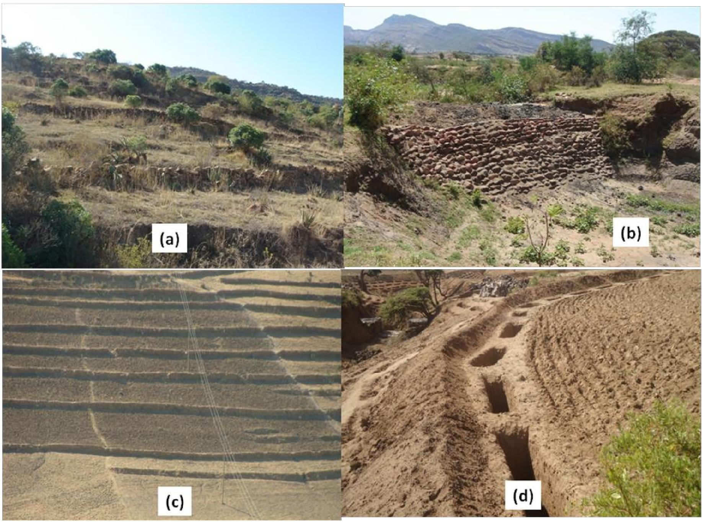
Some of the soil and water conservation measures in the study area in Ethiopia: Hillside terraces (a), Checkdams (b), Stone bunds (c) and trench bunds (d)
13
Burkina faso
The types of the soil and conservation techniques depend on the average precipitation, soil type and the topography. Thus, in wet areas where leaching of nutrients from the soil and water erosion are problems for agricultural production, soil conservation measures are of vital importance. However, in the dry areas where water is the main constraint of the agricultural production, water harvesting techniques are predominant (Bandré and Batta, 1998). According to the agroclimatic zoning of Burkina Faso, a variety of traditional and new soil and water conservation techniques are encountered (Vlaar, 1992) (Table 1).
Table 1 Adaptability of soil and water conservation techniques in Burkina Faso (adapted from Vlaar, 1992).
14
 | Function | Agro-climatic zone |  |  | Soil types |  |  |  | Topography
 | Function | Sahelian | Soudano | Soudano-  sahelian | Clay loamy | Sandy loam | Sandy | With crusts | Steep  slopes | Moderate  slopes
Deep ploughing | CE | - | + + | + | + + | + | - | + + | + | + +
Zaï | CS/CE/CR | +/- | + + | - | + | + + | - | + + | + | +
Half moon | CS/CR | + + | + | - | + | + + | - | + | + | + +
Earth dike | CS/CE | + | + + | - | + | + + | - | + | - | + +
Ditch bunds | CS/CE/CR | + | + + | + | + | + + | - | + | + | + +
Rocky bunds | CS/CE | - | + + | + | + + | + + | + | + | + | + +
In filtration dike | CS/CR (2) | + | + + | + | + + | + + | + | + | - | + +
Gully treatment | CS | + | + + | + + | + | + + | + + | + | + | +
Vegetation strips | CS | - | + | + + | + | + | + | + | + | +
+ + Highly adapted
+ moderately adapted - poorly adapted
CS = conservation of soil against water erosion CE = conservation of water
CR = runoff water harvesting
EE = conservation of soil against wind erosion
Sawadogo et al. (2011) reported that in a study in two villages (Somyaga and Ziga, North West Burkina), the rate of adoption of soil and water conservation measures by farmers ranged between 0% (no adoption) to more than 40%. They found that Zai scored the maxium rates in both villages while half moon was the least adopted, as they are at experimental stage as shown in the following table.
Percentage of the areas treated with SWC techniques in the villages of Somyaga and Ziga, North West Burkina
Village |  |  | SWC techniques
Village | Without SWC | Zaï | Rocky bunds | Rocky bunds +Zaï | Half-moons
Somyaga Ziga | 42.1 | 28.9 | 18.4  12.2 | 7.9 | 2.6  2.4
Somyaga Ziga | 31.7 | 51.2 | 18.4  12.2 | 2.4 | 2.6  2.4
Average | 36.7 | 40.5 | 15.2 | 5.1 | 2.5

Source : Sawadogo et al. (2011).

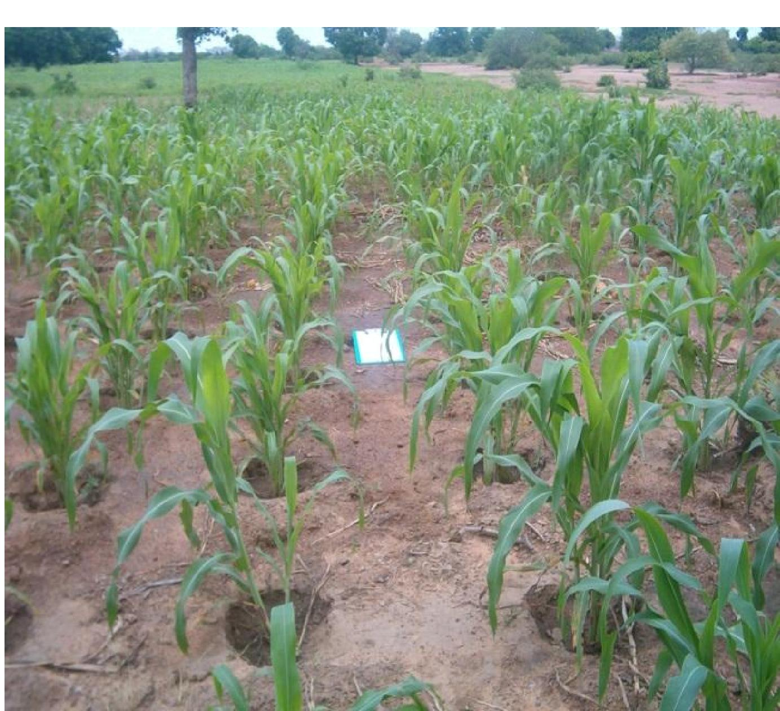

Sorghum in Zaï pits.
15
Tunisia
Overview of water harvesting
A comprehensive survey of traditional hydraulic works in the Maghreb countries was carried out by El Amami (1982). This document, written in Arabic, was followed by a second document, written in French, on Tunisia (El Amami, 1984). These manuscripts cover all the local small-scale irrigation techniques used in North Africa, with particular attention being paid to Tunisia. The English term ‘water harvesting’ was not specifically used by these reports to describe the indigenous systems of runoff water capture and use. The term was, in fact, only recently introduced into North Africa, the people in these countries being far more conversant with the French language. The terminology used in these reports refers to water harvesting techniques (WHT) as ‘small hydraulic structures or systems’. However, the techniques

described exhibit the three main characteristics of water harvesting listed by Boers and Ben-Asher (1982): (1) they are applied in arid and semi-arid regions, (2) they depend upon local water, and (3) they are relatively small-scale operations. El Amami’s fundamental works (1982; 1984) have triggered increased awareness of the potential indigenous technologies have in terms of drought mitigation. Since the works were published, a large number of studies have been made of the methods used to induce, collect, store and conserve local surface runoff for agriculture in arid and semi-arid regions. A compilation of these techniques was recently produced by Ennabli (1993), Ben Mechlia and Ouessar (2004), Ouessar et al. (2006), and Ouessar (2007).
16
Undoubtedly, the various water harvesting techniques (which are used on approximately one million hectares within Tunisia) are considered to be an integral part of the country’s national heritage. Not only do these techniques contribute to the country's wealth by increasing agricultural productivity and by enhancing natural vegetation, they play a key role in the protection of its natural resources (MEAT, 1998) and in the maintenance of social equilibrium in the different regions.
The main water harvesting techniques encountered in the country can be subdivided into three major groups: (1) runoff water harvesting that makes use of runoff as it is collected, thus eliminating the need for storage-included among such systems are the related micro-catchment techniques called meskat and jessour; (2) floodwater harvesting and spreading or spate irrigation using diversion dykes (mgoud); and (3) runoff water collection and storage in reservoirs of variable capacities, which provides drinking water for people and animals, as well as water for irrigation purposes.
! ^{Small to medium cistem}  ³⁰⁰⁰⁰⁰ ⁵⁰⁰⁰⁰⁰ ⁷⁰⁰⁰⁰⁰  #  !@  #  !@  #  !@  #  !@  #  !  !@  ± ±  ! ±  !@  !.  !@  ±  #  !.  #  !.  !@  ±  !@  #  !  !.  !.  !  #  !@  !@  !  ±  !  ±  !@  !  !@  !@  !  !  !  !@  ±  !@ ±  !  !  ^{Legend}  !  !  !@  ±  !@  !@ ±  ±  ^{Flood spreading}  ^{Jessour}  ^{Meskat}  ^{Wadi}  !@ ^{Gabion check dams}  # ^{Hill lake}  !. ^{Large cistem}  ± ^{Tabias}  ^{Sebkha}  ^{Recharge wells}  !  ⁰ ³⁰ ⁶⁰ ¹²⁰  ^{Km}  µ  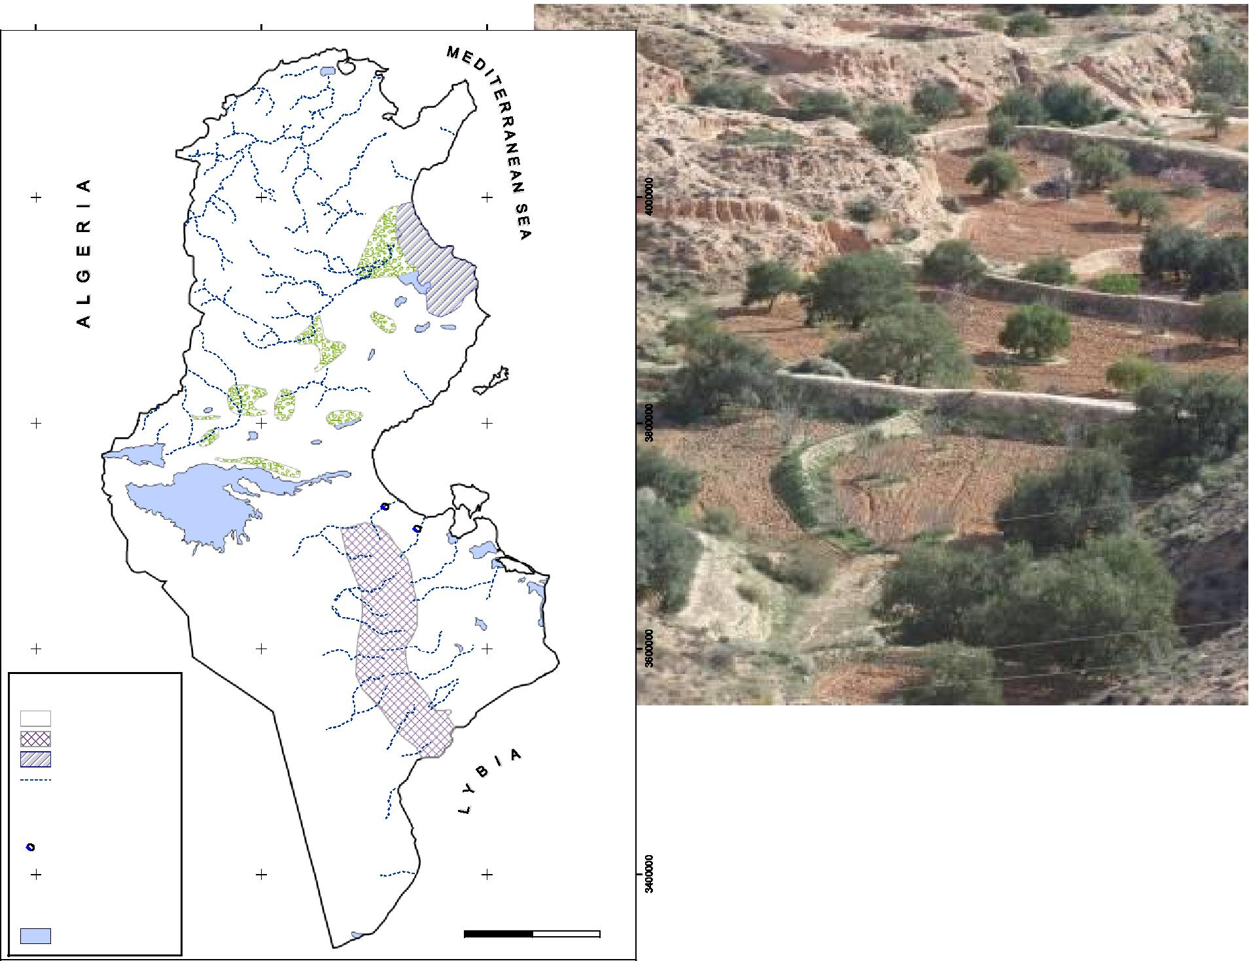  Main WHT encountered in Tunisia (Ouessar 2007). | Jessour in Southern Tunisia

Success stories
17
A commonly applied water harvesting technique in Tunisia is the jessr, in which runoff from a micro catchment, called impluvium, is collected on a terrace in order to increase water availability for vegetation (crop and trees). In this study, infiltration and runoff measurements were carried out at the impluvium of the Amrich jessr (southeastern Tunisia) in order to predict runoff and sediment transport for different rainfall events. The simulation results indicated the importance of the jessr in retaining water and sediment. Furthermore, over a period of 3 years, rainfall and infiltration data were used to assess the water balance on the terrace of the jessr. The results showed that especially during dry years the impluvium of the jessr provides an important supplementary amount of water for the cultivation of olive trees (Olea europeae). Finally, it was estimated that the ratio “impluvium area/terrace area” (CCR) should be at least 7.4 in order to provide, on average, sufficient water for olive cultivation, taking into account an average annual precipitation of 235 mm (Schiettecatte et al., 2004).
In arid Tunisia, a tabia system is a traditional macrocatchment water harvesting system. It consists of a runoff area, which occupies two thirds of the slope and is traditionally used for grazing; and one to five cropped plots within U-shaped soil banks arranged in a cascade in the third downstream area. These “run-on” areas accumulate and store the occasional runoff. Each soil bank is constructed with a discharge weir that allows modification of the flooded area and discharge of excess water towards downstream plots. Such a harvesting system, located in an area with 140 mm annual rainfall, was instrumented during four hydrological years (1995–1999) and 45 rainfall events were recorded. Eleven of these events gave a measurable inflow to at least one of the four plots. The observations showed that the traditional tabia system reduced total surface runoff from the catchment to essentially zero. The harvesting system significantly reduced peaks of surface runoff within the catchment, which also reduced erosion hazards. The cultivated area of about 5% of the total catchment could be supplied by a harvested water amount corresponding to about seven times the amount of each rainfall event larger than 20 mm (Nasri, 2002).
Zambia
Handia et al. (2003) reported that rainwater harvesting is a technology which is traditional in some parts of Zambia. It is done on an ad hoc, very low tech basis usually by placing buckets under the eaves to catch rain during storms/storing the water in containers such as old 210 l oil drums. Very few RWH systems had been installed, mainly at schools, but this was not widespread. These were roof harvesting systems consisting of a roof catchment, gutters and tank. The water was drawn through a tap from the tank. The water was used for drinking and washing by pupils, teachers and nearby communities. The Ministry of Agriculture had constructed a number of different rainwater harvesting systems for rural areas especially in the Eastern Province. Some of these were roofwater harvesting systems with ferrocement and brick tanks. Some of the installations were at schools whilst others were at individual houses. Livingstone Sustainable Food Programme had also worked with the rural communities. The structures constructed were mainly dams, weirs and boreholes. The local government, with support from UNICEF was planning to start piloting in 10 districts of 2 provinces. A RWH Association of Zambia had been formed to promote RWH in the country.
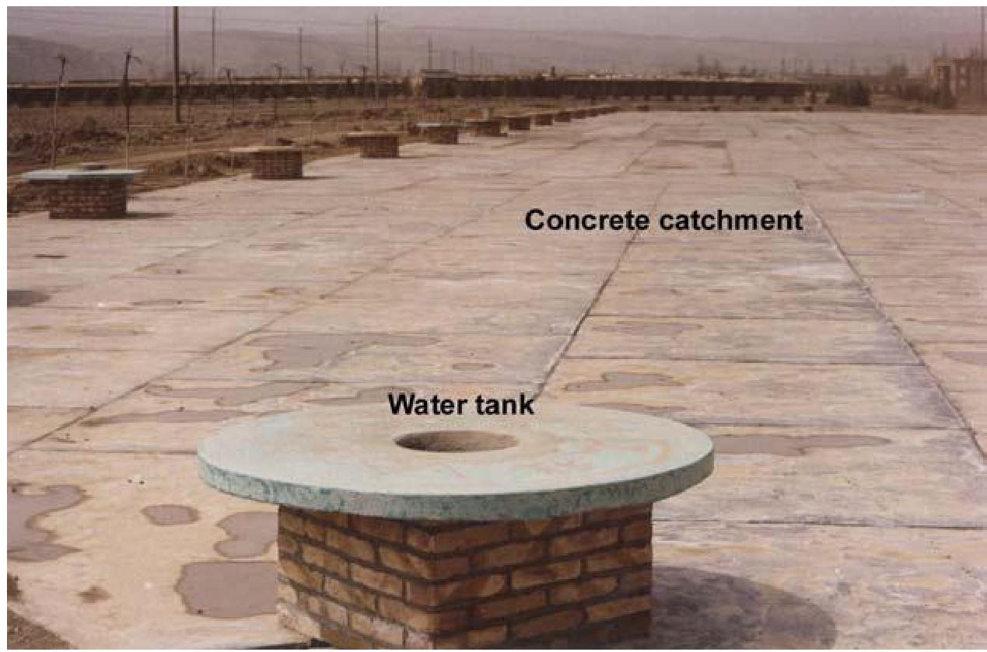
Water tank in Zambia.
18
- Conclusions
The African continent is very rich in various water harvesting and soil conservation technologies. They vary from macro and micro-catchment and floodwater harvesting to atmospheric and insitu water conservation technologies. The existing well known traditional and indigenous practices have been either improved and/or new technologies have been introduced to complement them. The same trends have been also observed in all the study sites. However, as Ethiopia and Zambia study sites are located in more humid climates, more soil conservation technologies are in use whereas the water harvesting practices are frequently encountered in Tunisia and Burkina study cases where the climate is drier. The high levels of the local know-how of the stakeholders (especially farmers, engineers, etc.) and their willingness to be fully involved in the different steps of the implementation of the project are key signs for good prospects of project progress in the study sites, especially the coming workshop on selection of the technologies to be implemented and monitored in the study sites, which will be implemented in WP2.
- References
Alaya, K., Viertmann, W., Waibel, Th. 1993. Les tabias. Imprimerie Arabe de Tunisie, Tunis, Tunisia. 192 pp.
Alouani, B. 1997. The Tunisian experience in the realisation of small dams and hill lakes (in Arabic). Rapport interne, Ministère de l’Agriculture, Tunis, Tunisia.
Bardin V. 2012. Water Harvesting Technologies (WHT) in Africa - a literature review focused on Tunisia and Burkina Faso. Wageningen University, The Netherlands.
Batta F. et Bandré P., 1998: Conservation des eaux et des sols (CES) au Burkina Faso/Overseas Development Institute/Voisins Mondiaux, 1998.
Chahbani, B. 1984. Contribution à l’étude de l’érosion hydrique des loess des Matmata et de la destruction des jessour: Bassin versant d’oued Demmer, Béni Khédache. M.Sc. thesis, Universite de Paris I, Paris.
El Amami, S. 1984. Les aménagements hydrauliques traditionnels en Tunisie. Centre de Recherche en Génie Rural (CRGR), Tunis, Tunisia. 69 pp.
Ennabli, N. 1993. Les aménagements hydrauliques et hydro-agricoles en Tunisie. Imprimerie Officielle de la République Tunisienne, Tunis, 255 pp.
Handia L., J.M. Tembo, C. Mwiindwa 2003. Potential of rainwater harvesting in urban Zambia. Physics and Chemistry of the Earth 28 (2003) 893–896.
Metameta and Acacia Water 2011. Overview of best practices.
19
Nasri, S. 2002. Hydrological effects of water harvesting techniques. Ph.D. thesis, Lund University, Sweden, 104 pp.
Ngigi, S.N., 2003. What is the limit of up-scaling rainwater harvesting in a river basin? Physics and Chemistry of the Earth 28: 943–956.
Ouessar M. 2007. Hydrological impacts of rainwater harvesting in wadi Oum Zessar watershed (Southern Tunisia). Ph.D. thesis, Faculty of Bioscience Engineering, Ghent University, Ghent, Belgium, 154 pp.
Oweis, T., Hachum, A., Kijne, J., 1999. Water harvesting and supplementary irrigation for improved water use efficiency in dry areas. SWIM paper No. 7. International Water Management Institute, Colombo, Sri Lanka.
Prinz, D., 1996. Water Harvesting: Past and Future. In: Pereira, L. S. (ed.), Sustainability of Irrigated Agriculture. Proceedings, NATO Advanced Research Workshop, Vimeiro, 21- 26.03.1994, Balkema, Rotterdam, 135-144.
Sawadogo H., Dao V., Ouedraogo B., Kini J., Kondombo S. 2011. WAHARA study site description in Burkina Faso.
Schiettecatte, W., Ouessar, M., Gabriels, D., Tanghe, S, Heirman, S., Abdelli, F. 2005. Impact of water harvesting techniques on soil and water conservation: a case study on a micro catchment in southeastern Tunisia. Journal of Arid Environments, 61: 297-313.
Siegert, K., 1994 Introduction to water harvesting: some basic principles for planning, design and monitoring. In: Water harvesting for improved agricultural production. Proceedings of the FAO expert consultation. Cairo, Egypt, 21-25 November 1993, FAO, Rome.
SIWI, 2001. Water Harvesting for Upgrading of Rainfed Agriculture. Problem analysis and research needs. SIWI Report 11. Stockholm International Water Institute, Stockholm, Sweden.
Vlaar J.C.J., 1992. Les techniques de conservation des eaux et des sols dans les pays du Sahel. CIEH Burkina Faso, Université Agronomique de Wageningen.
Vohland K, Barry B. 2009. A review of in situ rainwater harvesting (RWH) practices modifying landscape functions in African drylands. Agriculture, Ecosystems and Environment 131: 119-127.
Woldearegay K. 2002. Surface water harvesting and groundwater recharge with implications to conjunctive water management in arid to semi-arid environments (with the model of the Mekelle area, northern Ethiopia). Proceedings of the International Conference on Public Management, Policy and Development, June 3-6, 2001, Addis Ababa.
Woldearegay K. 2010. Surface water harvesting using small-scale dams in northern Ethiopia: challenges, opportunities and future directions. A paper presented at the International Seminar on „Challenges in the application of Integrated Water Resources Management“, March 15-16, 2010, Water and Environment Center, Sana’a University, Republic of Yemen.
Woldearegay K. 2011. WAHARA study site description. Mekele University, Mekele, Ethiopia. Woldearegay K. 2012. WAHARA stakeholder report. Mekele University, Mekele, Ethiopia.
Woldearegay K., Behailu M., Tamene L. 2006. Conjunctive use of surface and groundwater: a strategic option for water security in the northern highlands of Ethiopia. Proceedings of the HIGHLAND 2006 Symposium, September 08-25, 2006, Mekelle University, Ethiopia.

