Karamoja Water Harvesting Field Guide
This is a field guide detailing various water harvesting methods for the purpose of irrigation, livestock, and general water stocking for non-potable water use in the semi-arid Karamoja region. All water harvesting techniques contained in this guide are best implemented with an onsite hands-on demonstration/training to ensure correct transfer of techniques and project sustainability.

Important Note: Consult an agronomist before implementing any water harvesting techniques for crops. Many WH techniques will result in temporary water logging of the soil during higher than average rain events. Various drought resistant crops may not tolerate high moisture soil conditions.

By: Jack T. Chow, ACF Water Harvesting consultant
Introduction: What is water harvesting?

Water harvesting (WH) can be traced back through human history almost as far as the origins of agriculture. WH is defined as the redirection and productive use of rainfall. Unlike conventional irrigation, however, water harvesting does not depend on a constant flow of water; it is totally dependent on rain. Basically, harvesting involves a variety of methods used to get as much water as possible out of each rainfall. These ancient practices sustained ancient people when conditions would have otherwise totally prevented agriculture. Many peoples in the world have continued to rely on water harvesting practices.
WH can be considered as a rudimentary form of irrigation. The difference is that with WH the farmer (or more usually, the agro-pastoralist) has no control over timing. Runoff can only be harvested when it rains. In regions where crops are entirely rain fed, a reduction of 50% in the seasonal rainfall, for example, may result in a total crop failure. If, however, the available rain can be concentrated on a smaller area, reasonable yields will still be received. Of course in a year of severe drought there may be no runoff to collect, but an efficient water harvesting system will improve plant growth and increase likelihood of successful harvest in the majority of years.
Why water harvest in Karamoja?
In semi-arid lands – lands which receive only 300-700mm of rain each year – rainwater harvesting can help supply enough water to improve crop yields. In these dry climates, as many as four out of five seasons end up as either total crop failures or the harvest are too low to break-even. However, it is possible to double or triple crop yields through rainwater harvesting, using natural rainfall.
What is the most appropriate WH system for Karamoja?
It really depends on the site and topography. Appropriate WH systems should ideally evolve from the experience of traditional techniques - where these exist. They should also be based on lessons learned from the shortcomings of previous projects. Above all it is necessary that the systems are appreciated by the communities where they are introduced. Without popular participation and support, projects are unlikely to succeed.
Where is water harvesting most effective?
SLOPE: Water harvesting is not recommended for areas where slopes are greater than 5% due to uneven distribution of run-off and large quantities of earthwork required which will not be economical.
SOILS: For water harvesting to be effective, the soils need to be suitable for irrigation: they should be deep, not saline or sodic, and ideally be naturally fertile. Water harvesting will not work on soils with a sandy texture, because the infiltration rate will be too high. If the water soaks in as fast as it falls from the sky, no runoff will occur.

This field guide contains simplified WH techniques based on the comprehensive water harvesting manual published by FAO. Most of the diagrams and illustrations in this guide are adapted from the FAO manual. This field guide divides different water harvesting methods into four main categories: 1-small earth dams, 2-microcatchments, 3 - long slope flood water catchment, 4 – saturating groundwater storage. Table 1 summarizes the variety of WH options, their main use, brief description, appropriate use, and disadvantages. Brief discussion of rock catchments is also given since certain regions in Karamoja include potential sites for utilizing this special water harvesting technique.

Category | WH Options | Main use | Description | Where appropriate | Disadvantages
Small Earth Dams | Hillside dam | Stocking water | Dams characterized by being situated on a gentle slope catchment area on a hillside | Hillsides with gentle sloping catchment | High earthwork to water storage volume ratio
 | Charcot dam | Stocking water | Dams characterized by having a well defined narrow gully leading to an excavated circular reservoir | Having a well defined natural narrow gully | Potentially sandier soil at gully way. Heavy siltation from gully runoff.
Microcatchment  (short slope) | Negarim catchment | Trees | Closed grid of diamond shapes or open-ended "V" s formed by small earth ridges, with infiltration pits | For tree planting in situations where land is uneven or only a few tree are planted | limited to small scale.
 | Contour ridge/bunds | Trees/  crops | Earth bunds on contour spaced at 5-10 meters apart with furrow upslope and cross-ties | For crop or tree planting in semi-arid areas especially where soil fertile and easy to work | Not suitable for uneven terrain. Requires new technique of land preparation and planting, therefore may be problem with acceptance
Flood water long slope catchment | Permeable rock/check dams | crops | Long low rock dams across valleys slowing and spreading floodwater as well as healing gullies | Suitable for situation where gently sloping valleys are becoming gullies and better water spreading is required | Very site-specific and needs considerable stone as well as provision of transport
 | water spreading bunds | crops | Earth bunds set at a gradient, with a "dogleg" shape, spreading diverted floodwater | For arid areas where water is diverted from watercourse onto crop | Does not impound much water and maintenance high in early stages after construction
 | trapezoid bunds | crops | Trapezoidal shaped earth bunds capturing runoff from external catchment and overflowing around wingtips | Widely suitable (in a variety of designs) for crop production in arid and semi-arid areas | Labor-intensive and uneven depth of runoff within plot.
saturating ground water storage | subsurface dam | Stocking water | Concrete dam build on the bedrock of a sandy riverbed, trapping water under the sand surface of a dry riverbed | Narrow passage of a seasonal dry riverbed. Avoids surface water evaporation, contamination. | Critical site selection requires technical expertise/equipment. More expensive than earth dams. Does not store as much water as regular surface dams
Table 1: Four main categories of water harvesting options.
Negarim microcatchment:
Negarim microcatchments are diamond-shaped basins surrounded by small earth bunds with an infiltration pit in the lowest corner of each catchment basin (See Figures 1, 2). Runoff is collected from within the basin and stored in the infiltration or the planting pit. Microcatchments are mainly used for growing trees or bushes. This technique is appropriate for small-scale tree planting in any area which has a moisture deficit such as the Karamoja region. Besides harvesting water for the trees, it simultaneously conserves soil. Negarim microcatchments are neat and precise, and relatively easy to construct. This technique has been developed in the Negev desert of Israel. The word "Negarim" is derived from the Hebrew word for runoff - "Neger". Negarim microcatchments are a well-proven technique; it is often one of the first to be tested by new projects.

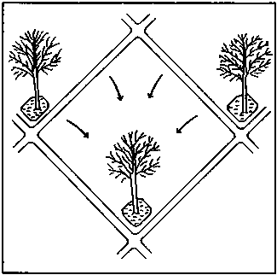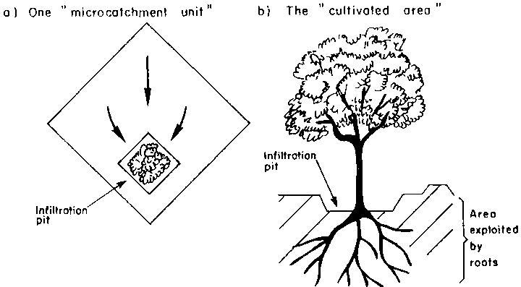
Figure 1: Negarim microcatchment

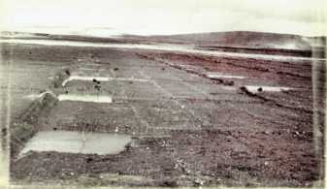
Figure 2: Field photos of Negarim catchments. Note the temporary water logging of the cultivation area/planting pit. Adapted from [Ref 2]
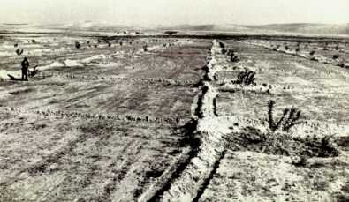
Figure 3: Field photos of Negarim catchments. Adapted from [Ref 2]

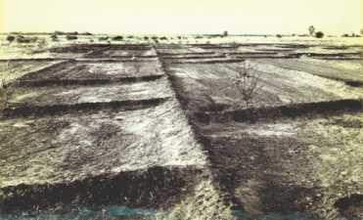
Figure 4: Field photos of Negarim catchments. Adapted from [Ref 2]

Technical details:
- Suitability
- Negarim microcatchments are mainly used for tree growing in arid and semi arid areas.
- Rainfall: can be as low as 150 mm per annum.
- Soils: should be at least 1.5 m but preferably 2 m deep in order to ensure adequate root development and storage of the water harvested.
- Slopes: from flat up to 5.0%.
- Topography: need not be even - if uneven a block of microcatchments should be subdivided.
- Overall configuration
Each microcatchment consists of a catchment area and an infiltration (planting) pit or cultivated area. The shape of each unit is normally square, but the appearance from above is of a network of diamond shapes with infiltration pits in the lowest corners (see Figure 5).
- Limitations
While Negarim microcatchments are well suited for hand construction, they cannot easily be mechanized. Once the trees are planted, it is not possible to operate and cultivate with machines between the tree lines. This limitation would not be a factor in most Karamoja projects since machines are not utilized.
- Microcatchment size
The area of each unit is determined on the basis of a calculation of the plant (tree) water requirement. Soil bund heights are shown in figure 5. The calculations of the required catchment area can be a rather involved process. Many successful water harvesting systems have been established by merely estimating the ratio between catchment and cultivated area. This may indeed be the only possible approach where basic data such as rainfall, runoff and crop water requirements are not known, such as in the Karamoja context.

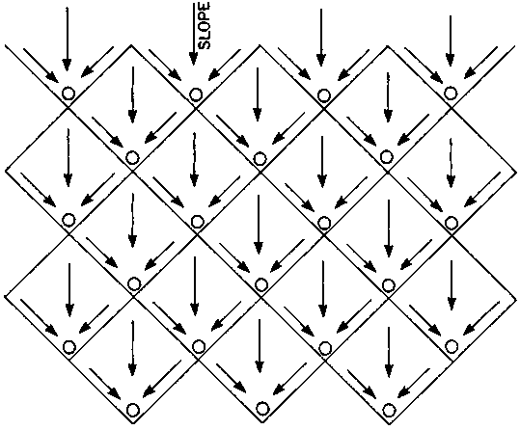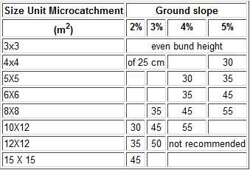
Figure 5: Negarim microcatchment layout and soil bund height table.

A common variation is to build microcatchments as single, open-ended structures in "V"
or semi-circular shape (see Figure 6). The advantage is that surplus water can flow around the tips of the bunds; however, the storage capacity is less than that of a closed system. These types of bunds are particularly useful on broken terrain, and for small numbers of trees around homesteads. In Karamoja this V-shaped soil bunds can be implemented after the tree seedlings are already in place. The 3mx3m spacing is the minimum spacing required for the Negarim catchment.

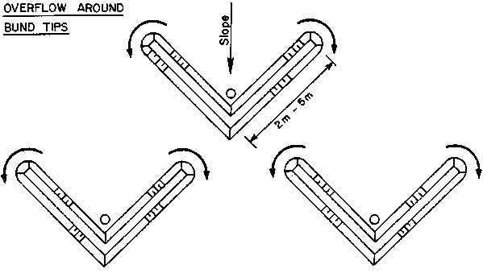
Figure 6: V-shaped Negarim catchment, suitable when seedlings already in place.

Construction of Negarim catchment:
- The first step is to find a contour line. This can be done by using a line level or an A-frame. Since natural contours are often not smooth, it will be necessary to even out the contours so that finally a straight line is obtained. The first line, at the top of the block is marked (see Figure 7). If the topography is very uneven, separate smaller blocks of microcatchments should be considered.
- By means of a tape measure, the tips of the bunds are now marked along the "straightened contour". The first line will be open-ended. The distance between the tips (a-b) depends on the selected catchment size (see Figure 7).
- A piece of string as long as the side length of the catchment (5 m for a 5 m x 5 m microcatchment) is held at one tip (a) and a second string of the same length at the other tip (b). They will exactly meet at the apex (c). The apex is now marked with a peg and the catchment sides (a-c) and (b-c) marked on the ground alongside the strings with a hoe. This procedure will be repeated until all bund alignments in the first row have been determined (see Figure 7).
- The next row of microcatchments can now be staked out. The apexes of the bunds of the upper row will be the tips for the second row and the corresponding apex will be found according to Step 3. When the second row of microcatchments has been marked, repeat the same procedure for the third row, etc. The final result will be a block of diamond-shaped microcatchments, with a first row which is open at the upslope end.

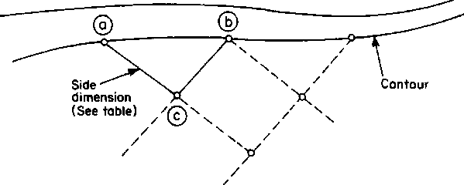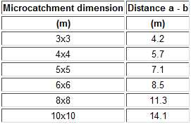
Figure 7: Negarim catchment construction layout

- Before constructing the bunds, the area within the microcatchments should be cleared of all vegetation. The bunds should then be constructed in two layers. The excavated material from the planting pit is used to form the bund.
- The bunds should be compacted during construction. Before compaction, the soil should be wetted wherever possible. Compaction may be done by foot or with a barrel filled with sand or water. To ensure a uniform height of the bund, a string should be fixed at the beginning and the end of each bund alignment and be adjusted above ground according to the selected bund height.
- The size of the infiltration pit is staked out and the pit is excavated - leaving a small step towards the back on which the seedling will be planted (See figure 9)

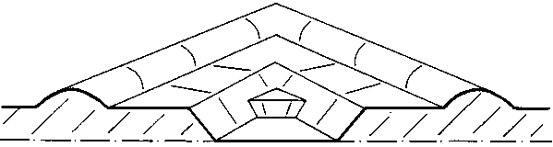
Figure 8: Planting/infiltration pit.

Maintenance:
Maintenance will be required for repair of damages to bunds, which may occur if storms are heavy soon after construction when the bunds are not yet fully consolidated. The site should be inspected after each significant rainfall as breakages can have a "domino" effect if left unrepaired.

Tree seedlings of at least 30 cm height should be planted immediately after the first rain of the season. It is recommended that two seedlings are planted in each microcatchment - one in the bottom of the pit (which would survive even in a dry year) and one on a step at the back of the pit. If both plants survive, the weaker one can be removed after the beginning of the second season. For some species, seeds can be planted directly. This eliminates the cost of a nursery.
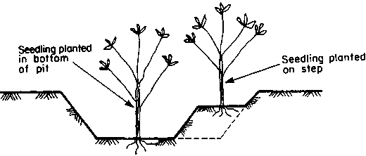
Figure 9: Seedlings in planting pit
Contour ridge/bunds:
Contour ridge/bunds for crops/trees are another form of microcatchments. As its name indicates, the ridge/bunds follow the contour, at appropriate spacing, and by provision of small catchment strips the system is divided into individual microcatchments.

Runoff is collected from the uncultivated strip between ridges and stored in a trench just above the ridges (see Figures 10, 11). Crops are planted on both sides of the trench. The system is simple to construct by hand and can be even less labor intensive than the conventional tilling of a plot.

The yield of runoff from the very short catchment lengths is extremely efficient and when designed and constructed correctly there should be no loss of runoff out of the system. Another advantage is an even crop growth due to the fact that each plant has approximately the same contributing catchment area.

Technical details:
- Suitability
- Contour bunds/ridges can be used under the following conditions:
- Rainfall: 200 - 750 mm; from semi-arid to arid areas.
- Soils: Must be at least 1.5 m and preferably 2 m deep to ensure adequate root development and water storage.
- Slopes: from flat up to 5.0%.
- Topography: must be even, without gullies or rills.

- Limitations
Contour bunds are not suitable for uneven or eroded land as overtopping of excess water with subsequent breakage may occur at low spots.

- Overall Configuration
The overall layout consists of a series of parallel, or almost parallel, earth ridge/bunds approximately on the contour at a spacing of between 1-2 meters for crops and 5 to 10 meters for trees. (see Figure 10)

The bunds are formed with soil excavated from an adjacent parallel trench on their upslope side. Small earth ties perpendicular to the bund on the upslope side subdivide the system into microcatchments. Infiltration pits are excavated in the junction between ties and bunds. A diversion ditch protects the system where necessary. (see Figure 12)

Construction:
- Contours are surveyed by a simple surveying instrument such as an A-frame or line level. The real contour should be smoothed to obtain a better alignment for agricultural operations.

- Contour keylines should be staked out every 10 or 15 meters. The alignment for the ridges is then marked in between the keylines according to selected spacing. On uneven terrain, the contours may come closer together at one point or widen at other points. It is necessary to stop lines where the contours converge or to add short extra lines in between where the contours diverge.

- The trenches are excavated usually by means of a hoe or are ploughed parallel to the marked alignments for the ridges. The excavated soil is placed downslope, next to the furrow, and the ridge is formed.

- Small cross-ties are built at intervals of about 5 meters dividing each trench into a number of segments. The ties are 15-20 cm high and 50 - 75 cm long.

- A diversion ditch should be provided above the block of contour ridges if there is a risk of damage caused by runoff from outside the system. The diversion ditch should be 50 cm deep and 1-1.5 m wide, with a gradient of 0.25%. The excavated soil is placed downslope. The ditch should be constructed before the contour ridges are built to prevent damage from early rains.
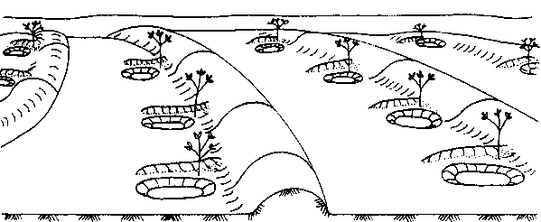
Figure 10: Contour bonds for tree planting.

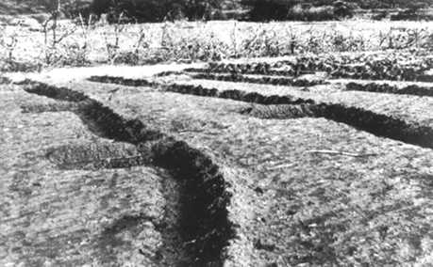
Figure 11: Field photo of contour ridges for crops.

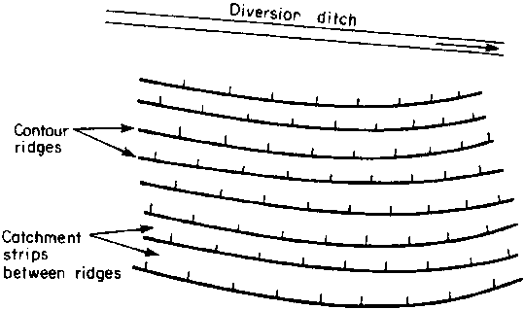

Figure 12: Contour bund/ridge field layout (diversion ditch optional)

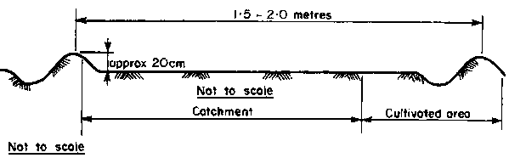
Figure 13: Contour ridge cross sectional view. Ridges need only be as high as necessary to prevent overtopping by runoff. Bund spacing for trees would need to be 5-10m.

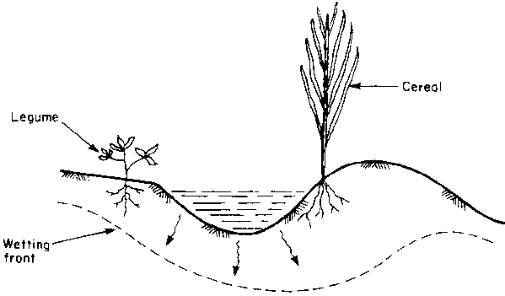

Figure 14: Contour ridge planting guide

Maintenance:
If contour ridges are correctly laid out and built, it is unlikely that there will be any overtopping and breaching. Nevertheless if breaches do occur, the ridges or ties must be repaired immediately. The uncultivated catchment area between the ridges should be kept free of vegetation to ensure that the optimum amount of runoff flows into the trenches.

At the end of each season the ridges for crops need to be rebuilt to their original height. After two or three seasons, depending on the fertility status of the soils, it may be necessary to move the ridges downslope by approximately a meter or more, which will result in a fresh supply of nutrients to the plants.

Permeable rock/check dams:
Permeable rock dams are a floodwater farming technique where runoff waters are spread in valley bottoms for improved crop production (see Figure 15). Developing gullies are healed at the same time. The structures are typically long, low dam walls across valleys. Permeable rock dams can be considered a form of "terraced wadi", though the latter term is normally used for structures within watercourses in more arid areas.
The large amount of work involved means that the technique is labor intensive and needs a group approach, as well as some assistance with transport of stone.
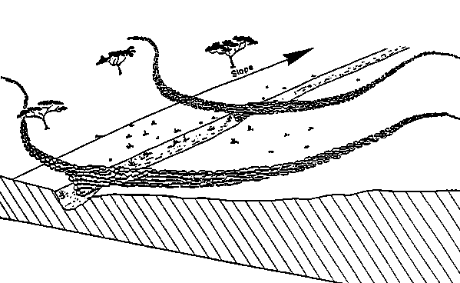
Figure 15: Permeable rock/check dam

Technical Details:
- Suitability
Permeable rock dams for crop production can be used under the following conditions:

- Rainfall: 200 -750 mm; from arid to semi-arid areas.
- Soils: all agricultural soils - poorer soils will be improved by treatment.
- Slopes: best below 2% for most effective water spreading.
- Topography: wide, shallow valley beds.
- The main limitation of permeable rock dams is that they are particularly site-specific, and require considerable quantities of loose stone as well as the provision of transport.

- Overall configuration

A permeable rock dam is a long, low structure, made from loose stone (occasionally some gabion baskets may be used) across a valley floor. The central part of the dam is perpendicular to the watercourse, while the extensions of the wall to either side curve back down the valleys approximately following the contour. The idea is that the runoff which concentrates in the centre of the valley, creating a gully, will be spread across the whole valley floor, thus making conditions more favorable for plant growth. Excess water filters through the dam, or overtops during peak flows. Gradually the dam silts up with fertile deposits. Usually a series of dams is built along the same valley floor, giving stability to the valley system as a whole.

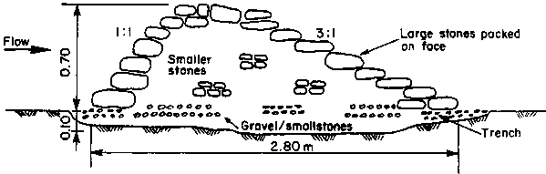
Figure 16: Permeable rock/check dam cross section

- Dam design

The design specifications given below are derived from a number of permeable rock dam projects in West Africa (see Figure 16). Each project varies in detail, but the majority conform to the basic pattern described here.

The main part of the dam wall is usually about 70 cm high although some are as low as 50 cm. However, the central portion of the dam including the spillway (if required) may reach a maximum height of 2 m above the gully floor. The dam wall or "spreader" can extend up to 1000 meters across the widest valley beds, but the lengths normally range from 50 to 300 meters. The amount of stone used in the largest structures can be up to 2000 tons.

The dam wall is made from loose stone, carefully positioned, with larger boulders forming the "framework" and smaller stones packed in the middle like a "sandwich". The sideslopes are usually 3:1 or 2:1 (horizontal: vertical) on the downstream side, and 1:1 or 1:2 on the upstream side. With shallower side slopes, the structure is more stable, but more expensive.

For all soil types it is recommended to set the dam wall in an excavated trench of about 10 cm depth to prevent undermining by runoff waters. In erodible soils, it is advisable to place a layer of gravel, or at least smaller stones, in the trench.

- Quantities and labor

The quantity of stone, and the labor requirement for collection, transportation and construction depends on a number of factors and vary widely.
Transport of stones by lorries from the collection site to the fields in the valley is the normal method. Considerable labor may be required to collect, and sometimes break, stone. Labor requirements, based on field estimates, are in the range of 0.5 cubic meters of stone per person/day - excluding transport.

- Design variations

Where permeable rock dams are constructed in wide, relatively flat valley floors, they are sometimes made straight across - in contrast to the usual design where the spreader bunds arch back from the centre to follow the contour. With straight dams, the height of the wall decreases from the centre towards the sides of the valley to maintain a level crest.

Permeable rock dams are similar in many respects to the "terraced wadis" traditionally used in North Africa and the Middle East. However, the terraced wadi system is used in more arid regions, across clearly defined watercourses. Cross-wadi walls of stone retain runoff to depths of up to 50 cm, with the excess flowing over spillways into successive terraces below. Crops and fruit trees utilize the residual moisture.

The "Liman" system, principally reported from Israel, is used on flood plains or in broad "wadi" beds. Bunds, often of earth, pond water to depths of 40 cm, and excess drains around an excavated spillway. "Limanim" (plural of Liman) may be constructed in series along a wadi bed. This technique is found where rainfall is as low as 100 mm per annum, and is used for crops, fruit trees or forestry.

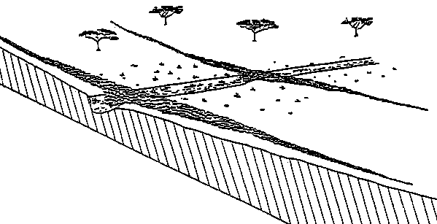
Figure 17: Check dam design variation example

Construction:

- Site selection depends both on the beneficiaries and the technicians. Theoretically it is best to start at the top of the valley, though this may not always be the people's priority. After site identification it is necessary to determine whether the structure needs a defined spillway: as a rule of thumb no spillway is required if the gully is less than one meter deep. For greater depths, a spillway is recommended. Gullies of over two meters depth pose special problems and should be only tackled with caution. It is important not to build a permeable rock dam immediately above a gully head, as there is the risk that the dam will fall into the gully if continued erosion causes the gully head to cut back.

- The alignment of the main dam walls can be marked out, starting at the centre of the valley (where there may/may not be a spillway). This alignment is ideally along the contour, or as close to the contour as possible. Thus the extension arms sweep backwards in an arc like the contours of a valley on a map. The arms end when they turn parallel to the watercourse. The contour can be laid out simply using an A-frame or line level.

- A typical cross section (taken from the design of the PATECORE project in Burkina Faso - see Figure 16) is recommended for general use. This is of 280 cm base width, 70 cm height and side slopes of 1:1 upstream and 3:1 downstream. Larger cross sections may be required dependent on catchment characteristics.
The first action after aligning the extension arms of the dam is to dig a trench at least 10 cm deep and 280 cm wide (according to the base width of the bund). The earth should be deposited upslope and the trench filled with gravel or small stones.

- The skill of construction is in the use of large stones (preferably of 30 cm diameter or more) for the casing of the wall. This should be built up gradually following the required sideslope, and the centre packed with smaller stones. The whole length of the bund should be built simultaneously, in layers. This layered approach reduces the risk of damage by floods during construction. Earth should not be mixed with the stone because it may be washed out and thus destabilize the structure. It is particularly important to pack the small stones well at the lower levels to increase the rate of siltation. The structure is finished off with a cap of large stones. It should be possible to walk on the structure without any stones falling off. The dam wall should be level throughout its length, which can be checked by the use of a water tube or line level.

- If a series of permeable rock dams is to be built, an appropriate vertical interval (VI) should be selected. Technically speaking it is correct to:

i. start at the top of the valley and work down;

ii. use a VI equal to the height of the structure - so that the top of one structure is at the same level as the base of the one above it.

Therefore for dams of 70 cm height, the VI should theoretically be 70 cm. However in practice this may not be practicable due to the amount of stone and labor involved. As a compromise, a V.I. of 100 cm might be more realistic. Even wider spacing could be adopted, and the "missing" structures "filled in" afterwards. The vertical interval can be determined most easily by the use of a line-level.

The horizontal spacing between adjacent dams can be determined from the selected VI and the prevailing land slope according to the formula:

HI = (VI x 100)/%slope

where:

HI = horizontal interval (m)
VI = vertical interval (m)
% slope = land gradient expressed as a percentage.

For example, for a VI of 0.7 m and a 1% land slope,

HI = (0.7 x 100)/1 = 70 meters

For a VI of 0.7 m and a 2% land slope,

HI - (0.7 x 100)/2 = 35 meters

Maintenance:
The design given above, with its low side slopes and wide base should not require any significant maintenance work provided the described construction method is carefully observed. It will tolerate some overtopping in heavy floods. Nevertheless there may be some stones washed off, which will require replacing, or tunneling of water beneath the bund which will need packing with small stones. No structure in any water harvesting system is entirely maintenance free and all damage, even small, should be repaired as soon as possible to prevent rapid deterioration.

Permeable rock dams improve conditions for plant growth by spreading water, where moisture availability is a limiting factor. In addition, sediment, which will build up behind the bund over the seasons, is rich in nutrients, and this will further improve the crop growth.

This technique is used exclusively for annual crops. In the sandier soils, which do not retain moisture for long, the most common crops are millet and groundnuts. As the soils become heavier, the crops change to sorghum and maize. Where soils are heavy and impermeable, water logging would affect most crops, and therefore rice is grown in these zones. Within one series of permeable rock dams, several species of crop may be grown, reflecting the variations in soil and drainage conditions.

The implementation of permeable rock dams raises several important socio-economic issues. Many of these are rather specific to this technique. This is because permeable rock dams are characterized by:

a. large quantities of stone needed;
b. outside assistance often necessary for transport of stone;
c. limited number of direct beneficiaries;
d. siting is often determined by the people rather than the technicians.

Water spreading bunds:
Water spreading bunds are often applied in situations where trapezoidal bunds are not suitable, usually where runoff discharges are high and would damage trapezoidal bunds or where the crops to be grown are susceptible to the temporary water logging, which is a characteristic of trapezoidal bunds. The major characteristic of water spreading bunds is that, as their name implies, they are intended to spread water, and not to impound it.

They are usually used to spread floodwater which has either been diverted from a watercourse or has naturally spilled onto the floodplain. The bunds, which are usually made of earth, slow down the flow of floodwater and spread it over the land to be cultivated, thus allowing it to infiltrate.
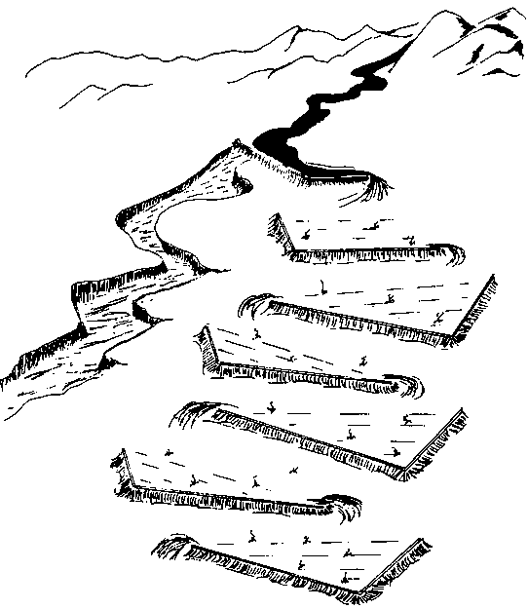
Figure 18: Water spreading bunds on a hillside

Technical Details:

- Suitability
Water spreading bunds can be used under the following conditions:

- Rainfall: 100 mm - 350 mm; normally hyper-arid/arid areas only.
- Soils: alluvial fans or floodplains with deep fertile soils.
- Slopes: most suitable for slopes of 1% or below.
- Topography: even.

The technique of floodwater farming using water spreading bunds is very site-specific. The land must be sited close to a wadi or another watercourse, usually on a floodplain with alluvial soils and low slopes. This technique is most appropriate for arid areas where floodwater is the only realistic choice for crop or fodder production.

- Overall configuration
Two design examples are given. The first is for slopes of less than 0.5%, where the structures are merely straight open ended bunds sited across the slope, which "baffle" (slow and spread) the flow. The second, for slopes greater than 0.5%, is a series of graded bunds, each with a single short upslope wing, which spread the flow gradually downslope. In each case, crops or fodder are planted between the bunds.

- Bund design
i. Slopes of less than 0.5%
Where slopes are less than 0.5%, straight bunds are used to spread water. Both ends are left open to allow floodwater to pass around the bunds, which are sited at 50 metres apart. Bunds should overlap - so that the overflow around one should be intercepted by that below it. The uniform cross section of the bunds is recommended to be 60 cm high, 4.1 metres base width, and a top width of 50 cm. This gives stable side slopes of 3:1. A maximum bund length of 100 metres is recommended.

ii. Slopes of 0.5% to 1.0%
In this slope range, graded bunds can be used (Figure 59). Bunds, of constant cross-section, are graded along a ground slope of 0.25%. Each successive bund in the series downslope is graded from different ends. A short wingwall is constructed at 135° to the upper end of each bund to allow interception of the flow around the bund above. This has the effect of further checking the flow. The spacing between bunds depends on the slope of the land. Examples for different slopes are given in Figures 58 and 59. The bund cross section is the same as that recommended for contour bunds on lower slopes. The maximum length of a base bund is recommended to be 100 metres.

- Design variations
There are many different designs for water spreading bunds possible, and that given in this manual is merely one example. Much depends on the quantity of water to be spread, the slope of the land, the type of soil and the labour available. Existing systems are always worth studying before designing new systems.

Trapezoid bunds:
Trapezoidal bunds are used to enclose larger areas (up to 1 ha) and to impound larger quantities of runoff which is harvested from an external or "long slope" catchment. The name is derived from the layout of the structure which has the form of a trapezoid -a base bund connected to two side bunds or wingwalls which extend upslope at an angle of usually 135 deg. Crops are planted within the enclosed area. Overflow discharges around the tips of the wingwalls.

The general layout, consisting of a base bund connected to wingwalls is a common traditional technique in parts of Africa. Three sides of a plot are enclosed by bunds while the fourth (upslope) side is left open to allow runoff to enter the field. The simplicity of design and construction and the minimum maintenance required are the main advantages of this technique. This section is based on the design and layout of trapezoidal bunds implemented in Turkana District in northern Kenya.

Technical details:

- Suitability
Trapezoidal bunds can be used for growing crops, trees and grass. Their most common application is for crop production under the following site conditions:

- Rainfall: 250 mm - 500 mm; arid to semi-arid areas.
- Soils: agricultural soils with good constructional properties i.e. significant (non-cracking) clay content.
- Slopes: from 0.25% - 1.5%, but most suitable below 0.5%. Topography: area within bunds should be even.

- Limitations
This technique is limited to low ground slopes. Construction of trapezoidal bunds on slopes steeper than 1.5% is technically feasible, but involves prohibitively large quantities of earthwork.

- Overall configuration
Each unit of trapezoidal bunds consists of a base bund connected to two wingwalls which extend upslope at an angle of 135 degrees. The size of the enclosed area depends on the slope and can vary from 0.1 to 1 ha. Trapezoidal bunds may be constructed as single units, or in sets. When several trapezoidal bunds are built in a set, they are arranged in a staggered configuration; units in lower lines intersect overflow from the bunds above. A common distance between the tips of adjacent bunds within one row is 20 m with 30 m spacing between the tips of the lower row and the base bunds of the upper row (see Figure 21). The planner is of course free to select other layouts to best fit into the site conditions. The staggered configuration as shown in Figure 21 should always be followed. It is not recommended to build more than two rows of trapezoidal bunds since those in a third or fourth row receive significantly less runoff. Recommended dimensions are given in Figure 21.

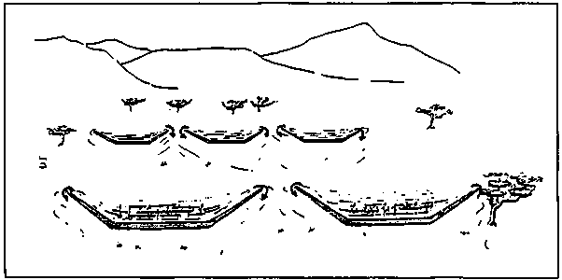
Figure 19: Trapezoid bund layout on a hillside slope

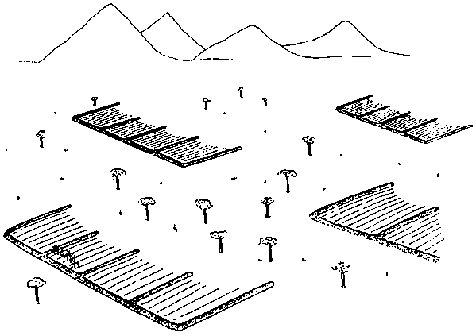
Figure 20: Variations of long slope bund catchment
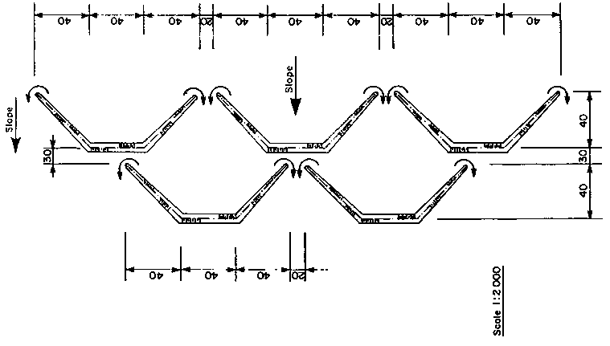
Figure 21: Recommended trapezoid bund dimensions

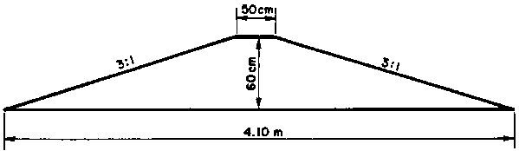
Figure 21a: Example bund dimensions

Subsurface Dam:
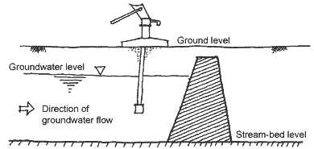

Figure 22: Cross sectional view of subsurface dam. In Karamoja ground level can be the dry sandy river bed. Dam must rest on impermeable foundation, usually bedrock.

Subsurface dams are structures that intercept or obstruct the natural flow of groundwater and provide storage for water underground, or in Karamoja‘s case, water is stored in dry sandy riverbeds. They have been used in several parts of the world, notably India, Africa and Brazil. Their use is in areas where flows of groundwater vary considerably during the course of the year, from very high flows following rain to negligible flows during the dry season.

The basic principle of the subsurface dam is that instead of storing the water in surface reservoirs, water is stored underground. The main advantage of water storage in subsurface dam is that evaporation losses are much less for water stored underground. Further, risk of contamination of the stored water from the surface is reduced because as parasites cannot breed in underground water. The problem of settling of land or soil which is normally associated with surface dams is not present with sub-surface dams.

Subsurface dams are built across streams or valleys. A trench is dug across the valley or stream, reaching to the bedrock or other stable layer like clay. An impervious wall is constructed in the trench, which is then refilled with the excavated material.
Various materials may be used for the construction of subsurface dams. Materials should be waterproof, and the dam should be strong enough to withstand the imposed soil and water loads. Dams may vary from 2 to 10 meters high. Materials include compacted clay, concrete, stones and clay, masonry wall or plastic sheets.

The reservoir is recharged during the monsoon period and the stored water can be used during the dry season. Excess water flows over the top of the dam to replenish aquifers downstream. Water may be obtained from the underground reservoir either from a well upstream of the dam or from a pipe, passing through the dam, and leading to a collection point downstream (see Figure 22)

Subsurface dams cannot be universally applicable as these require site specific conditions for proper functioning. The best sites for construction of subsurface dams are where the soil consists of sands and gravel, with rock or a permeable layer at a depth of a few meters. Ideally the dam should be built where rainwater from a large catchment area flows through a narrow passage.

Subsurface dams require specialized technical expertise and equipment in determining suitable site, bedrock depth, and providing construction oversight. Construction can only take place in the dry season, and in many cases will require water pumps during foundation excavation at the bedrock depth.

No more subsurface dam structure details will be given in this guide as an experienced technical consultant must be employed during the site assessment and construction phase.

Rock catchment: 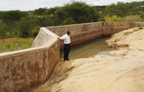
Rock catchment is a special type of rain water harvesting technique where a large rock outcrop is utilized to catch and concentrate rainwater runoff into a storage structure for domestic and livestock use to alleviate water shortages. This technique is very site specific and since it depends on the natural rock surface for collecting runoff, suitable site selection is critical.

Construction:

- Determine a suitable site with an expansive, impermeable rock out crop
- Clear and clean the site off vegetation
- Mark out the effective catchment area of the rock surface
- Estimate the amount of runoff volume (m3) anticipated = rainfall (m) x catchment area (m2)x runoff coefficient (normally 0.9 for rock surfaces). This is used to guide the design of storage structure.
- Site the water storage structure or masonry gravity dam on the outer edge of a hollow or depression on the rock surface
- Design the water storage structure or masonry gravity dam with capacity found in step 4.
- Estimate the material requirements for both the rock catchment and the water storage structure or dam.

References:

- Will Critchley, Klaus Siegert, A Manual for the Design and Construction of Water Harvesting Schemes for Plant Production, FAO, 1991.
- Matthew W. Fidelibus and David A. Bainbridge, Microcatchment Water Harvesting for Desert Revegetation, Soil Ecology and Restoration Group.

Appendix:

Q. What has to be considered in microcatchment site design?
Developing a site for microcatchments requires information on four main physiographic factors: the runoff producing potential, the soil surface condition (cover, vegetation, crust, stoniness), the gradient and evenness of slope and the water retention capacity of the soil in the root zone profile. These all contribute to the runoff threshold coefficient which is a key factor in determining the optimum size for a catchment. Other factors affecting the infiltration capacity of a particular area include the moisture content of the soil, macro-pores in the soil as a result of decaying roots and compaction of the soil.

Q. How much water will they yield?
To determine expected yields from microcatchments, three rainfall characteristics must be evaluated: 1) the average annual rainfall, 2) peak rainfall intensity and 3) the minimum expected annual precipitation. The optimal size of the microcatchment for each species depends on many factors including normal precipitation, soil quality and the slope of the site. The size and depth of the planting basin in relation to the size of the catchment area is also important. These factors determine the size of the surface area wetted by runoff and the volume and depth of the water column in the soil. If the infiltration rate of the soil and the water demands of the plant are known, the desired size of a catchment basin can be calculated. If a particular species of shrub requiring 10 inches of rain per year is being grown in a region of 5 inch average annual precipitation, then an additional 5 inches of rain is needed. If the catchment soil has a runoff coefficient of 10% (a typical runoff rate for untreated desert soils), then a shrub with 10 square feet of root area (a young bush) would need a 100 square foot catchment (10 x 10). However, larger catchments are often used for insurance in very dry years.

