WaterCone: Mobile Solar Potable Water Generation
January 2nd, 2007

HouseOfPulp in Design, Eco-Friendly, Energy Efficient, Products, WaterCone.Com
via WaterCone.Com
The Product
A Product that enables anyone, in a most simple fashion, an independent, cheap and mobile solar Potable Water generation from sea water or brackish water on the base of condensation by solar still.  This Invention represents a conical, self-supporting and stackable Unit made from transparent, thermo-formable polycarbonate (same as water dispensers) outfitted with a screw cap spout at the tip and an inward circular collecting trough at the base. Technically speaking it is a solar still. |  | 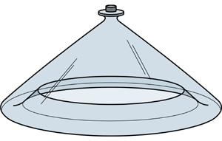

Function
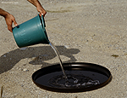 |  | 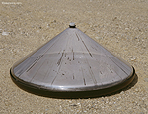 |  | 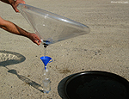
1.  Pour salty / brackish Water into pan. Then float the Watercone® on top. The black pan absorbs the sunlight and heats up the water to support evaporation.. |  | 2.  The evaporated Water condensates in the form of droplets on the inner wall of the cone. These droplets trickle down the inner wall into a circular trough at the inner base of the cone. |  | 3.  By unscrewing the cap at the tip of the cone and turning the cone upside down, one can empty the potable Water gathered in the trough directly into a drinking device.

Technical Information
The WATERCONE® system can be referred to as a one step water condensation process with a 40% effectiveness degree (GTZ Germany). Based on evaporation levels of 8.8 Liters per square meter (average solar irradiation in Casablanca, Morocco), the WATERCONE® (with a base diameter of 60 – 80 cm) yields between 1.0 to 1.7 Liters of condensed water per day (24 hours). The salty / brackish Water evaporates by way of solar irradiation and the condensation from that Water appears in the form of droplets on the inner wall of the cone. These droplets trickle down the inner wall into a circular trough at the inner base of the cone. By unscrewing the cap at the tip of the cone and turning the cone upside down, one can empty the potable Water gathered in the trough directly into a drinking device. Based on this concept, the cone does indeed apply innovative solutions to a problem, which has been a curse to mankind for millennia: turning salt water into potable water in an uncomplicated, cheap and swift manner. .  The WATERCONE® is a long lasting UV resistant Poly Carbonate product and can be used up to 5 years daily. The material is non-toxic, non-flammable and 100% recyclable. The black pan for the saltwater is already made out of 100% recycled PC. Even when the WATERCONE® becomes old and tarnished, it can still be used to collect rain water, as a roof panel or container for other goods. Another environmental impact is the fact that solar energy is used instead of gas, oil or electricity to desalinate seawater. In many countries, poor people cook the dirty water by burning the last remaining wood and therefore they promote the growth of deserts worldwide. The WATERCONE® could be used in these regions as well. |  | 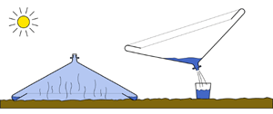  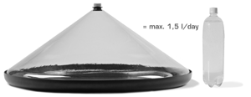
5 Reasons for global distribution of the Watercone

1. Much cheaper than bottled water.  Watercone life expectancy: 3 to 5 years. Price: planned below € 20.- Average Price of 1 liter of bottled water in developing countries: $US 0,50. Presuming a daily usage of the Watercone and a daily average yield of 1 liter, the Watercone has paid for itself in about 2 mounth and will work for free the next 5-7 years! |  | 2. Absolutely, low concept and low tech.  As opposed to other types of solar stills which feature electronics, photo-voltaic cells, tubes, filters, many parts, etc. the Watercone concept is understood within seconds with absolutely no need for academic background. Additionally it (cone & pan) is made from Bayer Makrolon, a high-tech ultra-rugged and highly recyclable polycarbonate, virtually insensitive to UV exposure or breakage, an all too common result of rough transport. |  | 3. Perfect for coastal dwellers.There are at least 50 sunny, developing countries worldwide with a significant amount of sea- or coastline. Many from their populations, hundreds of millions, live in nearest proximity to water but cannot drink it or use it for agriculture, because it is saltwater. Large families, hamlets, villages could all experience dramatically improved quality of life starting from as little as a dozen Watercones set up close by the sea.

 | 4. Perfect for medical purposes.There are thousands of hospitals in developing countries, field and mobile hospitals, first aid and emergency medical units around the world that are located in sunny climates and lack condensed water. Outfitted with just a dozen Watercones, a little field hospital could harvest 15 liters of condensed water per day. More than enough to make a difference for life or death. |  | 5. Creates jobs.For centuries water vendors have walked the markets of hamlets, villages and cities around the world, mostly in Africa, the Mid East and Asia. Based in the vicinity of salt or brackish water and outfitted with a minor credit line, these vendors could invest in a dozen Watercones and sell 15 liters of water a day and have their investment returned in no more than half a year.
Transportation
Generally speaking, it would be desirable to cover the largest possible evaporation surface with a huge Water Cone.  Unfortunately there are limitations set forth by the chosen production technology of thermo-forming. Additionally the Product must remain manageable in terms of handling and ergonomics. Also one has to consider the shipping aspect which will typically take place on Euro Pallets ( 80 x 120 cm).  Based upon these considerations, the Water Cone has received ideal dimensions featuring a 60 – 80 cm diameter at cone base and a height of 30 – 50 cm. One Euro Pallet can load 2 Boxes filled with 8 Water Cones and 8 respective (80 cm base diameter) Tubs each |  | 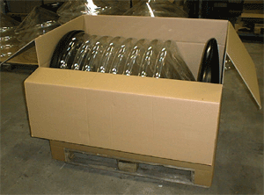

Source : http://houseofpulp.com/watercone-mobile-solar-potable-water-generation

