The Treatment Process
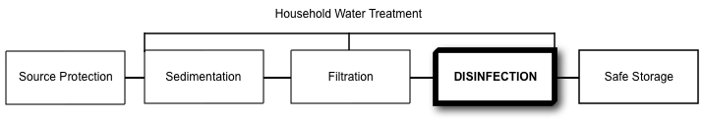
Potential Treatment Capacity
Very Effective For: | Somewhat Effective For: | Not Effective For:
- Bacteria  - Viruses  - Protozoa  - Helminths |  | - Turbidity  - Chemicals  - Taste/odour/colour

What is Solar Pasteurization?
Pasteurization is the process of disinfecting water by heat or radiation, short of boiling. Typical water pasteurization achieves the same effect as boiling, but at a lower temperature (usually 65-75°C), over a longer period of time.
A simple method of pasteurizing water is to put blackened containers of water in a solar cooker. The cooker may be an insulated box made of wood, cardboard, plastic, or woven straw, with reflective panels to concentrate sunlight onto the water container. It may also be an arrangement of reflective panels, or a reflective “satellite dish”, on which the water pot sits.
A thermometer or indicator is needed to tell when sufficient temperature is reached for pasteurization. Common devices for monitoring the water temperature use either beeswax, which melts at 62°C, or soya bean fat, which melts at 69°C. A simple device known as the Water Pasteurization Indicator (WAPI) has been developed at the University of California.
How Does It Remove Contamination?
As the water heats due to radiation from the sun, the increased temperature will kill or inactivate pathogens at 65°C.
Operation
Water is put into a black container, which is placed in a solar cooker that reflects sunlight onto the container. The box cooker should be frequently repositioned to ensure it is catching all available sunlight (and never in shade) until the indicator device shows the water has reached the required temperature. Water may take 1 to 4 hours or more to heat to temperature.
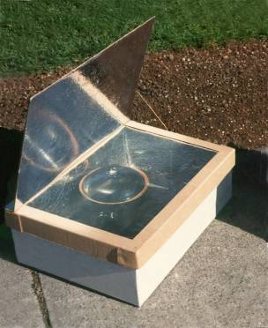
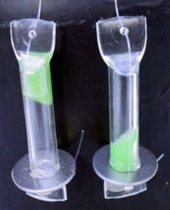
Solar Box Cooker
Water Pasteurization Indicator (WAPI)
(Credit: Solar Cooker International)
Box Cooker and Water Pasteurization Indicator (WAPI)
(Credit: Solar Cooker International)

Inlet Water Criteria
- No specific limits
Treatment Efficiency
 | Bacteria | Viruses | Protozoa | Helminths | Turbidity | Chemicals
Laboratory | > 100% ^{1,2} | > 100%³ | > 100%⁴ | > 100%⁴ | 0% | 0%
Field | Not available | Not available | Not available | Not available | 0% | 0%
¹ 100% E. coli in 1.5 hours at 60°C (Ciochetti & Metcalf 1984, Safapour & Metcalf 1998)
² 100% E. coli, Salmonella, S. dysenteriae, and V. cholerae at 70°C (Iijima et al., 2001)
³ 100% in 1.5 hours at 70°C (Safapour & Metcalf 1998)
⁴ Not tested, but other research suggests that many helminths and protozoa will be killed at a temperature of 70°C if maintained for 45 seconds
Operating Criteria
Flow Rate | Batch Volume | Daily Water Supply
Not applicable | Depends on container size | Depends on container size
Robustness
- Does not work during continuous rainfall or in very cloudy days
- Users require a thermometer or pasteurization indicator device
- Users need to keep track of containers to know which ones have been treated and ensure that they always have treated water
- Users may need to wait for water to cool prior to use
- Cookers are made from lightweight and easily breakable materials
- Recontamination is possible after the water has cooled; safe storage is essential
- The system requires no additional inputs after installation
Estimated Lifespan
- 5+ years
Manufacturing Requirements
Worldwide Producers:
- There are many worldwide producers
- Simple designs are available at no cost on the internet

Local Production:
- This device may be built with parts available throughout most countries.

Materials:
- Cardboard
- Straw
- Aluminium foil
- Glass or plastic sheet
- Silver/metallic reflective spray paint
- Dark paint or mud
- Glass or plastic water containers to be painted; or dark/black metal pots
- Water Pasteurization Indicators (WAPI) or thermometers
Fabrication Facilities:
- Workshop space to manufacture solar cookers

Labour:
- Anyone can be trained to construct a solar cooker

Hazards:
- No specific manufacturing hazards
Maintenance
- Cleaned on a regular basis
Direct Cost
Capital Cost | Operating Cost | Replacement Cost
US$20-25 | US$0/year | US$0
Note: Program, transportation and education costs are not included. Costs will vary depending on location
Other
- Solar pasteurization boxes can also be used as solar cookers for cooking meals
- Boiling is sometime preferred because it provides a visual measure of when the water has reached sufficient temperature without requiring a thermometer
References
Andreatta, D. (1994). A Summary of Water Pasteurization Techniques. S.E.A. Inc
http://solarcooking.org/pasteurization/solarwat.htm
Ciochetti, D. A., and R. H. Metcalf (1984). Pasteurization of Naturally Contaminated Water with Solar Energy. California State University, USA.
Iijima Y., Karama M., Oundo, J. O., and T. Honda (2001). Prevention of Bacterial Diarrhea by Pasteurization of Drinking Water in Kenya. Microbiological Immunology, 45(6), 413-416.
Safapour, N. and R. H. Metcalf (1999). Enhancement of Solar Water Pasteurization with Reflectors. Applied and Environmental Microbiology, Feb. 1999, p. 859–861.
Further Information
Solar Cookers International: http://solarcookers.org

Safe Water Systems: www.safewatersystems.com

CAWST (Centre for Affordable Water and Sanitation Technology)
Calgary, Alberta, Canada
Website: www.cawst.org, Email: cawst@cawst.org
Last Update: June 2011

