Potential Treatment Capacity
Very Effective For: | Somewhat Effective For: | Not Effective For:
- Bacteria
- Viruses
- Protozoa
- Helminths
- Turbidity
- Chemicals
- Salt and hardness
- Taste, odour, colour

What Is Solar Distillation?
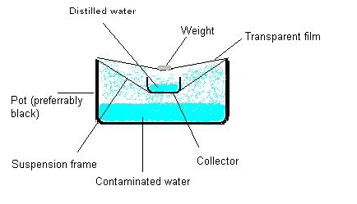
Solar distillation is an ancient method of using the sun’s energy to treat drinking water. Distillation is the process of evaporating water into vapour, and then capturing and cooling the vapour so it condenses back into a liquid. Any contaminants in the water are left behind when the water is evaporated.
There are many different designs for solar distillation units (also known as stills). The simplest are a piece of plastic stretched over a container with the source water in the bottom. The plastic is weighted down in the middle so that the condensate can drip into a smaller collection container inside the bucket.
A simple design requiring some basic construction, but yielding more water, is that of a flat bed, basin or box solar still. It consists of a shallow reservoir containing water covered with an angled piece of clear glass or transparent plastic sheet. The sunlight heats the water through the glass or plastic, and the water vapour collects and condenses on it, drips down, and flows into the collection channel.
Another simple still uses a removable plastic cone rimmed on the inside edge with a collection channel. The condensed water flows down the sides of the cone into the channel. Water is removed by opening a cap at the apex of the cone, and turning the still upside down into a container.

How Does it Remove Contamination?
As the radiation from the sun heats the water, it evaporates leaving behind any contaminants, including pathogens, chemicals and minerals. The contaminants collect in the bottom of the still and are periodically flushed or cleaned out.

Container Still (Credit: www.ehow.com)

Box Still (Credit: Smith, 2005)
Operation
Flat Bed/Box Still:
The still is filled daily with two to three times as much water as will be produced. This is so that the excess, using the built-in overflow outlets, will flush the unit clean each day (to remove accumulated salts and other contaminants). Treated water is collected in a safe storage container placed under the outlet.
If systems are not designed to be self cleaning and flush out accumulated contaminants, the reservoirs should be regularly cleaned using soap and clean water.
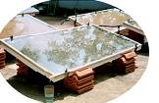
Flat Bed Still
(Credit: www.planetkerala.org)

Cone Still:

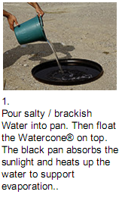
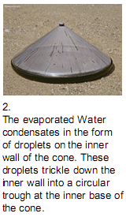
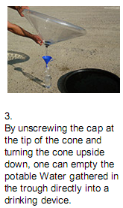

How to Use the WaterCone® (Credit: www.watercone.com)

Inlet Water Criteria
- No specific limits
Treatment Efficiency
 | Bacteria | Viruses | Protozoa | Helminths | Turbidity | Chemicals
Laboratory | > 99.9%¹ | Not available | > 100%¹ | > 100%² | > 100%² | > 99.9%¹
Field | Not available | Not available | Not available | Not available | Not available | Not available
¹ Smith (2005). The pilot project showed the stills to be effective in removing salts and minerals (Na, Ca, As, Fl, Fe, Mn); bacteria (E coli, cholera, botulinus); protozoa (giardia, cryptosporidium) and heavy metals (Pb, Cd, Hg). Theoretically should remove arsenic, although no data available at this time.
² Not tested, but theoretically distillation should remove helminths and turbidity.
Operating Criteria
Flow Rate | Batch Volume¹ | Daily Water Supply
Not applicable | 4–8 litres per m² (box)^{2,3}  1-1.7 L for cone⁴ | Variable⁵
¹ Solar still sizes can vary from 0.5 m² for household use up to around 600 m² for community use
² Foster (2005)
³ Planet Kerala (2006)
⁴ Watercone®
⁵ Daily water supply depends on number sunshine hours and temperature, as well as still size
Robustness
- No moving or mechanical parts to break
- Requires suitable climate and weather conditions
- Requires airtight seals and smoothly stretched plastic during construction and operation; poor handling can break seals
Estimated Lifespan
- Box still: 10+ years, depending on materials and construction quality
- Watercone®: ~5 years
Manufacturing Requirements
Worldwide Producers:
- There are many worldwide producers (e.g. Solaqua, Solar Water Distillation Products, Watercone®, Waterpyramid®)
- Simple designs are available at no cost on the internet

Local Production:
- Can be built with locally available materials

Materials:
- See design details (on internet)

Fabrication Facilities:
- Workshop space for filter construction

Labour:
- Anyone can be trained to construct solar distillation units

Hazards:
- No specific manufacturing hazards.
Maintenance
- Some systems are designed to be self cleaning to flush out accumulated contaminants
- Systems without a flushing function should be regularly cleaned using soap and clean water
- Very turbid water can be sedimented or filtered prior to distillation to reduce cleaning the reservoir
Direct Cost
Capital Cost | Operating Cost | Replacement Cost
US$10-400/m² (box still)¹  ~US$32 (cone still)² | US$0/year | US$0
Note: Program, transportation and education costs are not included. Costs will vary depending on location.
¹ A square meter for a single basin solar still costs about $400 in Mexico (Foster et al., 2005)
² Watercone®
Other
- About 0.5 m² of solar box still is needed per person to meet potable water needs consistently throughout the year (Foster et al., 2005)
References
Foster, R., Amos, W. and S. Eby (2005). Ten Years of Solar Distillation Application Along the U.S.-Mexico Border. Solar World Congress, International Solar Energy Society, Orlando, Florida, August 11, 2005. Available at: http://solar.nmsu.edu/publications/1437ISESpaper05.pdf
Planet Kerala (2006). Solar Distillation: A Natural Solution for Drinking Water, Now Practical. Available at: www.planetkerala.org/downloads/SolarDistillation.pdf
Smith, K. (2005). Still Distilled! Water Conditioning & Purification Magazine. Available at: www.wcponline.com/pdf/0705%20distilled.pdf
Further Information
Planet Kerala, Participatory Learning and Action Network, India: www.planetkerala.org/downloads/SolarDistillation.pdf

Solaqua, Solar Water Distillation Products, USA: www.solaqua.com/solstilbas.html

AquaConeTM: www.solarsolutions.info/main.html

Watercone®, Germany: www.watercone.com

Waterpyramid®, The Netherlands: www.waterpyramid.nl

CAWST (Centre for Affordable Water and Sanitation Technology)
Calgary, Alberta, Canada
Website: www.cawst.org, Email: cawst@cawst.org
Last Update: June 2011

