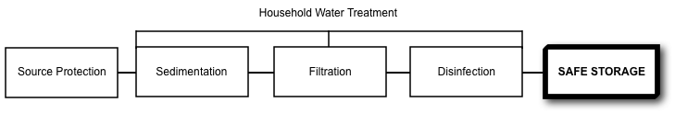
Treatment Type

Potential Protection Capacity
Very Effective For: | Somewhat Effective For: | Not Effective For:
- Preventing recontamination of safe water | - Keeping water cool  - Preventing algae growth | - Removing existing contaminants

What is Safe Storage and Handling?
Households do a lot of work to collect, transport and treat their drinking water. Safe water must be handled and stored properly to protect it from becoming recontaminated. Promoting safe storage and handling of water in the home is a critical component for safe drinking water. Recontamination of safe drinking water is a common issue around the world and has been documented in several cases.
What Causes Recontamination?
Water can become recontaminated through several different mechanisms, such as:
- Using the same container for water collection and storage
- Dipping a dirty cup or hand into the container
- Drinking directly from the container
- Children, animals or insects accessing the container
- Poor cleaning and hygiene practices
Recontamination is more likely to occur in uncovered containers that have wide openings (e.g. buckets, pots). Using chlorine can provide residual protection against recontamination, however, proper storage and handling are still essential for keeping water safe to drink.

Safe Storage and Handling Practices
Safe storage means keeping treated water away from sources of contamination. There are many designs for water containers around the world. A safe water storage container should be:
- With a strong and tightly-sealing lid or cover
- With a tap or narrow opening at the outlet
- With a stable base so it does not tip over
- Durable and strong
- Not transparent or see-through
- Easy to clean

Safe storage containers should also have pictorial and/or written instructions describing how to properly use and clean the container. Ideally the instructions are permanently affixed to the container, or they can be provided as a separate document to the household.
Sometimes it is difficult for rural and poor households to find or buy good storage containers. The most important things are to make sure that they are covered and only used to store treated water.
Safe water handling practices include:
- Using a separate container to collect source water
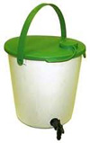
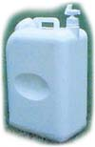
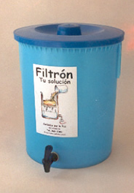
- Using a proper safe storage container for treated water, and never use this container for untreated water
Oxfam Bucket Used Mainly in Emergencies (Credit: Oxfam)
CDC Safe Water System (Credit: Centers for Disease Control)
Ceramic Filter Container (Credit: Potters for Peace)
- Cleaning the safe storage container frequently with safe water and soap or chlorine
- Storing treated water off the ground in a shady place in the home
- Storing treated water away from small children, animals and insects
- Pouring water from the safe storage container of using the tap when needed instead of dipping or scooping water from it
- Using the treated water as soon as possible, preferably on the same day
Examples of Safe Storage Containers
A number of internationally manufactured containers, locally produced containers, and locally adapted traditional containers can be used to store water safely.
Safe storage containers should always be evaluated in-country for their cost, availability, robustness and user acceptability.

CAWST (Centre for Affordable Water and Sanitation Technology)
Calgary, Alberta, Canada
Website: www.cawst.org, Email: cawst@cawst.org
Last Update: June 2011

