The Treatment Process
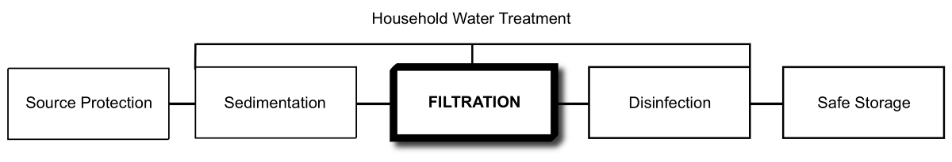
Potential Treatment Capacity
Very Effective For: | Somewhat Effective For: | Not Effective For:
- Bacteria  - Protozoa  - Helminths  - Turbidity  - Taste, odour, colour | - Viruses  - Iron | - Dissolved chemicals

What is a Biosand Filter?
The biosand filter (BSF) is an adaptation of the traditional slow sand filter, which has been used for community water treatment for hundreds of years. The BSF is smaller and adapted for intermittent use, making it suitable for households.
Water treatment is carried out by the sand inside the filter. The filter container can be made of concrete, plastic or any other water-proof, rust-proof and non-toxic material. The concrete filter box is cast from a steel mold or made with pre-fabricated pipe.
The container is filled with layers of sieved and washed sand and gravel (also referred to as filter media). There is a standing water height of 5 cm above the sand layer.
As in slow sand filters, a biological layer of microorganisms (also known as the biolayer or schmutzedecke) develops at the sand surface, which contributes to the water treatment.
A perforated diffuser plate or basin is used to protect the biolayer from disturbance when water is poured into the filter.

How Does It Remove Contamination?
Pathogens and suspended material are removed through a combination of biological and physical processes that take place in the biolayer and within the sand bed. These processes include: mechanical trapping, adsorption, predation and natural death.
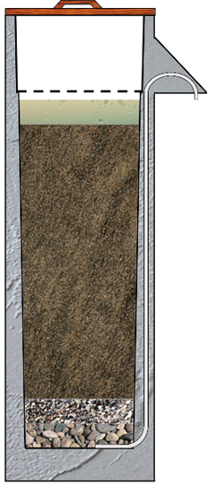
Standing Water
Filtration Sand
Lid
Diffuser
Outlet Tube
Drainage Gravel
Separating Gravel

Cross-Section of Concrete Biosand Filter
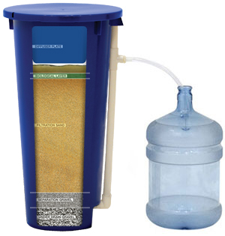

Cross Section of Plastic Biosand Filter
(Credit: TripleQuest)
Operation
Contaminated water is poured into the top of the filter on an intermittent basis. The water slowly passes through the diffuser, and percolates down through the biolayer, sand and gravel. Treated water naturally flows from the outlet pipe.
The biolayer is the key pathogen removing component of the filter. Without it, the filter is significantly less effective. It may take up to 30 days to establish the biolayer depending on inlet water quality and frequency of use.
The water from the filter can be used during the first few weeks while the biolayer is being established, but disinfection is recommended during this time, as during regular on-going use.
The biolayer requires oxygen to survive. When water is flowing through the filter, dissolved oxygen in the water is supplied to the biolayer. During pause times, when the water is not flowing, the oxygen is obtained by diffusion from the air.
Correct installation and operation of the biosand filter has a water level of approximately 5 cm above the sand during the pause period. A water depth of greater than 5 cm results in lower oxygen diffusion to the biolayer. A water depth less than 5 cm may evaporate quickly in hot climates and cause the biolayer to dry out.
A pause period is needed between uses to allow time for the microorganisms in the biolayer to consume pathogens in the water. Users should wait at least one hour after all the water has been filtered before filling the filter again. It is recommended to use the filter every day; however users can wait up to a maximum of 48 hours between batches.
The biosand filter has been designed to allow for a filter loading rate (flow rate per square metre of filter area) which has proven to be effective in laboratory and field tests. This filter loading rate has been determined to be not more than 600 litres/hour/square metre.
The recommended flow rate for the CAWST Version 10 concrete biosand filter is 0.4 litres/minute measured when the inlet reservoir is full of water. If the flow rate is much faster, the filter may become less efficient at removing pathogens. If the flow rate is much slower, the user may become impatient and not use the filter even though the filter is working well at removing pathogens. Since the flow rate is controlled by the size of the sand grains, it is very important to select, sieve and wash the sand properly.
The flow rate through the filter will slow down over time as the biolayer develops and sediment is trapped in the upper layer of the sand. For turbidity levels greater than 50 NTU, the water should first be strained through a cloth or sedimented before using the BSF.
The biosand filter requires maintenance when the flow rate drops to a level that is inadequate for the household use. This is done by a simple ‘swirl and dump’ procedure performed on the top of the sand, and only takes a few minutes.
The outlet should also be cleaned regularly using soap and water or a chlorine solution.
The treated water should be collected by the user in a safe storage container placed on a block or stand, so that the container opening is just under the outlet, minimizing the risk for recontamination.

Inlet Water Criteria
- Turbidity < 50 NTU (Nephelometric Turbidity Units)
Treatment Efficiency
 | Bacteria | Viruses | Protozoa | Helminths | Turbidity | Iron
Laboratory | Up to 96.5%^{1,2} | 70 to >99%³ | >99.9%⁴ | Up to 100%⁵ | 95% to <1 NTU¹ | Not available
Field | 87.9 to 98.5%^{6,7} | Not available | Not available | Up to 100%⁵ | 85%⁷ | 90-95%⁸
1 Buzunis (1995)
2 Baumgartner (2006)
3 Elliott et al. (2008)
4 Palmateer et al. (1997)
5 Not researched. However, helminths are too large to pass between the sand, up to 100% removal efficiency is assumed
6 Earwaker (2006)
7 Duke & Baker (2005)
8 Ngai et al. (2004) [Note: These tests were done on a plastic version of a biosand filter]

- Filtration sand selection and preparation are critical to ensure flow rate and effective treatment. Refer to CAWST’s Biosand Filter Manual for detailed instructions on how to select and prepare the filtration sand.
- Treatment efficiencies provided in the above table require an established biolayer; it takes up to 30 days to establish the biolayer depending on inlet water quality and usage
- Filter should be used every day to maintain the biological layer
- Best performance requires a consistent water source; switching sources may decrease treatment efficiency
- Swirl and dump maintenance will reduce treatment efficiency until the disturbed biolayer is re-established
- Taste, odour and colour of filtered water is generally improved
- Treated water temperature is generally cooler from concrete filters
Operating Criteria
Flow Rate | Batch Volume | Daily Water Supply
< 0.4 litres/minute* | 12-18 litres | 24-72 litres**
Note: Operating criteria is for the concrete biosand filter, plastic biosand filter may have different parameters.
* 0.4 litres/minute is the maximum recommended flow rate for the CAWST Version 10 concrete biosand filter. The actual flow rate will fluctuate over the filter cleaning cycle and between filters.
** Based on 4 batches per day (i.e. morning, lunch, dinner, before bed).

- Pause period is needed between uses to allow time for the microorganisms in the biolayer to consume pathogens in the water
- Recommended pause period is 6 to 12 hours with a minimum of 1 hour and maximum of 48 hours
Robustness
- No moving or mechanical parts to break
- Concrete filters have the outlet pipe embedded in the concrete, protecting it against breaks and leaks
- Plastic filters have an external outlet pipe which may be prone to damage and leakage; once broken repair is difficult or impossible
- Plastic filters are lighter (3.5 kg) than concrete filters (70-75 kg for thin wall version and 135 kg for heavy wall version)
- Poor transportation of concrete filters can lead to cracking and/or breakage; cracks can sometimes be repaired
- Plastic filters are made from medical grade plastic which is resistant to ultraviolet (UV) degradation and breakage
- Preferably, filters should not be moved after installation
Estimated Lifespan
- 30+ years for concrete filters; concrete filters are still performing satisfactorily after 10+ years
- 10+ years for plastic filters
- Lids and diffusers may need replacement over time
Manufacturing Requirements
Worldwide Producers:
- Concrete biosand filter designs are freely available from CAWST, Canada
- Plastic biosand filters are patented and licensed to International Aid, USA for manufacturing and sales

Local Production:
- Concrete biosand filters can be manufactured locally
- Molds can be borrowed, rented, bought or welded locally
- Filters can be constructed at a central production facility, or in the community
- Filter sand and gravel can be prepared (sieved and washed) on-site or nearby
Materials for Concrete Filters:
- Steel mold
- Sand, gravel, and cement
- Filter sand and gravel
- Copper or plastic outlet tubing
- Metal or plastic for the diffuser
- Metal or wood for the lid
- Water for concrete mix and to wash filter sand and gravel
- Miscellaneous tools (e.g. wrench, nuts, bolts)

Fabrication Facilities:
- Workshop space for filter construction

Labour:
- Skilled welder required to fabricate steel mold
- Anyone can be trained to construct and install the filter

Hazards:
- Working with cement and heavy molds is potentially hazardous and adequate safety precautions should be used
- Concrete filters are heavy and difficult to move and transport
Maintenance
- Required when the flow rate drops to a level that is insufficient for household use; frequency depends on turbidity of inlet water
- Swirl and dump maintenance for the top layer of sand is simple, takes a few minutes and can be done by household users
- Outlet, lid and diffuser should be cleaned on a regular basis
Direct Cost
Filter Type | Capital Cost | Operating Cost | Replacement Cost
Concrete | US$12-50 | US$0/year | US$0
Plastic | US$75¹ | US$0/year | US$0
Note: Program, transportation and education costs are not included. Costs will vary depending on location.
¹ Prices do not include shipping container, shipping fees, or clearing/related costs.
References
Buzunis, B. (1995). Intermittently Operated Slow Sand Filtration: A New Water Treatment Process. Department of Civil Engineering, University of Calgary, Canada.
Baumgartner, J. (2006). The Effect of User Behavior on the Performance of Two Household Water Filtration Systems. Masters of Science thesis. Department of Population and International Health, Harvard School of Public Health. Boston, Massachusetts, USA.
Duke, W. and D. Baker (2005). The Use and Performance of the Biosand Filter in the Artibonite Valley of Haiti: A Field Study of 107 Households, University of Victoria, Canada.
Earwaker, P. (2006). Evaluation of Household BioSand Filters in Ethiopia. Master of Science thesis in Water Management (Community Water Supply). Institute of Water and Environment, Cranfield University, Silsoe, United Kingdom.
Elliott, M., Stauber, C., Koksal, F., DiGiano, F., and M. Sobsey (2008). Reductions of E. coli, echovirus type 12 and bacteriophages in an intermittently operated 2 household-scale slow sand filter.Water Research, Volume 42, Issues 10-11, May 2008, Pages 2662-2670.
Ngai, T., Murcott, S. and R. Shrestha (2004). Kanchan Arsenic Filter (KAF) – Research and Implementation of an Appropriate Drinking Water Solution for Rural Nepal. [Note: These tests were done on a plastic biosand filter]
Palmateer, G., Manz, D., Jurkovic, A., McInnis, R., Unger, S., Kwan, K. K. and B. Dudka (1997). Toxicant and Parasite Challenge of Manz Intermittent Slow Sand Filter. Environmental Toxicology, vol. 14, pp. 217- 225.
Stauber, C., Elliot, M., Koksal, F., Ortiz, G., Liang, K., DiGiano, F., and M. Sobsey (2006). Characterization of the Biosand Filter for Microbial Reductions Under Controlled Laboratory and Field Use Conditions. Water Science and Technology, Vol 54 No 3 pp 1-7.
Further Information
CAWST (Centre for Affordable Water and Sanitation Technology): www.cawst.org

Triple Quest: www.hydraid.org

CAWST (Centre for Affordable Water and Sanitation Technology)
Calgary, Alberta, Canada
Website: www.cawst.org Email: cawst@cawst.org
Last Update: June 2011

