FROM FARM TO FOREST
Presentation of two methods for restoring native forests:
That Dr. Akira Miyawak and Dr. Stephen Elliott.

November 1, 2012 · by Sylvia Ramos · in Reforestation Project, Trees and Shrubs.

by Sylvia Ramos, birdwatchers and bird photographer. Blog: http://mindingthefarm.wordpress.com
Additional information from Benjamin Lisan, engineer.
When people think of planting trees, they usually think of either landscaping or tree farming. Landscaping is like interior decoration, but with plants. The goal is to create beautiful surroundings using plants, natural features like rocks, water, and fish and also man-made features like fences, and buildings. Landscaping usually requires a lot of care and maintenance. Tree farming usually involves planting one species of trees for the purpose of producing lumber. In the Philippines, popular species for tree farming are fast-growing exotics such as mahogany and gemelina.
At the farm, we plan to do reforestation. The goal of reforestation is to restore the complex and diverse life forms that co-exist in a natural forest. These include not just trees but also birds, insects, soil animals, trees and under storey plants. Once a natural forest is established, it does not require any upkeep or maintenance. It is possible to see positive changes in 6-11 years, such as: (from “Rainforestation: A Paradigm Shift in Forest Restoration in the Philippines for Sustainability and Climate Change Mitigation” by Paciencia P. Milan, PhD, University Professor Visayas, State University, presented during the Mindanao Rainforest Restoration Forum)

- improvement of soil chemical properties
- improvement of soil structure and water holding capacity
- improvement of soil organic matter and soil color (darker is better)
- improvement of nutrient status
- improvement of biological activity
- improvement of microclimate (cooler)

TWO INTERESTING METHODS
There are many different reforestation methods. The two that sound most interesting and promising are the Miyawaki Method and the Framework Species Method of Dr. Stephen Elliott. These two methods seem to have high success rates in short periods of time.

FRAMEWORK SPECIES METHOD
The Framework Species Method was developed in Australia and has been used in northern Thailand since 1994. About 30 species of trees are selected as the “framework species”. The ultimate goal however is to have even more species at the site that will be brought in by the birds, insects, and animals that were attracted by the framework species.

STAGES OF SITE DEGRADATION:
In this method, a site is categorized as Stage 1, 2, 3, 4, or 5. Each stage requires a different restoration approach. Stage one has the least degradation, Stage 5 has the most degradation
- Stage 1 – there are a lot of regeneration sources at the site.
Intervention: protect existing vegetation from fire and harvesting, protect wildlife from hunting
- Stage 2 – more trees have been removed, weed are beginning to take over. Fewer species at the site
Intervention: protection, weeding, applying fertilizer.
- Stage 3 – weeds are dominating site, sources of natural regeneration are insufficient, fire risk is high. There are still some remnant trees and some wildlife to act as seed dispersers.
Intervention – same as Stage 2, but with additional tree planting of framework species
- Stage 4 – no trees as seed sources remaining.
Intervention: same as Stage 3, but with more species of trees at high density, such as in the Miyawaki method. This is expensive and intensive and mainly applicable to small, urban sites.
- Stage 5 – even weeds have a hard time growing, soil erosion is significant.
Intervention: plant whatever can grow, even exotic species to help rebuild the soil. Then, move to Stage 4 or 3.

CRITERIA FOR SELECTING FRAMEWORK SPECIES TREES
This is Dr. Elliott’s definition of a framework species tree: “Framework Species are indigenous forest tree species that
enhance natural forest regeneration and accelerate biodiversity recovery.” The trees must meet the following criteria:

- must survive well when planted in deforested areas
- must have dense spreading crowns to shade out weeds
- should attract seed-dispersing animals by producing fruit, nectar, nesting sites, and perching sites
- if possible, must be resistant to fire

FRAMEWORK SPECIES SUCCESS STORY
Excerpt from talk given by Dr. Steve Elliott. FORRU is the Forest Restoration Research Unit at Chiang Mai University.
FORRU’s results using framework species have been very encouraging. Approximately six years after planting, the structure of the forest can almost be recovered, with stratification of large pioneers and smaller climax species. Species diversity also increases. At a demonstration site, for example, Dr. Elliott’s team planted 30 framework tree species that fostered the recruitment of an additional (non-planted) 72 tree species within 8-9 years. Moreover, within three years mammals began to return (pigs, deer) and bird diversity jumped from 30 species before planting to 87 species six years later, representing 63% of the bird community of the nearest natural forest.

from: Neidel, J.D., Consunji, H., Labozetta, J., Calle, A. and J. Mateo-Vega, eds. 2012. Mainstreaming Native Species-Based Forest Restoration: ELTI Conference Proceedings. New Haven, CT: Yale University; Panama City: Smithsonian Tropical Research Institute. ISBN 978-9962-614-22-7
Additional information can be found at the FORRU website.

NOTES FOR THE FARM:

- This method would work very well if there is remaining natural forest nearby, up to 10 km of the farm.
- Frequent weeding is necessary for up to 2 years after planting.
- Trees are randomly positioned across the site.
- Average distance between adjacent trees is 1.8 m (about 3,086 trees per hectare!). Density can be reduced if naturally established tree seedlings are present.
- Naturally established trees should be protected

BIBLIOGRAPHY / REFERENCE ON DR STEPHEN ELLIOTT METHOD:

Books:
Elliott, S., D. Blakesley and K. Hardwick, Restoring Tropical Forests: a Practical Guide. Kew Publications, London, 2013 in press.

Articles / papers :
Propagating framework tree species to restore seasonally dry tropical forest: implications of seasonal seed dispersal and dormancy, David Blakesleya, Stephen Elliott, Cherdsak Kuarakb, Puttipong Navakitbumrungb, Sudarat Zangkumb, Vilaiwan Anusarnsunthornb, Forest Ecology and Management, Volume 164, Issues 1–3 , 164 (1 july 2002) 31–38, Price : 31,50 $, http://www.sciencedirect.com/science/article/pii/S0378112701006090

Internet Pages:
Elliott S, Navakitbumrung P, Kuarak C, Zankum S, Anusarnsunthorn V, Blakesley D, 2003. Selecting framework tree species for restoring seasonally dry tropical forests in northern Thailand based on field performance. For Ecol Manage 184:177-191, http://www.dnp.go.th/fca16/file/arcdivclinc6unk.pdf
Thailand, restoration of seasonally dry tropical forest using the Framework Species Method, David Blakesley (Horticulture Research International, UK) and Dr Steve Elliott (Forest Restoration Research Unit, Chiang Mai University, Thailand), http://www.unep-wcmc.org/medialibrary/2011/05/24/241c807c/Thailand%2520highres.pdf
Effects of seed traits on the success of direct seeding for restoring southern Thailand’s lowland evergreen forest ecosystem, Panitnard Tunjai, Stephen Elliott, New Forests, May 2012, Volume 43, Issue 3, pp 319-333, http://rd.springer.com/content/pdf/10.1007%2Fs11056-011-9283-7 (PDF).
Forest restoration planting in northern Thailand, G. Pakkad, S. Elliott, V. Anusarnsunthorn, C. James & D. Blakesley, http://www.fao.org/docrep/005/AC648E/ac648e0e.htm
Testing the Framework Species Method for Forest Restoration, in Chiang Mai, Northern Thailand, Prasit WANGPAKAPATTANAWONG & Stephen ELLIOTT, Walailak J Sci & Tech 2008; 5(1): 1-15., http://www.unep-wcmc.org/medialibrary/2011/05/24/241c807c/Thailand%2520highres.pdf
Books of Dr Stephen Elliott are freely downloadable on Internet at this addresse: http://www.forru.org/FORRUEng_Website/Pages/engpublications.htm

Scientifics papers of Dr Stephen Elliott (http://www.forru.org/FORRUEng_Website/Pages/engscientificpapers.htm ) :
Papers in blue have either full text or abstract available to download :
BLAKESLEY, D., PAKKAD, G., JAMES, C., TORRE, F. and ELLIOTT, S. 2004.Genetic diversity ofCastanopsis acuminatissima (Bl.) A. DC. in northern Thailand and the selection of seed trees for reforestation. New Forests 27: 89-100.
BLAKESLEY, D. and S. ELLIOTT, 2004. Trees of Knowledge. Eden Project Friends, 14:14-16.
BLAKESLEY, D. and ELLIOTT, S. 2003. Restoring Northern Thailand's Highland Forests ETFRN News 38.
BLAKESLEY, D., ELLIOTT, S., KUARAK, C., NAVAKITBUMRUNG, P., ZANGKUM, S. and ANUSARNSUNTHORN, V. 2002.Propagating framework tree species to restore seasonally dry tropical forest: implications of seasonal seed dispersal and dormancy. Forest Ecology and Management Vol 164 : 31-38.
BLAKESLEY, D., K. HARDWICK, and S. ELLIOTT, 2002. Research needs for restoring tropical forests in Southeast Asia for wildlife conservation: framework species selection and seed propagation. New Forests 24(3):165-174
BLAKESLEY, D. and S. ELLIOTT, 2001. Tropical forest restoration. Horticulture Research International News, 28:14-15.
BLAKESLEY, D., V. ANUSARNSUNTHORN, J. KERBY, P. NAVAKITBUMRUNG, C. KUARAK, S. ZANGKUM, K. HARDWICK and S. ELLIOTT, 2000. Nursery technology and tree species selection for restoring forest biodiversity in northern Thailand. Pp 207-222 in ELLIOTT, S., J., KERBY, D. BLAKESLEY, K. HARDWICK, K. WOODS and V. ANUSARNSUNTHORN (Eds). Forest Restoration for Wildlife Conservation. Chiang Mai University.
BLAKESLEY, D., J. A. MCGREGOR and S. ELLIOTT, 2000. Forest restoration research in conservation areas in northern Thailand. Pp 262-275, chapter 12 in: WARHURST, A. (Ed.) Towards a Collaborative Environmental Research Agenda: Challenges for Business and Society. Macmillan Press Ltd., London, 300 pp.
BLAKESLEY, D, and S. ELLIOTT, 2000. Restoring conservation forests in northern Thailand and the monitoring of frugivorous birds. Oriental Bird Club Bulletin: 31, 23-26.
BLAKESLEY, D., S. ELLIOTT and V. ANUSARNSUNTHORN, 1998. Low technology tree propagation and the restoration of natural forest ecosystems. In: DAVEY, M. R., P. G. ANDERSON, K. C. LOWE and J. B. POWER (Eds.), Tree Biotechnology: towards the millennium. Nottingham University Press. pp 31-44..
BLAKESLEY, D., G. PAKKAD and S. ELLIOTT, in press. Selecting Castanopsis acuminatissima(Bl.) A. DC. parent seed trees for forest restoration using microsatellite DNA markers.
ELLIOTT, S. and Kuaraksa C., 2008. Producing Framework Tree Species for Restoring Forest Ecosystems in Northern Thailand. Small-scale Forestry 7:403-415
DOI 10.1007/s11842-008-9070-2
ELLIOTT, S., ANUSARNSUNTHORN, V., KOPACHON, S., MAXWELL, J., BLAKELSLEY, D. and N., GARWOOD, 1996. Research towards the restoration of northernThailand ’s degraded forests.
ELLIOTT, S., BAKER, P.J. and BORCHERT, R. 2006.Leaf flushing during the dry season: the paradox of Asian monsoon forests. Research Paper. Global Ecology and Biogeography.
ELLIOTT, S. and D. BLAKESLEY, 2005. Forest restoration science: recent advances and future challenges. Nat. Hist Bull. Siam Soc. 53(2): 152-153 (abstract).
ELLIOTT, S., V. ANUSARNSUNTHORN, J. F. MAXWELL, G. GALE, T. TOKTANG, C. KUARAK, P. NAVAKITBUMRUNG, G. PAKKAD. P. TUNJAI, J. THAIYING and D. BLAKESLEY , 2004 How to Plant a Forest. Proceedings of the Annual Biodiversity Research and Training Symposium, Oct 2004.
ELLIOTT, S., NAVAKITBUMRUNG, P., KUARAK, C., ZANGKUM, S., ANUSARNSUNTHORN, V. and BLAKESLEY, D. (2003).Selecting framework tree species for restoring seasonally dry tropical forests in northern Thailand based on field performance. Forest Ecology and Management Vol 184: 177-191.
ELLIOTT, S. and BLAKESLEY, D. 2003. Eden helps restore Thailand's tropical forests. Eden Project Friends 10: 33-35.
ELLIOTT, S. and D. BLAKESLEY, 2002a. Reaping the rewards of reforestation. Guidelines 9(12):24-32.
ELLIOT, S, KOPACHON, S, K. SURIYA, K. HARDWICK, G. PAKAAD, J. MAXWELL, V. ANUSARNSUNTHORN, D. BLAKESLEY, N. GARWOOD 1996. Forest restoration research in northern Thailand: 1. The fruits, seeds and seedlings of Hovenia dulcis Thunb. (Rhamnaceae).Nat. Hist. Bull. Siam Soc. 44: 41-52.
ELLIOTT, S., C. KUARAK, P. NAVAKITBUMRUNG, S. ZANGKUM, V. ANUSARNSUNTHORN and D. BLAKESLEY, 2002b. Propagating framework trees to restore seasonally dry tropical forest in northern Thailand. New Forests 23:63-70.
ELLIOTT, S., 2001. Replanting the World’s Tropical Forests. Nat. Hist. Bull. Siam Soc.49 (2): 125-128
ELLIOTT, S., 2000. Defining forest restoration for wildlife conservation. Pp 13-17 in ELLIOTT, S., J. KERBY, D. BLAKESLEY, K. HARDWICK, K. WOODS and V. ANUSARNSUNTHORN (Eds). Forest Restoration for Wildlife Conservation. Chiang Mai University.
ELLIOTT, S. 2000. Inter-relationships between wildlife and forest restoration. Pp 275-277 in ELLIOTT, S., J., KERBY, D. BLAKESLEY, K. HARDWICK, K. WOODS and V. ANUSARNSUNTHORN (Eds), Forest Restoration for Wildlife Conservation. Chiang Mai University.
ELLIOTT, S. (Ed.), 2000. The Chiang Mai research agenda to restore degraded forestlands for wildlife conservation in Southeast Asia. Pp 383-411 in ELLIOTT, S., J., KERBY, D. BLAKESLEY, K. HARDWICK, K. WOODS and V. ANUSARNSUNTHORN (Eds), Forest Restoration for Wildlife Conservation. Chiang Mai University.
ELLIOT, S., 1994. The effects of urbanization on Doi Suthep-Pui National Park. Proceedings of the international symposium on urbanization and forests, Chiang Mai University . pp 76-86
ELLIOTT, S., J., KERBY, D. BLAKESLEY, K. HARDWICK, K. WOODS and V. ANUSARNSUNTHORN (Eds), 2000. Forest Restoration for Wildlife Conservation. Chiang Mai University, 440 pp.
ELLIOTT, S. J. KERBY, V. BAIMAI and A. KAOSA-ARD, 2000. Implementing the Chiang Mai Agenda Pp 417-420 in ELLIOTT, S., J., KERBY, D. BLAKESLEY, K. HARDWICK, K. WOODS and V. ANUSARNSUNTHORN (Eds), Forest Restoration for Wildlife Conservation. Chiang Mai University.
ELLIOTT, S., P. NAVAKITBUMRUNG, S. ZANGKUM, C. KUARAK, J. KERBY, D. BLAKESLEY and V. ANUSARNSUNTHORN, 2000. Performance of six native tree species, planted to restore degraded forestland in northern Thailand and their response to fertiliser. Pp 244-255 in ELLIOTT, S., J., KERBY, D. BLAKESLEY, K. HARDWICK, K. WOODS and V. ANUSARNSUNTHORN (Eds). Forest Restoration for Wildlife Conservation. Chiang Mai University.
ELLIOTT, S., V. ANUSARNSUNTHORN, N. GARWOOD and D. BLAKESLEY, 1995. Research needs for restoring the forests of Thailand. Nat. Hist. Bull. Siam Soc. 43(2): 179-184.
ELLIOTT, S., S. PROMKUTKAEW and J. F. MAXWELL, 1994.Flowering and seed production phenology of dry tropical forest trees in northern Thailand.Proc. Int. Symp. on Genetic Conservation and Production of Tropical Forest Tree Seed, ASEAN-Canada Forest Tree Seed Project pp 52-62.
FOREST RESTORATION RESEARCH UNIT, 2000. Tree Seeds and Seedlings for Restoring Forests in Northern Thailand. Biology Department, Science Faculty, Chiang Mai University, Thailand. Edited by KERBY, J., S. ELLIOTT, J. F. MAXWELL, D. BLAKESLEY and V. ANUSARNSUNTHORN, 151 pp.
FOREST RESTORATION RESEARCH UNIT, 1998. Forests for the future: growing and planting native trees for restoring forest ecosystems. Biology Department, Science Faculty, Chiang Mai University, Thailand. Edited by ELLIOTT, S., D. BLAKESLEY and V. ANUSARNSUNTHORN.
GALE, G., PATTANAKAEW, P., MAXWELL, J.F., SCOTT, R and ELLIOTT, S. 2002. Do bird perches increase seedling recruitment in deforested tropical landscapes? Paper presented at 16th Annual Meeting of the Society for Conservation Biology, Cambridge, UK 2002.
HARDWICK, K., J. R. HEALEY, S. ELLIOTT and D. BLAKESLEY, 2004. Research needs for restoring tropical forests in Southeast Asia for wildlife conservation: accelerated natural regeneration. New Forests 27 (3): 285-302.
HARDWICK, K., J. HEALEY, S. ELLIOTT, N. C. GARWOOD and V. ANUSARNSUNTHORN, 1997.Understanding and assisting natural regeneration processes in degraded seasonal evergreen forests in northern Thailand. Forest Ecology and Management 99:203-214.
HITCHCOCK, D. and S. ELLIOTT, 1999. Forest restoration research in northern Thailand, III: Observations of birds feeding in mature Hovenia dulcis Thunb. (Rhamnaceae). Nat. Hist. Bull. Siam Soc. 47:149-152.
KHOPAI, O. and S. ELLIOT, 2003. The effects of forest restoration activities on the species diversity of naturally establishing trees and ground flora. Chapter 27 (pp295-315) in, Sim, H. C., S. Appanah and P. B. Durst, Bringing Back the Forests: Policies and Practices for Degraded Lands and Forests. Food and Agriculture Organization of the United Nations, Bangkok, Thailand.
KOPACHON,S, K. SURIYA, S. PLUKUM, G. PAKAAD, P. NAVAKITBUMRUNG, J. F. MAXWELL, V. ANUSARNSUNTHORN, N. C. GARWOOD, D. BLAKESLEY and S.Elliott 1997. Forest restoration research in northern Thailand: 2. The fruits, seeds and seedlings of Gluta usitata (Wall.) Hou (Anacardiaceae). Nat. Hist. Bull. Siam Soc. 45:205-215.
KUARAK, C. and S. ELLIOTT, 2005 . Growing trees for forest restoration: overcoming ecological constraints. Nat. Hist Bull. Siam Soc. 53(2): 173-74 (abstract).
KUARAK, C., S. ELLIOTT, D. BLAKESLEY, P. NAVAKITBUMRUNG, S. ZANGKUM and V. ANUSARNSUNTHORN, 2000. Propagating native trees to restore degraded forest ecosystems in northern Thailand. Pp 256-263 in ELLIOTT, S., J., KERBY, D. BLAKESLEY, K. HARDWICK, K. WOODS and V. ANUSARNSUNTHORN (Eds). Forest Restoration for Wildlife Conservation. Chiang Mai University.
MAXWELL, J. F. and S. ELLIOTT, 2001. Vegetation and Vascular Flora of Doi Suthep–Pui National Park, Chiang Mai Province, Thailand. Thai Studies in Biodiversity 5. Biodiversity Research and Training Programme, Bangkok. 205 pp.
MAXWELL, J., ELLIOT, S., PALEE, P. and V. ANUSARNSUTHORN, 1995. The vegetation ofDoi Khuntan National Park , Lamphun-Lampang Provinces , Thailand . Nat. Hist. Bull. Siam Soc. 43: 185-205.
PAKKAD, G., BLAKESLEY, D., ELLIOTT, S., JAMES, C. and ALMAZROOEI, S. (n.d.).Genetic variation and gene flow among Prunus cerasoides populations in northern Thailand: an analysis of a rehabilitated site and adjacent intact forest (APO02/072).
PAKKAD, G., ELLIOTT, S. and BLAKESLEY, D. (2004).Selection of Prunus cerasoides D. Don seed trees for forest restoration. New Forests Vol 28 : 1-9.
PAKKAD, G., TORRE, F., ELLIOTT, S. and BLAKESLEY, D. 2003. Selecting seed trees for a forest restoration program: a case study using Spondias axillaris Roxb. (Anacardiaceae). Forest Ecology and Management 182: 363-270.
PAKKAD, G., JAMES, C., TORRE, F., ELLIOTT, S. and BLAKESLEY, D. (2003).Genetic variation of Prunus cerasoides D. Don, a framework tree species in northern Thailand. New Forest Vol 27: 189-200.
PAKKAD, G., S. ELLIOTT, V. ANUSARNSUNTHORN, C. JAMES and D. BLAKESLEY, 2002. Forest restoration planting in northern Thailand. Pp 143 – 153 in Koskela, S, S. Appanah, A. P. Anderson and M. D. Markopoulos (Eds.) Proceedings of the Southeast Asian Moving Workshop on Conservation, Management and Utilization of Forest Genetic Resources. FORSPA, Bangkok.
PAKKAD, G., S. ELLIOTT, J. F. MAXWELL and V. ANUSARNSUNTHORN, 1999. Morphological database of fruits and seeds of trees in Doi Suthep-Pui National Park. In “Research Reports on Biodiversity in Thailand”, published by the Biodiversity Research and Training Program (BRT), Bangkok.
PAKKAD, G., MAZROOEI, S.A. , BLAKESLEY, D., JAMES, C., ELLIOT S., LUOMA-AHO, T., and J. KOSKELA (2007) Genetic variation and gene flow among Prunus cerasoides D. Don populations in northern Thailand : analysis of a rehabilitated site and adjacent intact forest. New Forests.
RIVERA, G., ELLIOT, S., CALDAS, L., NICOLOSSI, G., CORADIN, V. and R.BORCHERT, 2002.Increasing day-length induces spring flushing of tropical dry forest trees in the absence of rain. Trees: 16, 445-456.
SCOTT, R., P. PATTANAKAEW, J. F. MAXWELL, S. ELLIOTT and G. GALE, 2000. The effect of artificial perches and local vegetation on bird-dispersed seed deposition into regenerating sites.Pp 326-337 in ELLIOTT, S., J., KERBY, D. BLAKESLEY, K. HARDWICK, K. WOODS and V. ANUSARNSUNTHORN (Eds), Forest Restoration for Wildlife Conservation. Chiang Mai University.
TOKTANG, T., S. ELLIOTT and G. GALE, 2005 . The effects of forest restoration on the species diversity and composition of a bird community in Doi Suthep-Pui National Park. Nat. Hist Bull. Siam Soc. 53(2): 156-157 (abstract).
TUNJAI, P., KUARAK, S. ELLIOTT and S. SUWANARATTANA, 2005. Direct seeding for forest restoration in northern Thailand Nat. Hist Bull. Siam Soc. 53(2): 175-76 (abstract).
VONGKAMJAN, S., S. ELLIOTT, V. ANUSARNSUNTHORN and J. F. MAXWELL, 2001. Propagation of native forest tree species for forest restoration in northern Thailand. Pp 175-183 in Chien, C. and R. Rose (eds.) The Art and Practice of Conservation Planting. Taiwan Forestry Research Institute, Taipei.
WANGPAKAPATTANAWONG, P. and S. ELLIOTT, 2004. Replicating the framework species method for biodiversity restoration in northern Thailand. BRT 2004, Research Report: 311-315.
WANGPAKAPATTANAWONG, P. and S. ELLIOTT, 2008. Testing the Framework Species Method for Forest Restoration in Chiang Mai, Northern Thailand. Walailak J Sci & Tech 2008; 5(1): 1-15.
WOODS, K. & S. ELLIOTT, 2004. Direct seeding for forest restoration on abandoned agricultural land in northern Thailand. J. Trop. For. Sci. 16(2): 248-259.

MIYAWAKI METHOD
The Miyawaki Method of forest restoration was developed by Dr. Akira Miyawaki in the 1960′s after studying nature conservation and restoration in Germany under Professor Reinhold Tuexen. One of his early forest restoration project was at the Yokohama National University where a golf course with no intact forests was restored.

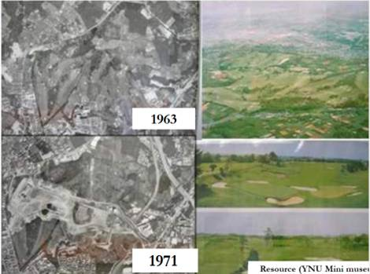
The site was originally the Hodogaya Country Club, the first golf course in Japan

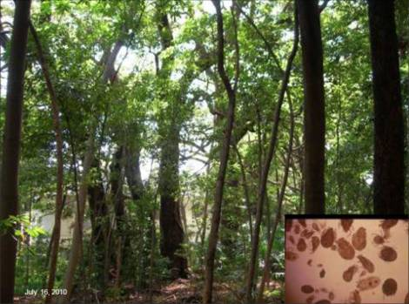
2010 photos from “Thirty-seven Years of Restoration Results and Future Prospects for the Miyawaki Method by Kazue Fujiwara & Akira Miyawaki Prof. Emerita YNU & Prof. YCU, kazue@ynu.ac.jp ”

The Miyawaki Method has since spread from Japan to other countries, mostly in Asia but also in Mediterranean countries.

FEATURES OF MIYAWAKI METHOD
- Dense Plantation – saplings are planted closely together to promote faster growth due to competition for light among the species. Recommended are 2-3 saplings per square meter or up to 12,000 saplings per hectare. In a natural forest, plants should be able to compete, edure, and co-exist.
- Mix of species – selection of the species to be planted is key. The ideal would be to plant the native canopy species that are most likely to have been growing naturally at the site. Try to imagine what the site was like before people came into the picture and plant those species.
- Well-prepared potted saplings – According to Dr. Miyawaki, most native species have strong tap roots. This makes them hard to transplant, so the seeds are started out in pots for easier transplanting. The saplings are ready to transplant when their roots fill up the pot and they are about 50-80 cm tall. The potted saplings are then taken to the site and left to acclimatize for up to 4 weeks before they are planted.
- Real vs Fake Plants – Dr. Miyawaki describes plants as either real or fake. Fake plants may look beautiful, but require a lot of care and maintenance. They are also less likely to survive storms and bad weather. Native plants are the real plants . They only require maintenance such as mulching, weeding and watering for the first two years. He said that if a plant still requires maintenance after 5 years, it is a fake plant!
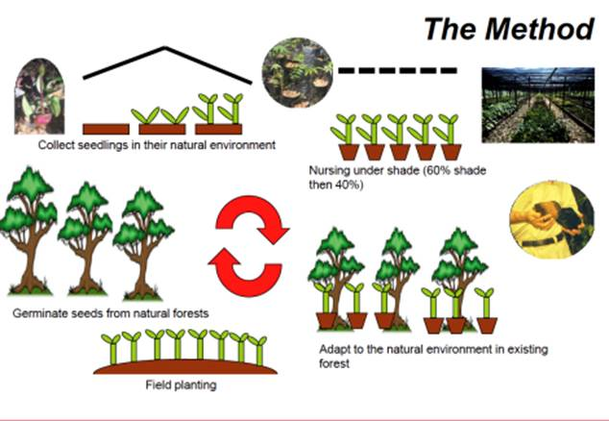
Miyawaki Method

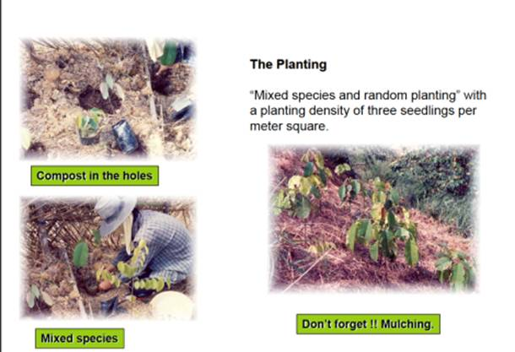
Miyawaki Planting Method
Mixed species and random planting with a planting density of threee seedling per meter square.

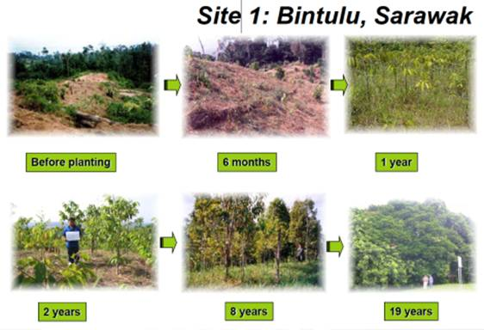
Miyawaki Method, before and after
Photos from “Restoration and Ecosystem Health Assessment of Degraded and Rehabilitated Forests by Prof. Drk. Nik Muhamad Majid Faculty of Forestry Universiti Putro Malaysia”

The following illustrations are from the Mitsubishi Corporation website:
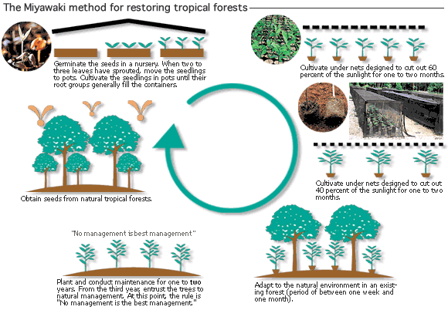
The Miyawaki Method
Source : http://www.mitsubishicorp.com/jp/en/csr/contribution/earth/activities03/activities03-02.html
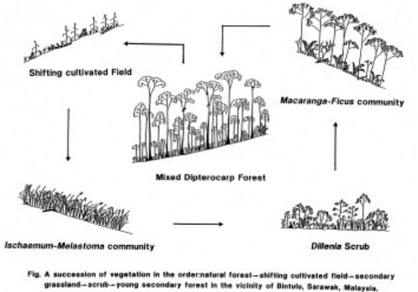
1) Mixed Dipterocarp Forest, 2) Shifting cultivated Field, 3) Ischaemum-Melastoma community, 4) Dilfenia Scrub, 5) Macaranga-Ficus community
Fig. A succession of vegetation in the order-natural forest – Shifting cultivated field – secondairy grassland - scrub - young secondary forest in the vicinity of Bintulu, Sarawak, Malaysia.
Secondary succession diagram of burned natural forest, Malaysia.
Source : http://www.af-info.or.jp/blueplanet/doc/essay/2006essay-miyawaki.pdf

How to Establish your own Native Tree Nursery
Since the germination potential of seeds begins to deteriorate about two weeks after they fall, they are immediately gathered and planted in seed beds.
When the germinated plants have produced two to six leaves, they are transplanted from the seed beds to pots.
When the plants are 30 to 50 centimeters tall and have root systems that fill the pots, the next stage is intensive, mixed planting at the rate of two to three plants per square meter. However, potted plants cannot be trans-planted immediately. In a tropical forest, each tree over 50 meters tall is surrounded by a throng of about 1,500 descendants. The plants need to become acclimatized in this natural environment, so the pots are set out in a suitable location, such as adjacent to the existing forest, for a period of between one and four weeks, depending on the species of tree and weather conditions at the time. They are then moved to the area to be reforested and are planted in a natural fashion.

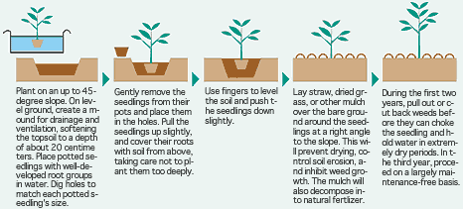
 |  |  |  | 
Plant on an up du 45 degree slope. On level group, create a mound for drainage and ventilation, softening the topsoil to a depth of about 20 centimeters. Place pottend seedling with well developed root groups in water. Dig holes top match each potted seedling’s size. | Gently remove the seedling from their pots and place them in the holes. Pull the seedling up slightly, and cover their roots with soil from above, talking care not to plant them too deeply. | Use finger to level the soil and push the seedling down slightly. | Lay straw, dried grass, or other mulch over the bare ground around the seedling at a right angle to the slope. This will prevent drying, control soil erosion, and inhibit weed growth. The mulch will also decompose into natural fertilizer. | During the first two years, pull out or out back weeds before they can choke the seedling and hold water in extremely dry periods. In the third year, proceed on a largely maintenance-free basis.
How To Plant Potted Seedlings with the Miyawaki Method
Source : http://www.mitsubishicorp.com/jp/en/csr/contribution/earth/activities03/activities03-03.html

SUITABLE TREES FOR THE PHILIPPINES
This is the list of trees for planting at Yokohama Tires in Clark, Pampanga using the Miyawashi Method. The soil at the site “was found to be low in water-holding capacity and depleted of nutrients as a result of volcanic ash. In this case, site preparationrequired first scrapping the ash and then enhancing the topsoil with compost and chicken dung. Dr. Edwino Fernando helped choose the species best suited for planting, and was assisted by 900 people from the surrounding communities in the planting process. The trees have shown phenomenal growth in less than two years, with some having grown as tall as 6.5 M.”

from: ISBN 978-9962-614-22-7 Vol 1 No 1, 2012, Conference Proceedings Mainstreaming Native Species-Based Forest Restoration

Trees list for Philippine :
1. Amugis (Koodersiodendron pinnatum)  2. Amuyong (Goniothalarnus amuyon)  3. Balakat (Zizigium talmai)  4. Balakat gubat (Balakata luzoniensis)  5. Banuyo (Wallaceodendron celebicum)  6. Bignai (Antidesma bunius)  7. Bitaog (Calophylum inophyllum)  8. Bolon (Platymitra arborea)  9. Dao (Dracontomelon dao)  10. Duklitan (Pouteria duclitan)  11. Dungon (Hentiera sylvatica)  12. Ilang-ilang(Cananga odorata)  13. Ipil (Intsia bijuga)  14. Kalantas (Toona calantas)  15. Kalingag (Cinnamomum mercadoi)  16. Kalumpit (Terminalia microcarpa) | 17. Kamagong (Diospyros blercoi) 18.  18. Lamio (Dracontomelon edule)  19. Ligote (Syzygium polycephaloides)  20. Mabunot (Gomphandra luzoniensis)  21. Magabuyo (Celtis luzonica)  22. Makaasim (Syzygium nitidum)  23. Malaipil (Afzelia bomeensis)  24. Molave (Vitex parviflora)  25. Palosapis (Anisoptera thurifera)  26. Panglomboien (Syzygium simile)  27. Saplungan (Hopea plagata)  28. Tagotoi (Palaquium foxworthyi)  29. Toog (Petersianthus quadrilatus)  30. White lauan (Shorea contorta)  31. Malabuho (Sterculia oblongata)  32. Balinghasai (Buchanania arborescens)
Preliminary list of species recommended for planting trees in Yokohama, Clark, Pampanga
(Yokohama Tires Tree Planting List).
Sources : http://mindingthefarm.files.wordpress.com/2012/11/screen-shot-2012-11-01-at-10-17-36-am.png &
http://mindingthefarm.files.wordpress.com/2012/11/guide_to_rainforestation_timber_species1.pdf

A list of planted trees for reforestation in Malaysia
No. | Species Name
1 | Shorea atrinervosa | 18 | Shorea parvifolia | 35 | Cotylelobium malayanum
2 | Shorea balanocarpoides | 19 | Shorea puauciflora | 36 | Cotylelobium melanoxylon
3 | Shorea beccariana | 20 | Shorea rubella | 37 | Upuna borneensis
4 | Shorea brunnescens | 21 | Shorea scaberrima | 38 | Vatica cuspidata
5 | Shorea crassa | 22 | Shorea scabrida | 39 | Vatica mangachapoi
6 | Shorea dasyphylla | 23 | Shorea venutosa | 40 | Vatica nitens
7 | Shorea domatiosa | 24 | Hopea beccariana | 41 | Vatica venulosa
8 | Shorea gibbosa | 25 | Hopea bracteata | 42 | Dracontomelon dao
9 | Shorea glaucescens | 26 | Hopea kerangasensis | 43 | Gluta wallichii
10 | Shorea laxa | 27 | Hopea pentanervia | 44 | Mangifera pajang
11 | Shorea leprosula | 28 | Parashorea parvifolia | 45 | Parishia insignis
12 | Shorea macrophylla | 29 | Parashorea smythiesii | 46 | Parishia maingayi
13 | Shorea macroptera | 30 | Dryobalanops aromatica | 47 | Pentaspadon motleyi
14 | Shorea maxwelliana | 31 | Dryobalanops beccarii | 48 | Neouvaria acuminatissima
15 | Shorea mecistopteryx | 32 | Dipterocarpus rigidus | 49 | Alstonia angustifolia
16 | Shorea multiflora | 33 | Dipterocarpus stellatus | 50 | Alstonia angustiloba
17 | Shorea ovata | 34 | Cotylelobium burckii
Source : http://www.mitsubishicorp.com/jp/en/csr/contribution/earth/activities03/activities03-01.html

A list of planted trees for reforestation in Brazil
No. | Species Name
1 | Euterpe oleracea | 16 | Inga alba | 31 | Eugenia cumuni
2 | Calophyllum angulare | 17 | Cassia mangium | 32 | Eugenia moleccensis
3 | Virola guianensis | 18 | Diplotropis purpurea | 33 | Cariniana integrifolia
4 | Virola surinamensis | 19 | Swartizia leptopetala | 34 | Eschweilera matamata
5 | Virola melinoni | 20 | Swartizia acuminata | 35 | Terminalia tanibouca
6 | Ceiba pentandra | 21 | Cassia alata | 36 | Rizophora mangue
7 | Bombax spruceanum | 22 | Simaruba amara | 37 | Bagassa guianensis
8 | Ochroma pyramidae | 23 | Trattinickia burserifolia | 38 | Brosimum ovatifolium
9 | Sterculia speciosa | 24 | Cedrella glaziovii | 39 | Joannesia princeps
10 | Theobroma sylvestris | 25 | Carapa guianensis | 40 | Hevea brasiliensis
11 | Theobroma grandiflorum | 26 | Swietenia macrophylla | 41 | Aspidosperma desmanthum
12 | Macrobium bifolium | 27 | Cedrella odorata | 42 | Cordia goeldiana
13 | Pterocarpus amazonicus | 28 | Cedrella fissilis | 43 | Tabebuia serratifolia
14 | Macrolobium acaciaefolium | 29 | Tapirira guianensis
15 | Ormosia getuilana | 30 | Spondias lutea
Source : http://www.mitsubishicorp.com/jp/en/csr/contribution/earth/activities03/activities03-04.html

The website Rainforest Information Portal has a downloadable list of native Philippine trees divided into 5 groups:

- Table 1 Sun demanding indigenous tree species recommended in Production, Restoration and Urban Areas with volcanic soil.
- Table 2 Shade tolerant local forest tree species recommended in Production, Restoration and Urban Areas with volcanic soils.
- Table 3 Sun demanding forest tree species that efficiently shade out weeds if planted closely.
- Table 4 Sun demanding forest tree species recommended in limestone areas.
- Table 5 Indigenous forest trees recommended for habitat restoration/wildlife conservation with reproductive parts eaten by some animals based on field observations.

Guide_to_Rainforestation_Timber_Species pdf

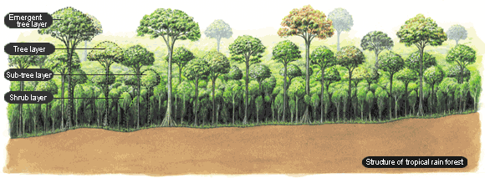
Structure of tropical rainforest
Source : http://www.mitsubishicorp.com/jp/en/csr/contribution/earth/activities03/activities03-03.html

BIBLIOGRAPHY / REFERENCE ON MIYAWAKI METHOD:

Books in English:
The Healing Power of Forests: The Philosophy Behind Restoring Earth's Balance With Native Trees, avec Elgene Owen Box, 2007, ISBN 978-4-333-02073-7.
Vegetation in Eastern North America: Vegetation System and Dynamics Under Human Activity in the Eastern North American Cultural Region in Comparison avec Kunio Iwatsuki (Auteur), Miroslav M. Grandtner (dir.), 1994, ISBN 978-0-86008-494-5

Books in Japanese:
日本植生誌 (litt. Journal japonais de la végétation), édition 至文堂, 2000, ISBN 978-4-7843-0040-2.
植物と人間 (litt. Les plantes et les Hommes), éditions NHK
緑回復の処方箋 (litt. Prescription pour un relance verte)
鎮守の森 (litt. Gardiens des forêts), revue Shinshio (新潮)
いのちを守るドングリの森

Pages Internet:
Creative Ecology: Restoration of Native Forests by Native Trees, Akira MiyaWaki, Plant Biotechnology (Review), 16(1), 15-25 (1999), http://www.wdc-jp.biz/pdf_store/jspcmb/pdf/pb16_1/pb16_1_015.pdf (in English).
RESTORATION OF TROPICAL RAINFORESTS BASED ON VEGETATION ECOLOGY – ITS SIGNIFICANCE, RESULTS AND VISION FOR THE FUTURE, Keynote Address, Akira Miyawaki, Rehabilitation of Tropical Rainforest Ecosystems, 24 – 25 October 2011, Kuala Lumpur, www.forr2.upm.edu.my/frp/images/abstract61.pdf (in English).
Akira Miyawaki, Wikipedia Français, http://fr.wikipedia.org/wiki/Akira_Miyawaki (in French).
Fiche de l'Ambassade de France sur la méthode Miyawaki, suite à une mission INRA, http://www.ambafrance-jp.org/IMG/pdf/foresteriefiche.pdf (PDF) (in French).
(en) Source principale : Source principale : Doc. de synthèse réalisé à l'occasion du prix 2006 attribué à Miyawaki par l'Asahi Glass Foundation de Tokyo, avec illustration, exemples de cartes de végétation (en Anglais), http://www.af-info.or.jp/blueplanet/doc/essay/2006essay-miyawaki.pdf (PDF) (in English).
2006 Blue Planet Prize Commemorative Lectures,
For establishing a theory to restore and to reconstruct forests based on the concept of "Potential natural vegetation" and by implementing the theory succeeded in reconstructing disaster-preventing environment-conserving forests and tropical forests, contributed in restoring the green on earth, Dr. Akira Miyawaki (Japan), Director, Japanese Center for International Studies in Ecology (JISE),
http://www.af-info.or.jp/en/blueplanet/doc/list/2006essay-miyawaki.pdf
http://www.af-info.or.jp/en/blueplanet/doc/prof/2006profile-eng.pdf
www.af-info.or.jp/blueplanet/doc/lect/2006lect-j-miyawaki.pdf (Japanese).
www.af-info.or.jp/publication/doc/nenpou2006.pdf (Japanese).
www.af-info.or.jp/blueplanet/doc/prof/2006profile-j.pdf (Japanese).

Restoration and Ecosystem Health Assessment of Degraded and Rehabilitated Forests, Prof. Dr. Nik Muhamad Majid, Faculty of Forestry, Universiti Putra Malaysia, 43400, Serdang, Selangor, Malaysia, http://www.biodic.go.jp/gbm/gbon/PDF/0722/a.m/1/Dr.Majid.pdf (in English).

Reference & publications:
↑ A. Miyawaki, 1992. Restoration of Evergreen Broad-leaved Forests in the Pacific Region. In: M.K. Wali (ed.). Ecosystem Rehabilitaiton. 2. Ecosystem Analysis and synthesis 233-245. SPB Academic Publishing, The Hague
↑ A. Miyawaki, K. Fujiwara & E.O. Box, 1987. Toward harmonious green urban environments in Japan and other countries. Bull. Inst. Environ. Sci. technl. Yokohama Natl. Univ. 14: 67-82. Yokohama.
↑ A. Miyawaki & S. Okuda, 1991. Vegetation of Japan Illustrated. 800 p. Shibundo, Tokyo (Japanese)
↑ ex : A. Miyawaki et al. 1983. Handbook of Japanese Vegetation, 872 p. (noms en japonais et en latin), avec carte de distribution des communautés végétales au Japon (168 p). Shibundo, Tokyo
↑ A. Miyawaki, 1980-1989. Vegetation of Japan. vol. 1-10 (Principale référence au Japon sur la végétation existante et naturelle potentielle du Japon)
↑ Voir aussi : A. Miyawaki, 1985. Vegetation-Ecological Studies on Mangrove Forests in Thailand, 152 p. Inst. Environ. Sci. Technl. Yokohama Natl. Univ., Yokohama
↑ A. Miyawaki, A. Bogenrider, S. Okuda & I. White, 1987. Vegetation Ecology and Creation of New Environments. Proceedings of International Symp. in Tokyo and Phytogeographical Excursion through Central Japan. 473 p. Tokai Univ. Press, Tokyo
↑ A. Miyawaki & E. O. Box, 1996. The Healing Power of Forests -The Philosophy behind Restoring Earth's Balance with Native Trees. 286 p. Kosei Publishing Co. Tokyo
↑ ("Changing Course," rapport du Business Council for Sustainable Development préparant le Sommet de la Terre de Rio, 1992).
Miyawaki A (1992). Restoration of Evergreen Broad-leaved Forests in the Pacific Region. In: M.K. Wali (ed.). Ecosystem Rehabilitaiton. 2. Ecosystem Analysis and synthesis. SPB Academic Publishing, The Hague
Miyawaki A, K. Fujiwara & E.O. Box (1987). Toward harmonious green urban environments in Japan and other countries. Bull. Inst. Environ. Sci. Technl. Yokohama Natl. Univ. 14: Yokohama.
Miyawaki A & S. Okuda (1991). Vegetation of Japan Illustrated. Shibundo, Tokyo (Japanese)
Miyawaki A et al. (1983). Handbook of Japanese Vegetation, Shibundo, Tokyo
Miyawaki A (1980-1989). Vegetation of Japan. vol. 1-10
Miyawaki A (1985). Vegetation-Ecological Studies on Mangrove Forests in Thailand, Inst. Environ. Sci. Technl. Yokohama Natl. Univ., Yokohama
Miyawaki A, Bogenrider, S. Okuda & I. White (1987). Vegetation Ecology and Creation of New Environments. Proceedings of International Symp. in Tokyo and Phytogeographical Excursion through Central Japan. Tokai Univ. Press, Tokyo
Miyawaki A, & E. O. Box (1996). The Healing Power of Forests -The Philosophy behind Restoring Earth's Balance with Native Trees. 286 p. Kosei Publishing Co. Tokyo
Miyawaki A, Plants and Human (NHK Books)
Miyawaki A, The Last Day for Man (Chikuma Shobo)
Miyawaki A, Testimony by Green Plants (Tokyo Shoseki)
Miyawaki A, Prescription for Restoration of Green Environments (Asahi Shinbun-sha)
Miyawaki A, Chinju-no-mori (Native Forests of Native Trees) (Shincho-sha).

External links:
Japanese Center for International Studies in Ecology biographical page, accessed 23 August 2011 (http://www.jise.jp/ENG/ENmiyawaki.html )
Yokohama Rubber Co. page on Yokohama Forever Forest project, accessed 23 August 2011
(http://www.yrc.co.jp/csr/en/feature/feature_1/index2.html & www.yrc.co.jp/csr/en ).

Source on Mrs Sylvia Ramos Internet page, presenting these two methods: http://mindingthefarm.wordpress.com/2012/11/01/from-farm-to-forest/

On the other native forests restoration methods:
Sgró, C.M., A. J. Lowe and A. A. Hoffmann, 2011. Building evolutionary resilience for conserving biodiversity under climate change. Evolutionary Applications 4 (2): 326-337
Lamb, D., 2011.Regreening the Bare Hills. Springer 547pp.
Mansourian, S., D. Vallauri, and N. Dudley (eds.) (in co-operation with WWF International), 2005. Forest Restoration in Landscapes: Beyond Planting Trees. Springer, New York
Reitbergen-McCraken, J., S. Maginnis A. Sarre, 2007. The Forest Landscape Restoration Handbook. Earthscan, London, 175 pp.
Shono, K., E. A. Cadaweng and P. B. Durst, 2007. Application of Assisted Natural Regeneration to Restore Degraded Tropical Forestlands. Restoration Ecology, 15(4): 620–626.
Goosem, S. and N. I. J. Tucker, 1995. Repairing the Rainforest, Theory and Practice of Rainforest Re-establishment in North Queensland's Wet Tropics. Wet Tropics Management Authority, Cairns, Australia. Pp 72 (Presentation of this book : http://www.wettropics.gov.au/site/user-assets/docs/RepairingRainforest1.pdf & http://isbndb.com/d/book/repairing_the_rainforest.html, Price : ~ $69.99).
What is forest restoration?, John A. Stanturf, 2005, in Restoration of boreal and temperate forests, CRC Press, Boca Raton, p. 3-11, http://www.treesearch.fs.fed.us/pubs/22209 (PDF).
Assisted natural regeneration of forests, ANR of FORESTS, http://www.fao.org/forestry/anr/en (English video).
Managing Forests for Climate change, FAO, http://www.fao.org/docrep/013/i1960e/i1960e00.pdf

External links:
http://en.wikipedia.org/wiki/Forest_restoration
http://en.wikipedia.org/wiki/Forest_landscape_restoration
http://en.wikipedia.org/wiki/Restoration_ecology

Article published on the site to assist reforestation projects _ www.projetsreforestation.co.nr _, with the consent of its author, Mrs. Sylvia Ramos.

Blog by Sylvia Ramos, ornithologist and photographer of birds : http://mindingthefarm.wordpress.com

