Project of hedges for preserving coconuts plantations in south of India

By Benjamin LISAN & « Friend-in-need » (« Un-ami ») Indian association,
Paris, December, the 19, 2010.

_ To see the summary, click on this link _.

Historical Introduction

The December 2004, a tsunami devastated the Indian Ocean coast of India.
In particular, its destructive wave toppled coconut trees all along this coast, which made living its inhabitants.
The coconuts are an important source of income for its inhabitants.
Currently, humanitarian projects are trying to replant these coconuts.
The "Friend-in-need" Indian Association is trying to replant coconut trees along the coast at the village Kameshwaram in Nagapattinam district of Tamil Nadu (south-east of India).

Goals
To recreate the coconut grove, it is necessary to erect a protective barrier deterrent, around the plantation so that the coconut nurseries are grazed or trampled by domestic animals or even stolen by the inhabitants. (See also chapter “Complement : impacts of a hedge”).

Location, size and topography
On the Indian Ocean coast, at the village Kameshwaram in Nagapattinam district of Tamil Nadu , in the south-east of India (coast of the Bay of Bengal).

We're dealing with a low, flat coast, so there would be little problem of contour lines to follow (to verify).
The area to be close by a hedge or several hurdles, is ???? km2 (data to find).
The total length of the hedge or hedges will be ???? km (data to find).

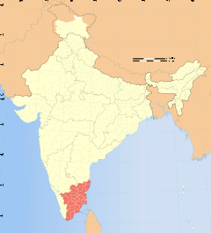 | 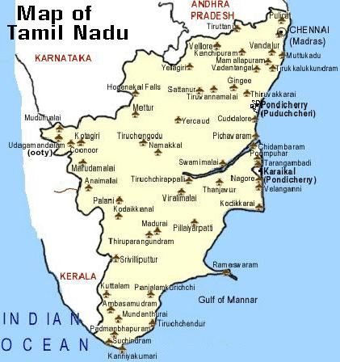
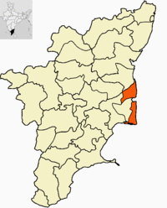 | 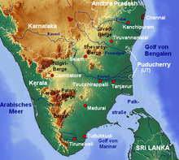  Geography of Tamil Nadu.

Soil type, salinity and water table
Sandy, light, soft soils (grounds). Lateritic basement (poor soils) (???).
Salinity of the water varies depending on episodes of monsoons or droughts (but still low).
Height of the fresh water layer varies, depending on rainfall.

To check and complete.
There is the need to take samples of water to measure groundwater salinity. And knowing its depth.
A study of droughts in the region is also expected.

Climate, rainfall
Tamil Nadu is heavily dependent on monsoon rains, and thereby is prone to droughts when the monsoons fail. The climate of the state ranges from dry sub-humid to semi-arid. The state has three distinct periods of rainfall:
- advancing monsoon period, South West monsoon from June to September, with strong southwest winds;
- North East monsoon from October to December, with dominant northeast winds;
- dry season from January to May.
The normal annual rainfall of the state is about 945 mm (37.2 in) of which 48% is through the North East monsoon, and 32% through the South West monsoon. Since the state is entirely dependent on rains for recharging its water resources, monsoon failures lead to acute water scarcity and severe drought.
Tamil Nadu is classified into seven agro-climatic zones: north-east, north-west, west, southern, high rainfall, high altitude hilly, and Cauvery Delta (the most fertile agricultural zone). The table below shows the maximum and minimum temperatures that the state experiences in the plains and hills.

 | Plains | Hills
Max. | 43 °C (109 °F) | 32.3 °C (90.1 °F)
Min. | 13.1 °C (55.6 °F) | 3.0 °C (37.4 °F)

Average rainfall in Tamil Nadu | 974.6 mm.

At the seaside village of Kameshwaram in Nagapattinam district, the average rainfall is 1,500 to 1,700 mm of rain.
To verify and complete.

Type of barrier selected
To protect the plantations and nurseries we had a choice between the wooden fence, barbed wire fence, electrified fence (to deter herbivores), a chainlink fence _ all these solutions are expensive and unfriendly environmentally _ and the hedge based on thorny shrubs or trees _ greener solution and requires less maintenance over the long term.
We chose a hedge, for ecological reasons, because it can introduce biodiversity and because it may provide wood to local residents.

As the "International Centre for Research in Agroforestry (ICRAF), we propose an improved hedge composed of multipurpose trees, usually spiny, which are densely planted on the periphery of the plot (of the cultures) to protect. Three to five years after its installation, the hedge provides lasting protection to crops, while promoting the conservation of the resource tree (Djimdé 1998). Assume that a better crop protection permits obtaining higher yields and therefore a surplus of production which can be sold on the market (see next section).
You can create a hedge of thorny shrubs, thorny bushes, thorny trees and bushes thorny fruit (or not) ... _ lemon etc. _, to encourage biodiversity _ the hedge used as a refuge for animals, birds, fruit trees etc.

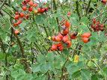  Wild rosehips (rosehip) can serve as thorny hedge of protection.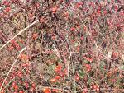 | 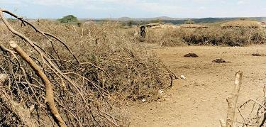  Dry hedge or "henkang" (solution not retained)

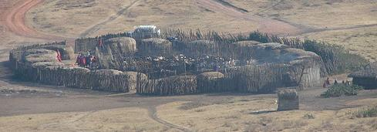
Thorny & protective barriers protecting some African villages.

Types of chosen plants

FAO proposes the following species for hedges of thorn in the tropics :

Species | Rainfall  400 - 700 mm | Rainfall  700 - 1000 mm | Rainfall  1000 - 1300 mm
Acacia mellifera | X | X
Acacia nilotica | X | X
Acacia senegal | X | X
Agave sisalana |  | X | X
Bauhinia rufescens | X | X | X
Citrus lemon |  | X | X
Commiphora africana | X | X
Dichrostachys cinerea |  |  | X
Euphorbia balsamifera | X | X
Haematoxylon brasiletto |  |  | X
Jatropha curcas | X | X
Moringa oleifera |  | X | X
Prosopis juliflora | X | X
Ziziphus mauritiana | X | X | X
Ziziphus mucronata |  |  | X

Table 1 - Recommended species for live fences in dry and semi-arid areas of West Africa (from Louppe, 1999).
Source : Live Tree Fences and Ligneous Windbreaks, FAO, http://www.fao.org/ag/againfo/programmes/en/lead/toolbox/Tech/22Livef.htm

As for the tree species proposed by ICRAF for making the hedge, it is :

Ziziphus mauritiana (jujubier _ arbres à fruits),
Acacia nilotica,
Acacia senegal (ou Acacia senegalis avec lequel on produit la gomme arabique),
Lawsonia inermis,
Bauhinia rufescens.

Source : L'adoption des haies vives d'épineux par les paysans du Mali, Virginie Levasseur ¹, Alain Olivier ¹ et Bocary Kaya ², http://www.fao.org/DOCREP/ARTICLE/WFC/XII/0018-B5.HTM

We will focus on these species.

But we could also use different species of Euphorbiaceae, various tropical species of Berberis or prickly pears and wild roses (rosehips etc..). More than 60 plants may be used.

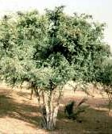  Bauhinia rufescens | 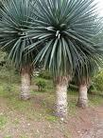  Agave Sisalana | 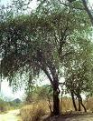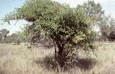  Ziziphus mauritiana
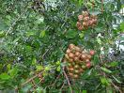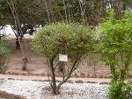  Lawsonia inermis | 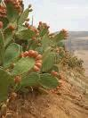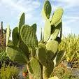  Prickly pear | 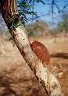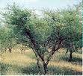  Acacia senegal (with arabic gum outgoing trunk)
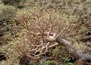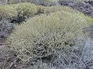  Euphorbia balsamifera | 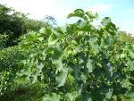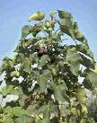  Jatropha curcas (produces biofuel) | 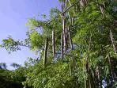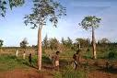  Moringa oleifera (product of edible oil)
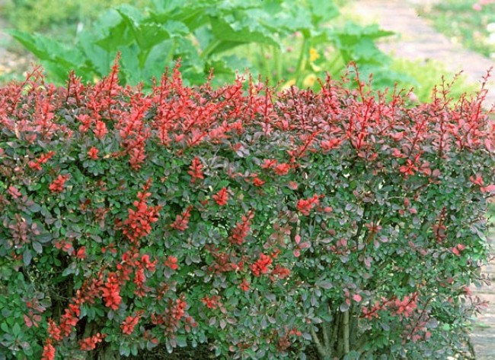
Berberis hedge.
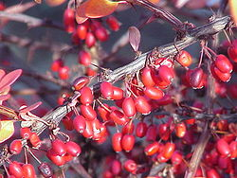
Berberis hedge (next).

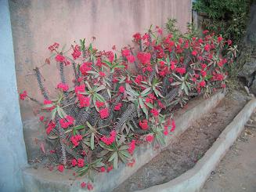
Image of a thorny shrub widespread in Madagascar _ both on his side as his "plateaus" _ and perhaps in Africa.

The problem of invasive plants

Warning! Some plants _ such as Agave sisalana, jujube etc.. _ can be highly invasive and behave as "plant pests".
If in doubt we always choose native species (local), before introducing new ones in the region.

Techniques de plantation de haies

On techniques for creating hedges and copses, see the work of D. Soltner shown below:

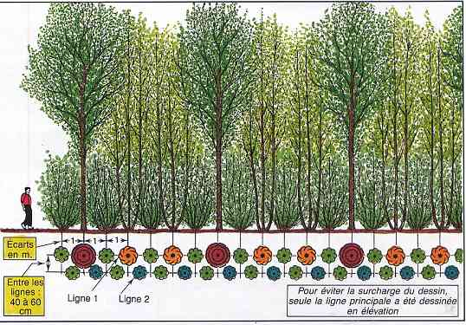
Example : 3-tier hedge
(Source « Planter des Haies » [Planting Hedges], Dominique Soltner).

Better prefer to plant seedlings on mounds of earth 60 cm high.

It will determine:
1) What plants are mixed in the hedge (if they are compatible).
2) What will be available and how often meters.

(Information to look for).
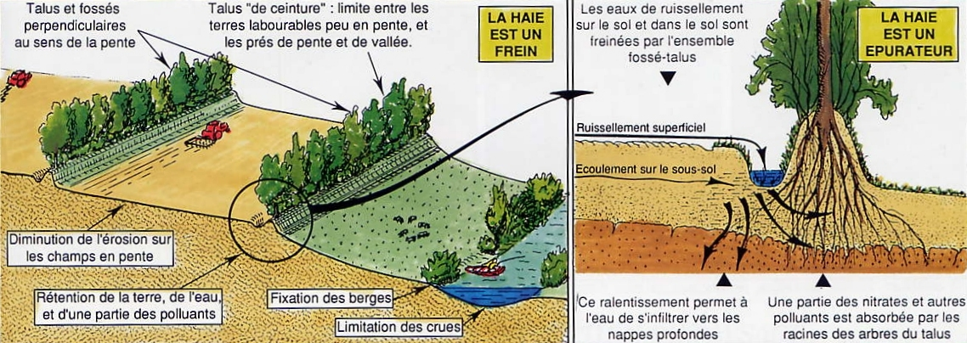
Techniques and rules for the planting of hedges and hedges roles. © D. Soltner
Source of these patterns: « Planter des Haies » [Planting Hedges] of Dominique Soltner.

English translation of the French comment in these two pictures:
First picture:
Slopes and ditches perpendicular to the direction of the slope.
Talus "belt": arable land boundary between the slight slope, and near the valley slope.
Less erosion on sloping fields.
Retention of land, water, and some pollutants.
Fixing the banks.
Limitation of flood.
The hurdle is an obstacle.

Second picture:
The hedge is a purifier.
Runoff on the soil and soil are hampered by all-ditch embankment.
Surface runoff.
Flow into the basement.
This deceleration allows water to seep into deep aquifers.
Part of nitrates and other pollutants are absorbed by the roots of trees in the embankment.

It is best planted at 50 cm from the property line for a fence not exceeding 2 m high and 2 meters, a hedge above 2 m high (preferably to plant in north-south direction if c is possible).

It must then COVER THE GROUND.

An agronomic principle is too often ignored: no grass within 50 cm of any planting (tree or hedge) for at least 3 years. Even cutting the grass competes with tree or shrub and slows or even stops growth.

Processes of land cover to conserve soil moisture: THE NATURAL MULCH.
Mulching uses many natural vegetable waste straw, hay, grass clippings, shredded bark and branches. Planting hedges on plastic film from 1976. has been put in the shade of natural processes mulching. These processes found today, with new applications, their value and their superiority:

- natural biodegradable mulching, so allows, once broken, allowing the establishment at the foot of the hedge spaces spontaneous shrubs and herbaceous plants, very useful for wildlife including beneficial insects,
• natural mulching is permeable, so allow better infiltration of rain, hence its superiority for planting on slopes and embankments, where it is also easier to install,
• natural mulching is generally the most economical, straw and hay do not cost hardly anything to farmers who use them, and for individuals it is very easy to get discount. The crushed bark and wood chips are also great, despite some reservations about the bark of pine trees because of their acidity and tannin content. But this effect can be corrected by a good layer of compost under the bark.

It gives results equivalent if not superior, to other techniques (plastic film ...), provided to be very well applied.

1 - The natural mulch before planting: a new method of "culture of hedges"

The new idea of this method is to prepare the ground 6, 8 to 12 months before planting, not by the action of machines, but by loosening and enrichment qu'assurent earthworms under a layer of very thick straw.
The condition is that the soil has been previously cleared of perennial weeds (quackgrass, Nettles, Brambles, Thistles ...) that promotes mulching. Destruction that can be done either by scratching repeated dry periods, or chemically.

2 - Natural mulching AFTER planting: the double-coverage straw compost

After planting trees and shrubs on bare soil, it begins to surround each plant with a forked compost or rotted manure.
Then covered the feeder layer, a thick mulch of straw or hay, 10 to 15 cm thick, at 2.5 to 3 kg per m2.
During the season, we can strengthen this mulch is a new layer of straw or hay, either grass clippings in thin layers dry if possible: avoid heavy layers of wet clippings which gives a very harmful fat rot.

3 - Mulch on compost: the "Jean Pain methode"

This ground cover with a layer of compost protected from the sun by a thick mulch, such is the essence of the method of Jean Pain (Source of information : “Planter des haies” ["Planting Hedges"], Dominique Soltner).
With this method, an exuberant vegetable crops without irrigation are possible under very hot and dry climates (see “Les Bases de la Production Végétale” [The Basics of Crop Production], Volume I (in French), “collection Sciences et Techniques Agricoles”, 49130 SAINT-GEMS-SUR-LOIRE). This gives a fertility and water savings that can be explained by the intense activity of earthworms and bacteria (see diagram below).
From a biological standpoint the ground, the method "manure and mulch on the surface" is similar to what happens in the forest.
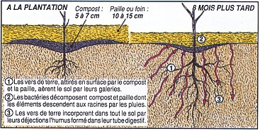
(Source Picture © D. Soltner).

Compost: 5-7 cm, straw or hay from 10 to 15 cm,
1) earthworms attracted to the surface through the compost and straw, aerates the soil through their galleries.
2) bacteria break down compost and straw whose elements down to the roots by the rains.
3) earthworms incorporate throughout the soil through their manure humus formed in the digestive tract.

Techniques of irrigation

Ideally, irrigation technology of drip irrigation (but expensive).
Otherwise, there is hand watering with manual sprinklers.
For example, to involve the villagers, schoolchildren, scouts, youth camps for watering seedlings and seedlings planted in the nursery, or along the hedge and so on.

Local actors and socio-cultural determinants

The region is heavily populated by Tamils, who speak the Tamil language.
The Tamil language is the official and primary language of the state. According to the 2001 census, Tamil is spoken by 89.43% of the population.
These Tamils are highly literate, more than 73.47% in 2001 and fertility rates among the lowest in India, with 1.7 or 1.8 ‰ .
They are Hindu religion to over 88%.
In the village, we mainly fishermen and farmers (including owners of coconut).

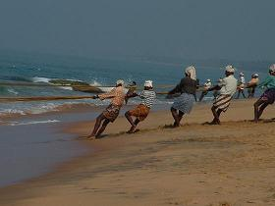
fishermen of Tamil Nadu.

The people like the majority of Indians are fascinated by all that comes from the West. Everyone wants to have a Western standard of living. Just something that comes from the West, they want to adopt.

Woodcutting

Most people in the country, India, using wood cut from the neighborhood, to cook their food. Which may contribute to the deforestation of these campaigns. Since pruning (cutting its regular branches by locals) which trees (and fences) are exposed, we need a strict discipline at the village level, the rules of sections (or how not to "mutilate "branches) and the amount of wood removed. For example, make rules (under a charter) to:

• The rotation cuts branches
• cut them every 7 years, 5 years (according to a campaign planned in advance) and so on.
• The type of mutilation permitted (and on what specific trees).

So there is a timber management to plan and implement with the villagers (with a schedule cuts, according to the "forest plot" intended).

It should also cut the hedge regularly, to maintain it and prevent its spread or proliferate too.
The loggers can be fitted with a scale _ or more, a large aluminum ladder _ and a pair of gloves gardener (skin) to avoid the "gardeners" of the hedge to prick or of injury from the spines of spiny plants. They also had a hand saw and a sharp pruning shears.
And a zebu cart (or a trailer and a tractor) to harvest timber.

Development of side projects

(To be added to the principal project of construction of thorny hedges).

What would be best to avoid too much pressure on the environment of human beings on the wood resource and therefore on the hedges, would also develop cheap solar cookers (box type) and biogas (based on a barrel of oil, bedroom truck air, or in the form of masonry vaulted tanks (more expensive)) in the surrounding villages.

Partner associations

Friends-in-need (Franco-Indian association, specialized in the promotion of the ecosans, in the Tamil Nadu State, India) : Friend-in-Need ( FIN) Trust, 28, Tennur High Road, Tennur, Trichy 620 017 T.N. India, www.friend-in-need.org.
Note: This association is directed by Dr. Shyama V. Ramani, UNU-MERIT & Maastricht University, email : ramani@merit.unu.edu & shyama_ramani@yahoo.com, tel (within France): 06 08 80 33 83, tel (outside France):00 33 6 08 80 33 83, Site: www.shyama-v-ramani.net

Experts consulted or to consult

In our study, we consulted several experts hedges in tropical region.

Note : The « Tamil Nadu Agricultural University » (TNAU), with its seven colleges and thirty-two research stations spread throughout the state contributes to evolving new crop varieties and technologies and their dissemination through its various extension agencies. Tamil Nadu is the home of Dr. MS Swaminathan (1925 -), known as the "Father of Green Revolution in India”.

Experts of soils (grounds) :
- Department of Soil Science and Agricultural Chemistry, Tamil Nadu Agricultural University, Coimbatore 641 003, Tamil Nadu, India.Telephone : +91-422-2431222 (Ext.235), +91-422-2456811, FAX : +91-422-2456816, Electronic mail : ssac@tnau.ac.in , Site : http://www.tnau.ac.in/scms/SSAC/Index.htm

- Remote Sensing Centre, Agriculture Engineering Department, Nandanam, Chennai - 600 035, India.

- Head office – Noida, India, GIS Development Pvt Ltd, GIS Development, A-145, Sector - 63, Noida (U.P.) - 201 301 India, Tel: +91-120-4612500, Fax: +91-120-4612555, +91-120-4612666, Email: info@GISdevelopment.net

Experts of tropical hedges :
- Département de Phytologie, Université Laval, Québec (QC), G1K 7P4, Canada. Téléphone: 1.418.656.2131 poste 8746. Télécopieur: 1.418.656.7856. Courriel: virginie_lev@hotmail.com, Alain.Olivier@plg.ulaval.ca

- Centre international pour la recherche en agroforesterie [International Centre for Research in Agroforestry] (CIRAF/ICRAF), B.P. 112, Ségou, Mali. To see if we can reach the contact.

- CIRAF/ICRAF, World Agroforestry Centre (HEADQUARTERS), United Nations Avenue, Gigiri, PO Box 30677, Nairobi, 00100, Kenya, Telephone: +254 20 7224000, Via USA +1 650833 6645, Fax: +254 20 7224001, Via USA +1 650833 6646, Email: icraf@cgiar.org, Site : www.worldagroforestry.org

- South Asia Regional Programme (CIRAF/ICRAF), 1st Floor National Agricultural Science Complex (NASC), Dev Prakash Shastri Marg, Pusa, New Delhi, India 110012, Telephone: +91 11 25609800/25847885/6, Fax: +91 11 25847884, Email: v.p.singh@cgiar.org

- Institut supérieur des sciences agronomiques, agroalimentaires, horticoles et du paysage, AGROCAMPUS, regroupement d’Agrocampus Rennes et de l’Institut national d’horticulture d’Angers, 65 rue de Saint-Brieuc, CS 84215, 35 042 Rennes Cedex, France - tél. : +33 (0)2 23 48 50 00, email : dircom@agrocampus-ouest.fr, Site : http://www.agrocampus-ouest.fr

Planning of the project

Part not yet realized.

Budget

Part not yet realized.

Funding and sponsors

Part not yet realized.

Appendix: Bibliography

Books and articles

On the thorny hedges and trees and shrubs in arid and semi-arid:

In English:
[1] Non-timber uses of selected arid zone trees and shrubs in Africa, F. E. M. Booth,G. E. Wickens, FAO Conservation Guide, 1988, Rome.
[2] Live Fences, Cherry, S.D. & Fernandes, E.C.M. 1999. http://ppathw3.cals.cornell.edu/mba_project/livefence.html (includes good example photos and descriptions as well as additional references).
[3] Availability and Role of Multipurpose Trees and Shrubs in Sustainable Agriculture in Kenya, Ariga, E, S. 1997, Journal of Sustainable Agriculture. 10:2/3, 25-35.
[4] The case of live hedges in the Central Plateau of Burkina Faso. Adoption of agroforestry technology. Ayuk, E.T., 1997. Agricultural Systems 54(2): 189-206.
[5] Technical advisory notes on live fencing in semi arid West Africa. Djimdé, M., 1998. ICRAF, Samanko, Mali. 7 p.
[6] A socioeconomic evaluation of live fencing and windbreak agroforestry technologies in Kaolack, Senegal. Satin, M. S. 1998. M.Sc., West Virginia University, Morgantown, West Virginia, USA, 255 p.
[7] Assessing autonomy among Sahelian woman: an analitical framework for women's production work. Simard, P., 1998. Development in Practice 8 (2): 186-202.
[8] Shrub, http://en.wikipedia.org/wiki/Shrub
[9] 28 Best Evergreen Shrubs for Landscaping Your Yard, HappyDIYHome Staff, October 17, 2020, https://happydiyhome.com/evergreen-shrubs/

In French:
[a] Les haies vives défensives en zones sèches et subhumides d'Afrique de l'Ouest. Atelier Jachères, Dakar. Louppe, D., Yossi H. 1999.
[b] Temps des villes, temps des vivres: l'essor du vivrier marchand en Côte d'Ivoire. Chaléard, J.-L., 1996. Karthala, Paris. 661 p.
[c] Propagation et comportement d'espèces à usages multiples en haies vives pour la zone sahélo-soudanienne: résultats préliminaires d'essais menés à Gonse et Dinderesso (Burkina Faso), Depommier, D., 1991, in: Riedacker, A., E. Dreyer, C. Pafadnam et G. Bory (éd.). Physiologie des arbres et arbustes en zones semi-arides. 20 mars - 6 avril 1990. Groupe d'Étude de l'Arbre Observatoire du Sahara et du Sahel, Paris et Nancy, France. pp. 155-165.
[d] L'expansion des marchés ouest-africains des produits végétaux frais. Harre, D.M., 1997. Les Cahiers de la Recherche et du Développement 44: 86-99.
[e] Rapport annuel d'activités, campagne agricole 1998/1999. Ministère du Développement Rural et de l'Eau, 1999. Bamako, Mali. 101 p.
[f] Campagne africaine en devenir. Arguments, Pélissier, P., 1995. Paris. 318 p.
[g] La dynamique des systèmes agraires dans le Sud-Ouest Nigérien: le cas des cultures de contre-saison dans la région du Boboye, Yamba, B., I.M. Bouzou et B. Amadou, 1997.. In: Pratiques de gestion de l'environnement dans les pays tropicaux. DYMSET, CRET, Singaravélou (éd.). Talence. pp. 295-309.
[h] La jachère en Afrique tropicale: rôles, aménagement, alternatives, Volume 1, Actes du séminaire international, Dakar, 13-16 avril 1999, Christian Floret,Roger Pontanier, John Libbey Eurotext editeur (en coopération avec l'IRD, le CORAF, la CE), _ sur les techniques de haies vives, voir page 730.
Source : http://books.google.fr/books?id=dhpr7dHxvz0C&pg=PA730&lpg=PA730&dq=haie+%C3%A9pineux+plantation+afrique&source=bl&ots=_zpnTogb3U&sig=AZe6zTNQ6vb5odz04wwVo5op3Vw&hl=fr&ei=xrkLTdqSOZWQ4QaWnLyMDQ&sa=X&oi=book_result&ct=result&resnum=5&ved=0CDYQ6AEwBA#v=onepage&q&f=false

On the planting of hedges and copses:
[j] Planter des haies. Méthodes de création de haies et bocages, Dominique Soltner, collection Sciences et Techniques Agricoles, 49130 SAINT-GEMMES-SUR-LOIRE. Prix 22,60 €. On trouve ce livre, à la librairie « La Maison Rustique », 26 rue Jacob, 75006 PARIS, tél. : 01.42.34.96.60.

Internet sites

[1] Live Tree Fences and Ligneous Windbreaks, FAO, http://www.fao.org/ag/againfo/programmes/en/lead/toolbox/Tech/22Livef.htm
[2] Cultivation of jatropha curcas in India [and plantation of Edges], http://www.jatropha.pro/PDF%20bestanden/Cultivation%20of%20Jatropha%20curcas%20in%20India.pdf
[3] The live database in Africa. World Bank [Banque Mondiale], Washington, DC, 2002. www.worldbank.org/afr/stats/ldb.cfm.

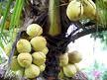
Type of coconut found in Tamil Nadu.

Appendix : coconut cultivation

Needs of coconuts

Heat requirements
The coconut palm requires a mean temperature of 27 ° C, as constant as possible (minimum 20 ° C).

Water needs
The coconut is very water demanding, both on the annual amount that the distribution of this amount throughout the year. It needs at least 1500-1700 mm of rainfall, well distributed.
It is a palm that requires high and regular humidity (to verify).
The air humidity must be made between 80 and 90% with a minimum of 60% (to verify).
Discussions: we have coconuts, in the village of Ifaty _ Mozambican coast west of Madagascar _, although this region has a dry season of almost 6 months. So here, the water table is certainly important in the development of the coconut of Ifaty).
Water can be slightly salty (brackish), coconut does not suffer too much.

Light requirements
The coconut palm requires strong sunshine: 2,000 hours per year.

Altitude requirements
The altitude is reached on the coconut tree and through the temperature and humidity.

Soil requirements
The coconut palm requires light soil, furniture, deep, well-ventilated, properly drained and coarse textured.
Soil pH can vary from 4.5 to 8.

Types of coconuts

Family: Palmaceae.
Species : Cocos nucifera.
. Coconut trees cross-pollinated: who are tall coconut trees (up to 30 m high).
. Coconut trees pollinated: dwarves are coconut trees (10 to 12 m high), very early, carrying a large number of small nuts (Madagascar).

They can be classified into two groups:
• "Mozambican" and Comoros Type: tall trees, large nuts round or pear-shaped, thick coconut (6 nuts per kilo of copra). Fruit set at 7 years (range about us).
• The Seychelles type: smaller trees, nuts small, oblong fruit with eccentric, copra thinner (7-8 nuts per kilo of copra). Maybe a little earlier.Techniques culturales.

Choosing seed
We will collect nuts for seed from trees that provide regularly a large number of fruits, the largest possible with a coconut, which are abundant and healthy.
Before putting the nuts selected, it is good to place them in a place sheltered from sun, rain and well ventilated for 3 weeks to 1 month, so they all give a good degree of maturity.

Getting propagator
The propagator should be set up near a water point, a light soil and permeable. Plowing at 15 to 20 cm deep and then dig small pits of 10 x 3 and 15 cm depth which will contain 1,000 nuts (30-40 nuts / m²).
Nuts are placed 5 cm from each other, they are lying on the side and buried three-quarters.
The top nut is mulched and watered copiously propagator is every day, the wad of nut must always be soaked in water.
After a few weeks (8-20) the first sprouts appear, they are transplanted into nursery
11 (Diagram of a propagator).

Transplant Nursery
We transplanted only 60% of germinated nuts, 40% of germinated nuts are ultimately eliminated. The first sprouted nuts coconuts will give the fastest. This simple selection propagator increases production by a quarter.
We choose a field light, permeable, homogeneous, healthy and close to the watering hole.
We plowed to 20 to 25 cm deep, it breaks the clods and smooths it.
Sprouted nuts are transplanted staggered intervals of 0.60 m and you put mulch with coconut husks or palm.
Watered once every two days during the dry season.
The seedlings remain in the nursery until they have 3-4 leaves developed, which occurs around 6-7 months after transplanting, under normal conditions.
12 (Figure nursery)

Planting
Site Preparation
Once the land selected is cleared and cleared the ground, and we proceed to the leveling
We do the picketing: driveways, block planting, planting rows and planting holes spaced 8.5 to 9 m staggered.
In the case of land subject to excess water, create a drainage system.

Trouaison [trough] and patching
One month before planting, is carried on the pecked “trouaison” [trough ?] locations. Each hole will be 1 m3 in a soil medium.
A month later, the holes are blocked again: there is: 50 Kg floss nuts, 50 kg of well-rotted manure in rotation with the earth. It completely blocked again the hole with good topsoil.
13 (Figure coconut seedling)

Actual planting
Is chosen in the nursery, the plants vigorous, with a thick neck and very green foliage.
We plant the coconut in the center of each hole filled. By digging a small hole. It covers the nuts alternating the young coconut 5 cm of soil and one cup with the soil around the base of coconut.
14 (Scheme implementation young coconut)

Maintenance
Replacement of missing coconuts.
Frequent weeding during the first 5 years, 2 times per year thereafter
Mulching the base of young coconuts, after finishing the weeding.
Remove dead leaves and store them on where they are spaced decays.

Fertilization
Organic fertilizer:
- When planting:
In each hole: 50 kg of coir pith
- On the plantation:
Every year 50 to 100 kg of well-rotted manure
Mineral fertilizer:
It varies with age of the coconut, climate and soil type

Harvest and yield
The harvest date varies greatly with the destination of the nuts:
. For direct consumption (water and albumen) fresh, you will reap between the 6th and 8th month.
. For the coconut can be harvested from the 11th month.
. For seeds are harvested at full maturity, that is to say between the 12th and 13th months.
Is formed, on average, a monthly plan. It is therefore necessary to periodically throughout the year to gather the ripe nuts.
The number of nuts varies greatly with the age of coconut:
. 3-5 nuts per tree to 6-7 years
. 15 to 30 nuts per tree at about 10 to 15 years
. 40 to 70 nuts per tree from 15 to 40 years from 60 years, production decreases. It should be 3.5 to 10 nuts to produce 1 kg of copra.
Yields vary from 0.5 to 2 T coconut / ha / year.

Note: The dwarf coconut trees are small but very productive.

Diseases and Enemies
Diseases
- Decline
- Deficiencies
. Nitrogen deficiency: more or less pronounced yellowing of the vegetative
. Potash deficiency: non-uniform yellowing of the vegetative with numerous brown spots and irregular

Enemies
. Oryctes: that perforate the base of the petiole and sometimes come to gnaw the terminal bud of the coconut tree, causing the death of the tree.
. Scale insects: biting the leaflets to suck sap. The leaves turn yellow and there may be early fall of the fruits.
. Track: that plague the leaflets and inflorescences
. Termites attacking nuts during germination
. Melitommas: whose larvae burrow at the base of the trunk and roots
. Rats: who also address the nuts during germination, eat young coconuts at the neck and feed on nuts at all stages of maturation.
. Bats: pierce nuts to consume water and endosperm.
. Coconut crabs (Birgus latro): it is known for its ability to crack coconuts with its strong claws and eat the contents.

Use of products and by-products

. Envelope: containing fibers (coir) of various lengths. It makes ropes, brushes, mats, carpets, bags, upholstery, ...
. Almond: can be eaten fresh or are dried (copra) to extract the oil. It is used to make margarine and vegetable seeds, soap, fatty alcohol, plasticizers ... The meal is used for feeding livestock and poultry. We can chop fresh almonds and dry the grated coconut that is used for cakes and biscuits.
. Coconut Water: refreshing beverage
. Hull: finely milled after drying, is used as molding powder in the industry or for the manufacture of floor coverings (linoleum). It can also be carbonized to obtain carbon absorbs gases and vapors.
. Inflorescences to yield a sap that is used in the manufacture of alcoholic beverages, alcohol, vinegar or for the extraction of sugars used in pharmacy.
. Roots used in pharmacy
. Trunk: used in woodworking
. Leaves: for making mats, hats ...
. Terminal bud: to be eaten fresh or cooked (cabbage coconut).
The longevity of the plant exceeds a century. Its economic life is estimated at fifty, but some much older coconuts are still covered with fruit.

Bibliography

. Recueil des fiches techniques d'agriculture spéciale par Mr. Paul HUBERT - Ingénieur d'Agronomie. [Collection of sheets of special agriculture by Mr. Paul HUBERT - Engineer of Agronomy].
. Mémento de l'agronome [Memento of the agronomist], 1984.

Sources :
- http://www.maep.gov.mg/filtecocotier.htm
- http://fr.wikipedia.org/wiki/Cocos_nucifera
- Fiche N° 8 - 1983 - La noix de coco FAO, http://www.fao.org/WAIRdocs/x5425f/x5425f08.htm

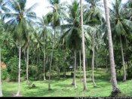
Coconuts plantation.
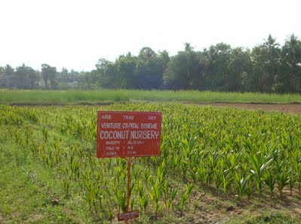
Coconuts plantation (nursery) in Tamil Nadu (India). Source : http://sites.tnau.ac.in/ trri/ars-pkt

Appendix : Production and yield of coconut throughout India and in Tamil Nadu

COCONUT production and yield for all India
YEAR | YIELD OF COCONUT  AREA  (M.HECTS) | PRODUCTION  (00 MILLION  NUTS) | YIELD/HECTARE  IN NUTS  (NUMBER)
1997-98 | 1.9 | 130.88 | 6898

état | AREA  (M.  HECTS) | % OF TOTAL  AREA | PRODUCTION  (00 MILLION NUTS) | % OF TOTAL  PRODUCTION | Rendement  (KGS/  HECT)
TAMIL NADU | 0.32 | 16.8 | 37.16 | 28.4 | 11621
Production of Tamil Nadu, almost 30% of the production of copra (coconut) all over India.

Source : Coconut statistical info in India : http://www.indiancommodity.com/statistic/coconut.htm

Appendix : Where to get plants?

We could get the seedlings or seeds:

• For samples in local vegetation to be grown in nurseries after. Samples (in the form of suckers, shoots, seeds, etc…) to be grown in nurseries after.
• In the Indian agricultural institutes (in their garden and their Seed trade or bank) _ see addresses above in chapters "experts. "
• In the stores of plants and nursery schools.

(In Europa, for example:

- Top tropical, rare plants for home and garden, http://toptropicals.com/cgi-bin/store/store.cgi?first_mid=3010&NoPromoItem=1 ).

Appendix: a possible barrier facing a tsunami?

(For reference).

It is known that the presence of lush vegetation (virgin forest type) or an edge of mangrove coast can mitigate the destructive effects of the tsunami wave in the "breaking up" (by "breaking") and / or the slowing.
As far as the barrier of the fence may have a dampening effect on the wave would require the hedge is an important dimension and is robust _ that is composed of shrubs strong, well rooted in the earth, through strong roots.

A barrier of mangroves to the ocean side to protect it?
A mangrove is the best protection for ribs, facing a tsunami. Even then it has to exist or to create it, you have a bay with calm waters, choppy (for example, behind a barrier reef which protects it from storms and waves offshore). Otherwise, a mangrove is easy to plant, by planting seeds of mangroves (we plant them, such swords, in the mud of the coast).
Although sustainably managed, mangroves can provide firewood, construction, fish, crustaceans, shellfish and function as carbon sinks.

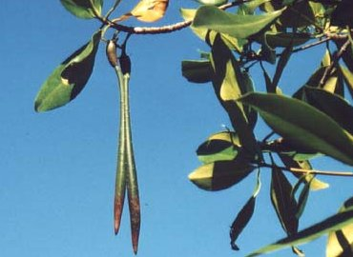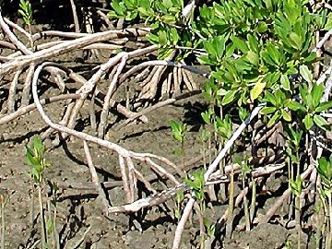
Left : mangrove seed. Right : its aerial roots into the mud shoreline.
Source: Cultivation of mangrove seeds, http://jmsnat.free.fr/site/culturepaletuvier.html

- Party to develop, correct or delete.

Appendix : impacts of a hedge
- Positive environmental impacts
  - Improvement of the micro-climate (wind-break effect).
  - Reduction of water and wind erosion.
  - Improvement of rain water infiltration.
  - Increased biodiversity of plants (many spontaneous species in the hedge).
  - Increased biodiversity of animals (habitat for different species).
  - Improved graze management and rotation.
  - Forms part of the diversity of the landscape.
  - Certain types of hedge may include economically productive species, e.g. sisal, citrus
- Negative environmental impacts
  - Concentration of bird predators.
  - Presence of snakes and other harmful animals.
- Impacts on livestock productivity
  - Optimization of graze management hence improved meat production.
  - Improvement of grazing animals' comfort, with a positive impact on their health and growth (it offers feeds and shadow to animals).
  - Reduced risk of conflicts between livestock farmers and crop farmers, but slightly reduced areas under grass or crops.
Source : http://www.fao.org/ag/againfo/programmes/en/lead/toolbox/Tech/22Livef.htm
Sommaire
Table des matières
1 Historical Introduction 1
2 Goals 1
3 Location, size and topography 1
4 Soil type, salinity and water table 2
5 Climate, rainfall 3
Average rainfall in Tamil Nadu 3
6 Type of barrier selected 3
7 Types of chosen plants 5
8 The problem of invasive plants 8
9 Techniques de plantation de haies 8
10 Techniques of irrigation 11
11 Local actors and socio-cultural determinants 11
12 Woodcutting 12
13 Development of side projects 13
14 Partner associations 13
15 Experts consulted or to consult 13
16 Planning of the project 14
17 Budget 14
18 Funding and sponsors 14
19 Appendix: Bibliography 14
19.1 Books and articles 14
19.2 Internet sites 15
20 Appendix : coconut cultivation 16
20.1 Needs of coconuts 16
20.2 Types of coconuts 16
20.3 Use of products and by-products 19
20.4 Bibliography 19
21 Appendix : Production and yield of coconut throughout India and in Tamil Nadu 20
22 Appendix : Where to get plants? 21
23 Appendix: a possible barrier facing a tsunami? 21
24 Appendix : impacts of a hedge 22

Coconut statistical info from IndiaCommodity.com : http://www.indiancommodity.com/statistic/coconut.htm
"Tamils" (தமிழ் நாடு), in Tamil.
Assessment Report from the National Drought Mitigation Center, Univ. of Nebraska-Lincoln : Assessment of Recent Droughts in Tamil Nadu, K. K. Nathan, Water Technology Centre, Indian Agril. Research Inst., New Delhi, Indi, http://drought.unl.edu/pubs/dnn/arch9.pdf
United Nations, System of Organizations : Andhra Pradesh and Tamil Nadu, http://www.unsystem.org/SCN/archives/india/ch16.htm
IndiaAndIndians.com : Tamil Nadu, http://www.indiaandindians.com/tamilnadu/tamil_nadu.php
The disadvantage is that they Euphorbiaceae are all more or less toxic because of their toxic sap (with some exceptions).
Berberis, the barberries or pepperidge bushes, is a genus of about 450-500 species of deciduous and evergreen shrubs from 1-5 m tall with thorny shoots, native to the temperate and subtropical regions of Europe, Asia, Africa, North America and South America. They are closely related to the genus Mahonia, which is included within Berberis by some botanists. Source : http://en.wikipedia.org/wiki/Berberis
But I do not know his name. This plant is quite a deterrent for any man wanting to cross a fence made with this plant, despite the fact that this plant never reaches more than 1.5 meters high.
With a population density of more than 511 persons per kilometers square, in 2008. Updated population estimates for Tamil Nadu as of 01/07/2008. http://geohive.com/cntry/india.aspx
"Census of India – DISTRIBUTION OF 10,000 PERSONS BY LANGUAGE". Government of India. http://www.censusindia.gov.in/Census_Data_2001/Census_Data_Online/Language/Statement3.htm. Retrieved 23 September 2009. http://www.censusindia.gov.in/Census_Data_2001/Census_Data_Online/Language/Statement3.htm
The Tamil Nadu picture on Frontline Magazine, http://www.frontlineonnet.com/fl1809/18090930.htm
Indian states ranking by fertility rate, http://en.wikipedia.org/wiki/Indian_states_ranking_by_fertility_rate
www.mohfw.nic.in/NRHM/State%20Files/tamilnadu.htm
Fertility Rate Decline in Tamil Nadu: Some Issues , de R Savitri, Economical and Political Weekly, 1994, http://www.jstor.org/pss/4401485
Source : Shyama R. Ramani, director of the association « Friend-in-need » (or « Un-Ami », in French) _ see latter un this document.
http://en.wikipedia.org/wiki/Tamil_Nadu_Agricultural_University à Coimbatore, www.tnau.ac.in
http://en.wikipedia.org/wiki/M._S._Swaminathan
They reproduce by forming seeds shaped darts that are planted in the muddy ground for new growth, Source : Mise en culture de graines de palétuviers [Cultivation of mangrove seed], Jean-Marc Schaeffer http://jmsnat.free.fr/site/culturepaletuvier.html
On the mangroves, see http://en.wikipedia.org/wiki/Mangrove, http://fr.wikipedia.org/wiki/Pal%C3%A9tuvier (in French). In this article (en French), it states that "mangroves occupy the ecotone [territory marking the boundary between two ecosystems] land-water-air and mangroves are one of the most bioproductive ecosystems in the world. These are the only large species to survive in anoxic vessels. They are a real reef wood that becomes the support and shelter of an important fauna, and protects unstable coastal assaults from the sea and storms. "

