
MICROFICHE
REFERENCE
LIBRARY
A project of Volunteers in Asia The Scythe Book by David Tresemer
Published by:
Green River Tools 5 Cotton Mill Hill
P.O. Box 1919 •
Brattieboro, Vermont 05301
USA
évailable from: same as above
Reproduced by permission.
Reproduction of this microfiche document in any form is subject to the same restrictions as those of the original document.

Mowing Hay, Cutting Weeds, and Harvesting
Small Grains with Hand Tools
David Tresemer
.19-•• "«-
pli: R • r'...\•:;:+ei
•
••⁷ ,

.,••
'
‘t•
- ^{s}, .; .1,6 le
•••••n••••n•••nnnn...111.111n1101•••
11•••n101n1Mbe
THE SCYTHE BOOK

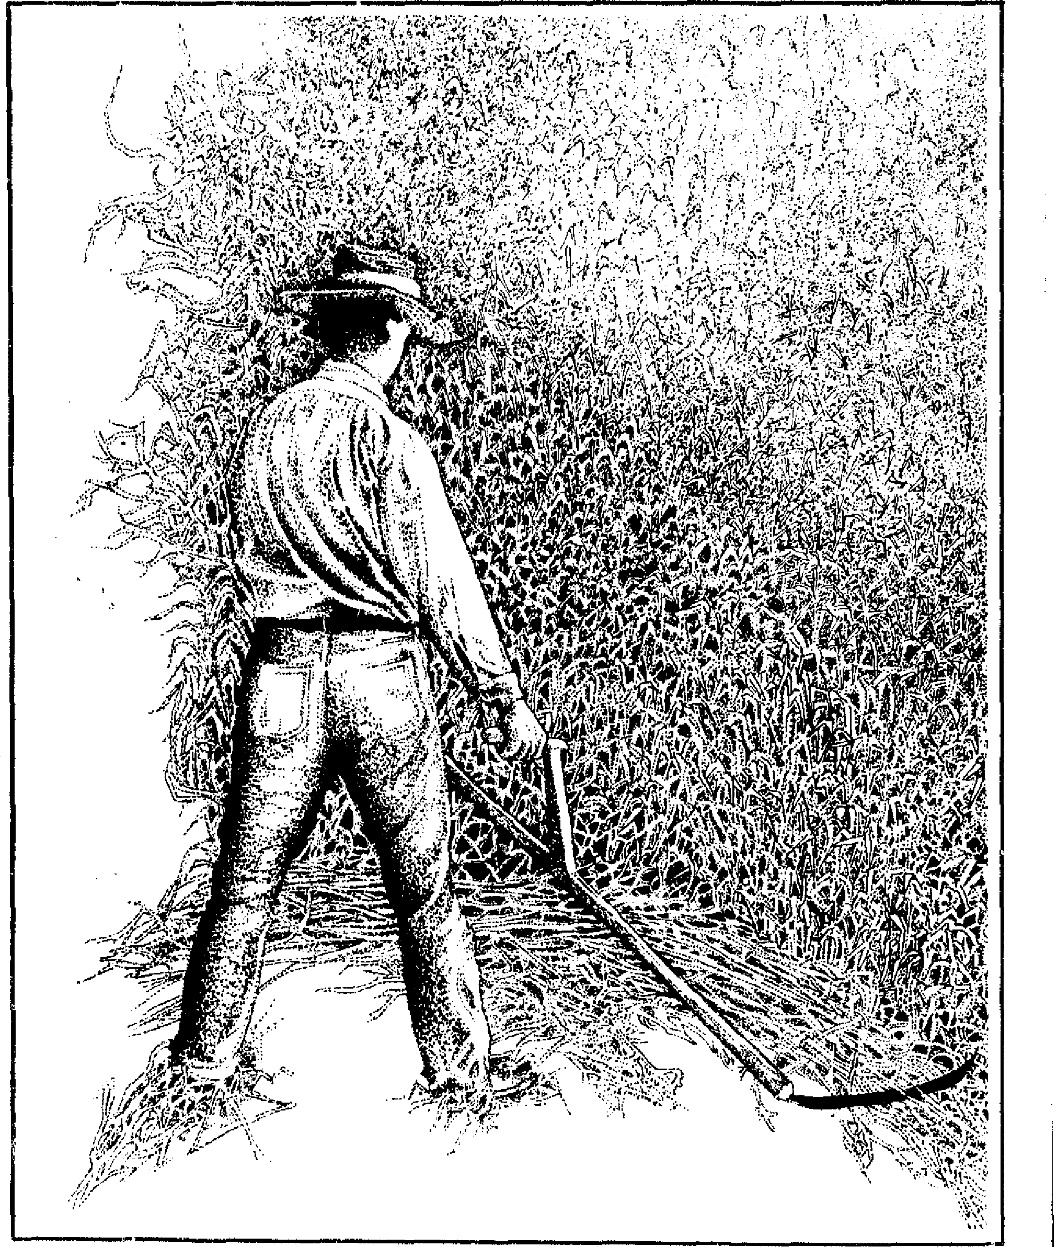
THE SCYTHE BOOK
"I bid you corne walk in the meadow." | 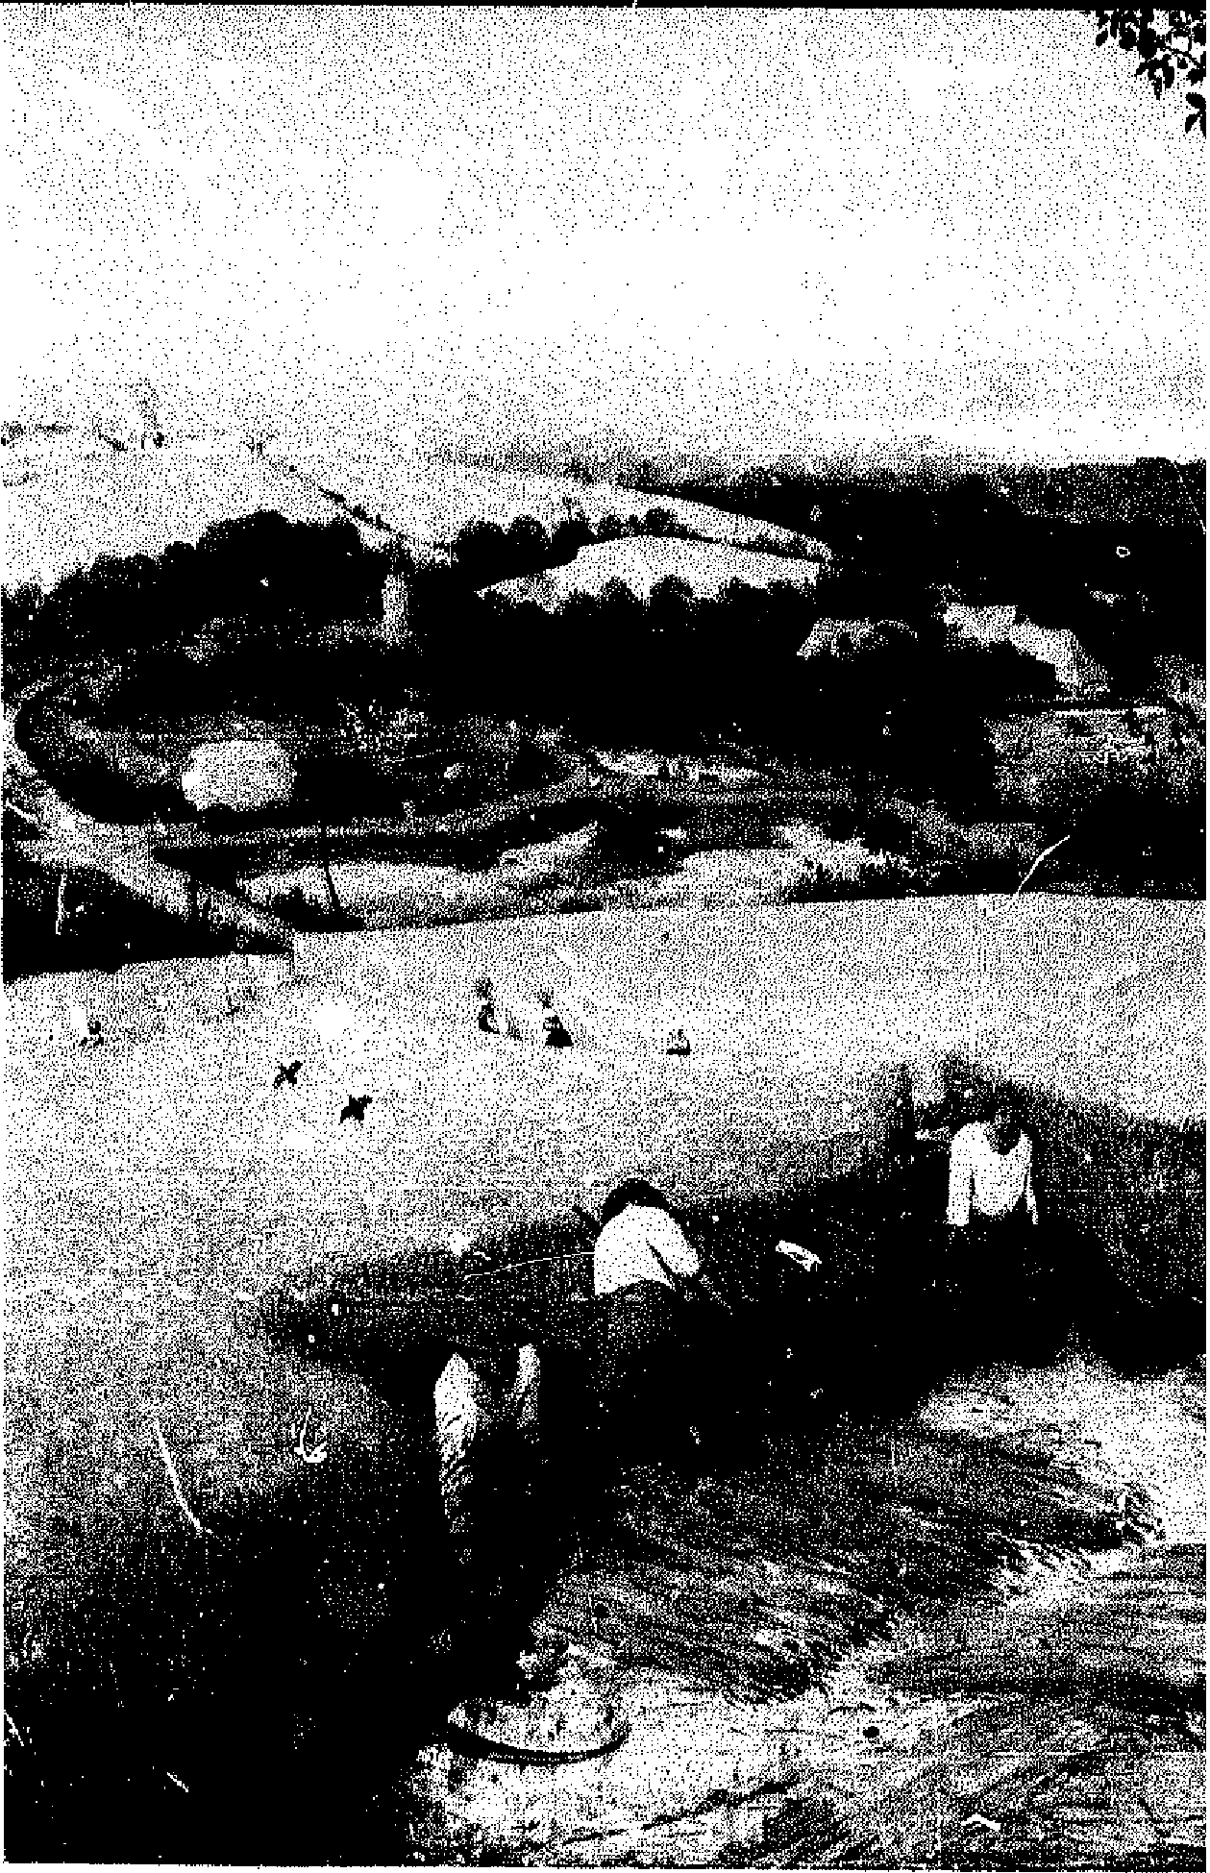

MOWING HAY, CUTTING WEEDS, AND HARVESTING SMALL GRAINS, WITH HAND TOOLS

THE SCYTHE ^{B}OOK
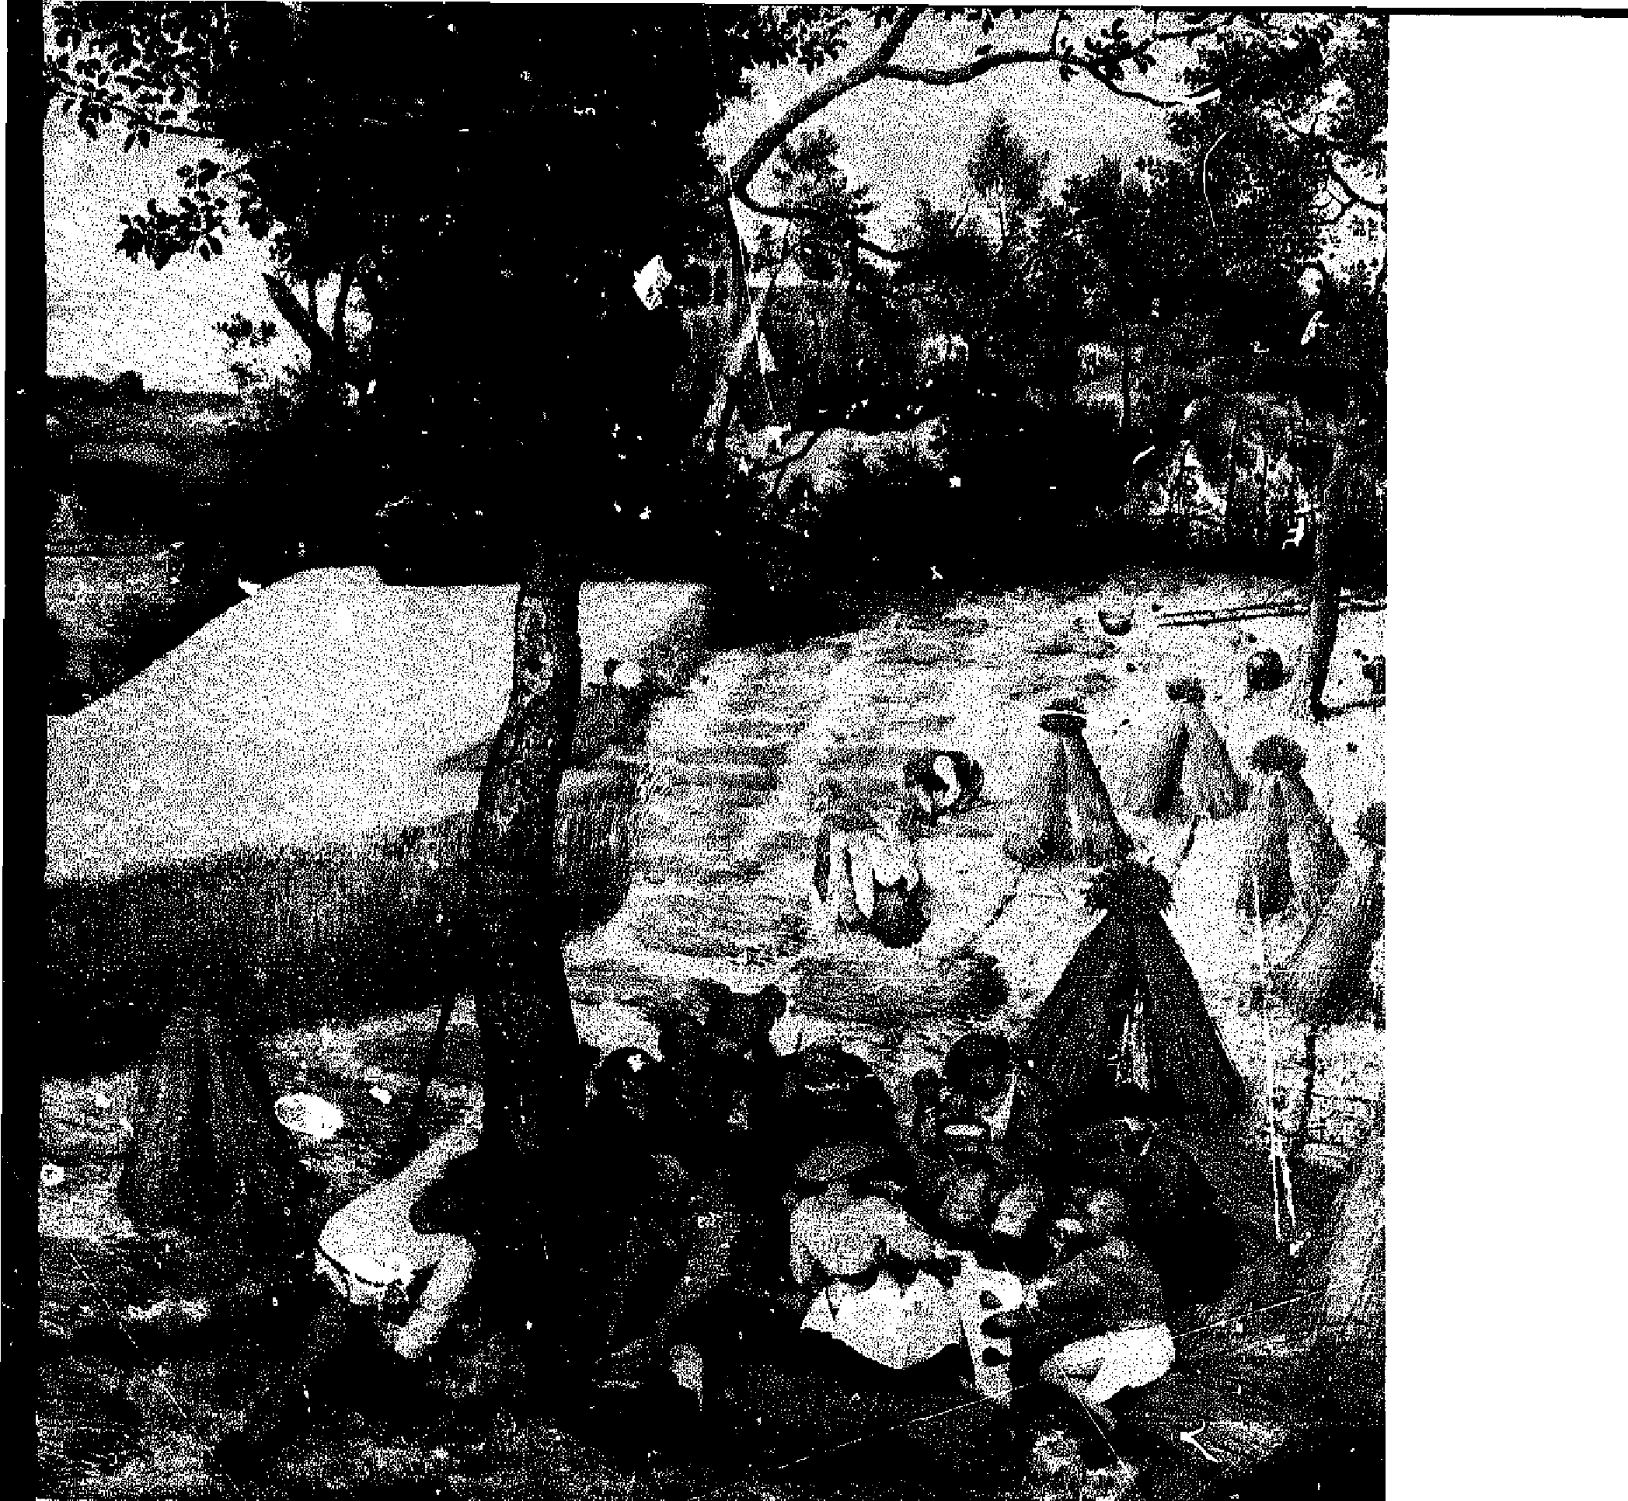
by David Tresemer
DRAWINGS BY TARA DEVEREUX
BY HAND & FOOT, LTD. BRATTLEBORO, VERMONT MCMLXXXI

Also by David Tresemer: SPLITTING FIREWOOD
Copyright 01981, 1982 by David Tresemer
Ail rights reserved including the right of reproduction in whole or in part in any form with the exception of a reviewer, who may quote brief passages in a review.
LIBRARY OF CONGRESS CATALOGING IN PUBLICATION DATA
Tresemer, David Ward. The scythe book.
Bibliography: p. Includes index.
1. Scythes. I. Tille.
S695.T74 631.3'5 81-609'7
AACR2
ISBN 0-938670-00-X
CREDITS
FRONTPIECE: Pieter Brueghel the Eider, "The Harvesters," 1565 (Metropolitan Museum of Art, New York, Rogers Fund, 1919);
7: Chansonetta Emmons (Conty College Art Museum, Waterville, Maine);
- Ferdinand Hodler, "Der Mâher," 1910 (Aargauet Kunsthaus, Aarau, Switzerland);
- Detail of Francis Alexander's "Ralph Wheelock's Farm," 1822 (National Gallery of Art, Washington, Gift of Edgar William and Bernice Chrysler Garbisch);
23: Detail of painting by E. B. Nebot, 1738 (Buckinghamshire County Museum, Aylesbury, }kicks);
- Jean Francois Millet, "Death and the Woodcutter," 1859 (Ny Carlsberg Glyptotek, Copenhagen);
- Terracot. a votive mask, Attic period (Museum of Fine Arts, Boston, Catherine Page Perkins Fund);
- Emile Bernard, "Le blé noir," 1888 (Josefowitz Collection, Lausanne);
- Thomas Hart Benton, "Cradling Wheat," 1939 (St. Louis Art Museum, St. Louis);
All the other figures were drawn by Tara Devereux.
Quotations from Anna Karenina by Leo Tolstoy courtesy of Bobbs-Merrill Co., Inc.; from The Poetr,v of Robert Frost (edited by Edward Connery Lathem, 1923, 1934, © by Holt, Rinehart and Winston, copyright 1951, 0 1962 by Robert Frost), by permission of Holt, Rinehart and Winston, Publishers.
By Hand & Foot, Ltd.
Since 1976, By Hand & Foot, Ltd., has been engaged in an effort to import, manufacture, and improve the best in humanpowered tools. We work with the following label:
byra⁻Tna & g^{i}ot, Itc
Tools dependent on human energy. 1M
P. O. Box 611
Brattleboro, Vermont 05301
- integrated tool systems for kitchen, garden, and small farm
-- for health, security, and independence
- tools which enhance rather than abuse our relationship to the
task and to the earth
When comparing machine-powered and human-powered tools, our emphasis has been on replicable scientific experiments, that is, an objective analysis of the advantages and disadvantages of the different tools. However, we have not ignored subjective information from the human body, from emotional or spiritual experiences.
The results of our research are featured in a series of manuals on separate tools.
We feel it is very important to make available the tools discussed in each manual: all the tools described herein can be obtained from By Hand & Foot, Ltd.
Acknowledgements are due to Eliot Coleman for introducing me to the European scythe; to Tommy Thompson for introducing me to its best use; and ta Castle Freeman and Susan Tresemer for helping me to write about it; also ta Keith Squires, Stephen Boume, and Brian Gabree for assisting in time trials; to Tommy Thornpson, Rachel Hillel, and Peter Payne for reading portions of the manuscript and offering suggestions; to Bob Anderson and Irving Perkins for carefully guiding the production of the printed work.
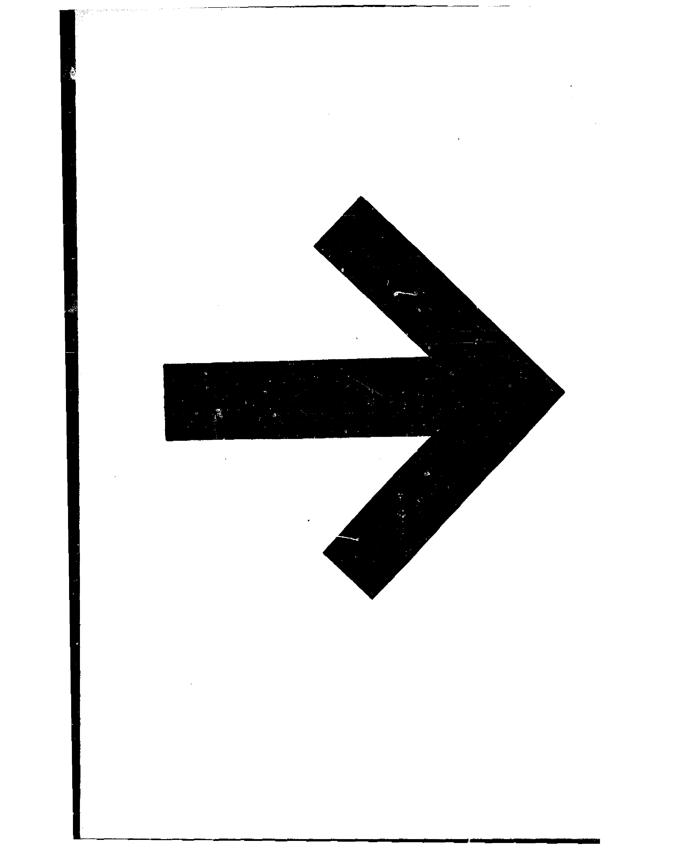
Contents
Introduction I
This Book 3
The Parts of the Scythe 5
The Blade 5
Blade Caver 11
Snath 12
Sharpering 19
Peening 20 Whetting 24
Mowing Technique 30
A Helpful Exercise 30
With the Scythe 32
Small Advances 38
Reading the Grass 40
The Use of the Body 42
Reconsidering the Twisting Exercise 48
Mowing Hay 49
Making the Hay 52
Tools for Making the Hay 56
Mowing in Teams 59
Haytime Drinks 62
Clean Culture 64
Weeds | 64
Pasture | 65
Lawn | 66

Harvesting Small Grains 69
The Scythe and lu
Predecessors 70
Cradle Scythes 74
vii
Cutting Grain with Old
viii Contents
and New Tools 79
Sowing, Reaping, Thrrshing, Winnowing 82
Bringing the Harvest Home 95
Notes 105
Bibliography 113
Index 119
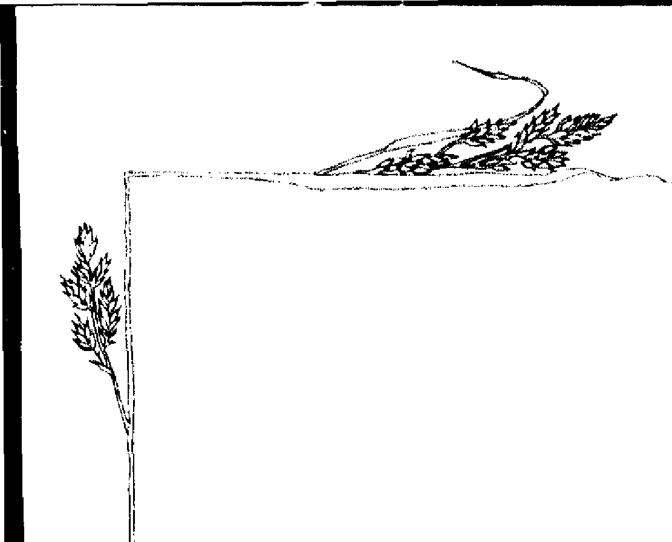
Introduction

YEARS AGO 1 bought a scythe at the local hardware store. 1 bought it to keer, the dandelions, milkweed, lamb's quarters, couchgrass, and so on from going to seed. There were too many to pull up by hand, and too few to justify the hiring of a farmer's mowing machine. 1 had watched powerlessly as their flowering and seeding progressed. 1 wielded my scythe a few hours, and then hung it up. It was awkward, it left me sore, and the grasses laughed at my efforts by bending over and bobbing back up after the blade had passed. I concluded that our ancestors were made of stouter stuff than I am!
1 learned later that the scythe I had used was the traditional "American" type, having a heavy, bent ash snath and a narrow, hard steel blade. Five years ago, I was introduced by Eliot Coleman at the Small Farm Research Association in Harborside, Maine, to the "Austrian" style scythe, which has a light blade and snath. My first use of this scythe was in happy contrast to my earlier labors with the "American" scythe. The expérience was marked by the same observations anyone can make on discovering a good tool:

—h fits: The scythe complements the contours and dynamics of my body firmly and comfortably, and feels like a welldesigned extension of my hands and feet;
—h doesn't hurt: There is no excessive strain on any one part of my body as 1 use the scythe, and I can use it for hours at a time without abusing myself;
—h works: We work together; my energy is efficiently translated into the desired effect without waste of effort. 1 can tell 1 have found a good tool when I hesitate to let it go. With the Austrian-style scythe, I went on mowing and mowing.
1 use a scythe to mow a few acres of hay which 1 use to mulch my gardens and to feed the small li vestock population 1 keep over the winter. 1 also harvest with the scythe, a variety of small

2 Introduction
grains for bread and pancakes. With a vert' modest expenditure of time and effort, I am thus able to raise my own hay and grain. With the scythe I keep the marginal areas of my property free of weeds going to seed, and have thus redLced the weeding prof"- lem in my gardens by at least the time taken in the scything. I have found that a scythe can perform a moderately sized task in the same amount of time it would take to fetch, attach, adapt, and repair a mechanical substitute. Maintenance of the machine means money spent; maintenance of the human body means health gained. It is not impossibly strenuous or diflicult tu wield a scythe; both my experience of mowing and the tool it self are resources of enduring value.
Before the widespread use of mowing and harvesting machines, commencing in the latter part of the nineteenth century, the scythe was the main tool responsible for harvesting hay and grain, as well as for keeping trim and neat the estates of rich lords and modest freemen. As with any commun tool, little of the early writing about the scythe explains its use, which was generai knowledge. Beginning in the ear/y part of the twentieth century, however, increased interest in rural file has led to the acceptance of a form of autobiography, summarized as "my expeliences back on the farm," in which the authors, recording the recollections of old country people, often include some instructions in forgotten practices from the old-timers whom they encountered. S aine of these writers have become good mowers themselves, and have passed on what they learned.
From these autobiographies, from old agricultural journals, from the evidence of drawings, paintings, and sculpture, and from the work of anthropologists and historians, we can piece together a fairly accurate picture of how the scythe was designed and used. There are many small variations depending on period and region. I shah! nin document them all. Suttice it to say that for every "rule" or tradition I have for scythe design and technique, somebody someplace else did it a Little differently and got the grass cut.

There is a certain romance in using an ancien( tool in the old way, experiencing what our ancestors must have experienced. However, a tool must still be efficient today. That is, romance aside, it must make such an effective use of a person's tinte and energy that it is competitive with other means for accomplishing the task at hand. A chipped stone knife, white representing an immense technological leap for its time, does not meet this criterion. A sickle for harvesting grain does meet this criterion for small areas. A good scythe meets the criterion of practical efficiency for langer areas, and for a wider variety of tasks.
Introduction 3
University extension agents argue persuasively that a l'armer cannot afford the time to mow: he is forced by economics to sit all day atop his tractor attaching one implement after another to produce enough te make the payments on the loan for the equipment. I do not offer the scythe and its related tools as an alternative to this scale of agriculture. Yet, even here the scythe has a place, trimming the edges where the machine cannot go.
I do not use a scythe in order to make enough money to support a livelihood, but rather simply to support a livelihood. Not only is the product of my labor----hay, mulch, grain—superior to any I could obtain elsewhere in this chemical age. ln addition, I deeply enjoy the experiences of contributing to my own sustenance and of relating intimately to the earth,
THIS BOOK
The first section of this manual covers the parts of the scythe in more detail than the casual mower probably wants. I began this writing expecting to produce a brief' manual on mowing technique, but found the details of manufacture and tradition and so forth to be so important to my mowing that I teck the research as far as it could go, and the manual became a small book. I asked one American write' who had written that he was "one of the very few true authorities on the scythe" what resources he used for his technique. He exclaimed, "Are you kid
4 Introduction
ding? J ust go outside and swing the thing!" That was ali he would say about how to use the scythe. I am, however. convinced that with the right tool, the casual mower will soon becorne a serious mower, at which time the dotait I provide here will be more interesting. In any case, though, reading the sections on sharpening and mowing technique is all that is rcquired for stepping out to encounter the legions of da ndelions. Sections follow which set out the minimum considerations necessary to mow hay, eut weeds, and harvest grains,

The Parts of the Scythe
l'HE HI .A
TURF: us a story told in LeGrand Cannon's Look to the Moto,- tain in which the master blacksmith makes a scythe blade of Damascus steel fora young mower in New Hampshire in 1769» in the high heat of bis forge he pounds bars of iron and steel together, folding them over cadi other again and again. After tempering, the effect of the mingled metals in the blade is much like fudge ripple. The irn gives the blade tlexibility as an antidote to the steers brittleness; the steel holds the edge razor sharp, and gives the enduring shape of the blade. The price? Twentyone cords of rock maple eut, split, and stackcd. The master smith assures the young man that there will be al least one btow
of the hammer for every st; of the ax.
Today the common hardware-store scythe blade is starnped in a powerful drop-forge press and ils edge is ground sharp Cil a high-speed grinding wheel. In contrast, the edge of the sharper and more delicate European- or Austiian-style blade is hamrnered to the correct thinness, in much the same way it has been since the fifteenth century, when the scythesmith guilds were established in the mountain valleys of Austria. The advent of water-driven trip hammers, and, now, of small but powerful hand-guided air hammers, have made fine scythe Macles cost Iess then twenty-one cords of split hardwood, but the hand forged Austrian blade is still more expensive than the starnped blade. The process al its best involves a set sequence of twenty-six steps, pictured in Figure 3. Although Little change is apparent between steps 14 and 20, here is where the most important tempering ara4
final shaping take place. The blade is heated cooled
in warm oit, sandblasted, and diagonal-harnmd, to give the optimum curve and thickness to the back and edge.
The common hardware store Made is usually called the "American" type, the becter blade the "Austrian" type. In tact,
s
Blade enrep
adjustuble grip
tang HAUMERED neek BLADE
4eard
kitobi
scythe ring
Meyer grip or
néb
wing nua
for adjustment
scythe key
^{e}nee^{r} VIF
OP leià
1. The parte of the aga»,
STAMPED HLAbE
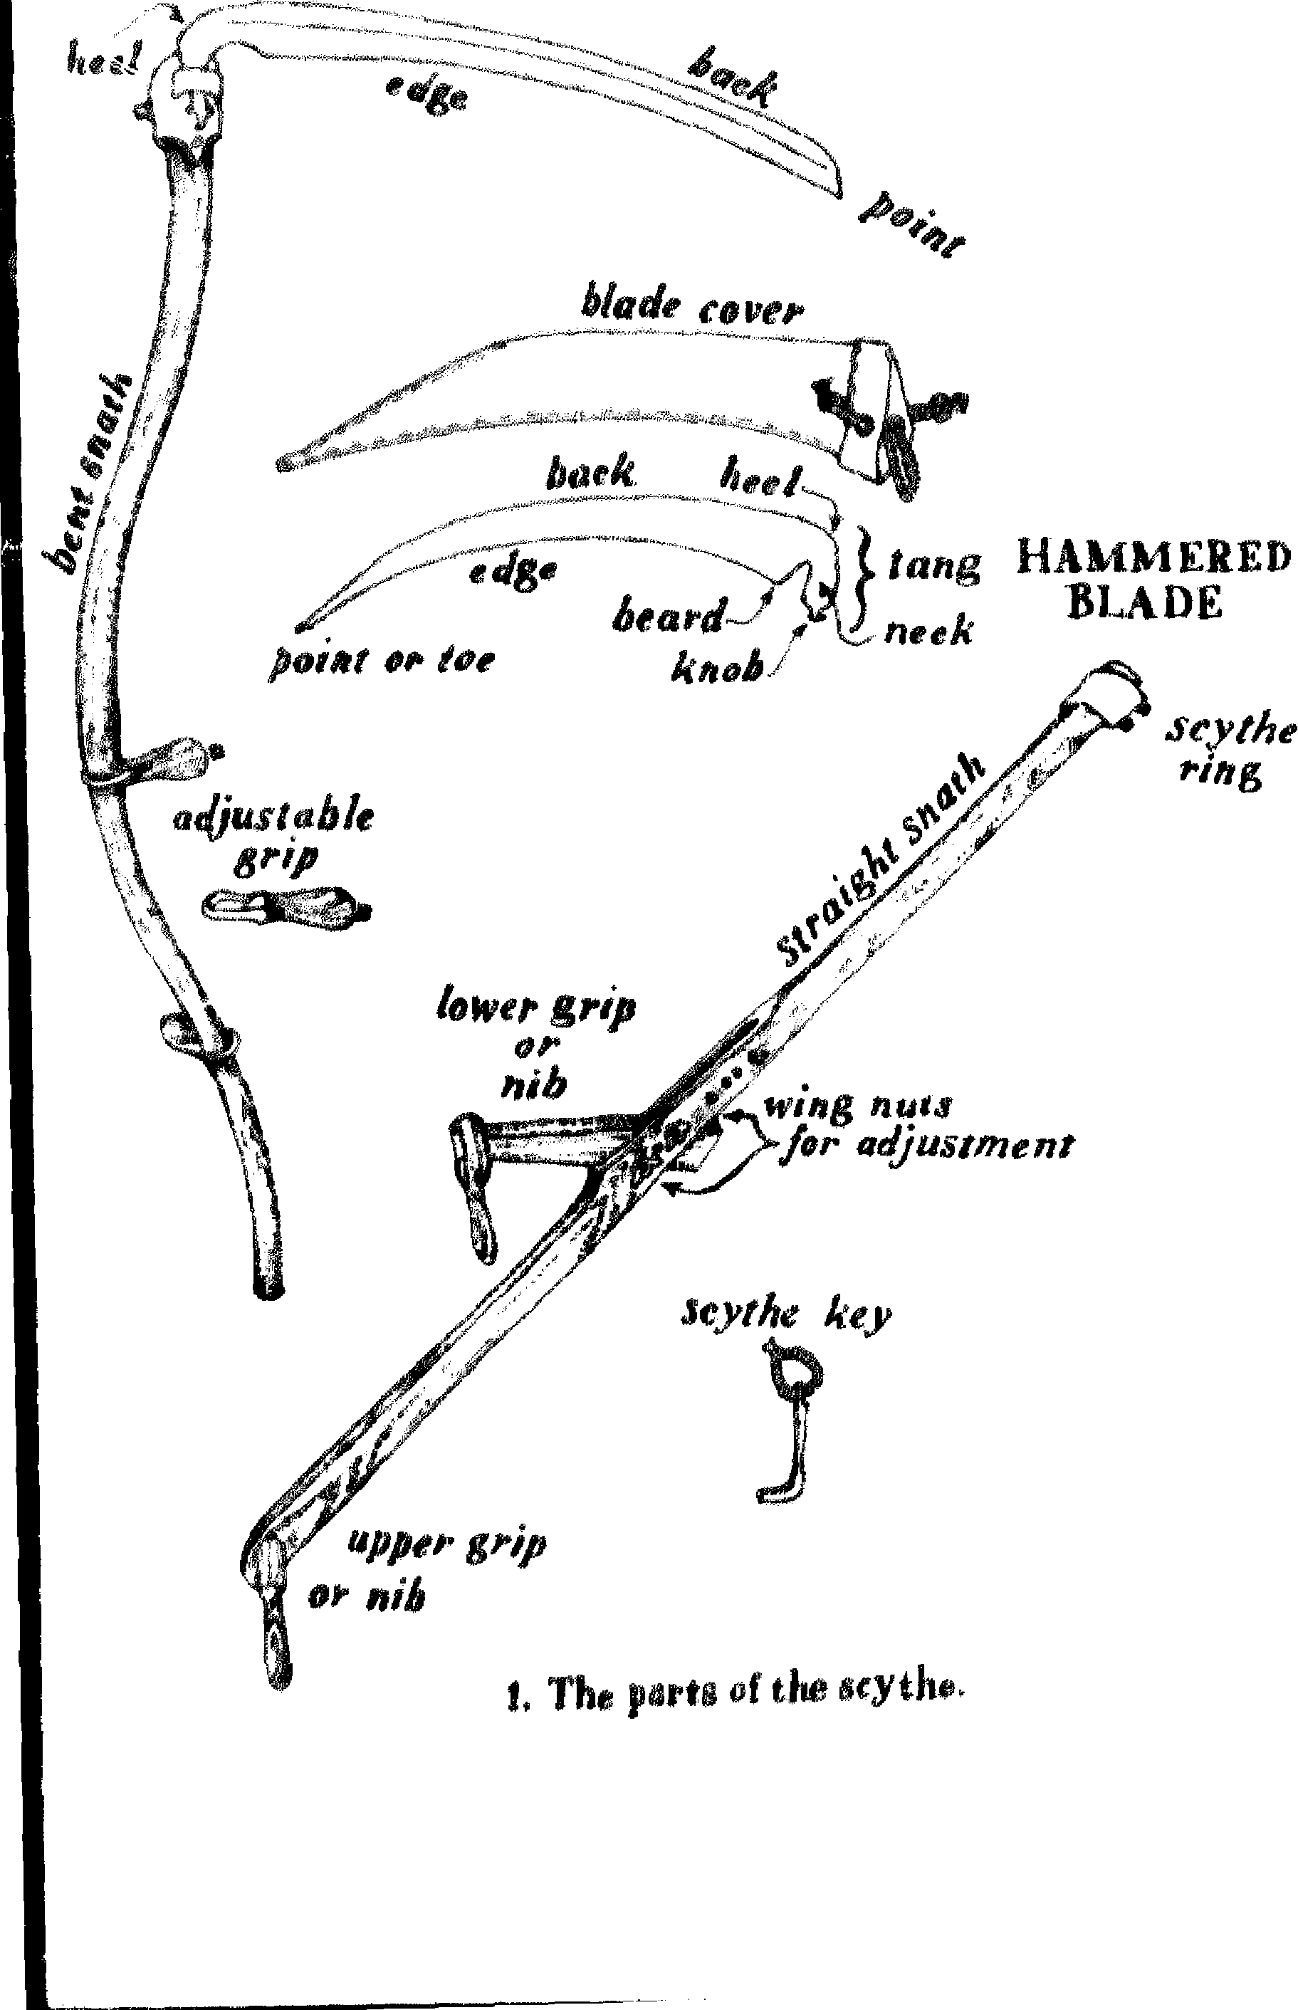
STAMPF D BLADE HAMMERED BLADE

 | face  view

edge view

end
view
hafting
edge & tang
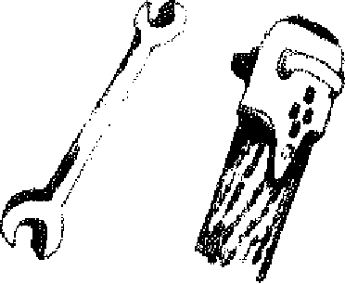
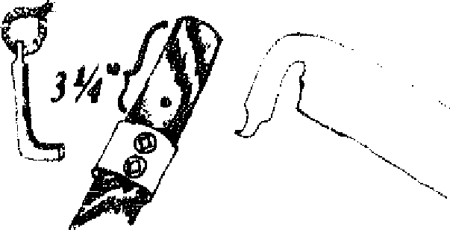

ng
edge


2. Starnped and harnmered blades.
scythe blades have not been manufactured in this country for nearly twenty years, and, when they were, some were of fine quality. The "American" pattern blades arc made in Europe by the same companies who produce the liner blades; they freely admit that the stamped blade is the bottom of their line.
A fine scythe blade must be light in weight, and tempered to carry an edge that will cut tissue paper without tearing it. Yet it must be soft enough to dent instead of break if a stone or stump is accidentally hit, and capable of having its edge restored through hammering with a light hammer.
The problem is to tind a steel of the right consistency to achieve this wonderful balance of hard and soft. ln England, "Crown" blades were once made with an edge of harnmereCI iron sandwiched between two pieces of mild steel to hold the overall chape. Blades are still made in England in which the edge steel is rivetted to a stronger back of "mile steel.' The New Hampshire

3.Twenty-six steps in the manufacture of the hammered Made.
1
==
-----
,---
"^{nle}e^{en}enmeiNig.,,
,--
_{,n;},9::fi'Y-I²e'¹⁹ie;•;+¹.Mice,d4,.....
.. ...

"el
19

- -eer,,,ipeeee,e².⁰meteresi.›
- „ 4,>•
20
--------
15
⁻⁻⁻16-------. e.

- .
- •
2
- n••••••n⁻..._{rrw}...
---
21 -
. - -
,,,,_{r}enneee!ememtre..1.4.
22

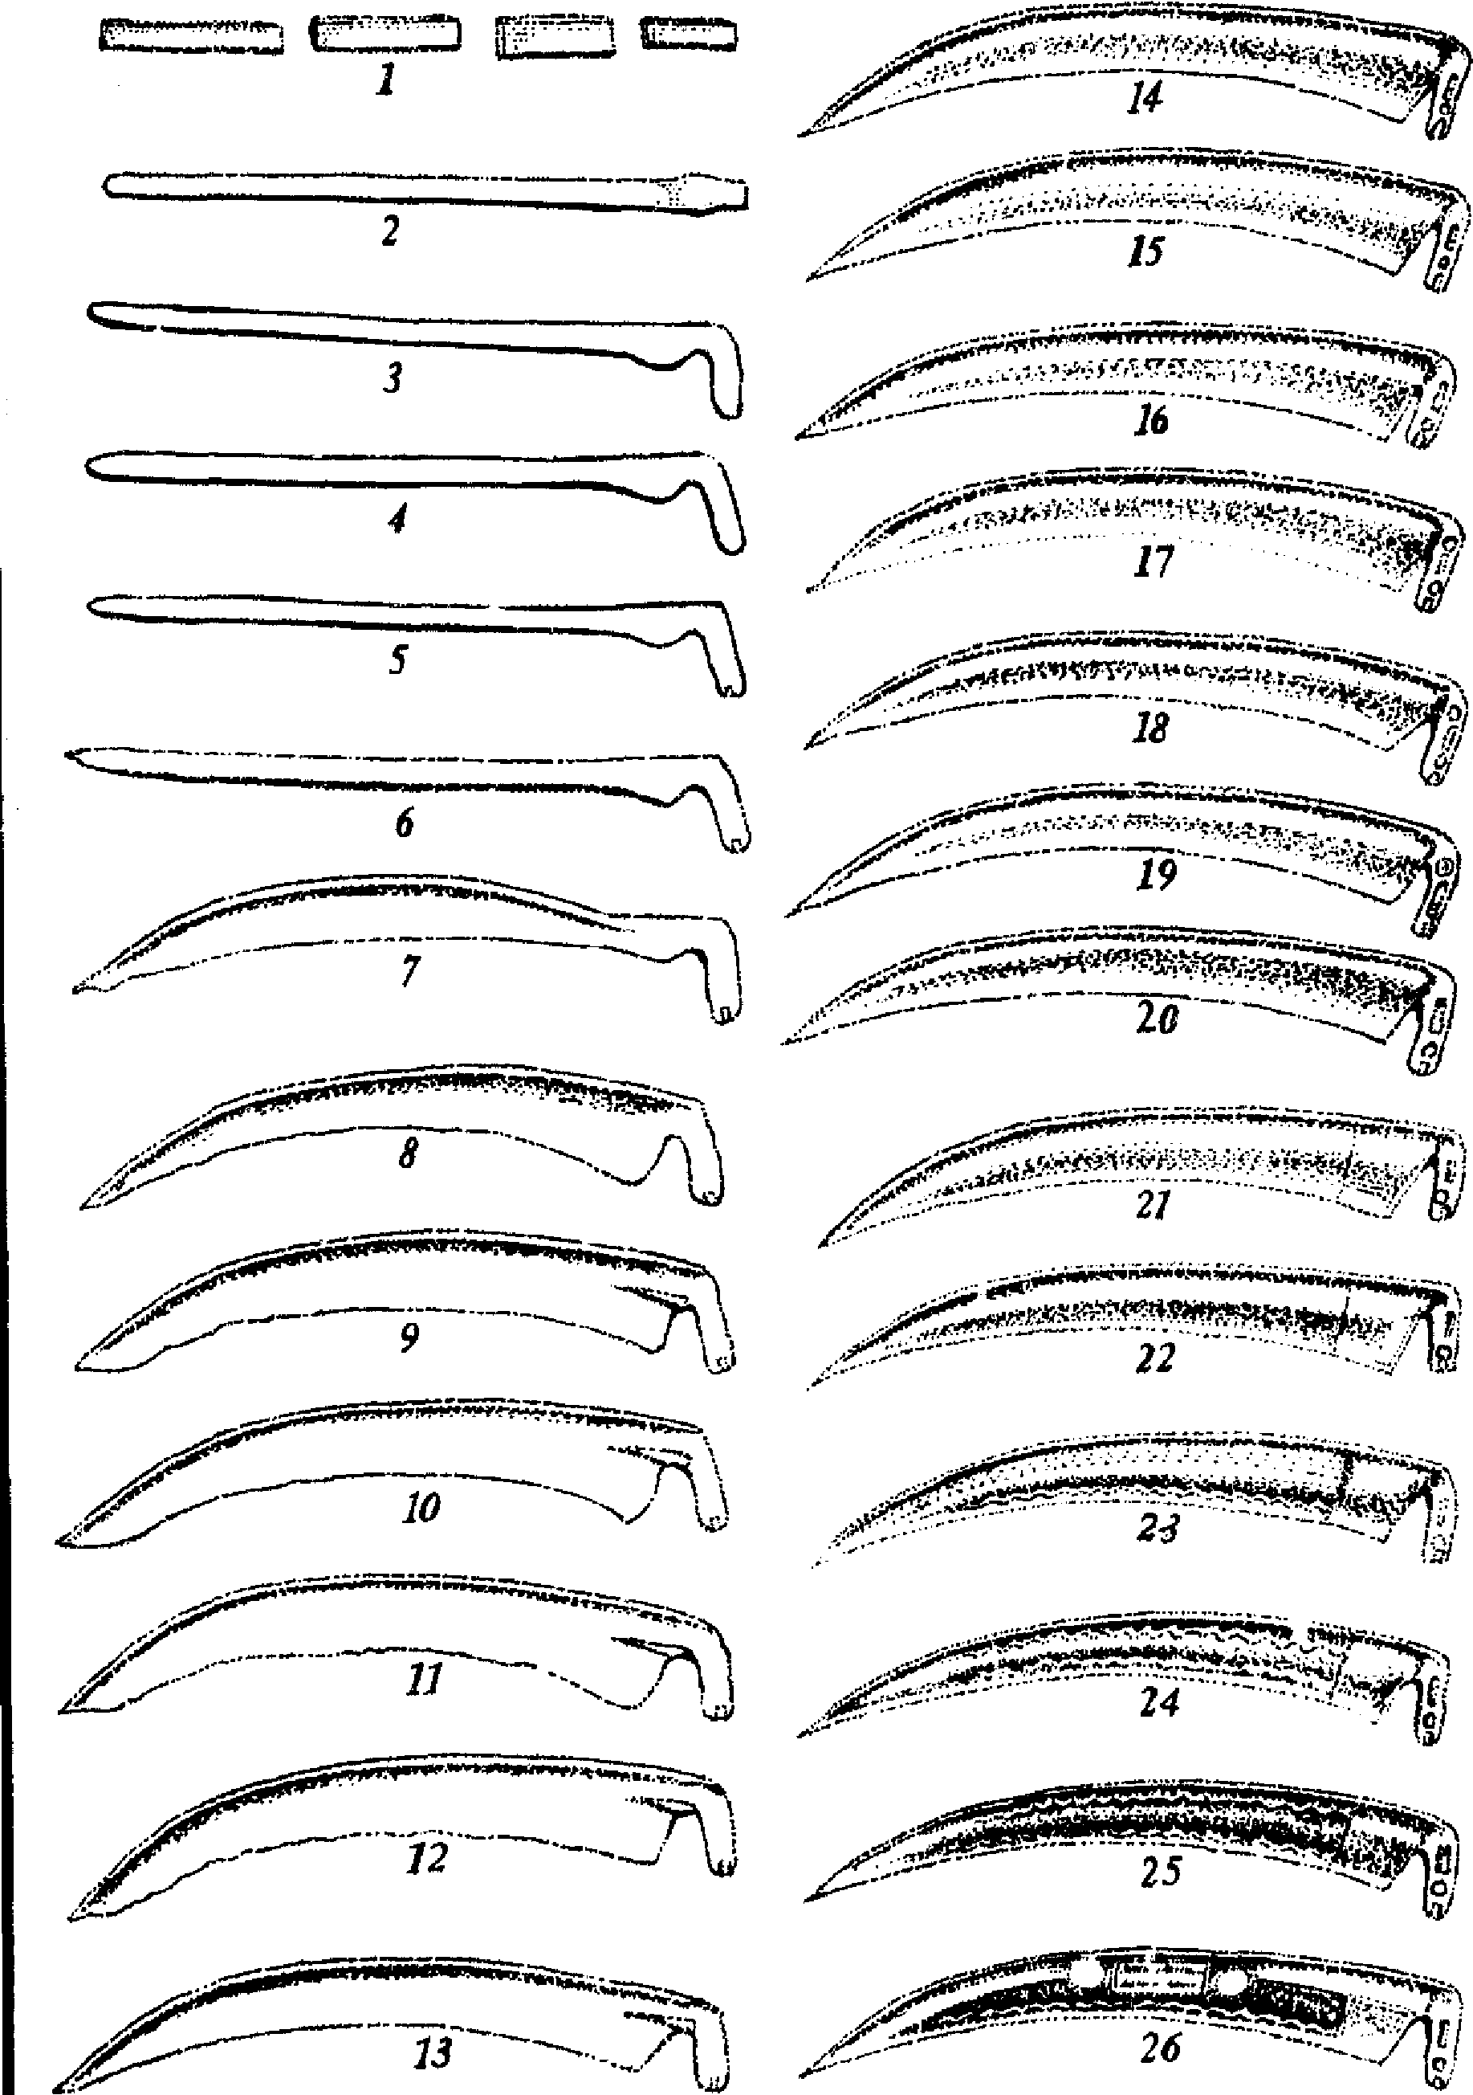
The Parts of the Scythe 9
blacksmith of 1769 had to mix the iron and low-grade steel to get the right effect. In one tradition, mowers hung their scythes in a tree for the winter to rust the iron out, thus—according to the tradition—raising the percent of carbon, and the hardness of the Made. The carbon content of the "American" blade is already fairly high, and in fact makes the blade too hard; the impact of accidentai strains from stones and stumps leads not to dents but to microscopie cracks which will in time cause the blade to break.
The shapes of the two types of blades differ (Figure 2). The stamped blade is expectedly flat. The hammered blade is curved in every dimension to optimize the relationship of the body to the task of cutting. The "beard" and heel are distinguished in the hammered blade because of their distance from each other; in the stamped blade, that whole end is called the heel. The tang (queue or tai) in French) is the very strong projection from the back rib which attaches to the snath; the parts of the tang are the heel, neck, and knob.
The manufacture of the hammered blade shown in Figure 3 begins with a high-quality steel, and, by working it hot and cold, aligns the molecules and strain-hardens the steel. Exact requirements for these blades make it clear why over half of the blades which begin the twenty-six stages of manufacture are rejected along the way. Omitting any of the manufacturing steps makes other brands of blade less expensive, but only at the loss of the desirable characteristics of the finest blades.
The better blades are stamped on the tang with the trademarks of the manufacturers (Figure 4) which can be checked in the directories of Franz Schrëkenfux and Josef Zeitlinger. These references match the trademarks with the methods of manufacture of the particular company as well as with the genealogy of the master smiths, leading back to the influences of the Ottoman Empire in the fifteenth century. In recognition of these Turkish origins one brand has the name Turkensensen, or "Turkish scythes."

enlarged
detail

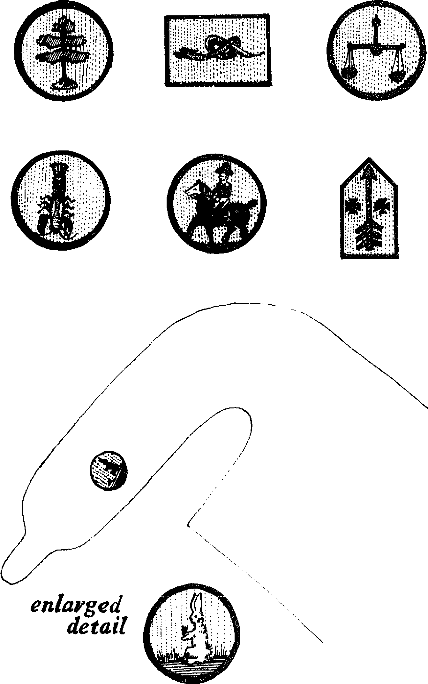

4. Some Made trademarks
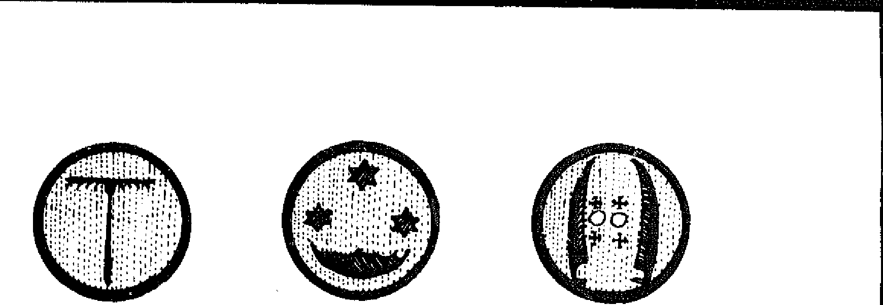

The Parts of the Scythe 11
Several models of blade have a series of a hundred hammered dots that look like a bail bouncing across the edge of the blade stopped in flight by a stroboscopie light. The dots are both a fanciful ornament and a testimony to the skill that guides the hammer.
When the scythe was the predominant tool for many agricultural tasks, blades were made in different lengths, from very short blades for careful work around vines and trees, to very long blades—over four feet in some areas---for less exacting tasks such as mowing expansive estate lawns. The lerigth now used most frequently on European faims for the widest variety of tasks is 27 1/2 inches (70 centimeters). Bush or brush scythe blades are as short as fifteen inches and often thicker to withstand repeated blows against young saplings. The grass blade of 70 centimeters is adequate for all grasses, weeds, briars, and one-year old trees.
BLADE COVER
You cannot cut yourself with a scythe when you are holding the grips. In transit to or from work, however, the blade can be dangerous to oneself and others. A good way to prevent cutting people and nicking the edge is to slip on a sheath that completely covers the blade, and tic it securely around the heel end. The narrow strips of plastic sometimes taped to the blade to protect the edge from the parcel service should b discarded after delivery, because they are unreliable for repeated use.
At the commencement of cutting, remove the cover and put it folded in your pocket. At the end of cutting, wipe off the grass and dirt from the blade, and put the cover back on. Secure it with a simple overhand knot behind the heel of the blade. At the end of the season, the scythe should be stored high up out of children's reach. And remember that the cover does not protect the kg of bystanders d uring mowing, or the hands of the sharpener.
When scythes were used more widely, the blades were covered
12 The Scythe Book
with a bag or custom-made sheath when not in use. ln one area in England where scythe covers were not used, the tradition was to march en masse to the field with the blade in the air, the right hand holding the top grip and the lower grip thrust firmly under the right armpit. This regimentation prevented mishaps.³ In every a_ ea, during the break for the midday mea!, the scythe blades were laid in the uncut grass or grain, into which no man, woman, or child would dare stray, thus protecting blade and flesh. In modern times, these traditions are not known to all, and the blade cover gives a necessary margin of safety.
SNATH
A great variety of sneads or sneds or snaths have been used with the same long, curved scythe blade. One Engtish tradition used oni" naturally curving willow saplings, white in East Europe an offset handle was mortised into a straight pole, usually of ash or hickory. A traditional Scottish design had a long offset handle which met the snath almost at the scythe ring. The scythe is one of the few asymmetrical hand tools; with it the hands do not perform opposite or interchangeable tasks.⁴
The grips (or nibs or nogs) have been attached to the snath in many different ways, sometimes pointing out in the same direction as the blade, sometimes in the opposite direction, and occasionalty mixed. Adjustable grips, made of a vire hoop around the snath tightened by twisting the wooden grip, have been found in museum collections pointing in nearly every direction. In some traditions only the lower iiib is used; in others the upper part of the snath is cradled in the crook of the left elbow.s These countless variations can be expected from any tool which is locally made.
The typical sweeping curved snath found in American hardware stores is made with bent swamp ash from the Southern United States. The potes are st amed, bent to the desired shape, and dried. The problem with this method is that the amount of
The Parts of the Scythe 13
wood necessary to keep a permanent bend increases the weight of the snath. Old-timers tell of going to the farm supply store to buy a snath and taking half a day to try out each one of the snaths in stock, all of them slightly different. To reduce this variability in shape, snaths are now made even heavier, so each one turned out holds an identical pattern. Several samples weighed in 1980 averaged 4³4 pounds. With the heavier stamped blade, this added up to 61/2 pounds for the bent ash snath with blade, versus 3¹/2 pounds for the hammered blade and straight snath. Consider what this difference in weight will mean after the approximately ten thousand strokes required to cut an acre of grass.
It seems to me that the curving "American" snath, with han-dies which rotate completely around to point in any direction, tries to bring the angles of the hammered blade (Figure 2) to the simpler stamped blade. I prefer the simpler snath and the better blade. Sometimes an old bent snath will be very light and well-balanced, the primary disadvantages being the wood is dried out and fragile, and the adjustable nibs are permanently loose. Also some old scythe rings were so small that only certain very narrow tangs could fit through them.
The weight of the heavy wooden snath makes more strious the tendency of the American-style scythe to put the right wrist in a cramped position. This position in which the little finger is bent back toward the wrist ("ulnar deviation") reduces the capabilities of d⁻te wrist and may lead to strain in the tendons.⁶
Lighter snaths in the American style are occasionally available made from aluminum, but I confess to a suspicion of aluminum used in tools under stress. Unlike steel, aluminum gets weaker and weaker with use—there is no "fatigue limit," meaning no limit to weakening of the metal from normal use.' Eventually it breaks. Even a little bend can upset the angle of the snath to the blade.
After three years of experimenting with different snaths from several different countries, I decided that a slightly curved tubu-
14 The Scythe Book
lar steel snath made in Europe was the best available for the average user. It is light but strong; the blade is set at the correct angle to the snath; the lower grip nearest the blade can be adjusted though the upper grip is fixed. Every adjustable grip eventually becomes loose and must be shimmed with, a bit of hardwood or leather. The knob of the tang fits into a siot at the end of the snath, and is secured by two screws in the scythe ring tightened with a special key for that purpose. The key can be stored in the very end of the blade cover or looped around the belt; if the key is lost, the 1/4-inch-square adaptor from a socket wrench set fits the screws of the scythe ring well. The snath needs very little care except a cursory wipe at the end of the day.
I have also developed a straight wooden snath made of airdried Vermont ash. Its design was synthesized from several different models currently used in Europe. It has the additional feature of a mortised channel for the lower grip, permitting adjustments to different body sizes. It is light, strong, and permits use while standing erect. Like all wooden tools, however, a wooden snath requires extra care: if it gets too wet, it can warp slightly and change the angle between snath and blade. Then it needs adjustment. It should be lightly oiled at the beginning of the season—one part linseed oil to one part turpentine is a penetrating and clean solution. The section between the lower grip and the blade should be oiled again after each extended use of the scythe in wet grass. The choice to varnish instead of oil must be made at the very beginning, and the snath requires four or five coats of varnish to be absolutely certain that every pore in the wood has been filled.
Without this little extra care, the wooden snath can become a less useful tool than the tubular steel snath. Therefore, this snath is best for those with some prior experience of mowing on which to base their decisions for adjustments. The advantage of the wooden snath is in the user's ability to perfect it as a tool uniquely fitted to him or herself, a graceful tool closely complementing the individual's body proportions, rhythm, and style. It is a
The Parts of the Scythe 15
grander snath than any other and permits full use of the blade's virtues in a balanced swing. The flexibility of wood has a nice feel as an intermediary between the flesh of the hand and the metal of the blade.
Several rules for the placement of blade in relationship to snath, and for the adjustment of the grips &long the snath, recur repeatedly in the old accounts of the art of the scythe:
- If the heel of the blade is set next to the heel of the right foot, the first grip should corne to a point just below the right hip bone (Figure 6).
- When the scythe is held in this position, the left foot should swing out along the blade following its curvatures. Continuing this arc with the left foot gives a good idea of the shape of the longer blades once used for mowing lawns. To obtain the angle of the hlade and snath (the "hafting angle") more accurately, set the snath against a building with the upper grip resting on the ground and the snath in the "twelve o'clock" position (Figure 5). Mark the point where the "beard" of the blade (the edge nearest the snath) touches the wall. Now pivot the snath to the right on its upper grip so the snath is at about two o'clock, and the tip of the blade is in a verticial line with the mark on the wall. The tip should be three fingers below the first mark. This method can be adapted to setting in the field by using marks on the ground.
- The two grips should be as far apart as the length between the elbow and the fingertips (the Mesopotamian cubit). This puts the top grip at the shoulder (Figure 6). This measurement can vary according to conditions, in easy cutting becoming as short as four hands (a hand being about four inches).
- The scythe should balance with the blade parallel to the ground on one finger held in the middle of the lower grip.
The scythe blade is twisted, or cocked, with respect to its tang. When scythe blades were sent out with no angle to the tang, and the blade was attached with a simple ring and wedges, the fitting





....z> •
3 lingers difference
mark height
of point
fr
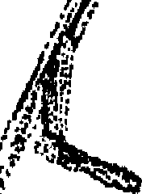
f ec'
e,
mark height 5.
;
of beard ^{e}s:S.
4
hi
1.‘



it  r | 

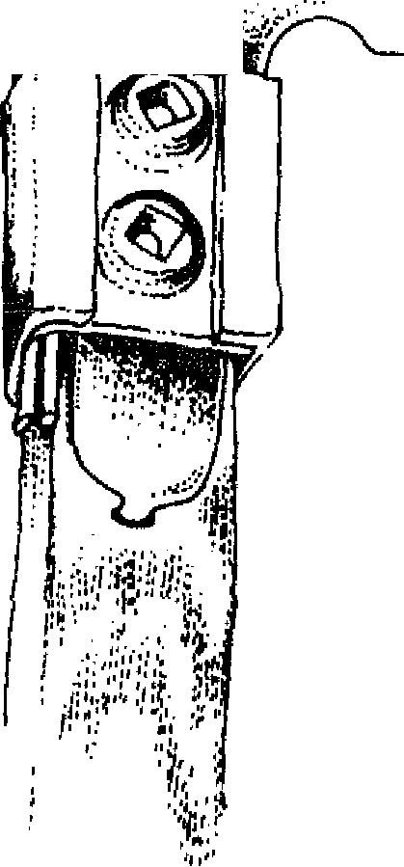

    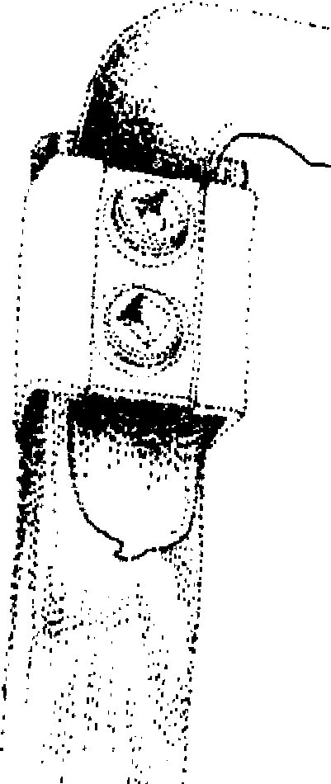  with hardwood shim  to hold Made in rough catting  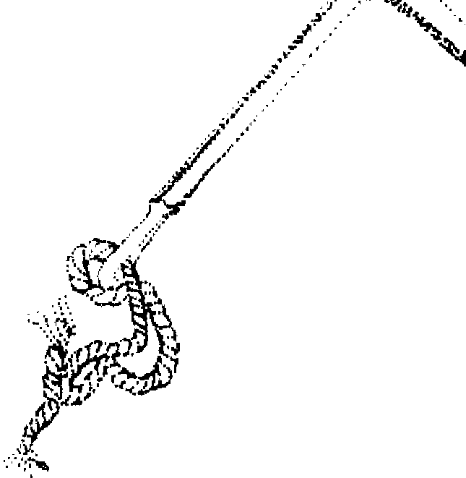 | 5. Correcting the angle of h.aft.

The Parts of the Scythe 17
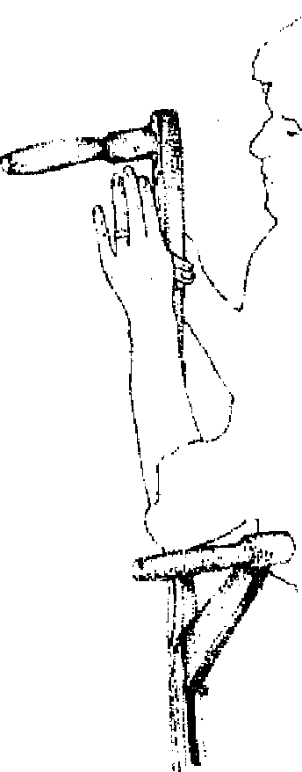
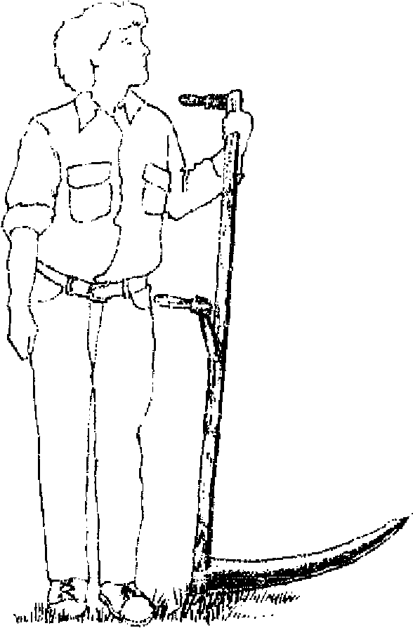

fingertip w Mon) distance
!mer nib at hip height

6. Adjusting the nibs.
required a careful bending in a vise until the tang is rotated to an angle with the blade of about twenty-five degrees (Figure 2, End view).
The basic cule here is that the scythe can be dragged on ifi rounded back without engaging the edge in the ground, but wi, the edge no more than ¹/₄-inch above the ground. This is how the lawn is mown, and if you can mow the lawn, then the blade is properly cocked and hafted.
These rules should give a general idea of relationships hetween the parts of the scythe, but different designs of scyth,,>. different people, and different conditions of cutting sometimes require modifications.
The straight snath of air-dried ash can be fitted to any size of adult in a way not possible with any other available snath. The upper grip is fixed. The lower grip is adjustable within a mortised slot and is secured by two carnage bolts and wing nuts (Figure 1). This grip should be set at a cubit's length from the top grip, or a little further. The snath is quite long so that the heel can

18 The Scythe Book
be eut by the owner to a different length if necessary; the iower grip should corne just below the hip bone when the scythe is resting on the heel of the blade. A hole ⁵/16-inch wide and 1/2-inch deep must be drilled in the center of the snath 3 1/4 inches from the end into which the knob of the tang fits (Figure 2). The blade is hafted as in number 2 above, and held in place with the set screws of the scythe ring.
You can experiment with leaving the snath a littie longer than suggested above, but if it feels too unwieldy, and the blade scems to be pulling you over when you cut, then trim the snath down to size. The scythe ring keeps the blade tightly in place, but if there is a problem with the tang working on the drilled hole, then a piece of metal (such as roof flashing or eighteen gauge sheet steel) with a ⁵/16-inch hole in its center can be tacked onto the snath for strength.
A smaller size of snath for small people and for boys and girls between six and fifteen is also manufactured, and is fitted in the same way. A shorter blade (40 centimeters or 15³/4 inch) is best for children. Such a tool is used in Switzerland, rot only for young people but also when mowing the forty-five-degree siopes in the mountains. In areas where snaths and blades were by tradition heavy and long, scythes were rot used by children for harvesting; in order to use the labor of the children the sickle was the traditional tool. An adjustable snath, however, gives smaller people the opportunity to stand erect when mowing, and learn the enjoyment of working together with their friends. I have used Tom Sawyer's technique of getting the fence whitewashed with adult mowers and child mowers. I find that, once the cultural aversion to physical work is overcome, we have the good time of shared work.
Sharpening
The faults (which the unlearned man) hath he will learn how to hide and colour them, but not much to amend them; like an ill mower, that mows on still, and never whets his scythe.
—Francis Bacon
The Advancernent oflearning, 1605
He, therefore, that spends his whole time in recrea-
tion, is ever whetting, never rnowing.
—Bishop Joseph Hall
Oreasional Mechiations, 1633
With the "American" blade of hard stamped steel, the traditional method of sharpening was on a large circular grindstone (Figure 7). Thus Robert Frost could write about turning the crank as a boy white an older man held the blade at just the right angle to the rotating stone. Frost complained about the length of time it took and the wear on his arrns; violent emotions arose toward the end.
7. The grindstone (E. Portland, Maine, 1910 ).
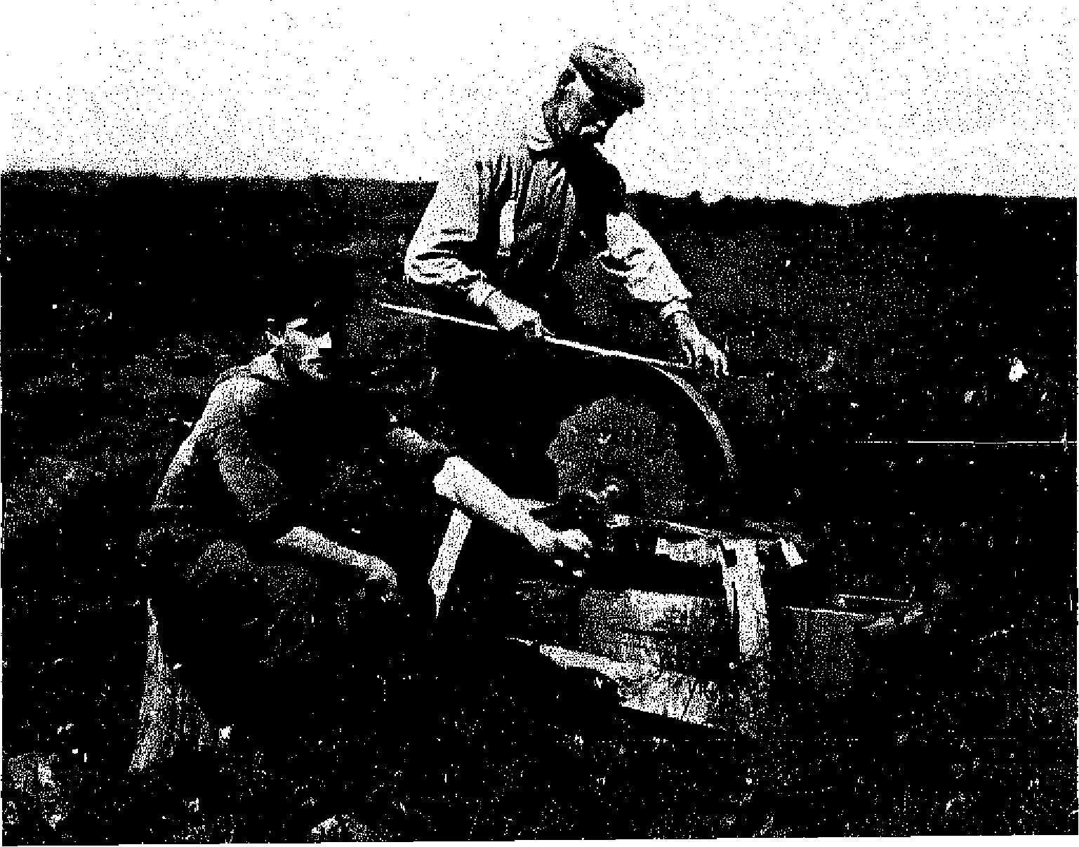
20 The Scythe Book
Once when the grindstone almost jumped its bearing
lt looked as if he might be badly thrown
And wounded on his blade. So far from caring,
I laughed inside, and only cranked the (aster,
(It ran as if it wasn't greased but glued);
I'd welcome any moderate disaster
That might be calculated to postpone
What evidently nothing could conclude.
Today the handyman sharpens this type of blade with a small grindstone rotated in an electric drill, followed by a file, followed by a coarse Carborundum or Crystolon "scythe stone."
Yet old accounts tell of taking a strickie to the fields—that is, a stick scored with a saw, which was covered with grease and rolled in sharp sand. The strickie was used to touch up the edge of the blade while the mower was working in the hayfield; but this blade was made of a finer more malleable steel than the hard blade that Frost helped to sharpen. The grindstone would cause excessive wear on it. Worse, the grinding would overheat the area of the blade in contact with the stone, leading to loss of temper; after grinding, the softer, finer blade would not hold its edge as before.
The method of sharpening appropriate to the Austrianpattern blade involves two steps: 1.) peening: hammering the blade upon a small anvil; and 2.) whetting: the final honing with a whetstone.
PEENING
Peening is practiced on American and European farms today in a way unchanged from the way it is illustrated in Brueghers sixteenth-century painting, "Haymaking." A small anvil is set into the earth or into a bench, and the blade is lightly hammered with a bar peen or cross-peen hammer (Figure 8). The lightest cross-peen hammer made in this country is an expensive blacksmith's hammer weighing over two and a half pounds; the imported hammer weighs about one and a half pounds.
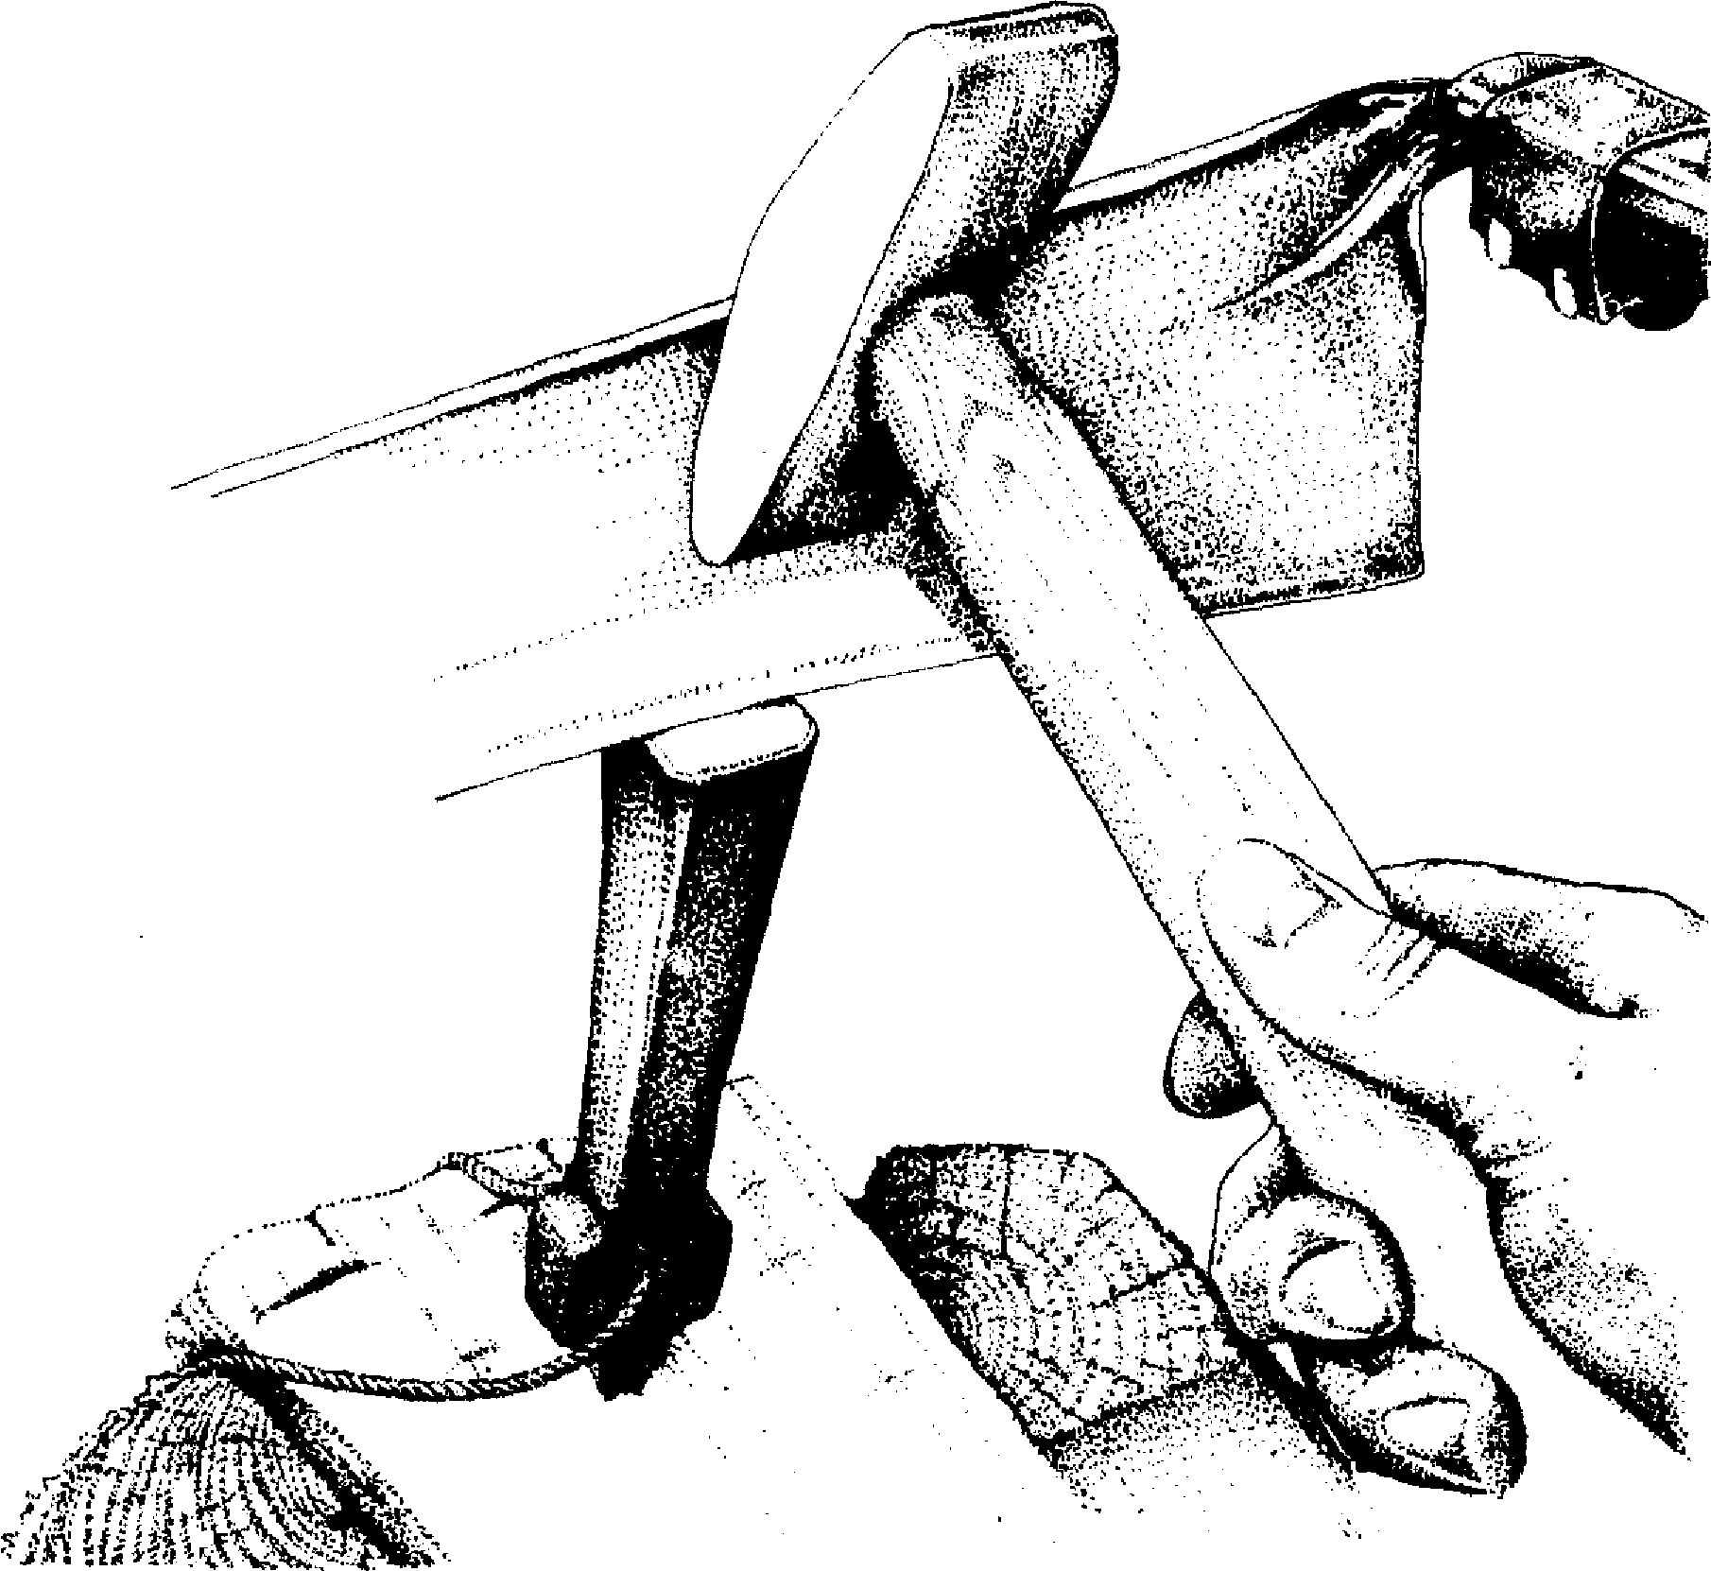
8. Peening: hammer, blade, and mil.
The edge of the blade rests perfectly flat on the anvil. The hammer blows begin about ³/₈-inch away from the edge, and proceed to the edge. It is casier to achieve this stroke with several fast and light taps in the direction of the sets of four blows shown in Figure 9. The bar peen strengthens the steel along the edge; either the hammer or the anvil or both must have this bar. Two flat faces or a common hall-peen hammer would not properly align the steel molecules along the edge. The bottons of the blade must be against the tool with the flat face, se that when using a flat hammer and a bar peen anvil, the blade must be topside down.
22 The Scythe Book
To keep the blade flat on the anvil, you may balance the snath over your right shoulder, or another person can hold the top grip at the right height while you hold the blade with one hand and the hamner with the other. The top grip can also be tied to a string from a branch or rafter, as diagrammed in Figure 10; the person then can sit on either side of the blade. The whole process of pecning takes five minutes, and should be done every twelve hours of use, or as necessary to straighten out an accidentai dent in fhe blade.
The cold-hammering of the tempered Made draws out the steel a tiny bit with each blow, to maintain the ideal thickness. Most people do not believe that it is possible to shape steel withot t a blacksmith's forge. With the hard "American" blade, it probably isn't. However, the crystalline structure of high quality tempered steel can be molded. In the molecular realignment of cold work, the steel becomes strain-hardened without losing its
9. The sequence of haminer blows in peening.
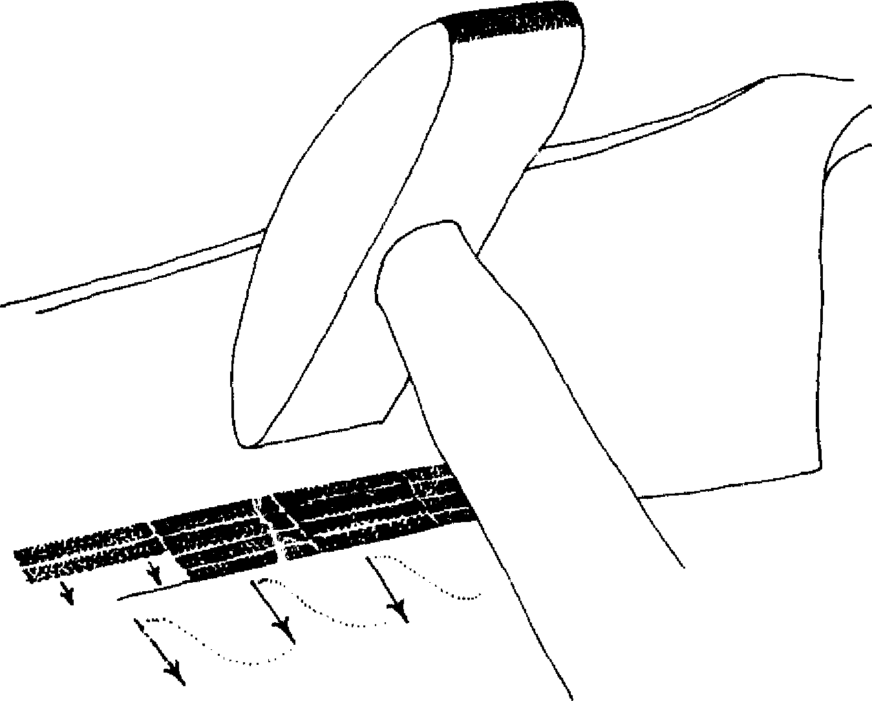
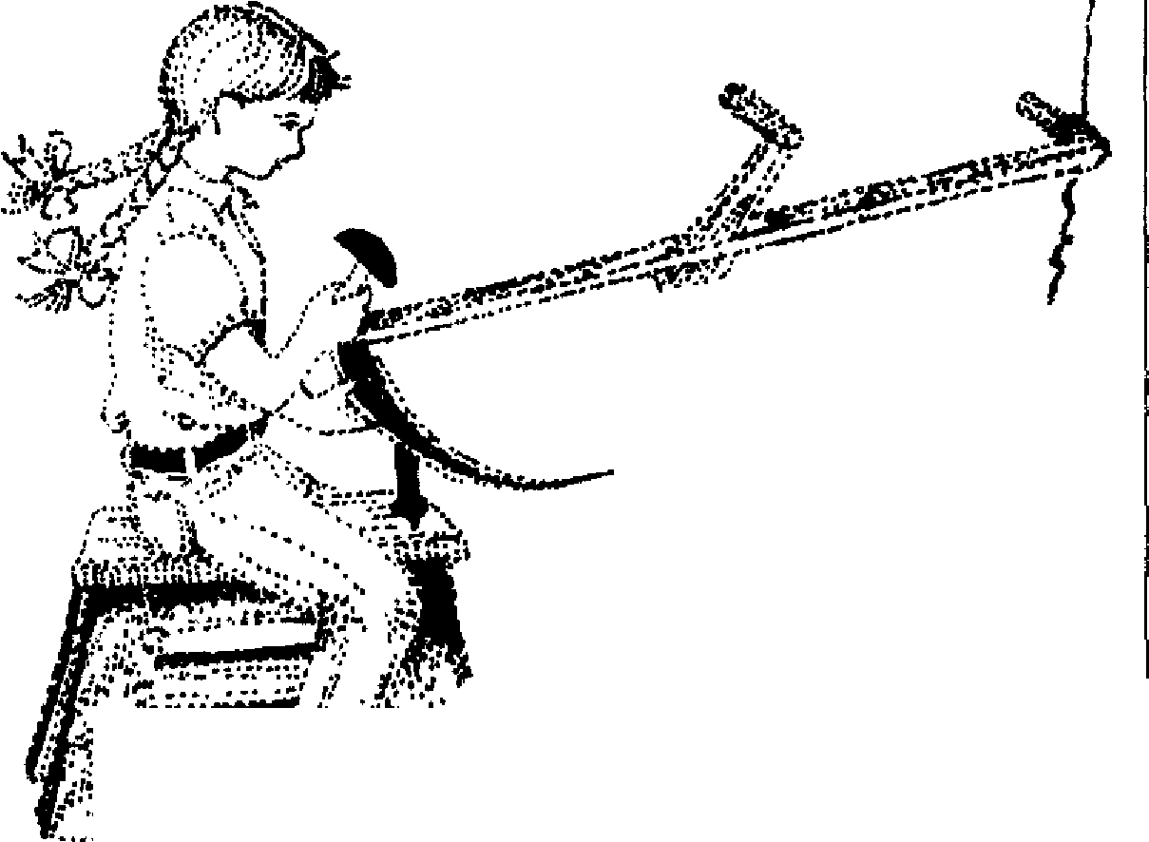
r - •
.₁₇
10. A simple arrangement for holding the scythe when peening.
ability to dent under severe stress (ductility). However, if the pounding-out is overdone and leaves an edge too thin and brittle, the blade will break at the weaker points. The abject in peening is to maintain the bevel and thickness of the original blade, as it was crafted by the master smiths. A rule of thumb is to hold the blade as in Figure 8 and push up on the very edge with your thumbnail. If the edge can be slightly moved by this pressure, then it is the right thickness. If it does not moue at all, then it needs more peening. If it moues but does not spring back into place, then you have been hammering for much more than fine minutes!
Many daim they could not possibly hammer the blade evenly along its length, and that such hammering would soon use up all of the blade. Not so. I have seen several blades used every season for twenty to thirty years, and they are from 1/4- to ¹/2-inch narrower than their original width. The edges, no longer perfectly straight, have become a little wavy, showing that the wear and/ or the sharpening has been uneven. However, this is accep-
24 The Scythe Book
table for a scythe, and does not impair its performance. As Adriun Bell said in Apple Acre,"liis scythe edge is as wavy as the sea; every nick is a history of his labour."
If by accident the blade strikes a stone or stump hidden by the grass, a section of the edge may be blunted, or bent over, or it may even show a tear up to 1/2-inch long. The risk of such damage should be avoided, in the first place, by not demanding the scythe to do the job of an ax or billhook. These high-quality scythe blades will cut year-old trees and brambles, but not tree trunks the diameter of your finger or larger. However, accidents with stones, fentes, and trees do happen, and peening is the only way to straighten out a dent. The hammer and anvil are made light-weight with holes through which strings can be attached so they may be carried easily to the place of work for such ernergencies. By repeatedly tapping around the edges of a dent, you bring the blade back to its original shape. And, if you're smart, you take the opportunity to remove or clearly mark the obstruction.
When staring down at a large dent, 1 must remind myself that it is better to dent the blade than not to. The dent can be mended; the blade that shows no evidence of stress has stored the damage in tiny cracks which will shorten its life.⁸
WHETTING
Anew with merry stave and jest The shrieking houe we ply. ---William Allingham
The Mo wers, 18.65
Whetting with a stone gives the blade its even razor-sharpness, and is repeated at intervals during the work. You mow once around the hayfield, or let us say you mow fifteen minutes' worth, then stop for thirty seconds or a minute to whet the blade. Seen from the tradition of the hard stamped blade, which never got as sharp as the hammered Made, and only slowly lost the sharpness it had, this pause is thought lazy. However, the higher-
S harpening 25
quality blade well repays this periodic attention to its sharpness with a much more thorough cut requiring less effort. The routine sharpening is not time wasted, since the mower starts afresh with a better tool. Using a dull blade encourages more violent swings of the scythe to do the cutting—this is tiring and potentially dangerous. The two quotes at the beginning of the chapter show a conflict in attitude about how much time should be spent sharpening; but I prefer to sharpen as often as I can break the trance of mowing. This may be every fifteen minutes.
Historically, whetstones were cut from natural outcrops of the right sort of rock. Since the advent in 1906 of mass-produced and therefore cheaper synthetic abrasives, natural stones have been used less. The hardware store "scythe stone" is usually made of silicone carbide or aluminum oxide from Canada bonded with resin and baked at 2500 degrees Fahrenheit. These common stones are too coarse for the blade of finer steel. European stones of silicone carbide have a finer grit and are more appropriate to use following the peening of the hammered blade. Natural stones are of a much finer grit still; when used for the very final honing, they impart a sort of perfection to the edge that may not be noticed by the beginner but is greatly appreciated by the mower with a little experience. To use the metaphor of sandpaper grit, the common stone is like 50 grit; the European synthetic stone, 120 grit; and the natural stone, 320 grit.
The beginner is advised to proceed slowly with whetting, wearing a glove on the hand holding the stone. The point of the scythe blade can be set firmly against a tree or post or into the ground for stability. The scythe can also be held upright with the left hand, the left foot stepp:ng on the top grip. Wipe the blade clean with a rag or some cut grass. H old the stone against the blade so that across the back side of the blade, the angle of stone to blade is zero degrees. You should see the first _{1/4-inch} of the edge brighten with the whetting. The bevel of the edge is dictated by the sharpening of the front of the blade. Here the stone is
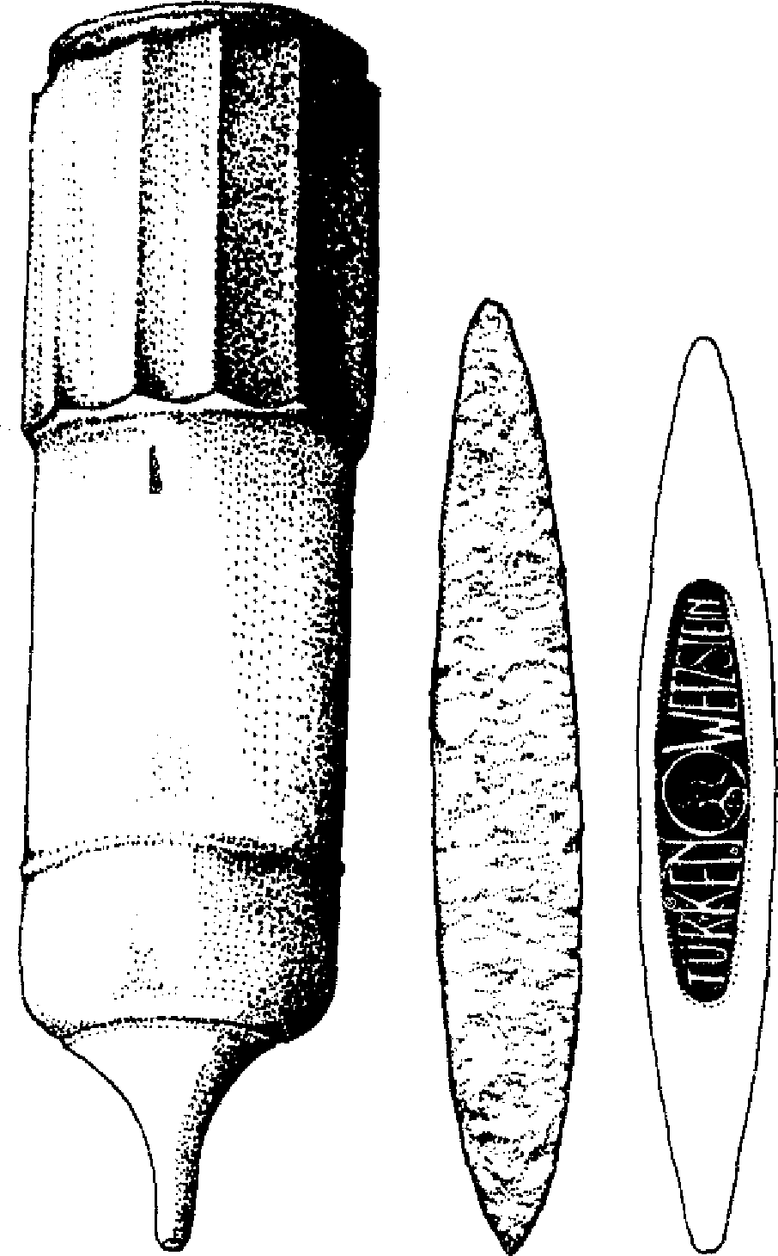

11.⁻Whetstones and holders.
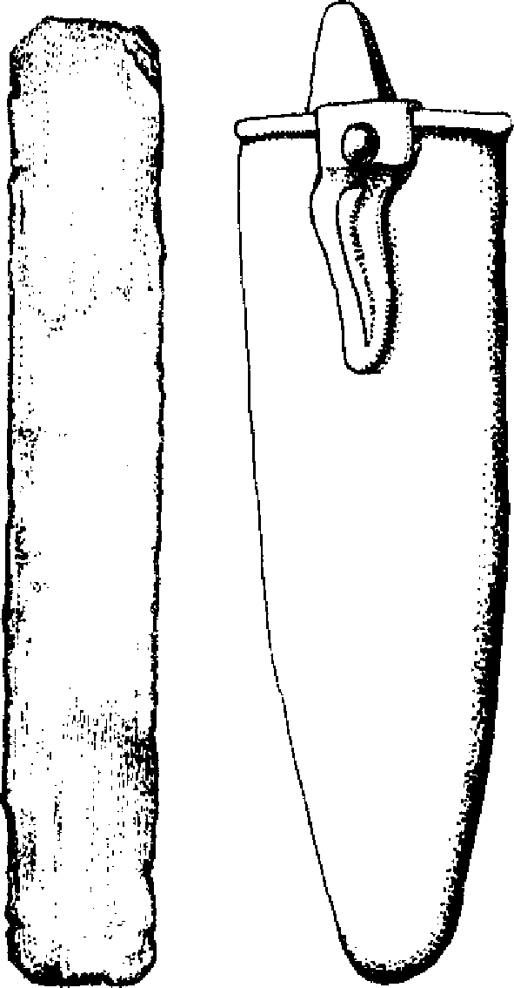
wooden quarried stone European  holder fine grit silicon carbide  medium grit | my grandfather's stone  sicle front  vicie | plastic holder  with belt clip
guided by the rib which stands out along the back of the blade. Whet slowly; the correct angle is far more important than rapidity of strokes.
As in the drawing (Figure 12), begin with the base of the stone at the base of the blade and finish with the point of the stone at the point of the blade; from heel-and-heel to toe-and-toe, or ba se-and-beard to point-and-point. The reason for this sequence is that tiny serrations or sawteeth are built up pointing in the direction of the blade's point. These help the cutting of the grass. If I were sharpening a shaving razor, 1 would begin sharpening at toe-and-toe and hone back, toward the blade, to eliminate the very small burr of excess metal that occasionally builds up beyond the blade's edge. For cutting grass, this burr does not
Sharpening 27
impair the cutting, and scon breaks off. In any case, it is less dangerous to slide the whetstone and the hand away from the edge rather than toward it.
One tradition recommends that the whetter stand with the light falling over the left shoulder to better see how the stone is bearing on the edge. Some say that during whetting the blade should point either north or south. In fact there are interactions between the earth's magnetic field and the aligument of steel molecules in the edge, but they are very subtle. (Boat-builders traditionally lay the keels of the boats they are constructing in a north-south direction, presumably for the same reason.)
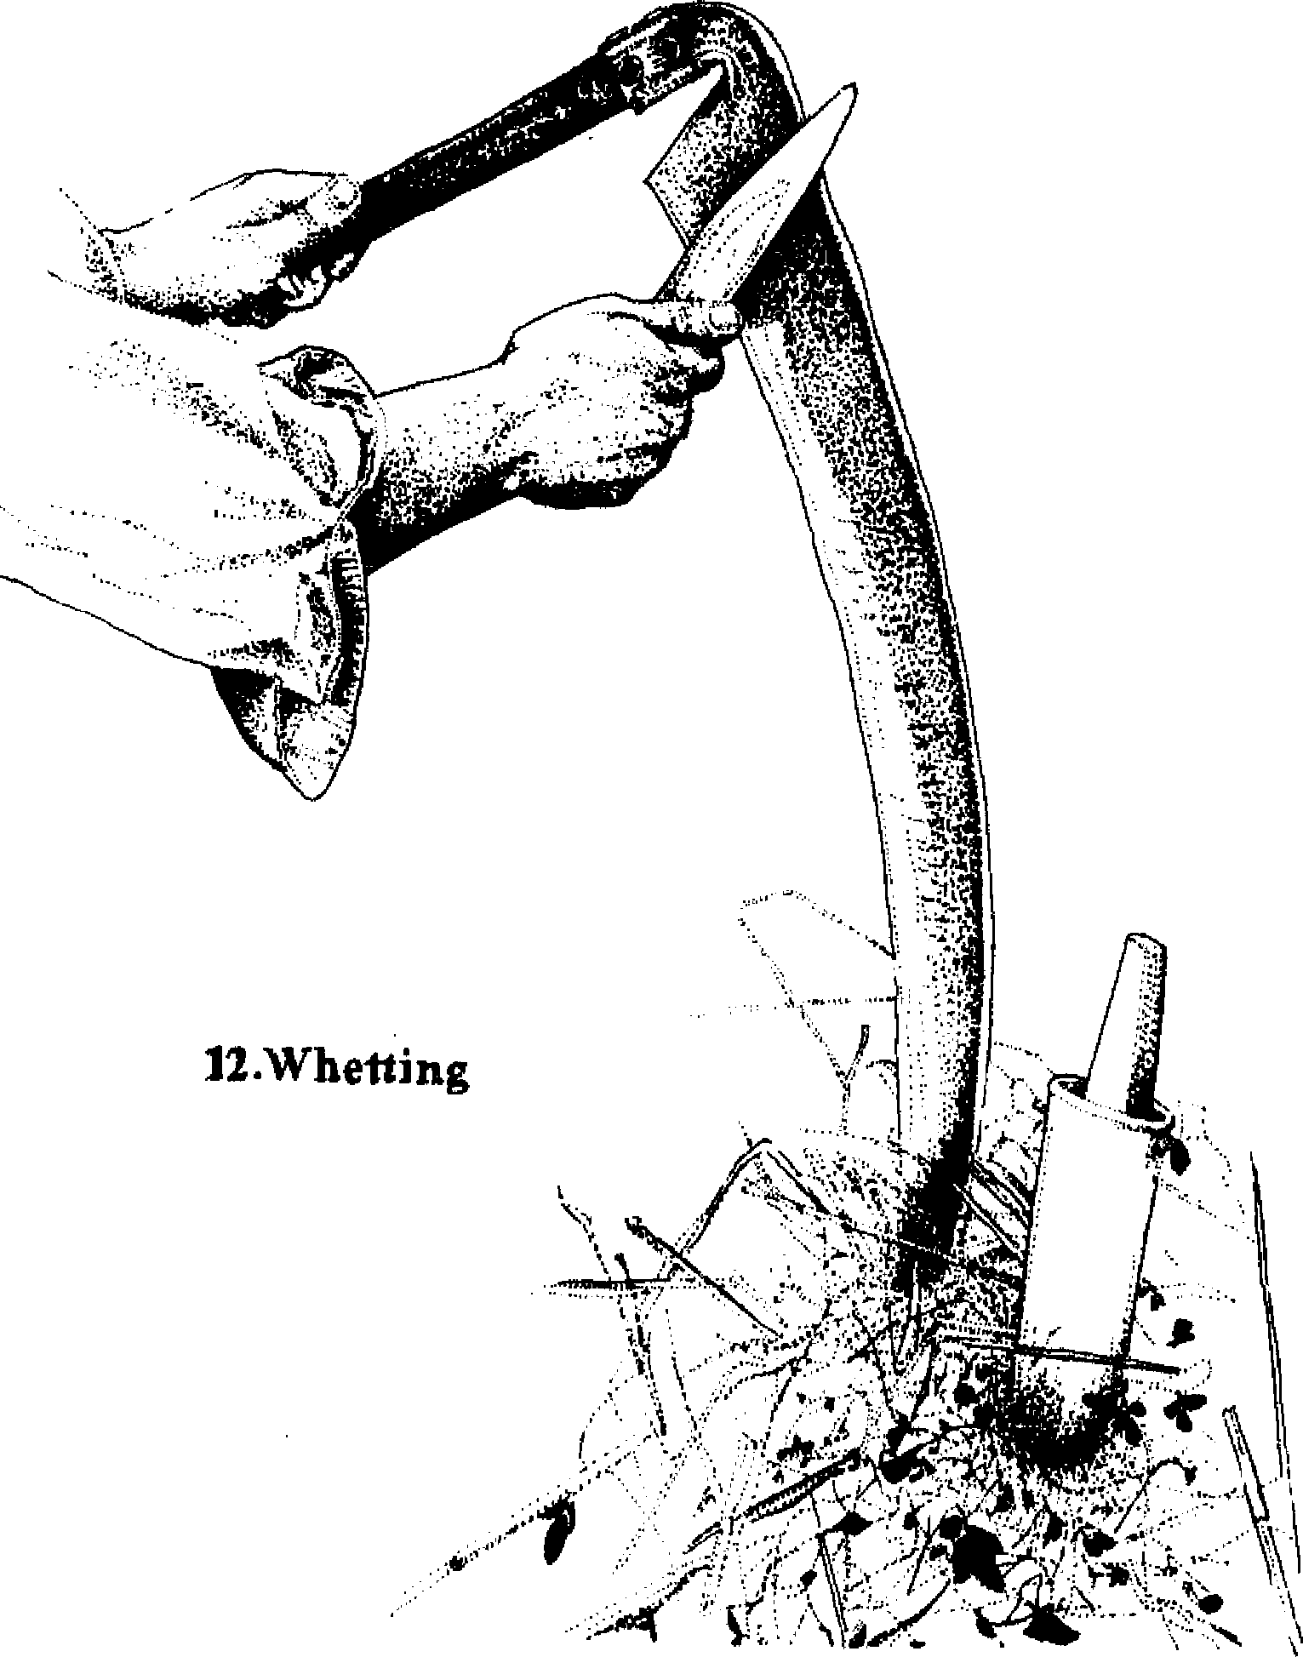
28 The Scythe Book
The whetstone-holder (see Figure 11) protects the brittle stone in transit. It also holds a little water (mixed with vinegar by the Pennsylvania Dutch) so that the stone can be cleaned of the microscopie pieces of metal that clog its pores during whetting. Holders of old were made of cow's horn or wood ornately turned and individualized. But cow's horn is rare and wood cracks, and they have given way to hard plastic holders with a belt clip loicarrying. The stone should be jiggled in the water every fifteri seconds during whetting to clean the pores.
At one time, much discussion was devoted to the virtues of the different slates and sarsens of every color—blue, green with red bands, brown, grey, white—from the different quarries local to every region. In his book, Man the Tool-maker, Kenneth Oakley shows a piece of sarsens (sandstone hardened by secondary silica intrusion) used to sharpen primitive axes thousands of years ago. Particularly good paving stones and monuments were once popular as stationary whetstones.⁹ I have a piece of slate from the nearby Whetstone Brook and a whetstone of slate from my grandfather worn down from years of use, and have found that they do impart a very sweet edge. The final touch cornes from an English tradition which I have never heard mentioned in this country, though I have tried it and been satisfied: honing with the dried shelf fungus of the sort that grows on dead birch trees (Polyporus betulinus), which perfectly fits the hand.
In some places the strickle was used instead of a stone, and a whole new set of tools was necessary for the sharpening process. A saw or a special iron strickle-pricker was used to make small "delfs" (hales) to take the tallow or grease; extra grease was carried to the fields in special pouches or horns; sharp sand or emery powder was found and carried to the field in little bags; snaths were sometimes made seven feet long to accommodate a strickle-holder.i° Keeping the grease cool enough not to run off, and the sand sharp enough, and so forth—these are lost arts. I am content with the sharpness I get from my two grades of stone.
The final step in keeping a sharp edge is wiping the blade after
13. Cleaning the blade.
Sharpening 29
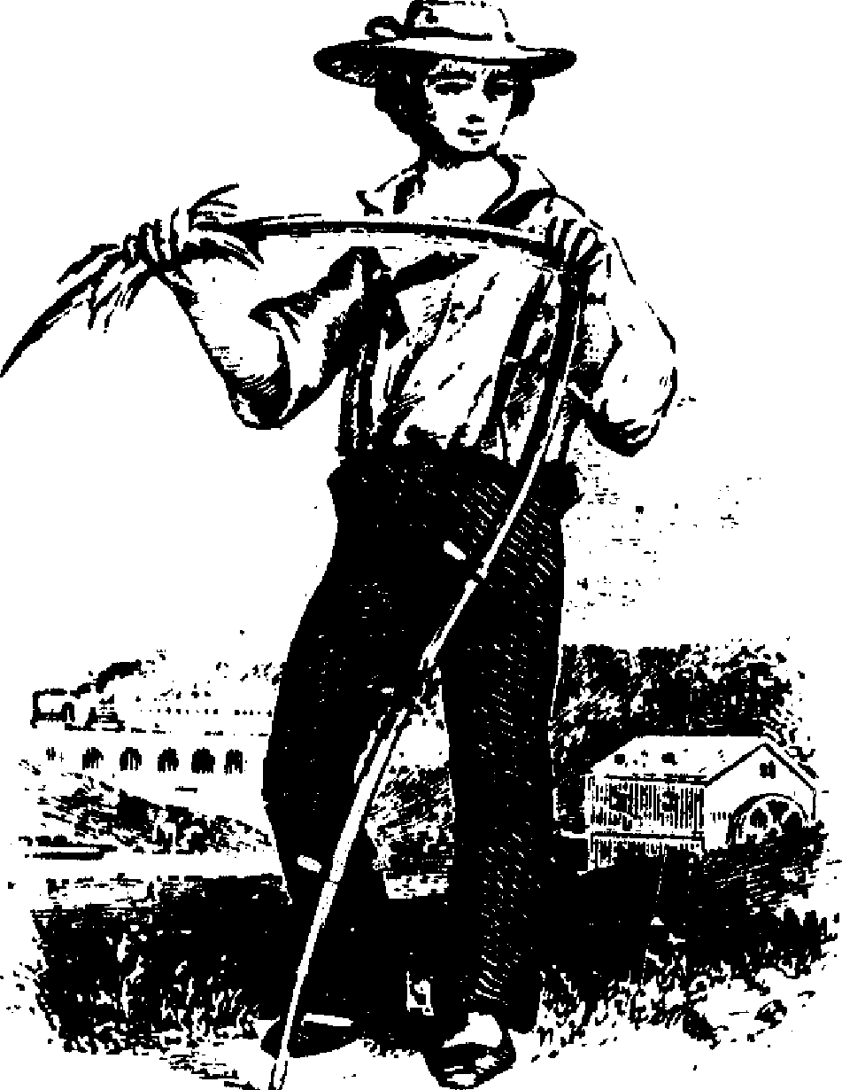
euh day's use, shown in Figure 13, preventing rust and improving the mirror-like finish. The mower Damon's blade was such that in it, "I see my Picture done, As in a crescent Moon the Sun,"¹¹
I do rot loan my scythe. I reap the benefits of a carefully tended edge, and am reminded of my responsibility by a dull edge. Each time I peen and whet the blade, I remake the tool as my own; in time it becomes a mirror of my attitude toward work. A Finnish tale describes a tired mower who exciaimed "May the devil whet my scythe!" The devil did so, leaving only the snath.
Mowing Technique
O sound to rout the brood of cares, The sweep of scythe in morning dew --Alfred, Lord Tennyson
In Memoriam LXXXIX, 1833
MOWING SHOULD be comfortable, flot too strenuous, notimmediately—tiring. If it is exhausting, it is wrongly done. Dress for mowing, therefore, should also be comfortable. The best includes loose-fitting pants and shirt. The shoes should be light; the feet are flot threatened, and mowing was often done barefoot. A sun hat is a good idea, and is alwa: Ï worn by the European mower. A scarf may be useful to warm the neck in the early morning, and to mop the brow in the afternoon.
A HELPFUL EXERCISE
An exercise to begin each mowing session helps remind me of the shape of the movement (Figure 14). I stand erect, neither slumping nor rigidly at attention, and consider gravity as the fundamental force of the earth, which acts upon my entire body at every moment. Gravity is an acceleration, as opposed to a steady velocity: an ever-new force that pulls me downward faster and faster. I respond with an acceleration upward, in opposition, also renewed every moment, an anti-gravity. I prefer the terms energy or spring to anti-gravity for denoting this countermovement; it is flot an anti-earth force, or a rejection. The earth is the entity from which we spring. We are the earth's offspring. The other connotations of spring are ail correct. Neither pulled back to merge with the source, nor flying up uncontrollably in escape, I stand erect, firmly grounded yet springing toward heaven. The stance itself is an act of creativity. Although this interaction between myself and gravity always goes on, it is usually unconscious. Mowing reminds me of the relationship, as it restores the balance of gravity and spring.
30
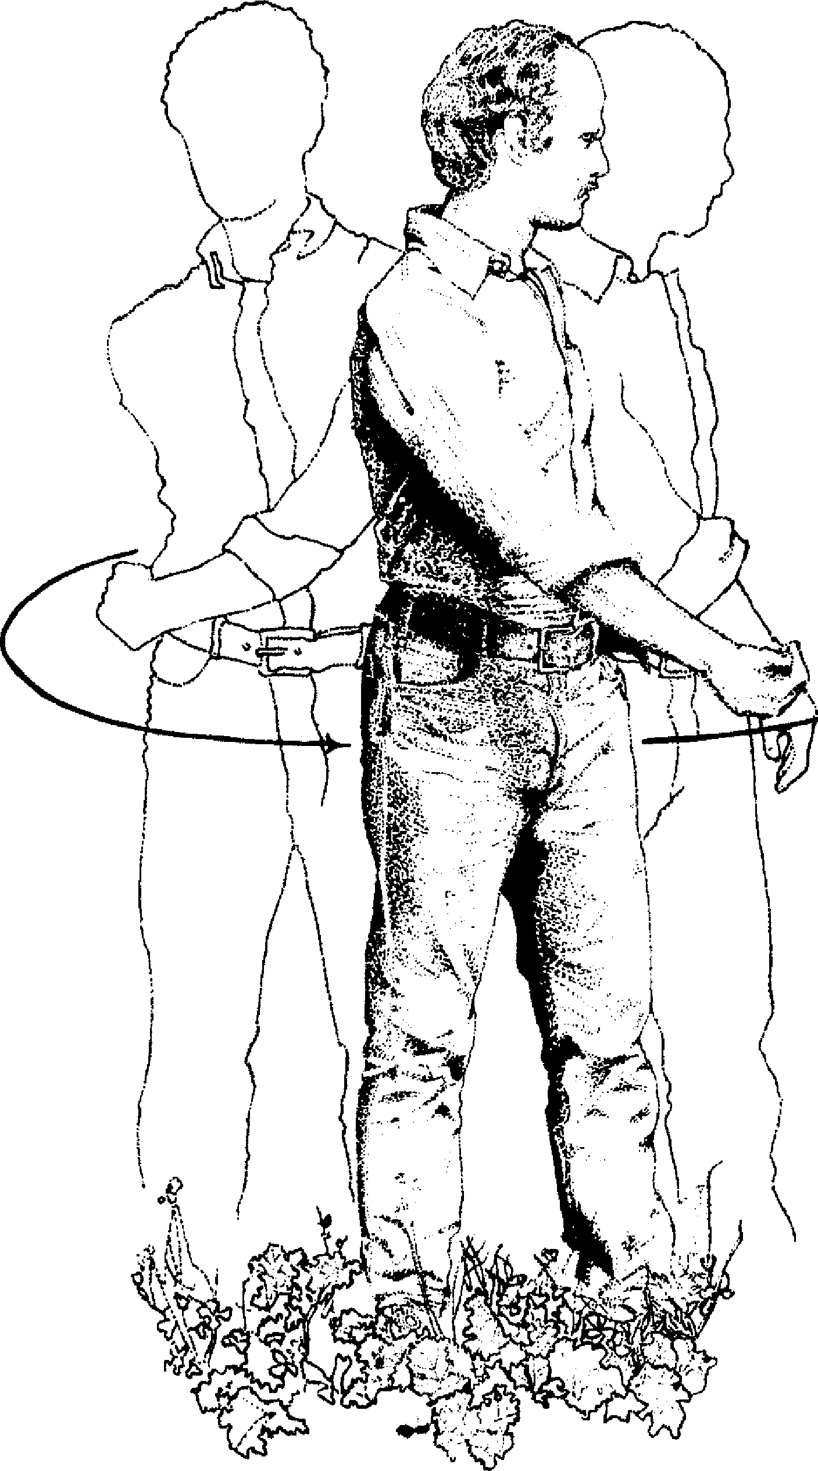
14. Twisting exercise.
32 The Scythe Book
In the middle of these two accelerating flows of gravity and spring, I am relaxed; my shoulders are not hoisted up, my neck is not stiff, and I can mentally travel from one part of my body to another releasing unnecessary tension. Then I begin to twist my torso from one side to another, to face my right, then my left, letting my arms swing free. My right hand flops against my left thigh, and a full second later my left hand flops against my right thigh. There is twisting movement in my ankles, knees,, hips, and ail along my spine. The exercise serves to remind me of three things:
- Mowing is a twisting movement, from the right side of my body around the front to the left side;
- My arms and shoulders need not be tense, but may be relaxed; and
- My whole body is involved in the twisting motion. The human body can be seen as two coils twisting diagonally in opposite directions up through the body in dynamic equilibrium. ln mowing, this dynamic equilibrium becomes a rhythm between one side and the other.
The energy that issues in the mowing stroke is stored in our tendons and muscles as we mow. Tendons are superior to the yew wood used in hunting bows for storing energy under stress. They are even superior to modern spring steel. In Greek and Roman times animal tendons were wound in a spiral to power very effective catapults that could send a 360-pound stone a quarter mile. ^{'z} When I am at one extreme of a twist in the body, my tendons are storing energy, as a wound rubber band does. This energy is released to aid the contraction of muscles when I twist to the other side. The best stroke uses all the tendons in all the joints.
WITH THE SCYTHE
Moving from the exercise to mowing, I let my right arm bang loosely to the side. This is where I had it at the beginning of the
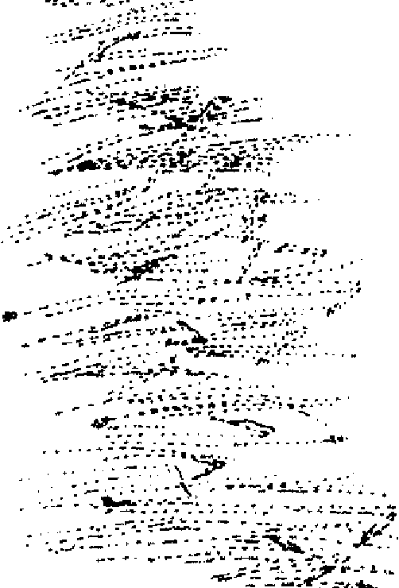
Mowing Technique 33
scythe stroke. The point of the blade is in line with both feet (Figure 15, Beginning). My left elbow is cocked enough to set the blade at the desired height.
I. stand upright. The stereotypical picture of the man with a scythe shows him bent over in a posture that would leave him exhausted and crooked at the end of an hour. Today's cheap hardware-store scythe also pulls the body over in a stoop, a fatiguing position. One should be able to use a good tool all day,
A 11.
' e l i ¹ ^{l' f}i , ' 1 • • ^{A}t ,.
_{V} le:
,.! ,— ^{i} Î ' Iii u 1 ....,,_ ..4. li' 1 • 1 .1., . _{n} _{I} li 4. ?": ‘ ....) . ,..
,,,,, ,.,:¹' • ¹ ' 1! i i 1 1' 1 ''' A ;
'e^{. e}tc • ,..—e. .,,: ‘. .,. . _{i}: , ,, 1 1 , r_{i} .1 ,-. ' . / ,.: à ' ..et, ,, ,
• • - -4 e ..,, .,
- ,%,,,— .•.,„. —
-...
_{e../} _{i}î ₁ ,. ,, , ..,.
---, ., • , ...: i 1 4 i ly. 1 I f I , .., .i 't %::, _{,,.s.}
4 ^{f} ., _{v} .‘t .1 111e' '' cI
%, . ‘. (% ,?. ist 4 A , t ,' 1 • s "^{T}t
„ ,,.,,o
...,,, 1
1
>t '‘ i ^{4 ,}z •^{i}i i't ¹ ¹., .1 '‘ ''''', 'i; .
ie"..,/,,,_{i}1 , \ ,
''etl, 1 ,1 7
windrow • ez..-, \'‘ •. s_{t} ie> ; .
t 1 I 1
Y...,, ., , ..,... , ..:,
le:-.--,:.:2--- :'n • • 1 t"....^{e}
- .:Iii,-.: :
7....."•. . e
.. >. - -1 • .,,..
.IUT "'..
Li ,. ..,
^{I}\ \
‘ 1 \ '... ie,N.
\‘‘!ii )".. ^{e}1 ''' 1 .1 i 1
r. e . ....,, _{AI}, -,..
:.:. e ¹
.4?-1.f2.'.'^{"--}
i, ---..,..r-ar......" '.
beginning of stroke -4 ^{•..i}1 . 1 ''‘ % ,o7; 1
.e. ;SIN..."*. •, a q , g
- te ' ¹:: ' ¹_{l}' '' •‘,
- '.'., i_{t}$ ' 1 '• •?, ,i
»:⁻';e:
15. Beginning and end of the stroke.
ending of stroke
•
- -
1.1

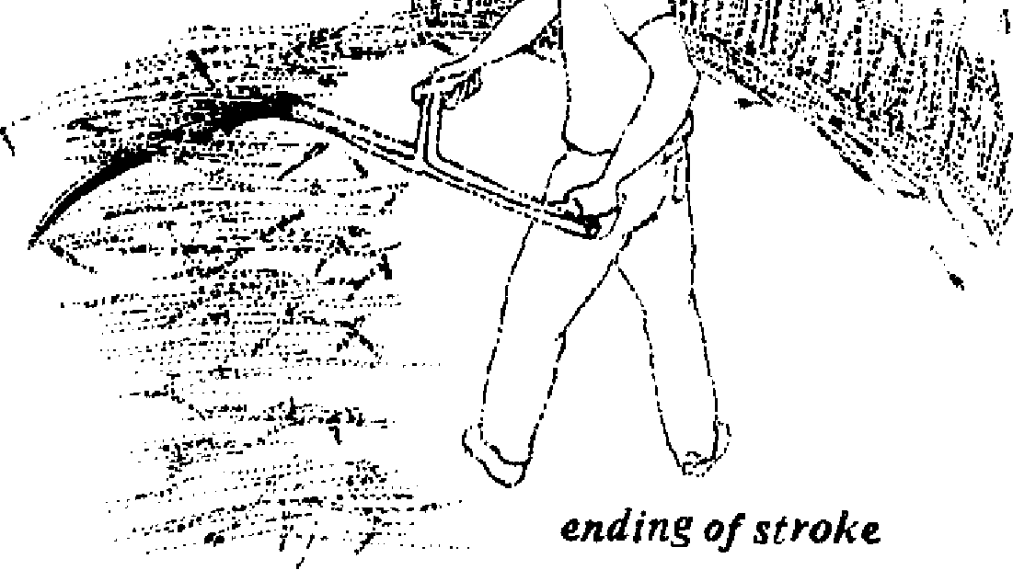
34 The Scythe Book
every day, without pain or abuse to the body. The great improvement in Roman Gaul of the long-handled scythe over the shorthandled scythe and sickle of early Roman times lay in the user's ability to stand erect and relaxed, and thus do more work.
My whole body twists around to the left, my left elbow bending further and leading the way around the back of my body. The stroke ends when the blade cuts through the line made by both feet (Figure 15, Ending). At this point my left elbow is almost touching my backbone. My chest faces left. There is tension in every joint as the pendulum of the swing cornes to its furthest point.
At its best, the stroke does not have to be stopped. It is initiated with just enough energy that the last of the grass is cut and thrown to the windrow as the momentum of the stroke is reduced to zero; the leftover energy is comfortably stored in the tendons to power the recovery back to the right.
As I swing back to the beginning of the next stroke, I move bath feet forward a step. The heel and toe of the scythe are parallel to the ground and just above it at all times. The shape of the cut area is a crescent.
The grass tends to be thrown to the left by the scythe; therefore I proceed as if walking along the edge of the uncut grass. Many people confuse a scythe with a broom or a golf club. They face the field straight on rather than walk along it, and try to slash the grass. The heel of the blade aiways rises uselessly above the ground at the beginning of the stroke. Despite a vigorous swing, little is cut. The grass that is cut is thrown into the next swath. This approach is pictured in Figure 16.
For the right approach, I walk along the edge of the field, twisting my body, keeping the heel of the blade down to the ground from beginning to end (Figure 17). In golf or croquet there is only one point of impact on the bail. In mowing, there are a hundred points of impact and they must all be hit at the right height. Rudyard Kipling gave a vice metaphor for the sweeping arc of the mowing stroke: "The foresail scythed back
Mowing Technique 35
and forth against the blue sky." The mower is the mast, the boom is the scythe.¹³
I practice on a lawn, dragging the blade in the stroke and in the return. In a cross-section of the blade from edge to rib, the area behind the edge is gently curved out (Figure 2). In close mowing the convex blade slides along without digging in, as the stamped blade would. With this dragging exercise, the lawn gets mowed, and I can perfect keeping the blade parallel and close to the ground.
For a wider swath, my right and left hands reach out to the right at the beginning of the stroke and are further from my body in the swing. The mower painted in Figure 18 leans toward the grass without losing his balance and without stooping. An experienced mower in good grass can cut a swath seven feet wide or more with the 70-centimeter blade. An average swath six to seven feet wide was used as a unit of measure in hayfields in England. Inexperienced mowers would be wise to take smaller bites by walking a bit to the left, even walking in the cut grass of the previous row. It is no disgrace to be cutting a swath two feet wide. The importance of a clean cut over a wide cut is illustrated by the scoring systems of mowing contests. At the annual meeting of the Dairy Herd Improvement Association of Sullivan County, New Hampshire, 45 points are offered for neatness of the stubble, 30 points for width of swath, 15 points for time to cut one swath fifty feet long, and 10 points for making it to the end. In the Austrian national mowing competition, the time is recorded for cutting an area 10 meters square (1076 square feet), and lime is subtracted for sloppiness of cutting. The width of the swath is not counted at all, which seems to me fairer to different sites and shapes of people. The emphasis is on speed and the amount of cleanly cut grass, which is after all the aim of mowing. The same emphasis on a clean cut was made in the Librarv of Useful Knowledge in 1830: "The mowing should be so performed, that neither the strokes of the scythe nor the junction of the swaths can be discerned."
from ahead in the rom;
'
fram behind
I6.The hacking stance.
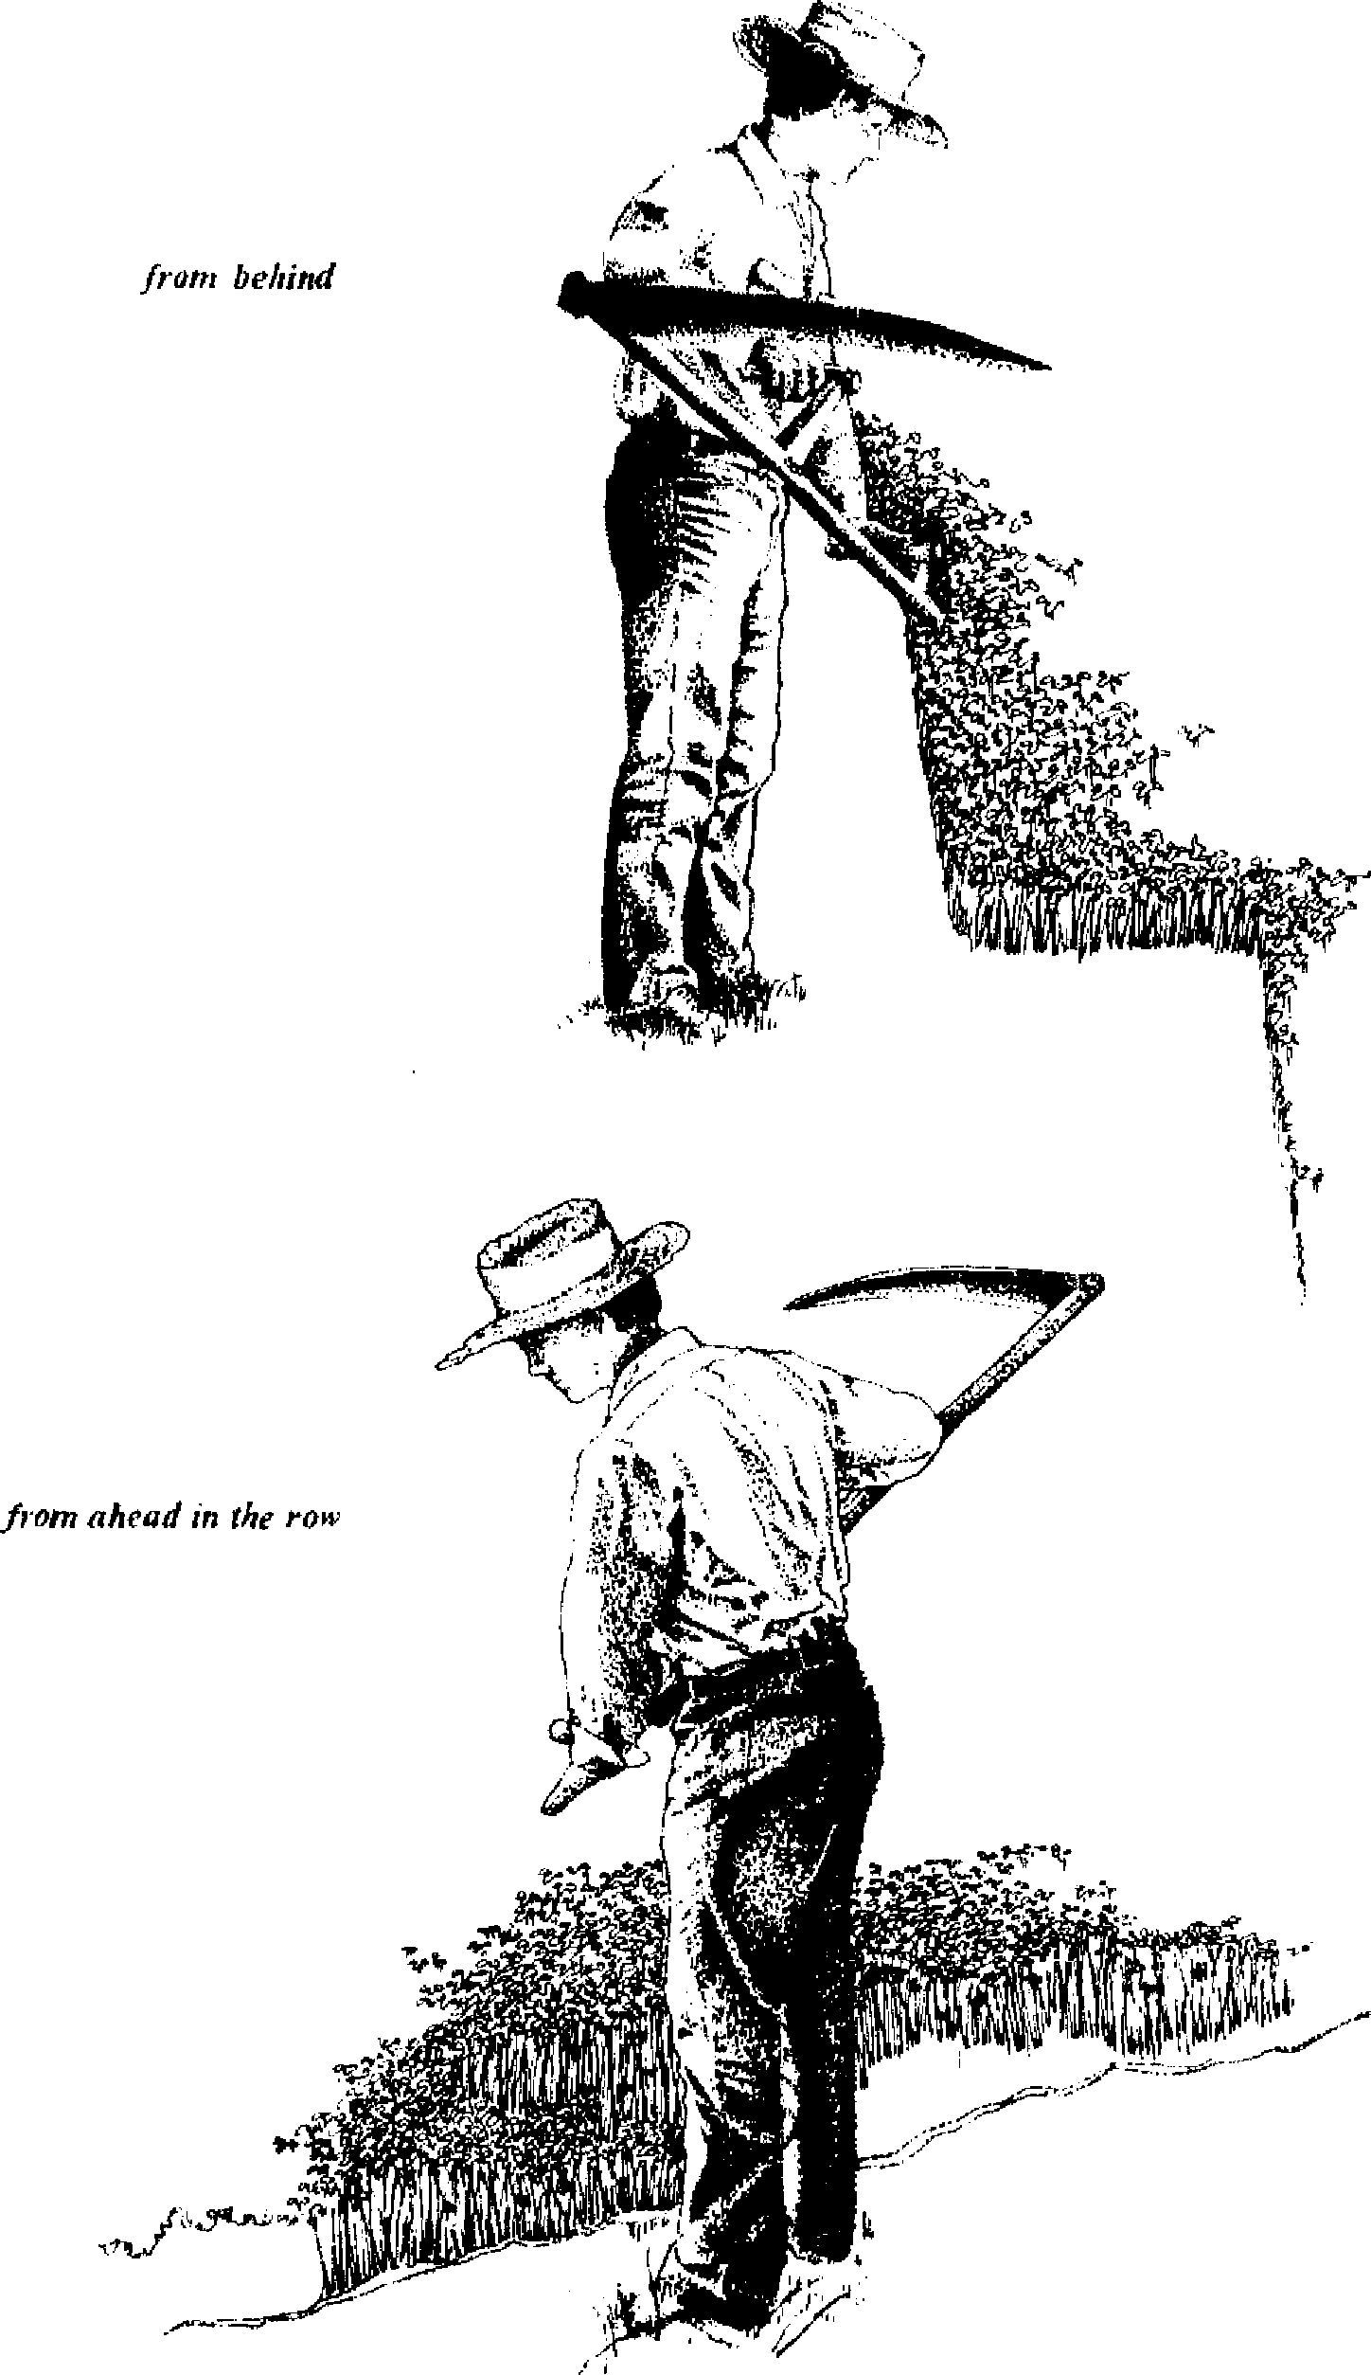
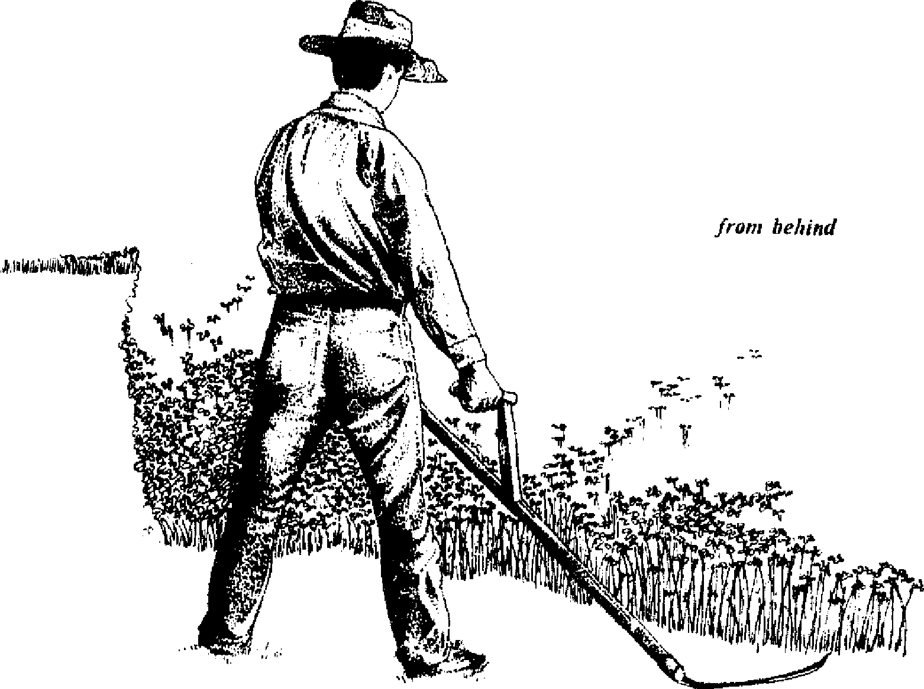

from ahead in the rois
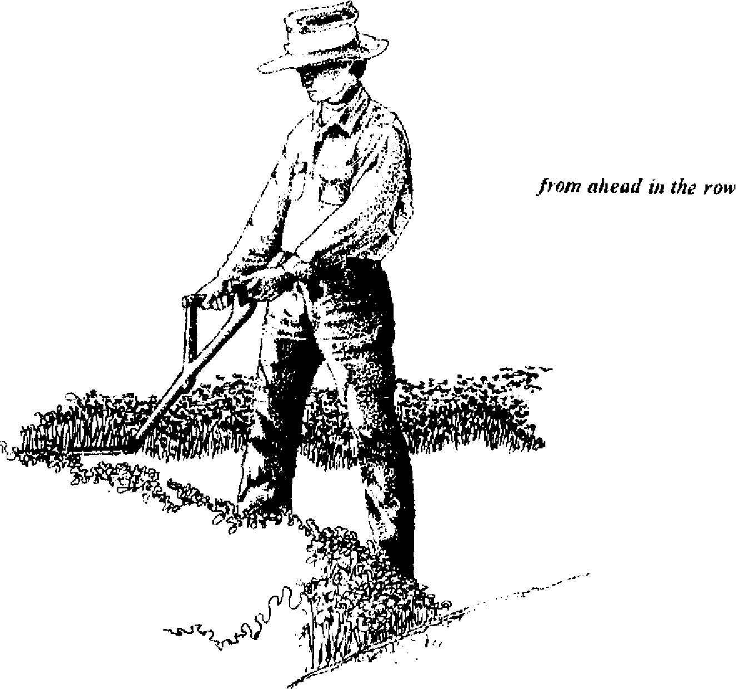

Aî•
17. The rhythmic twisting of scything, blade always close to the ground.

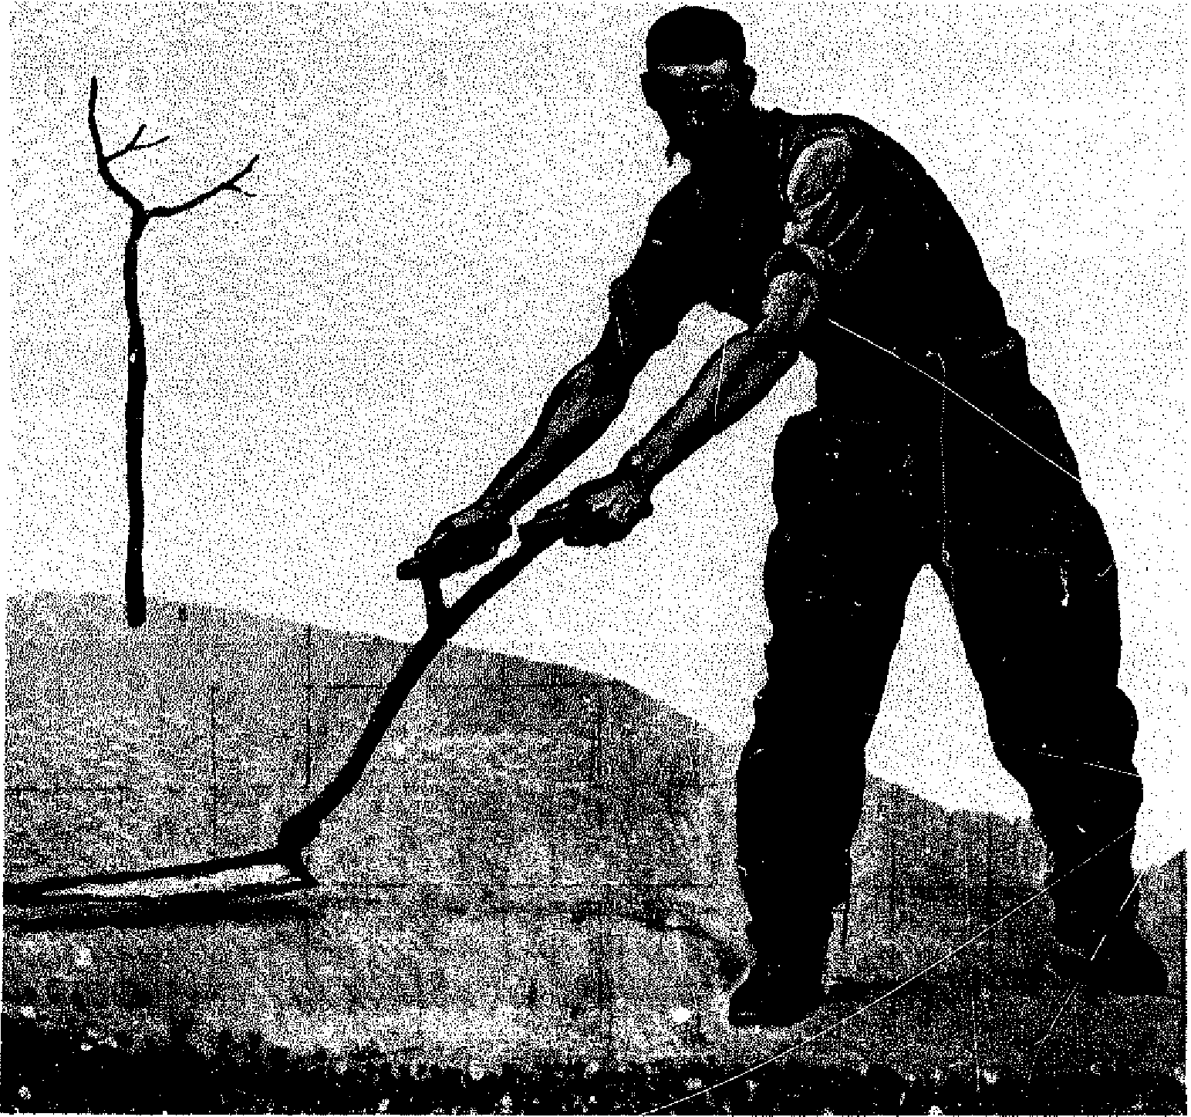
18. Reaching out to enlarge the swath.
Most often it is not strength which permits a wider cut but rather the proper twisting movement to store energy in the tendons. The length and breadth of the swath also vary with the crop to be eut, its condition, and the evenness of the terrain. Poor grasses that are short and brown in August on hilly stony soil are obviously harder to mow than tall dewy greens in May on level ground.
SMALL ADVANCES
Although it is best for the beginner to stand erect without stooping over, he or she will have the experience of being pulled forward when the width of the swath is increased. When this position becomes a stoop, it should be abandoned; the knack of positioning yourself in mowing is to learn how to lean into the work without losing balance.
Mowing Technique 39
Even following all the rules of technique, there are still opportunities for variations. The snath and blade are manufactured to hold the cutting edge in the right relationship to the grass. The blade can, however, be manipulated to maximize the cutting angle. I cut, always, with the blade parallel to the ground; but this lets me try two different approaches to the grass. If I put my left hand against my beit and bring the right hand around through the stroke, I can make a cramped slice. The opposite approach is to pull the whole blade straight across the grass like a cleaver hacking meat. Neither extreme works. With the narrow slice, a mere two inches of grass is cut; with the broad hack, the grass tends to bend over. All mowing ideally combines the two approaches; in varying conditions I must alter the approach to have more slice or more hack. If the cutting is easy, I may reach out at the beginning of the stroke to increase the size of the swath, while sacrificing some of the slicing effect. If the cutting is difficult, I may wish t© maximize the slicing effect and minimize the hacking effect by closing the blade inward. Within the limits of the scythe ring, the blade itself can be shifted slightly in its seat to increase the slice or hack effects (Figure 5), but I have found that changing the way in which I use my arms, as just described, is adequate to adapt to most mowing conditions.
In some conditions I do not hold my feet stationary while cutting. I begin with my whole weight on the right foot; then, as my body begins to unwind, my weight moves onto the left foot. I move down the field in a slow walk.
These and other variations are appropriate in different conditions of cutting. Experiment. The grass will teach you.
The account given in Anna Kcrenina by Leo Tolstoy of the nobleman Levin joining the peasants for a day of mowing is a fine articulation of the ease and style inherent in mowing:
The old man, holding himself erect, moved in front., with
his feet turned out, taking long, regular strides, and with a
40 The Scythe Book
precise and regular action which seemed to cost him no more effort than swinging one's arms in walking, as though it were in play, he laid down the high, even row of grass. It was as though it were not he but the sharp scythe of itself swishing through the juicy grass .
The longer Levin mowed, the oftener he felt the moments of unconsciousness in which it seemed not his hands that swung the scythe, but the scythe rnowing of itself, a body full of life and consciousness of its own, and as though by magie, without thinking of it, the work turned out regular and well-finished of itself. These were the most blissful moments.
It was only hard work when he had to break off the motion, which had become unconscious, and to think; when he had to mow round a hillock or a tuft of son⁻el. The old man did this easily. When a hillock came he changed his action, and at one time with the heel, and at another with the tip of his scythe, clipped the hillock round both sides with short strokes. And while he did this he kept looking about and watching what came into his view: at one moment he picked a wild berry and ate it or offered it to Levin, then he flung away a twig with the blade of the scythe, then he looked at a quail's nest, from which the bird flew just under the scythe, or caught a snake that crossed his path, and lifting h on the scythe as though on a fork showed it to Levin and threw it away.
For both Levin and the young peasant behind him, such changes of position were difficult. Both of them, repeating over and over again the same strained movement, were in a perfect frenzy of toit, and were incapable of shifting their position and at the same time watching what was before them.
READING THE GRASS
The grass will teach you how to mow better than words on a page or proddings by a teacher in the field. But you must pause
Mowing Technique 41
to observe the grass if you are to learn its lesson. Clearly speaking from his own experience, Tolstoy writes of Levin:
His pleasure was only disturbed by his row not being well cut. "I will swing less with my arm and more with my whole body," he thought, comparing Tirs row, which looked as if it had been cut with a line, with his own unevenly and irregularly lying grass.
Look back over what you have cut. Do the cut ends of the grass slope up to the right into the uncut grass? The blade is too high at the beginning of the stroke. Keep it down. Stop occasionally at the beginning of a stroke and look over at the blade to check its height.
Are there tufts of grass between the swaths? The blade is too high at the end of the stroke, and you are probably trying for too wide a swath. You may also be throwing the cuttings into the standing grass. Step to the left, take smaller bites of grass, and finish the stroke all the way to the left.
Is there uncut grass in the middle of the swath? Sharpen your blade, and try more slicing.
Looking back over several strokes, does the swath have the appearance of rolling waves? The blade is probably not being held parallel to the ground, and the point is cutting at a different height from the heel.
And so on. If I cannot understand why the swath is uneven and irregular, I try to reproduce the badly cut grass, with exaggeration. Then I can discover the source of the trouble within my stroke, and correct my technique.
The grass will teach you, but it is easier to learn on lush green hay or weeds than on wiregrass and hardhack. Young clover teaches an unstrained style as the blade whispers through the fragrant stems. The more difficult cutting of briers and tough weeds can then be approached with more effort but in a good style.
Improvement in mowing technique also requires reading the
42 The Scythe Book
body with as much attention to detail as any athlete needs to apply.
Do your biceps ache from the work, or your back? Let your right arm hang straight. Twist your hips more, using the power in your ankles and knee.
Is your neck sore? Do not hunch up your shoulders, or stoop over, or work too bard on a wide swath.
Does your stomach hurt? Don't stop breathing. A common complaint is a soreness in the stomach because of the unaccustomed twisting. You are probably facing the field as in golf and should discipline yourself to keep the right and left feet perpendicular to the line of the cut, or even advance the right foot beyond the left.
Keeping the blade under the control of the body's twisting rhythm, rather than violently thrashing the grass, prevents exhaustion, and prolongs the mower's working day and his working years. When all the parts are working together, you will agree with the experience of Sir Stephen Tallents, who mows by "guiding my blade serenely through" the grasses.
Watch other mowers, and have someone watch you to see how small changes affect the cutting of the grass. There is room for personal differences in style. In some people the energy bursts from the left hip-bone, in others from the left elbow, in others it spreads evenly throughout the body.
THE USE OF THE BODY
Levin to his urban brother after his day of mowing: "You can't imagine what an effectuai remedy it is for every sort of foolishness. I want to enrich medicine with a new word: Arbeitskur." Arbeit is German for work, movement, energy; kur means cure.
—Leo Toistoy
Anna Karenina, 1876
Awareness of the dynamics of one's own body can be employed ta improve one's ability at mowing, and, indeed, vice versa.
Mowing Technique 43
Most helpful for this understanding is the knowledge provided in the teachings of F. Matthias Alexander.
Alexander was an actor and public lecturer at the turn of the century whose career was interrupted by progressively worse vocal problems. Unable to find a medical explanation or cure, he spent several years carefully observing himself with the aid of mirrors, while speaking and at rest. He discovered that just before speaking, and even when thinking about speaking, he had been quite unconsciously tilting his head backward while jutting his chin forward. Though a small movement, it had cramped his neck and cut off the column of energy in his seine and throat, stunting his voice and presentation. At the same time, Alexander found, he would lift his chest and narrow his back, further cramping his larynx. After months of observation, he found that preventing the tension and movement in bis head and neck resulted in a return of his voice as well as an improvement in his general state of health. Asthma, which had plagued him throughout his life, diminished gradually, until the attacks ceased altogether.
Suspecting that his discovery of the head-and-neck's rote in voice production contained even greater benefits, Alexander proceeded in his investigation to a scrutiny of the connection of head and neck to the entire human organism, and to the use of the body, or more accurately the use of the entire self. Working from the premise of the primary importance of the head-neck relationship, he was able to teach others to become aware of their habituai use, thus freeing them for a re-educated use of their bodies more appropriate to the natural functioning of the human organism.
Alexander found that when he tried to keep a dynamic balance between head and neck and torso, his efforts were in vain. His body became rigidly fixed in a new position. He also found that without mirrors he could not reliably know what he was doing with his head and neck, and therefore did not know if he was carrying them "correctly." Since he couldn't do anything
44 The Scythe Book
to remedy the poor use, he was left with not doing what was hurting him. Inhibition of wrong habituai patterns of use thus became the central feature of Alexander's approach. In the words of a disciple of Alexander's:
Before an unrecognized pattern of behavior can be brought to your awareness, you must either recognize the habit, for example through mirrors, or an Alexander teacher's observation, or by "thinking yourself to stop" just when you are about to engage in an activity. Just when you are about to move, think "NO!" And, gradually, through repeated inhibition, rather than repeated habit, you develop an increased sense of kinesthetic perception, enabling you to sense yourself when "setting yourself" physically to do something.¹⁴
In my case, I first became aware of my poor use of myself in mowing; for example, I found that seeing dry wiregrass ahead in the row caused my neck and shoulders to tense, and thus put off my scythe stroke. I learned to inhibit this constriction during mowing in the way just described. Once 1 had inhibited the habituai response, I had created a pause between the stimulus (perception of wiregrass) and the responsc (tensing up for the anticipated harder mowing). In that pause is the opportunity for re-education of my use of myseif. In that pause, Alexander suggested a series of three directions, to be given to myself silently as orders:
L Let the neck be free (do not increase the tension in the neck),
- Let the crown of the head go forward and up (do not pull the head back or clown),
- Let the torso lengthen and widen out (do not shorten and narrow the back).
These instructions sound simple enough, but they are nearly impossible to enact each by itself. Taken together, the three instructions make up one unified sensation, which Alexander called "the true and primary movement in each and every act."
Mowing Technique 45
The term "primary movement" is a reminder that we are always moving in response to the accelerating force of gravity, and that the head-neck relationship is the controlling center of this response. Alexander also termed this the "primary control" to emphasize how important inhibition was to suppressing habituai wrong patterns and permitting the body to do what it knows best. I use the term "primant movement" without ignoring the sense found in "primary control."
Primary movement can be observed in any small child, as well as in top athletes. Its loss leads to abuse of the body, with attendant symptoms of impaired functioning. To aid the client in rediscovering primary movement, the practitioner of Alexander technique uses the lightest direction of his or her hands, most often in the region of the head and shoulders. One can relearu to stand in a state of equilibrium, without tension (without military "Attention!") and without slumping under the burden of one's own weight. The experience of the body's antigravity power used in the twisting exercise before mowing is an example of positive use of the primary movement in relationship to the earth's power.
The anthropologist Raymond Dart used the name "poise" for "primary movement." By poise he meant a never-fixed dynamita equilibrium that is in effect even when the body is at rest. He related poise to the balanced energies in the double spiral of voluntary muscles twisting in opposite directions through the entire length of the body» The twin serpents coiled about each other in the insignia of the medical profession effectively illustrate this same principle.
At the beginning of the scythe stroke my body is twisted to the right from toe to crown; at the end to the left. In each stroke I pass through the centering point of relaxed poise; at this moment, the blade is slicing through the grasses, and I am tempted to compress and tighten the muscles of my neck and back. It is worth the extra time to learn to be at my freest and loosest at this moment, while directing (ordering) my "neck to be
46 The Scythe Book
free," "head to go forward and up," and "back to lengthen and widen."
The scythe grips are held by the hands only, and need not involve the arms and shoulders in tension. The "primary movement" of head freed from the spine, forward and up with the crown, leaves abundant energy for the twisting through the rest of the body. The tool can swing freely, powered equally by every joint, and thus freeing them all.
The intrinsic rhythm of tool and mower combined, like a twisting and untwisting clockwheel, has a power and creates a time-frame all its own. A British fumer speaks of this experience:
I corne to feel an indolence in action, letting the scythe do it, and a force that is not me takes possession of us both and we swing, swing.¹⁶
Again we consuit Levin:
Another row, and yet another row, followed— -long rows and short rows, with good grass and with poor grass. Levin lost all sense of time, and could not have told whether it was late or early now. A change began to corne over his work, which gave him immense satisfaction. ln the midst of bis toit there were moments during which he forgot what he was doing, and it all came easy to him, and at those same moments his row was almost as smooth and well cut as Tit's. But so soon as he recollected what he was doing, and began trying to do better, he was at once conscious of all the difficulty of his task, and the row was badly mown.
We see that Alexander's "primary movement" has been well expressed by others, and we can encounter another aspect of best use of the body, how it can change our perception of time. When I am using my body well, I enter into this other time-frame and follow the rhythm of my primary movement in relationship to the scythe, to the grass, and to the earth.'7
Mowing Technique 47
Experiences recorded in Michael Murphy's Golf in the King-dom and Eugene Herrigel's Zen in the Art of Archers reinforce Alexander's lessons and articulate them in the spiritual realm. The Zen paradox is that if I give up the hurried intention of "getting the hay in," I will in fact cut better. From Alexander's point of view, the hurried mower has forgotten the best use of the body in ail the rush. h is so tempting to orient to the goal and forget the means we employ to get there. Always end-gaining, we forget what is actually happening. My objective is to have the hay; my attention is on the process of cutting it: I set myseif at the beginning of the swath and let the mowing commence. "God speed the mowing!" as a form of salutation among mowers, much like "Good morning to you," seems to me to be an invocation ta promote primary control.
Inhibiting my habituai tensions and permitting myself to enter into the clockwheel movement with the scythe can, however, be done while I am unaware of my surroundings. Then I am so entranced with the inexorable rhythm of my own primary movement that I do not look back on my work to check the stroke, and variations in the rhythm, such as are demanded by molehills, stones, and the rare toad or partridge, easily destroy the heavenly balance. Entering into a poised rhythm with awareness of my environment permits me to perform as evenly and fiexibly as Levin's old teacher.
The human rhythm of mowing, and the fiexibility it permits, are central to the superiority of the scythe as a tool. The first mechanical mowing machines used one or several scythes whirling about in complete circles from a horizontal wheel directly powered by the wheels of the machine turning on the ground. The inventors were trying to do what the human mower was doing, only faste'. In fact, these machines performed worse than humans—they were unable ta accomodate to changes in terrain, type of grass, direction of lay in lodged grass, and obstacles. On any but the smoothest homogeneous ground, the blades often dug into the ground or bent the grass over without cutting it.18
The Scythe Book
RECONSIDERING
THE TWISTING EXERCISE
The meditative repose in which he performs (the preparations for working) gives him that vital boasening and equability of all his powers, that collectedness and presence of mind, without which no right work can be done.
—Eugen Herrigel
Zen in the Art of Archery, 1953
I again stand in a relaxed manner with the scythe on the ground in front of me. I take a moment to relax. Then 1 let my ankles become looser, so that I begin to rotate from side to side. I loosen my knees, hips, and Corso, letting my arms flop from one side to another. 1 am always aware of the relationship of my head to my neck and to the rest of my body.
To this point I have concentrated on my own primary control and on inhibition of my habituai ways of moving, so that my body can twist more freely. Now, without actually doing it, I think about holding the scythe in this movement. If I tense up, then I can take the time to relax that tension without the real distraction of the scythe in my hands.
I then pick up the scythe and continue the twisting experiment, feeling the weight and shape of the tool. Finally, I can approach the grass with the scythe. In this way I proceed carefully from my relationship to gravity, to my own primary control, to my relationship with the tool, to my relationship with the grass. The scythe draws my primary control out beyond my own body to relate to the earth.'9

Mowing Hal'
Grass is the forgiveness of nature—her constant benediction. . . . should its harvest faii for a single year, famine would depopulate the world.
—Senator John James Ingalls "In Praise of Blue Grass," 1872
Unlike the leaves of other plants, the leaves of grass (Family Gramineae) grow rot from their tips but from cells at the base of their sheaths. Therefore they can be cut, mown, and nibbled again and again and yet grow back. "Greenstufl" is harvested to feed animais and to mulch garderas and orchards. Modern farming equipment has made the harvest easier, so that in place of the teams of mowers there is the tractor operator, his mowing machine, tedding machine, baling machine, and trucks for transport. Smaller farmers, gardeners and homeowners have difficulty with haying because they cannot afford this equip-
19. Mowing in Massachusetts in 1822.
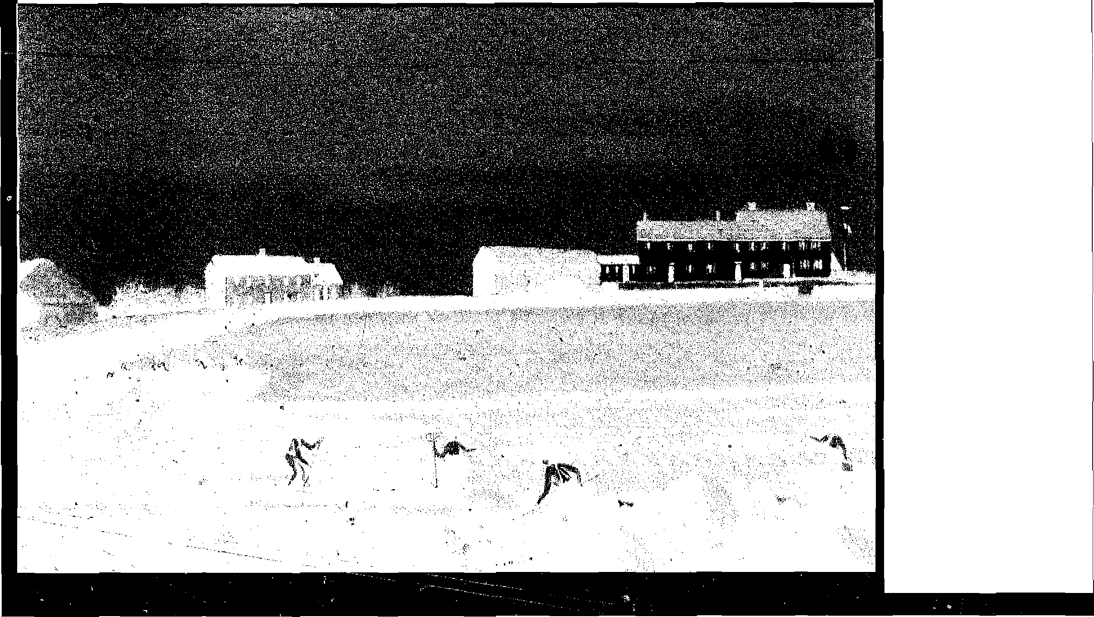
50 The Scythe Book
ment, cannot rent it in the suburbs, and cannot hire it from the larger farmer, who needs it at the same season.
Hay is cut first in the spring when the leaves are green, juicy, and full of protein, and when the fiber content of the plant is low. The digestibility and worth of the hay is at its highest quite early--May 15 in Vermont and earlier further south. Every day after this date digestibility decreases by half of a percent, as the proportion of protein to fiber decreases. Later on there is more quantity of hay as the grasses mature, but it is actually less useful to the animais. (Hay which is harvested for the first time in August has tough brown stalks without much ieafy green: "Won't make butter, but in keep `cm alive," as one dairy farmer said.)
The reason mechanized farmers often wait until June and July to cut hay is that the weather has not settled and the fields are too wet for heavy equipment. When mowing by hand, however, there is no danger of getting stuck in the wet spots. Furthermore, grasses at the peak of nutritive value are more succulent and easier to mow than older grasses. An early first cut lets the grays grow back for equally fine second and third cuts later in the summer (even more further south). These second cuttings (rowen or aftergrass) are very popular with the animais.
A scythe is also more versatile than a rrechanical mower along the edges and in the corners of the field. In many New England hayfields the treeline has crept onto the field, leaving the stonewall boundary ten or twenty yards back into the young forest. Tractor-drawn mowers are not designed to cut to the very edge. The scythe is more maneuverable and precise, and can mow in corners and close along watts. For very large fields, it could be used for margin-trimming in conjunction with the machines.
One thing harvested along the field's edge is small one-yearold trees. Having observed that ail grazing animais spend so much time eating the leaves from the trees at the edge of the pasture, the authors of Bio-Dynarnic Agriculture suggest adding a "leaf hay" to the daily feed ration as an added resource. So the
Mowing Hay 51
scythe's trimmings along the field's edge are a boon to the hay.²°
Historians report a greater diversity of plants and flowers in centuries past in the meadows used for hay and pasture. "Biological" farmers strive for a similar diversity, in contrast to the one or two kinds of plant found in the hayfields of modern largescale agriculture. One popular seed mixture from England for permanent pasture or hayfield contains nineteen different plants:²¹
'2 lb. Danish Roskilde Cocksfoot or Orchard grass (Daetylis glomerata)
3 lb. Aberystwyth S. 143 Cocksfoot (Dactylis glomerata)
3 lb. Aberystwyth S. 26 Cocksfoot (Daetylis glomerata)
2 lb. Danish Meadow Fescue (Festuca pratensis)
I lb. Alta American Tall Fescue (Festuca elatior)
¹/₂ lb. Rough Stalked Meadow Grass (Poa trivialis)
V_{I} lb. Smooth Stalked Meadow Grass (Poa pratensis)
4 lb. R. V. P. Italian Ryegrass (Lolium italicum)
7 lb. Reveille Tetraploid Perrenial Ryegrass (Lolium perenne)
th lb. Canadian Climax Timothy (Phleum pratense)
2 lb. Grasslands Huia White Clover (Trifolium repens)
1V₂ lb. Alsike Clover (Trifoliurn hybridurn)
1 lb. Altaswede Red Clover ( Trifolium pratense perenne) l/2 lb. Kent Wild White Claver ( Trifolium repens silvetre) I lb. French Chicory (Ciehorium intybus)
2 lb. Burnet (Poterium sanguisorba)
I lb. Sheeps Parsley ( Petroselinum sativum)
'/₂ lb. Ribgrass (Plantago lanceolata) ¹/₄ lb. Yarrow (Achillea millefolium)
33 lb. per acre
The last Pive of these hayfield plants are herbs, sown in small quantities to provide a different sort of nutritional resource for the animals.²² This is in fact the reason for including such a variety of seeds: from year to year and from week to week in each season, one or another plant will find the conditions in which it will thrive using the soif to the maximum benefit of the animais that feed on it. Herbal hay is not only for ruminants such as cows and goats. For raising poultry, an ounce of varied greenstuff per
52 The Scythe Book
chicken per day is the secret of absence of disease and healthy laying.²³
The scythe mower has a final reward. The cut ends of each type of grass have their own unique perfume to add to the enjoyment of diversity.
MAKING THE HAY
My long scythe whispered and left the hay to make.
—Robert Frost "Mowing," 1913
An acre was regarded as the equivalent of a day's mowing. However, some could mow two acres a day without arising too early. An Engiish legend is a man who, on a bet, mowed over five acres in one day; he used two scythes and employed a helper to whet the scythe not being used.
These measurements are relative to the type of "acre" being used. Our current acre contains 43,560 square feet; but the old Scottish acre was 1.27 of our acres, the old Irish acre was 1.62 acres, the old Cheshire acre was 2.12 acres, and several measures from Eastern Europe measure 1.42 acres. Each one may originally have related to the area mowed in a day.
The serious mowers would begin at four in the morning, when they could hardly see to whet their blades. The early morning dew gave the grass greater weight and inertia; it was less likely to bend than to be cut. Ease of cutting is not the only reason to cut low: for hay or mulch, there is more quantity in each stalk nearer the ground. Thus the saying, "An inch at the bottom is worth two at the top."
In England an attachment was used to improve the delivery of the cut grass to the windrow. Called a "grass nail," it was a stiff piece of wire connecting a hole in the beard with a hole three inches up the snath just higher than the tang. Another attach-
Mowing Hay 53
ment used in different parts of Europe was a small semicircular bow with a four-inch radius attached to the base of the snath and rising perpendicularly to the line of the blade (much like the large bow cradle in Figure 26).²⁴
Hay has been dried in a variety of ways. In one tradition, boys and girls followed the mower, strewing the freshly cut grass alternately with each hand over the opposite shoulder to lay it as lightly as possible. They rame back with a hayfork to turn it again, exposing different surfaces to sun and wind, In Austria I observed the use of saplings with several branch stubs left. These eight-foot poles, called heinzen, were stuck in the ground, and the hay was draped around them using the branch stubs as books. Also in Europe, footcocks or small haystacks are made, sometimes on a tripod and platform to let air into the center. Three poles lashed at the top keep the hay up off the ground for better drying; such a tripod is shown in the background of Figure 20. The grass on the surface is combed with a rake so that rain is deflected from the bulk of the grass while it slowly dries. On small farms in the mountainous areas of Scandinavia, horizontal wires are rigged between support poles and the grass is hung up as on a clothsline.
Rain is not only a nuisance because it prolongs drying Lime; it can actually leach away nutrients from the surface of the plants. "He shall corne down like the rain upon the mown grass" (Psalms, 72:6). If rain threatens, it is best to gather up the windrows of drying hay into a large stack, and cover the stack. After the ground has dried, spread the hay out again. Or bring the hay under cover in a ventilated area and let it dry more slowly there before stacking it in storage.
The purpose of drying the grass is to preserve it. If it is too wet bacteria will rot and ruin it. The rotting also builds up a great deal of heat, and through history has caused the burning of many a barn. However, when they are too dry the very leafy crops such as alfalfa (lucerne), the clovers, and herbs will pulver-
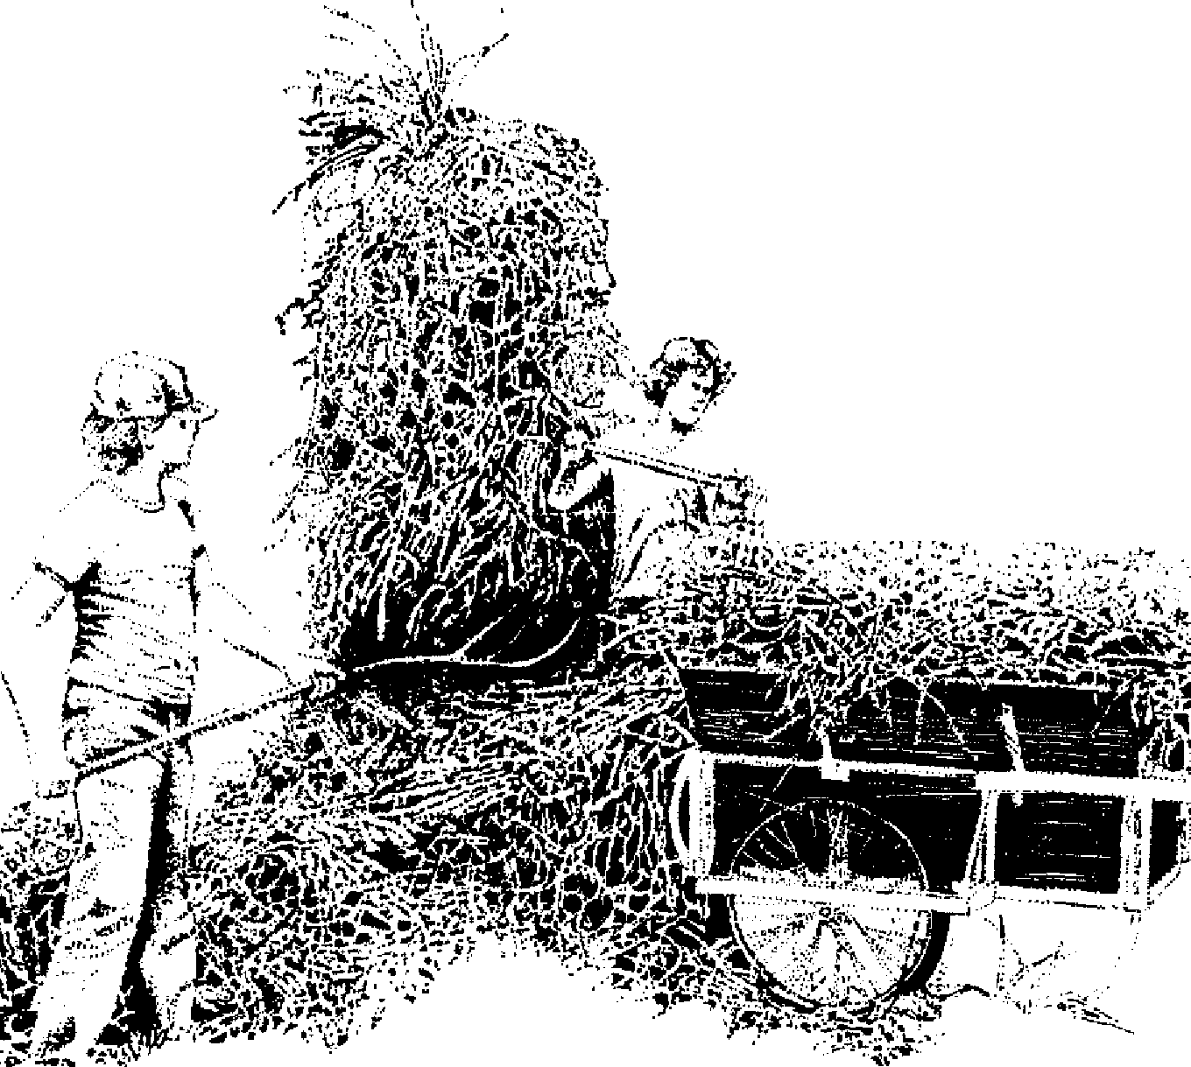

ize in handling and be left in the field or on the way to the place of storage.
54 The Scythe Book
20. Making hay.
.4/•;,4" 4.s! •
When old-timers smelled the hay's deliciously heavy perfume in the field, they knew it was dry enough, and they snatched it up so it would Jose no more of its essences. If left too long in the sun, the hay becomes light yellow, sometimes bleached almost white. The best hay is dry enough to rustle when picked up, but is blue green. The optimum range of moisture is 16-24 percent, but there is no way to know what the percentage of moisture in hay is without an expensive testing device. Finding the point where it as dry as possible without being brittle is learned with a few trials. If the hay has 30-40 percent moisture, there is a fire hazard; a temperature over 180 degrees Fahrenheit is critical, and the hay should be spread apart or removed from the barn.
Hornes Complete Grazier (1830) gives a hay-making sched-
Mowing Hay 55
ule designed for areas of unsettled weather. On the first day, the grass must be mown before vine in the morning. Then it is tedded or spread, every lump shaken out to expose the maximum surface area to sun and wind. Then it is turned again. In the afternoon it is raked into windrows and lastly into grass-cocks. The cocks, or little piles of grass, are combed on the outside to lead any rain away from the center. On the second day, the grass-cocks are pulled apart into staddles, then turned twice in the day, alternating with the tending of the grass newly mown that day. Then the first day's grass is again raked into cocks a Little larger than before. On the third day, the grass is raked out into staddles and turned; if not dry enough to carry to the barn, it is raked into great-cocks until the next day. And so forth. Horne is accurate when he estimates that the work of twenty haymakers is needed for that of four mowers in areas where the drying is slow. Clarence Danhof estimated that in ideal conditions the work of tedding and raking took a half day for every day of mowing. Francis Alexander's painting of haymaking in South-bridge, Massachusetts, in 1822 (Figure 19) shows four mowers, three rakers, one cart loader, and one person carrying refreshment to the field.²⁵
This working and reworking of the same piece of ground can lead to the sort of intimacy which Andrew Marveil described in 1681:
I am the Mower Damon, known Through ail the Meadows I have mown. On me the Morn her dew distilis Before her darling Daflodills And, if at Noon my toit me heat, The Sun himself licks off my Sweat. White, going home, the Ev'ning sweet In eowslip-water bathes my feet.²⁶
Going over the same piece of land again and again, learning where the obstructions are hidden, where the grass grows well and where poorly, is the original meaning of being the best in your field.
TOOLS FOR MAKING HAY
56 The Scythe Book
We shook the hay on our forks, whisking and whirling it shred from shred, scooping up more from the ground while that which was fast on our forks was still falling, so that a continuous windy curtain of hay billowed before us.
—Adrian Bell
¹;unrise te Sumer. 1944
Corne, lads, let us be merry and all of one mind.
And then we will expose the hay unto the Sun and Wynd. —"The M onths of the Year"
Nineteenth-century English song
On a small scale, the handling of hay requires a hayfork, hayrake, and some sort of conveyance (Figures 20 and 21). Hayforks were once forked sticks made from saplings which had grown into the right shape. Now forks are commonly available with three metal tines, which I find very useful in the barn or hay shed for pitching piles of hay from floor to loft and back again. In the field, however, I find a wooden hayfork, fashioned by hand along the grain of a single piece of hardwood, to be a more dependable tool. I can slide the blunter wooden tines along the ground and underneath the grasses I am trying to gather. The wooden fork is also wider than the metal one. Not everybody agrees; an elderly neighbor hayed as a boy one whole summer to receive twenty-five cents and a coveted two-pronged metal hayfork as his entire pay.
For tedding, the fork Hicks the hay this way and that to fluffit up and fil it with air. For loading, the fork draws together the withered leaves and compresses the air out of them. To pick up stray wisps of grass, the fork is best used, not as a rake, but in a stirring motion to tangle the pieces of grass together.
Bull, buck, or drag rakes, occasionally four to five feet in width, were pulled along the ground to clean up the extra grass.
0 . 0⁻⁷⁷⁷;5707
HAND CARVED RAKE from Denmark
BULL or DRAG RAKE
-60" —
HAY PINS
-0
FORKS
^{/1}Ns.
_{fi}g
_{3Q}»
4' RAKE sapling metal ri yen
(after Braeghel) 3 sine 3 tine
21. Haying equipment.
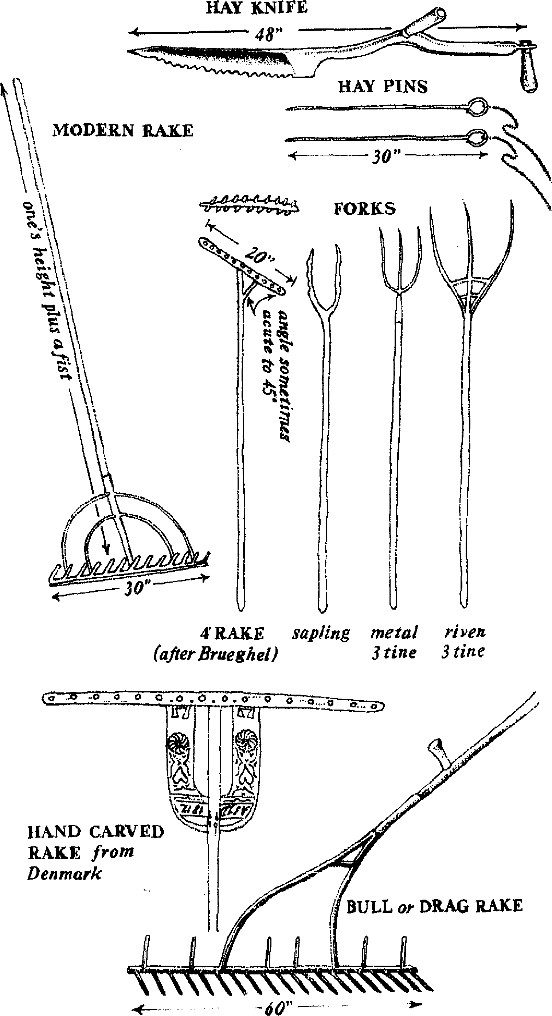
58 The Scythe Book
Rakes varied in their overall width, in the length of the wooden teeth, in the length of the handle, and the direction in which the teeth pointed depending on the terrain and type of grass. One type of rake has teeth pointing both up and down from the rake head, which attaches to the handle at a forty-five degree angle; by turning the rake over you can push the grass to one side or another into windrows rather than into a heap at your feet.²⁷ Another type is attached to the belt and dragged in that way. A long-handled hayrake 21/2-feet wide, with fourteen teeth and a well-braced connection between head and handle, is still available, and is adequate for the job of cleaning the field. h is also easier to transport than some of the bigger bull rakes.
The best way to hold a hayrake can be observed in Brueghel's painting "Haymaking," as well as on ancient Egyptian scrolls: the thumb of the upper hand points up the pole white the thumb of the lower hand usually points down. In this way, the rake is not drawn across the ground where it might get tangled in the grass and break a tooth. Like a comb, the rake draws the cut grass up and oui of the stubble.
If a tooth is broken, the broken stub must be drilled out and a new dowel of hardwood set it its place. Stronger replacement teeth can be made by hand, cleaving along the grain. In rake teeth or wooden pitchforks, hand cleaving exposes less end-grain to the weather than does a saw, and makes the tool much more d urable.²⁸
Light vehicles for moving hay were common when power was provided by the draft animal. Modern motorized equipment is often not available, too heavy for a moist field in the spring, or unable to get to a certain place. Most garden and farm carts available in the United States have an unprotected space between the wheels and the body of the cart; when the grass fails into this area, it fouis the wheels. One sturdy cart design has detachable flare boards (also traditionally called "cart ladders"), which protect the vulnerable area between body and wheel and functionally increase the volume of the cart threefold.29
Mowing Hay 59
Since volume, and not weight, is the problem in transporting hay, the load can be increased even further with the use of hay-pins, long thin metal rods which, like hairpins, were stuck down into the hay to hold the top of the load fixed to the grass beneath it, These pins must have eyes with strings attached for pulling them out of the load. Have you ever wondered how the missing needle in a haystack got there in the first place? These are the rïeedles, and they must be retrieved for the next load of hay.
When loading a larger cart or truck, set each forkful of hay in a circle at the edge of the hay bed. Make the circle smaller as the load gets bigger, so the bulk of the hay tilts toward the center. Often there is a helper on the growing pile who sets the forkfuls in the best place for a large and stable load. At the barn the sanie person should take the forkfuls apart in the very same order in which the load was made.
When loose hay is forked into the hayloft or haymow, it naturally settles over time; some farmers encourage this by walking on it to exclude the air and thus better preserve the dehydrated greens. When the hay is compacted, it can only be taken out the way it was put in, a forkful at a time from the top. Long two-handled hayknives can be used to make vertical ruts in the hay to get to it from the side or to make exact divisions. In 1939, eighty-six percent of the hay cut in the United States was put up loose, so it is still within the memory of living farmers.
MOWING IN TEAMS
A scythe-sweep, and a scythe-sweep, We mow the claie together.
William Ailingham The Mo vers, 1865
The mowers arrange themselves at intervals along the edge of the field. The best among them begins the cutting in a relaxed rhythm which will quicken as the day wears on. Each in turn follows a few strokes later, mowing one swath to the right of his
60 The Scythe Book
fellow and leaving the grass to the left in even rows. The team progresses around the field in a clockwise direction, each lap shorter than the last (Figure 22). At the very end, the outside edge of the field is carefully trimmed in a counterclockwise direction, throwing the grass into the field. Teams of three and four were a common sight in Britain at the turn of the century, and still can be seen in the high hills of centrai and eastern Europe. Levin in Anna Karenina mowed in a team of forty-two. What ground they must have covered in a day! In some areas farmers preferred to mow in teams with fellow farmers, moving from one neighboring farm to another.³⁰
Some accounts speak of putting the best mower first to set a moderate but constant pace; the other mowers are compelled to keep up. Other accounts show the best mower put at the end of the row; the tickling sensation in the heels of the mowers in front of him keeps them going through the moments when they feel like pausing for a little conversation and rest. Even though some written accounts refer to the times when the mower behind yells, "Watch out, or I'll cut your legs off!", on the whole these teammates were well coordinated and quite used to working together. Making mowing a competitive match is unfair to beginners and usually ruins both the grass and the mower's primary movement. There should be more space and more leeway among amateur teammates.
Teammates also share their common rhythm through song. Though often heard among mowers, none of these songs has been recorded, probably because they were simple ditties, half nonsense. One hint of what the songs may have sounded like is the mower's lament at the food his master was providing, muttered in time with the stroke: "Bread and tea, no good for me." If the diet was changed, the chant would be, "Ham and eggs, look out [for] your legs." The main function of these chants and charms and songs was to coordinate the breath and scythe stroke, and to "deceive the tedious time, And steal unfelt the sultry hours away,"31
ellrentrielln= le
g
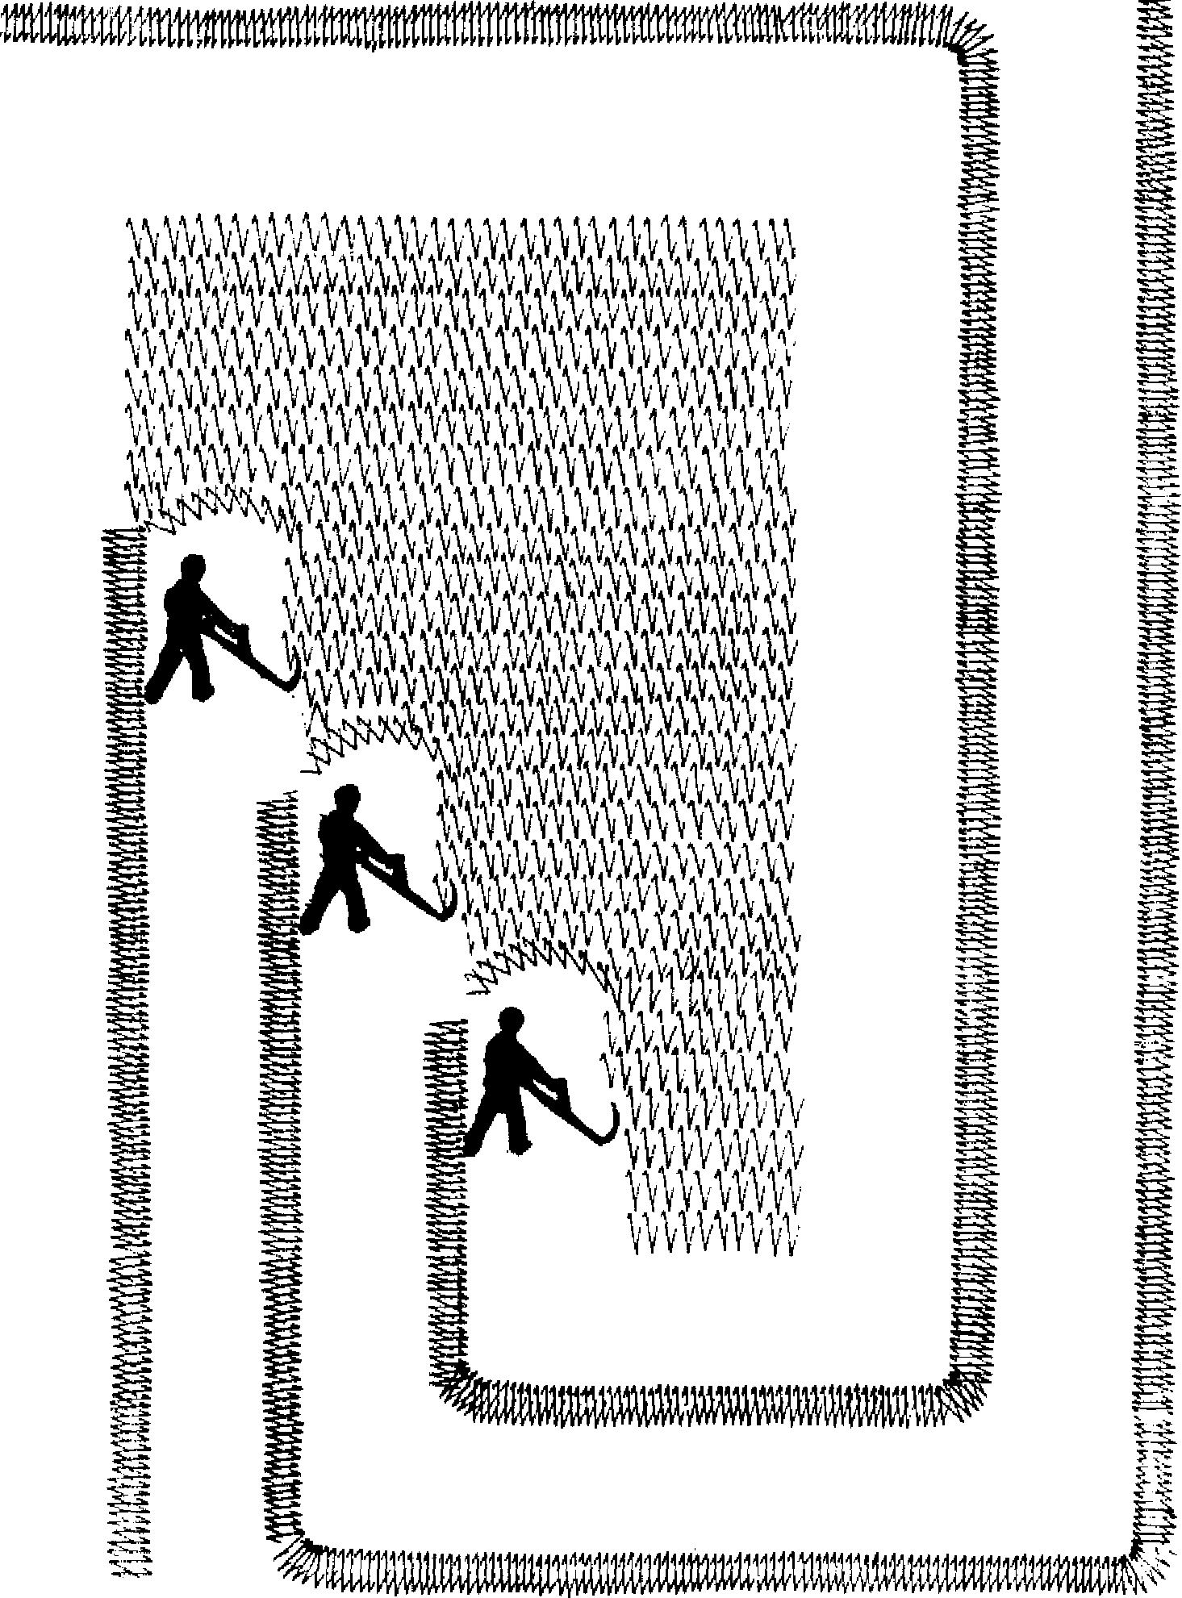
22. The progress of mowing.
62 The Scythe Book
With practice, a mower can learn to mow in relationship to the body, the tool, the grass, the earth, and the team of mowers. Many relationships of which to be aware! This expertise cannot be hurried, but must be grown into. As the separate mowing rhythms of the different mowers synchronize through experience, one can discover an intimacy of shared work that is as thrilling as the discovery of good use of the body in relationship to the grass.
HAYTIME DRINKS
Oh, let the eider flow
In plowing and in sowing-
The healthiest drink I know,
In reaping and in mowing.
—Devonshire work sceng
Mowing would begin very early in the morning and continue until about eleven. Then the mowers would break for beer, cheese, and bread, followed by a nap, work to resume two hours later.³² They might work until dark. Refreshment was the reward and the fuel, and lrishmen hired out for the haying season expected to be paid partly in beer—a forty-three gallon barrel of it for each mower. Unless they had to, mowers would avoid drinking before the midday break. But at that break!
There is the moisture he craves and a cask with a tap already inserted. Beer! His wife meets him and hands an uncorked jar. He nods briefly, draws his band across sticky, clammy lips, and lifts the familiar vessel. . . The gods must have had attractive temporal joys to offer mortals if they had better things to give them the all-absorbing ecstasy of that draught. . . .³³
Also drunk profusely at the midday break was hard cider, which had a similar alcoholic content to beer and brought on a good sleep before the afternoon mowing. Hay is usually needed
M owing H ay 63
for wintertime feeding in areas where apples grow well. Good eider is made from many diflerent kinds of apples, including a small proportion of crab apples, and is aged in oak barrels to improve its flavor. It is a wonderfully refreshing drink.
Still another popular pick-up tonie for haytime was switchel:
cup maple syrup, honey, or brown sugar
I cup apple cider vinegar
1/2 cup light molasses
I tablespoon ground gifler
I quart cold water
Combine and stir well. Makes about 6 seven-ounce glasses. Hertzberg, Vaughan and Greene, in Putting Food By, recommend switchel for modern athietes as a "good energy-restorer without promoting `cotton mouth.' ^{"34} These drinks provided one of the rewards for the very long days of labor put in at haying time. The modern mower can enjoy them, too.
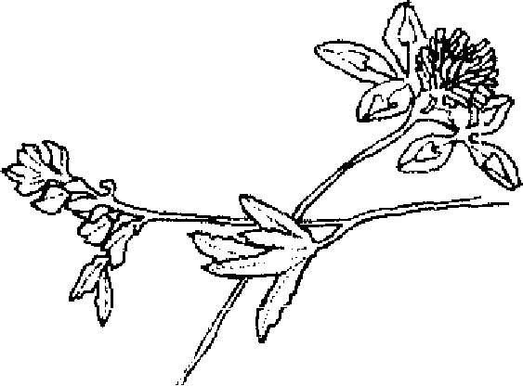
Clean Culture
Springing herbes reapt up with brasen sithes.
—Surrey's Aeneid, 1547
. every farmer mowed every bit of roadside, all
around his land. Every bit of grass was eut, around stonewalls, trees, buildings. .
—Floyd Fuller of Randolph Center, Vermont³⁵
WEEDS
If I conscientiously cut the weeds around the garden, along the roadside, and in every marginal area before they go to seed, I will slowly improve my homesite. A favorite nesting site of garden pests is removed; over the years, the legions of weeds will retreat. Every European farm, large and small, which I have visited had at least one scythe; on several highly mechanized farms, the scythe's only use was extensive trimming. Such obsessiveness is not a quaint trait of the old country. Every minute spent with the scythe in this manner is repaid double in minutes saved weeding.
When cutting weeds, the scythe must be controlled more carefully than is necessary in mowing. The strokes must be shorter and very accurate to shave around stones, trees, fente posts, a bird's nest, a flower desired to be left. I am slowly learning to use the point of the scythe to make the finest distinctions between blade of grass and the trunk of apple tree.
In "The Tuft of Flowers," Robert Frost describes his discovery of "a tall tuft of flowers beside a brook,"
64

A leaping tongue of bloom the scythe had spared Beside a reedy brook the scythe had bared.
Clean Culture 65
The mower in the dew had loved them thus, By leaving them to flourish, not for us,
Nor yet to draw one thought of ours to him, But from sheer morning gladness at the brim.³⁶
An opportunity for discrimination and observation is given with the scythe that is not available from its mechanical substitutes. Many weeds have great virtues, and when kept under control with the scythe can be more deeply appreciated. Dandelions make a fine wine, milkweed pods make excellent fritters, lamb's quarters make a very nutritious early saiad green (which gives this plant another name, "wild spinach"), goldenrod makes a simple dye for children's school projects, and so forth.³⁷
When cutting down weeds in different places around the home or farm, 1 ask the question: Why is this particular speciesgrowing here? Ehrenrend Pfeifler wrote a short pamphlet to help answer this question, entitled Weeds and What They Tell. The closeness to the earth which the scythe permits, compared with a tractor, makes identification of weeds possible. The information is available for interpretation, and may help in decisions to improve the land.
PASTURE
In pastures the nutritive and sweet-tasting plants are eaten first, then the less desirable. Finally there remain the plants that the animais won't eat. These mature, go to seed, and eventually take over. The animais eat themselves out of a food supply. Good pasture management involves not only attention to the minerai balance of the soil and periodic rests of the land in rotation, but also getting the worst plants down before they go to seed. A scythe can do this quickly, even in large fields, since the mower has more maneuverability than a tractor when going from one clump to another.
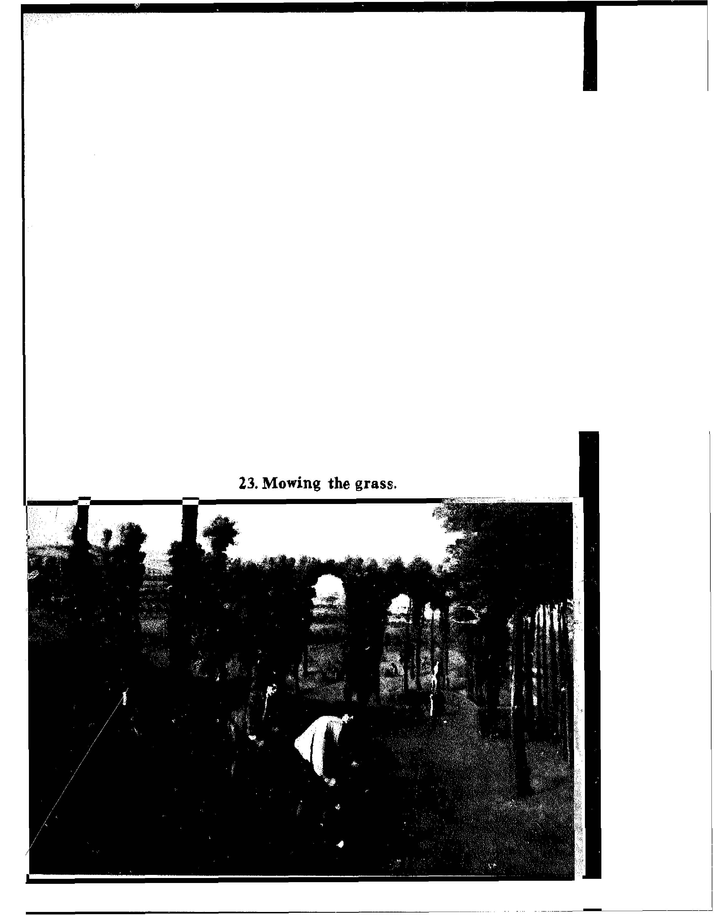

66 The Scythe Book
LAWN
The emphasis in a lawn is on what is left after the cut grasses are taken away; therefore, lawn-tending is a variation of the clean culture approach. Until the invention of the hand-pushed rotary lawn mower in 1831, ail lawns were kept trimmed by nibbling animais or by gardeners with long-bladed scythes (Figure 23). From reports of travelers, the scythe is stil! used in Greece and Turkey, and perhaps elsewhere as well, for cutting lawns. To cut my lawn of eight thousand square feet, the 70-centimeter scythe requires an hour and a quarter; a hand -pushed and a gasolinepowered mower both average about forty minutes. Considering the cost of new equipment and of maintenance, and granting myseif a reasonable wage for my labor, the scythe is economically competitive. It is also free of noise and exhaust, and free of the dangers of gasoline-powered mowers (the Consumer Product Safety Commission estimates that each year 77,000 people are
Clean Culture 67
cut or lose a finger or toe to lawnmowers). The scythe would be still more economical on a smaller scale, but not for the modern golf course.
For the border of the lawn, the new gasoline-powered scythesubstitutes feature a short nylon cord that whirls around at the end of a three-foot handle held in the hands. The whirling nylon beats the grass blades apart, resulting in bruised rather than cleanly cut leaves. The nylon also gets beaten apart, though more slowly, and is added to the lifter at the lawn's edge. I have many times observed men using these tools very effectively, as fast as they could learn to wield a scythe. I have also seen them many times attacking small tufts of weeds, passing the tool back and forth obstinately over stems that lie too flat to be bludgeoned while the operator is treated to the high whine of the machine and the billows of oily blue-gray smoke. With the scythe, I would have leaned over to pull the difficult weeds by hand, or I would have returned with an edging hoe whose blade extends straight from the handle to cut through the sod along the fine between the lawn and something else.
One situation in which the scythe and rake definitely have the edge over conventional lawn mowers is a lawn that has been neglected and grown to a hayfield. However, an article by George Taloumis entitled "Cutting a Lawn Gone to Meadow" makes no mention of the scythe. Instead, for his eight-thousand
foot backyard he hired a lawn service which used four gasolinepowered tools: self-propelled mowing machine large enough not
to be clogged by the tall grass, a nylon cord trimmer, an air rake, and a truck to h'ul them. The job required nearly four and a half hours.
Mowing the lawn by hand is easiest when the grass is heavy with morning dew. I stand with my feet wide apart to give a wide
swath, and drag the blade along the ground. To raise the height of the cut I raise my left hand during the stroke still letting the blade drag on the ground. If I follow the blade with my eye, I can see it moving through the grass in a way which is obscured in the
68 The Scythe Book
hayfield; it looks like a fish speeding through water seen from above the surface.
The scythe leaves the lawn grasses in windrows which must be raked up, or more traditionally swept up with a besom of tree branches. In August these are the greenest and most succulent grasses on the farm, and I feed them to the animais as "green chop." At the end of the season, I am relieved of the chore of thatching the lawn—that is, raking it firmly to pull out the dead grass cuttings left by the power or hand-pushed lawnmowers. However, hiilocks in the lawn are frustrating to the scythe, and I am drawn to the extra task of rolling the lawn in the spring to make it more even.
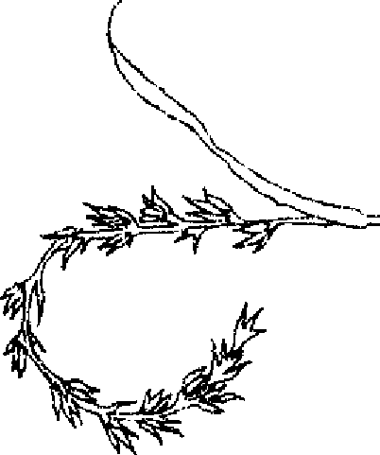
Harvesting Small Grains
Sowing in the morning, sowing seeds of kindness, Sowing in the noontide and the dewy eve;
Waiting for the harvest, and the time of reaping,
We shah! corne rejoieing, bringing in the sheaves.
—George Minor and Knowles Shaw
Nineteenth-century hymn,,
FROM STUDIES of the modern American diet, it seems many people have forgotten an axiom known to agricultural man until just one generation ago: Bread is the staff of life. Bread in ail its forms—from pancakes to hardtack to croissants—is grain made edible. While many of our children know grains only in the form of sugared breakfast cereals and hamburger buns, l'amers not long ago were familiar with a diversity of grains which they used for specific purposes. They knew what was best to eat for themselves and their animais under certain workloads and in certain weather conditions. And they knew what was best for brewing.
The modern gardener or small farmer can easily raise a small quantity of grains for his or her own table. It is worth a try. With an expenditure of a couple of hours, on a good patch of soif 38 feet square, you can grow a bushel of wheat, which will make 1792 four-inch pancakes (at the rate of 30 bushels/ acre). Other sections for rye, oats, barley, buckwheat, and so on add different tastes and different experiences. By becoming familiar with the different sorts of nutrition these grains offer the body, you can make a link with the heritage of agricultural use of the land leading back into Neolithic times, ten thousand years ago.³⁹ Mahatma Gandhi added a moral dimension to growing one's own: he insisted that each perron should contribute a portion of his or her labor to his or her own sustenance; he called it "bread labor."
69
70 The Scythe Book
Ever since grains (which are also of the Gramineae or grass family) have been harvested, a scythe-like tool has been used, that is, a tool with a cutting e;dge of stone or metal attached at a right angle to the handle. Europeans, who call the local grain of any ares "corn," discovered a very different sort of corn cultivated in the American continent. They called this "Indian corn" "maize." It is the only grain crop that cannot be harvested with a scythe, although the traditional "[Indian] corn knife" is a very sharp twelve-inch blade hafted at a right angle to a short wooden handle.
This section first gives a brief history of harvesting tools for small grains, then a description of how small grains are produced, and finally a brief illustration of some old and new harvest customs.⁴⁰
THE SCYTHE AND 1TS PREDECESSORS
At first, grains were harvested by pulling the whole plant up by the roots, or the kernels were knocked off into a basket. Early cutting tools were animal jawbones with sharp chips of flint stuck in where the teeth had been, or crooks of wood, also with flint chips. These designs all used the idea of a hook—the tool was passed in behind the standing grasses and jerkud towards the body. Early bronze sickles were also hafted at a right angle to a handle of wood or bone. The blade was eventually made to curve back to the right, and then was continued in a long curve to the point at the left. Thus the weight of the tool was evenly balanced and the wrist was less strained after wielding the sickle accurately hour upon hour.
A short-handled scythe held with one hand permitted the reaper to work white standing erect. When using a sickle, the reaper's left hand grabbed bunches of straw to be cut. With the short-handled scythe, the left hand was extended with a short
24. Ancieut and modern harvesting implements, drawn to s cale.
«

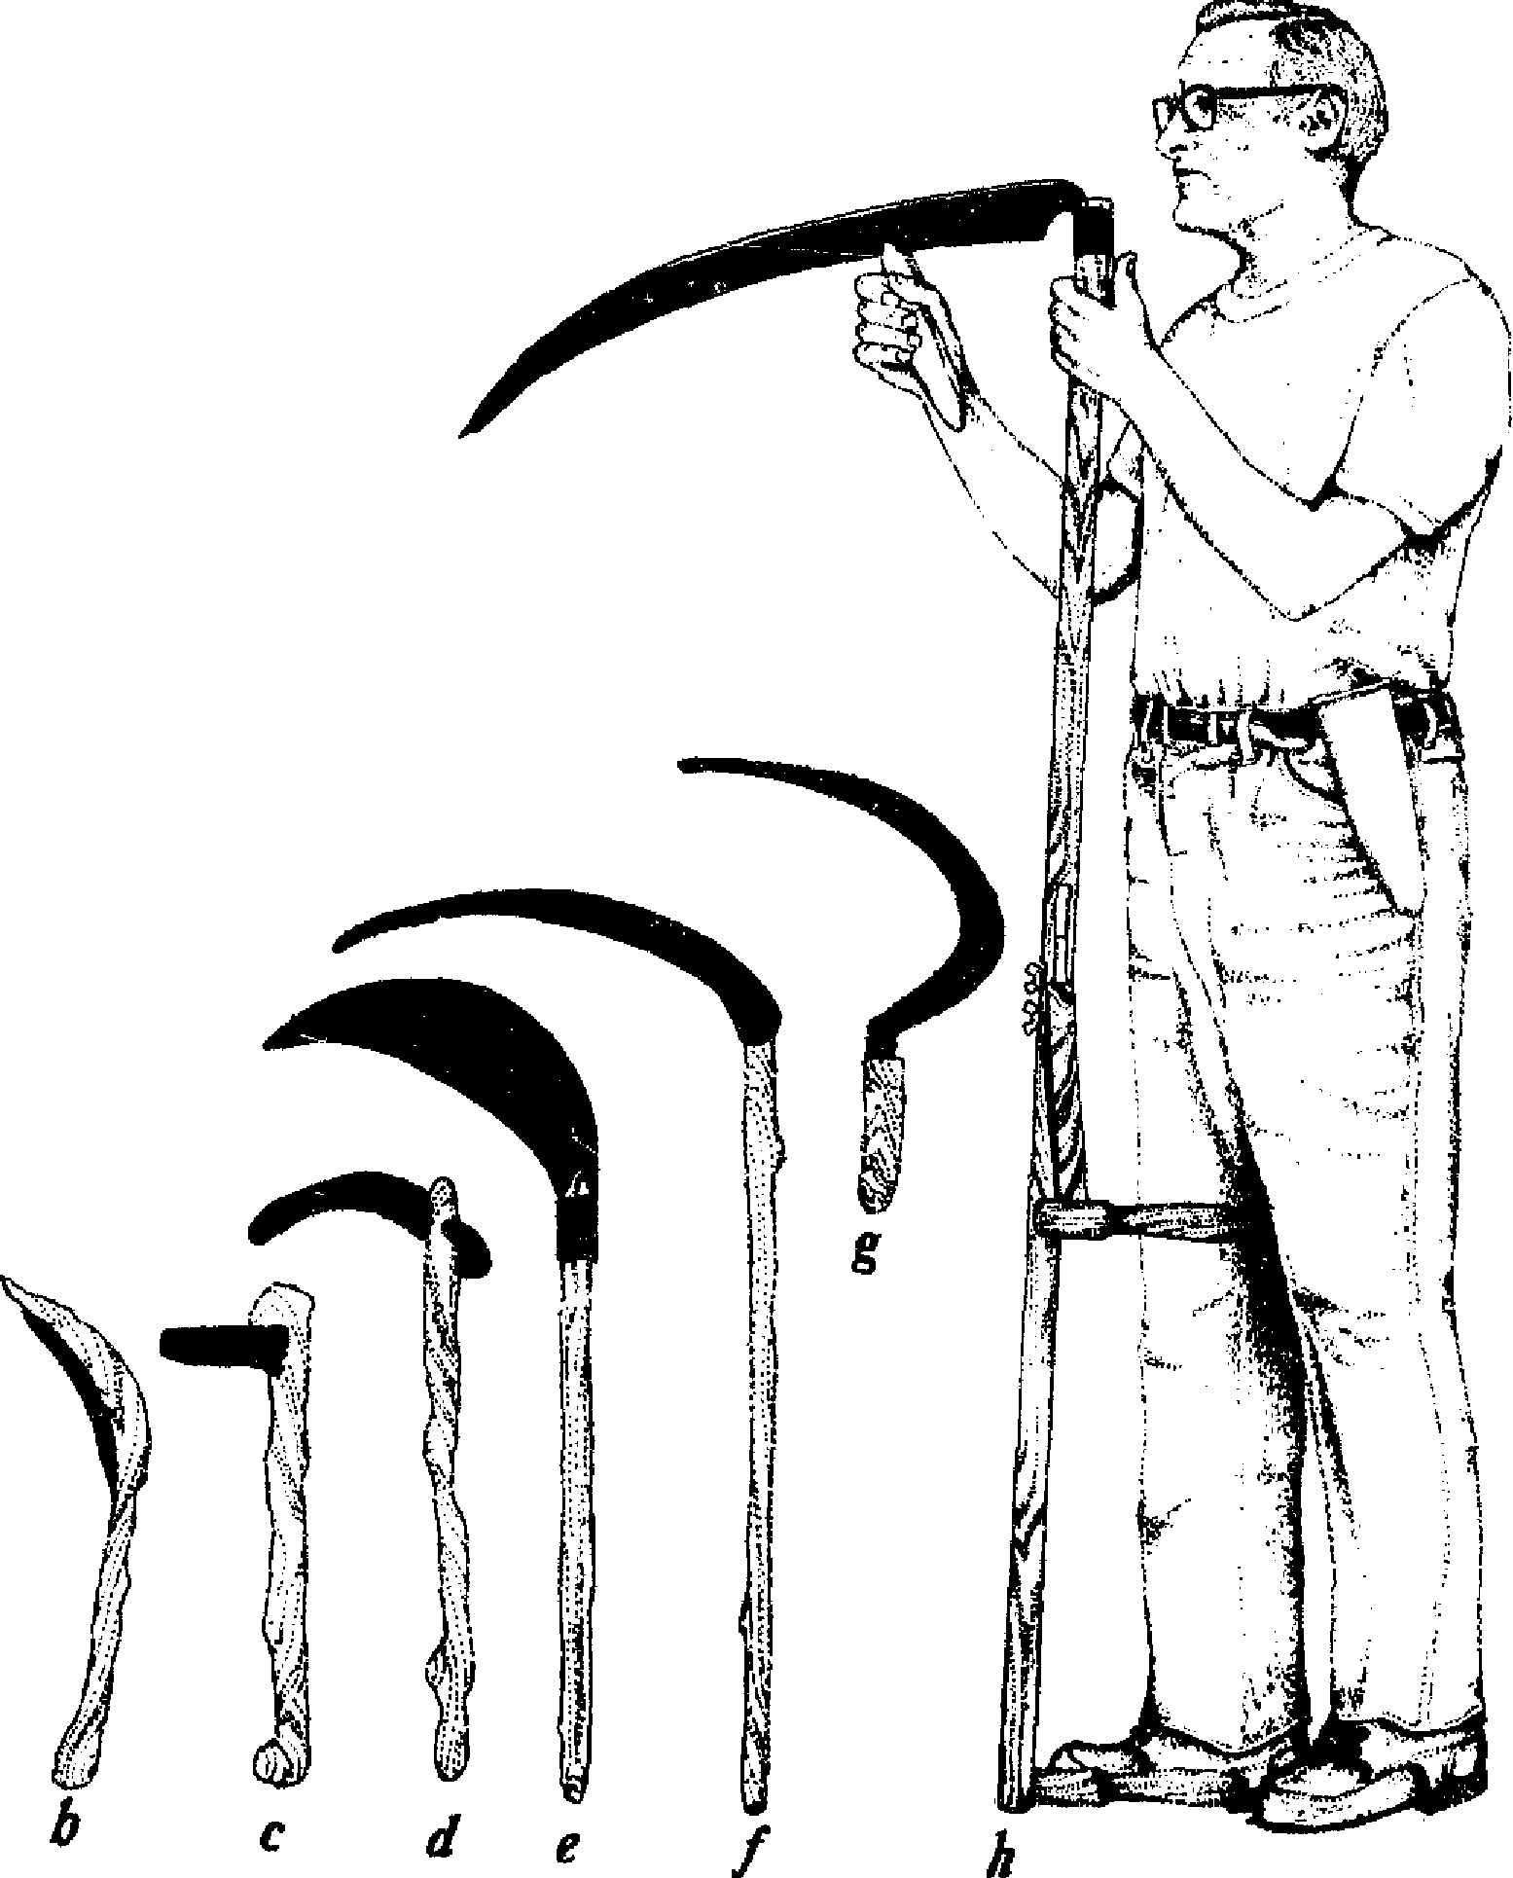
72 The Scythe Book
wooden crook to draw the cut grain out of the field as it fell to the scythes stroke. An easily accessible illustration of this method can be found in the famous fifteenth-century Très Riches Heures of Jean, Duke of Berry.
The Hainault, or Flemish, type of short-handled scythe had a blade over two feet long, and a snath fourteen inches long with a delicately carved hand-grip at right angles to the snath. The wooden crook, or mathook, was also carefully shaped ta fit the hand. Stephens (The Book of the Farm) estimated that this scythe saved 25 percent of the work compared to the sickle. However, the Flemish scythe was much more dangerous to the operator than the long-handled scythe hetd_in hoth hands. JohnGerard, in his seventeenth-century Herball, recorded an accident wherein the mower
made a wound to the bones, and withall very large and wide, and also with great effusion of blood; the poore man crept upon this herbe (Clownes Wound wort or All-heale), which he bruised with his bands, and tied a great quantity of it unto the wound with a piece of bis shirt, which presently stanched the bleeding, and ceased the paine, insomuch that the poore man presently went to his dayes work againe, and so did from day to day, without resting one day until he was perfectly whole, which was accomplished in a few dayes.
The Flemish scythe was widely used in th2 Dutch settlements in the Hudson, Mohawk, and Schoharie valleys of New York.⁴'
lt was in the undermanned Roman estates in Gaul, where greater efficiency was required in the harvest season, that the long-handled scythe was developed, originally longer than the scythe we know today, and without grips. Scythes with one grip first appear in illustrations from the twelfth century; this design enabled the mower to swing the full stretch of his arms, and thereby to increase the width of the swath. Later two grips appeared in most localities, further increasing the tool's efficiency.
Harvesting Small Grains 73
In an analysis of probate inventories and wills, Georges Duby found that most medieval European farmers had a single scythe, often as their only metal implement. In the fourteenth century, Duby reports that a scythe in Haute Provence was worth a fortune. A presentation of probate records by John Roper shows that scythes were ais° valuable in sixteenth-century England. By comparing the appraised values for scythes and other items in the probate inventories, such as horses, swine, and heifers, and comparing with modern prices for the same farm animais, we can guess that a scythe blade at one shilling in sixteenth-century England was worth about $87 in 1981 United States currency. The expense was one reason why it was not until the eighteenth century that the long-handled scythe became the universal reaping tool in the Western world.
Despite advances in the efficiency of scythe design, when workers were unskilled and slow, or when the mature grain had blown over in strong wind and heavy rain, the farmer preferred to use sickles sine it was more difficult to damage the crop with sickles. In some areas, the tradition persisted to harvest wheat and barley with the sickle, oats and rye with the scythe.

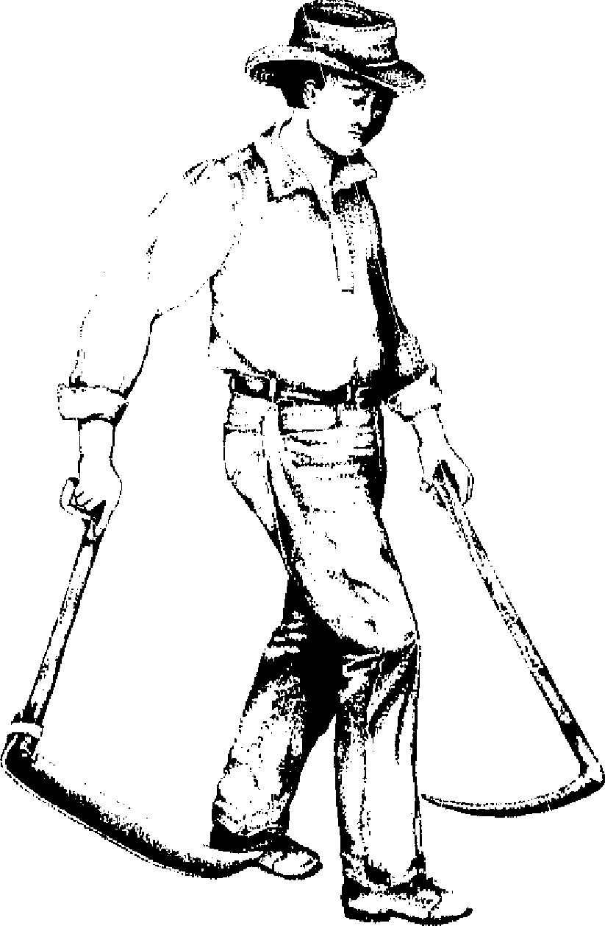
25. Fientish scythe and reaping hook.

74 The Scythe Book
CRADLE SCYTHES
They use a greater Sythe with a long Snath,
and fenced with a crooked frame of stickes,
wherewith with both hands they cut downe the Corne, and lay it in Swathes.
—Conrad Heresbach
Foure Bookes of Husbandrie, 1577
The most elaborate and most beautiful invention for laying out grain more neatly to the side in scything is the grain cradle. According to thorough research by Jared Van Wagenen it was invented in New England in 1776.⁴² h was really a completeiy different tool, quite like a scythe in principle, but with a rack of three to five wooden tines curved to follow the shape of the blade ( Figure 26). At the end of the stroke, the straws would be bunched together and supported by the tines. The cradler would then tilt the whole thing to the left and let the cut grain slide out in a neat bundle. In the middle of the nineteenth century there were a million cradle scythes being used in the northeast United States alone; they have been used in the small fields of hilly areas in Appalachia and the Ozarks until quite recently.
plot all authorities agree with Van Wagenen that this cradle scythe was an American invention. Axel Steensberg daims that the cradle was developed in Scandinavia white other European authors daim different points of origin. Steensberg reported a reference in the psalter of Margrethe Skulesdatter in the beginning of the thirteenth century. He carefully analyzed the Danish probate records from the seventeenth and eighteenth centuries, and found that by 1767 cradle scythes accounted for half of all reaping and mowing implements. What Steensberg means by cradle scythe, however, is certainly a different design from that of the American cradle: a finie rake of two or three teeth attached to the scythe ring, rising all of eight inches from the
Harvesting Small Grains 75
Made, the teeth extending six to fifteen inches along the blade.⁴³
In the American cradle scythe, the craftsmen were able to raise the rack fully twenty-four inches from the blade, with the tines curved to follow the exact contour of the blade for thirty-six inches. The invention, therefore, is really a dramatic extension of an existing design. Bigger snaths and bigger cradles for a bigger country.
The American cradle scythe came in different shapes, most commonly a straight or "turkey wing" shape, and a very bent or "grapevine" shape. With the grapevine, the cradler must be quite stooped over to obtain the best angle of cut. In some localities the tradition is to balance the cradle with the right arm and left leg while the bundle of cut grain is stooped off the rack with the left hand and laid on the ground. This balancing act has always seemed to me to be a terrifie amount of work, and hardly a good use of the body. With the turkey wing model use of the body is better; the cradler stands more erect, and at the end of the stroke the cradle is tilted to the left and jerked to dump the bundle of grain onto the ground.
Directions for constructing a grain cradle attachment to an "American" scythe are given in an article by Richard Weinsteiger. There are two problems with this cradle. First, it is quite difficult to construct properly—bending the wooden tines and fitting the pieces together required experienced hands, and fine cradles were marked with their makers' names (for example, "Christian Bouck" of Minerai Springs, New York). Secondly, the cradle attachment makes the "American" scythe even heavier and more difficult to work with.
In Europe cradle-like attachments were developed for the grass scythe to make it more efficient in harvesting grain. These attachments are usually a wooden or wire bow beginning at the blade end of the snath and attaching again to the snath just below the lower grip. Thus the eut grain stalks were not "cradled" or supported along the entire length of the blade, but
LARGE RAKE, turkey wing snath
LARGE RAKE, guipe vine site,
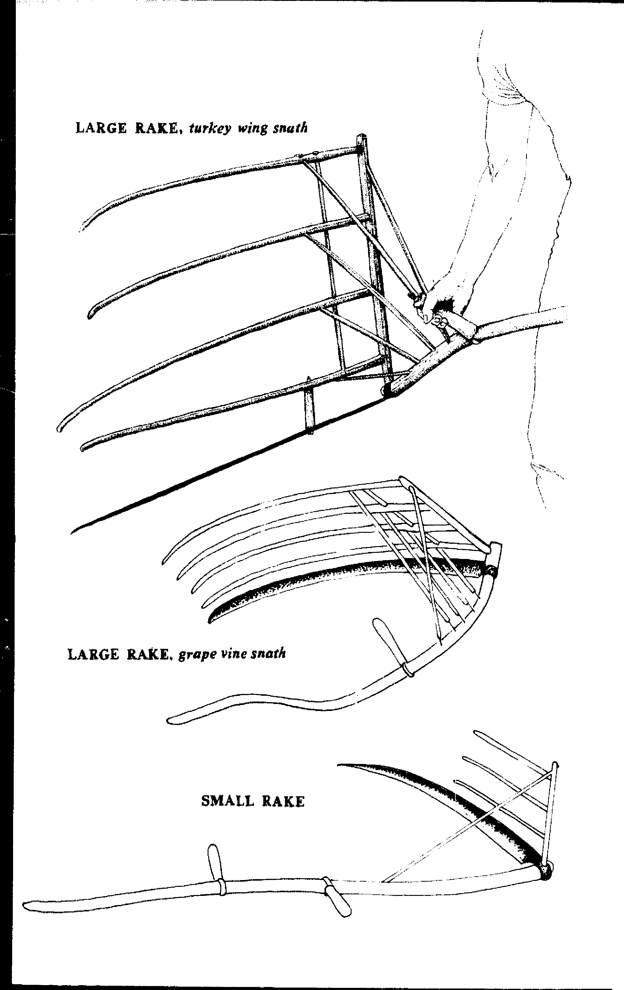
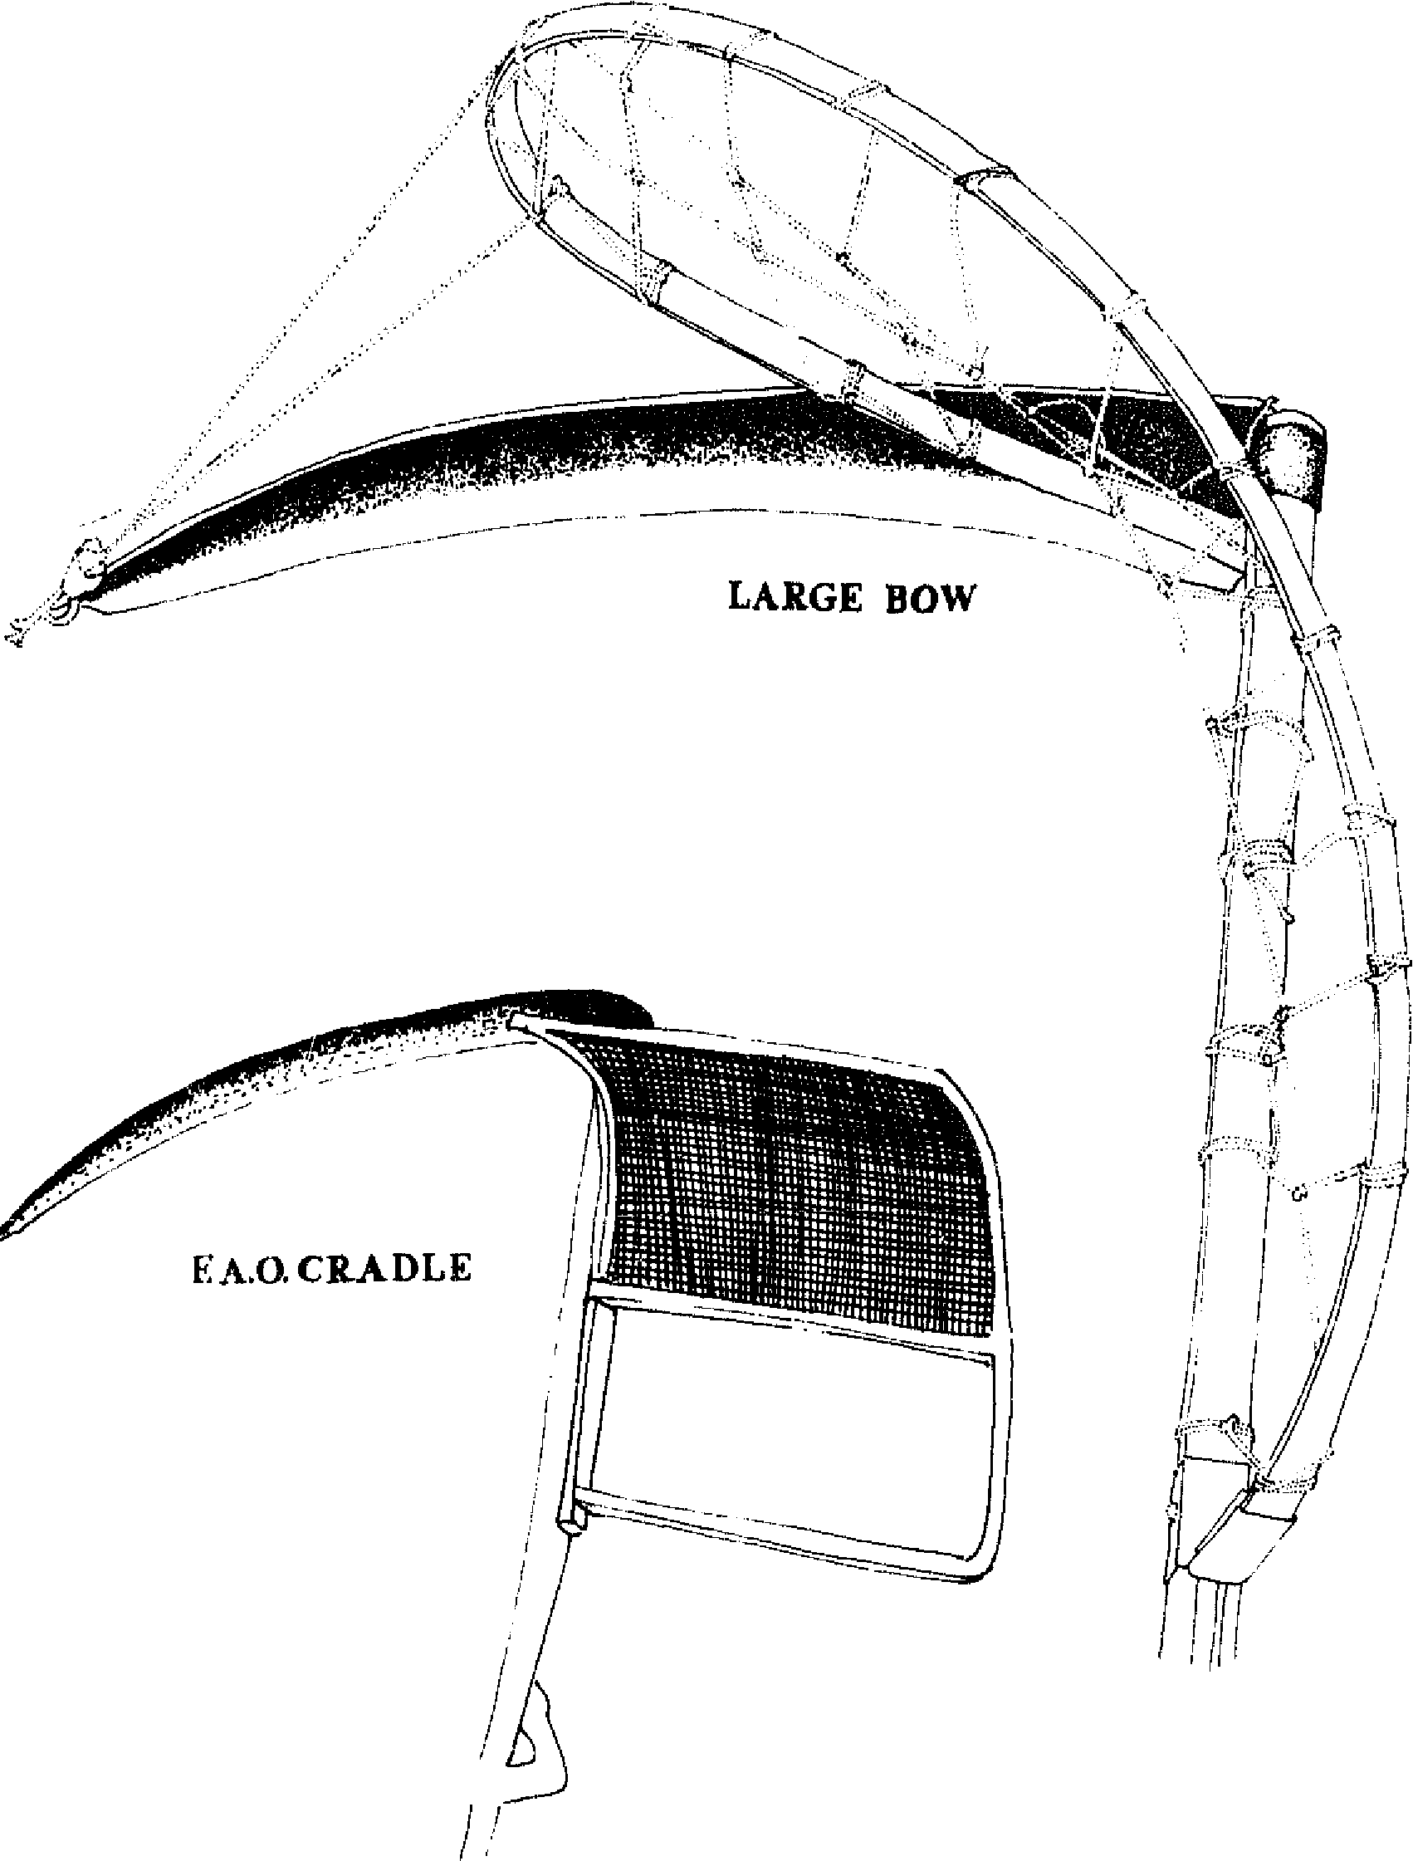
I.

26.Cradle Scythes (not drawn to scale

78 The Scythe Book
were caught toward the end by this simple framework. The attachment was light, it could be detached when not needed, and the reaper's posture could remain as erect as it was in mowing. It seems that the Lime lost in somewhat less efficient piling of the bundles of grain would be more than gained back in the more efficient use of the reaper.
Today's European-style large bow cradle, shown in Figure 26, is mailed as a straight hardwood splint with two metal fittings on each end. One fitting is slipped between the scythe ring and blade and is held there by the two set screws in the scythe ring. The other fitting is bolted through the snath just below the lowest position of the lower grip so that it points slightly away from the blade. The reaper makes a framework of strings between snath and bow to catch the grain as in a cradle and to extend the strength of the snath to the relatively flimsy bow. The shape is adjusted to match that of Figure 26, and is further adjusted to accommodate the conditions of the reaping. With the thinner gauge of the two types of bow, a support string may be needed to come forward te loop around the tip of the blade. The heavier weight bow holds its own shape, but it must be molded into that shape by steaming the wood for fifteen minutes and bending to the right curve before attaching it to the snath. For either type, when the reaping is over, the strings can be untied from the snath and the cradle stored until the next season.
Many variations of these basic designs have been found and are stiil in use. In the I 920s, the Seymour Manufacturing Company in Seymour, Indiana, offered sixteen different patterns of the American large rake grain cradle. The bow form of cradle has been found in every size, as small as a semicircle with an eight-inch radius for short grains or tall grass. It is uliclear when and where each of the different designs originated, and exactly what crop condition each variant design was trying to accommodate. Just after World War II, the Food and Agriculture Organization in Rome introduced to Third World countries a detachable cradle for a straight snath with Austrian-pattern
Harvesting Small Grains 79
blade, but the cradle was too complicated to manufacture and repair, and the emphasis in the "Green Revolution" soon came to be placed on bigger and better machinery."
CUTTING GRAIN WITH OLD AND NEW TOOLS
In his fascinating study of modern and ancient harvesting implements. Axel Steensberg performed comparative timetrials using a variety of sickles and scythes from all periods of agriculture. In August of 1938 and 1939 he cut mature barley and oats with each tool from an area 5 meters wide and 10 meters long (538 square feet). Steensberg actually counted the number of straws in each plot, and arrived at an average figure of 26,646! In Table 1 I have given brief descriptions of the tools he used and the time it took to harvest these matched plots. When Steensberg cut more than one plot, I have given the repeat times; this shows some of the variations that can occur, apparently randomly, under identical conditions.
All of the flint implements in Steensberg's tests were tools actually used over six thousand years ago, which had been dug up by archeologists. They ranged from 4¹/₂ to 7 inches in length. The Stenild flint sickle (11.6 centimeters or 4¹/2 inches long) is famous because it was recovered at Stenild in Jutland with the handle intact, and so could be copied exactly (c in Figure 24). It is dated in the early Bronze Ag, approximately six thousand years ago, since the haft showed signs of being worked by meut. The dates of the bronze implements range between 4000 BC and
1500 BC, and have edges between 6 and 8 inches long. The Roman short-handled scythe found at Uggerby at the northern tip of Denmark (e in Figure 24) is more recent, perhaps dating
from the first century before Christ; its blade is 30.5 centimeters (12 inches) long, and its handle 61 centimeters (24 inches). The Norwegian short-handled scythe, of the age of the Vikings, is more recent still, with a blade about 18 inches long and a handle
80 The Scythe Book
31 inches long, held between 18 and 22 inches from the Made (fin Figure 24).
The hafts of the tools in Steensberg's tests ranged widely:
- No haft, the blade being wrapped in cloth or hide to protect the hand (a).
- A crescent-shaped piece of wood looking like a boomerang in which the cutting edge was embedded (b).
- The "knob" type, where the bronze blade was set in the end of the handle so that a portion protruded to the other side, suggesting an early form of poil to balance the blade's weight (d).
- The Roman and Viking hafts, in which haft and blade were joined much as in modem scythes (e and f).45
In August of 1979 and 1980, I performed time-trials of four different methods of harvesting oats and barley, and have given the times, based on a plot size of fifty square meters, in Table L1 cannot be sure if there were fifty straws in each square foot, as in Steensberg's trials, since I did not count. My stand was, however, too thick with grain, and had clovers and herbs undersown, so the harvesting was probably more difficult than in Steensberg's case.
The general indications are clear enough: Improvements in design have improved performance. Some of the ancient tools are amazingly efficient for their crudity, although 1 do not know how the reaper would feel after a full day's work, since several of these implements required seven or eight strokes to cut through a handful of straws. Rating the continuous output of the human body at 1/ 20 horsepower, all the hand-tool performances produce more per unit horsepower than the machine, even in comparison with the modern 190horsepower combine, which takes twenty-four feet of standing grain in at one end, and delivers the grain threshed, cleaned, and bagged at the other end at the rate of one bushel of wheat in twenty seconds." It is important to consider, in this context, the time and energy required to maintain a hand-tool corn-

Harvesting Small Grains
Table 1. Minutes required to cut barley and oats in 50 square meters (538 square feet), using ancient and modern harvesting implements.
Steensberg's time trials: MINUTES
One-piece flint sickle: unhafted,
held in the hand (a in Figure 24) 95,76
Stenild flint sickle, single flake embedded in haft
of birch at right angle (c) 76,101
Crescent-shaped flint serrated "saw": flake set in
slightly bent piece of wood (b) 73, 59, 72
Crescent-shaped bronze serrated sickle: bronze edge
set in crescent-shaped piece of wood 65, 69
Smooth-edged "knob" bronze sickle, two types: curved fileta! blade at right angle to haft (d)

Modem balanced sickles, two types (g) 30, 31
Short-handled Roman scythe of iron, straight
24-inch handle (e) 30
Short-handled Norwegian scythe of Viking Age, straight 31-inch hancile (f)


My lime trials:
Modem serrated American sickle (g)
(Grain laid neatly by handfuls for ease in binding)
Modem scythe with "Austrian" ha mmered blade (h)
(Grain laid in slightly unaligned rows requiring more
work in binding)
Modern scythe with "Austrian" blade, European-style
cradle
(Grain laid in evenly aligned piles for case in binding)
Modern cutter bar, powered and hydraulically lifted by
gasoline-fed tractor (30 hp)
(Grain laid every which way requiring sorting and realigning
in binding)

pared to the time required to maintain a tractor or combine.

23, | 27, |  | 38
 | 6, | 6, | 9
 |  | 6, | 7

1 began two other plots with old American cradle scythes, a turkey wing and a grapevine. Both broke before the plot was finished, renewing my sense of caution with old wooden tools left to sit.

82 The Scythe Book
Others have measured the area covered by a cradle scythe. Thomas Jefferson's diaries record an average of three acres reaped a day for the cradle scythe. Stephens, in The Book of the Farm, reported 2.75 acres of wheat and 4.125 acres of barley and oats per reaper in a ten-hour day.⁴⁷ Translated to the units of barley and oats of the time-trials in Table 1, a rate of four acres in ten hours cornes to an average of two minutes per fifty square meters! The actual time necessary to reap an experimental plot must await further time-trials.
In my own experience, the Austrian-style scythe without cradle is faster than the American cradle in cutting, the latter being heavier and more cumbersome (average weight, eight pounds); the cradle, however, does leave less work for the gatherers and binders. The European-style bow cradle also leaves the grain in neat piles, but it is much lighter (average weight, four pounds) than the large rake cradle, and to my surprise, was no slower than the scythe without cradle in cutting.
SOWING, REAPING, THRESHING, WINNOWING
Sowing in the sunshine, sowing in the shadows, Fearing neither clouds nor winter's chilling breeze; By and by the harvest, and the labor ended, We shall corne rejoicing, bringing in the sheaves.
—George Minor and Knowles Shaw
Small grains are best sown in an area which has been cleaned of weeds, preferably by growing root crops in the plot the year before. You must keep the weeds out of the root crops through cultivation; the grain will benefit from this clean culture. Excess nitrogen and lack of potassium causes lodging or falling over of the grain, making harvesting difficult. A cradle cannot be used on lodged grain, and lodged grain must be harvested soon with a scythe or sickle to keep the kernels from sprouting by being too
Harvesting Small Grains 83
close to the damp earth. Lodged grain can be raked and tedded like hay.
Grain can be sown in the fall or early spring, depending on the climate and on the farming schedule. If grain is sown too late in the fall, or too early in the spring, the cold and damp soif will rot the seed before it germinates. Though higher yielding, winter wheat sown in August or September can be completely killed by a hard winter. The finest baking four with the highest gluten content to promote rising is spring-sown hard red wheat, in varieties such as Neepawa, Olaf, Manitou, Justin, and Selkirk. Barley, oats, and buckwheat are also sown early in the spring because they are not winter-hardy. Rye can be sown nearly anytime since it is very hardy and requires only a short season for growing; the saying "wheat for fat, rye for strength" may indicate more the types of people who live in short-season growing areas than the nutritional quality of the grain. The seed can be broadcast by hand from a sack, though a rotary hand-turned seeder will give more uniform results. Cross the field back and forth in one direction, then again in a direction perpendicular or diagonal to the first for best results; an acre requires an hour by this method. One hundred pounds per acre is an average seeding rate.
After sowing, the seed must be covered with soil by raking the area, to improve germination and to protect the seed from the birds. The hayrake serves here as a grading rake, and it is best to step in the raked earth while raking, because the feet press the covered seeds into the earth. For larger areas, there are machines which spread the seeds, bury them, and firm the earth all in one pass.
It is often a good idea to sow clover or alfalfa at the same time. When the grain is harvested the slower legumes will grow into autumn and give the field a protective cover through winter and a hay trop in the spring.
On the efficiency of sowing by casting the seed in all direc-
84 The Scythe Book
tions, by hand or with a whirling machine, George Fusse!! cites the parable of the sower:
Behold a sower went forth to sow; and when he sowed, some seeds fell by the wayside, and the fowls came and devoured them up; some fell upon stony places, where they had not much earth; and forthwith they sprang up because they had no deepness of earth; and when the sun was up, they were scorched; and because they had no root they withered away. And some fell among thorns; and the thorns sprang up and choked them; but others fell into good ground and brought forth fruit, some a hundred fold, some sixty fold, some thirty fold.
Fusse!! used this story as evidence for the superiority of seed drills, which plow a small furrow, drop seeds into it, cover them over, and firm the earth above.⁴⁸ If a seed drill is available, such as the old and dependable Planet Jr. row planter, the grain can be sown thickly in rows seven to twelve inches apart from each other.⁴⁹ The drill can be adjusted for seeding rate, depth of furrow, and distance between rows, all determined by expérimentation within the limits of soif and climate. The space between the rows can be cultivated or hoed once or twice in the growing season to suppress competition from weeds. Yields in row-sown plots are often better than with broadcast seed, and there is less problem of weeds in the mature grain. Row-sowing is a popular method among organic farmers in Europe. There is definitely more work involved, however, and, if a patch of land is free of weeds to begin with, I use the broadcast method, and read the parable of the sower as a parable.
In 1911, F. H. King, former Chief of the Division of Soil Management of the United States Department of Agriculture, published his memoirs of a tour of the Orient, where he found wheat grown in hills or groups averaging forty-six stalks each. The hills were twenty-four inches apart in the row, the rows were in pairs sixteen inches apart, and each pair of rows was thirty inches from the neighboring pair. The spaces in between the hills
Harvesting Small Grains 85
were hoed conscientiously after every raie to eliminate weeds, to incorporate frequently applied composted human wastes, and to create a moisture-conserving fluffy dirt mulch. King observed a harvest in drought of 12 bushels per acre, but calculated that the fine harvest of 1901 measured 116 bushels per acre.⁵⁰
When should grain be harvested? Farm books give the infuriating answer: When it's ready. Working with other farmers and
raising grains myself, 1 was surprised to find that there is no
better answer. When you press a fingernail into the kernel of
grain you are about to harvest, it shouldn't squirt out its contents
as in the "rnilk" stage. But when it is really hard it is also ready to
fall off; then the grain head shatters when the plant is eut, and all
the kernels fall irretrievably to the ground. Rub a seed head
between both palms to determine how fragile it is; chew it to determine if the kernels are at the "bard dough" stage—ready for harvest.
With either a scythe or a cradle scythe, the stroke for reaping is broader than the mowing stroke, with more hacking and less
slicing. With the cradle, the left hand is as close to the ground
through the stroke as is comfortable in order to keep the cradle
structure upright. The right hand cornes up at the end of the
swing, and the left hand drops abruptly to dump the load with
the grain heads pointing away from the uncut grain. With the
scythe, the left hand lifts abruptly at the end of the swing, thus
ending the stroke and leaving the straws together with heads
pointing toward the uncut grain. Too much swing to the left, and
the straws get mixed up. The scythe is lighter than the cradle, but
requires more control. Grain is easier to eut than hay, rince the weight of the grain heads and the height of the stem gives the plant such inertia that it has Little tendency to bend rather than be eut. In recognition of this greater ease of cutting, the Larousse Agricole for 1921 recommends adjusting the stroke and the angle of the blade to snath to regulate the depth of swath: 12-14 inches compared with 6-9 inches for hayfields and pastures.
With reaping, the support staff needs to be much larger than

86 The Scythe Book
for haying. Thomas Jefferson hired fifty-eight people to harvest his wheat in 1795:⁵¹
18 cradlers 18 binders 6 gatherers
3 loaders
6 stackers
4 carters
2 cooks
57
The fifty-eighth was the foreman or "Harvest Lord." In 1812, he recorded 15 cradlers, 15 binders, 16 gatherers (which must have included the loaders and carters), 4 stackers, and 2 cooks. The gatherers, loaders, and stackers would often be children. He describes this group as a "machine" which
would move in exact equilibrio, no part of the force could be lessened without retarding the whole, nor increased without waste of force. . . . This force would eut, bring in and stack 54 acres a day, and complete my harvest of 320 acres in 6 days.
Stephens recommended the harvest be organized in units of two scythemen (without cradles), two gatherers, two binciers, and one raker.⁵²
So it is clear that the time spent cutting grain with the scythe is only a part of the entire harvest process. Each cut of grain must be gathered together into sheaves and bound with a simple overhand knot made of two or three of the straws. The diameter of the, sheaf is limited by the length of the straw used to tie it, although old sheaf gauges used to check the sheafs size were twelve inches across. If the straws are too dry and brittle to tie, I use one or two weeds which are still green and tall from growing up at the edge of the stand of grain. Encircle the sheaf with the binder of straw or weed until the top and bottom of the binder overlap. Holding onto the very bottom of the binder, slip its top
Harvesting Small Grains 87
under its own base in a half hitch. Slide this half hitch along the base until the sheaf is bound tight. Bend the stiffer base of the binder back over the half hitch and tuck it under itself against the sheaf. A woolder for tying sheaves is a block of wood two inches square with a thirty-six inch piece of twine through a hole in the middle. One end of the twine is knotted so it is tight against the wood; the other end is wound around the sheaf and then around the twine beneath the wood block. The woolder may be reused for any binding task.⁵³
Several sheaves are stacked against each other with the grain heads up to form a stook or shock. There are traditions about how many sheaves of wheat, oats, rye, and barley make a stook, but I usually Lean eight or ten against each other. In the stook the grain heads will dry and harden in the wind and sun. With one large sheaf draped over the top of the stook, even the rain will be turned away, although if the weather beconies very wet, grain must be stacked and covered or brought into the barn. Thomas Jefferson had a large granary for every forty-acre field, where his grain did mort of its drying. Some people like to stack their grain atop a platform that is proof against rats (off the ground on mushroom-shaped stilts), grain heads to the center, and thatch the top of the big stack or cover it with plastic. Whatever method you use, slow drying in the sheaf ripens the kernels so they will store well. Modem methods include heat-drying treatments,
which often kill the germ of the grain. Taking the life away from the grain leaves no seed for next year and leaves the grain with
questionable nutritional value. On the other hand, unless you have a fleet of cats, storing the sheaves loose in the barn for too long before threshing will transfer all the nutritional value to the rodent population.
Not all the grain cooperates by falling into neat bundles as it is cut, and the field may look a mess after harvest. At ore time the
privilege to glean a farmer's fields after nar"est was much coveted because of what was left. I could go on and on picking up straws. Instead I turn the chickens or geese into the field.
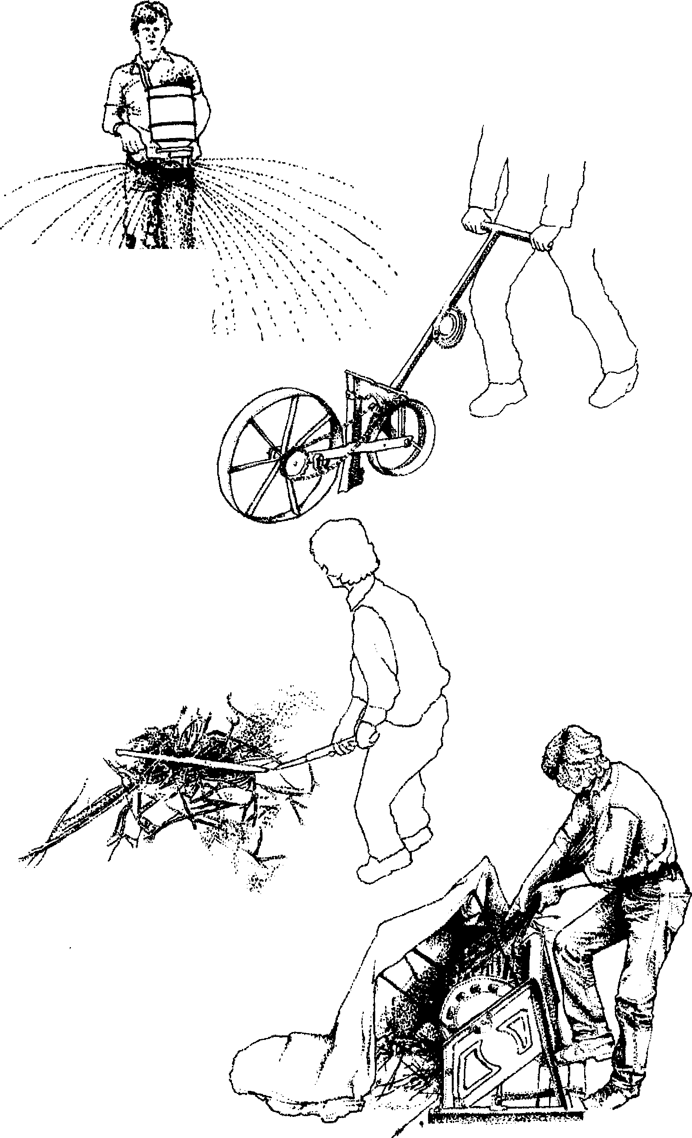
27. Tools for small grains.
;
SOWING broadcast
SOWING:seed drill
THRESHING:fiad
TITRESHING: drum
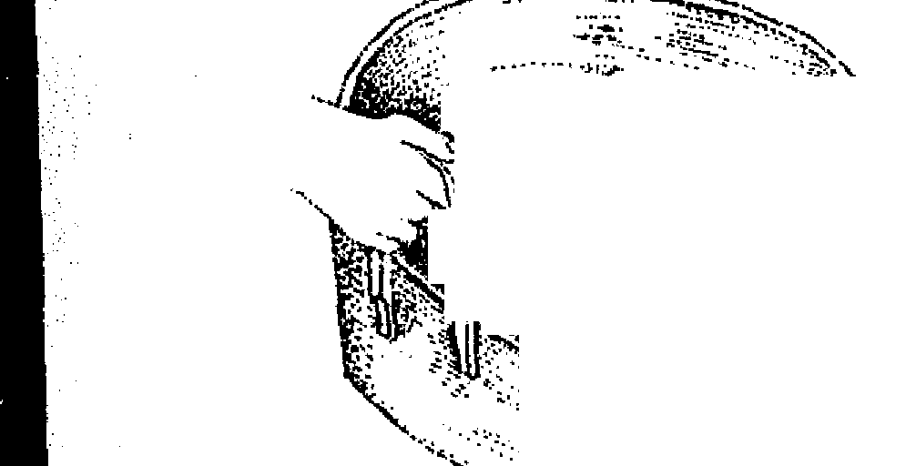

winnowing tray riddle or sieve
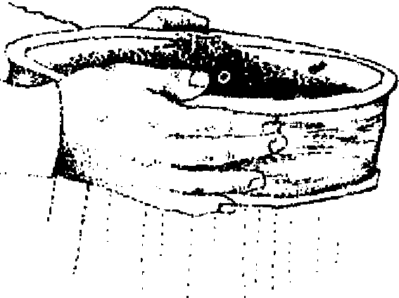

WINNOWING, CLEANING, GRADING

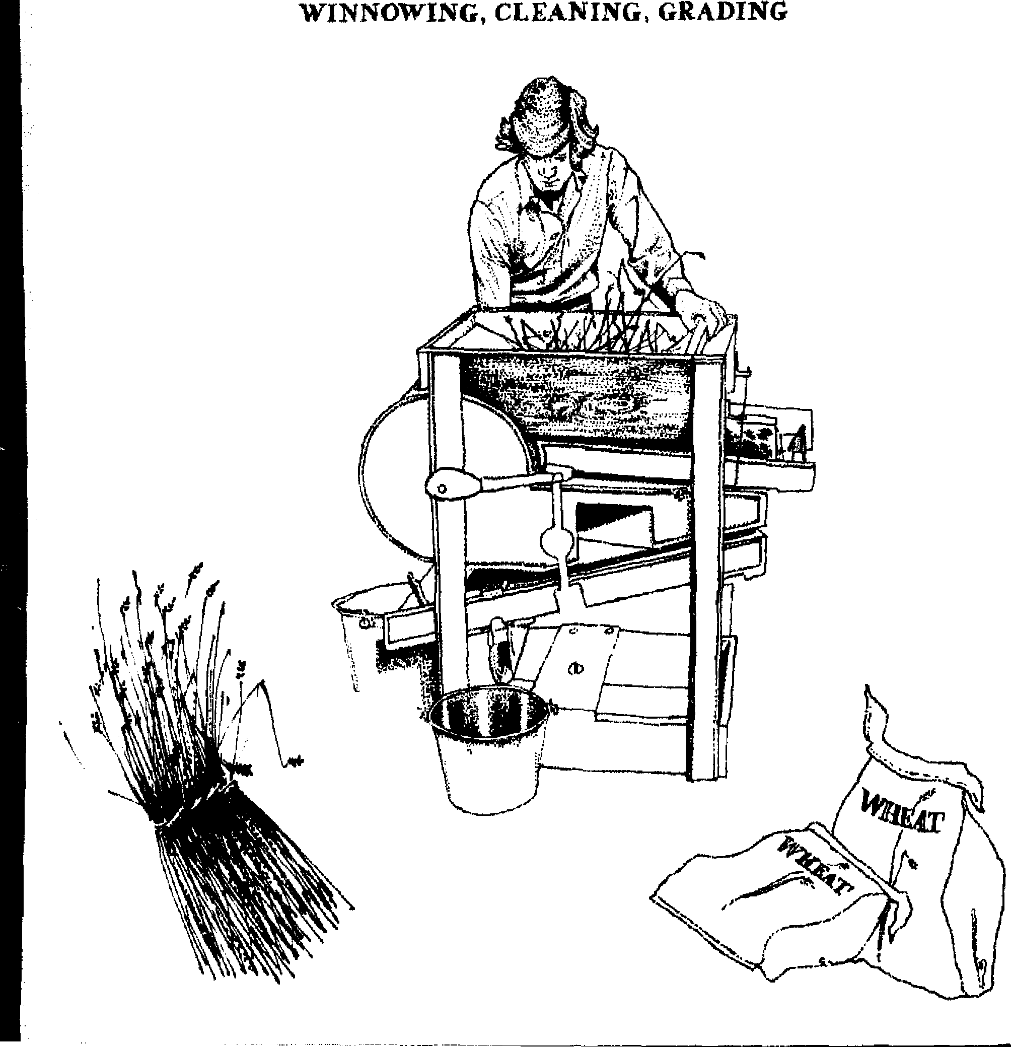

. . . . ..... _
.....,.,,,,-..;-_{v}-...,.--".... .
,, "- •^{A,.}"..^{e}! a
4271,
..._
er',.........--'''
y ')%
, `n•--,,Jr^{. ei}:ev. ....... ^{te 7.}
eel'⁻'7 r'^{r.}
_{.1/4} }'
1. 14 .„,
.....1 . .⁴. ,}.
;1i

90 The Scythe Book
Finally, the undersown clovers and grasses grow up through the stubble to give a late hay crop and a good winter cover for the grain field. I only recently discovered Thomas Tusser's sixteenth-century recommendations to do the same:
Corn carried, let such as be poor go and glean, and after them thy cattle, to mouth it up clean; Then spare it for rowen tilt Michel be past, to lengthen thy dairy, no better thou hast.⁵⁴
Sometime in the fall or winter I take the sheaves of grain apart and separate the kernels from the straw and cha ff by threshing: hitting them over the bock cf a chair, or banging them around inside a barre!, or jumping on them, or driving heavy-hoofed animais over them, or flailing them, or using a threshing drum. The two-piece fiai!, used since the fourth century, is a six-foot pole to whic'Ë is hinged an eighteen-inch beater or swingle or swepk or soupire made of hardwood or occasionally knotted rope. The swingle is boisght up easily ta shoulder height and brought down along its full length onto the thick pile of opened sheaves with a thump, then again, and again. The blow need sot be violent nor exhausting; the grain is sot beaten out, but shook out of the deep pile of straw by the blows of the fiait. As with scything, there is a rhythm intrinsic to the task of threshing which makes the work easier. The leader of threshing teams coordinated the succession of blows with work songs or chants or even dances specific to threshing.
The problem of flail design is the material for the hinge. Even leather wore out quickly, so eelskin was used whenever available. Robert Johnston has proposed an excellent design to keep the swingle from getting tangled in its own hinge material (Figure 28). The heavy wire revolves freely around the sotch at the end of the handle so the twine does sot get too twisted.
A field before harvest may look like amber waves of grain, but threshing reveals that the kernels are but a small fraction of the weight taken from the field. The quantity of chaff and straw seem prodigious by comparison to the pile of kernels, which are
Harvesting Small Grains 91
one twenty-fifth of the whole by weight, and a srnaller fraction of the volume.
Wheat, rye, and buckwheat thresh easily. Only the "naked," or "hull-less" varieties of barley and oats thresh easily. The hulled varieties require more work with the fiait heating and light grinding also removes the hulls.
Threshing with a flail was considered the hardest work on the farm because of the large quantities of grain that were required to feed the livestock. Mechanized threshers were greeted with a cheer. However, neither threshing nor any like task is drudgery when done on a small scale; also, the work is definitely practical, and is valuable experience. Of the flail separating the seed from the huli and stalk, H. J. Massingham said, "The man who swung the flail was a person who moulded the sources of life; the man who tends the machine risks himself to the inanimate."⁵⁵
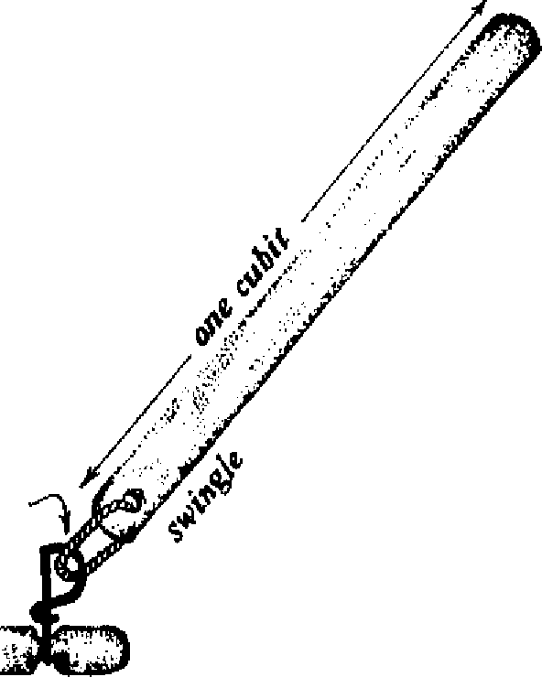

The early threshing machines to which Massingham referred were very large, noisy, and dangerous. In contrast, the footpowered threshing drum, uscd widely on small quantities of grains in J apan (and pictured in Fukuoka's One Straw Revolution), is a cylinder of wooden slats covered with wire loops rotated away from the operator by a treadle at 350-450 revolutions per minute. The straw is held in both bands over the moving wire loops, which beat the kernels out. This machine supposedly threshes six bushels an hour, with less risk of cracked kernels than in flail-threshing. However, in a series of
28. Attachment of swingle to handle.
twine
wit.A₊
handIe
--n.mrnç•eWMrrr•••.Pre.r.!"...r.7!

92 The Scythe Book
experiments comparing threshing with the rotating drum to threshing with a flail, I found that the rotating drum performs best only when the kernels are extremely loose in the grain head. If the kernels are easily detachable and the sheaves are held carefully over the many steel fingers, the threshing drum takes the same amount of time as the flail—from a half hour to an hour per bushel—for an average of one third more kernels. Hurrying, however, decreases the yield below that of the flail. The expense of the threshing drum thus seems justified only for large quantities of grain.
Roller threshers which take in the whole sheaf between two rollers, pressing the kernels out and bruising the straw for better value as livestock feed, were once made in one- and two-person models. But no longer; the same design is used in the small and expensive gasoline-operated threshers made in this country today.
The straw remaining alter threshing can be used for animal feed, for thatching of roofs, for animal bedding or garden mulch, for which it is superior to sawdust and hay, for straw rope to tie down haystacks against winter winds, or for the many beehives, baskets, and mats necessary around a farm, or for the traditional straw birthing bed. Indeed, I met several European farmers who grow grain specifically for the straw to use with their vegetables or orchards; Fukuoka's fertility program for barley and wheat depends entirely on returning the threshed straw to the fields with a little chicken manure. And straws of the threshed grain can be snipped between nodes to drink through, pleasing the children with the original organic drinking straw!
The difficulty in the past of separating the grain from the chah, dirt, broken kernels, weed seeds, bits of stem and leaf, and other foreign matter that collect on the threshing floor or tarp is well illustrated by the many folktales where the hero or heroine is charged with the impossible task of sorting a bushel of grain in one night. Besides cleaning by hand, the traditional method of
Harvesting S mail Grains 93
separating grain from waste was to wait for a favorable breeze, then throw the mass of grain and other matter up into the air; the chaff and dirt were blown to the side while the grains dropped back into the winnowing tray. The chaff was saved to fill mat-tresses, store sausages, etc. To separate the grain from the bits of stem, a series of riddles or sieves was used through which the grain kernels dropped. Handpicking of remaining impuriTes followed, making grain cleaning the most time consuming task of harvest. Washing the grain—rinsing then drying on troisfloats away the remaining chaff and cleans off any dirt. Even so, bread must have concealed other ingredients besides grain meal.
An early improvement was the winnowing fan, used to create a draft on a windless day; Odysseus's last task was to travel inland with an oar over his shoulder until he should meet someone who mistook it for a winnowing fan. Some small-scale farmers today use an electric fan with the same effect. The winnowing sheet was flapped for a breeze a great deal in the United States prior to the nineteenth century; three-quarters of an hour were required for every bushel of grain. Studies in 1898 concluded that over twenty-six hours were required to thresh twenty bushels with a flail, winnow with a sheet, sack the grain, and stack the straw, ⁵⁶ much more time than modern farmers feel they have for growing their own grains.
The rotary winnowing machine with crank handle, in use in China by 40 BC, was brought to Holland, and then to Scotland in the late eighteenth century, a lag of fourteen hundred years. By 1794, it was used by every husbandman and made by every country carpenter in Britain.⁵⁷ Recent improvements have been in the types of screens used. In the hand-cranked version pictured in Figure 27, threshed grain is dumped in of the top, and a hand-crank turns a fan as well as jiggiing three screens. The screens are selected from over a hundred for the specific sorting task, experimentation with which I fznd vert' enjoyable. Particles that are too large are directed out one spout, too small out
94 The Scythe Book
another, chaff is blown out a third, and the grains are separated into two sites. The output can be twenty to thirty bushels an pour, less if there is a great deal of straw with the grain.
Storing in the grain bin or granary requires dryness. The bin should be elevated off the floor so air cari circulate beneath it. Several two-by-fours can be set vertically in différent places in the bin. When the bin is full, the wood is removed io pro 'ide passages for air movement. Protection from rats is obta.ied with heavy screen or solidly constructed wooden bins. The possibility of insect infestation can be eliminated with small quantities of grain by setting portions in a home freezer for a day, or, with larger quantities, by storing outside in the winter cold. Dry ice (carbon dioxide) is feasible for killing insects in the grain with large or small quantities. These treatments do not kill the germ in the kernel as do high heat and strong chemicals.
As for grinding and cooking grains, there are many books on the subject. h should be said that the whole grain is a natural storage container in which the nutritional qualities and seed viability are kept intact. Seeds unearthed from the tombs of the Egyptian pharaohs have sprouted when moistened, and wheat has been found to have a germination rate of eighty-five percent after thirty-two years in storage.⁵⁸ This protection is destroyed when the kernel is cut in any way; then the contents begin to lose their potency and the oils turn rancid. It is best to keep the grain whole until shortly before it is used. Then the full life-giving power of the staff of life can be utilized.
I wanted to know just how my homegrown wheat measured up to other available sources so I designed a simple experiment to test it. I nto each of two bags I sifted six cups of a commercial brand of "whole wheat flour" (though it is called whole wheat, it does not have the full germ since this would shorten its super-market shelf life). I nto two more bags I sifted six cups of bard spring wheat from North Dakota which I had ground into ffour that morning. Into the last two bags I sifted six cups of wheat I had grown and harvested myself, and ground into flour that
Harvesting Small Grains 95
morning. I randomly assigned the letters A to F to the six bags, then delivered them to a professional whole wheat baker with instructions to treat al] six bags in the same manner. Using a simple recipe for whole wheat bread by the sponge method, he baked six loaves that day. I arranged taste tests that evening and the next two days for several individuals. The judges unanimously awarded last place to the commercial flour. Distinctions between the other four loaves were more subtle, most judges having good things to say about one individual loaf or another. The baker's favorite was a homegrown loaf: it rose most nicety, sliced the thinnest, and had the best flavor. The majority of opinion was for the homegrown bread. When the identities of the flours were revealed, most judges groaned, saying, "I guess I'll have to grow some wheat next year." I must confess I was surprised: "just as good" would have been adequate, and "superior" was an unexpected confirmation of my labor.
BRINGING THE HARVEST HOME
Your hay it is moved and your corn is reap'd, Your barns will be full and your hovels heap'd. Corne, boys, corne,
Corne, boys, corne,
And merrily roar out our harvest home. —John Dryden and Henry Purcell King Arthur, 1691
When grains were harvested by hand, the fields could be cared for in smaller parcels, and with more careful scrutiny than is usually possible today. Men, women, and children who worked together around the center of a farm, community, or neighborhoodhome in its broadest sense—would corne together in work at harvest time. The participants might act in different occupations for the rest of the year; but these could be put off. The harvest could not.
The link to the land and to the harvest task was also shown in
96 The Scythe Book
the form of payment. The part-time laborers could take home a portion of the crop, or be paid in other forms of the farmer's, and therefore the community's, wealth. For example, Thomas Jefferson set the "proper allowance" for six long days of work from each of his fifty-eight wheat harvesters at "4 gallons whisky, 2 quarts molasses, 1 midling (i.e., side of bacon) besides fresh meat per day, with peas." This was in addition to a portion of the crop, also given in payment. In thirteenth century. England, it was customary for the lord to grant his mowers as much hay as each could lift on his scythe at the end of the day; at the end of the season, they were given a sheep to catch and share.
Shared meals deepened the relationship between the harvesters. H. J. Massingham recorded eight meal breaks in the harvest day:
Forebit and breakfast, Rearbit and dinner, Nunchins and crunchins And a bit after supper.
The confirmation of the community family through work and the close bond to the earth through agriculture have been feit since the beginning, and it is not merely nostalgie to bemoan the loss of the relationships in industrial societies. The loss of the traditional forms of cooperative labor means it is more difficult to find the opportunities for companionship in work. Approaching hay, weeds, or small grains with a scythe is one such opportunity. To the hard-headed realists which we have all become, a scythe or other tool must first make sense economically. Beyond that, we are free to discover the other benefits---physical, mol tional, intellectual, and spiritual---which the use of the scythe permits. Exploring old customs can help in the articulation of these benefits.
One old custom has been the portrayal of Death and Time wielding a scythe (Figure 29):
Harvesting Small Grains 97

See how Death preys on humane Race;
Out with his Scythe the Tyrant goes, Great Multitudes at once he mows.⁵⁹
If the scythe is the Grim Reaper's favorite tool, was it considered to be a terribly dangerous weapon? No. Sharp as they are, scythes could never be used in combat unless the blades were reattached to extend straight out from the snath. Such a connection is tenuous, and did not seem to work well. Stories that the Assyrians attached scythes to their chariot wheels to mow the enemy down are a mistranslation: knives and swords were used for this purpose, while scythes could not be. In fact, the scythe is
29. Death reaps with the scythe.
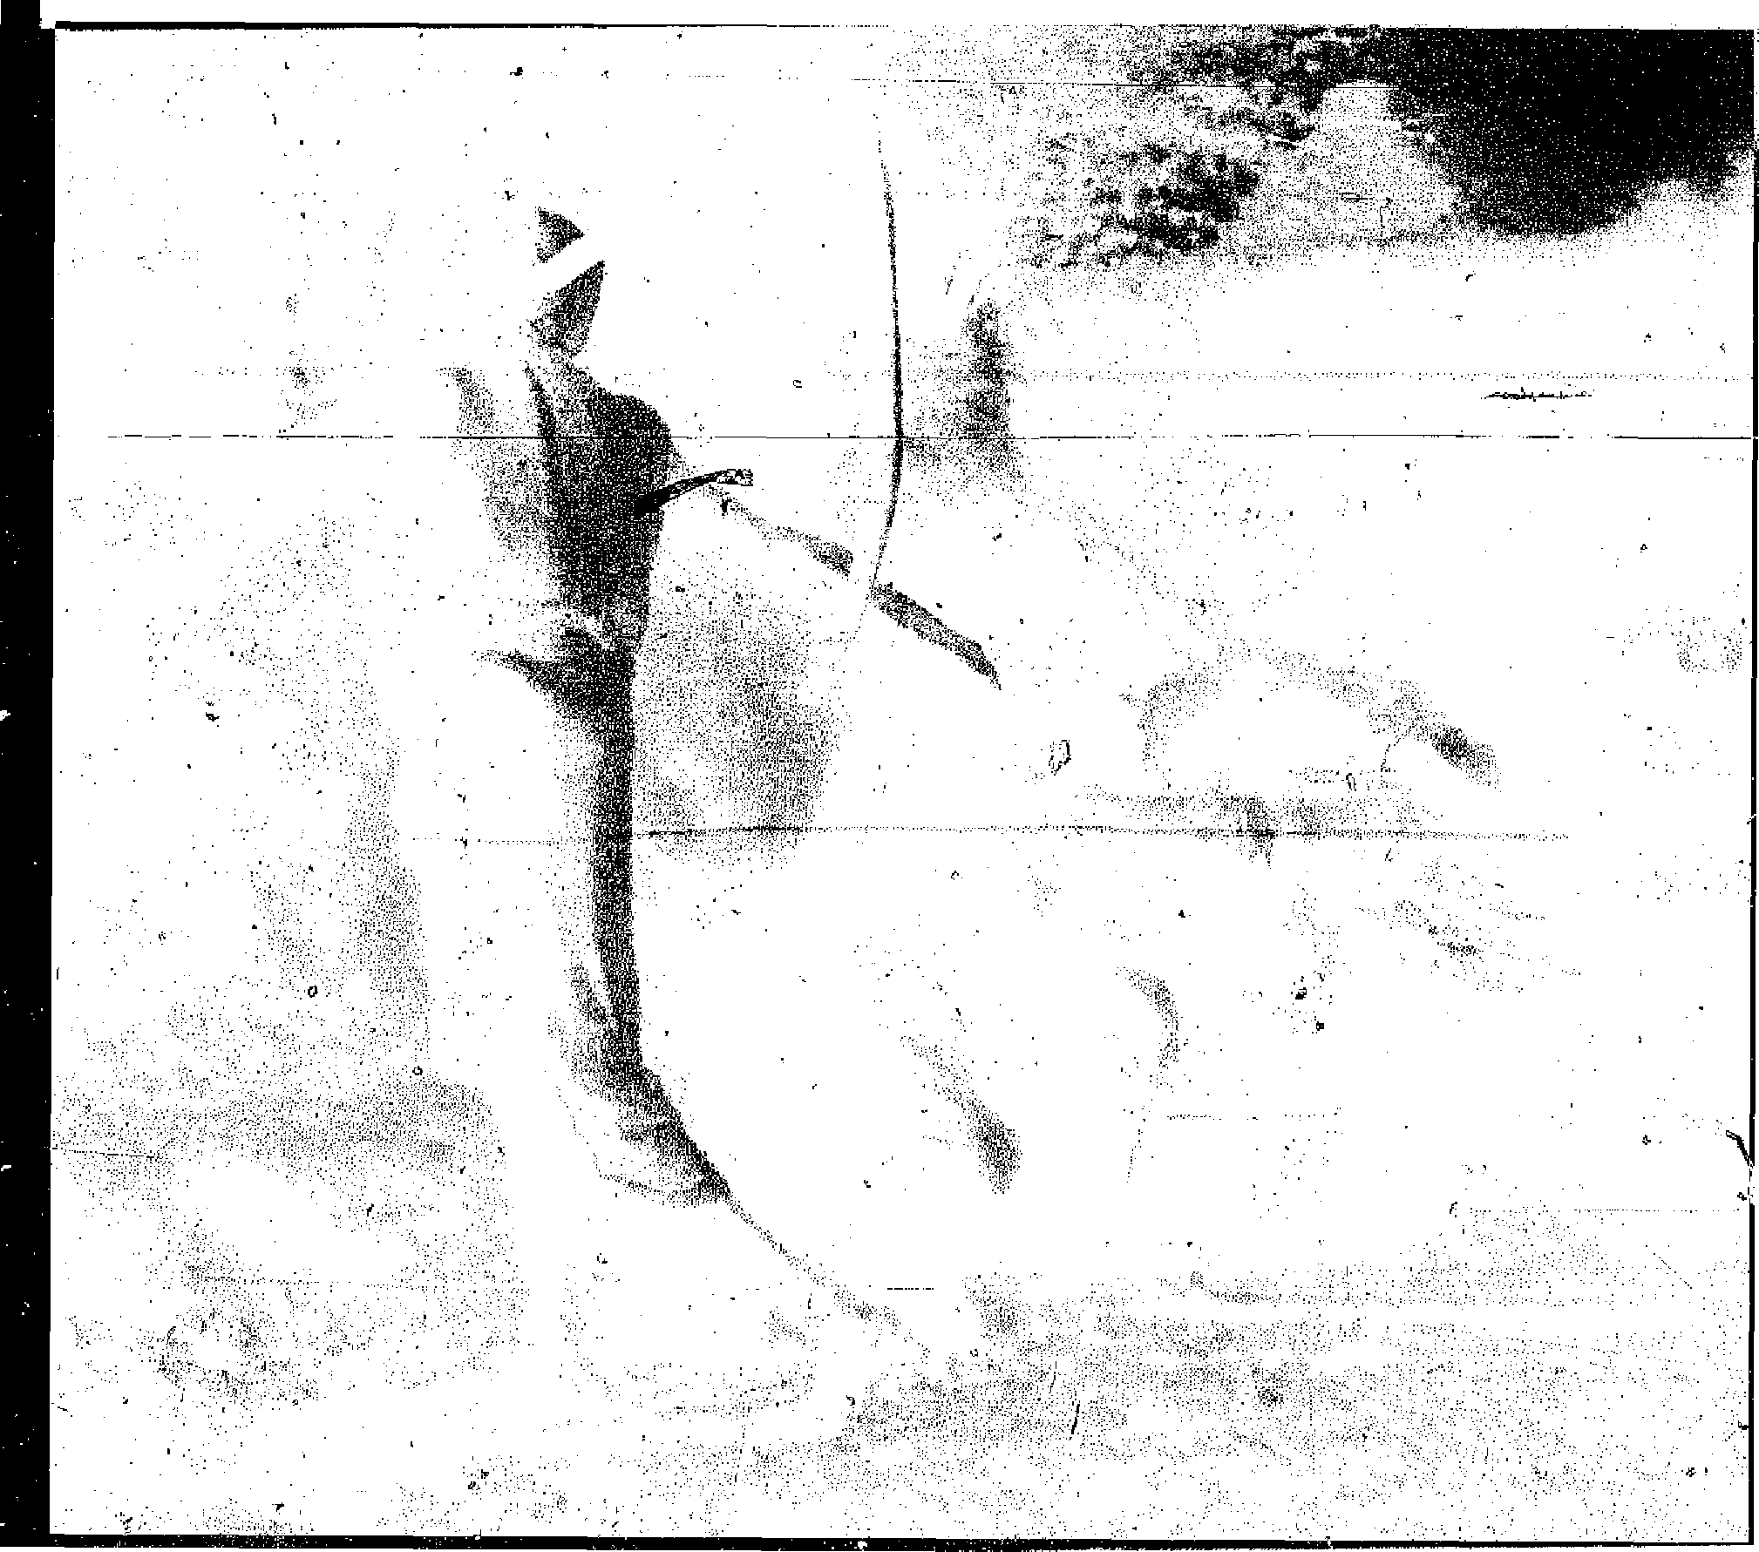
98 The Scythe Book
the very symbol of peaceful, settled farming of the land. In The Book of Isaiah (2:6), the nations that have given up war "shall beat their swords into ploughshares and their spears into scythes." For John Milton also, the scythe represents the peaceful pastoral life:
While the ploughman near at hand Whistles o'er the furrowed land, And the milkmaid singeth blithe, And the mower whets his scythe.
Every author cited in the section on technique has referred to this sweet ring of the blade when sharpened with a stone.
Then why, if the scythes other connotations are so benign, do Time and Death wield a scythe? Because mowing has a rhythm so strong and compelling that it feels, like Time, unstoppable. There is a correspondence between the inexorable laying down of the grass and the inexorable laying down of our lives. "For they shall be cut down like the grass" (Psalms, 37:2). This compelling rhythm is stronger than with any other tool I have experienced. Time could have had a hammer and knocked heads about, or a saw, or. . . Ail these other tools conjure up more grisly images for Death than does mowing and reaping, Rets linked to the earth's seasons in parallel to the thriving and passing of a person's life. And in the rhythm of creation, Death's reaping is also linked to the hope of spring's recreation of life.
And nothing 'gainst Time's scythe can make defense Save breed, to brave him when he takes thee hence.⁶°
So grain, and the tool to harvest it, have been linked to death and burial, conception and birth.
Customs that deal specifically with the end of harvest, with bringing the fruits of the earth home, have varied from region to region. A common experience is the feeling of being finished,
Harvesting Small Grains 99
released from toil, when the last load of grain or of hay is brought back to the barn, 3.midst shouts and songs:
Harvest Home! Harvest Home! We've ploughed, we've sown, We've reaped, we've mown,
We've brought ail the harvest home. Harvest Home! Harvest Home! We want water and can't get none! [whereupon the singers were drenched with a bucket of waters
Finished, but not released altogether. Since ancient times a common thread in the customs of farming peoples everywhere has been the belief that the last sheaf embodied the living Corn Spirit ("corn" as the staple grain of a particular area). All the harvesters cut the last sheaf of corn together—the single remaining stand of vertical grain in a field now flattened by the harvest. This moment was extremely potent; a stranger passing by the field at this time was scowled at, while the mowers loudly whetted their scythes, or he was approached threateningly with scythes, or he was tied up in a sheaf and motions were made to cut off his head. Thus the stranger was treated as a disturbance of an important ritual, and also as an embodiirient of the spirit of the grain. Olten the very last ears of grain were plaited together, and occasionally dressed as a Corn Dolly to preside over the farm table at the Harvest Supper and to be kept until the next harvest. ⁶¹
too, have felt the crackling concentration of energy in the last upright bunch of grain in a field laid flat by the scythe and dotted with the piles of tied sheaves. Where does that energy go when the last bit is cut? I do not know, but I understand the impulse to treat the last sheaf in a special way as if the special energy stayed with it, and I do treat the last sheaf of my harvest in a special way.
The welfare of the crops was to the mind of the ancients

30. Demeter.
assured by the Goddess of Agriculture—Demeter to the Greeks, Ceres to the Romans. In Figure 30 is pictured an eighteen-inch high votive mask of Demeter used in ancient Greece with the prayer: "May it be mine, beside Demeter's altar to dig the great winnowing fan through her heaps of corn, while she stands smiling by with sheaves and poppies in her hand." In more recent times, the Corn Dolly has held the Grain Mother's assurance through the winter of spring and new crops—the Dolly is Demeter until the Goddess returns to the meadows in the spring. The Dolly is therefore given due respect at the
autumn celebrations of plenty. "That great and mai mys-
Harvesting Small Grains 101
tery of perfect revelation, a cut stalk of grain,"⁶² was the center of agricultural ceremonies for thousands of years before Christ. And, as bread, grain has continuel its mysterious, religious association with the body of Christ ever since.
Our celebration of Thanksgiving late in November has its roots in this same tradition, though it has lost its attachment to the season's rhythms, to the feeling of being done with work in
31. The harvest.
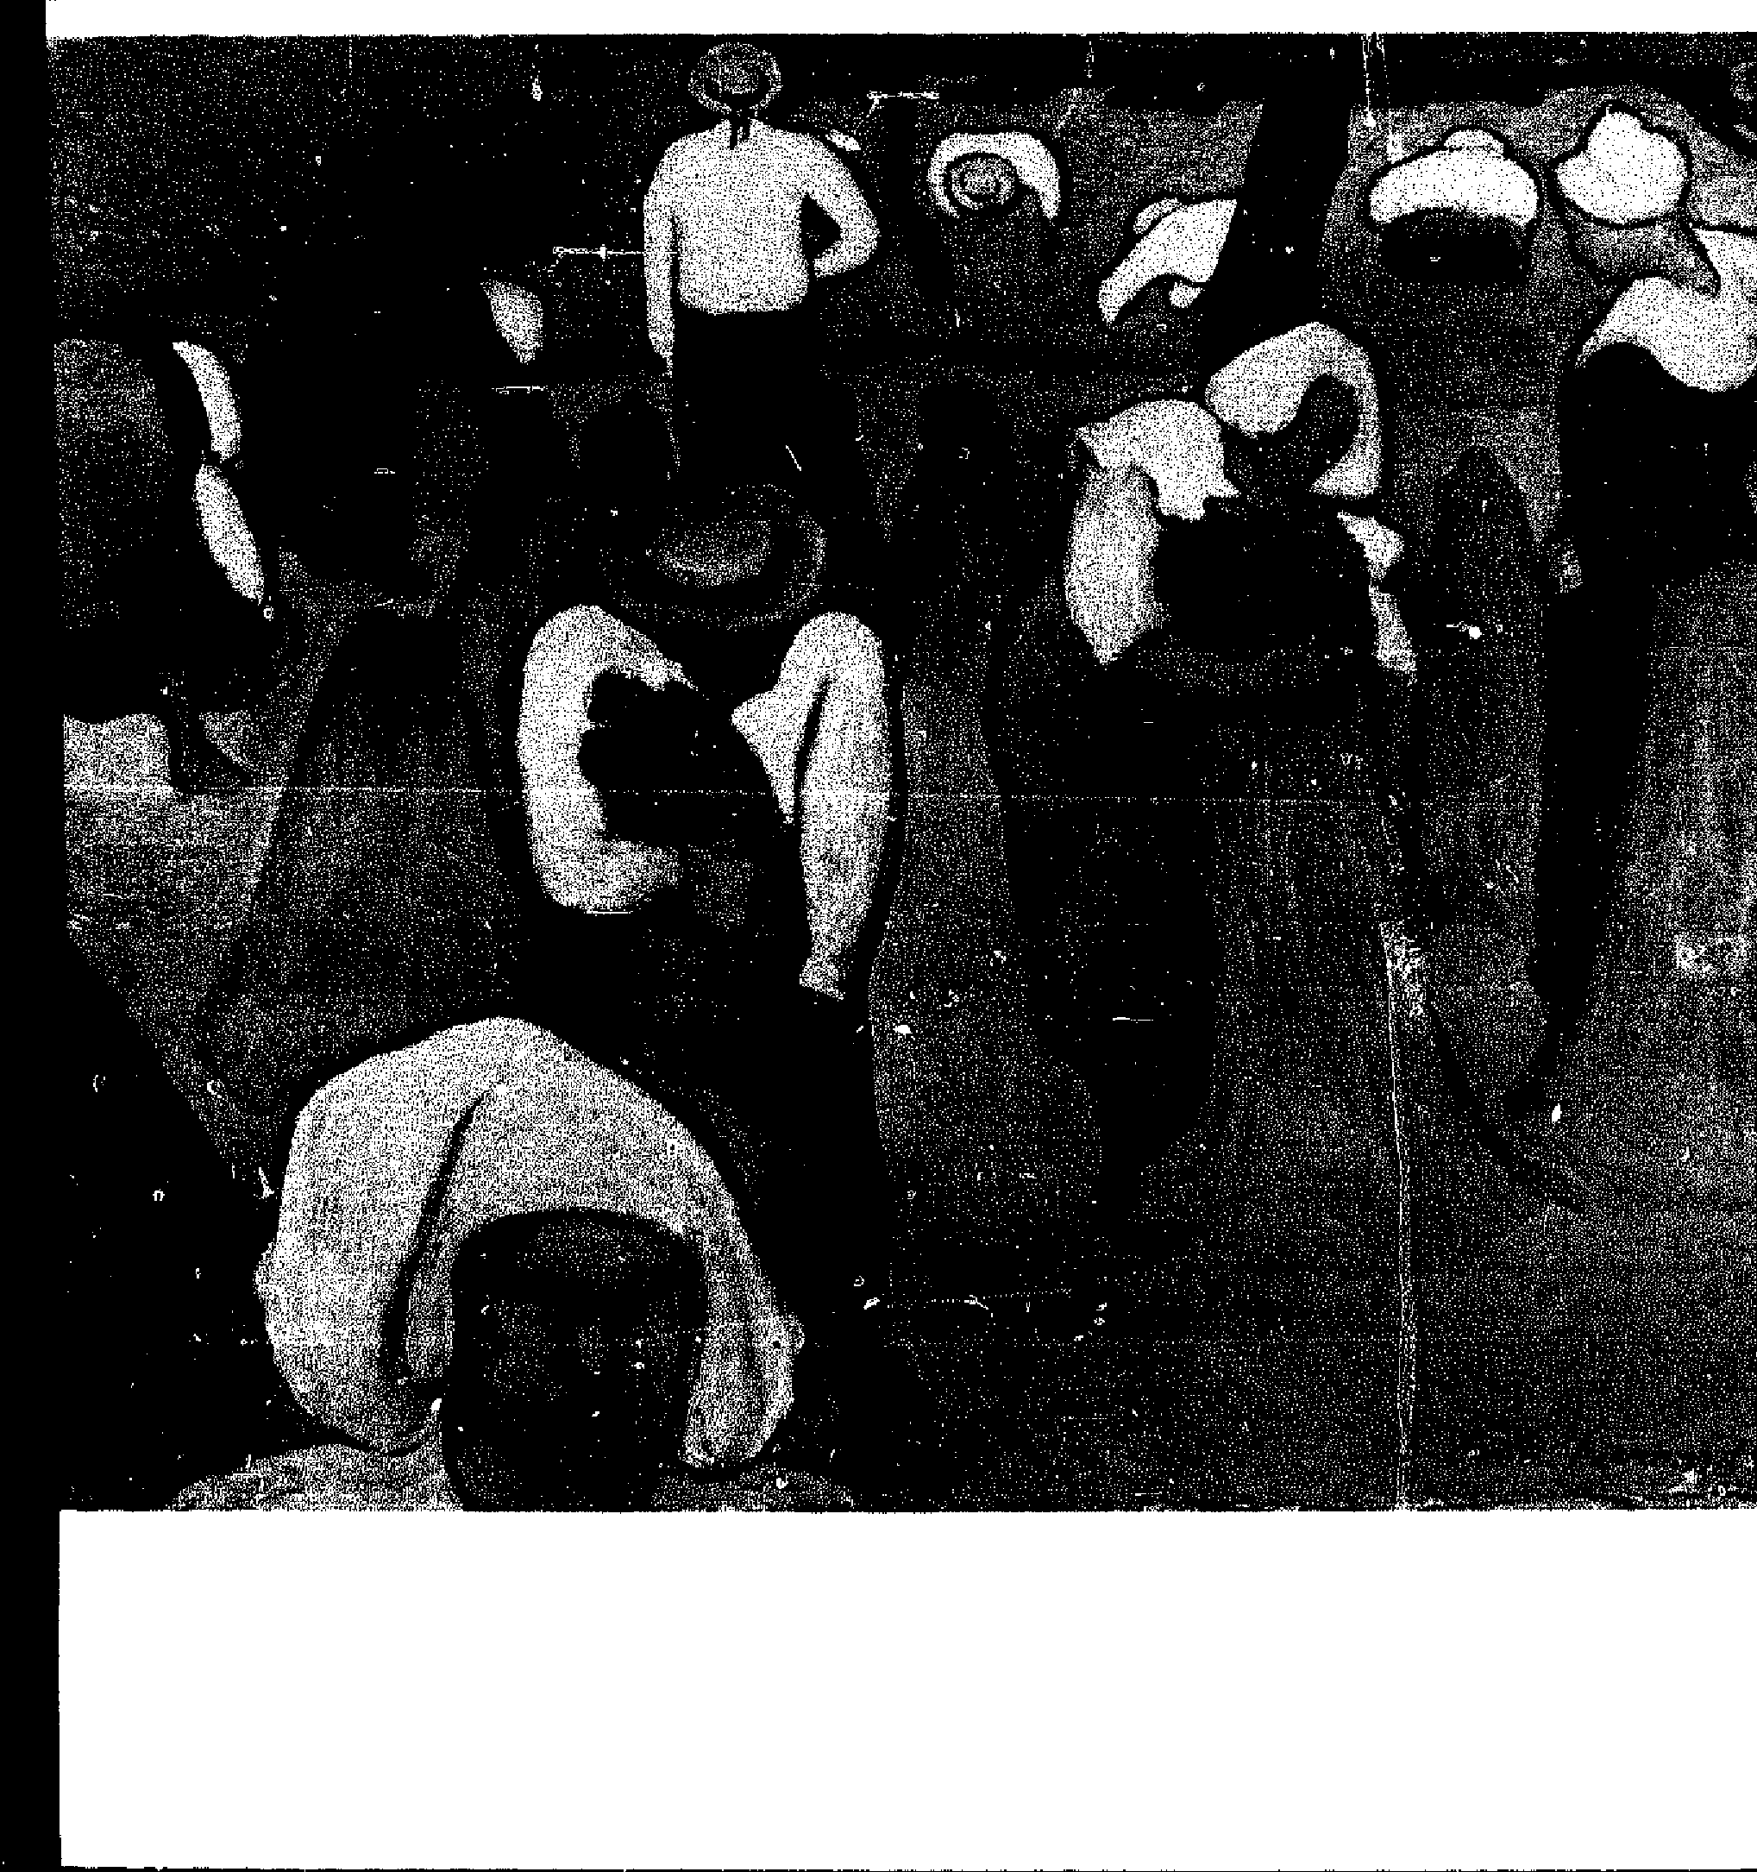
32.Cradling wheat.
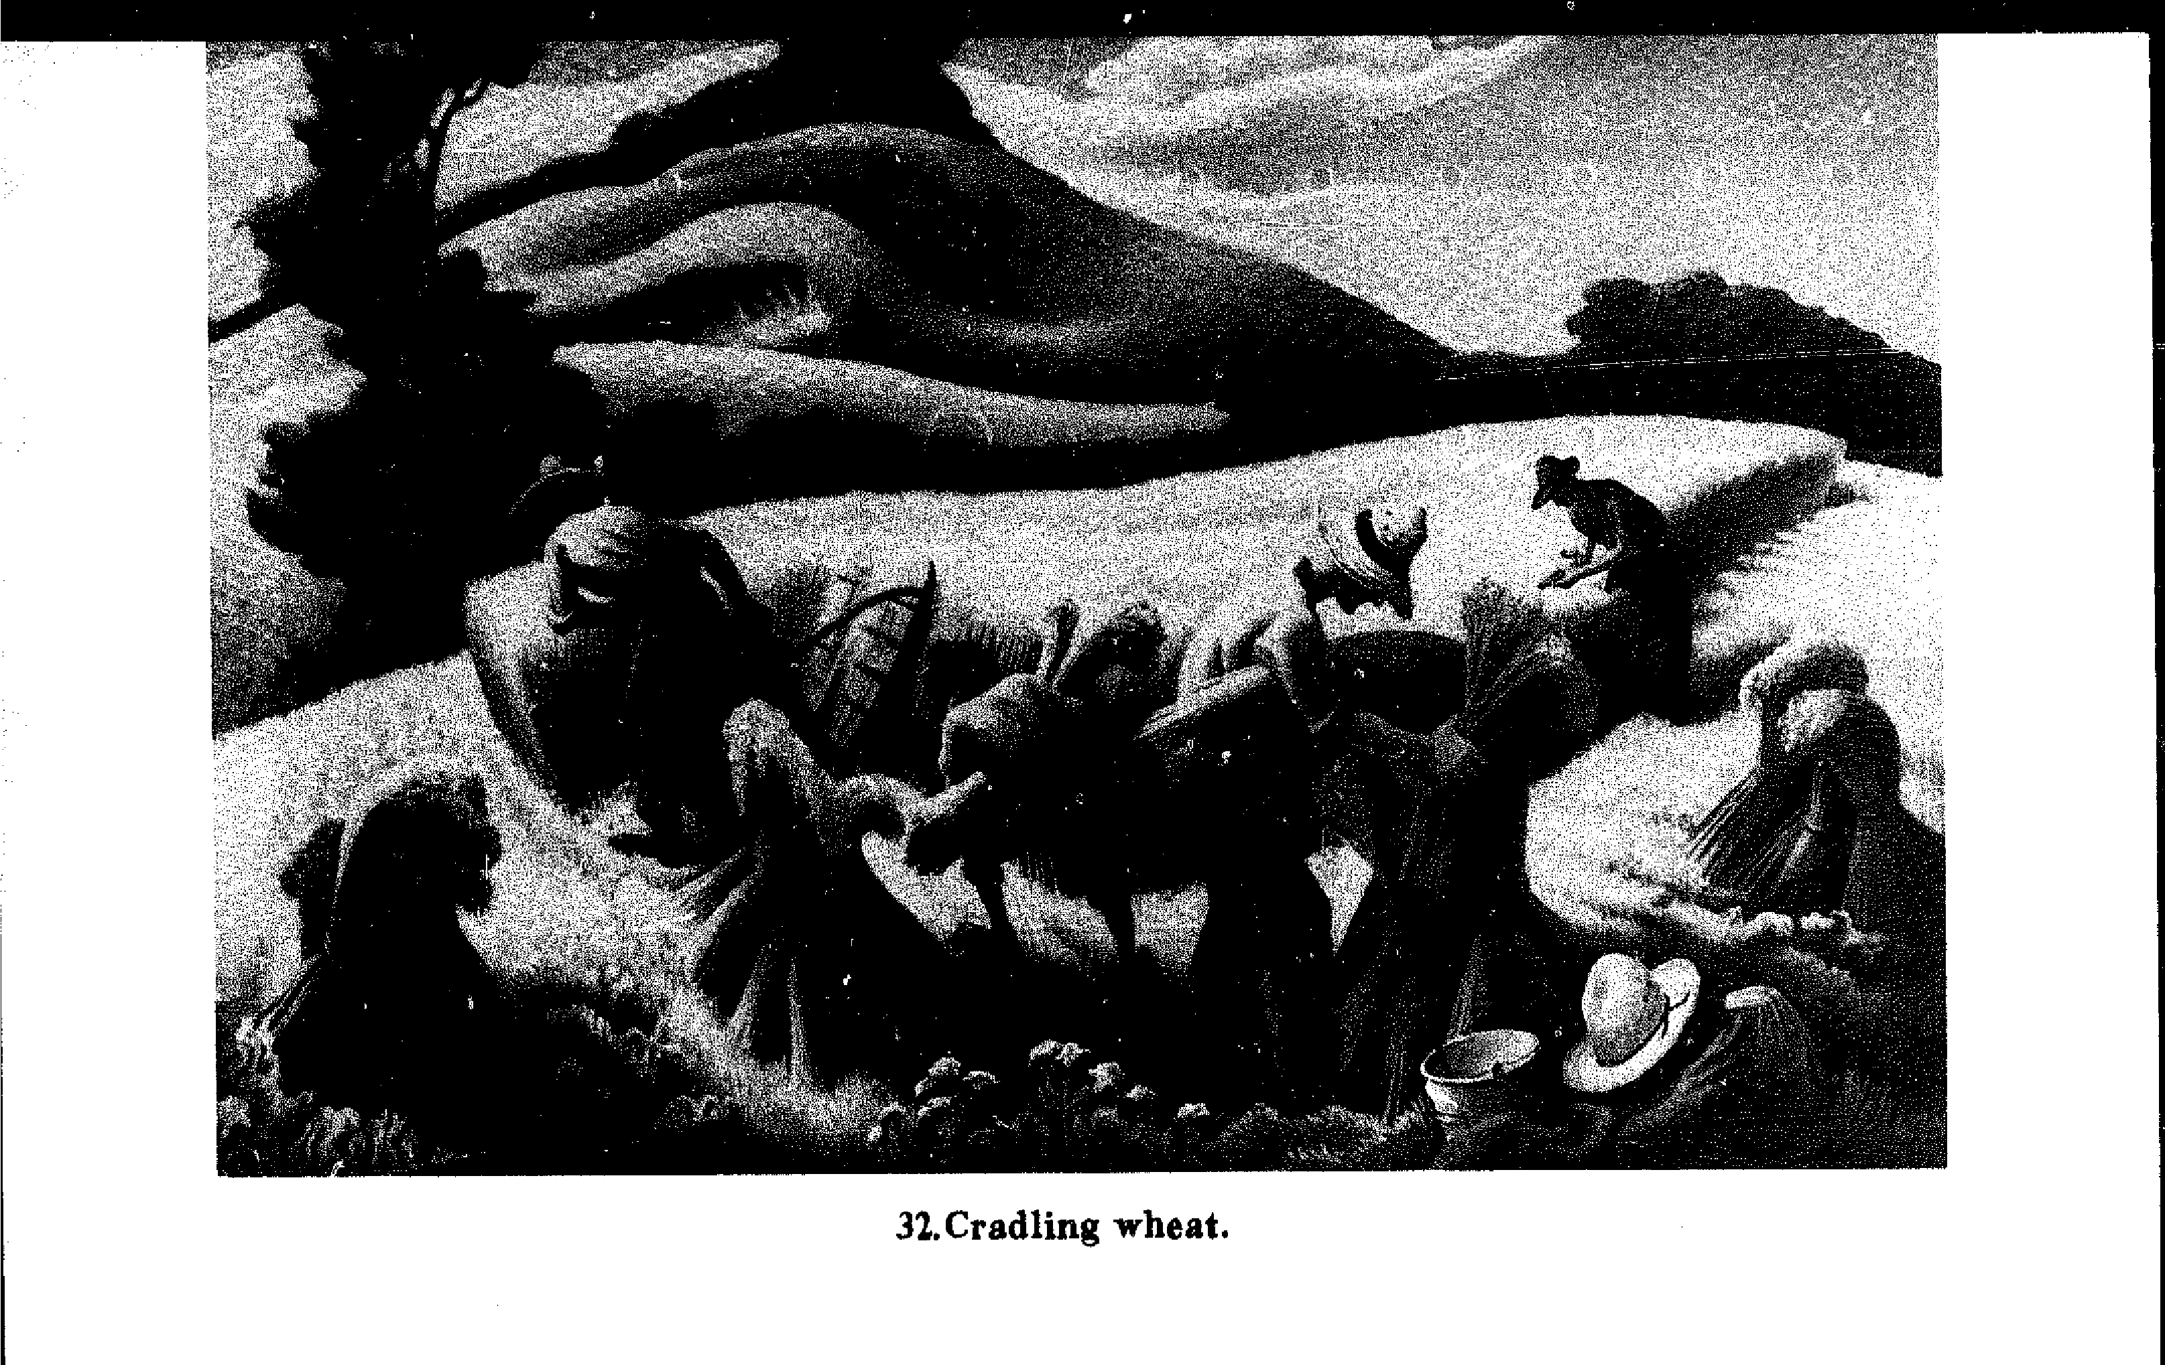
Harvesting Small Grains 103
the fields and gardens, to the feeling of barns and homes bounteous with the fruits of the earth, providing nurturant protection against winter. Now the dimly remembered strings of the harvest melody are plucked by the sale in gift shops of plaited Corn Dollies, mass-produced by an expert hand. But the year-round availability of harvest trinkets is not the point of living on the land. The embodiment of the Corn Spirit need not be a handsome, saleable item. Its purpose is to intensify in a symbol the communion of the farmerf gardener, through agriculture, with a little piece of the earth. For me, the painting of the harvest by Emile Bernard in Figure 31 evokes most powerfully the emotions of mingling with the Corn Spirit, and drawing up the energy for our sustenance out of the earth.
The attachment to earthly rhythms may be lost in the modern industrial age, but is hardly unrecoverable. While we no longer know a dozen traditional harvest songs to sing around an overflowing Harvest Supper, the experience of relating to the earth in a profound way is always available. It is just outside the door. The Findhorn Community in Scotland has even brought the pursuit of greater awareness to more articulate levels in its work with plants, and with the seldom-seen spiritual beings that sur-round them.⁶³ I do not believe this just because they have written a book about it. I am practical. When I talk to the grasses, weeds, and grains, and spend time listening in return, does it change the nature of the crop? Does it change my experience in sowing, reaping, and eating? I will not argue whether this is fanciful superstition, or a dutiful and necessary recognition of the elemental kingdom. At the very least, I know, the old adage is true: "Farmer's footsteps are the best manure." It is my desire on this land, in the context of this small farm, to know the best use of my body, and to move with the scythe as an extension of my body—in relationship with the grass, and in a team of mowersin the process developing my own communion with the divinity that creates the task and all its parts.
Notes
I. The word scythe is a corruption of the more easily pronounced Old English sithe. Peter Cousins suggests an earlier Dutch word, zicht. as an origin. These three share the
same lndo-European root, sek-, as "saw," "sword," "sickle," as well as "(plow) share,"
"schism," "science," and so on. All the derived words have the sense of splitting one thing from another. The modern German word for scythe is die Sense, and relates to the lndo-
European root, sent-, meaning "to head for or go": the scythe is a cutting tool with which you go from one place to another. In some areas, scythe is pronounced like"sigh"; there is no etymological relationship save for the similar sound of blade cutting grass and strong exhalation. The French faux and the Italian felce derive from the Latin faix ,fbenaria, without an earlier root.
- "Mild" steel has Iess than the 0.2% minimum carbon content of hard steel and is less strong, less brittle, less sharpenable, and more flexible. Geraint lerikin's The Craft
Industries describes in great detail the history of blade manufacture in the British Isles.
- In Marc Chagall's painting of 1911 of his childhood in Russia, I and the Village (Museum of Modem Art, New York), the top grip is held by the mower's right hand, the
snath rests horizontally on the right shoulder, and the blade points down behind the back. In Winslow H amer% painting of 1869, Man with Scythe (Cooper-Hewitt Museum, Washington, D.C.), the lower grip rests in the crook of the mower's right elbow, the right hand holds the snath just below the upper grip, and the blade is behind and pointing to the right a foot above the ground.
- There is no mention of left-handed models in the writings on the scythe (with the one exception of a passing reference in the 1921 Larousse Agricole). Nevertheless, in
sonie prominent illustrations scythes appear left-handed. An example is Brueghel's "The
Haymakers" (1565, Narodni Museum, Prague). A Norman Rockwell illustration of Poor Richard's Almanac first published in 1964 seems to show a left-handed scythe, and
has provoked many chuckles from old-timers (Country Beautiful, The Most Amazing American: Benjamin Franklin, page 38). The apparently left-handed scythes may,
however, have been due to the artist's wish to render a harmonious design many
illustrators show faulty scythe technique, though in pretty pictures.
- Resting the snath in the crook of the left elbow greatly restricts the range possible with offset handles held by the hands. Nonetheless, this method is shown in the scene for
July of eleventh-century calendar from Britain (E. M. Jope, "Agricultural Implements")
and surprisingly in modern times in rural Finland (Christopher Williams, Craftsmen of Necessity). M odern travelers have photographed scythes with only one lower nit) at use
in Greece and Turkey. H. J. Hopfen (Farm Implements) has presented the six basic regional types of snath, unfortunately without any discussion of the different ways in which they might be used. Steensberg's Hostredskaber shows many different kinds of homemade snaths found in the secluded mountain valleys of Scandinavia.
- E. R. Tichauer and Howard Gage, "Ergonomie Principles Basic to Hand Tool Design."
- Any primer on engineering can explain these fascinating realignments at the molecular level. Van Vlack's Elements' of Materials Science is particularly clear. The "fatigue limit" or "endurance limit" of a metal is the point past which it will not deform
105
under normal stress. Thus the steel snath will slowly defarm a small amount, and then stop. The aluminum snath does not stop,
106 Notes
- By Hand & Foot, Ltd., offers the service of cold-working a badlydented blade with a powerful band-operated press manufactured in Switzerland for just this purpose.
- An entry in the register of a London parish dated April 23, 1646, reads: "A child found at Mr. Sawyers in the Street on a place to whet knives and was named Edward Sharp." This reference ta the use of paving stones for sharpening was noted by Rudolf Hommel in China at Work: he also found stationary whetstones widespread in China and Japan in the 1930's.
- A strickle can be observed in use in William Sydney Mount's 1848 painting, "Farmer Whetting his Scythe," at the Suffolk Museum, Stony Brook, Long Island.
I L From Canto V111 of "Damon the Mower," by Andrew Marvell, in the edition of Marvell's works edited by Margoliouth.
- Tendons store 2500 joules per kilogram of tendon, compared to 900 for yew wood and 130 for spring steel (J. E. Gordon, Structures). ln the middle ages, the more efficient catapult design of the Greeks and Romans utilizing animal tendons was apparently forgotten. lnstead, a simple heavy counterweight was used to toss a iighter weight into the air. The earlier design stored much more energy in a much lighter material. Thus the image of mowing as a twisting clockwheel depends not only on its pend ulum aspect -the lifting of a weight into the air thus creating potentiai energy for the return mr-eementbut also on the torsion of the dock springs.
- In Imgard BarteniefFs system (Body Movement: Coping with the Environment), the scythe stroke as a whole bas the quality of a "Press movement" (strong, direct, and
sustained). is initiated with a trànmentary "Slash movement" (sudden, strong, and
indirect) not a jerky motion, but a fle.tiblelaunch into the effort, much like the rnovement of a clockwheel.
- From a letter by Tommy Thompson in October 1980. Thompson is an Alexander teacher in the Boston area who was trained by the late Frank Pierce Jones, who in turn was trained by F. M. Alexander. Jones's Body Awareness in Arian is a fine work on the technique. In The Ressurection of the Body, Edward Maisel has collected the best of Atexander's own writings, and written a long and helpful introduction ta thern.
- Raymond Dan, "The Attainment of Poise," and "Voluntary Musculature in the H u man Body."
- Adrian Bell, Apple Acre.
- lrmgard Bartenieff (Body Movement) is articulate about the need for this sort of rhythm:
Industrialized society often has a devitalizing effect on organic rhythms. Its pressures reduce the flow or exertion/ recuperation rhythms necessary to the continuity of vitality in activity. . . . when people confine themselves w actions without recuperations, or attempt to fit the actions totally to the machine, the human element on which the next levels of creativity depend is abandoned. (page 75)
R. L. Ardrey, American Agricultural lmplernente George Fussel, The Farmer's Tools: 1500-1900.
19. Jacob Bronowski said in The Ascent of Man, "The tool that extends the human harle' is also an instrument of vision" (page 118). His statement seems especially true of the scythe, since the words sight and insight (sithe in Old English) have the same root as "scythe," sek- (see Note 1). Through the scythe I have the opportunity to better know my body, and my world, and how they interrelate.
20. Herbert Koepf, Bo Petterson, and Wolfgang Schaumarin, Bio-Dynamic Agriculture.
Notes 107
2!. This seed mix, as well as each ingredient, is available from Hunter's of Chester, Seedsmen, Chester, England. Hunter's Guide ta Grasses. °avers, ami Weeds has colored drawings of forty-two plants of the meadow, and is available from By Hand & Foot, Ltd. These particular plants may not be appropriate to ail areas; diversity is the a im.
- In 1952 Newman Turner (Fertility Pastures and Caver Crops) set out plots of thirty-cive différent grasses, clovers, and herbs to see which plants the cows preferred. Several of those which the cows grazed most are included in the permanent pasture seed mix given here and are missing from conventional hay or pasture seed mixes.
- Jim Worthington, Natural Poultry-Keeping.
- Also pictured in Brueghel's "Haymaking."
- Clarence Danhof, "Gathering the Grass." Philip Wright, in Old Farm hnplements, gives the wages for each of these tasks in Essex in 1661. While the actual amounts do net mean much in terms of current prives, they can be compared with each other te give an idea of the relative amount of time it Look to do each job. The wage for mowing one acre of grass was 1/10; for raking and cocking one acre of grass 2 / -; for reaping, shearing, and binding one acre of wheat 4/ -; ditto, rye 4/ -; for mowing one acre of peas or velches 1191/2; for threshing two coombs of wheat 1/ -. The monetary units are shillings and pence; at that time twelve pence made a shilling. A coomb is four British bushels, or 4.13 American bushels.
- About cowslip-water, Margoliouth quotes from a herbal of Marvell's day: "Of the juive or water of the flowers of cowslips, divers Gentlewomen know how to cleanse the skin from spots or discolourings therein, as also to take away the wrinckles thereof, and cause the skinne te become smooth and faire."
- 1 observa these rakes at use in France. The same design is aise pictured in Brueghers painting, "Haymaking," from the Netherlands in the sixteenth century. Rudolfs Drillis ("Folk Norms and Biomechanics") found the measurements of rakes among Latvians to be personalized: length of hanche equal to one's height plus the width of a list. width of the rake head equal to one cubit, and distance between teeth equal to the width of two fingers.
- Construction of wooden hayforks and hayrakes is detailed in Drew Langsner's Country Woodcraft. The many pictures and drawings show well just how difficult the manufacture of simple tools can be.
- These carts are available from By Hand & Foot, Ltd.; their design features are thoreughly described in the forthcoming Handcarts Through History, aise from By Hand & Foot, Ltd.
- As Rudolf Laban said in Des Kindes Gymnastik und Tenz (cited by Bartenieff, Bod4' 41Ovement, page 69):
Work and festivities have their rhythms, their laws, and they must be organized according to the sense of these rhythms. People cry l'or rhythmie power waves- -work and festive—ta revive and enliven into meaningfulness their suppressed sense of life.
In the !930's Laban organized "movernent choirs" among groups of industrial workers in the cities of Germany; the movements were based on teamwork in agricultural tasks. The Gurdjieff movements practiced in this country originated with these chairs.
- From James Thomson, "The Seasons," in O. Henry Warren, The Good Life. In
The Song tore of Ireland, Masan Redfern gives work sangs for plowing, smithing, and spinning, that is, tunes actually used during work rather than about work sung afterwards. Simple repetitive songs which may have accompanied work are mentioned in Cecil Sharp's English Folk Songs (including "Mowing the Barley," as well as "Little Sir Hugh" and "The True Lover% Farewell") and English Folk Songs from the Southern Appalachians ("Reap, Boys, Reap"). The scene of planting riez intime with a drummer and a chanter at the end of Kurosawa's film Seven Samurai is the best example I know of what I term a work song; viewing this scene makes the power of such songs immediately evident. "Negro Work Songs and Calls" (Library of Congress recording AFS L8) also has this power. In Scotland, Alexander Fenton (Scottish Country Life) reports that dances which coordinated threshing teams were not performed for audiences even if these observers were familiar te the workers. The same may have been true with mowing, in which case the songs have died with the mowers who were displaced by the machine. 1f the current thinking in sociobiology is correct, however, the memory of these movements is still in our blood and can be rediscovered through the work.
108 Notes
- The "elevenses" or midday break has been well pictured in William Sidney Mount's painting, "Farmer's Nooning" (Suffolk Museum, Stony Brook, Long Island), and Winslow Homer's "Nooning" (Wadsworth Athaneum, Hartford). Brueghel's "Harvesters," reproduced at the beginning of this book, shows some reapers enjoying the noontime break white others work on. The artist clearly wanted to depict different tasks from diffèrent parts of the day in the same painting.
- Adrian Bell, The Open Air.
- Ruth Hertzberg, Beatrice Vaughan, and Janet Greene, Putting Food By.
- From the oral history by Bette Silloway and Jessica Wright, Maple Sugar Trees and Red Oldsmobiles Revised.
- "The Tuft of Flowers," as well as "Mowing," is from Robert Frost's first book, A Boys Will, which was published in 1913. A similar sentiment is expressed in the August 18, 1923, caver of the Saturday Evening Post by Norman Rockwell. The cover shows a farmer, with the upper nib of his snath held in the crook of his elbow, rescuing a bird whose nest he had disturbed.
- Many more weeds and uses can be found in Ben Charles Harris's Fat the Weeds.
- Knowles Shaw (1834-1878) wrote "Bringing in the Sheaves" inspired by Psalm 126 and the evangelist A. D. Fillmore. [t is a prominent hymn for the Patrons of H usbandry or Grange, a rural social and pofitical organization which attached rich symbolic value ta the tasks and tools of American farmers.
- Peter Ucko and G. W. Dimbleby, The Domestication and Exploitation of Plants and Animais. Michael Jacobsen, in The Changing American Diet, documents recent trends in the American diet. Henry Miller's "The Staff of Life" is a wrathful appraisal of American bread and the American diet.
- Greater detail about the different grains and their culture can be found in SmallScale Grain Raising by Gene Logsdon, Bio-Dynamic Agriculture by Koepf et ai, and the Cornell Field Crops Handbook. Bio-Dynamic Agriculture has several unconventional suggestions—such as planting a few camomille plants in the wheat field te prevent lodging—which are substantiated by experiment. Sources of seed which cannot be found locally are the Natural Organic Farmers Association (P.O. Box 86, G reensboro Bend, VT 05843), and Johnny's Selected Seeds (Albion, ME 04910).
- Peter Cousins has presented the evidence in his thoroughly researched Hog Novi, and Sith, Good resources on the design of harvesting implements before the modern scythe and cradle are K. D. White's Agricultural implements of the Roman World, E. M.
Jope's "Agricultural implements," and Axel Steensberg's Ancien! Harvesting hnplements. G. E. Fussell ("The Hainault Scythe in England") reports that the mowers usually wore leather leggings for protection.
Notes 109
- Van Wagenen attributes the establishment of this fact to Professor William Henry Brewer (1828-1910), of the Yak Sheffield Scientific School. The first United States patent for a grain cradle was granted in 1823, although local and state patents were perhaps granted before that time. lndeed, the very first patent granted in this country was for an improved scythe, and was issued by the colony of Massachusetts in 1646 ( Victor Clark, History of Manufactures, volume 1, page 48). However, Joseph Sandford ("Sickle, Scythe and Cradle") daims that the American grain cradle was an improved version of the long-rake scythe from Silesia, introduced to this country by Germait immigrants in the sixteenth century. Leo Rogin ( The introduction of Farm Machiner') cites evidence for a cradle used in Virginia prior to 1760, but does flot say which type it was.
- This design is shown in the several books of Stephens, Partridge, and Cousins, as well as the Larousse Agricole.
- H. J. Hopfen and E. Biesalski illustrate an officiai of the Food and Agriculture Organization of the United Nations, clean-shaven and dressed in khaki safari shirt and pith helmet, demonstrating die FAO cradle ta a bearded, turbanned, and robed Afghan fariner. Still another wooden structure that combines the designs of the FAO and the European large bow is shown in L'Agriculture dans les Beaux-Ans by the Musee d'Agriculture in Budapest, Hungary, and in Edit Fél's Gerâte der Ah:mer Bauern. Steensberg's Hostredskaber shows several examples from Scandinavia of constructing a cradle by tying a hayfork ta bath rtibs of the scythe.
- Axel Steensberg's later studies ( New Guinea Gardens) revealed several more types of ancient harvesting implements. Wood cutting knives, made of bamboo or palm, were cut very thin and sharpened on one end to be hacked at the grass. The knives therefore had no separate haft. After they were used up they were thrown away. Stone knives hafted like axes, ancestors of machetes, were struck against the grass, requiring that a heavy stick of wood be placed behind the stems as a chopping block. These techniques were found in bath the New Guinea highlands and the Scandinavian Draved Wood experiments in Neolithic swidden (slash and burn) agriculture.
- Donald Othmer, "Man versus Materials." According ta Joseph K. Campbell, "Power for Field Work," continuous human output would be Gloser ta I / 10 horsepower, but this does flot change the point of the comparison. Campbell's formula for periods between four minutes and eight hours is: human horsepower = 0.35 — 0.092 log I(I' is time in minutes). Thus the human reaper has between 1900 and 3800 times less horsepower available than the I90-horsepower combine, but in an equal amount of time produces more than this fraction of the combine's output. In the South, the cradle was used for over thirty percent of the crop in 1939, perhaps because labor was available and inexpensive; elsewhere in the U nited States in 1939, the cradle harvested less than ten percent of the crop ( M. R. Coo per el al.. Lahor Requirements,and A. P. Broda. Machine and Hand Methods).
- These figures may have been fora scythe without cradle, which Stephens preferred: "Every species of the cereal grains may be mown with the scythe"( The Farmer's Guide, p. 341). His measurements compare the reaping times of three implements, and are given below in the English units of acre, rood, and perch. A rod is 161/4 feet; a perch is a square rod; and a rood is 40 perches or 40 square rads. 1 acre = 4 roods ---- 160 perches. Thus the scythe reaped two acres and three roods or 2.75 acres of wheat.
AREA REAPED IN A TEN-HOUR DAY
110
Notes
WHEAT  Scythe  Smooth sic kle Toothed sickk | BARLEY AND OATS  A. R. P.  2 3 0  1 I 18  1 0 8 | A. R. P. 4 0 20 2 2 IO 2 0 10

Van Wagenen, Johnston, and the New England Farmer of 1834 all claimed four or more acres a day for reaping small grains, without giving data for their claims. The many references cited by Rogin range from two to four acres a day for a cradle scythe.
- George Fussell, The Farmer's Tools: 1500-1900.
- Made of cast iron parts, the very same planters made today can be found still serviceable aster decades on many farms in America and Europe. The Planet Jr. leaves a steady stream of seeds behind, in comparison to most tractor-mounted ututs and the "Shur Grow Planter" which leave one or several seeds at fixed intervals in the row. The first type is sometimes called a sower, the second a drill.
- F. H. King, Farmers of Forth Centuries.
51, Edwin Betts, Thomas Jefferson's Farm Book. Henry Best (Rural Econohly in Yorkshire in 1641) organized his harvest in yet another way; "Wee allowe one stooker usually to three binders and six Sythes."
- Peter Cousins estimated three vvorker-days per acre to reap with a sickle, with two worker-days to bind and stook. He estimated one worker-day per acre to reap with the Flemish scythe, and two worker-days to bind and stook. Rogin estimated ten hours of labor per acre to reap with a cradle scythe, bind, and stook, making Jefferson's calculations a little optimistic.
- Before baling machines, some farmers bound their hay in the same way as grain. As a symbol of British heraldry, the tied sheaf of grain or "garb" is included in insignia of many different regions and times, with great variation in the material and style of binding. Dorothy Hartley says that binders were cut from long strong grass that grew where oxen dropped or urinated. The ties in Brueghel's "Harvesters" are especially high on the sheaf and the straw particularly long, indicating that the straw (probably rye) was being carefully dried straight for use in roof thatching.
- Cited in Dorothy Hartky's Lost Country Life. The Moabite Ruth was a gleaner, and through ber hard work won the respect of the Hebrew patriarch Boaz.
- H. J. Massingham, Country Relies. Not least of these henefits is participation in the rhythm of effort and recuperation (see Notes 17 and 30). George Sheldon, "The Passing of the Stall-Fed Ox and the Farm Boy," gives a delightful picture of threshing in the context of farming in the Connecticut River Valley in the 1830's. Compare Massingham's statement with the passionate analysis of Henry Milles "The Staff of Life." For example,
lf they knew what good bread was they would not have such wonderful machines on which they lavish all their time, entre and affection. . . The machines get the best food, the best attention. Machines are expensive; humas
!ives are cheap.
- These studies were reported by the Commissioner of Labor in "Hand and Machine Labor." I have relied on the interpretations of this complicated report in Leo R ogin's The introduction of Farm Alachinery.
Notes 1 1 1
- Joseph Needham, Science and Civilisation in China, volume I, page 242; George Fusseil, The Farmer's Tools; 1500-1900. Seed Processing and Handling, edited by Charles Vaughan, shows how these very same processes have been performed by modern machinery.
- Mary Haferkamp et al., "Studies on Aged Seeds." Lela Barton (Seed Preservation and Longevity) rejects the reports of grain recovered from the tombs of Egypt.
- Bishop Ken, Hytnnotheo, 1711. Also, see Marvell, in the last fine of "Damon the 11lower:" "For Death thou art a Mower tort" Time, Cronos, and Saturn are ail names for, the giant culer of the gods before the age of Zeus. Saturn brought agriculture to the world; his standard was the scythe. Many illustrations from medieval texts in C. G. Jung's Psvehology and Alchemy give a doser look at Saturn with the scythe. Many drawings of Time show the scythe badly dented, which suggests that Time does not have enough time to peen its blade.
- William Shakespeare, Sonnet 12, preccded by John Milton, L'Allegro, 1631. These quotations are from other countries and other times. 1 have asked myseif why, when thousands of scythe blades are sold each year in the United States, there is so much less symbolic expression about it than in Europe. lt is perhaps partly because the first American tool has been the ax—the trees needed to be cleared before the grasses could grow. From one point of view the ax was a scythe: "At each swing they cut down a section of timber as a scythe cuts down a swathe of grain" (Wallace Wadsworth, Paul Bunyan), "When Paul Bunyan started lumber:ng in the West, the fir and redwoods began to fali lite grays" (Adrien Stoutenburg, American Tall Tales). Thus the scythe did not have in this country as in Europe the hundreds of years of use before meclianical agriculture. A nyone using the scythe, however, can participais immediately in the source of so many hidden aymbolic references permeating our cultural background.
- In The Golden Bough, Sir James Fraser has given many variants of these harvest customs. To make a Corn Dolly, any pattern of weaving the pliant straws will do. lf you wish to try your hand at the traditional English designs, James Arnold's Book of Country Crafts and Germaine Brotherton's Rush and Leafcraft are good introductions.
- From the Christian bishop Hippolytus, cited in Joseph Campbell's The Masks of God: Primitive Mythology, page 185. The reference is to the culmination of the initiation rites of Demeter centered at Eleusis. Ceres, from ker-, relates to "cereal," "create," and "crescent;" Demeter, from mater-, relates to "mother," "matter," "matrix," and "meter." Each emphasizes an aspect of the whole which was worshipped in their names. For a doser look at the symbolic association to the harvest, with implications for the scythe and its place, begin with Joseph Campbell's book cited a bove, and Essays on a Science of Mrthology by K. Kerényi and C. G. Jung, and Campbell's The Mysteries.
- Findhorn Community, The Findhorn Garden. There are now many intentional communities which seek to develop this awareness.
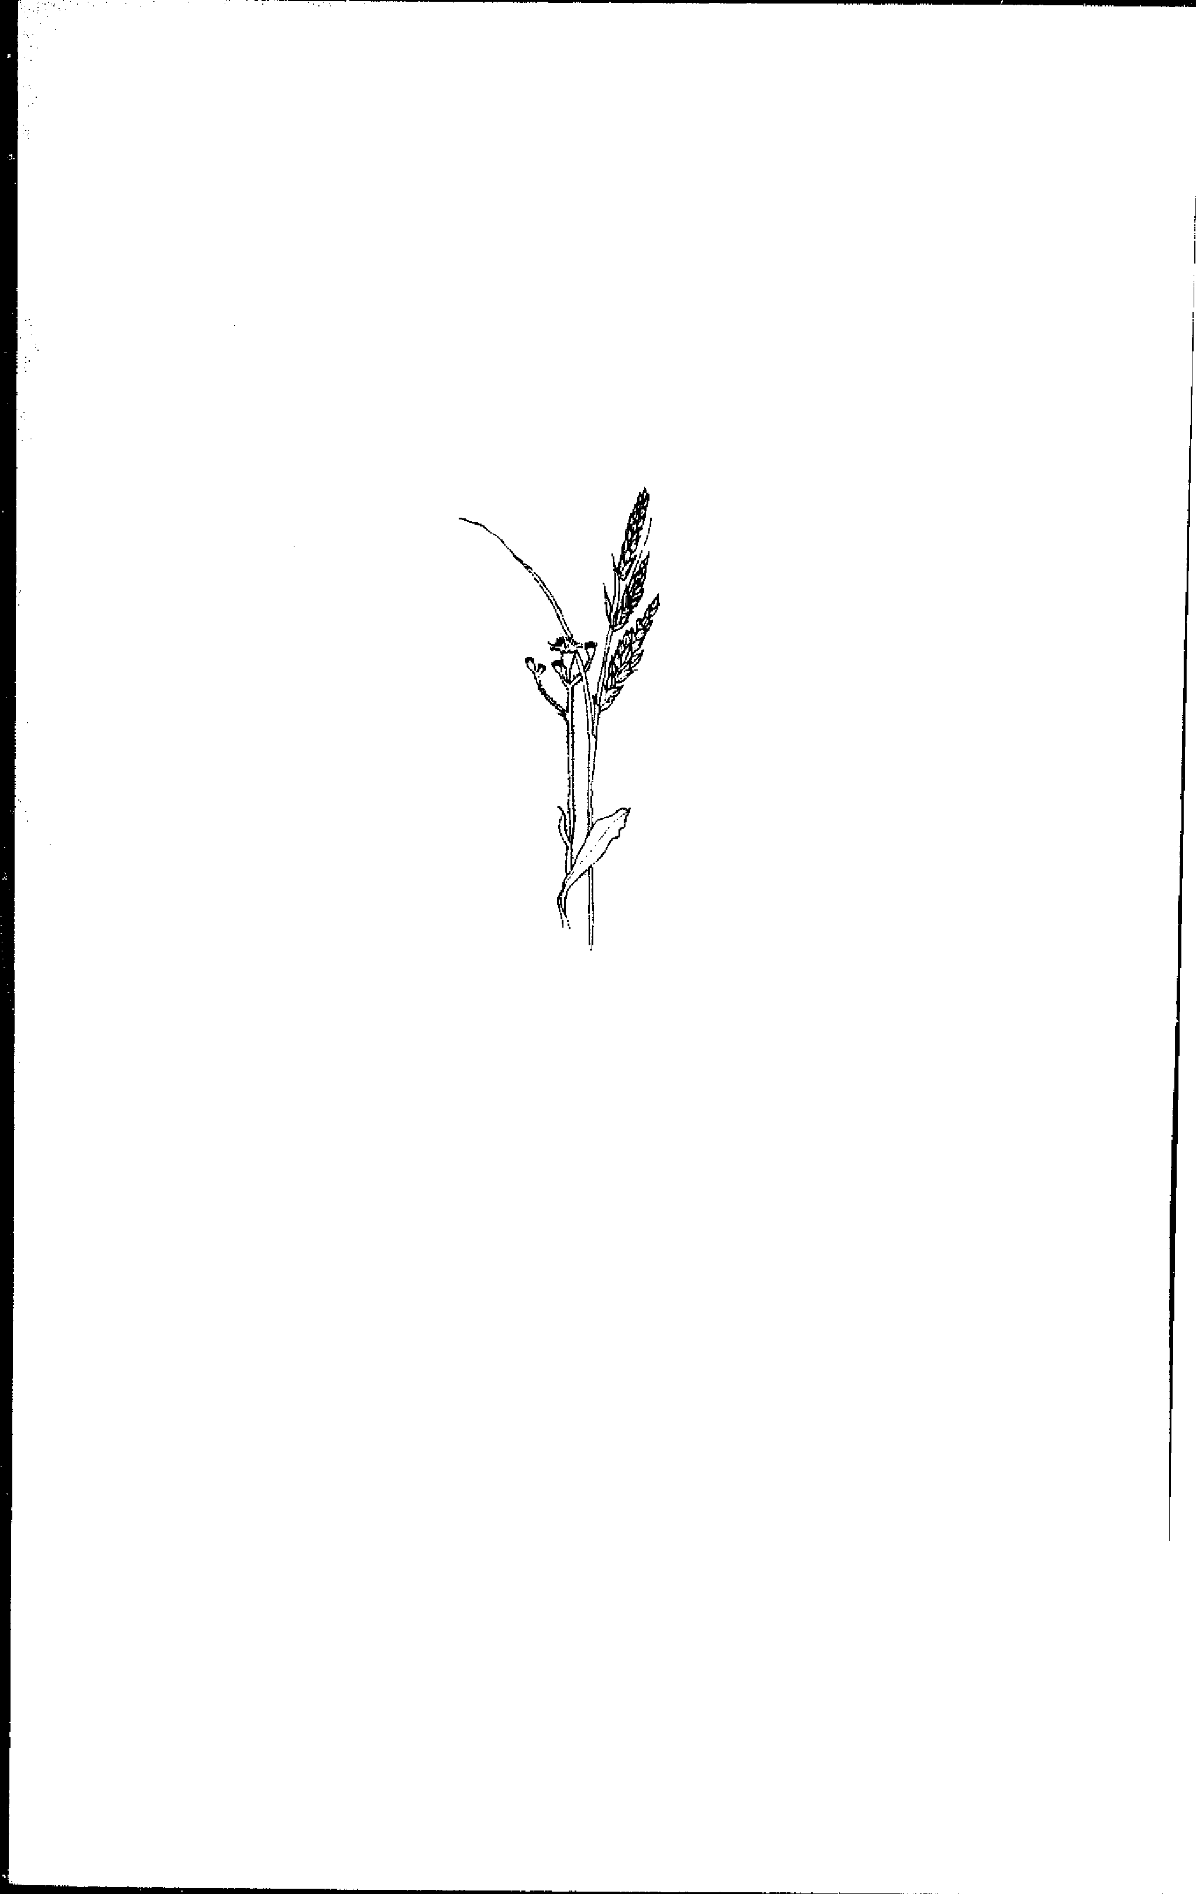
Bibliography
113
Allingham, William. Fifty Modem Poems. London: Bell & Daldy, 1865. Ardrey, R. L. American Agricultural Implements. New York: Arno Press, 1972 (1894).
Arnold, James. The Shen Book of Country Crafts. London: John Baker, 1968. Bartenieff, Irmgard, with Dori Lewis. Body Movemern: Coping with the Environnent. New York: Gordon and Breach, 1980.
Barton, Lela V. Seed Preservation and Longevity. New York: lnterscience Publishers, 1961.
Bayerische und Tiroler Sensen-Union. "Einige Aufschlüsse über die Sensenherstellung." Landrnaschinen- Markt, 1950, 29.
Bell, Adrian. Apple Acre. London: Brockhampton Press, 1942.
Bell, Adrian. The Open Air. London: Faber & Faber, 1936.
Bell, Adrian. Sunrise ta Sunset. London: John Lane, Bodly Head, 1944. Berry, Wendel'. "A good scythe." Organic Gardening, January 1980, 138-141. Best, Henry. Rural Economy in Yorkshire in 1641. London: Surtees Society,
1857.
Betts, Edwin (Ed.). Thomas Jefferson's Farm Book. Princeton, NJ: Princeton University Press, 1953.
Blandford, Percy. Old Farm Tools and Machinery. Detroit: Gale, 1976. Brodell, A. P. Machine and Hand Methods in Crop Production (Farm
Management Report 18). Washington, DC: United States Department of
Agriculture, Bureuau of Agricultural Economics, 1940.
Bronowski, Jacob. The Ascent of Man. Boston: Little Brown, 1973. Brotherton, Germaine. Rush and Leafcraf I, Boston: Houghton Mifflin Company, 1977.
Campbell, Joseph. The Masks of Gad.• Primitive Mythology. New York: Viking Press, 1959.
Campbell, Joseph (Ed.). The Mysteries (Bollingen Series XXX, Volume 2). Princeton, NJ: Princeton University Press, 1955.
Campbell, Joseph K. "Power for field work." In Diana Branch (Ed.) Toolsfor Homesteaders, Gardeners, and Small Scale Farmers. Emmaus, PA: Rodale Press, 1978, 89-92.
Cannon, LeGrand. Look to the Mountain. New York: Henry Holt, 1942. Clark, Victor. History of Manufactures in the United States, three volumes, New York: Peter Smith, 1949 (1929).
Collins, E. J. T. Sickle w Combine. Reading, Berkshire; Museum of English Rural Life, 1969.

114 Bibtiography
Commissioner of Labor. "Hand and machine labor." Thirteenth Annual Report, volume 2. Washington: United States Dept. of Labor, 1898, Cooper, M. R., W. C. Holley, H. W. Hawthorne, and R. S. Washburn. Labor Requirernents for Crops and Livestock (Farm Management Report 40). Washington, DC: United States Department of Agriculture, Bureuau of Agricultural Economics, 1943.
Cornell Field Crop Handbook. Ithaca, NY: New York State College of Agriculture and Life Sciences, 1978.
Country Beautiful. The Most Amazing American: Benjamin Franklin. Waukesha, Wisconsin: Country Beautiful, 1973.
Cousins, Peter H. Hog PlowandSith. Dearborn, Michigan: Greenfield Village and Henry Ford Museum, 1973.
Danhof, Clarence. "Gathering the grays." Agricultural History, 1956, 30, 169-173.
Dart, Raymond A. "The attainment of poise." South African Medical Journal, 1947, 21, 74-91 (also, Human Potential, 1968, 1).
Dart, Raymond A. "Voluntary musculature in the human body: the double-spiral arrangement." British Journal of Physical Medicine, 1950, 13, 265-268 (also Human Potential, 1968, 1, 89-98).
Drillis, Rudolfs J. "Folk norms and biomechanics," Human Factors, 1963, 5, 427-441.
Duby, Georges. Rural Economy and Country Life (Cynthia Pastan, trans.). Columbia, SC: University of South Carolina Press, 1968.
Fél, Edit, and Tamâs Hofer. Geste der Atemyer Bauern. Kopenhagen:
Kommisson der Koniglich Danischen Akademie der Wissenschaften, 1974, Fenton, Alexander. Scottish Country Life. Edinburgh: John Donald Publish-
ers, 1976.
Findhorn Community. The Findhorn Garden. New York: Harper and Row, 1975.
Fischer, Franz. Die D'arien Sensen. Graz-1(45ln: Verlag Hermann Bohlaus, 1966.
Fraser, Sir James George. The Golden Bough (3rd ed.). New York: Macmillan, 1966 (1911).
Frost, Robert. Complete Poems. New York: Holt, Rinehart and Winston, 1949. Fukuoka, Masanobu. The One-Straus Revolution: An Introduction tu Natural Farming. Emmaus, PA: Rodale Press, 1978.
Fussell, George Edwin. The Farmers Tools: 1500-1900. London: Andrew Melrose, 1952.
Fussell, G. E. "The Hainault scythe in England," Man, 1960, 60, 105-108. Gordon, J. E. Structures. New York: Plenum, 1978.
Gould, John. "There's safety in scything." Christian Science Monitor, Harris, lien Charles. Eat the Weeds. Barre, MA: Barre Publishers, 1971. Herrigel, Eugen. Zen in the Art of Archery (R. F. C. Hull, trans.). New York: Jacobsen, Michael. The Changing American Diet. Washington, D.C.: Center Jenkins, Geraint. The Croft Industries. London: Longman, 1972.
Johnston, James F. W. Notes on North America: Agricultural, Economical, Johnston, Robert, Jr. Growing Garden Seeds. Albion, Maine: Johnny's Se-Jones, Frank Pierce. Body Awareness in Action: A Study of the Alexander ,tope, E. M. "Agricultural implements." In Singer, Charles, E. J. Holmyard, Haferkamp, Mary E., Luther Smith, and R. A. Nilan. Studies on aged serfs 1: Homans, George Caspar. English Villagers of the Thirteenth Centurv. Hommel, Rudolf P. China at Work: An Illustrated Record of the Primitive Hopfen, H. J. Farm Implements for Arid and Tropical Regions (rev. ed.) Hopfen, H. J., and Biesalski, E. Srnall Farm Implements (FAO Development Ingalls, John James. "In praise of blue gras." In U.S. Depl,rtment of AgriHertzberg, Ruth, Vaughan, Beatrice, and Greene, Janet. Putting Food By. Horne, Thomas Hartwell. The Cornplete Grazier (5th ed.). London: Baldwin Hunter, Peter J. P. Hunter's Guide tu Grasses, Clovers, and Weeds. Chester,
October 6, 1978, 20.
(FAO Agricultural Development Paper No. 91.). Rome: Food and Agriculture Organization of the United Nations, 1969.
Relation of age of seed to germination and longevity. Agronomy Jourf:ah
Pantheon, 1953.
& Cradock, 1830.
Agri-
culture Grass: The Yearbook of Agriculture 1948. Washington D.C.:
and Social, Volume 1. Edinburgh, 1851.
and A. R. Hall (Eds.) A History of Technology, Vol. 2. Oxford: Oxford New York: Russell & Russell, 1960.
Industries of China's Masses, Whose is Toi!, and thus an Account of
Nations, 1953.
Government Printing Office, 1948, 6-8.
for Science in the Public lnterest, 1978.
lected Seeds, 1976.
Chinese Civilization. New York: John Day, 1937.
Paper No. 32). Rome: Food and Agriculture Organization of the United
England: Hunters of Chester, n.d.
University Press, 1956, 81-102.
1953, 434-437.
Brattleboro, VT: The Stephen Greene Press, 1973.
Bibliography Technique. New York: Schocken Books, 1976. 115
116 Bibliography
Jung, C. G. Psychology and Akhemy (Second edition; R F. C. Hull, trans.) Princeton, NJ: Princeton University Press, 1968.
Jung, C. G. Symbols of Transformation (Second edition; R. F. C. Hull, trans.) Princeton, Ni: Princeton University Press, 1967.
Kerényi, K., and Jung, C. G. Essays on a Science of Mythology (R. F. C. Hull, trans.). Princeton Ni: Princeton University Press, 1971 (1949).
King, F. H. Farmers of Forty Centuries, or Permanent Agriculture in China, Korea, and Japan. Emmaus, PA: Rodale Press, (1911).
Koepf, Herbert H., Petterson, Ho D., and Schaumann, Wolfgang. BioDynamie Agriculture. Spring Valley, New York: Anthroposophic Press, 1976.
Kushi, Michio. The Book of Macrohiotics. Tokyo: Japan Publications, 1977, Langsner, Drew. Country Woodcrati. Emmaus, PA: Rodale Press, 1978. Logsdon, Gene. Small-Seale Grain Raising. Ernmaus, PA: Rodale Press, 1977. Lühning, Arnold. Die Schneidenden Erntegeriite (Unpublished doctoral
dissertation). Gôttingen: Georg-August Universitât, 1951.
Maisel, Edward. The Resurrection of the Body: The Writings of F. Matthias Alexander. New York: Delta, 1969.
Margoliouth, H. M. (Ed.) The Poems and Letters of Andrew Marvell. Vol. 1: Poems (3rd ed.). Oxford: Clarendon Press, 1971.
Massingham, H. J. Country Relies. Cambridge, England: Cambridge University Press, 1939.
Miller, Henry. "The staff of life." Selected Prose, volume 1. London: Macgibbon & Kee, 1965, 331-345.
Mitchell, John. "Scyther's complaint." In Wayne Hanley and John Mitchell (Eds.) The Energy Book. Brattleboro, VT: The Stephen Greene Press, 160-175.
Murphy, Michael. Golf in the Kingdom. New York: Dell, 1972.
Musee d'Agriculture. L'Agriculture dans les Beaux-Arts. Budapest: Musee d'Agriculture, 1959.
Mylonas, G. E. The Hymn to Demeter and Her Sanctuary at Eleusis. St. Louis: Washington University Press, 1942.
Needham, Joseph. Science and Civilisation in China, volume 1. Cambridge: Cambridge University Press, 1954.
New England t'armer, 1834, 13:3, p. 22.
Oakley, Kenneth P. Man the Tool-Maker. Chicago: University of Chicago Press, 1968.
Othmer, Donald F. "Man versus materials," Transactions of the New York Academy of Sciences, Series 11, 1970, 31, 287-303.
Partridge, Michael. Farm Tools Through the Ages. Reading, Berkshire: Osprey Publishing Co., 1973.
Bibliography 117
Pfeiffer, Ehrenrencl. Weeds and What They Tell. Wyoming, RI: Pio-Dynamic Farming & Gardening Association, 1974.
RecIfern, Mason. The Song Lore qf Ireland. Ann Arbor, MI: Gryphon Books, 1971
Roger, Jean-Marie. "Blé," Encyclopedie Permanente d'Agriculture Biologique. Available from the International Federation of Organic Agriculture Movements, Coolidge Center for the Advancement of Agriculture, Tops-field, Massachusetts,
Rogin, Leo. The Introduction of Farm Machinery in its Relation 10 the Productivity of Labor in the Agriculture of the United States During the Nineteenth Centurv (University of California Publications in Economics, volume 9). Berkeley: University of California Press„ 1931.
Roper, John S. Early North Worcestershire Scythesmiths and Scythegrinders—A Study Based on Wills and Probate Inventories, MI-1647. Cambridge University: Dudley House, 1967.
Sandford, Joseph E. "Sickie, scythe and cradle," The Chronicle of the Early American Industries Association, December, 1938, 2:7, 49, 51-52.
Schriikenfux, Franz. Geschichte der ôsterreichischen Sensenwerke und deren Besitzer. Linz-Donau: Herausgegben von Franz John, 1975.
Sharp, Cecil J. English Folk Song (4th ed.). Belmont, CA: Wadsworth Publishing Co., 1965.
Sharp, Cecil J. English Folk Songs from the Southern Appalachians. London: Oxford University Press, 1966 (1932).
Sheldon, George. "The passing of the stall-fed ox and the farm boy." Proceedings of the Pocumtuek Valley Memorial Association, 1898, 111, 5-29.
Silloway, Bette, and Jessica Wright. Maple Sugar Trees and Red Oldsmobiles Revised. Chelsea, Vermont: Acorn Fress, 1974.
Steensberg, Axel. Ancien, Harvesting Implements: A Study in Ardreology
and Human Geography. Copenhagen: Bianco Lunos Bogtrykkeri, 1943. Steensberg, Axel. Hâstredskaber. Lyngby: Nationalmuseets Etnologiske
UrKlersidgelser, 1941.
Steensberg, Axel. New Guinea Gardens: A Study of Husbandry with Parallels in Prehistoric Europe. New York: Academic, 1980.
Stephens, H. The Book of the Farm (4th ed., revised by James MacDonald). Edinburgh: William Blackwood and Sons, 1891.
Stephens, H. The Farrner's Guide. New York: Leonard Scott, 1852.
Stoutenburg, Adrien. American Tall Tales. New York: Viking, 1966.
Tallents, Sir Stephen. Green Thr;...ights, London: Faber & Faber, 1952. Taloumis, George. "Cutting a lawn gone to rneadow,"Bosion Sunday Globe, June 15, 1980, 82.
118 Bibliography
Thomas, James. "The Seasons." ln O. Henry Warren, The Good Life. London: Eyre and Spottiswoode, 1946, 237.
Tichauer, E. R., and Gage, Howard. Ergonomie Principles Basic ta Hand Tool
Design. Akron, OH: American Industrial Hygiene Association, 1977. Tolstoy, Leo. Anna Karenina (Constance Garnett, trans.). Indianapolis:
Bobbs-Merrill, 1978 (1876).
The Très Riches Heures of Jean, Duke of Berry. New York: George Braziller, 1969.
Turner, Newman. Fertility Pastures and Caver Crops (2nd ed.). Pauma Valley, CA: Bargyla and Gylver Rateaver, 1974.
Ucko, Peter J., and G. W. Dimbleby (Eds.). The Domestication and Exploitation of Plants and Animais. Chicago: Aldine, 1969.
Van Vlack, Lawrence. Elements of Materials Science. Reading, Mass.: Addison-Wesley Publishing Co., 1959.
Van Wagenen, Jr., Jared. The Golden Age of Homespun. Ithaca, NY: Cornell University Press, 1953.
Vaughan, Charles E., Bill R. Gregg, and James C. DeLouche (Eds.) Seed Processing and Handling. State College, Mississippi: Seed Technology Laboratory, Mississippi State University, 1968.
Wadsworth, Wallace. Paul Bunyan and his Great Blue Ox. Garden City, NY: Doubleday, 1964 (1926).
Warner, Anne S. "On scything," Country Journal, August 1975, 96. Weinsteiger, Richard. "Bu ild-it-yourself grain crad le." In Diana S. Branch(Ed.)
Tools for Homesteaders, Gardeners, and Small-Scale Farmers. Emmaus,
PA: Rodale Press, 1978, 244-245.
White, K. D. Agricultural Implements of the Roman World. Cambridge: Cambridge University Press, 1967.
Williams, Christopher. Craftsmen of Necessity. New York: Random, 1974. Worthington, Jim. Natural Poultry-Keeping. London: Crosby Lockwood Staples, 1960.
Wright, Philip. Old Farm Implements. North Pomfret, VT: David and Charles, 1975.
Zeitlinger, Josef, of Leonstein. Sensen, Sensensehmiede, und ihre Technik. Linz-Donau: J. Wimmer, 1944.
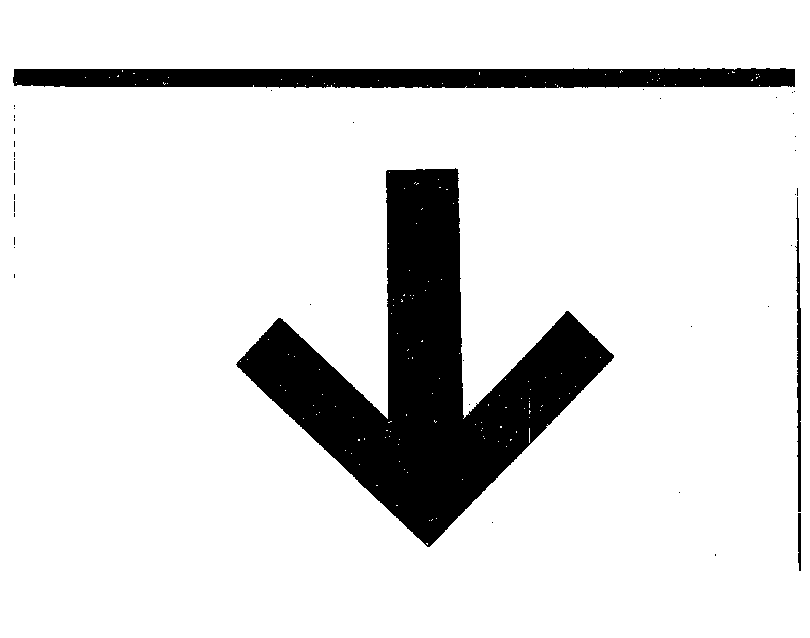
Index

acre, 52, 82, 109-110
Alexander, F. M., 43-47, 106
Allingham, William, 24, 59
aluminum, 13, 106
"American" scythe, 1, 5-6, 13, 19, 22, 24,
33, 35, 75
anvil. See peening
"Austrian" scythe, 1, 5, 13, 20, 24-25, 35, 75
ax, 111
beard, of scythe, 6, 9, 15, 16
beer, 62, 69
Bell, Adrian, 24, 56, 106
blade, 5-1I, 73
blade cover, 6, 11-12
bread, 2, 83, 93, 94-95, 110
bread Tabor, 69
Brueghel, Meer the Eider, Frontispiece,
20, 58, 105, 107, 108
Bush scythe, Il
Cannon, Le Grand, 5
cart, 58-59, 107
Ceres, 100, III
children's scythe, 18
Christ, 101
eider, 62-63
cocks, 53, 55, 110
Corn Dolly, 99, 100, 103, 111
Corn Spirit, 99, 103
cover. See blade co ',Per
cradle scythes, 74-79, 81-82, 85-86,
109
Food and Agriculture Organization,
78-79, 109
grapevine, 75, 81
grass rail, 52
large bow, 53, 75-78, 8i-82, 109
large rake, 74-77, 81-82, 109
small bow, 53, 75, 78
small rake, 74-77
turkey whig, 75, 81
"Crown" blades, 7
Damon, 29, 55, 106, 1 1 1 Death, 96-98
Demeter, 100, II 1 drill, seed. See sowing
"European" scythe. See "Austrian" scythe
119
fatigue lirait, 13, 105
Findhorn, 103, 111
flail, 88, 90-92
Flemish scythe, 72, 73, 109, 110
Food and Agriculture Organization,
78-79, 109
fork, 53, 56, 57, 107, 109
Frost, Robert, 19-20, 52, 64-65, 108
Fukuoka, Masanobu, 91, 92
garb, 110
gleaning, 87, 90, 110 grain, of wood, 58
grains, small, 3, 69-103 grass, 2, 49-52, 70, 107 grip, 6, 12-16, 72, 105
hafting, 7, 15-18, 39, 80
gainault scythe. See Flemish scythe hammer. See peening hammered blade. See "Austrian" scythe harvesting tools, ancient. See specific
types, e.g., sickie
Harvest Home, 95, 99 hay, 3, 50-62, 67-68, 83. See also specific
entries, e.g., fork, pins heinzen, 53
Jefferson, Thomas, 86, 87, 96
key, scythe, 6, 14, 16 knives, hay, 57, 59 knives, stone, 3, 79-81
lawn, Il, 17, 35, 66-68 Levin, 39-41, 42, 46, 60
machines, compared with hand tools, 2,
47, 48, 58, 66-68, 80-81, 87, 91-92, 93, 108, 109
mowing technique, 30-48, 85, 106

mowing contests, 35 mulch, 3, 92
120 Index
nib. See grip
pasture, 65
peening, 7, 20-24
Pfeiffer, Ehrenrend, 65
pins, hay, 56, 59
primary movement, 45-48
rakes, 56-58, 83, 107
riddle, 89, 93
ring, scythe, 6, 12, 15, 18, 78
rowen, 50, 90
Saturn, 111
seeder. See sowing
sharpening. See peening, whetting
Shaw, Knowles, 69, 82, 108
sheaf, 86, 110
sickle, 3, 18, 71, 73, 79-81, 105, 110
sieve, 89, 93
snath, 6, 12-18, 105
song, work, 60, 90, 107-108
sowing, 51, 82-84, 88, 110
stamped blade. See "American" scythe
steel, Damascus, 5
tnild, 7, 105
temper, 20, 22
Steensberg, Axel, 79-81, 105, 109
stook, 87
strain-hardening. 22-23
straw, 92, 93, 110
strickle, 20, 28, 106
swath, width of, 35
switchel, 63
tang, 6, 7, 9, 13, 14, 16
tendons, 32, 106
threshing, 88, 90-92, !07, 110 threshing drum, 88, 91-92
Time, 96-98, 111
ToIstoy, Leo, 39-41, 42, 46, 60 trademarks, 9, 10 Turkensensen, 9
ulnar deviation, 13
weeds, 2, 64-65, 108
whetstones. See whetting natural, 25, 106
synthetic, 25
whetting, 24-29, 71, 106 winnowing, 89, 92-94 woolder, 87

$6.95 "Preservation of heritage is important to those who inherit the future, and while scythes and scything play ncs be needed for commercial harvest, David Tresemer bas shown the practicality for small scale and parttime food producers. In addition, he reminds readers of the romance and rhythm of scything, a nearly lost art.
Tools dependent on hurnan energy. TM
P. O. Box 611
Brattleboro, Vermont 05301 ISBN 0-938670-00-x
David has a feel for the basic instincts of survive, creativity. and beauty, as he relates the history of scythes to our modern world. While seemingly a "how to" publication for the serions agriculturist, I find the Scythe Book a must interesting and relaxing piece of work to be enjoyed by all."
—Winston A. Way, Extension Agronornist, University of Vermont
"The whole book is intriguing, especially the descriptive chapters on the enjoyment of scything. I started scything in my teens, and have cut grass and hay with the same swing for more than eighty years. It is first-class, fresh-air exercise, that stirs the blood and flexes the muscles, white it clears the meadows."
--Scott Nearing, Forest Farm, Harborside, Maine
"The Scythe Book is lovely. The writing reminds me of that finest of traditions--classical agricultural writing that meets the needs of the spirit as well as the farmer's intellect."
—Samuel Smith, Caretaker Farm, Williamstown, Massachusetts
"He integrates personal experience with a practical guide to the use and ownership of the scythe."
—David Katz, Director, Center for Sustainable Agriculture, Farallones Institute, Occidental, California

For the gardener, farmer, or homeowner, a scythe, a good scythe, is an efficient and enjoyable tool for encountering grasses and weeds, and for harvesting grains. In this book, David Tresemer, a psychologist trained at Harvard University and a small farmer in Vermont, brings together ail the fields of his experience into the one field of the mower.


