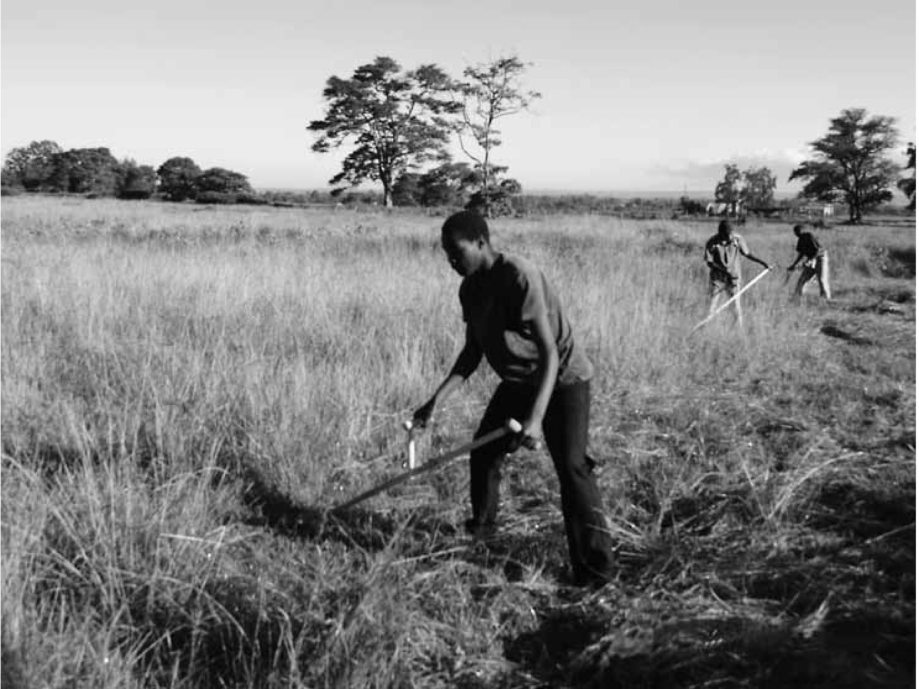 | Mowing  with a  Scythe




INTRODUCTION
The scythe is an instrument used to cut grass or shrub. It was used extensively in Europe and North America until the early twentieth century, after which it went out of favor as farm mechanization progressed. However, the scythe is gaining new interest among small farmers in the West, and could be a useful tool for farmers in the tropics who do not have the resources to buy expensive mowing equipment. This becomes more important with the increasing demand for dairy and meat products in developing countries.
For example, the dairy sector—and the need for forage with it—is growing rapidly in the east African highlands. While animals can be grazed in the rainy season or fed fresh fodder when grass is plentiful, stored hay, or haylage, is needed to guarantee milk production in the dry season. Additionally, because milk is often produced near urban centers due to the absence of milkcooling facilities, fodder needs to be transported to the dairy regions even in the rainy season. Because properly dried hay has a low moisture content, it is preferred over silage if transportation is required. All this has led to high prices of hay in local markets, which provides entrepreneurial individuals with an opportunity to turn this into a profitable business. However, small farmers are faced with the huge obstacle of not being able to cut forages quickly. One observes women and men cutting hay with machetes or slashes, tools not really designed for this purpose. One swing of a machete cuts a swath perhaps 20 inches (50 centimeters) long and 2 inches (5 centimeters) wide. Compare this with one swing of a scythe, which can easily cut a swath 6 feet (2 meters) long by 4 inches (10 centimeters) wide.
Power mowers are usually beyond the means of many farmers; in addition, issues with maintenance, transportation, and the cost of inputs make them unattractive. Therefore, for many reasons the scythe is a good start for enabling small farmers to engage in the hay production business. Surprisingly, few people in developing countries know of the existence of scythes. At the same time, there are many landowners in the West who are interested in making hay on a few acres but are unable to afford expensive mowers. The scythe may be a tool that allows them to make productive use out of what otherwise would be a lawn that just needs to be maintained.
Finally, there is a vibrant alternative agriculture movement interested in agricultural production without extensive fossil fuel inputs. The scythe is an ideal instrument for making hay using renewable resources.
Despite the interest in scythe mowing, it is difficult to find knowledgeable individuals who can guide potential users in scythe selection, maintenance, and operation. Knowledge about scythes is basically absent in developing countries, and even among farmers such as the Amish in the United States, knowledge of scythes has mostly disappeared as they have transitioned to using
horse-drawn sickle-bar mowers. Fortunately, a small community of enthusiasts is making resources on scythes available. Online information sources include www .sythesupply.com and www.onescytherevolution .com. An invaluable book is The Scythe Book (2001, 2nd ed.) by David Tresemer. Useful videos clips available online of different aspects of scythe mowing are posted on YouTube under the name “scythesman8.” These resources were combined with experience with scythe mowing to compile this fact sheet, which gives a description of different types of scythes, the parts of the scythe, and sharpening and mowing techniques. I hope this resource will help stimulate successful use of the scythe around the world.
THE SCYTHE Types
—2—
There are two types of scythes: the American scythe and the European (or Austrian) scythe (Figure 1). Confusion sometimes results because both types are made in Austria. The American scythe has a thicker, narrower, straight steel blade and an intricately curved “snath” (handle). The European scythe has a blade that is much thinner and curved, but its snath is straight or almost straight. The American scythe is what one would normally find in a farm supply store in the United States. The European scythe is common in Europe. Although preferences may vary, the European scythe is more suited for extensive use. It weighs a lot less than the American scythe. An American scythe purchased in a local farm store in Pennsylvania weighs almost 6 pounds (2.70 kilograms), while a European scythe weighs less than 4 pounds (1.75 kilograms). It is clear that when making ten thousand cuts to mow one acre, there is a big difference in the effort needed.
Second, the blade of the European scythe follows the ground smoothly because it is shaped to accommodate the distance of the blade to the ground as the mower moves his or her arms. Third, the blade of the European scythe is made of steel that is alloyed and heat treated to be strong, tough, and malleable. The malleability of the steel makes it easy to draw the steel to a thin cutting edge by peening (hammering the cutting edge very thin), and it is sharpened in the field with a whetting stone. In contrast, the American scythe needs to be sharpened with a grinder or other sharpening device, which usually cannot be carried to the field.
The Parts of a Scythe
A scythe has a blade and a snath (Figure 2). The blade parts are the point (or toe), edge, back, heel, beard, knob, and neck (Figure 3). The heel, knob, and neck together form the tang. The American-style blade does not have a beard; instead, the neck is immediately connected to the blade. Blades come in different lengths, varying from 12 inches (30 centimeters) to 50 inches (125 centimeters)

—3—
Blade
Snath
Lower grip or “nib”
Upper grip or “nib”
Figure 2. The basic parts of a scythe.
Point or toe
Knob Neck
Tang
Beard
Edge
Heel
Back
Figure 3. The components of the European scythe blade.
American scythe European scythe
Figure 1. Comparison of American and European scythes (note different shape of blade and snath).
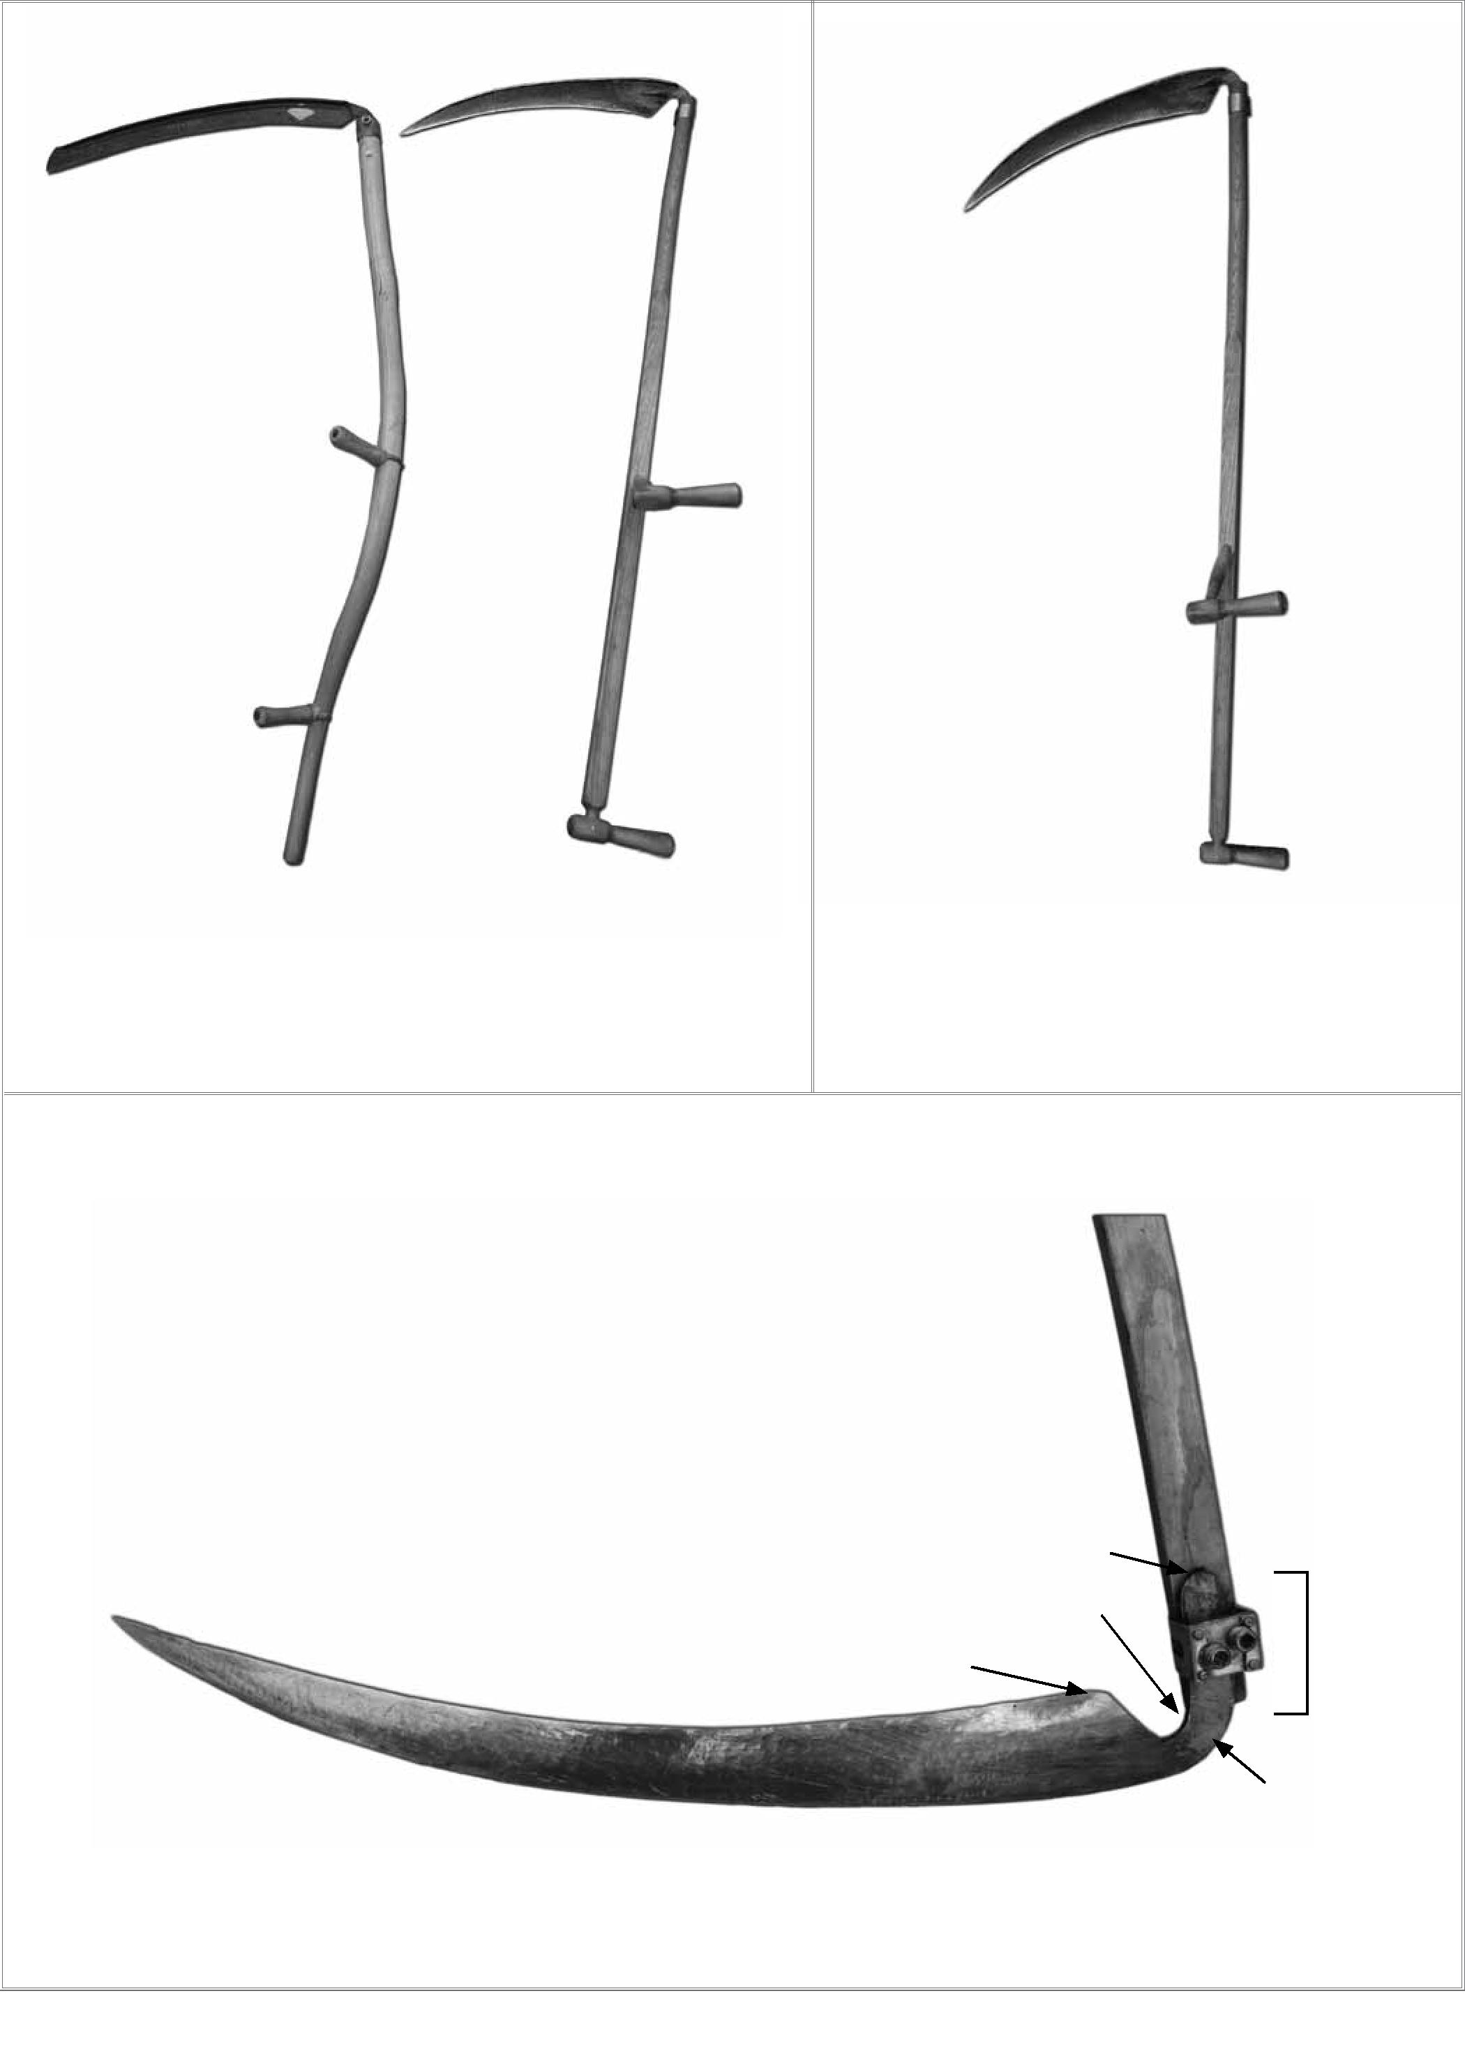

long. The short blades are fit to work in tight corners and around obstacles, while the longer blades are useful for wide-open fields or lawns. Bush blades are made heavier than grass blades to accommodate the increased stress exerted by brush and stems of one- or two-year-old trees. The snath of the American scythe has an intricate curve, while the European scythe usually has a straight snath (sometimes with a slightly bent-up end). The grips of the American scythe are adjustable. The grips of the European scythe may be adjustable as well, but the top grip is usually fixed once attached. Both grips may also be fixed on the European scythe, in which case they have to be mounted at the right place on the snath to accommodate the dimensions of the mower.
—i—
MOUNTING THE BLADE ON THE SNATH
The straight blade of the American scythe is mounted on the snath with a U-bolt that is fastened with two nuts at the backside of the snath. The tang is inserted through the U-bolt and the knob is inserted into a hole in a metal plate. The different holes allow the blade to be positioned at the desired angle to obtain best cutting action; the optimum angle can change with variations in forage species, density, or maturity. The tang of the European scythe is inserted through a scythe ring so that the knob fits into a hole 31/4 inches from the end of the snath. The blade neck can be moved from side to side to adjust the angle of the blade with the snath (the “hafting angle”).
If one cannot get a sufficient hafting angle for the blade, it is possible to insert a shim on one or both sides of the ring, between the ring and the snatch, to increase the distance between the sides of the ring. The scythe ring is tightened by fastening two set screws with the square scythe key. If the hole wears out, a metal plate can be attached to the snath with a 5/16-inch hole through which the knob can be fitted. Normally, the correct angle is acquired as follows: stand the snath upside down with the blade hanging loose in the scythe ring. The tang should hang toward the blade. Now tighten the set screws on the scythe ring (Figure 4).
A method to check proper mounting of the blade on the snath suggested in The Scythe Book is as follows: Hold the snath straight up with the upper handle resting on the ground against a wall. Make a mark at the lower tip of the beard. Now move the snath to the right (for the right-hand mower) or the left (left-hand mower) while leaving the upper grip in the same position until the point of the blade reaches the same vertical position as the mark on the wall. The point should be three fingers below the mark on the wall. If not, adjust the angle of blade with snath (the “hafting angle”). On my own scythe the distance between the mark on the wall and the point of the blade was only one finger, but the angle between blade and snath could not be narrowed any farther. The hafting angle changes occasionally, especially when mowing in rough conditions. The mower will immediately notice the effect because the scythe will lay
Figure 4. The proper hafting angle in which the tang hangs snug against the blade side of the scythe ring.
the grass over instead of cutting it. The initial reaction is usually to start hacking to cut the grass. Instead, the hafting angle needs to be adjusted by loosening the set screws, correcting the angle of the blade to the snath, and refastening the set screws.
Proper
hafting angle
Scythe ring

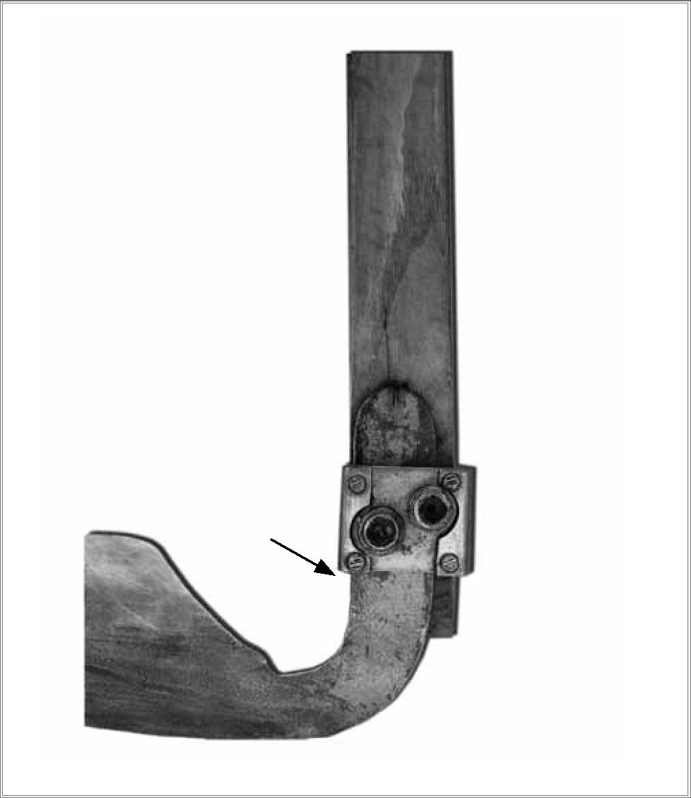
PROPER PLACEMENT OF GRIPS
The grips of the European scythe should be mounted as follows:
- The lower grip should be at hip height when the mower stands upright holding the snath parallel to the body with the blade resting on the ground. The hip is defined as the peak or point of the pelvis. Mounting the lower grip high enough is important to enable comfortable mowing without a stoop.
- The lower and upper grip should be spaced apart as far as the distance between elbow and index fingertip.
- The scythe should balance with the blade parallel to the ground when resting the middle of the lower grip on a single finger.
As explained in the appendix of The Scythe Book, these measurements can be adjusted depending on body shape and main mowing tasks (trimming or field). A trimming scythe could have a snath 4 inches shorter than a field scythe, and the distance between lower and upper grip could be 2 inches less. When purchasing a scythe, provide the supplier with the distance between your index finger and your elbow and the length between the sole of your

Figure 5. A peening hammer, peening jig, and a peening anvil.
Peening anvil
Peening hammer
Peening jig with two rings

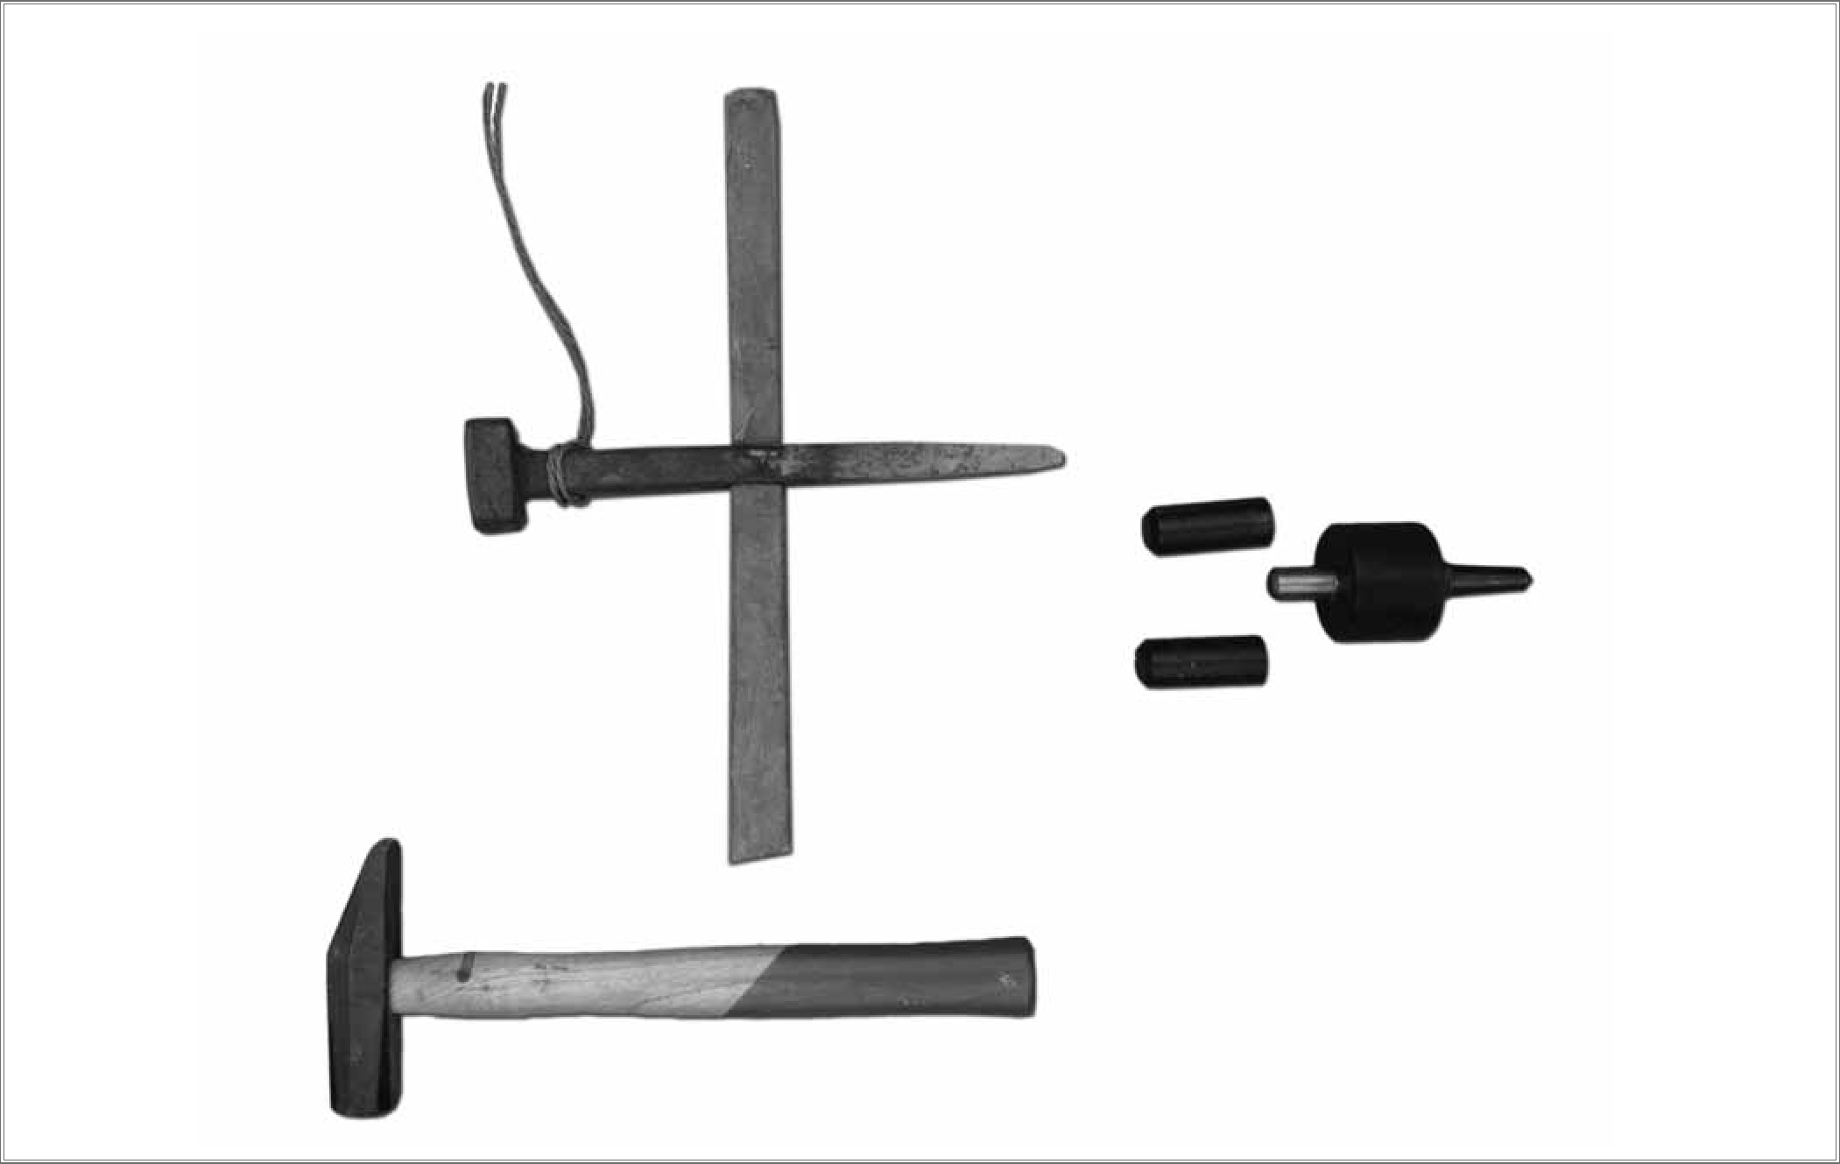

foot and the top of your femur bone. The supplier will then send you the proper snath and grip positions to enable you to mow in the most relaxed posture. When mounting grips, find a comfortable position for mowing before gluing them on. It is helpful to drill a small hole in the upper grip and hammer a steel nail through the grip into the snath to keep it from coming loose (don’t use a screw because it will snap off).
SHARPENING
A properly sharpened scythe makes the difference between frustration and satisfaction. It is very important to sharpen the blade and keep it sharp while mowing. If the edge is not sharp, the grass will be pushed flat against the ground instead of being sliced by the scythe.
PEENING
Peening is the hammering of the edge of the blade to bring steel to the edge to harden the steel and make it thin so that it slices through the grass without much effort. Peening is an art—it takes practice to learn. Peening too little will leave a thick blade edge, which blunts quickly, necessitating more frequent whetting. On the other hand, peening the blade too thin will make it brittle and weak so it is more likely to be damaged when hitting a rock, stump, or other obstruction.
There are two methods to peen a scythe blade. The first uses a specialized peening jig available from supply stores of the European scythe, and the second method uses a peening hammer and anvil. (A third, which uses a peening apparatus, will not be discussed here.) It is recommended that you remove the blade from the snath before you start peening because it is much easier to balance the blade without the snath attached.
A peening jig comes with three parts: a base and two caps (Figure 5). The base has a tapered end, which should be inserted into a slightly undersized hole drilled into a block of wood. Ideally, the block of wood should be tall enough to allow you to sit on a chair, rest the blade on the base, and provide further support to the blade by your legs. If you cannot rest the blade on your legs, you will have to keep the blade at the proper position by supporting it otherwise. The caps are distinguished by one or two grooves machined in the circumference of the cap. Their order of use corresponds with the number of grooves. The cap with one groove is used less frequently than the one with two grooves. The first cap brings out the steel from the blade to the edge. The second cap will flatten the edge of the blade. Peening with a jig will not sharpen the edge; it will dull the edge. Drawing out the edge with the jig thins the steel, forcing it against the center post and creating a dull edge. This is an inherent fault with the peening jig. The primary purpose of
—5—

peening is to shape the edge, but it needs to be followed by whetting to create a sharp edge.
You should peen the blade approximately every day of use. It usually takes 5–15 minutes to peen a 26-inch blade. It is important to lay the blade flat on the base, gently pushing it against the center of the base, with the edge under the cap. Use a normal carpentry hammer, nothing heavier. Using the hammer’s weight, uniformly hammer the blade, moving it slowly from the beard to the point as you go. First use the cap with one bevel, then repeat the job with the cap with two bevels. You don’t have to use the cap with one groove as frequently as the one with two grooves.
Despite the ease of use of the peening jig, the experienced scythe mower will want to learn how to peen with peening anvil and hammer. The hammer has a flat head that is slightly rounded. To bring the steel from the blade to the edge, make a slight arc with the hammer, hitting the steel a small distance from the edge. The hammer movement should bring the steel toward the edge. After peening the entire length of the blade in this manner, make a second pass in which the peening hammer moves straight up and down on the very edge of the blade to harden and sharpen the edge. The hammering should be kept light—just enough force to move steel the desired amount. The experienced scythe mower will be able to create a perfectly uniform blade edge that is razor sharp. However, it takes a lot of practice to reach this level of perfection. Do not worry, even if the edge is slightly wavy. The most important
thing is to make the blade edge strong and sharp. Slight irregularities will have a minor impact on mowing effectiveness.
WHETTING
Whetting (also called “honing”) is done with a stone with proper grit. Natural and synthetic whetting stones are available (Figure 6). The coarser grit takes off more steel, while the finer grit leaves a more smooth edge but takes longer to whet the blade.
After peening, mount the blade on the snath using the scythe ring. Turn the scythe upside down with the upper handle resting firmly on the ground. You will be looking at the bottom of the blade, which we will call “front,” while the top of the blade faces away from you, which we will call “back.” Secure the snath by placing a foot on the upper handle. The point of the blade may be positioned against a tree or post, if available. Swirl the whetting stone, which you keep in the stone holder attached to your belt, in water. The water removes any fine particles from the pores of the stone and enables the stone to do its job.
The stone has a shape allowing you to sharpen a very penetrating edge on the blade. Hold the beard of the blade firmly with your left hand (if you are righthanded). Holding the whetting stone in the palm of your hand, start at the beard and move toward the point. Whet with the narrow edge, exerting considerable pressure against the back of the blade. Move the stone toward you while whetting, and make sure the passes of the whetting stone overlap as you move closer to the point.

Water holder for natural whetting stone
Synthetic whetting stone
Natural whetting stone
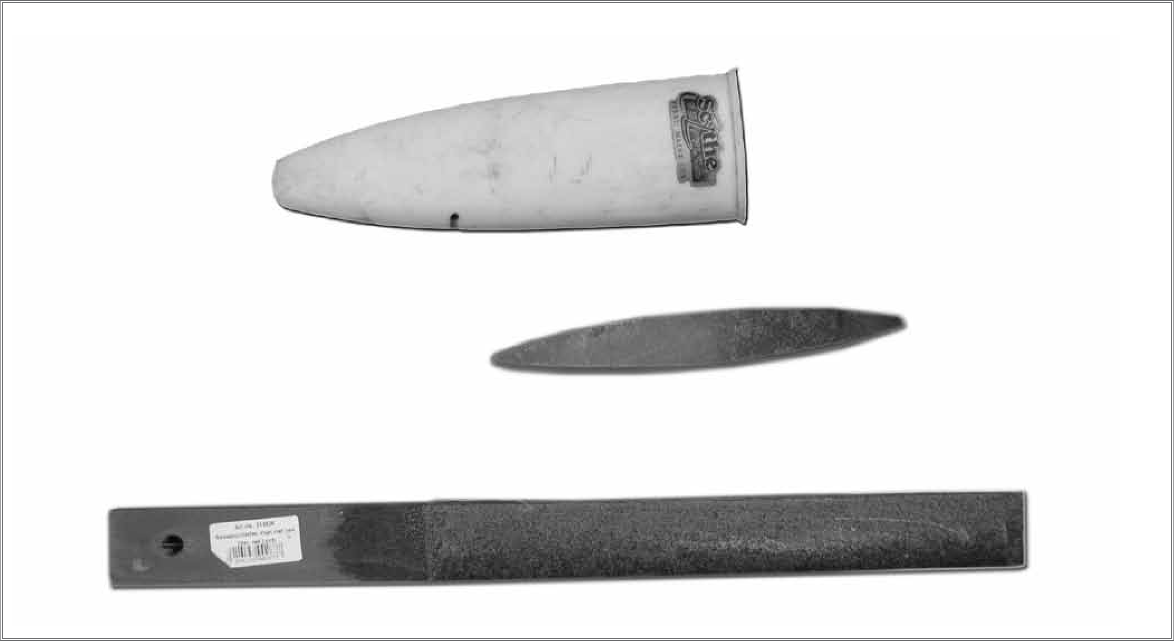

Figure 6. Whetting stones and holder.
—6—

Once finished whetting the back, take off the burr from the front. You should apply about twice as much force when whetting the back of the blade than the front. Once you become more experienced, you may wish to alternate whetting the blade’s front and back as you go down the blade.
Another whetting technique is to use the stone in a swiping movement along the entire edge of the blade, alternating between top and bottom. This technique is common with the use of the synthetic stone mounted on a wooden stick.
When in the field mowing, whet the blade approximately every 15 minutes. You will quickly notice when the blade loses its cutting power and needs to be whetted anew because the blade will push the grass over instead of cutting it.
MOWING
The scythe can mow different types of vegetation. It is best to start practicing with green grass that has gone into head in a smooth field without obstacles. It is preferable to avoid bunch grass, at least for the beginner. The stems of heading grass provide more resistance than lush, green grass, making it easier to cut. Stand firmly on two legs, with the left leg slightly in front of the right leg if you are right-handed. Now move the scythe backward to the right by swinging your upper body to the right. Make an arc with the back of the blade resting on the ground. If the field is rough because it has holes or old wheel tracks, it may be necessary to keep the blade slightly off the ground. When the back of the blade rests on the ground, the cutting edge will be slightly off the ground, cutting at a height of 1/4–1/2 inch.
It is better from a biological point of view to cut grass a few inches above the soil. This lower stem, known as stubble, contains large amounts of sugar and starch used by the plant during regrowth. Leaving less than 2 inches of stubble can greatly reduce the rate of regrowth of many temperate grasses, and leaving less than 4 inches of growth can reduce the regrowth of semitropical and tropical species. However, the scythe needs the resistance offered by the part of the plant that is anchored in the soil. The need to mow close to the ground is a disadvantage of mowing with a scythe. Cut a thin slice of grass. If you try to cut large slices at a time, the scythe tends to get stuck halfway, and much effort is needed. Instead, cut small bites at a time. The blade should move easily through the grass and deposit it at end of the arc on your left hand. Do not make a hacking movement. Move the scythe back, having it rest gently on the soil surface to avoid carrying the weight of the scythe.
A swath will form as you mow a section. Move forward a little and take the next cut. You will move one foot a step and then the other foot a step, making a dancing-like movement as you cut the grass. Start making a pass around the outside, moving clockwise around the field. This way the swath will always be
deposited in the recently cut grass instead of on the grass that still needs to be cut. When mowing in teams, the front mower will be ahead of the second mower.
If the blade does not cut smoothly, the tendency is to compensate by starting to hack. This makes cutting grass with a scythe laborious. The reason for hacking is usually that the scythe is not sharp or the angle of the blade with the snath needs to be readjusted. When you notice that you are starting to use more force to cut the grass, it is time to sharpen the blade with the whetting stone and check the angle between the blade and the snath. If you notice that the blade dulls easily, it is time to peen it because the edge has become too thick.
—7—
When to Mow
The right time to mow grass with the scythe is early in the morning when the grass is covered by dew. From the standpoint of quickly drying hay and preserving its quality, it would be better to mow later, after most of the dew has evaporated. However, the dew offers additional mass, making it easier to cut grass. In addition, grass that is under some drought stress loses some of its turgor (internal pressure of the water in the cells), which makes it also more difficult to slice through the stems and leaves.
It is important to spread the grass immediately after it is cut. At that time, the recently cut plants continue photosynthesizing; the stomata on the leaves remain open, continuing to draw moisture from the plant’s vascular tissues. In addition, sugars are still produced shortly after the grass is cut, which makes the hay more nutritious because these sugars stay in the grass leaves and stems instead of being transported through the phloem to the roots. It is important to dry hay as quickly as possible. Once photosynthesis shuts down and the stomata close, the moisture needs to pass through the cuticle of the grass leaves and stems instead. Therefore, the best time to mow hay is on a sunny, windy, and warm day. When the grass dries slowly, there is potential for loss of biomass through bacterial decomposition and extended periods of plant respiration. Sugars are the first to be used by microbes; hence, the quality of the hay degrades quickly. Thus, it is best to mow forage and have a second person behind you to spread it right away.
When the top of the hay is dry after a few hours, it is time to “ted” the hay, which is turning it with the fork and loosening it so the bottom of the spread swath is exposed to sunlight and moving air, increasing the rate of drying. In my experience in the east African highlands, it was possible to mow grass from 6:00 to 11:00 a.m. and collect hay at 4:00 p.m. on a bright sunny day with low humidity and a slight breeze. In humid climates, it may take several days for hay to be dry enough for safe storage.

CONCLUSION
—8—
Mowing with scythes is a skill that can greatly facilitate mowing forages and making hay on a small scale. Skill is required to operate and maintain scythes as described in this fact sheet. Once properly trained, scythe mowing can be a satisfying and profitable experience. If you have feedback on this fact sheet, please send comments to Sjoerd Duiker at sduiker@psu.edu.
Prepared by Sjoerd Duiker, associate professor of soil management and applied soil physics
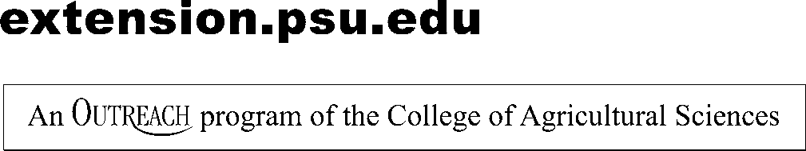
Penn State College of Agricultural Sciences research and extension programs are funded in part by Pennsylvania counties, the Commonwealth of Pennsylvania, and the U.S. Department of Agriculture.
This publication is available from the Publications Distribution Center, The Pennsylvania State University, 112 Agricultural Administration Building, University Park, PA 16802. For information telephone 814-865-6713.
This publication is available in alternative media on request.
The Pennsylvania State University is committed to the policy that all persons shall have equal access to programs, facilities, admission, and employment without regard to personal characteristics not related to ability, performance, or qualifications as determined by University policy or by state or federal authorities. It is the policy of the University to maintain an academic and work environment free of discrimination, including harassment. The Pennsylvania State University prohibits discrimination and harassment against any person because of age, ancestry, color, disability or handicap, genetic information, national origin, race, religious creed, sex, sexual orientation, gender identity, or veteran status and retaliation due to the reporting of discrimination or harassment. Discrimination, harassment, or retaliation against faculty, staff, or students will not be tolerated at The Pennsylvania State University. Direct all inquiries regarding the nondiscrimination policy to the Affirmative Action Director, The Pennsylvania State University, 328 Boucke Building, University Park, PA 16802 5901; Tel 814-865-4700/V, 814-863-0471/TTY.
Produced by Ag Communications and Marketing © The Pennsylvania State University 2012 Code # EE0025 3M4/12mpc5135

