Universal Nut Sheller (with forms)
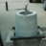
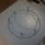
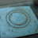

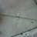

Author:Jural
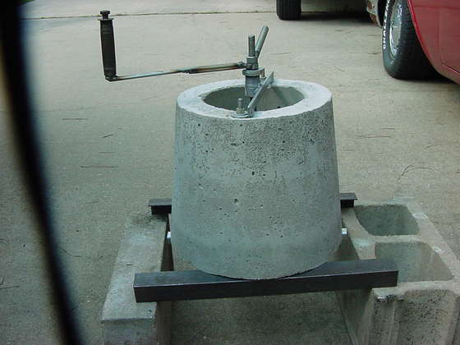
i
- 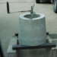
- 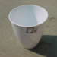
- 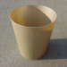
This Instructable was inspired by the Universal Nut Sheller invented by Jock Brandis of the Full Belly Project . The original design can be found here .
Items needed
8 bolts - I used 6 one and one half inch and 2 two inch bolts. You'll need the nuts also.
Various washers. At least 3 for the rotor.
1 threaded rod (1/2 inch x 24 inches)
1 angle iron (36 inches)
Scrap metal
2 two inch threaded iron pipe (3/4 inch)
4 threaded PVC pipe (1/2 inch)
1 2 x 2 foot blue 1/2 inch insulation board
2 plastic waste paper baskets (found at Walmart or most other home supply stores.
2 forty pound bags of sand mix concrete
Bearing grease
Tools needed
Welder
Angle Grinder
Hack Saw
Pliers
Adjustable wrench
Razor knife
Marker
Duct tape (masking worked also)
Bucket or plastic bin to mix concrete
Small shovel
Remove these ads by Signing Up

Step 1Preparing the forms and blue board.
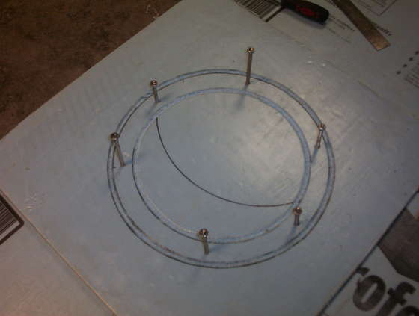
i
- 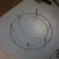
- 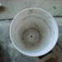
1. Place the blue board on a flat working surface and get out your marker.
2. Put the larger stator mold top down in the center of the blue board.
3. With your marker, draw a line around the edge of the stator.
4. Take the rotor form and center it within the first circle. Draw a line around it.
5. Take a razor knife and carve a groove just to the inside of each circle. 1/4 inch wide and 1/4 inch deep will be fine. This will hold the forms in place while pouring the concrete.
6. Again with your marker, mark six evenly spaced dots within the area you have created between the circles. This will serve as a guide for the placement of the bolts.
7. Cut the bottom out of the larger stator form.
8. Cut the form down the side from top to bottom. This allows for and easier release for the set concrete.
9.. Drill a 1/2 inch hole in the center of the bottom of the smaller rotor form.
10. Cut the sides of the rotor forms 3/4 of the way down from the top. Make the cuts directly across from each other. This allows it to release from the set concrete.

Source : http://www.instructables.com/id/Universal-Nut-Sheller-with-forms/

