Copper Alembic head DIY
by GurKin

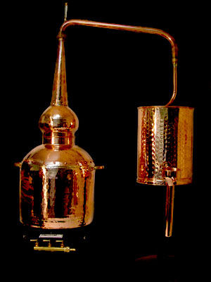

I decided to make own whiskey (in extremely traditional way)
As I was unable to buy Alembic I wish I decided to cinstruct one.
I collected Oak few casks and a lot of other hardware.
Most dramatic (for me) was to find round-shaped copper 'anything' to make Alembic head.
Geography in school was lil boring except globe, especially the way how to stick flat map on round base.

Step 1:

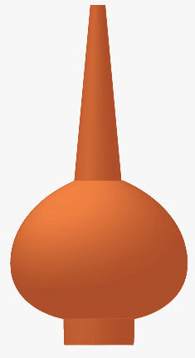

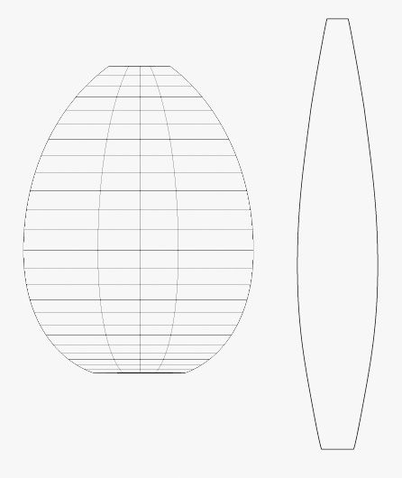

So, I steal the shape of Alembic head from whiskey alembic maker's site, traced it in adobe illustrator and calculated all the radius-es etc. to receive single form printed on paper.

Step 2:

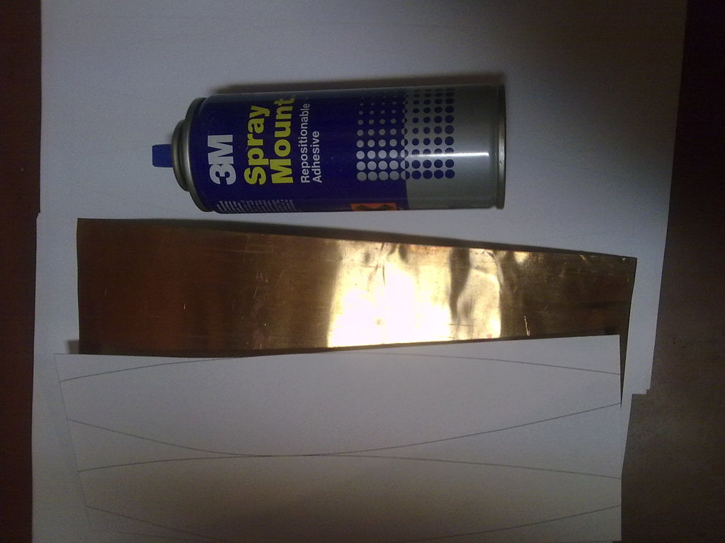

After printing it was mounted on copper stripe with Mount spray, cutted by scissors
and formed by rubber hammer in and on colander (!)

Step 3:

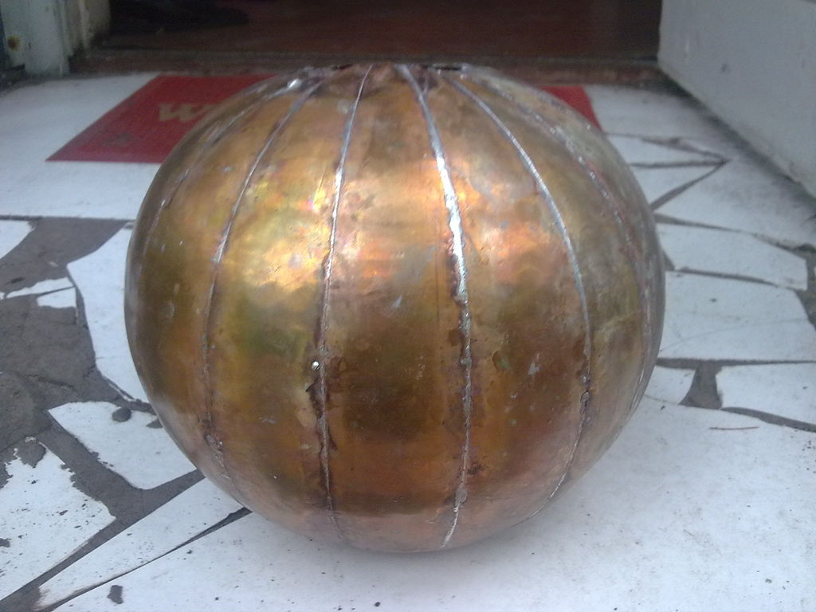

Soldering (with lead-free solder!) was both ease - because of acid flux was used - and hard because of positioning each leaf take bunch of patience.

Step 4:

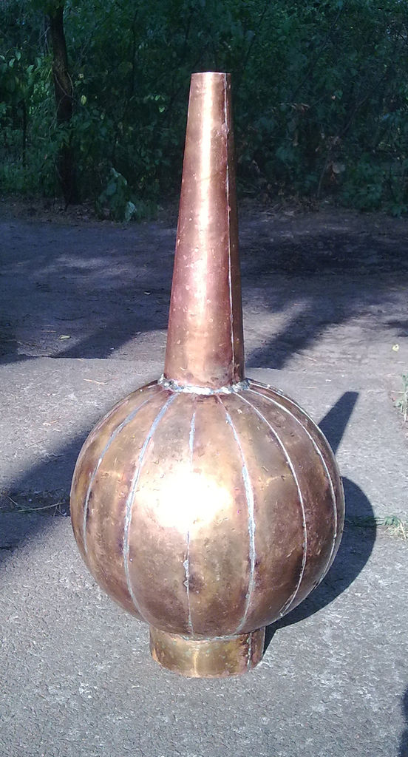

Adding top and bottom (drawed in illustratort too) was easiest part)
Voila)
Source : http://www.instructables.com/id/Copper-Alembic-head-DIY/?ALLSTEPS

