4.7 WIND POWER

4.7.1 Background and State-of-the-Art

i. Background
The wind has been used for pumping water for many centuries; it was in fact the primary method used for dewatering large areas of the Netherlands from the 13th century onwards; [36]. Smaller windpumps, generally made from wood, for use to dewater polders, (in Holland) and for pumping sea water in salt workings, (France, Spain and Portugal), were also widely used in Europe and are still used in places like Cape Verde; Fig. 107.
However the main type of windpump that has been used is the so-called American farm windpump; (Fig. 108). This normally has a steel, multibladed, fan-like rotor, which drives a reciprocating pump linkage usually via reduction gearing (Fig. 109) that connects directly with a piston pump located in a borehole directly below. The American farm windpump evolved during the period between 1860 and 1900 when many millions of cattle were being introduced on the North American Great Plains. Limited surface water created a vast demand for water lifting machinery, so windpumps rapidly became the main general purpose power source for this purpose. The US agricultural industry spawned a multitude of windpump manufacturers and there were serious R&D programmes, some sponsored by the US government, [37], to evolve better windpumps for irrigation as well as for water supply duties.
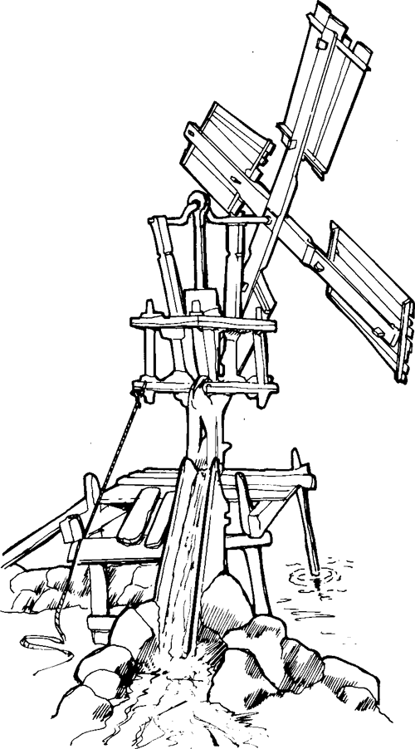
Fig. 107 Wooden indigenous windmill pump for pumping sea water into salt pans on the Island of Sal, Cape Verde
Other "new frontiers" such as Australia and Argentina took up the farm windpump, and to this day an estimated one million steel farm windpumps are in regular use [38], the largest numbers being in Australia and Argentina; [39], [40]. It should be noted that the so-called American Farm Windpump is rarely used today for irrigation; most are used for the purpose they were originally developed for, namely watering livestock and, to a lesser extent, for farm or community water supplies. They tend therefore to be applied at quite high heads by irrigation standards; typically in the 10 to 100m range on boreholes. Large windpumps are even in regular use on boreholes of over 200m depth.
Wind pumps have also been used in SE Asia and China for longer than in Europe, mainly for irrigation or for pumping sea water into drying pans for sea salt production. The Chinese sail windpump (Fig. 110) was first used over a thousand years ago and tens if not hundreds of thousands, are still in use in Hubei, Henan and North Jiangsu provinces [41]. The traditional Chinese designs are constructed from wire-braced bamboo poles carrying fabric sails; usually either a paddle pump or a dragon-spine (ladder pump) is used, typically at pumping heads of less than lm. Many Chinese windmills rely on the wind generally blowing in the same direction, because their rotors are of fixed orientation. Many hundreds of a similar design of windpump to the Chinese ones are also used on saltpans in Thailand, (Fig. 111).
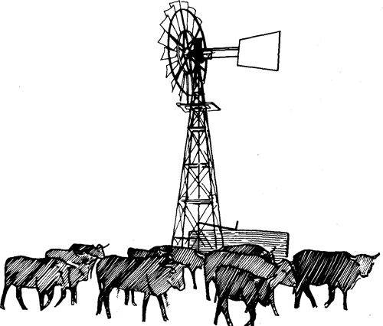
Fig. 108 All-steel 'American' farm wind pump
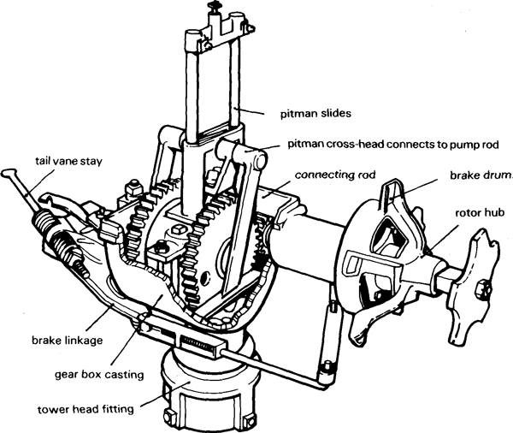
Fig. 109 Gearbox from a typical back-geared 'American' farm windmill
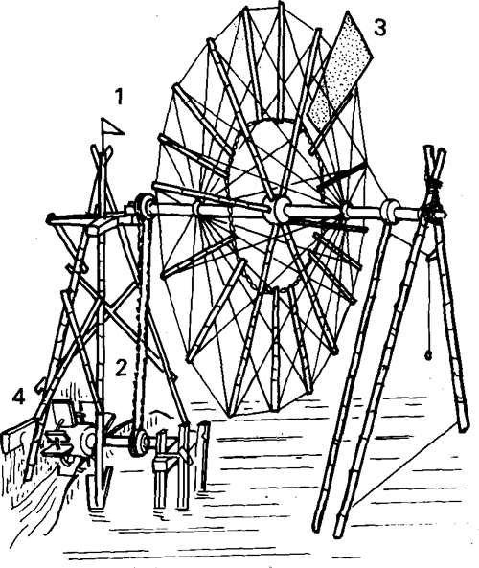
Fig. 110 Chinese chain windmill
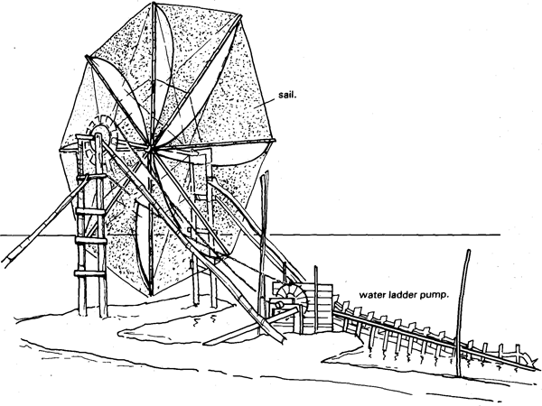
Fig. 111 Thai windpump (after Schioler [24])
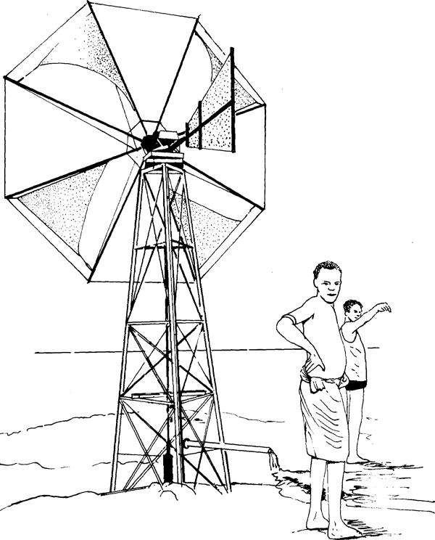
Fig. 112 'Cretan' type of windmill used on an irrigation project in Southern Ethiopia (after Fraenkel [15])
Some 50 000 windpumps were used around the Mediterranean Sea 40 years ago for irrigation purposes, [42], These were improvised direct-drive variations of the metal American farm windpump, but often using triangular cloth sails rather than metal blades. These sail windmills have a type of rotor which has been used for many centuries in the Mediterranean region, but today is often known as "Cretan Windmills" (see Fig. 112). During the last 30 years or so, increased prosperity combined with cheaper engines and fuels has generally led farmers in this region to abandon windmills and use small engines (or mains electricity where available). However Crete is well known as a country where until recently about 6 000 windpumps were still in use [91], mostly with the cloth sailed rig. The numbers of windpumps in use in Crete are rapidly declining and by 1986 were believed to be barely one thousand.
Another branch of wind energy technology began to develop in the late 1920s and early 1930s, namely, the wind-generator or aero-generator. Many thousands of small wind generators, such as the Australian Dunlite (Fig. 113), were brought into use for charging batteries which could be used for lighting, and especially for radio communication, in remote rural areas. Such machines can also provide an alternative to a photovoltaic array for irrigation pumping in suitably windy areas, although they have not so far been applied for this purpose in any numbers.
Large wind turbines for electricity generation have been (and are being) constructed, the largest being a 5MW (5 000kW) machine under development in West Germany. However, more modest, but still quite large medium sized machines are being installed in large numbers for feeding the local grid notably in the state of California (where over 10 000 medium sized wind generators have been installed in little more than 3 years for feeding the grid) and in Denmark. Fig. 114 shows a typical modern 55kW, 15m diameter Windmatic wind turbine, from Denmark. Machines of this size may in future be of considerable relevance for larger scale irrigation pumping than is feasible with more traditional mechanical windpumps, (see Gilmore et al [43], and Nelson et al [44]).

ii. State-of-the-Art
There are two distinct end-uses for windpumps, namely either irrigation or water supply, and these give rise to two distinct categories of windpump because the technical, operational and economic requirements are generally different for these end uses. That is not to say that a water supply windpump cannot be used for irrigation (they quite often are) but irrigation designs are generally unsuitable for water supply duties.
Most water supply windpumps must be ultra-reliable, to run unattended for most of the time (so they need automatic devices to prevent overspeeding in storms), and they also need the minimum of maintenance and attention and to be capable of pumping water generally from depths of 10m or more. A typical farm windpump should run for over 20 years with maintenance only once every year, and without any major replacements; this is a very demanding technical requirement since typically such a wind pump must average over 80 000 operating hours before anything significant wears out; this is four to ten times the operating life of most small diesel engines or about 20 times the life of a small engine pump. Windpumps to this standard therefore are usually industrially manufactured from steel components and drive piston pumps via reciprocating pump rods. Inevitably they are quite expensive in relation to their power output, because of the robust nature of their construction. But American, Australian and Argentinian ranchers have found the price worth paying for windpumps that achieve high reliability and minimum need for human intervention, as this is their main advantage over practically any other form of pumping systems.
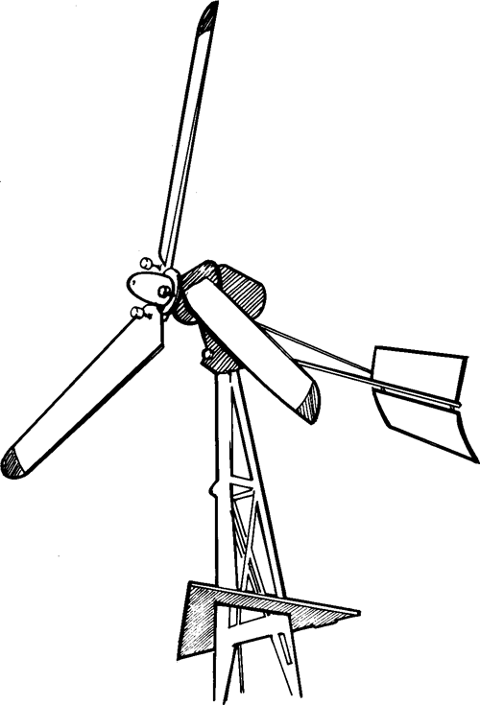
Fig. 113 2kW Dunlite wind electricity generator
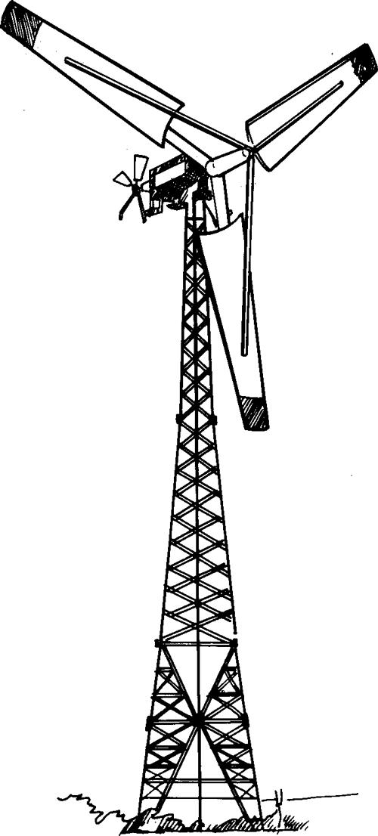
Fig. 114 55kW Windamatic wind electricity generator
Irrigation duties on the other hand are seasonal (so the windmill may only be useful for a limited fraction of the year), they involve pumping much larger volumes of water through a low head, and the intrinsic value of the water is low. Therefore any windpump developed for irrigation has to be low in cost and this requirement tends to overide most other considerations. Since irrigation generally involves the farmer and/or other workers being present, it is not so critical to have a machine capable of running unattended. Therefore windmills used for irrigation in the past tend to be indigenous designs that are often improvized or built by the farmer as a method of low-cost mechanization; (eg. Figs. 110, 111 and 112). If standard farm windpumps (Fig. 108) are used for irrigation, usually at much lower heads than are normal for water supply duties, there are quite often difficulties in providing a piston pump of sufficient diameter to give an adequate swept volume to absorb the power from the windmill. Also most farm windpumps have to, be located directly over the pump, on reinforced concrete foundations, which usually limits these machines to pumping from wells or boreholes rather than from open water. A suction pump can be used on farm windmills with suction heads of up to about 5-6m from surface water; (see Fig. 115 for typical farm windpump installation configurations). Most indigenous irrigation windpumps, on the other hand, such as those in China, use rotary pumps of one kind or another which are more suitable for low heads; they also do not experience such high mechanical forces as an industrial windpump, (many of which lift their pump rods with a pull of over 1tonne, quite enough to "uproot" any carelessly installed pump).
Attempts have been made recently to develop lower cost steel windpumps that incorporate the virtues of the heavier older designs. Most farm-windpumps, even though still in commercial production, date back to the 1920s or earlier and are therefore unecessarily heavy and expensive to manufacture, and difficult to install properly in remote areas. Recently various efforts have been made to revise the traditional farm windpump concept into a lighter and simpler modern form. Figs. 116 shows the "IT Windpump", which is half the weight of most traditional farm windpump designs of a similar size, and is manufactured in Kenya as the "Kijito" and in Pakistan as the "Tawana". The latter costs only about half as much as American or Australian machines of similar capability. It is possible therefore that through developments of this kind, costs might be kept low enough to allow the marketing of all steel windpumps that are both durable like the traditional designs, yet cheap enough to be economic for irrigation.
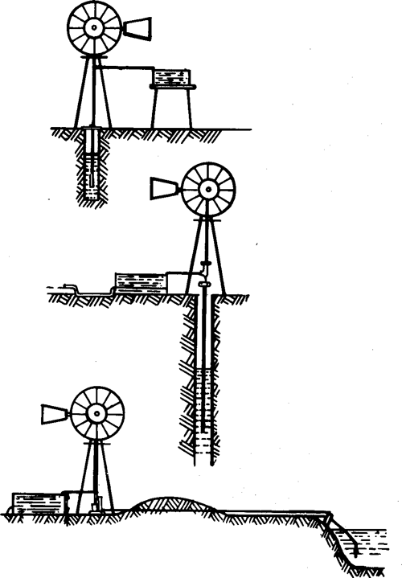
Fig. 115 Typical farm windpump installation configurations
A. borehole to raised storage tank
B. well to surface storage tank
C. surface suction pump
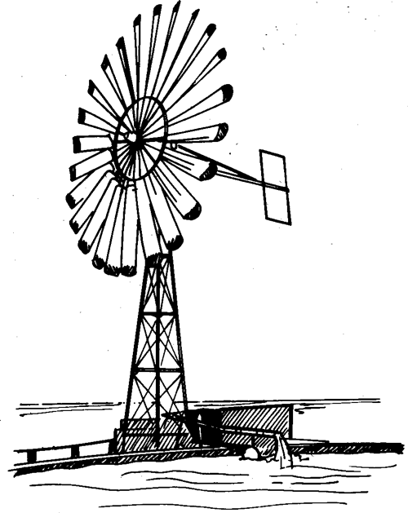
Fig. 116 IT windpump, made in Kenya as the 'Kijito' and in Pakistan as the 'Tawana'

4.7.2 Principles of Wind Energy Conversion

i. Power available in the wind
The power in the wind is proportional to the wind speed cubed; the general formula for power in the wind is:
where P is the power available in watts, p is the density of air (which is approximately 1.2kg/m³ at sea level), A is the cross-section (or swept area of a windmill rotor) of air flow of interest and V is the instantaneous free-stream wind velocity. If the velocity, V, is in m/s (note that lm/s is almost exactly 2 knots or nautical miles per hour), the power in the wind at sea level is:
Because of this cubic relationship, the power availability is extremely sensitive to wind speed; doubling the wind speed increases the power availability by a factor of eight; Table 16 indicates this variability.
Table 16 POWER IN THE WIND AS A FUNCTION OF WIND SPEED IN UNITS OF POWER PER UNIT AREA OF WIND STREAM
wind  speed | m/s | 2.5 | 5 | 7.5 | 10 | 15 | 20 | 30 | 40
wind  speed | km/h | 9 | 18 | 27 | 36 | 54 | 72 | 108 | 144
wind  speed | mph | 6 | 11 | 17 | 22 | 34 | 45 | 67 | 90
power  density | kW/m² | .01 | .08 | .27 | .64 | 2.2 | 5.1 | 17 | 41
power  density | hp/ft² | .001 | .009 | .035 | .076 | .23 | .65 | 2.1 | 5.2
This indicates the very high variability of wind power, from around 10W/m² in a light breeze up to 41 000Wm² in a hurricane blowing at 144km/h. This extreme variability greatly influences virtually all aspects of system design. It makes it impossible to consider trying to use winds of less than about 2.5m/s since the power available is too diffuse, while it becomes essential to shed power and even shut a windmill down if the wind speed exceeds about 10-15m/s (25-30mph) as excessive power then becomes available which would damage the average windmill if it operated under such conditions.
The power in the wind is a function of the air-density, so it declines with altitude as the air thins, as indicated in Table 17.
Table 17 VARIATION OF AIR DENSITY WITH ALTITUDE
altitude (ft) | 0 | 2 500 | 5 000 | 7 500 | 10 000
a.s.l. (m) | 0 | 760 | 1 520 | 2 290 | 3 050
density correction factor | 1.00 | 0.91 | 0.83 | 0.76 | 0.69
Because the power in the wind is so much more sensitive to velocity rather than to air density, the effect of altitude is relatively small. For example the power density of a 5m/s wind at sea level is about 75 watts/m²; however, due to the cube law, it only needs a wind speed of 5.64m/s at 3 000m a.s.l. to obtain exactly the same power of 75 watts/m². Therefore the drop in density can be compensated for by quite a marginal increase in wind velocity at high altitudes.

ii. Energy available in the wind
Because the speed of the wind constantly fluctuates, its power also varies to a proportionately greater extent because of the cube law. The energy available is the summed total of the power over a given time period. This is a complex subject (Lysen [45] gives a good introduction to it). The usual starting point to estimate the energy available in the wind at a specific location is some knowledge of the mean or average wind speed over some predefined time period; typically monthly means may be used. The most important point of general interest is that the actual energy available from the wind during a certain period is considerably more than if you take the energy that would be produced if the wind blew at its mean speed without variation for the same period. Typically the energy available will be about double the value obtained simply by multiplying the instantaneous power in the wind that would correspond to the mean wind speed blowing continuously, by the time interval. This is because the fluctuations in wind speed result in the average power being about double that which occurs instantaneously at the mean wind speed. The actual factor by which the average power exceeds the instantaneous power corresponding to the mean windspeed can vary from around 1.5 to 3 and depends on the local wind regime's actual variability. The greater the variability the greater this factor.
However, for any specific wind regime, the energy available will still generally be proportional to the mean wind speed cubed. We shall discuss later in this section how to determine the useful energy that can be obtained from a wind regime with respect to a particular windmill.

iii. Converting wind power to shaft power
There are two main mechanisms for converting the kinetic energy of the wind into mechanical work; both depend on slowing the wind and thereby extracting kinetic energy. The crudest, and least efficient technique is to use drag; drag is developed simply by obstructing the wind and creating turbulence and the drag force acts in the same direction as the wind. Some of the earliest and crudest types of wind machine, known generically as "panamones", depend on exposing a flat area on one side of a rotor to the wind while shielding (or reefing the sails) on the other side; the resulting differential drag force turns the rotor.
The other method, used for all the more efficient types of windmill, is to produce lift. Lift is produced when a sail or a flat surface is mounted at a small angle to the wind; this slightly deflects the wind and produces a large force perpendicular to the direction of the wind with a much smaller drag force. It is this principle by which a sailing ship can tack at speeds greater than the wind. Lift mainly deflects the wind and extracts kinetic energy with little turbulence, so it is therefore a more efficient method of extracting energy from the wind than drag.
It should be noted that the theoretical maximum fraction of the kinetic energy in the wind that could be utilized by a "perfect" wind turbine is approximately 60%. This is because it is impossible to stop the wind completely, which limits the percentage of kinetic energy that can be extracted.

iv. Horizontal and vertical axis rotors
Windmills rotate about either a vertical or a horizontal axis. All the windmills illustrated so far, and most in practical use today, are horizontal axis, but research is in progress to develop vertical axis machines. These have the advantage that they do not need to be orientated to face the wind, since they present the same cross section to the wind from any direction; however this is also a disadvantage as under storm conditions you cannot turn a vertical axis rotor away from the wind to reduce the wind loadings on it.
There are three main types of vertical axis windmill. Panamone differential drag devices (mentioned earlier), the Savonius rotor or "S" rotor (Fig. 117) and the Darrieus wind turbine (Fig. 118). The Savonius rotor consists of two or sometimes three curved interlocking plates grouped around a central shaft between two end caps; it works by a mixture of differential drag and lift. The Savonius rotor has been promoted as a device that can be readily improvized on a self-build basis, but its apparent simplicity is more perceived than real as there are serious problems in mounting the inevitably heavy rotor securely in bearings and in coupling its vertical drive shaft to a positive displacement pump (it turns too slowly to be useful for a centrifugal pump). However the main disadvantages of the Savonius rotor are two-fold:
- it is inefficient, and involves a lot of construction material relative to its size, so it is less cost-effective as a rotor than most other types;
- it is difficult to protect it from over-speeding in a storm and flying to pieces.
The Darrieus wind turbine has airfoil cross-section blades (streamlined lifting surfaces like the wings of an aircraft). These could be straight, giving the machine an "H"-shaped profile, but in practice most machines have the curved "egg-beater" or troposkien profile as illustrated. The main reason for this shape is because the centrifugal force caused by rotation would tend to bend straight blades, but the skipping rope or troposkien shape taken up by the curved blades can resist the bending forces effectively. Darrieus-type vertical axis turbines are quite efficient, since they depend purely on lift forces produced as the blades cross the wind (they travel at 3 to 5 times the speed of the wind, so that the wind meets the blade at a shallow enough angle to produce lift rather than drag). The Darrieus was predated by a much cruder vertical axis windmill with Bermuda (triangular) rig sails from the Turks and Caicos Islands of the West Indies (Fig. 119). This helps to show the principle by which the Darrieus works, because it is easy to imagine the sails of a Bermuda rig producing a propelling force as they cut across the wind in the same way as a sailing yacht; the Darrieus works on exactly the same principle.
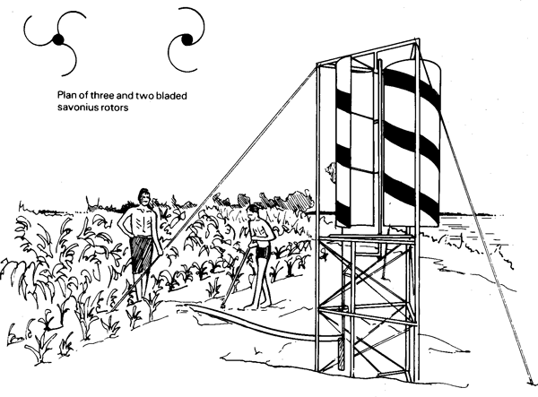
Fig. 117 Savonius Rotor vertical-axis windpump in Ethiopia. It was found to be less cost-effective than the 'Cretan' windmill of Fig. 112 (See ref. [15])
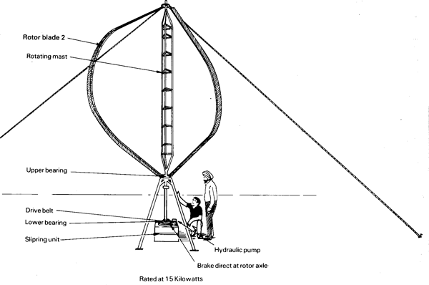
Fig. 118 Typical Troposkien shaped Darrieus vertical axis wind turbine
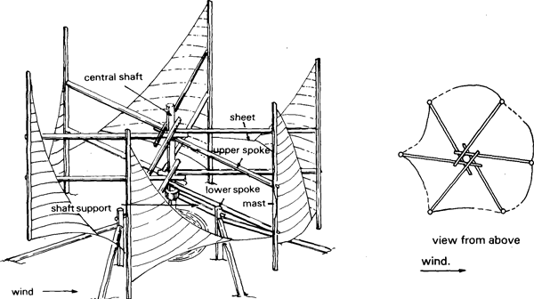
Fig. 119 Turks and Caicos islands vertical-axis sail rotor (after UNESCAP [51])
There are also two main types of Darrieus wind turbine which have straight blades; both control overspeed and consequent damage to the blades by incorporating a mechanism which reefs the blades at high speeds. These are the Variable Geometry Vertical Axis Wind Turbine (VGVAWT) developed by Musgrove in the UK and the Gyromill Variable Pitch Vertical Axis Wind Turbine (VPVAWT), developed by Pinson in the USA. Although the Musgrove VGVAWT has been tried as a windpump by P I Engineering, all the current development effort is being channelled into developing medium to large electricity grid-feeding, vertical-axis wind-generators, of little relevance to irrigation pumping.
Vertical axis windmills are rarely applied for practical purposes, although they are a popular subject for research. The main justification given for developing them is that they have some prospect of being simpler than horizontal axis windmills and therefore they may become more cost-effective. This still remains to be proved.
Most horizontal axis rotors work by lift forces generated when "propeller" or airscrew like blades are set at such an angle that at their optimum speed of rotation they make a small angle with the wind and generate lift forces in a tangential direction. Because the rotor tips travel faster than the roots, they "feel" the wind at a shallower angle and therefore an efficient horizontal axis rotor requires the blades to be twisted so that the angle with which they meet the wind is constant from root to tip. The blades or sails of slow speed machines can be quite crude (as in Fig. 107 ) but for higher speed machines they must be accurately shaped airfoils (Figs. 113 & Fig. 114 ); but in all three examples illustrated, the principle of operation is identical.

v. Efficiency, power and torque characteristics
Any wind turbine or windmill rotor can be characterized by plotting experimentally derived curves of power against rotational speed at various windspeeds; Fig. 120 A. Similarly the torque produced by a wind rotor produces a set of curves such as in Fig. 120 B.
The maximum efficiency coincides with the maximum power output in a given windspeed. Efficiency is usually presented as a non-dimensional ratio of shaft-power divided by wind-power passing through a disc or shape having the same area as the vertical profile of the windmill rotor; this ratio is known as the "Power Coefficient" or C_{p} and is numerically expressed as:
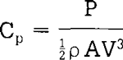
the speed is also conventionally expressed non-dimensionally as the "tip-speed ratio" ( /?/. ). This is the ratio of the speed of the windmill rotor tip, at radius R when rotating at ω radians/second, to the speed of the wind, V, and is numerically:
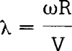
When the windmill rotor is stationery, its tip-speed ratio is also zero, and the rotor is stalled. This occurs when the torque produced by the wind is below the level needed to overcome the resistance of the load. A tip-speed ratio of 1 means the blade tips are moving at the same speed as the wind (so the wind angle "seen" by the blades will be 45°) and when it is 2, the tips are moving at twice the speed of the wind, and so on.
The c_{p} versus curves for three different types of rotor, with configurations A, B, C, D, El, E2 and F as indicated, are shown in Fig. 121. The second set of curves show the torque coefficients, which are a non-dimensional measure of the torque produced by a given size of rotor in a given wind speed (torque is the twisting force on the drive shaft). The torque coefficient, C_{t}, is defined as:
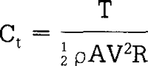
where T is the actual torque at windspeed V for a rotor of that configuration and radius R.
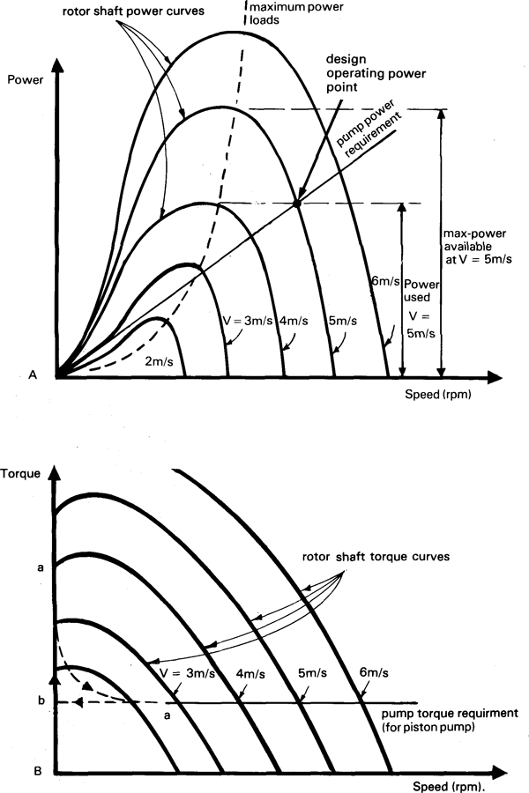
Fig. 120 The power (A) and torque (B) of a wind rotor as a function of rotational speed for difference wind speeds
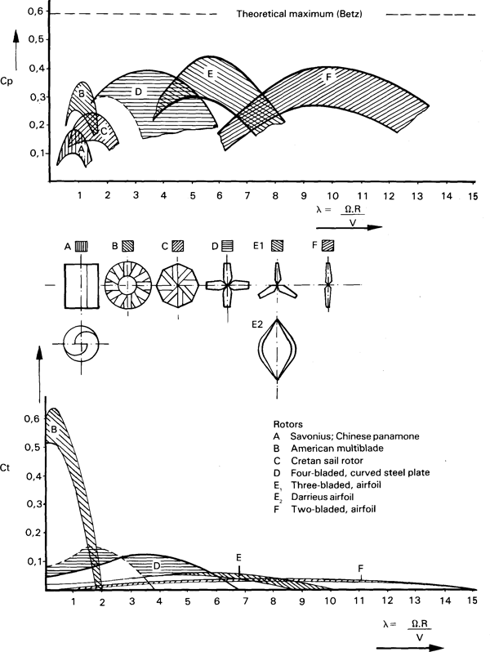
Fig. 121 The power coefficients (Cp) (above) and the torque coefficients (Ct) of various types of wind turbine rotor plotted against tip-speed ratio (λ) (after Lysen/CWD [45])

vi. Rotor solidity
"Solidity" (ó) is a fairly graphic term for the proportion of a windmill rotor's swept area that is filled with solid blades. It is generally defined as the ratio of the sum of the width, or "chords" of all the blades to the circumference of the rotor; i.e. 24 blades with a chord length (leading edge to trailing edge) of 0.3m on a 6m diameter rotor would have a tip solidity of:
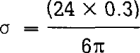
Multi-bladed rotors, as used on windpumps, (eg. rotor "B" in Fig. 121) are said to have high "solidity", because a large proportion of the rotor swept area is "solid" with blades. Such machines have to run at relatively low speeds and will therefore have their blades set at quite a coarse angle to the plain of rotation, like a screw with a coarse thread. This gives it a low tip-speed ratio at its maximum efficiency, of around 1.25, and a slightly lower maximum coefficient of performance than the faster types of rotor such as "D", "E" and "F" in the figure. However, the multi-bladed rotor has a very much higher torque coefficient at zero tip-speed ratio (between 0.5 and 0.6) than any of the other types. Its high starting torque (which is higher than its running torque) combined with its slow speed of rotation in a given wind make it well-suited to driving reciprocating borehole pumps.
In contrast, the two or three-bladed, low-solidity, rotors "El" and "F" in Fig. 121, are the most efficient, (with the highest values for C_{p}), but their tips must travel at six to ten times the speed of the wind to achieve their best efficiency. To do so they will be set at a slight angle to the plain of rotation, like a screw with a fine thread and will therefore spin much faster for a given windspeed and rotor diameter than a high solidity rotor. They also have very little starting torque, almost none at all, which means they can only start against loads which require little torque to start them, like electricity generators (or centrifugal pumps) rather than positive displacement pumps.
All this may sound academic, but it is fundamental to the design of wind rotors; it means that multi-bladed "high-solidity" rotors run at slow speeds and are somewhat less efficient than few-bladed "low solidity" rotors, but they have typically five to twenty times the starting torque.

vii. Matching rotors to pumps
High solidity rotors are typically used in conjunction with positive displacement (piston) pumps, because, as explained in Section 3.5, single-acting piston pumps need about three times as much torque to start them as to keep them going. Low solidity rotors, on the other hand, are best for use with electricity generators or centrifugal pumps, or even ladder pumps and chain and washer pumps, where the torque needed by the pump for starting is less than that needed for running at design speed. Table 18 indicates the relative characteristics and C_{p} values for various typical wind rotor types so far described.
Table 18 COMPARISON BETWEEN DIFFERENT ROTOR TYPES
Type | Performance  characteristic | Manufacturing requirements | Cp | Solidarity 6 | t.s.r.* (Optimum)
Horizontal axis —
Cretan sail or flat paddles | Medium starting torque and low speed | Simple | 0.05 to 0.15 | 50% 1.5-2.0 | 1.5-2.0
Cambered plate fan (American) | High starting torque and low speed | Moderate | 0.15 to 0.30 | 50 to 80% | 1-1.5
Moderate speed aero-generator | Low starting torque and moderate speed | Moderate, but with some precision | 0.20 to 0.35 | 5 to 10% | 3-5
High speed aero-gen. | Almost zero starting torque and high speeds | Precise | 0.30 to 0.45 | under 5% | 5-10
Vertical axis —
Panemone | Medium starting torque and low speed | Simple | under 0.10 | 50% | .4-.8
Savonius rotor | Medium starting torque and moderate speed | Moderate | 0.15 | 100% | .8-1
Darrieus rotor | Zero starting torque and moderate speed | Precise | 0.25 to 0.35 | 10% to 20% | 3-5
VGVAWT or Gyromill | Zero or small starting torque and moderate speed | Precise | 0.20 to 0.35 | 15% to 40% | 2-3
*t.s.r. = tip-speed ratio (X)
Fig. 120 A and B shows the load lines for a positive displacement direct-driven pump superimposed on the wind rotor output curves. The dotted line on Fig. 120 A indicates the locus of the points of maximum power; the system will only function continuously when the operating point is to the right of the line of maximum power, as under that condition any slight drop in wind speed causes the machine to slow and the power absorbed by the shaft to increase, which results in stable operation. The operating point can only remain to the left of the maximum power locus under conditions of increasing windspeed. It can be seen that the positive displacement pump requires more or less constant torque of 10Nm in the example, once rotation has been established, but it needs over three times as much torque to start it for reasons explained in Section 3.5. The torque curves in Fig. 120 B indicate that 5m/s windspeed is needed to produce the torque required to start the windpump rotating, but once rotation has commenced, the windspeed can fall to 3m/s before the operating point moves to the left of th maximum powere locus and the windpump will stop. Note that the broken line a'-a represents a transient condition that only occurs momentarily when the windpump starts to rotate.
To extract the maximum power from a windpump at all times would require a load which causes the operating point to follow close to the locus of maximum power; (Fig. 120). The figure also indicates that that the operating point will always be where the windpump rotor curve for the windspeed prevailing at a given moment coincides with the pump load line. In the example, the operating point is shown for a windspeed of 5m/s; in this example, it can be seen that only about two-thirds of the maximum power that could be produced in this wind speed is used by the pump, because its load line diverges from the cubic maximum power curve. This discrepancy is a mis-match between the prime-mover (the windmill rotor) and the load (the pump). The proportion of the power available from the rotor in a given windspeed which is usefully applied is known as the "matching efficiency", and is analysed in detail in Pinilla, et al [46], The figure illustrates how this mis-match becomes progressively worse as the wind speed increases. This mis-match is actually less serious than it may seem, since the time when the best efficiency is needed is at low windspeeds when, fortunately, the best efficiency is achieved. When a windmill is running fast enough to be badly matched with its pump, it means that the wind is blowing more strongly than usual and the chances are that the output, although theoretically reduced by bad matching, will be more than adequate, as the extra speed will compensate for the reduction in efficiency.
It may be thought that centrifugal pumps would match better with a windmill than positive displacement pumps, but in practice their efficiency falls rapidly to zero below a certain threshold running speed at a fixed static head. In otherwords, centrifugal pumps do not readily run with adequate efficiency over as wide a speed range as is necessary to match most windmills rotors and they are therefore not generally used with windmills (except with intermediate electrical transmission which can modify the relationship between the pump and windmill speeds).
When generators are used as a load, instead of pumps, a much better match can be obtained. Wind generators therefore tend to have a better matching efficiency over their whole range of operating speeds than windpumps; the interested reader is referred to a text on this subject, such as Lysen [45].
There is considerable scope for improving the overall performance of wind pumps by developing methods of improving the rotor-to-pump match over a wider range of windspeeds; a certain amount of, work is being carried out in this field and if successful could result in considerably more effective windpumps in the future. But in the meantime the main problem is to choose the most appropriate pump size for a given windmill in a given wind regime and location. Fig.122 shows how the pump load line can be altered simply by changing the mean pump rod pull, either by changing the stroke (by lengthening or shortening the crank) or by changing the diameter of the pump being used. A longer stroke and/or a larger pump will increase the pump rod force, and increase the mean torque requirement and hence the slope of the load line, and vice-versa. In Fig.122 it is clear that increasing the load increases the hydraulic output at higher speeds, but it also increases the value of V_{s}, the starting windspeed. Therefore, pump "C" in the diagram will start in a much lighter wind than the other pumps, but because of the shallower load line the output will be much smaller in high winds. There is therefore an important trade-off between achieving starting in adequately light winds and achieving a good output.
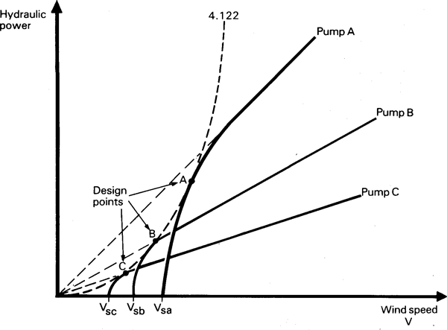
Fig. 122 The trade-off between starting windspeed and output for differently loaded windpumps
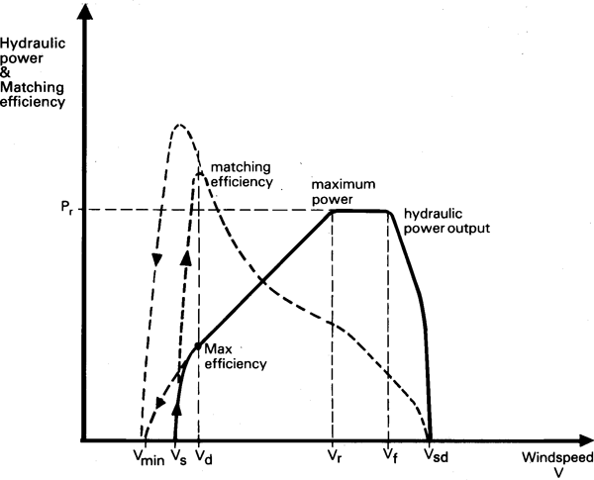
Fig. 123 The operating characteristic of a windpump showing how the power output and matching efficiency vary with windspeed
The operating characteristic of a typical windpump, given in Fig. 123, shows how if the start-up windspeed is V_{s} a windpump can run down to a slightly lower windspeed V (as explained earlier, assuming the use of a piston pump). It reaches its best match with the rotor at windspeeds close to V_{min} (in theory at 0.8V_{S}) [46] which is the "Design Windspeed", and then increases its output almost linearly with windspeed to V (its rated windspeed). At still higher windspeeds means must be introduced to prevent it speeding up further, or the machine may be over-loaded and damaged or destroyed; various methods for doing this are discussed in the next section below. At very high windspeeds, the only safe course of action is to make the windmill "reef", "furl" or "shut-down"; the figure shows how this process commences at a windspeed V_{f} (furling speed) and is completed at windspeed v_{sd} (shut-down).

viii. Methods of storm protection and furling
Windmills must have a means to limit the power they can deliver, or else they would have to be built excessively strongly (and expensively) merely to withstand only occasional high power outputs in storms. Sailing ships "take in canvas" by wholly or partially furling the sails (manually) when the wind is too strong, and Cretan sail windmills and other such simple traditional designs generally use exactly the same technique; fewer sails are used in high winds or else the sails are partially rolled around their spars. Metal farm windmills, however, have fixed steel blades, so the solution most generally adopted is to mount the rotor offset from the tower centre (Fig. 124) so that the wind constantly seeks to turn the rotor behind the tower. Under normal conditions the rotor is held into the wind by a long tail with a vane on it. This vane is hinged, and fixed in place with a pre-loaded spring (as illustrated), then when the wind load on the rotor reaches a level where the force is sufficient to overcome the pre-tension in the spring, the tail will start to fold until the wind pushes the rotor around so that it presents its edge to the wind, as in Fig. 124 This furling process starts when the rated output is reached and if the windspeed continues to rise, it increases progressively until the machine is fully furled. Then when the wind drops, the spring causes the tail vane to unfold again and turn the rotor once again to face the wind. On commercial farm windmills, this action is normally completely automatic.
Wind-generators and other windturbines with high speed, low-solidity rotors often use a mechanism which changes the blade pitch; e.g. the Dunlite machine of Fig. 113 which has small counter-weights, visible near the rotor hub, which force the blades into a coarser pitch under the influence of centrifugal force when the rotor reaches its furling speed, against the force of a spring enclosed in the hub. Alternatively air-brake flaps are deployed to prevent overspeed. Larger windturbines do not use tail vanes to keep them facing the wind, as they cannot stand being yawed as fast as might occur if there is a sudden change in wind direction. Instead they usually have a worm-reduction gear mechanism similar to that in a crane, which inches them round to face the wind; this can be electrically powered on signals from a small wind direction vane, or it can use the mechanism visible on the Windmatic in Fig. 114, used on large windmills for several centuries, where a sideways mounted windrotor drives the orientating mechanism every time the main rotor is at an angle other than at right angles to the wind direction.
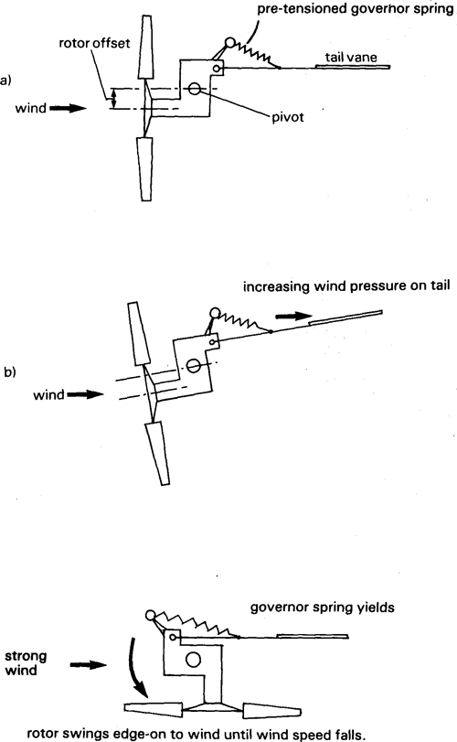
Fig. 124 Typical windpump storm protection method in which rotor is yawed edge-on to the wind (plan view)

4.7.3 The Wind Resource
It is not intended to attempt a detailed discussion of the complex subject of the causes and behaviour of the wind or how it is measured and analysed; useful references are Lysen [45], Park [46], Golding [47] and the W.M.O. [48].
The main fact to be aware of is that although the wind is extremely variable and unpredictable on a minute-by-minute or an hour-by-hour basis, the actual average windspeed at a given location over any given month of the year will not differ much from year to year. So if mean monthly windspeed figures are available, taken over a number of years, a reasonable prediction of the performance of a windpump should be possible. A variety of methods may be used to do this, some of which are described in the next section.

i. The minimum wind requirements for windpumps
It has shown that, typically, windpumps require an average "least windy month" windspeed of about 2.5m/s to begin to be economically competitive, (eg. Fraenkel, [40]). Because of the cube relationship between windspeed and energy availability, which is true for any optimally matched wind pump, and wind regime, the economics of windpumps are very sensitive to windspeed. Therefore, windpumps are one of the most cost-effective options (compared with engines or any other prime-movers) for pumping in locations with mean wind speeds exceeding about 4m/s, but, conversely, they are not at all cost-competitive where mean windspeeds are significantly below 2.5m/s. Fig. 125 rather crudely indicates the world's windspeed distribution pattern. This is considerably simplified and a much more detailed treatment of this topic is available from the World Meteorological Organization; [48]. It can be seen that much of the world, with the exception of the centres of the major land-masses, and the equatorial forested regions, is suitable for deploying windpumps. As a rule of thumb, areas that are free of trees (i.e. savannah grasslands, semi-deserts and deserts) tend to be windy and suitable for windpumps, while forested and wooded areas not only have less wind but trees make siting of windmills difficult unless very high towers can be used.
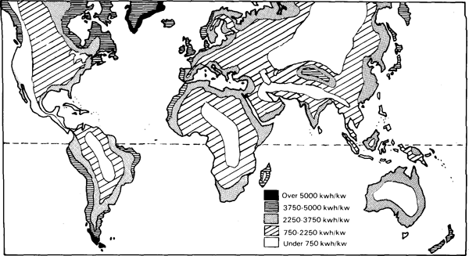
Fig. 125 Annual mean wind speeds (approximate indication)
Various studies on the potential market for windmills in different parts of the world, eg. [49], plus numerous country-specific studies of meteorological data, suggest that quite a number of developing countries probably have areas with adequate wind speeds for the use of windpumps. Some of these are listed below; those where windpumps are already known to be in at least moderately widespread use are marked (+):
Algeria, Argentina(+), Cape Verde Islands(+), Chile, China (+), Cyprus (+), Ecuador, Egypt, Ethiopia, India, Jordan, Kenya(+), Libya, Madagascar, Malta, Mauritania, Mauritius, Morocco (+), Mozambique, Namibia(+), Oman, Pakistan, Peru(+), Senegal, Somalia, Sudan, Syria, Tanzania, Thailand(+), Tunisia(+), Uruguay, Zambia, Zimbabwe(+).
There are also many small islands which are not listed but which invariably have adequate wind regimes due to the proximity of the open ocean.

ii. Variation of wind speed with height
The speed of the wind increases with height. The rate of increase is dependent partly on the height and partly on the nature of the ground surface. This is because rough ground, with many uneven trees, bushes or buildings, causes turbulence, while a flat and unobstructed surface like the sea or a flat grassy plain allows the air to flow smoothly which results in higher windspeeds nearer to the surface. The relationship between windspeed and height can be estimated as follows:
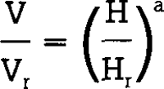
where V is the wind velocity at height H and V_{r} is a reference wind velocity measured at height H_{r}. The exponent "a" is a function of the surface roughness, as follows, [50]:
type of terrain | a
smooth sea or sand | 0.10
low grass steppe | 0.13
high grass and small bushes | 0.19
woodlands and urban areas | 0.32
For example, if there is high grass and small bushes, and a mean reference windspeed, for example, of 5m/s recorded at the standard meteorological office recommended height of 10m, this can be adjusted to obtain the mean windspeed at 20m windmill hub height as follows:
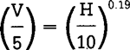
from which V= 5.7m/s A gain of 0.7m/s from mounting a windmill at 20m rather than at 10m may sound small in relation to the cost of the extra high tower required, but the energy available at those two heights will be related to the cube of the velocities (assuming optimally matched pumps in each case) and will therefore be:
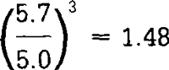
this shows that a 48% increase in energy availability can be gained in terrain of that type from using a 20m tower instead of a 10m tower (or a windmill with a smaller rotor could be used to gain the same energy - in this case the rotor area could be reduced so that a windmill with 20% smaller rotor diameter on a 20m tower would be used compared with one on a 10m tower).

iii. Effects of obstructions
Any obstruction to the wind has a wake extending up to 20 or 30 diameters (of the obstruction) downwind. The wake is depleted of wind energy compared with the surrounding wind, and is turbulent. For example a large mango tree (or similar rounded, well-leafed tall tree) can have a wake which even 200-300m downwind has 10% less wind energy than either side of it. Sharp edged and irregular obstructions such as rock outcrops, cliffs and escarpments, or large buildings can cause violent turbulence which, apart from depleting the energy available, can cause damage to a windmill located nearby.
Therefore it is normal to recommend that windmills are mounted so that the rotor is at least 200-300m from any significant obstruction to the wind. Ideally if obstructions like trees or buildings are nearby, the rotor should be mounted on a high enough tower so its bottom edge is a clear 5m or more above the highest point of the obstruction. In reality it is often impossible to avoid obstructions, so the least that can be done is to try and locate the windmill so that it is unobstructed from the direction of the prevailing wind. Because the wind lifts to go over an obstruction, siting windmills with large obstructions nearer than 100-200m downwind should also be avoided.

iv. Wind measurements and wind records
Sizing of a windmill for a particular pumping duty is commonly done, where windmills are already in general use, on the basis of the experience of other nearby users of windpower. If a nearby site looks better or worse in terms of exposure to the wind, then some suitable allowances must be estimated to compensate, without too much risk of serious misjudgement. Usually in such situations where windpumps are reasonably common, the suppliers will be able to recommend a suitable size to suit the duty requirement on the basis of past experience.
It is less easy to pioneer the use of windmills in any particular area; in such situations it is necessary to obtain some estimate of the local wind regime. One way to do this is by obtaining data from the nearest meteorological station or airport and making allowances on the basis of the relative exposure of the proposed site compared with the measuring station. Usually the protocol for obtaining this data is to request it from the head office of the Meteorological Department or the Civil Aviation Authority. Unfortunately, however, most small rural meteorological stations were not set up primarily to log wind data, and more often than not, they have incorrectly sited anemometers. Often the anemometers are on 2m tall masts and are surrounded by trees or buildings; any readings from such a site are next to useless for wind energy prediction purposes yet, unfortunately, they are often logged, sent to head office and incorporated in the national data-base, where they distort the apparent wind regime so far as its value for wind power is concerned. Therefore, when using data from a local rural meteorological station, it is strongly recommended that a visit should be made to the station to check whether the data were measured in an acceptable manner to make them of value. Data from international airports (or from major meteorological stations) are usually reliable as the anemometers are normally located at the W.M.O. recommended height of 10m and they will be unobstructed. This is especially true at airports where wind behaviour is of considerable interest from the point of view of aircraft safety. Most such stations log wind speed and direction data continuously on either paper charts or on magnetic tape.
The most basic format for national wind statistics is as in Fig. 126 which shows average wind speeds collected over a number of years, for each month, for a selection of meteorological stations in India. The Indian irrigation season typically occurs in the dry period from January to May, so by inspection it is possible to identify places with seemingly adequate wind regimes during this period; i.e. with monthly means preferably exceeding 2.5-3m/s.
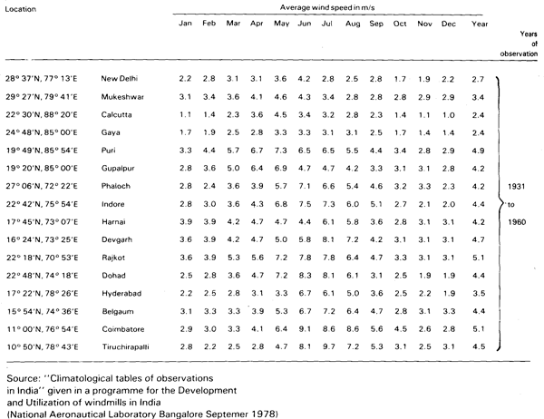
Fig. 126 Typical presentation of long term wind data as monthly averages
Another format commonly used for the presentation of wind data is given in Fig. 127, which shows a so-called "wind rose"; this includes information on the wind direction as well as its strength. The figure in the middle is the percentage of calm, (defined as less than 3 mph) and the "petals" of the rose are aligned with the points of the compass, (N, NNW, NW, WNW, W, etc.) and shows both the percentage of time the wind blows from each direction; (the concentric circles are 5% intervals) and the mean windspeeds (given in this case in "bins" of 3-8, 9-15, 16-38 and over 39mph. In the example shown the wind is clearly predominantly northeasterly and southwesterly. Wind roses are of most interest for comparing different locations. They are difficult to analyse from the point of view of predicting wind energy availability; raw wind data or even monthly mean wind data are more useful.
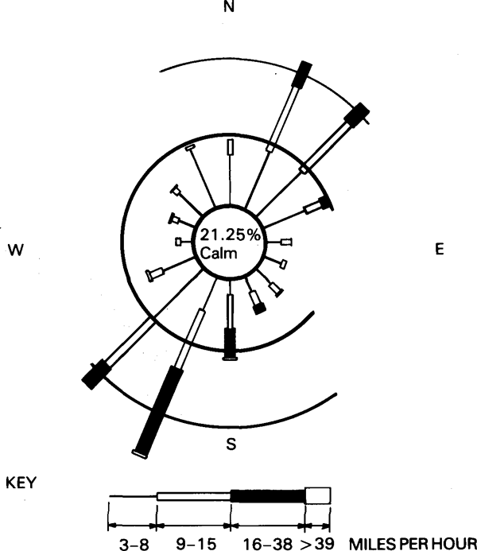
Fig. 127 Wind rose
If wind records are not available from a sufficiently close or representative existing meteorological station, then it is necessary to set up an anemometer and log wind records for at least one year and preferably two to three years. Obviously this is not a recommendation so much for the small farmer wanting one small windpump, but rather for institutional users contemplating a large investment in wind power which needs to be soundly based on objective wind records. Ideally, about three years of records are required to obtain reasonably representative averages, as mean monthly wind speeds can vary by 10-20% or so from one year to the next. The need for this is of course greater in areas which are thought to be "marginal" for the use of windpumps; it will be shown in the next section that commercial windpumps begin to become economically competitive with engines or other sources of power for water lifting in windspeeds above about 2.5m/s. Therefore, in places which are decidedly windy; i.e. with mean wind speeds almost certainly in excess of say 4m/s, there is no great risk in guessing the mean wind speed when ordering a windpump, and it probably is not worth the trouble and cost of carrying out long term wind measurements in advance. It is possible to "fine tune" the original guess, if it turns out not to be sufficiently accurate, simply by changing the stroke or the pump size. Subsequent windmills can be ordered on the basis of experience with the first one. However, if it turns out that there is just not enough wind, no amount of tampering with the stroke or pump sizes will adequately correct that misjudgement.
The most simple method of measuring mean wind speeds is to install a cup-counter anemometer which simply totalizes the kilometres (or miles) of wind run just as a car odometer totalizes kilometres of road run. By noting the time when each reading is taken, and dividing the difference between two readings by the time interval, it is possible to determine the mean wind speeds over the time period. A mechanical cup-counter anemometer of meteorological office quality costs around US $300 (without a mast - the mast can be improvised with 2" water pipe and guy wires). Ideally such instruments should be read three times per 24 hours, in the early morning, at mid-day and in the evening to allow the diurnal pattern of wind to be recorded. This allows the mean wind speeds for the mornings, afternoons and night periods to be separated. Failing this, an early morning and an evening reading should be taken each day to allow day and night averages to be calculated. Once-a-day or once-a-week readings, providing they are consistently and accurately logged, are however a lot better than nothing, although they will not show diurnal patterns at all.
The effort involved in analyzing raw, continuously recorded data is formidable, so with the recent upsurge of interest in windpower, numerous electronic data loggers have come onto the market which can record wind data in a form that is convenient for "wind energy prospectors". A commonly used approach is to log the frequency with which the wind speed is measured to be blowing within a series of pre-defined speed "bins", such as 0-5 km/h, 5-10 km/h, 10-15 km/h, and so on. If more accurate results are wanted, then narrower bins may be defined to improve the resolution, but this of course requires a more sophisticated logger or more analytical work afterwards.
The most useful starting point for any sophisticated attempt to predict the performance of a windmill in a given wind regime is to create or obtain a velocity-frequency histogram which shows the percentage of the time that the wind blows at different speeds; (as in Fig. 128). This has been constructed from hourly wind data by adding up how many hours in the year, on average, the wind was recorded as having been blowing at a velocity within each pre-defined "bin"; for example, in Fig. 128, the bins are at 1 mph intervals, and there were about 5 hourly records of 0 mph, 100 hourly records of 1 mph, and so on. Clearly an electronic data-logger that automatically measures and records the frequency of wind speeds in predetermined bins makes this task much easier.
It is also quite common to present wind data as a velocity-frequency curve. These are in effect fine resolution velocity-frequency histograms. The wind regime of a given site is characterized by the velocity-frequency curve which will have a similar shape every year and will not vary very much from one year to the next. Velocity frequency curves can be synthesized by a sophisticated mathematical process using what is known as a Weibull Probability Distribution Function, which, providing certain parameters are correctly selected, will produce a passable correlation with natural empirically measured wind regime curves; the analysis required is beyond the scope of this book and is dealt with in ref. [45] among others.
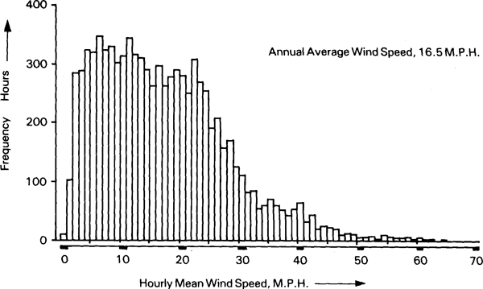
Fig. 128 Wind velocity-frequency histogram
Therefore, the best information that is ever usually available will be an hour-by-hour wind frequency distribution curve for the site. Ideally, this should be combined with data giving the monthly mean wind speeds and the percentage of calm per month. For irrigation pumping it is of critical importance to consider the wind regime during the month of maximum water demand; annual averages are not good enough for this.

v. Windpump manufacturers' performance claims
The easiest method of estimating the performance to be expected from a windpump is to use manufacturers' data as printed in their brochures. For example, Fig. 129 shows a table and performance curves for the "Kijito" range of windpumps, based on the "IT Windpump" and made in Kenya, (see Fig. 116). The table indicates the average daily output to be expected at different pumping heads for the four sizes of Kijitos in three different average speeds, defined as "light" 2-3m/s, "medium" 3-4m/s and "strong" 4-5m/s while the curves reproduce these results just for the "medium" wind speeds. It is interesting to note how sensitive windpumps are to windspeed; the smallest machine with a 12ft (3.7m) rotor will perform in a 5m/s wind almost as well as the largest machine (24ft or 7.3m) does in a 3m/s wind; this is because there is 4.6 times as much energy per unit cross-section of a 5m/s wind as in a 3m/s wind as a result of the cube law.
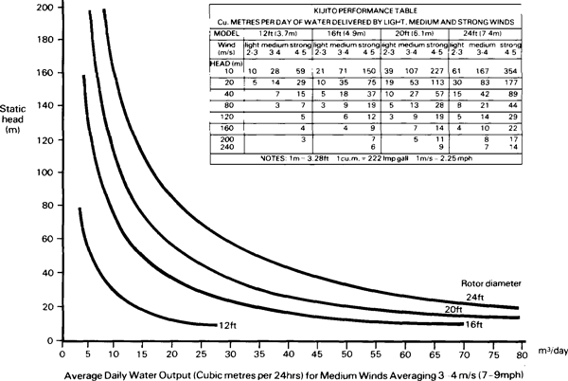
Fig. 129 Manufacturers' performance data for the Kenyan-made 'Kijito' windpump range based on the I.T. windpump (see also Fig. 116 )
A problem with manufacturers' performance claims is that some brochures include inaccurate, unreliable or even incomplete data. For example, it sometimes is not clear what wind speed applies for the manufacturer's claimed outputs. There is a tendency for manufacturers to quote performance figures for unusually high average wind speeds, no doubt because this makes the performance look more impressive, and they then give rules of thumb which in some cases do not seem accurate for reducing the outputs to more realistic levels for more common wind speeds.
The difficulty inherent in monitoring the performance of a windpump often prevents users from actually checking whether they are getting what they were promised; if a cup counter anemometer and a water meter is available, it is possible to measure the wind run and the water output over fixed periods of time (either 10 minute intervals or daily intervals - short-term and long-term - is recommended). The mean wind speed and mean water output over these periods can be logged and then plotted as a scattergram. When enough points are obtained on the scattergram, a "best-fit" curve can be drawn to obtain the performance characteristic. It is recommended that institutional users and others who need to procure numerous windpumps should seek performance guarantees from their supplier and should make some attempt to verify whether the performance is being achieved, for example, in the manner just suggested. In some cases sub-optimal performance can occur simply because the wrong pump size or wrong stroke has been used, and considerable improvements in performance may result from exchanging the pump for the correct size or from altering the stroke.

4.7.4 Windpump Performance Estimation

i. General principles
To size a windpump for irrigation purposes will usually require an estimate to be made of the week by week or month by month average output. One method for making such an estimate is to combine data on the known performance of the windpump at various hourly average wind speeds with data from a wind velocity distribution histogram (or numerical information on the number of hours in the month that the wind blows within pre-defined speed "bins"). This is illustrated by Table 19, which gives the expected output of a windpump in various windspeeds, and the statistical average number of hours that the wind blows within each speed range, (or speed "bin" is the favoured jargon). Hence, the total output for each speed bin is obtained by multiplying the output per hour at that speed and the number of hours at which that speed is likely to recur. By adding together the output for each speed bin we arrive at the total annual output. The importance of doing this monthly is that quite often the least windy month will have a mean windspeed of only around 60 to 70% of the annual mean wind speed, so the available wind energy in the least windy month can be as little as 20% of what can be expected for a mean windspeed equal to the annual average wind speed. Therefore if annual averages are used, a considerable margin of safety is necessary to allow for "least windy month" conditions, (assuming irrigation water is needed in the least windy month or in a month with a mean windspeed below the annual average.
Table 19 CALCULATION OF WINDPUMP OUTPUT USING "BINNED" WINDSPEED DATA
Annual output of water for a given wind regime
Wind speed |  | Annual duration  hours | Output rate  m³/hr | total output  m³
m.p.h. | m/sec | Annual duration  hours | Output rate  m³/hr | total output  m³
7 | 3.15 | 600 | 0.3 | 180
8 | 3.6 | 500 | 1.4 | 700
9 | 4.05 | 500 | 2.3 | 1,150
10 | 4.5 | 400 | 3 | 1,200
11 | 4.95 | 500 | 3.7 | 1,850
12 | 5.40 | 450 | 4.2 | 1,890
13 | 5.85 | 450 | 4.7 | 2,115
14 | 6.30 | 300 | 5.2 | 1,560
15 | 6.75 | 300 | 5.7 | 1,710
15 plus |  | 1,700 | 6 | 10,200
 |  |  |  | Annual
 |  | Total 5,700 |  | Total 22,555 m³
A graphic way of achieving the same result as used in the Table 19 is illustrated in Fig. 130. Here the wind velocity frequency histogram, (preferably for a month at a time) shown in (a) is multiplied by the windpump performance characteristic shown in idealised form in Fig. 130 (b); in this example a windpump is assumed which starts at a nominal 2m/s, produces 3kW of output at its rated speed of 5m/s and is fully furled at 9m/s. A windpump performance histogram using similar speed "bins" to diagram (a) is constructed over the windpump performance characteristic. Finally the windpump's generalised performance histogram in (b) is multiplied by the wind velocity distribution histogram in (a) to arrive at a performance prediction histogram (c). To illustrate the mechanics of multiplying two histograms together, the first speed bin in (a) is 200h, the first in (b) is zero kW, so their product in (c) is zero kWh; the second is 600 x 0 = 0, the third is 750hours x 0.5kW = 375kWh, the fourth 800h x 1.5kW = 1200kWh, and so on.
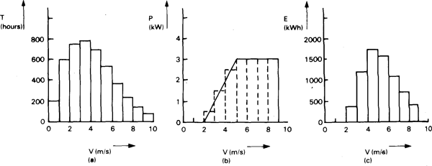
Fig. 130 Example of how to calculate the energy output of a windmill by using the velocity frequency distribution of the wind regime (a) and multiplying it by the windmill performance characteristic (b) to obtain the output (c)

ii. Simple "rule-of-thumb" approach
The problem with the above methods is that the result is only as good as the wind and performance data used, which all too often are unreliable. Therefore, if only approximate data are available, a simpler rule of thumb may be more appropriately used than attempting any detailed analysis, (and is often useful anyway as a cross check on other methods). This method was originally proposed in [45] and [51], and provides a reasonable method of estimation.
The rule of thumb assumes that a windpump system will, on average, be 17% efficient in converting wind energy into hydraulic output, which in many cases is probably not a bad estimate (the losses in a windpump system and the total efficiency that can be expected are discussed in more detail in the next section of this chapter). The average hydraulic output power for a windpump of about 17% average efficiency will be:
because the density of air at sea level is approximately 1.2kg/m³, it follows that:
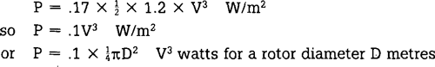
If .1V³ is multiplied by the time interval in hours applying to the average windspeed used, then the output can be calculated. For example, if V is the daily mean windspeed (based on 24 hours), then the daily hydraulic energy output will be:
if this is multiplied by the rotor area in square metres, it gives the daily hydraulic energy output. Dividing the number of watt-hours per day by 2.725 converts this to a daily "cubic metres-metre" product, or m³.m (i.e. output in cubic metres times head in metres). Although an unusual method of expressing energy, this can readily be converted to a daily output of water at any particular pumping head; eg.:
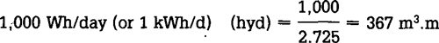
which is 36.7m³/day if lifted through 10m, or 3.67m³/day through 100m, etc.

iii. Overall system efficiency
Table 20 indicates the efficiency factors relating to windpumps,and shows that between 7 and 27% of the value obtained for the energy in the wind (using the mean wind speed) can be converted to hydraulic energy. Because the speed of the wind continuously varies, the actual energy in the wind is considerably greater than if the wind blew continuously at the mean wind, speed. The exact proportion by which the energy available exceeds the figure that can be calculated based on the mean depends on the shape of the wind velocity distribution curve, but typically it can be twice the figure arrived at using the mean. This explains why there is an "efficiency" factor of 180-250% used to allow for the underestimate which would otherwise occur if the mean wind speed were simply cubed with no other allowance.
Table 20 FACTORS AFFECTING WINDPUMP SYSTEM EFFICIENCY
factor | typical efficiency
rotor to shaft | 25 - 30
shaft to pump | 92 - 97
pump | 60 - 75
wind regime % energy capture | 30-50
actual wind energy to wind energy calculated using mean wind speed | 180 - 250
TOTAL EFFICIENCY OF ENERGY CONVERSION BASED ON MEAN WIND SPEEED | 7 - 27 %
This result indicates that the figure of 17% overall efficiency used to produce the 0.1V³ rule of thumb described above may vary with different windpumps and wind regimes by plus or minus 10% of the total energy available. Therefore, the rule of thumb coefficient used of 0.1, and hence the predicted output using this method, may generally be expected to be within the range of 0.6 to 1.6 times the result obtained by using 0.1 and the mean wind speed.

iv. Wind requirements for economic operation
A convenient method for costing and comparing windmills is to estimate the total installed cost of a system as a function of rotor area (e.g. in dollars per square metre of rotor). Since the energy output is a function of the wind regime combined with the system efficiency and its rotor area, the unit cost of the rotor area will give an indication of the cost of energy in a given wind regime if a uniform system efficiency is assumed, (or upper and lower limits such as indicated in the previous section may be used).
Wind pump prices correlate quite closely with the area of rotor being purchased. Prices for industrially manufactured windpumps, (not including shipping and installation) are in the US $200-400/m² range, while wind generators tend to be about three times as expensive per unit of rotor area (for small machines) or twice as expensive for larger machines. Windpumps made in developing countries can be significantly cheaper; for example the "Tawana", Pakistan-made version of the I T Windpump costs about $130/m² (in 1985). "Do-it-yourself" windpumps, built in the village, such as are used in Thailand are very much cheaper still, but the cost depends very much on what assumptions are made on the value of the construction labour.
Combining these costs with the previously given performance assumptions will show that at current prices, most windpumps need mean winds speeds in the region of 2.5 to 3m/s to begin to be economically attractive, and wind generators need 3.5 to 5m/s. Moreover the cube law ensures that the economics of windmills improve dramatically at higher windspeeds, making them a most economically attractive technology in most wind regimes having mean windspeeds exceeding say 5m/s.
Source : http://www.fao.org/docrep/010/ah810e/AH810E10.htm

