simple saw dust wood gas stove
information on simple practical wood gas stove design

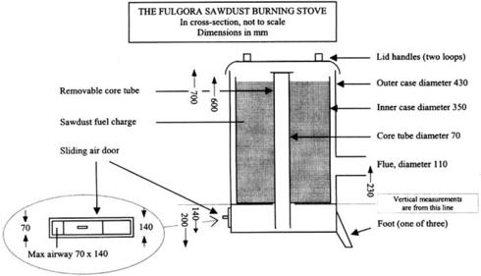
http://www.nzdl.org
http://www.nzdl.org/gsdl/collect/fnl2.2/archives/HASH579f.dir/p06a.jpg
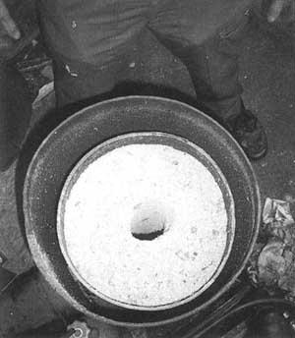
Anila stove :gasification combined pyrolysis
Nzdl

View Stove : HEDON Household Energy Network
HEDON, the place where, practitioners, policy-makers, funders, and business-owners actively pursuing a cleaner, affordable and more effic...
Hedon
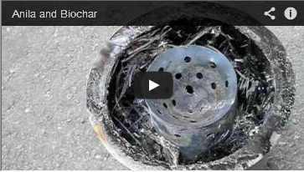
http://www.youtube.com/watch?feature=player_embedded&v=G-SLnWTAoW0
Anila and Biochar
EcoTainment
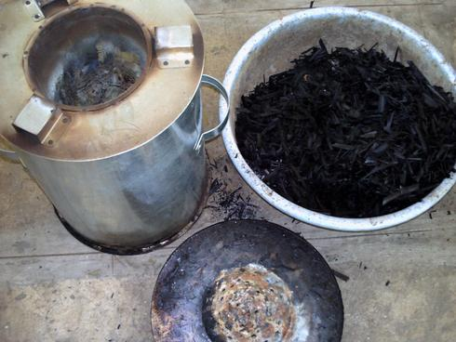
Wordpress
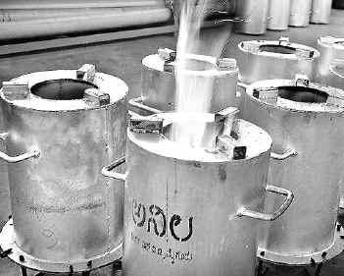
Hindu
Fbcdn
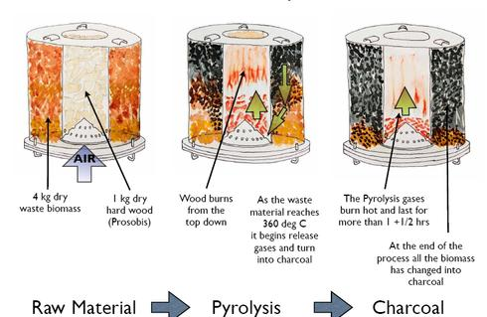
Googleusercontent
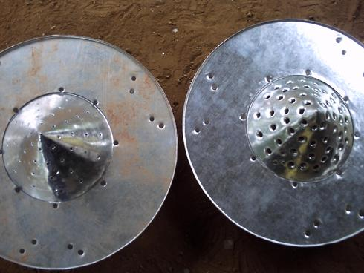
Wordpress
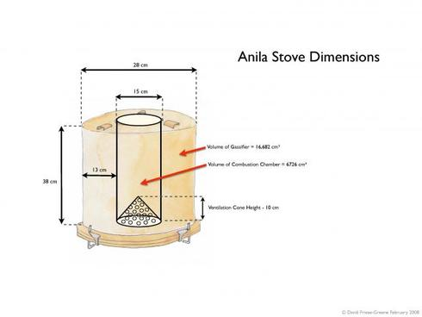
Bioenergylists
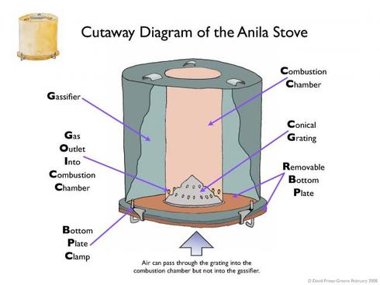
Bioenergylists
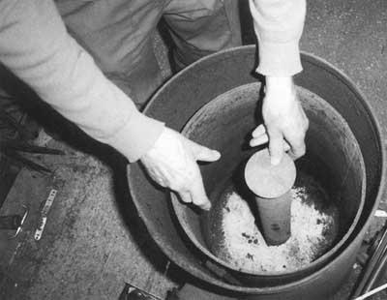
Nzdl
·

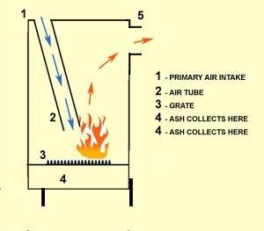
Stovesonline

Sawdust Burning Stove
Jan 26, 2011 ... A sawdust burning stove which burns smokeless, unattended for over 8 hours per charge. Perfect for a woodworking shop ...
tinyhouseblog.com
Sawdust furnace - Swistun, Gwido K.
Sep 15, 1981 ... A sawdust-burning furnace comprising an inner shell, an outer shell disposed ... Also see Fulgora, Slow Combustion Sto...
Freepatentsonline
Stoves for Rice Husk and Other Fine Residues - Media | Practical ...
Feb 2, 2007 ... Heating stoves Sawdust is particularly useful as a heating fuel. The Fulgora stove (Bland, 1999) was originally patente...
Practicalaction
The Fulgora sawdust burning stove - HEDON Household Energy ...
Aug 5, 2011 ... Received: Tue 28 of Sep., 2010. Accepted: Tue 28 of Sep., 2010. Abstract. This is a brief article based on personal exp...
Hedon
Sawdust!
I have a sawdust burning stove in my workshop, made by "Fulgora" Battersea London. Free heating! and its E frendly. Runs for ...
Greenbuildingforum
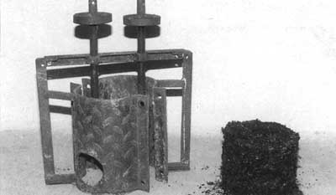
Boiling Point No. 43 - Fuel Options for Household Energy (ITDG ...
The Fulgora sawdust burning stove. View the document, A compressing machine for briquetting biomass waste into usable fuel. View the do...
Nzdl
Motherearthnews
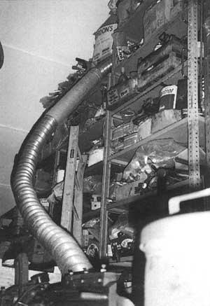
Wood gas stove
Nzdl
http://www.youtube.com/watch?v=pyofhLYYVC8&feature=player_embedded
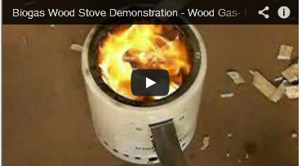
http://www.youtube.com/watch?v=pyofhLYYVC8&feature=player_embedded
Biogas Wood Stove Demonstration - Wood Gas- Producer Gas
knowpub

pannirbr
Biofuel and integrated Biosystem
Natal, Brazil
http://myonepage.com/pvpabr
✚ Follow
Autres histoires de pannirbr
macro algae , biofuel and bioenergy
The recent story of Brazilian biodiesel Father
Brazilian Green Bio Economy and Political News
New story on MacroAlgae Biotechnology News
Source : http://storify.com/pannirbr/simple-saw-dust-wood-gas-stove

