Charcoal from portable kilns and fixed installations
by FRED C. SIMMONS, FAO Forestry Officer
FRED C. SIMMONS is now serving on a United Nations Special Fund project in Chile.
Recent improvements in charcoal production facilities and methods
IN 1956 THE Food and Agriculture Organization of the United Nations issued a 116-page bulletin under the same title, prepared by Professor J. Savard and Mr. J. Condreau of the Centre technique forestier tropical at Nogent-sur-Marne (France). This discussed in detail charcoal production methods in use at that time, particularly in Europe and North America. It also covered the theory of carbonization of wood and recovery of by-products, and yields obtainable by different methods from a variety of species.
Since 1956 there have been a number of improvements in charcoal production facilities and methods. These have occurred especially in North America where there has been a spectacular increase in the markets for charcoal. Consequently there has also been a considerable increase in interest in methods of producing this commodity more efficiently.
The new techniques discussed here include the development of:
1. several new types of kilns, constructed of masonry (cast concrete, cinder block, and brick);
2. a simple inexpensive method of determining temperatures in various parts of these kilns during carbonization, as a means of controlling the carbonization process more efficiently;
3. several highly efficient new types of vertical retorts designed to obtain maximum yields of uniform and high-quality charcoal, particularly from sawmill residues (slabs, edgings and trim) with a minimum use of man power;
4. new methods of carbonizing fine wood residues (sawdust and shavings) and briquetting the resultant carbon.
Practically all these recent innovations deal with the production of charcoal from hardwood species, since dense nonfriable hardwood charcoal is preferred in the markets. All the new installations in the United States and Canada are designed to recover charcoal only, without any effort to make by-products such as methanol, acetic acid, or wood oils. These former byproducts of the carbonization process can now be made synthetically at a much lower cost, and in a much purer state than the natural products can be produced. Only six of the wood distillation plants in the United States are now trying to recover any by-products, and these companies have limited special markets such as the production of wood methanol as a denaturant for ethyl alcohol. These special markets are currently oversupplied. Other wood distillation plants, and a number of the newer types of installations, use the wood tar and volatile gases produced in carbonization as a supplementary source of fuel for charcoal production.
At many universities and other research institutions, however, attempts continue to be made to discover some special values in the by-products of wood carbonization, or some more efficient methods of producing these byproducts that will once again make some of them marketable commodities.
Owing to exploitation and transport facilities existing in the United States and because of the high cost of man power and the rather low price, masonry kilns are now popular and are used on a very large scale. Among the existing models in operation it is interesting to note cinder block kilns, brick beehive kilns, and poured concrete kilns.

Cinder block kilns
The most popular masonry kilns in the United States, in terms of numbers at least, are the rectangular cinder brook kilns (Figure 1). These were first devised as an emergency measure during the steel shortage in the second world war by Hickock and Olsen at the (Connecticut Agricultural Experiment Station, New Haven, Connecticut. The original plans and specifications¹ were for very small kilos of this type, holding from 1 to 2 cords.²
¹ Connecticut Agricultural Experiment Station Bulletin 519.
² 1 cord = 28 cubic feet = 3.65 cubic meters of firewood.
FIGURE 1. - Battery of 9-cord cinder block kilns near Warrensburg, N.Y., U.S.A.
The kilns were so successful that the basic design has recently been enlarged, so that most of the kilns of this type how erected have a capacity of from 7 to 20 cords, with a consequent increase in efficiency and yield.
The most trouble-free, economical, and efficient masonry kilns are still those with a 20-centimeter (8-inch) thick single wall, of high-quality, water-cured, cinder-concrete block, as in the original design. The walls are laid up with lime mortar. Attempts to make self-sealing kilns of this type, with double walls and a layer of sand or dirt between the walls, have not been successful. This is primarily because of the practical impossibility of patching cracks when they occur on the inside wall, and the steady settling of the between-the-walls sealer. With the single wall kiln such cracks are easy to locate because of the leakage of steam or gas, and easy to patch with an application of clay or additional mortar.
Several changes have been made in the design of these kilns when they are built in larger sizes. The door at the front, for charging and discharging, is now frequently closed with one or two steel plates, held in place by bolts or C-clamps, rather than with a wall of additional cinder block as originally prescribed (Figure 2). These door openings call for a sturdy lintel overhead particularly when they are built wide enough to allow a lift truck to enter the kiln. U-shaped lintel blocks, which can be tied together with a filling of concrete and steel reinforcing rod, are available but better still is a specially cast lintel, with steel rod or cable reinforcement, cast from the cinder-cement mixture. Steel beam lintels have also been successfully used. The doors themselves are usually built from 14-gauge hot-rolled sheet steel suspended from an overhead monorail. When in use the edges are sealed to the kiln walls by mineral wool and mortar.
Also commonly used on these larger kilns is a roof of 18-gauge corrugated steel sheets supported by a framework of iron pipe (Figure 3) which in turn is suspended from steel beams or wooden rafters overhead. Steel rods from this overhead framework extend down-ward through holes in the roof plate and around the pipes that support it from underneath. The holes in the plate through which the rods pass are sealed airtight with glass wool and then the entire roof is covered with 5 to 10 centimeters (2 to 4 inches) of sand to seal it airtight. Two holes 20 to 25 centimeters (8 to 10 inches) in diameter are cut in the roof directly behind the door, and two more at the rear in front of the chimney. These holes are covered with steel plates 5 centimeters (2 inches) larger in diameter which are also sealed in place with a sand covering. Attempts have been made with these kilns to use multiple chimneys but their superiority over a single large diameter chimney, built above an underground box at the rear of the kiln (Figure 4), has not been established.
FIGURE 2. - Cinder block kiln with steel-plate doors.
Almost every successful operator has his own variations on the design, and in the method of operation, of these kilns, but all of them seem to be useful. Most variations follow pretty much the method first worked out by Charles Grothe, owner-manager of Heartwood Products, Warrensburg, New York. Grothe built his 9-cord kilns as described above, on a sturdy foundation of native rock.
For operation the kiln is tightly packed with hardwood sawmill slabs, laid on a grid of round material about 10 centimeters (4 inches) thick to about 45 centimeters (18 inches) back from the door. In the remaining space the kindling for igniting the charge is piled. This consists of dry wood, "brands" or "bones" ³ from previous charges, paper, and oil-soaked rags. Then the doors are closed leaving an opening underneath for igniting the kindling, and the four holes in the roof are left open. The kindling is allowed to burn freely for about 30 minutes, and then the holes overhead are covered, first those at the front and, a little later, those at the back. In this way the smoke and fire are forced to find an outlet through the charge and down into the base of the chimney at the back. All the draft inlets at the sides of the kiln are closed with dirt except the first two nearest the door end. When red coals appear at these holes they are closed off, and the next two toward the rear of the kiln opened. Carbonization thus proceeds in a fanwise direction from the front to the back of the kiln, with the draft inlets being successively opened and closed until finally the last two at the sides of the kiln toward the rear glow red. At this point carbonization is complete, and the kiln is completely sealed off for cooling. The chimney is left open for about an hour after the last two air inlets are closed to let the hot gases escape, and then it, too, is completely sealed. Carbonization in a 9-cord kiln normally takes about 48 hours.
³Partially carbonized wood.
FIGURE 3. - Underside of steel-plate roof showing pipe supports.
FIGURE 4. - Cinder block kiln showing side air inlets and single chimney at rear.
FIGURE 5. - Installation of 5 thermocouples to guide control of "burn" in 9-cord kiln.
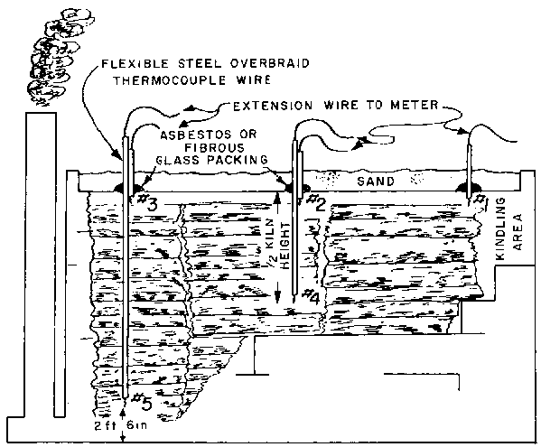
There are, of course, many variations on this basic procedure depending on the idiosyncrasies of the individual kiln, the dryness of the charge, the direction and velocity of the wind, the outside temperature and humidity. In some cases, it is necessary to block an inlet on the windward side to keep the charge from burning, or to block it partially with a baffle. In other cases, downdrafts in the chimney cause trouble and it is necessary to provide a baffle there. When a crack opens in the walls or around the roof of the kiln it is necessary to patch it immediately to forestall the inflow of an excess amount of air which may burn up part of the charge or even cause an explosion.
One of the most worthwhile aids to successful kiln operation is the simple inexpensive pyrometer and thermocouple installation developed by Ralph Peter of the United States Forest Service, at its Southeastern Forest Experiment Station branch at Athens, Georgia.⁴
⁴U.S. Forest Service, Southeastern Forest Experiment Station Paper 73.
The pyrometer is made from a D.C. microameter, range 0 - 25, with 2,200 ohms internal resistance, and in the United States costs about $20.00. The thermocouples are made from iron-paired constantan wire with an asbestos insulation and a stainless steel over-braid. This 16- or 18-gauge paired wire is priced in the United States at 28 to 30 cents a running foot and is used only for installations inside the kiln, as shown in Figure 5.⁵ Outside the kiln a cheaper paired iron-constantan extension 24-gauge wire, with a weatherproof polyvinyl insulation, can be used, costing only about 3 US cents per running foot.
⁵Note that in the figures that follow measurements are in feet and inches. 1 foot = 0.3 meter; 1 inch = 2.5 centimeters.
The method of installation is as follows. A new scale, as shown in Figure 6, is made for the microameter, reading in either degrees Fahrenheit or degrees Centigrade. This is carefully cemented to the back of the scale plate, removed from the microameter, and the plate replaced in reverse. Then the instrument is installed in a box (Figure 7). A short piece of constantan wire is attached to the positive terminal of the meter, and connected to a piece of iron wire forming an exposed reference (cold) junction as shown. A longer piece of constantan wire is attached to the negative terminal of the meter. Both leads from the meter are attached to binding posts at the back of the box. Then the extension cord from any of the thermocouples inside the kiln can be attached to these binding posts, taking care that each type of wire is attached to the proper terminal. The extension cord leads to the top of the kiln, where each side is soldered to the proper side of the thermocouple wire coming through the roof. The extreme end of the thermocouple wire, at the point where the temperature is to be read, has its insulation stripped 5 centimeters (2 inches) back from the tip, and the two wires are twisted together and welded at the tip.
FIGURE 6. - New scale for conversion of microameter to pyrometer.
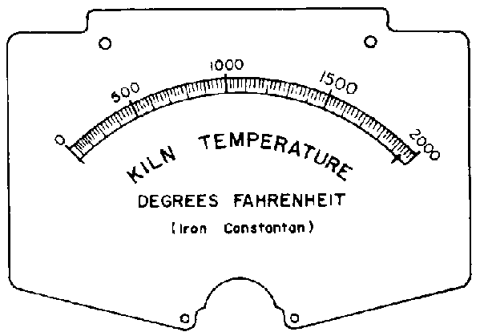
FIGURE 7. -Reference junction wiring.
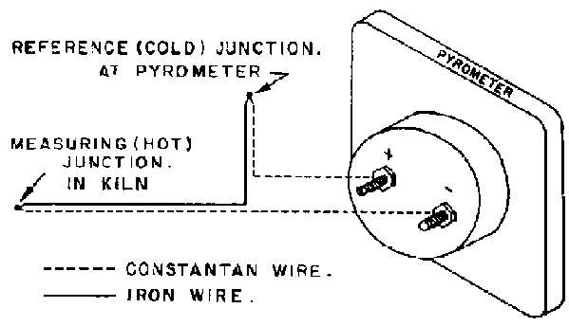
It has been found that five thermocouples are adequate to guide the control of a "burn" in a 9-cord kiln. Three are placed crossways at the center of the kiln close to the roof, as shown in Figure 5, and the other two are placed lengthways at the center of the kiln just above the chimney outlet near the back. The one at the center of the kiln is about halfway from the roof to the Boor, and the one above the chimney outlet is about 60 centimeters (2 feet) from the floor. During the firing period, after the initial flare-up, temperatures at thermocouple 1 may reach about 650 to 750º C (1,200 to 1,400º F). Such high temperature should not be permitted to continue, however, for more than 10 to 15 minutes, and then only if the kiln has a steel roof. After the roof vents and the firing port are closed, temperatures are regulated by manipulation and partial closure of the air inlet ports along the bottom sides of the kiln. The temperature at thermocouple 1 should be brought down to about 500º C (950º F) at this time. The same temperature will be obtained, in a relatively short period, at thermocouples 2 and 3, and a little later on, at thermocouple 4. When the temperature at thermocouple 5 reaches about 450º C (850º F), carbonization is nearly complete. This temperature should be held for about an hour, and then the entire kiln, including the smokestack, sealed off for cooling.
Some success has been attained by a few operators in the use of a heat exchanger (Figure 8), to accelerate the cooling period. The heat exchanger consists of two or three 55-gallon steel oil drums welded together. The joint* in the pipe connecting this heat exchanger with the smokestack, and in the pipe connecting it with the interior of the kiln through the roof at the front, are also sealed tightly so that there will be no leakage of air into the system. A high-temperature-resistant blower (such as is used in hot air heating systems) should be installed in the pipe, and also closely sealed.
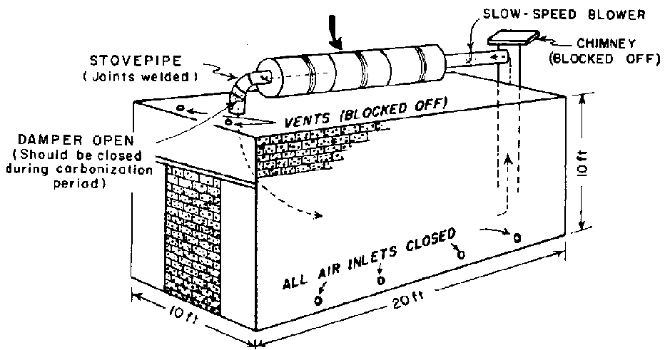
FIGURE: 8. - Details of the heat exchanger used to speed the cooling-off process in a 9-cord cinder block kiln.
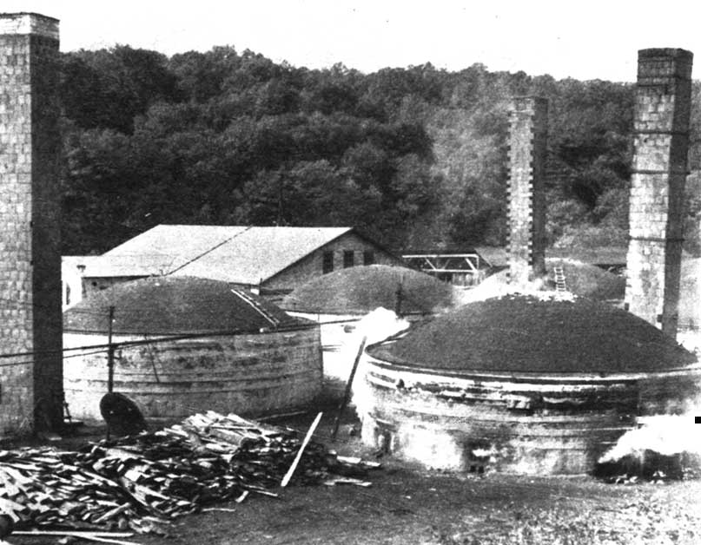
FIGURE 9. - Brick and tile baking kilns, converted to charcoal production.
The inert gases left in the kiln at the end of the burn are circulated through the heat exchanger during the cooling period. Some operators report that they have succeeded in reducing this cooling period for a 9-cord kiln from six down to three days, by the installation and use of such a device.
In the United States these small kilns, even though they are run in multiple batteries of from three to ten units, cannot compete economically in the same market with units of larger size. Their labor requirements, maintenance, and other costs are so high, per ton of charcoal produced, that they must sell their product locally, often directly to consumers, at relatively high prices. Fortunately, because lump charcoal is a bulky product and somewhat difficult to handle, small operators can compete in local markets with those who can produce charcoal at a lower cost but who are located at a considerable distance from market.

Brick beehive kilns
A number of commercial operations, therefore, use larger size kilns.
Many very large brick beehive type kilns, originally erected for baking brick and tile products, have been converted to charcoal manufacture (Figure 9). These generally hold from 30 to 90 cords of wood. When slabs and edgings from a sawmill provide the raw material supply, they produce from 10 to 30 tons of charcoal per charge. When charged with dense hardwood roundwood, yields are increased about 20 percent. The entire production cycle, including loading, carbonization, cooling and unloading, generally takes from 20 days to a month. A typical schedule for operation of 90-cord capacity kilns, for example, would comprise about four days for loading, seven days for carbonization, twelve days for cooling, and six days for unloading (Figure 10). A crew of five men, including the chief burner, is adequate to operate a battery of five such kilns, operating on a staggered schedule, if the product is packaged in 10- to 15-kilogram (20- to 30-pound) bags. The chief burner, of course, must be a skilled and experienced man.
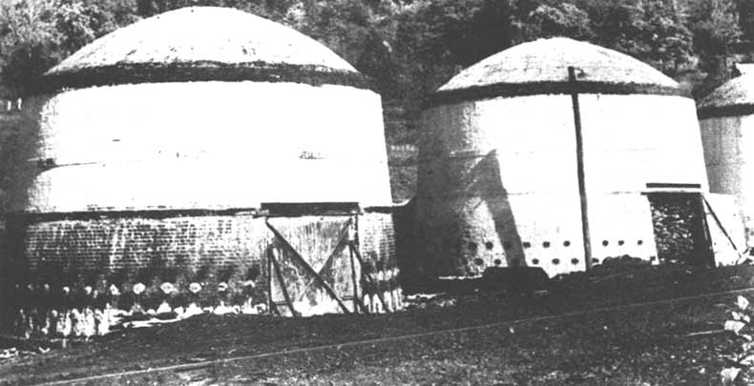
FIGURE 10. - 90-cord beehive kilns.
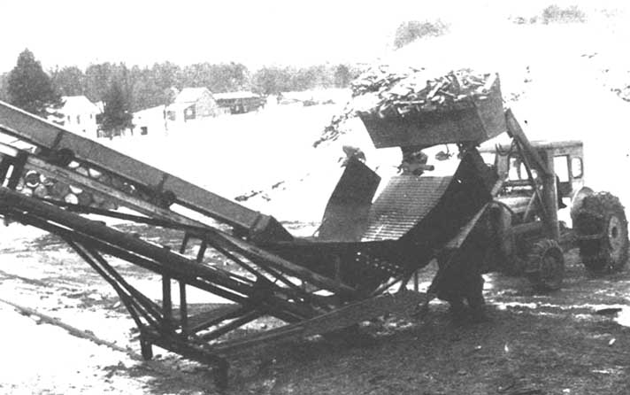
FIGURE 11. - Loading wood into conveyer with lift truck scoop.
Some of these beehive kiln operations have been mechanized to reduce manpower requirements, improve the uniformity and quality of the charcoal produced, and cut down on the overall length of the cycle schedule.
It is possible, for example, to cut the wood into short, 30- to 40-centimeter (12- to 16-inch) lengths, and stack it as tightly by rough and tumble methods as it is to stack longer lengths piled carefully by hand. This has been done by placing a sloping powered chain conveyor from the ground to a point above an opening in the top of the kiln. At the foot of this chain the short lengths of wood are dropped in a trough from a scoop mounted on the front of a lift truck (Figure 11). The conveyor carries this wood to the top of the kiln, where it is dropped through the hole and arranges itself in the interior. By this means it is possible to reduce loading time from four days to one day, and the size of the loading crew from five men to two.
Similarly, carbonizing time is reduced by igniting the charge by a gas burner or torch flame piped to the bottom center of the kiln, and by an exhaust blower at the base of the chimney alongside the kiln. This gathers the gases from outlet ports around the inside base of the kiln. A pyrometer, connected to thermocouples placed around in different positions inside the kiln aids the burner to gauge advancement of the "burn" and tells him when to close either partially or fully the air inlet ports around the sides of the kiln.
So far as is known, no completely successful method of reducing the time of the cooling period has as yet been devised, although it has been attempted by circulating cool inert gases through the hot charcoal charge, or by introducing a fog or water vapor spray into the kiln. Both of these methods, however, are apt to cause explosions, and the second may easily result in water-logging part of the charcoal yield and thus degrading it.
Unloading has been successfully mechanized in a number of cases. A successful method is to remove the charcoal with the same scoop on the front of a lift truck mentioned above, which then conveys the product to the infeed trough of a screening system, or in the case of a briquetting plant, of the grinding equipment.
When all of these methods are in use total cycle time for a 90-cord kiln is reduced from about a month to 20 days, more than half of which are utilized for the cooling period. More important, the crew needed to operate a battery of five such kilns is reduced from five workers to two, and yields are somewhat increased. (The blower sharply reduces the amount of partially carbonized "brands" or "bones" remaining in the bottom of the charge.) The end result is that these two men produce about 7.5 tons of charcoal per day.
In the Province of Quebec, Canada, much smaller beehive type kilns are commonly operated. These are of 12- to 15-cord capacity. The production cycle is generally from 10 to 15 days, and yields per cord are comparable to those from larger brick kilns. Construction and operation of these smaller brick beehives has been well described in a series of bulletins by Professor Joseph Risi of Laval University, Quebec.

Poured concrete kilns
Most of the newer masonry kilns of larger size are built of poured concrete since this is usually a cheaper and quicker type of construction than brickwork, and fewer skilled men are required to accomplish it. One of the more popular and successful types of poured concrete kilns is the Missouri type ⁶. This is a Quonset Hut type of structure (similar to the wartime Nissen hut), with big steel doors in the front and back, large enough to allow the entry of a fork lift or motor truck for loading and unloading. Overall dimensions 10.6 × 6.8 meters (34 feet 8 inches × 22 feet 4 inches), with walls 2.6 meters (8 feet 6 inches) high and a domed roof rising 1.5 meters (5 feet) above them (Figure 12). It is said that, according to prices prevailing in Missouri in 1960, this kiln can be constructed for from US $2,000 to $4,000. (A brick beehive kiln of the same capacity would probably cost twice that much.)
⁶ University of Missouri Engineering Experiment Station, Engineering Series Bulletin 48. The wood charcoal industry in the State of Missouri. Columbia, Missouri. May 1960. &fives detailed description, plane and specifications for 40-cord kiln.
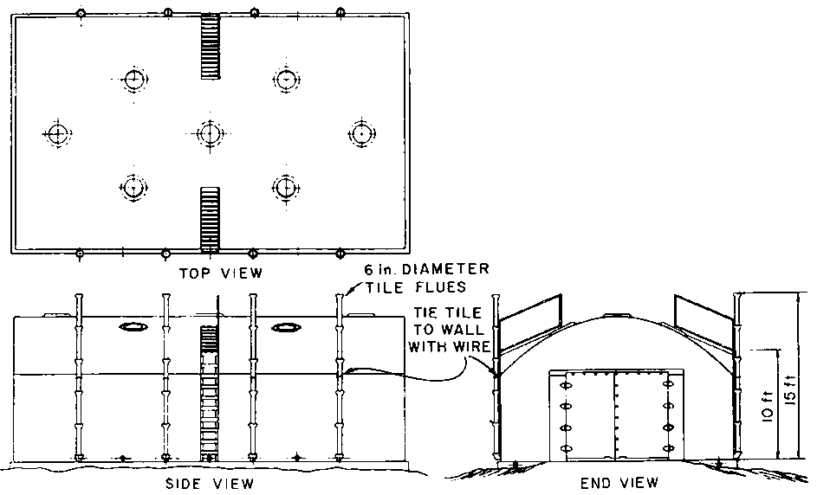
FIGURE 12. - Missouri-type charcoal kiln.
The complete schedule for a "burn" in one of these kilns also stretches over about a month, with two days for loading, four to six days for carbonization, 10 to 14 days for cooling, and something like four days for unloading. Yields with round hardwood, such as oak or hickory, are reported to be excellent, ranging from about 30 to 450 kilograms (800 to 1,000 pounds) per cord. With slabwood, of course, yields are somewhat lower, due to the greater percentage of bark and the lesser volume of wood in a stacked cord.

Newer types of retorts
Several new types of vertical, insulated steel retorts have been developed in the northeastern United States. These give higher yields, shorter operation cycles, make more uniform and higher quality charcoal, and use less man power per ton of charcoal produced than do any of the kilns. These retorts are the results of a considerable period of research by a number of workers, notably Donald Warner of Speculator, Alvin Keil of Rochester, and Fenimore Thomas of Oswego - all in New York State.
Modern retorts consist of upright steel cylinders, adequately insulated on the outside, in which carbonization takes place. When carbonization is completed, in a matter of hours rather than days, the charcoal is allowed to cool down to about 200º C (400º F), and then it is dumped into empty 210-liter (55-gallon) steel drums, which are sealed with a tight cover. In these the charcoal is allowed to cool, generally for from two days to a week with the cover in place, and then for several more days with the cover removed. Then the charcoal is dumped out for use or for packaging.

Thomas' retort
The simplest and cheapest of the current models of these retorts is the one designed by Fenimore Thomas (Figures 13 and 14). Two commercial manufacturers now offer this retort for sale. The smaller size, made by Vega Industries of Syracuse, New York, has a steel carbonizing unit 3.6 meters (12 feet) high by 1.2 meters (4 feet) in diameter, and sells for about $1,000. A larger one, with a steel chamber 4.5 meters (15 feet) high and 1.7 meters (5 feet 6 inches) in diameter, is sold by the Charcoal Retort and Equipment Company, Spruce Pine, North Carolina for about $2,400. This retort has several added features, including two thermometers, but basically the two retorts and their operation are the same.
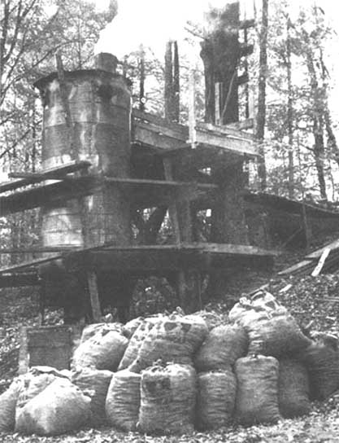
FIGURE 13. - Thomas' vertical charcoal retort.
The method of operation is as follows. First, a fire is started at the bottom of the retort by dropping dry kindling and papers down the stack, opening all the knockout ports near the bottom of the shell, and igniting the charge through one of them by means of a torch of oil-soaked rags. When the fire is burning well, green wood is dropped down the stack and allowed to ignite; then the ports are closed. One of the air control valves (generally the one on the side away from the wind) is opened, and the stack is partially closed. Green wood is fed to the charge from time to time until the shell is full and a condition develops as shown on the right of Figure 14. Thereafter the door in the concrete block compartment at the bottom of the retort is opened at intervals of about two or three hours when an empty oil drum is placed under the gate, the gate is then opened and about 90 to 135 kilograms (200 to 300 pounds) of hot charcoal is poked down into the drum by means of a steel rod inserted through the knockout openings. When full, the drums are covered and removed from the compartment for cooling. New green wood is loaded through the chimney after each batch of charcoal is removed, so that this retort can be continuously operated day and night. About 1.5 tons of charcoal are obtained from green slabs and edgings in the smaller of these retorts; the larger one produces nearly 3 tons from green material, and with air-dry wood the yield of both is practically doubled.
A considerable number of these retorts are being operated in the eastern United States. Some, as adjuncts to small sawmills, make charcoal from their slabs and edgings; others are operated as part of forest management projects. In the latter case the retorts may be used as semiportable units, set up at temporary locations in the woodlots, as illustrated in Figure 13. The Vega Company offers a completely portable unit, with a prefabricated all-steel compartment welded to the retort base. This eliminates the need for job site construction of the concrete block base compartment. The retort with integral base housing may be moved easily from place to place, and set up ready for immediate operation.

Cornell retort
The Cornell retort, developed by Donald Warner, and manufactured and sold by the Cornell Manufacturing Company of Laceyville, Pennsylvania, is also being operated successfully. This is a true retort, as illustrated in Figures 15 and 16, in that it has an outside source of heat, usually an oil burner, a blower and thermostatic controls. Thus carbonization is closely and completely controlled, very high yields are obtained in comparison to the amount of wood used, and the quality of the charcoal produced is uniform and of any specific quality desired.

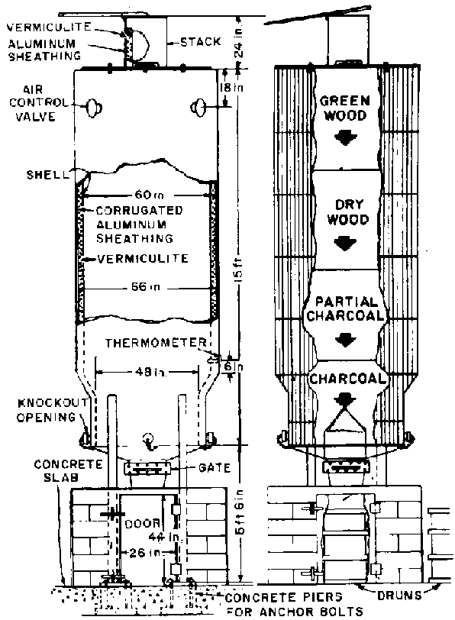
FIGURE 14. - Diagrammatic sketch of Thomas' retort. Left, plan; right, method of operation.
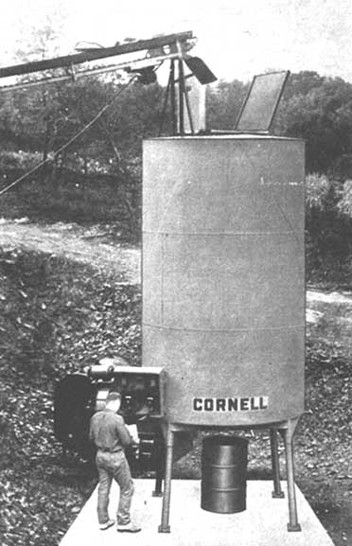
FIGURE 15. - Cornell retort.
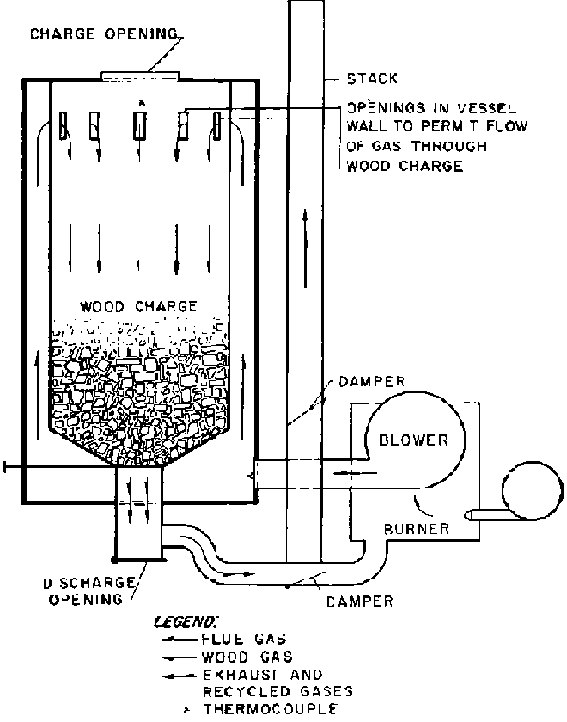
FIGURE 16. - Diagrammatic sketch of Cornell retort.
The Cornell retort is sold complete for less than $5,000. Both installation and operation are very simple. At many small sawmills, where batteries of these retorts have been installed, the slabwood is automatically cut into 30- to 40-centimeter (12- to 16-inch) lengths, carried outside by means of a conveyor belt and dropped into the top of the retorts throughout the day. Yield of slabs at most hardwood mills is from 0.5 to 0.75 cord per 1,000 board feet⁷ of lumber produced. Consequently, one of these retorts can contain the coarse residues produced in the manufacture of about 3,000 board feet of lumber. Generally the practice is to fill all the retorts during the course of the working day, and then start the "burn" in the evening, when the mill proper closes down. The night watchman can easily give what little attention the retorts require, as the "burn" is completed, normally in six to eight hours, depending on the moisture content in the wood. Then the retorts automatically shut down and are allowed to cool until the mill crew reports the next morning. Two or three men can unload the charcoal into drums in less than an hour and then go to their regular jobs or to packaging charcoal made some time previously and which is now completely cool. In this way a mill cutting 10,000 board feet of lumber per day can keep three of these retorts operating, obtaining upward of 2 tons of charcoal from its coarse mill residues, which may be salable at from $50 to $100 per ton.
⁷ 1,000 board feet = 83.3 cubic feet = 2.36 cubic meters.
At one operation in New York State, kiln-dried edgings and trim blocks from a furniture plant are being carbonized in a battery of four of these retorts and, instead of taking overnight, a "burn" is completed in about five hours (two hours for carbonization and three hours for cooling).
As is apparent in Figure 16, one of the unique features of the Cornell retort is that the gases are circulated in a reverse direction, down through the charge, by means of blowers. This means that there is a very short distance for these gases to travel between the bottom of the retort and the combustion chamber, and consequently little or no chance for cooling and condensation to take place. The volatile gases and tare burn almost completely in the combustion chamber, and thus little or no odor is produced by this retort during the combustion period. The hot gases circulated through the charge, moreover, are almost completely inert, and there is no deposition of tars on the wood or charcoal.
Operation of the oil burner is thermostatically controlled, and consumption of fuel oil is surprisingly low, particularly with dry wood and relatively high outside temperatures. Even with less favorable conditions, the cost of fuel oil at 20 cents a gallon rarely exceeds $2 per charge. This cost is more than counterbalanced by a yield of charcoal approximately 180 kilograms (400 pounds) greater than the same wood would yield in a kiln; at the equivalent of 2 cents a pound this results in an extra income of about $8.
When this increased yield per day is considered, the investment costs of these retorts are not excessively high. One of these retorts running on green slabwood at the rate of two charges per day, will produce about 1,450 kilograms (3,200 pounds) of high grade charcoal each 24 hours. With a retort cost of $4,500, this calls for an investment of about $140 for each 45 kilograms (100 pounds) daily yield of charcoal. A 9-cord cinder block kiln costing $1,000 will produce about 2,540 kilograms (5,600 pounds) of charcoal from slabwood each ten days. This works out at an approximate investment of $180 for each 45 kilograms (100 pounds) of charcoal produced daily.

Keil-Pfaudler retort
The third and largest of these new types of retorts is the Keil-Pfaudler, made by the Pfaudler-Permutit Company of Rochester, N. Y. This is illustrated in Figures 17 and 18. It has a 4.5 cord capacity, and costs in the neighborhood of $15,000, complete and ready to run. Yields are comparable to those in the Cornell retort, about 450 to 550 kilograms (1,000 to 1,200 pounds) of charcoal per cord of dense hardwood. Fuel consumption is also comparable, being about $5 per charge under relatively unfavorable conditions. Investment costs per 45 kilograms (100 pounds) of daily yield, therefore, work out to about $300, but this may be counterbalanced by low labor and maintenance costs. Stainless steel is used in the Keil-Pfaudler retort in places that might be subject to corrosion, and the whole structure, of course, is heavier and sturdier than that of the Cornell retort. Experience over a period of years will be required to give true comparative costs of producing charcoal in these two competitive devices.
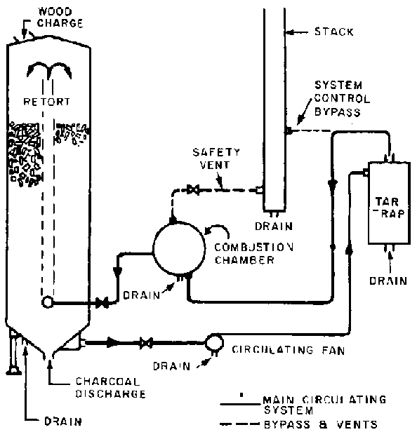
FIGURE 17. - Diagrammatic sketch of Keil-Pfaudler retort.
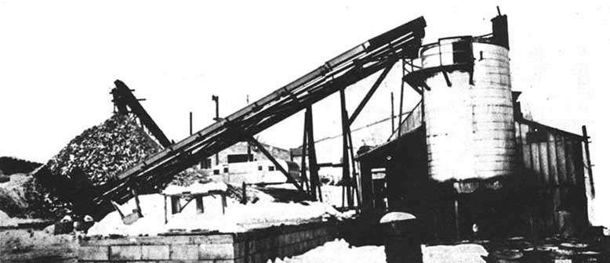
FIGURE 18. - Keil-Pfaudler retort in operation.

Retorts for sawdust, shavings and wood chips
Many attempts have been made to develop devices for the commercial production of charcoal from sawdust, shavings, and wood chips. Until recently the vertical Badger Stafford retorts⁸ were the most successful of these devices, although their use was usually restricted to dry wood chips. Attempts to carbonize in this type of retort more finely divided material, or chips with a higher moisture content were not commercially successful.
⁸ See FAO Forestry Occasional Paper 2 - Charcoal.
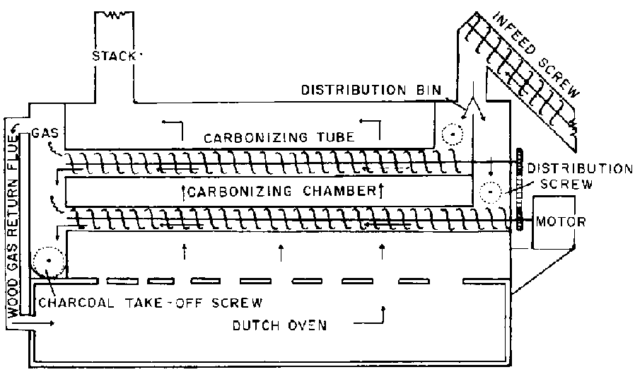
FIGURE 19. - Flow chart, fine wood residue carbonizer.
Recently, however, several carbonizing units have been developed using horizontal tubes fitted with screw propellers to feed the material to be carbonized through them. Some are now operating commercially with considerable success.
An outstanding example is the Thompsen retort developed by Svend Thompsen of Ontario, Canada. The initial stages of adaptation of this retort to commercial operation were reported in an article by Dargan and Smith.⁹ A sketch of this retort is given here (Figure 19). In its commercial form the retort is constructed of brick and concrete, 9.4 meters long, 4.5 meters wide and 3.6 meters high (31.4 × 15 × 12 feet). A single metal tube with screw conveyor carries the finely divided wood residue to the entrance hopper, where it is distributed evenly to 13 parallel tubes that carry the material through the combustion chamber. These tubes drip the carbonized residue into a single exit tube in which steam is applied to cool the charcoal and partially activate it. This exit tube carries the charcoal to storage vats, or directly to a briquetting machine. The heat passes through ducts in the top of the Dutch oven to the upper heating chamber where the tubes are located.
⁹DARGAN, E. E. and SMITH, W. H. in Forest Products Journal of Forest Products Research Society, Madison 5, Wisconsin. November 1958.
A wood fire started in the Dutch oven several hours prior to carbonization time raises the temperature in the upper chamber to 510º C (950º F), for carbonization of the wood. The volatile gases produced by the carbonization process are fed back into the Dutch oven to sustain this temperature, so that the whole operation becomes automatic without any supplementary source of heat.
Sawdust, bark, shavings, and pecan shells have been successfully carbonized. The material carbonized varied from approximately 5 to 150 percent moisture content.
The more humid the material, the longer is the period required for carbonization. For this reason the feed screws can be driven at varying speeds, to permit the successful carbonization of whatever type of material is being processed.
For most uses the finely divided carbonaceous material produced by this and similar processes must be briquetted to be readily salable. The output of the Thompsen unit, which is between 6 and 10 tons per eight-hour shift, is in close correspondence with a minimum size briquetting plant having a capacity of about one ton per hour.
Development and sales rights to this process, outside the State of North Carolina, have now been taken over by the Larus Brothers Tobacco Company of Richmond, Virginia, U.S.A., which is now operating a sizable unit of this type on a commercial scale on the outskirts of that city.

Briquetting charcoal
Since much charcoal is sold as briquettes, some prospective producers may be interested in the briquetting process. Charcoal briquettes are generally made by combining about 73 percent of crushed charcoal, 4 percent starch, and 23 percent water, by weight. This mixture is formed in a special machine into briquettes which are then dried in a heated chamber. Other binding agents have been used - such as bituminous material, waste pulpmill liquor, and even waste from a citrus cannery - but none have proved so satisfactory as starch.
Probably the minimum economic size of a briquetting plant is one producing 1 ton per hour, which is the capacity of one modern briquette-forming machine costing about $10,000. This, however, is only part of the equipment needed. Below is a list of the major items needed for such a plant together with their current (1963) prices as provided by a leading manufacturer in the United States.
The necessary site, buildings, and other expenses connected with the establishment of such a plant would undoubtedly bring the total cost to more than $150,000.
Cost of briquetting in such a minimum size plant is usually about $25 a ton. Briquettes usually sell for a price only a little higher than lump charcoal, but they are cheaper to handle, transport and store than lump charcoal, and there is less deterioration from handling.
In consequence, manufacturers whose plants are located a long distance from their markets generally briquette their charcoal, both to take advantage of these economies and also because buyers often prefer briquettes to lump charcoal.
Item: | US $
1. Paddle mixer | 1,500
2. Two-shaft vertical fluxer | 6,825
3. Charcoal mixture conveyor | 2,500
4. Briquette press and feeder | 8,190
5. Discharge conveyor | 400
6. Briquette dryer | 18,000
7. Hammermill | 2,100
8. Syntron starch feeder | 300
Price of items 1 through 8 | 39,816
Price of motors for items 1 through 8 | 3,580
In addition: charcoal-handling equipment, a surge bin, dry briquette handling equipment, and a dry briquette storage bin and a steel boiler, rated at 30 hp and 15 psig¹⁰ will be needed, which will cost approximately | 26,000
TOTAL COST OF EQUIPMENT | 69,396
¹⁰ psig = pounds per square inch gauge.
Source : http://www.fao.org/docrep/00950e/00950e07.htm#TopOfPage

