Biogas Digester Construction Photos & Details

Copyright © 2002 R.L. Crosby, Biorealis Systems, Inc.
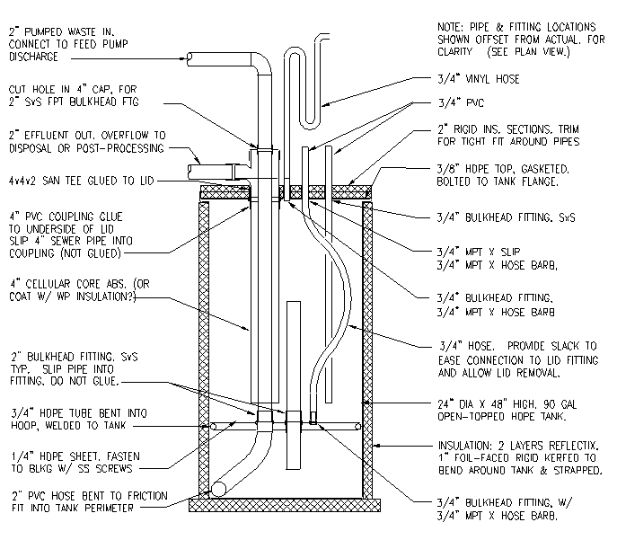
Acid/Methane Tank Baffle Construction:
Tools required for welding plastic: Welder, small air compressor, HDPE welding rod. | 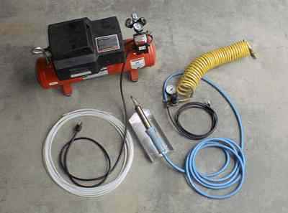
Looking down into open tank, showing 3/4" HDPE tube bent into hoop and welded into tank. Hoop acts as support blocking for baffle partitioning vertical tank into two chambers. | 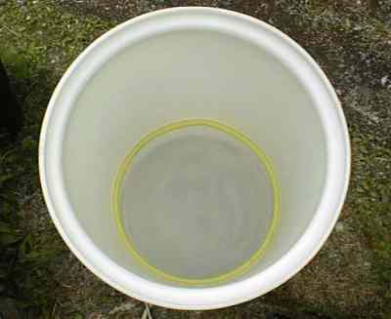
Closeup of hoop welded to wall of HDPE tank. | 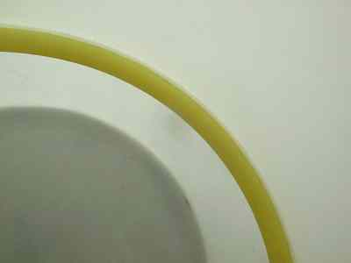
Assembled baffle plate, top view: Disk is cut from 1/4" HDPE sheet, holes/fittings in baffle are for 3/4" gas vent, 2" transfer pipe (center), 2" influent in. | 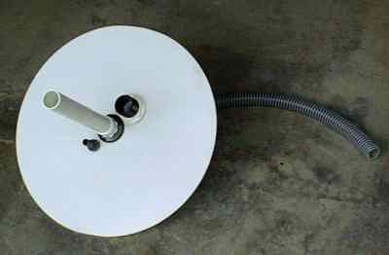
Assembled baffle plate ready for installation in tank. | 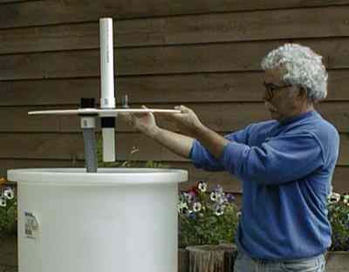
Looking down in tank with completed baffle plate in place. Baffle is attached to support blocking (3/4" tube hoop) with self-tapping stainless steel screws, sealed with silicone caulk. (Note: 3/4" hose connecting gas vent to lid is not shown.) | 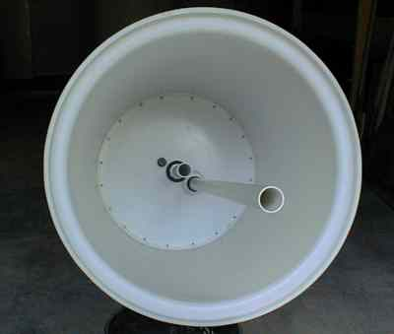
Digester Lid Construction
Cut tank lid from 3/8" thick HDPE sheet to fit inside flange of open top HDPE tank. (Diameter varies depending on tank selected -- which will depend on amount of material to be digested. Use design tool to select tank.) Holes cut in tank are for influent/effluent heat exchanger assembly, biogas out, biogas recirculation, and gas vent from acid reactor. Top view. | 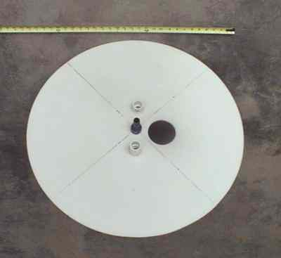
Closeup view of underside of lid showing silicone caulk bead and fittings. Large hole is caulked in preparation for inserting 4" ABS heat exchanger assembly (see photos below). | 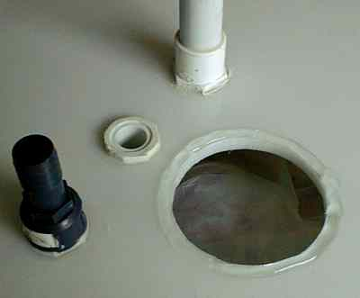
Assembled lid with gas vent hose and gas recirculation conduit attached to fittings. | 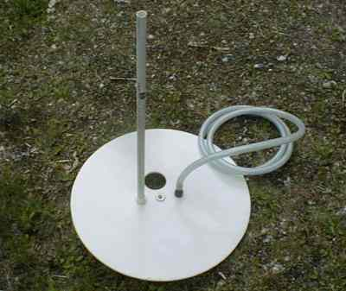
Influent/effluent heat exchanger, assembled from 4" ABS pipe with 2" PVC inside
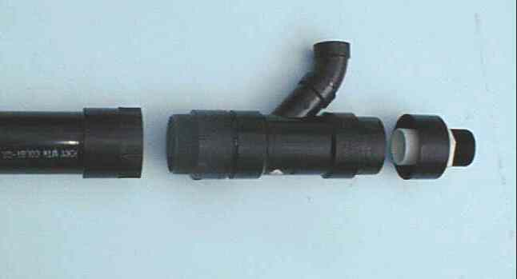
Closeup of top of HX assembly showing 2" PVC bulkhead fitting inserted into hole drilled through 4" ABS cap. | 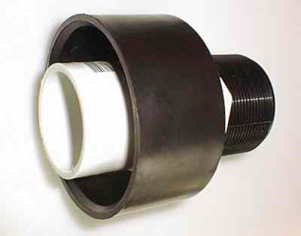
Completed digester prior to final installation of lid and wrapping with insulation. Heat tape is wrapped around tank and attached with aluminum tape.  (Note also an immersion well installed in lid, for temperature measurement -- not included in construction drawings.) | 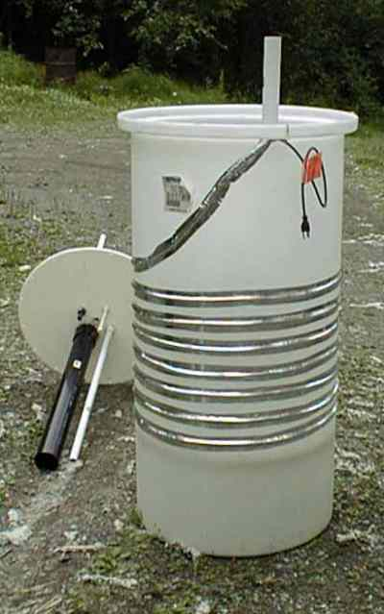

Copyright © 2002 Robert .L. Crosby Jr; this information may be copied, distributed and/or modified under certain conditions, but it comes WITHOUT ANY WARRANTY; see the Design Science License for more details.

Design and Build Your Own Small Scale Digester

