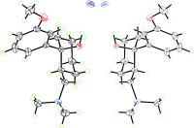
The root of the matter: The analgesic tramadol has been isolated from the root bark of N. latifolia, an African medical plant. This finding is a rare example of a common synthetic drug that occurs at considerable concentrations in nature. Cl purple, N blue, O red.

