Farming techniques
In Darfur, an isolated north-western province of Sudan with very low rainfall but a dependence on rain-fed agriculture, Practical Action’s work includes:
- Training farmers in agricultural techniques – terracing and wadi (valley bottom) cultivation -- which extend the range of crops they can grow and which make more efficient use of scarce water resources. Around 1000 women and men farmers are being trained per year, mainly by local extensionists
- Strengthening of the capacities of local village committees to manage and develop agricultural and water projects
- Construction of dams for rainwater harvesting, and training in dam construction, as well as improvement in the techniques of construction of tumad (shallow wells) in the wadis and the construction of haffirs (channels) for water supply
- Establishing several irrigated demonstration farms
- Introduction of donkey carts for transporting water – for household use, and other goods, reducing the time and drudgery, especially for women, in collecting water

Low impact earth dams
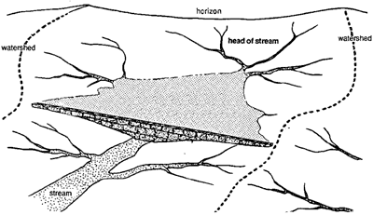
Constructed across gullies, earth dams can save thousands of litres of rain water. Farm plots nearby are irrigated throughout the growing season. The dams take around three months of manual labour, often by the women who farm, to complete.

Crescent terraces
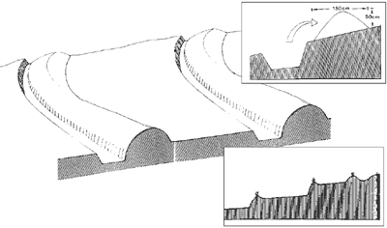
These terraces are labour-intensive to construct, but are low-cost and are proven to work. Used for centuries, the terraces collect rainwater instead of letting it flow downhill. Crops like naturally drought-resistant millet can survive the who growing season. Water and nutrient-filled soil that would otherwise wash away is instead collected between raised earth strips, allowing plants to grow longer and healthier.

Wadis
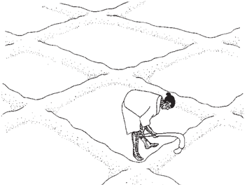
Wadis are earth basins that form a water-saving bowl. Rainwater flows from the sides to the centre of each planting bed. Each basin is surrounded by a ridge of earth about 15cm high. In flat fields the basins are two metres square – they are smaller on sloping land. In fields with deep soil, farmers use a hoe to build up walls around each plot.
Source : http://practicalaction.org/farming_techniques

