PEPPER PROCESSING
Figure 1: black peppercorns. Photo: Practical Action / Neil Noble
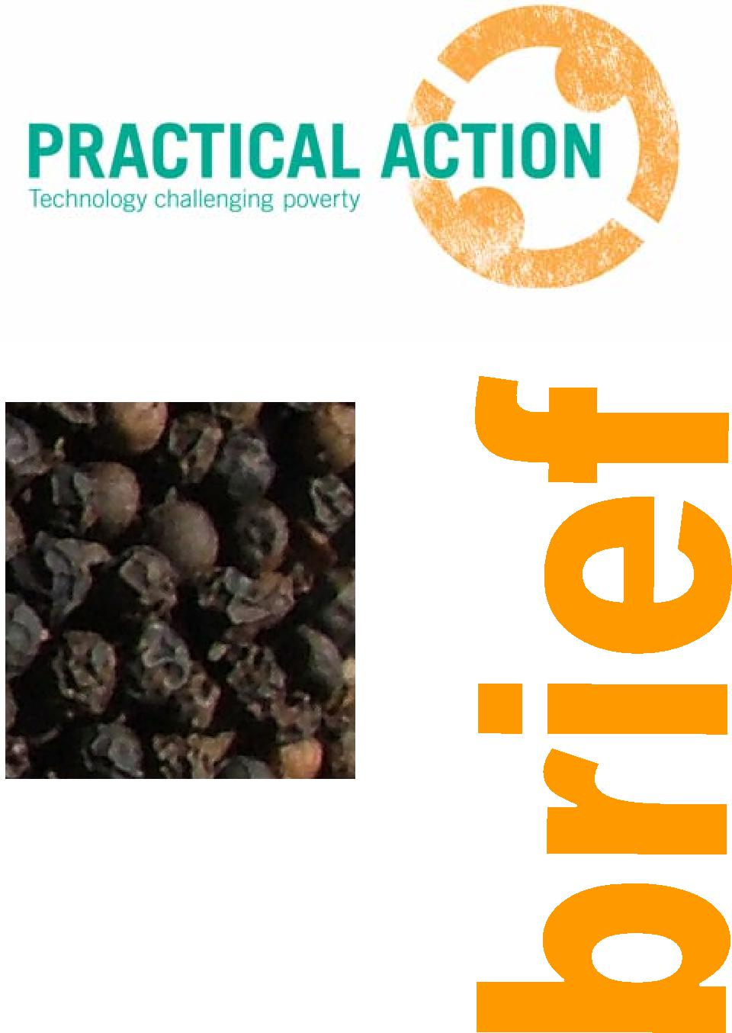
Introduction
Pepper is one of the oldest and most popular spices in the world and is known as the ‘King of Spices’. At one time, peppercorns were more valuable than gold and were used to pay for rent, taxes and dowries. In Europe there has always been a high demand for pepper as a food preservative and for adding heat and flavour to meat. This demand for pepper was what initiated the great explorers to set out on voyages in search of the Spice Islands.
The name pepper comes from the Sanskrit word pippali, which means berry. It originally referred to the Indian long pepper (Piper longum) which used to be quite common, but which is now difficult to find. The pepper used today is from the plant Piper nigrum, which is a perennial vine that originated on the Malabar Coast of India. From India, the pepper vine was taken to Indonesia and then throughout the Far East to Malaysia, Borneo, Sumatra, Sri Lanka, Penang and Singapore. Pepper grows best near to the equator and today it is also grown in Thailand, tropical Africa, the South Sea Islands and Brazil.

Pepper must be dried before it is stored and sold for market. This brief outlines the important steps that should be taken pre-harvest and post-harvest to ensure that the dried pepper is of top quality for the market.

Types of pepper
- Black peppercorns are the dried ripe berries from piper nigrum.
- White peppercorns are the dehusked berry from piper nigrum. The pepper berries are soaked to soften the outer skin, which is then removed to leave behind the pale inside peppercorn.
- Green peppercorns are the fresh peppercorn berries, still on the long stem. Fresh peppercorns are usually only available in the country they are grown. They are sometimes pickled in brine or vinegar, or can be freeze-dried to preserve them.
Pepper production
Pepper is a branching perennial vine that grows to about 10m in height. It is often grown over other ‘live’ supports such as kapok or gliricidia or as an intercop in tea or coffee plantations. The plant has small white flowers that grow in groups of about 50 blossoms that form dense slender spikes. The berry-like fruits are round, about 0.5-1.0cm in diameter and contain a single seed. The berries become yellowish red when they mature and have a hot taste and strong aroma.
For optimum growth, the plant requires a long rainy season (over 2000mm annually), fairly high temperatures (20-40°C) and partial shade. It grows best in coastal areas or at elevations lower than 1200mm. The plant is usually propagated by stem cuttings, which are set out near a tree or a pole that can provide support for the vine. The vines begin to bear fruit 2 to 5 years after planting and continue to bear fruit every three years for up to about 40 years.
Practical Action, The Schumacher Centre for Technology and Development, Bourton on Dunsmore, Rugby, Warwickshire, CV23 9QZ, UK
T +44 (0)1926 634400 | F +44 (0)1926 634401 | E infoserv@practicalaction.org.uk | W www.practicalaction.org
Practical Action is a registered charity and company limited by guarantee.
Company Reg. No. 871954, England | Reg. Charity No.247257 | VAT No. 880 9924 76 | Patron HRH The Prince of Wales, KG, KT, GCB

Harvesting
2




Pepper processing Practical Action

Harvesting at the correct stage of maturity is essential to produce high quality peppercorns. In Kerala, India, the crop takes 6-8 months from flowering until harvest. The pepper spikes are picked when one or two of the berries on the spike begin to turn orange and the berries are hard to touch. The whole spikes of berries are picked by hand. The flavour and pungency of pepper develop as the berries ripen and mature. Pepper berries can be harvested while they are still green, but the dried peppercorns will have less heat and flavour than berries which are harvested later.
The pungency of peppercorns increases throughout maturity, but does not increase very much during the last few stages of ripening. The latest possible time for harvest of the berries is when a few of the berries on each spike begin to turn orange or red. If the berries are harvested after this time, they will begin to rot.
The best black pepper is made from berries that have just turned yellow/orange. This type of pepper is usually produced in India and is traded as Tellicherry pepper. The peppercorns of Tellicherry pepper are slightly larger than normal, are a dark brown colour and are sold for a premium price.
When the berries are left to ripen for longer, there is more risk of them being eaten by birds or being lost due to bad weather. However, the processor will get a better price for the dried peppercorns as they will be of a higher quality.
Production of white pepper
White pepper is made from pepper berries that are fully ripe. After harvest the outer husk of the berry has to be removed. This is done by soaking the ripe berries in slow running water for up to a week, to soften the outer husk and make it easy to remove. The soaked berries are trampled on to remove the softened outer husk. They are then washed and dried in the same way as black pepper. Because of the extra work involved in the preparation of white pepper, and the higher risk of losing the entire crop to birds or to the weather, this type of pepper is more expensive to buy than black pepper.
Sorting/threshing
After harvest the pepper berries are removed from the stems either by hand or by beating with sticks (threshing) or by using a minim mechanical thresher. The stems are separated out and discarded.
Scalding/blanching
The pepper berries are blanched by placing in boiling water for about 10 minutes which causes them to turn dark brown or black in about an hour. Blanching accelerates the drying and browning of the berries, but the cost of fuel for heating water may be prohibitive for the very small scale processor. After scalding they are dried.
Drying
This is the most important part of the process as it affects the quality of the final product. It is important to dry the peppercorns rapidly so that mould does not begin to grow on the berries during drying. To obtain the full black colour of dried pepper, it needs to be dried in direct sunshine. This can be achieved by drying in the sun, using a solar drier or in a combined solar drier and wood burning drier. Pepper berries should be dried until they are black and winkled and have a final moisture content of 8-10% to prevent the growth of mould.
Sun drying. Traditionally, pepper berries are spread on a concrete floor to dry using the natural heat from the sun. The best drying surfaces to use are bamboo mats coated with fenugreek paste, concrete floors or high density black polythene, which give a better quality and cleaner final product. The berries should be raked several times a day to turn them over and allow them to dry fully. Sun drying takes anything from 7 to 10 days depending upon the local climate and the density of the pile of berries.
Solar drying. The use of a solar dryer should improve the quality of the dried peppercorns as it is a cleaner, more controlled environment. The simplest type of solar dryer is the cabinet dryer which can be constructed locally from available materials such as bamboo, coir fibre or nylon weave.
Pepper processing Practical Action
Wood-fired dryer. During the wet season or at times of high humidity, it is not practical to use a solar dryer or to dry in the sun. A mechanical dryer, such as a wood-fired dryer should be used. A combination wood-burning and solar dryer such as the one shown in figures 1-3 has been used in Sri Lanka.

For further information see the Practical Action’s Technical Briefs on drying.

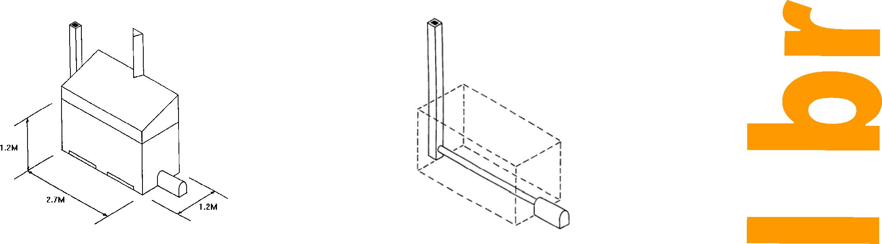

Figure 3: Combination wood and solar dryer, complete with solar cover.
3

Figure 2: Wood burner and chimney.
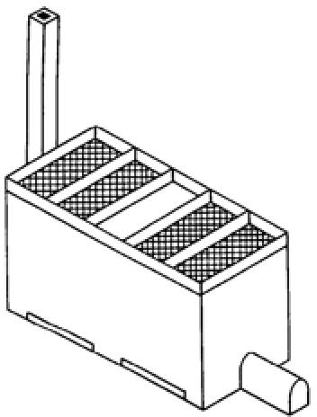
Figure 4: The drying cabinet
Grading
Pepper is graded by size, colour and relative density. Colour grading is done by hand. Small machines are available for grading pepper according to the size or relative density of the peppercorns.
Grinding
Grinding can be a method of adding value to a product. However, it is usually not advisable to grind spices as this makes them more vulnerable to spoilage. The flavour and aroma compounds are not stable and will quickly disappear from ground products. The storage life of ground spices is much less than for the whole spices. It is very difficult for the consumer to judge the quality of a ground spice. It is also very easy for unscrupulous processors to contaminate the ground spice by adding other material. Therefore most consumers, from wholesalers to individual customers, prefer to buy whole spices.
If the processor wishes to grind the peppercorn on site, they can choose between manual or mechanical grinders, depending upon the scale of the operation. A separate, well ventilated room should be available to house the mill or grinder as it will create a lot of dust.

Manual grinding mills are generally for the small-scale processor. They tend to be based on circular stones or plates that are turned against each other, crushing the peppercorns between the stones. With a good mill, an experienced processor can hand grind about 20kg pepper in an 8 hour day. However, this is very labour intensive, boring work. To make the process easier, the mill can be semi-mechanised by adding a treadle or bicycle wheel – this should enable the processor to grind up to 30kg a day. The fineness of grinding is determined by the distance between the grinding plates.
4

Pepper processing Practical Action
Mechanical grinding mills suitable for peppercorns include horizontal and vertical plate mills and hammer mills.
Packaging
Ground pepper must be packaged in polypropylene bags to prevent the loss of flavour. Polythene bas are not suitable as they allow the flavour components to be lost.
Whole peppercorns are packaged in moisture proof packets. Sealing machines can be used to seal the bags. Attractive labels should be applied to the products. The label needs to contain all relevant product and legal information – the name of the product, brand name (if appropriate), details of the manufacturer (name and address), date of manufacture, expiry date, weight of the contents, added ingredients (if relevant) plus any other information that the country of origin and of import may require (a barcode, producer code and packer code are all extra information that is required in some countries to help trace the product back to its origin). See the Practical Action Technical Brief on labelling for further information on labelling requirements.
Storage
Dried peppercorns must be stored in moisture-proof containers away from direct sunlight. The stored peppercorns should be inspected regularly for signs of spoilage or moisture. If they have absorbed moisture, they should be re-dried to a moisture content of 10%.
The storage room should be clean, dry, cool and free from pests. Mosquito netting should be fitted on the windows to prevent pests and insects from entering the room. Strong smelling foods, detergents and paints should not be stored in the same room.
Standards
 | US Government requirements and ASTA | International Standards Organisation | British Standard
Moisture (%) | 12.0 | 12.0 | 12.0
Extraneous matter (% by weight) | 1.0 | 1.5 | 1.5
Lights (% by weight) | 4.0 | 10.0 | 10.0
Pinheads (% by weight) | - | 4.0 | 4.0

Equipment suppliers
This is a selective list of suppliers of equipment and does not imply endorsement by Practical Action.
This website includes lists of companies in India who supply food processing equipment. http://www.niir.org/directory/tag/z,,1b 0 32/fruit+processing/index.html
Dryers
Pepper processing Practical Action

Acufil Machines
S. F. No. 120/2, Kalapatty Post Office
Coimbatore - 641 035
Tamil Nadu
India
Tel: +91 422 2666108/2669909
Fax: +91 422 2666255
Email: acufilmachines@yahoo.co.in
acufilmachines@hotmail.com
http://www.indiamart.com/acufilmachines/#
products
Bombay Engineering Works
1 Navyug Industrial Estate
185 Tokersey Jivraj Road
Opposite Swan Mill, Sewree (W)
Mumbai 400015
India
Tel: +91 22 24137094/24135959
Fax: +91 22 24135828
bomeng@vsnl.com
http://www.bombayengg.com/contact.html
Premium Engineers Pvt Ltd Plot No 2009, Phase IV, GIDC Vatva, Ahmedabad 382445 India
Tel: +91 79 25830836 Fax: +91 79 25830965
Rank and Company
A-p6/3, Wazirpur Industrial Estate Delhi – 110 052
India
Tel: +91 11 7456101/ 27456102 Fax: +91 11 7234126/7433905 Rank@poboxes.com
www.teriin.org/tech cardamom.php
Threshing machines
Udaya Industries
Uda Aludeniya
Weligalla Gampola Sri Lanka Tel: +94 8 388586
Fax: +94 8 388909
Industrias Technologicas Dinamicas SA Av. Los Platinos 228 URB industrial Infantas
Los Olivios
5

Lima
Peru
Tel: +51 14 528 9731
Fax: +51 14 528 1579
Ashoka Industries Kirama
Walgammulla
Sri Lanka
+94 71 764725
Kundasala Engineers Digana Road
Kundasala
Kandy
Sri Lanka
Tel: +94 8 420482
Alvan Blanch
Chelworth, Malmesbury
Wiltshire
SN16 9SG
UK
Tel: +44 1666 577333
Fax: +44 1666 577339
enquiries@alvanblanch.co.uk
www.alvanblanch.co.uk
Mitchell Dryers Ltd
Denton Holme, Carlisle
Cumbria
CA2 5DU
UK
Tel: +44 1228 534433
Fax: +44 1228 633555
webinfo@mitchell-dryers.co.uk
http://www.mitchell-dryers.co.uk/

Milling and grinding machines
Pepper processing Practical Action

Central Institute of Agricultural Engineering

Nabi Bagh
Berasia Road
Bhopal 462 038
Madhya Pradesh
India
Tel: +91 755 2737191
Fax: +91 755 2734016
director@ciae.res.in
http://www.ciae.nic.in/
Gardners Corporation
158 Golf Links
New Delhi 110003
India
Tel: +91 11 3344287/3363640
Fax: +91 11 3717179
Premium Engineers PVT Ltd India (see above)
Packaging and labelling machines
Acufil Machines India (See above)
Gardners Corporation India (See above)
Gurdeep Packaging Machines
Harichand Mill compound
LBS Marg, Vikhroli
Mumbai 400 079
India
Tel: +91 22 2578 3521/577 5846/579
5982
Fax: +91 22 2577 2846
MMM Buxabhoy & Co
140 Sarang Street
1st Floor, Near Crawford Market
Mumbai
India
Tel: +91 22 2344 2902
Fax: +91 22 2345 2532
yusufs@vsnl.com; mmmb@vsnl.com;
yusuf@mmmb.in
Rajan Universal Exports PVT Ltd
Post Bag no 250
6
162 Linghi Chetty Street
Chennai 600 001
India
Tel: +91 44
25341711/25340731/25340751
Fax: +91 44 25342323
rajeximp@vsnl.com
http://rajeximp.com/rajeximp/contact.html
Kundasala Engineers Sri Lanka (see above)
Alvan Blanch UK (see above)
C S Bell Co
170 West Davis Street
PO Box 291
Tiffin
Ohio 44883
USA
Tel: +1 419 448 0791
Fax: +1 419 448 1203
Narangs Corporation India
P-25 Connaught Place New Delhi 110 001 India
Tel: +91 11 2336 3547 Fax: +91 11 2374 6705
Orbit Equipments Pvt Ltd
175 - B, Plassy Lane
Bowenpally
Secunderabad - 500011, Andhra Pradesh
India
Tel: +91 40 32504222
Fax: +91 40 27742638
http://www.orbitequipments.com
Pharmaco Machines
Unit No. 4, S.No.25 A
Opp Savali Dhaba, Nr.Indo-Max
Nanded Phata, Off Sinhagad Rd.
Pune – 411041
India
Tel: +91 20 65706009
Fax: +91 20 24393377
Rank and Company India (see above)

Pepper processing Practical Action
Banyong Engineering  94 Moo 4 Sukhaphibaon No 2 Rd Industrial Estate Bangchan  Bankapi  Thailand  Tel: +66 2 5179215-9  John Kojo Arthur  University of Science and Technology Kumasi  Ghana | Technology and Equipment Development  Centre (LIDUTA)  360 Bis Ben Van Don St  District 4  Ho Chi Minh City  Vietnam  Tel: +84 8 940 0906  Fax: +84 8 940 0906  Alvan Blanch UK (see above)

Contacts
7

The following contacts should be able to provide further information:
Indian Institute of Spices Research (IISR)
Marikunnu PO, Calicut
Kerala
India 673012
Tel: +91 495 2731346
+91 495 2730294
parthasarathy@iisr.org; rdinesh@iisr.org
http://www.iisr.org/package/index.php?spice=pepper&body=Overview
Indian Institute of Technology (IIT) Bombay
Powai
Mumbai 400076
India
Tel: +91 22 2572 2545
Fax: +91 22 2572 3480
http://www.ircc.iitb.ac.in/webnew/
Further reading
Drying Practical Action Technical Brief
Spice processing Practical Action Technical Brief Labeling food products Practical Action Technical Brief
This document was produced by Dr. S Azam Ali for Practical Action March 2007. Dr. S Azam-Ali is a consultant in food processing and nutrition with over 15 years experience of working with small-scale processors in developing countries.
Practical Action
The Schumacher Centre for Technology and Development
Bourton-on-Dunsmore
Rugby, Warwickshire, CV23 9QZ
United Kingdom
Tel: +44 (0)1926 634400
Fax: +44 (0)1926 634401
E-mail: inforserv@practicalaction.org.uk
Website: http://practicalaction.org/practicalanswers/
Practical Action is a development charity with a difference. We know the simplest ideas can have the most profound, life-changing effect on poor people across the world. For over 40 years, we have been working closely with some of the world’s poorest people - using simple technology to fight poverty and transform their lives for the better. We currently work in 15 countries in Africa, South Asia and Latin America.

