Trichoscypha acuminata Engl.
27/10/2015 Trichoscypha acuminata - Useful Tropical Plants

Anacardiaceae + Synonyms
n
Fruit cut open to show the flesh and seed Photograph by: Ehoam Bidault I (cc) =II
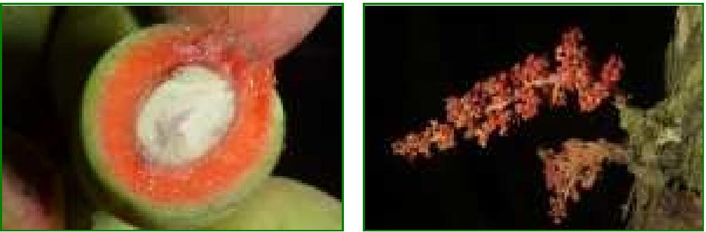

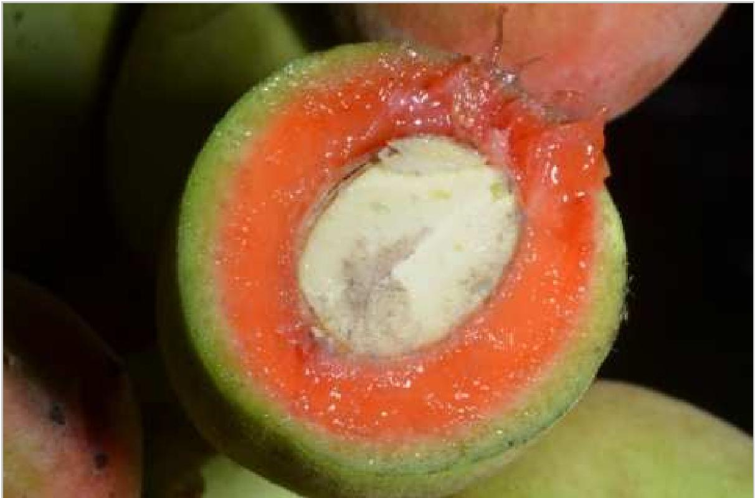
Common Name:
General Information
Trichoscypha acuminata is an unbranched or poorly branched evergreen tree; it can grow 15 - 20 metres tall. The straight bole can be 50cm in diameter, the leaves are usually crowded at the tops of the stem or any branches[328, 332].
The tree is harvested from the wild for local use as a food and medicine.
Known Hazards
None known
Botanical References

Range
West tropical Africa - Nigeria, Cameroon, Central African Republic, Equatorial Guinea, Gabon, Congo, DR Congo, northem Angola.

Habitat
http://tropical.theferns.info/viewtropical.php?id=Trichoscypha+acuminata 1/2
Humid rain forest; terra firma forest; at elevations from 90 - 1,500 metres[ ,
1.
Properties
Edibility Rating
Medicinal Rating
Habit | Evergreen Tree
Height | 15.00 m
Cultivation Status | Wild

Cultivation Details
Not known
Edible Uses
Fruit - raw[332]. The pulp is eaten, it has a vinous taste[332].
The fruit-juice makes a pleasant drink[ ].

Medicinal
27/10/2015 Trichoscypha acuminata - Useful Tropical Plants
http://tropical.theferns.info/viewtropical.php?id=Trichoscypha+acuminata 2/2
The bark, and also that of other closely related species, is used as a remedy against constipation in
infants[ ]. A bark decoction is given to women to treat sterility and dysmenorrhoea, and for haemorrhage
during pregnancy[332].
A bark-decoction is used to wash small-pox pustules and to bathe rheumatics[M]. A decoction is also used in steam baths and in frictions of the lees for bronchial affections, headache, feverish stiffness, pains in the
sides or stomach, as a vermifuge and an aphrodisiac[ ].
The fruit is given to convalescents and to anaemic people as a tonic[332].
A trace of saponin is reported present in the bark[332] Tannins are present in the bark and roots[332].
Other Uses
None known
Propagation
Seed -
Add a Comment:
If you have any useful information about this plant, please leave a comment. Comments have to be approved before they are shown here.
Name:
Email(Private): Message:
Captcha: Type the digit seven into the box

Submit

Last update on 2015-09-25: Now containing 10389 plants.
Useful Tropical Plants Database 2014 by Ken Fern, web interface by Aina Fern with help from
Richard Morris.
The database and code is licensed under a Creative Commons Attribution-NonCommercialShareAlike 3.0 Unported License.


