Fig. 5. The juicy pulp surrounding the secds is the mon dayorful part of the tree tomato. Because the skin is biner, Colombian field workem squeeze out and consume the refreshing pulp and discard the "shells". (Photo by Julia Morton).
- 'aes'
^{1"}:.`
- .•..•
- .•Zow

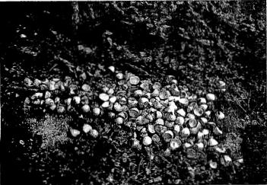
84
pareil commiri^{s}ially in a factory in Auckland, New Zealind. Being high in pectin, the fruit is easily made into jelly but it oxidizes and discolors without special treatment during processing. Whole, peeled fruits, with sugar, are cooked to a sauce for use on ice cream. The peeled fruits may be pickled whole, or may be substituted for tomatoes in a hot chili sauce (7, 10, 20, 24, 26, 35. 38).
Food Valus
Analyses of trec tomatoes in Ecuador. Guatemala and India showed the following constituents, per 100 g: mois-sure, 82.7 to 87.8 g; protein, 1.5 g; total carbohydrates, 10.3 g; fat (ether extract), 0.08 to 1.28 g; crude liber, 1.4 to 4.2 g; nitrogen, 0.223 to 0.445 g; ash, 0.61 to 0.84 g; calcium. 3.9 to 11.3 mg; phosphorus (with seeds), 52.5 to 65.5 mg, or (without seeds), 13.1 mg; iron, 0.66 to 0.94 mg; carotene, 0.371 to 0.658 mg; (or, calculated as xitarain A. 540 I. U.): thiamine, 0.038 to 0.137 mg; ribollavin, 0.035 to 0.048 mg; niacin (with seeds), 1.10 to 1.38 mg, or (without seeds), 1.011 mg; ascorbic acid, 23.3 to 33.9 mg. Most of the ascorbic acid is lost in cooking (I, 17, 28, 29).
Proc. Fia. State Hort. Soc. 95: 1982.

