Revision of the Structures of Citrifolinin A, Citrifolinoside, Yopaaoside A, Yopaaoside B, and Morindacin, Iridoids from Morinda citrifolia L. and Morinda coreia Ham.

Jan Schripsema ,*†‡ Geisa P. Caprini ,† and Denise Dagnino §
Grupo Metabolômica, Laboratório de Ciências Químicas, Centro de Ciência e Tecnologia, Universidade Estadual do Norte Fluminense, Av. Alberto Lamego 2000, Campos dos Goytacazes, RJ BR-28015-620, Brazil, Laboratório de Biotecnologia, Centro de Biociências e Biotecnologia, Universidade Estadual do Norte Fluminense, Av. Alberto Lamego 2000, Campos dos Goytacazes, RJ BR-28015-620, Brazil, and Department of Analytical Biotechnology, Technical University Delft, Julianalaan 67, 2628 BC Delft, The Netherlands
Org. Lett., 2006, 8 (23), pp 5337–5340
DOI: 10.1021/ol0622108
Publication Date (Web): October 10, 2006
Copyright © 2006 American Chemical Society

Abstract
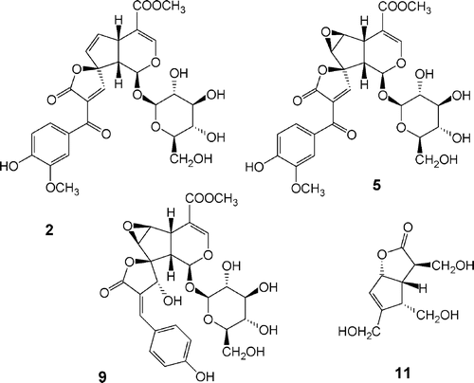
Citrifolin A was revised to dehydromethoxygaertneroside (2). Citrifolinoside and yopaaoside A were found to be identical, and their structures were revised to the new structure dehydroepoxymethoxygaertneroside (5). Yopaaoside B was revised to citrifolinoside A (9), and morindacin was revised to borreriagenin (11).
Source : ASC Publications, http://pubs.acs.org/doi/abs/10.1021/ol0622108?journalCode=orlef7

