Manual on Mangrove Nursery
Raising Techniques
M. S. Swaminathan Research Foundation Chennai, India
T. Ravishankar
and
R. Ramasubramanian

MSSRF/MA/04/15
Printed by: AMM Screens, Chennai
M. S. Swaminathan Research Foundation 3rd Cross Street, Institutional Area Taramani, Chennai – 600 113, INDIA.
Tele: 91 44 22541229; 22541698
Fax: 91 44 22541319
www.mssrf.org
Email: msswami@mssrf.res.in
executivedirector@mssrf.res.in raviethnobotanist@rediffmail.com
September 2004
Citation:
Ravishankar, T. and R. Ramasubramanian. 2004. Manual on mangrove nursery techniques. M.S. Swaminathan Research Foundation; Chennai, India. pp 48.
This manual was prepared with the generous support of India Canada Environment Facility (ICEF), New Delhi
Foreword

There is now much public awareness of the need to conserve the remaining mangrove forests and also to rehabilitate the degraded mangrove wetlands. This awareness is growing among coastal communities, particularly because of severe storms and also because of the linkages between exudates from mangrove roots and sustainable fisheries. So far the propagation and planting of mangrove trees have remained essentially a responsibility of Forest Departments. It is clear that unless local communities are also involved in the raising of nurseries and rehabilitation of damaged mangrove wetlands, the tasks of conservation and restoration will not be accomplished speedily and effectively.
It is in this context that this manual on Mangrove Nursery Raising Techniques assumes significance. I hope this Manual will help women and men living in coastal areas to raise nurseries and to raise mangrove forests along the coast. This will lead to a concurrent strengthening of the livelihood and ecological security of coastal areas. I thank Drs T Ravishankar and R Ramasubramanian for preparing this manual. I hope it will be widely used and will promote a community mangrove afforestation movement.

M S Swaminathan
Acknowledgment
We are grateful to Prof. M.S. Swaminathan, Chairman, M.S. Swaminathan Research Foundation, for his encouragement and guidance. We thank Dr. M. Velayuthum, Executive Director, MSSRF, for his guidance and Dr. V. Selvam, Programme Director, MSSRF, for his critical comments and suggestions in preparing this Manual.
We thank Shri. S. Sankaramurthy, Prof. S. Chelliah and Shri. K. Johnson for their contributions to the projecct.
We are thankful to Shri. A.V. Joseph, IFS, Chief Conservator of Forests, Shri. Ramesh Kalghatgi, IFS, Shri. J.V.K.T. Prabakar Rao, IFS, Shri. Manoranjan Bhanja, IFS, Conservators of Forests, for their support in implementing the project. Shri. N. Varaprasada Rao, Shri. Thatha Rao, Shri. K. Ravi Kumar, Shri. K. Prakasha Rao, Deputy Conservators of Forests, Shri. N. Bhujanga Rao, Shri. C.V.V. Satyanarayana, Shri. M. V. Satyanarayana Murthy, Shri. Mallikarjuna Rao, Forest Range Officers and the staff of Coringa and Krishna Wildlife Sanctuaries, Andhra Pradesh, for their help during the mangrove restoration work from 1996 to 2003.
We thank Dr. Ujwal Chaudary and Dr. Jaya Chatterji of India Canada Environment Facility (ICEF), New Delhi, for their support in making this work possible.
We extend our thanks to Mr. Maqbool of MSSRF and the members of the Eco Development Committee (EDC) and Vana Samrakshna Samiti (VSS) committees of Godavari and Krishna mangroves for their participation and involvement in restoration. We also thank Shri. R. Satyanarayana, AFBO and Shri. D. Srinu, for their help and assistance in the field work and the boat drivers Shri. Satyam and Shri. M. Srinu. We thank Shri. N. Veerabhadra Rao for his neat typing and page making.
Contributors
M.S. Swaminathan Research Foundation
T. Ravishankar
R. Ramasubramanian
D. Sridhar
Najibullah Sheriff N. Srinivasa Rao M.M. Jeelani
Community
Dr. B.R. Ambedkar VSS, Bhairavalanka Sri Vigneswara EDC, Matlapalem Dheenadayaljee EDC, Dheenadayalapuram
Andhra Pradesh Forest Department
T. Satyanarayana M. Bhaskara Rao M. Srinu
Contents
- Introduction 09
- Natural regenration of mangroves 14
- Need for mangrove nurseries 15
3.1. Advantages of mangrove nurseries 16
- Selection of site for mangrove nursery 16
- Selection of mangrove species 17
5.1. Collection of seed material and planting in nursery_ 17
5.2. Identification of matured propagules 20
5.3. Fruiting season 20
5.4. Identification of mangrove species 20
- Techniques in preparing the nursery 20
6.1. Soil 20
6.2. Nursery bags 21
6.3. Preparation of nursery beds 21
6.4. Sowing 23
6.5. Application of Fertilizers 23
6.6. Grading 23
6.7. Pest control 23
- Nursery techniques for different species 23
7.1. Avicennia marina and Avicennia officinalis 27
7.2. Excoecaria agallocha 30
7.3. Sonneratia apetala 32
7.4. Xylocarpus moluccensis 34
7.5. Aegiceras corniculatum 36
7.6. Bruguiera gymnorrhiza 38
7.7. Rhizophora apiculata and
Rhizophora mucronata 40
- Seed germination and growth of seedling 42
8.1. Viability of seed material 42
- Role of nurseries in participatory management 44
- Mangrove nurseries as livelihood
alternatives for women 45
References 47
Acronyms
AFBO - Assistant Forest Beat Officer APFD - Andhra Pradesh Forest Department
EDC - Eco-Development Committee
ha - Hectare
IFS - Indian Forest Service
IUCN - International Union for the Consevation of nature and
natural resources
MMU - Mangrove Management Unit
MSSRF - M.S. Swaminathan Research Foundation
NGO - Non-Government Organization
ppt - Parts per thousand
PRA - Participatory Rural Appraisal
RF - Reserve Forest
sq km - Square kilometres
VLI - Village level institution
VSS - Vana Samrakshana Samithi
Manual on Mangrove Nursery
Raising Techniques
1. Introduction
Mangroves are known to provide shelter, act as nursery grounds and are also habitats for economically important fishes, prawns, crabs and molluscs. In addition to from providing nutrition in the form of detritus, mangroves also play an important role by improving water quality and controlling coastal erosion caused by flooding and storm surges. They also act as a barrier during cyclones and protect the coastline.
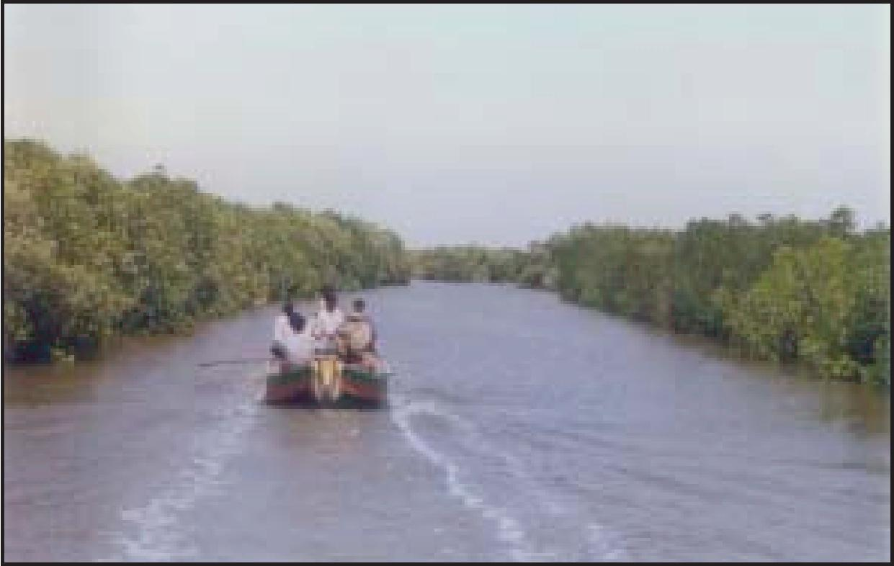
It is estimated that mangrove forests occupy 75% of the tropical coasts worldwide and are distributed in approximately 18.15 million ha. India’s mangrove wetlands range from 6,81,000 ha. (Sidhu, 1963) to 5,00,000 ha. (FSI, 1999) (Map-1). The mangrove forests in Andhra Pradesh are located in the estuaries of the Godavari and Krishna rivers. The Godavari mangroves are located in the Godavari estuary of East Godavari district and the Krishna mangroves in the Krishna estuary of Krishna and Guntur districts (Maps 2 & 3). Apart from these estuaries, mangroves are also
M. S. Swaminathan Research Foundation
10
Size of the circle indicates the extension of distribution
h I I
ri A
.1 4 Y T
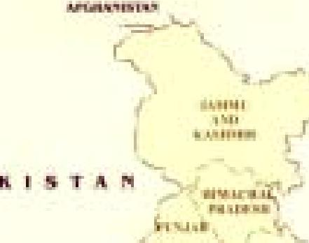

r • - :
111%11Y 1..1C§ •
•• ."........ jir ..... I ....IP'
..... -- .
MiJ.11111% • ' . I MI FL LEI Hl , 1 .
.-. Je "T. es. _,_{ii}pt e^{" -I-} •"1._-. r.:4^{1.}7:.
.
- e Immo ...._{j}e
1._ .
— ---.
I'l 1.1111i
-'..—.1>eef..-1 ^{L'a 1.1 .}..44 IN,
- - n-, «"-• ' ^{"-}e. ' •,..
—Jr- I.
X. D I A , .. . ...iuddee_{ri}
_ ..
* IR avril . "t^{all}'inv^{i}ii4.1%
.11171108 7%.1.11 n 1.1.11,..1 mi si . I
i liF Illime• ¹11.1.1 I ¹. Imm.. 1.1,. 1 . NITAIIPffli
a '
I -

- I. | 1.1r. I 1111.  r• na •

11'
-Ab ILImIi
- • - 4,₄,
•
MAY
 |  | 6

Map 1. Distribution of Mangroves in India
Map 2. Location of Godavari Mangroves
Map 3. Location of Krishna Mangroves
11

Manual on Mangrove Nursery Raising Techniques
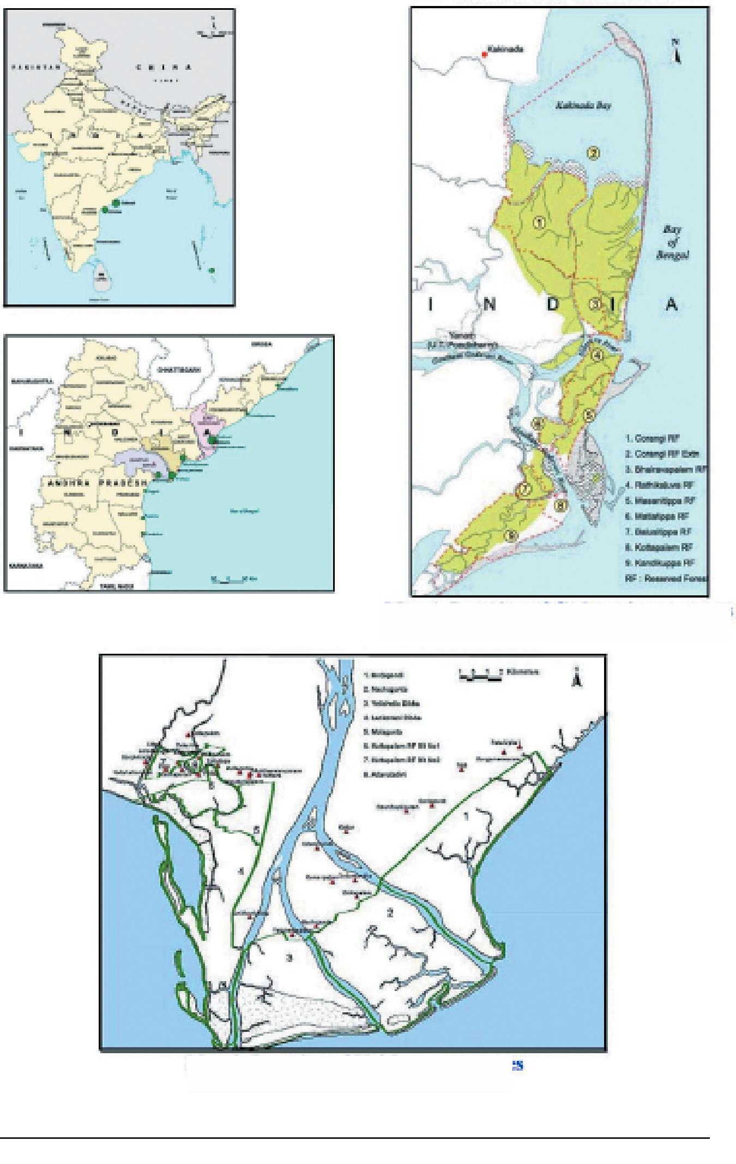
M. S. Swaminathan Research Foundation
12
found in small patches along the coast of Visakhapatnam, West Godavari, Guntur and Prakasam districts. The total area under Godavari and Krishna mangrove wetlands is 58,263 ha of which 33,263.32 ha are under Godavari and 24,999.47 ha are in Krishna. However, the dense mangroves in Godavari and Krishna are only 17,000 ha and 7,347 ha respectively. The rest are distributed between mudflats, water bodies, sand bodies and casuarina plantations. Due to anthropogenic pressures and increased land use practices such as conversion of mangroves into agriculture and aquaculture ponds, the mangrove area has reduced to less than 50% of the original total cover. In addition to this, geomorphological changes, like elevated topography of the mangrove area, prevent free movement of tidal water and fresh water inflow into mangroves. This has resulted in increase in salinity and caused degradation of mangroves. Conversion of mangrove forests into aquaculture ponds has resulted in the exposure of acid-sulphate soils and increased the levels of salinity. As a result, the soils have become unsuitable for the natural regeneration of mangroves.
In order to overcome the issue of reduction in mangrove cover, attempts were made by government and non-government organizations to restore the mangroves wherever possible. In Andhra Pradesh, MSSRF, jointly with eight village level institutions (namely Sri Vigneswara EDC, Matlapalem, Sri Nookalamma EDC, Dindu, Sri Devi EDC, Kobbarichettupeta, Sri Kanakadurga EDC, Gadimoga, Dr. B.R. Ambedkar VSS, Bhairavalanka, Dheenadayaljee EDC,Dheenadayalapuram, Zinkapalem EDC, Zinkapalem and Sri Sita Rama Lakshmana EDC, Nali) and the Andhra Pradesh Forest Department, has restored 520 ha. The restoration has improved the mangrove forest cover (Remote sensing images of Godavari and Kridhna mangroves - 1986 & 2001). It has also arrested further degradation of mangroves adjoining the degraded patches and increased the fishery resources. The bio-diversity of the area has improved. The crab
Manual on Mangrove Nursery Raising Techniques
13
population in the restored areas has increased due to the increased water regime. Since the work involves intensive labour, the
Godavari Mangroves
1986 2001

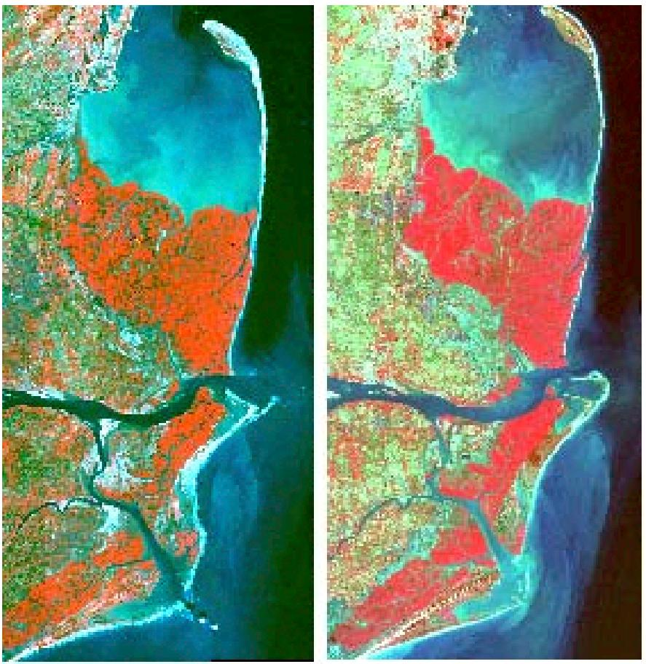
Krishna Mangroves
1986 2001

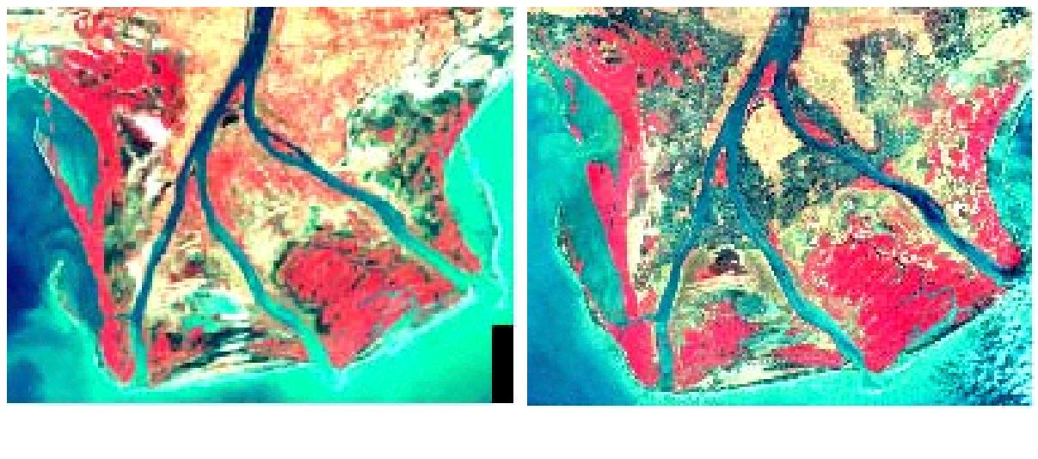
M. S. Swaminathan Research Foundation
14
members of the village level institutions were benefitted by the employment opportunities generated. To restore the degraded areas, mangrove seedlings were raised in mangrove nurseries by developing nursery techniques. These techniques were developed by applying standard propagation and rearing methods followed in the project “Coastal Wetlands: Mangrove Conservation and Management”, which was implemented from 1996 to 2003 by M.S. Swaminathan Research Foundation with its regional centre at Kakinada. This project was supported by India Canada Environment Facility, New Delhi.
The techniques for mangrove nursery design, establishment and operation, and the use of nursery stock for mangrove restoration, which are described in this Manual will help in raising mangrove nurseries and in the restoration of degraded mangroves, involving local communities.
2. Natural regeneration of mangroves
Mangroves regenerate naturally when the conditions are suitable for their growth and establishment and also when the adjacent atmosphere suits the ecological niche. These conditions prevail in places where the natural course of tidal influx and river water flow occurs. Mangroves, like any other forest ecosystem, regenerate as a cyclic phenomenon. Each species has its distinguished character of regenerating: by seeds in the case of species such as Excoecaria agallocha, Sonneratia apetala and by viviparous germination through propagules in the case of Rhizophora apiculata, R. mucronata and Bruguiera gymnorrhiza. Natural regeneration occurs particularly in the accreted areas along the seaward side.
However, due to changes in geomorphological and hydrological conditions, the natural regeneration of mangroves is hindered. In the Godavari mangroves, the degraded areas near the old lighthouse near Gaderu River receive increased tidal flushing due to the breach in the sand spit of Hope Island during the 1996
Manual on Mangrove Nursery Raising Techniques
15
cyclone. This increase in tidal flushing has resulted in the regeneration of mangrove species, namely Avicennia marina and Excoecaria agallocha, but only till the time the breach was opened. The mangroves are also establishing in the newly accreted mudflats near the river mouths which are inundated daily by the natural cycle of spring and neap tide.
3. Need for mangrove nurseries
The season for flowering, fruiting and production of seeds and propagules are not the same as the season of planting in degraded areas. The fruiting season of nursery raised saplings viz. Avicennia marina and Avicennia officinalis, which are mainly used in restoration, is October to November. However, the areas will be suitable for planting only during July to November. Hence, the seedlings raised during the first year will be used for planting in the second year, due to the mismatch of seasons between fruiting and planting. It was also seen during the implementation of the project from 1997 to 2003, that the rate of survival of nursery raised saplings is 50% greater when compared to direct dibbling of seeds. The casualty is due to the reason that the crabs damaged the sprouting seeds by eating the hypocotyle. The chemical reaction that takes place in the sprouting seeds emits a gaseous smell
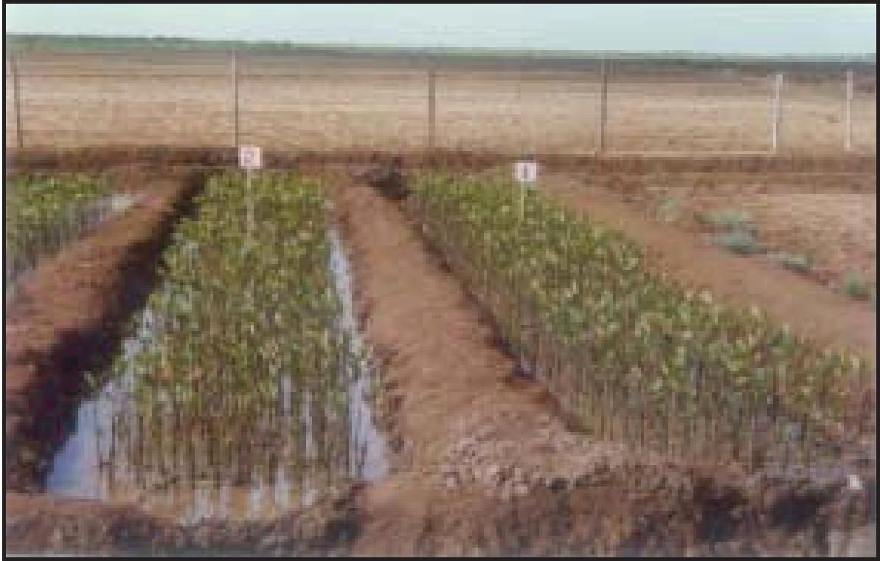
M. S. Swaminathan Research Foundation
16
that attracts the crabs. It has been observed by the mangrove project of IUCN, Bangladesh, that the seeds kept in running water had a better survival rate (personal communication of Mr. Junaid Chaudhary with Dr. T. Ravishankar).
The major requirements for a mangrove nursery site are
areas with periodic inundation
access to good quality salt and fresh water
pumps for pumping saline water from the creeks for the saplings
access to road/creek to mobilize transport and labour to the planting sites and
good quality propagation stock.
3.1. Advantages of mangrove nurseries
The establishment of a nursery has several advantages. The survival rate of nursery raised seedlings in restoration areas is high (90%) when compared to the direct dibbling of seeds / propagules. This is due to the fact that nursery-raised saplings have a well established root system, as they are maintained for 8-9 months in the nursery (from October to July) under simulated conditions, before being transplanted in the degraded areas, which were under high saline conditions for long periods.
4. Selection of site for the mangrove nursery
The mangrove nursery site should be selected in the inter-tidal area, in close proximity to creeks with drainage into canals. The water quality should be good and the area should be fenced with barbed wire, to prevent grazing by feral cattle inhabiting the mangrove forests. It should be connected by road and waterways, to reduce the cost of transportation of seedlings from the nursery to the restoration site. It should be provided with water pumping facility by the Forest Department, especially during summer.
Manual on Mangrove Nursery Raising Techniques
17
Channels for inflow and outflow of tidal water should be dug to facilitate natural inundation as shown in chart 1.
Chart 1. Mangrove Nursery Layout
5. Selection of mangrove species

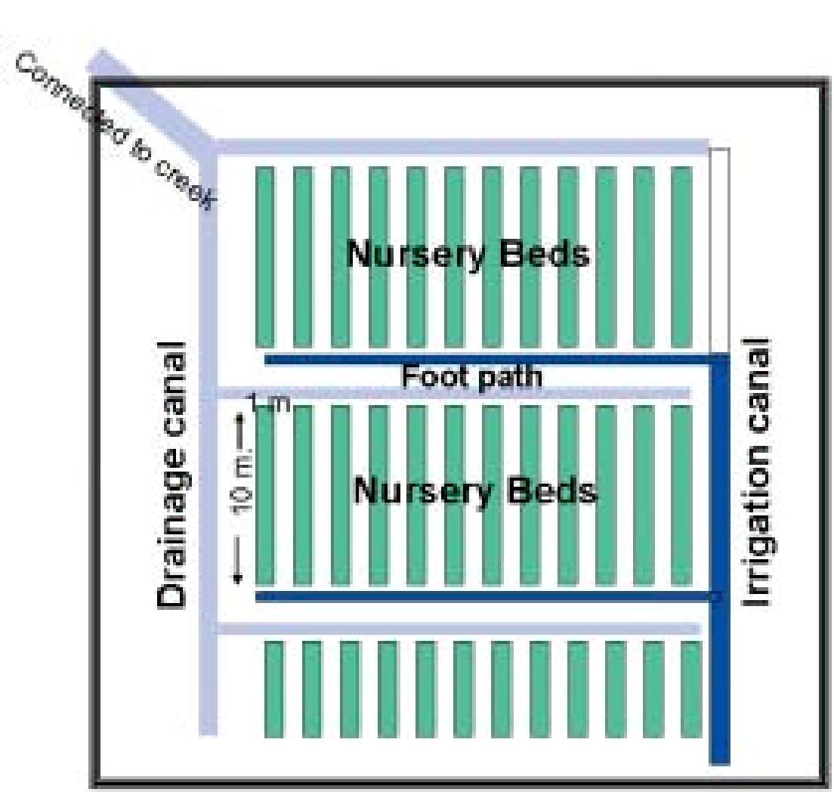
Mangrove species should be selected, based on the salinity of the degraded area or the area chosen for afforestation. Nine mangrove species were selected for raising in the mangrove nursery (Table-1). The first three species were raised for planting in the degraded area to increase forest cover, bring back the greenery and enable the bird species to come back. The other six mangrove species were raised for planting in the degraded area in order to maintain genetic diversity.
5.1. Collection of seed material and planting in the nursery
Mature and healthy fruits / propagules were collected from the forest in the morning, involving locally trained villagers and kept in the shade. The fruiting season for a majority of the mangrove
M. S. Swaminathan Research Foundation
18
species in Godavari is between September and December. Except Sonneratia apetala and Aegiceras corniculatum all other species were gathered from good quality fallen propagules. The collected seeds were examined for incidence of diseases or pests.
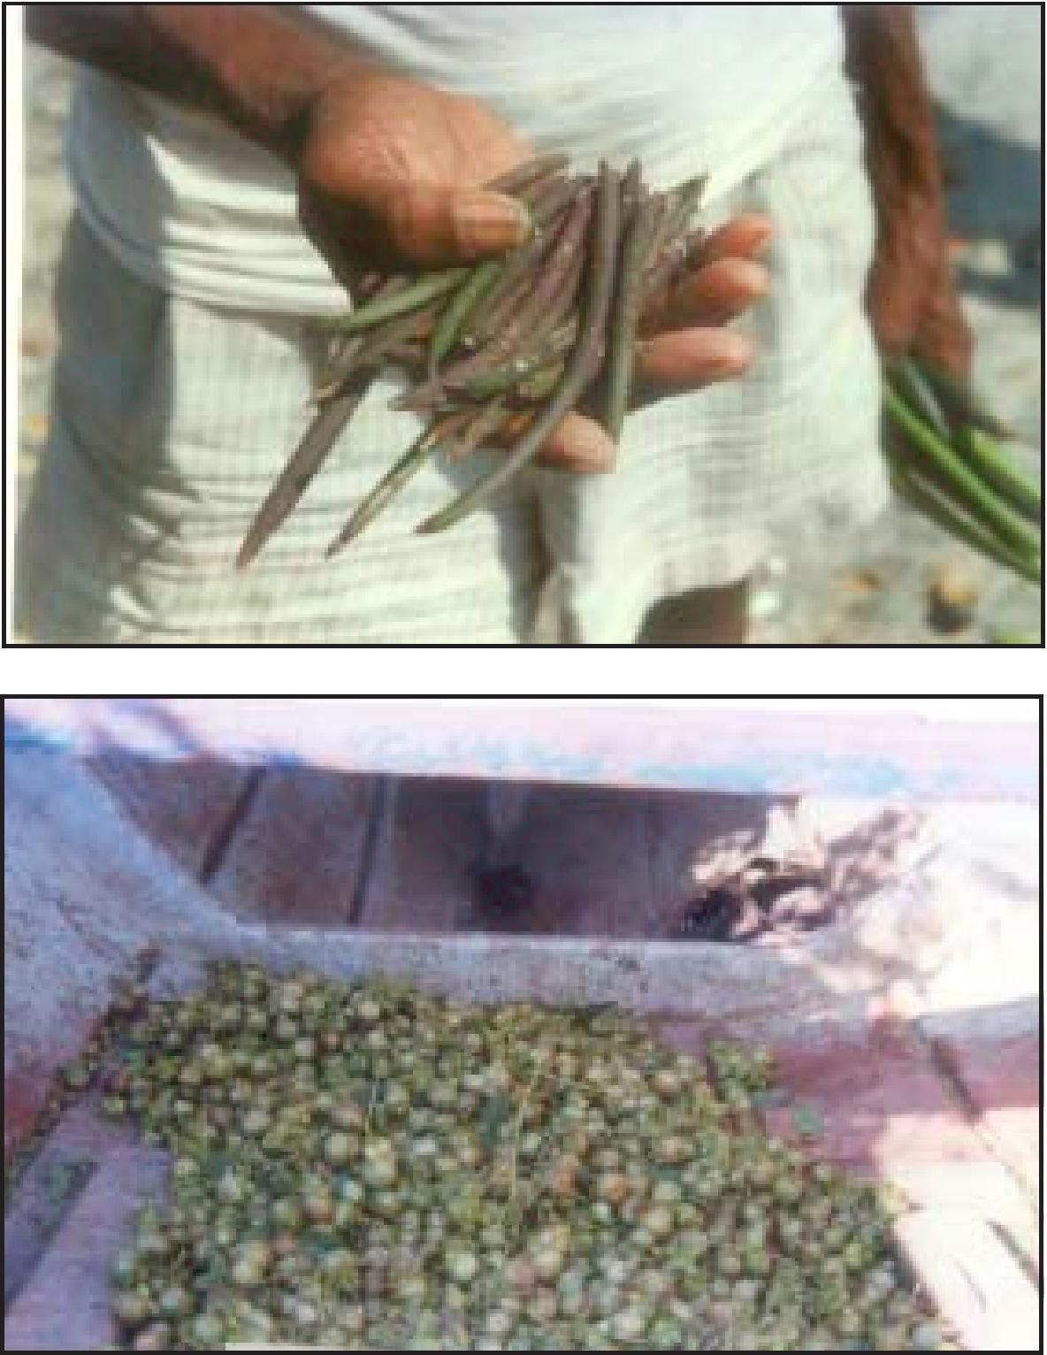
Seeds of Avicennia marina and Avicennia officinalis were collected from the ground beneath the trees during low tide.They were stored in separate bags and labeled. Floating propagules of Rhizophora apiculata, Rhizophora mucronata, Bruguiera gymnorrhiza and Xylocarpus moluccensis were collected from
Manual on Mangrove Nursery Raising Techniques
19
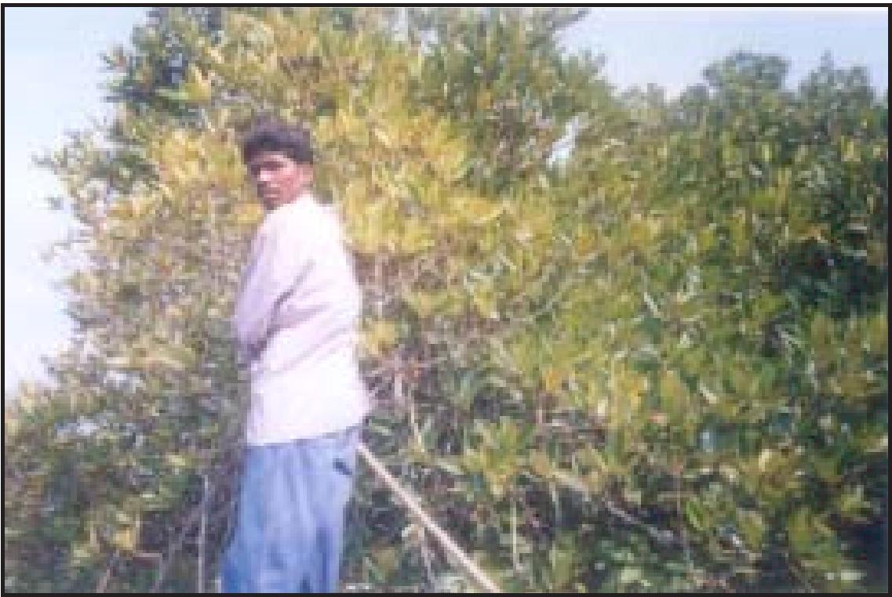
Table 1. Details of mangrove species and the planting material
S.No | Mangrove Species | Planting material | Purpose
 | Avicennia marina (Forsk.) Vierh. | Fruits | Planting in degraded areas
 | A. officinalis L. | Fruits | Planting in degraded areas
 | Excoecaria agallocha L. | Young seedlings | Planting in degraded areas
 | Aegiceras corniculatum (L.) Blanto | Propagules | Planting for genetic diversity
 | Bruguiera gymnorrhiza (L.) Savigny | Propagules | Planting for genetic diversity
 | Rhizophora apiculata Bl. | Propagules | Planting for genetic diversity
 | R. mucronata Lamk. | Propagules | Planting for genetic diversity
 | Sonneratia apetala Buch.-Ham. | Seeds | Planting for genetic diversity
 | Xylocarpus moluccensis (Lamk.) M.Roem. | Seeds | Planting for genetic diversity

the creeks using hand nets. Mature seeds of Aegiceras corniculatum were collected from the trees. The collected seeds and propagules were kept in either polythene bags or in jute sacks and transported to the nursery.
M. S. Swaminathan Research Foundation
20
5.2. Identification of mature propagules
Rhizophora mucronata can be easily identified from R. apiculata by its larger size and green colour. The seeds were planted within a day or two of collection, as delay in planting reduces the rate of germination. Young seedlings of Excoecaria agallocha (about 2" height) were collected locally in the morning and planted directly in the bags in the evening. The mature fruits of Sonneratia apetala can be easily identified by change in the colour from pale green to deep green. The taste of the fruit becomes sour as it matures.
5.3. Fruiting season
Field observations in Coringa Wildlife Sanctuary in Godavari mangroves indicated that the ideal season for collecting the propagules is from September to December. However, Bruguiera gymnorrhiza, Rhizophora apiculata and R. mucronata bear fruits throughout the year, though the peak fruiting season is during August – November. The viability of the seeds depends on the age of the tree. For eg. Rhizophora is able to produce fruits from the age of four years, but the propagule should be collected from the trees older than 5 years i.e. trees which are taller than 5-6 m.
5.4. Identification of mangrove species
The species can be identified with the help of Flora of the Presidency of Madras by Gamble (1915-38), Mangroves in India – Identification of Mangroves by Banerjee et al. (1989) and Mangroves of Andhra Pradesh - Identification and Conservation Manual by Ramasubramanian et al. (2003).
6. Techniques in preparing the nursery
6.1 Soil
Only muddy soil which is clayey should be used for preparing the nursery bags. The soft clayey mud available in the mud flats during low tide should be collected. Any debris or hard material should be removed before filling the bags with mud.
Manual on Mangrove Nursery Raising Techniques
21
6.2 Nursery bags
Polythene bags of 5"x8" should be used to raise the mangrove saplings in the nursery. Mud from nearby creeks should be collected
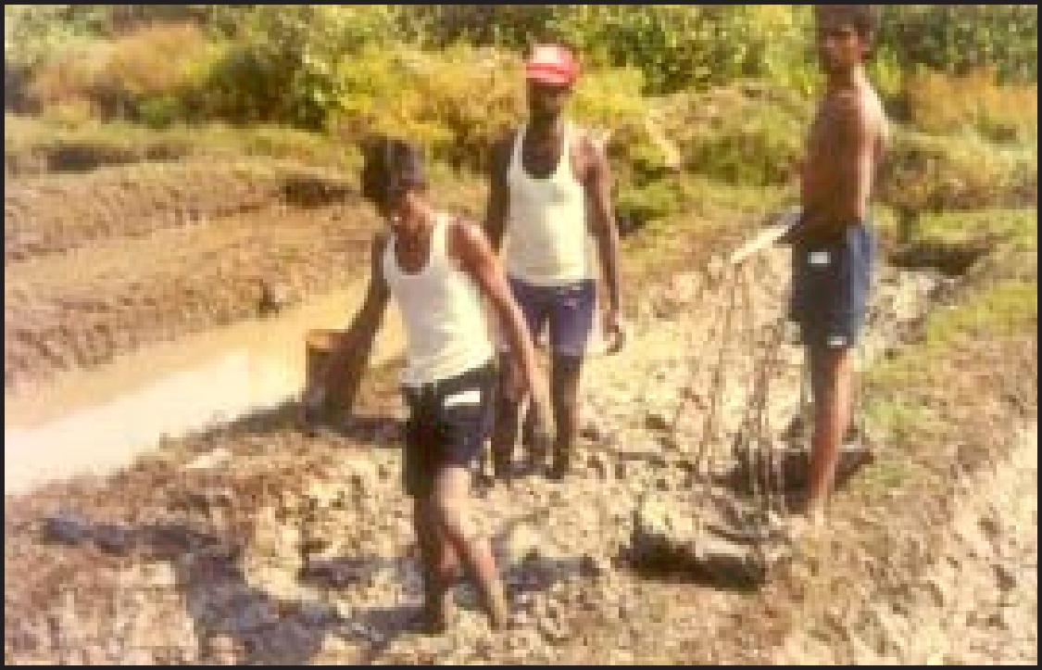
and used to fill the polythene bags. Small perforations should be made at the bottom of the bag in order to drain excess water. The filled bags should be kept in the shade to harden.
6.3 Preparation of nursery beds
The mangrove nursery which was raised jointly by Andhra
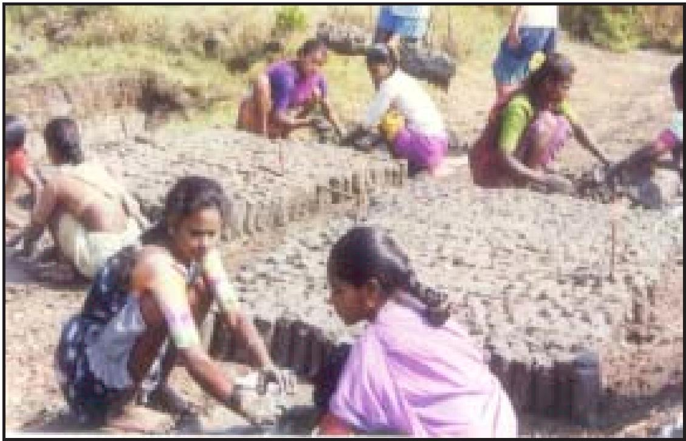
M. S. Swaminathan Research Foundation

22
Pradesh Forest Department and MSSRF for restoring about 1,500 ha has the capacity to raise 1,20,000 saplings per year. It has 80 sunken beds of 10 x 1 x 0.3 m (LBH respectively). Each bed can hold 1500 bags. Bamboo poles were placed horizontally at both the ends and also in the middle to keep the bags intact. The nursery
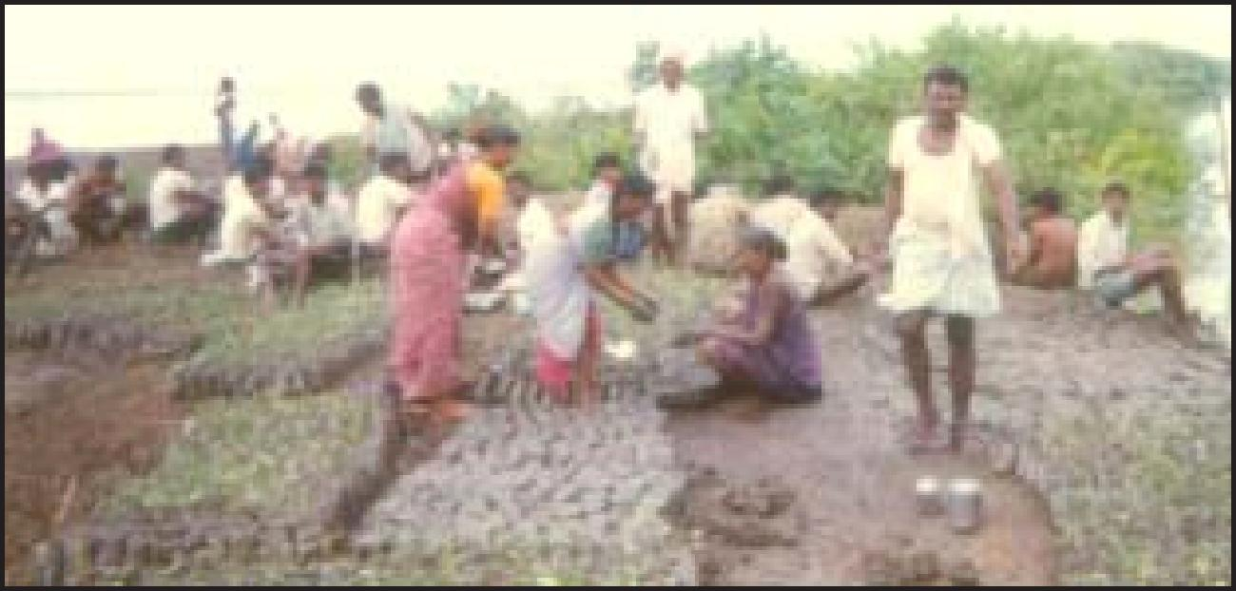
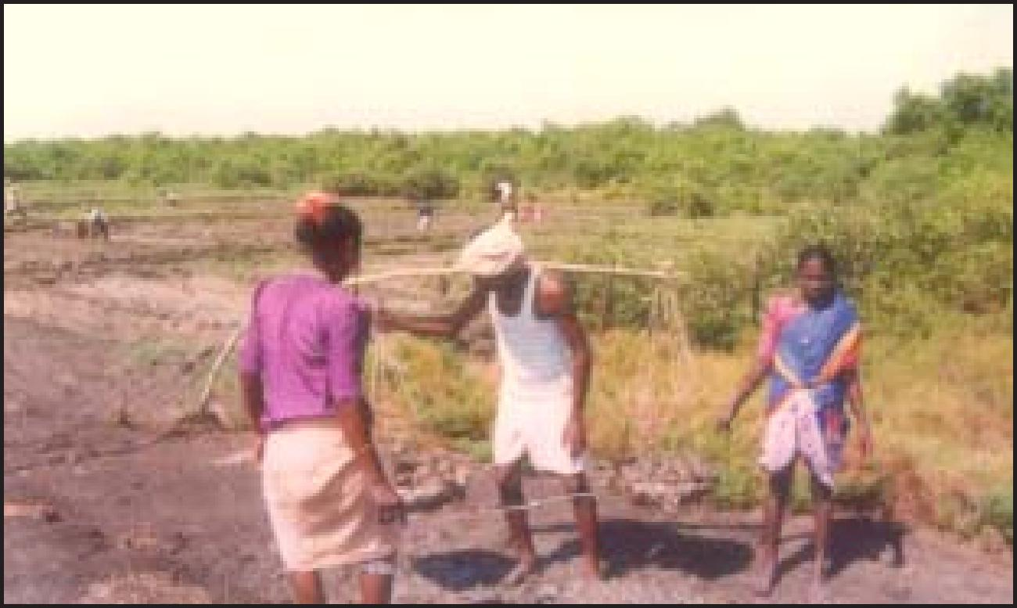
bags were placed inside the beds, which were then flooded to a depth of about 10 cm. The nursery sites and beds may be prepared according to the number of seedings.
Manual on Mangrove Nursery Raising Techniques
23
6.4 Sowing
Viviparous seeds of Rhizophora apiculata, R. mucronata and Bruguiera gymnorrhiza were planted directly in the bags placed in the beds. Similarly, young seedlings (about 2" height) of Excoecaria agallocha collected from the forest and Sonneratia apetala from the primary bed were planted directly in the bags. However the seeds of Avicennia marina, A. officinalis and Xylocarpus moluccensis were sown in bags kept outside and were transported to the nursery bed after germination.
6.5 Application of Fertilizers
Inorganic fertilizers like N:P:K 17:17:17, Di-Ammonium Phosphate and Urea were added after 60 days for better growth of the mangrove seedlings, so as to ensure root establishment. A micronutrient mixture may also be added to enhance the growth of the saplings.
6.6 Grading
The sapling bags were shifted periodically and the empty bags were separated. Shifting of bags with seedlings helps in preventing rooting into the soil.
6.7 Pest control
The seedlings were periodically checked for pest or wood borer damage as the sprouting seeds / propagules are susceptible to caterpillar damage. Pesticide was sprayed when pest attack was severe. The water from the beds was drained completely before applying the pesticide in order to avoid the spread of pesticide residue to other areas.
7. Nursery techniques for different species
Nursery techniques differ from one species to another, depending on the salt tolerance level and the ecological zone. In the following pages, guidelines that should be followed for each species are described. Comprehensive details are given in Tables 2 & 3 and Chart 2.
M. S. Swaminathan Research Foundation
24
-
Pests
Crabs
Nursing
Crabs
caterpillars
Rats, Crabs, caterpillars
Crabs
caterpillars
Crabs
caterpillars
Crabs
caterpillars
Watering
Fully once a day
Fully once a day
Fully once a day
Fully once a day
Fully once a day
Twice a day
At neap tide
Sowing
Push
radicle of
seed into
soil
On top of soil
On top of soil
On top of soil
On top of soil
Push
hypocotyle 5 – 8 cm
Push calyx
portion 1 cm
d ee p
5
10
10
Seed characteristics
Seeds
storage (Max. Days)
7
10
10
15
< 100 mg.
>10 cm. long
5 to6 cm long
Fruit
>15mm. diameter
Weight of seeds > 5g
Weight of
seeds >
1.5g.
Weight of
seeds >
30g.
Seed
collection (criteria)
Floats in water
Indicators of maturity
Dark brown fruits
Reddish brown or greenish red hypocotyls
Yellow to brown fruit
Floats in water
Yellowish fruit skin
Yellowish fruit skin
Yellow Epicarp
Oct – Nov
Jul – Sep
Jul – Sep
Sep – Oct
Oct – Nov
Aug – Oct
Sep – Nov
Seed
collection (months)
Species
Table 2. Details of mangrove species, sowing and maintenance in the nursery
Avicennia marina
Excoecaria agallocha
Bruguiera
gymnorrhiza
Sonneratia apetala
Avicennia officinalis
Xylocarpus moluccensis
Aegiceras
corniculatum

Manual on Mangrove Nursery Raising Techniques
25
Table 3. Action plan for the preparation of the nursery
Species / Item | Month
 | Jan | Feb | Mar | Apr | May | Jun | Jul | Aug | Sep | Cct | Nov | Dec
Avicennia oificinalis Collection & Sowing Raising period Planting in degraded area
Avicennia marina Collection & Sowing Raising period Planting in degraded area
Excoecaria agallocha Collection & Sowing Raising period Planting in degraded area
Aegiceras corniculatum
Collection & Sowing Raising period
Planting in degraded area
Sonneratia apetala Collection & Sowing Raising period Planting in degraded area
Xylocarpus moluccensis
Collection & Sowing Raising period
Planting in degraded area
Bruguiera gymnorrhiza
Collection & Sowing Raising period
Planting in degraded area
Rhi~ophora apiculata Collection & Sowing Raising period Planting in degraded area
Rhi~ophora mucronata
Collection & Sowing Raising period
Planting in degraded area
Gathering soil

M. S. Swaminathan Research Foundation
26
Chart 2. Procedure for preparation of Nursery
Selection of seedlings
Out planting
Seed material
Seed collection
Seed selection and
processing
Storing seeds
(Temporary)
Preparation of nursery bags
Gathering mud
Removing
debris
Filling mud in the
nursery bags
Nursery bed preparation
Making sunken beds, water facility, bamboo poles for keeping the nursery bags
Sowing
Nursing
Watering, pest control, hardening

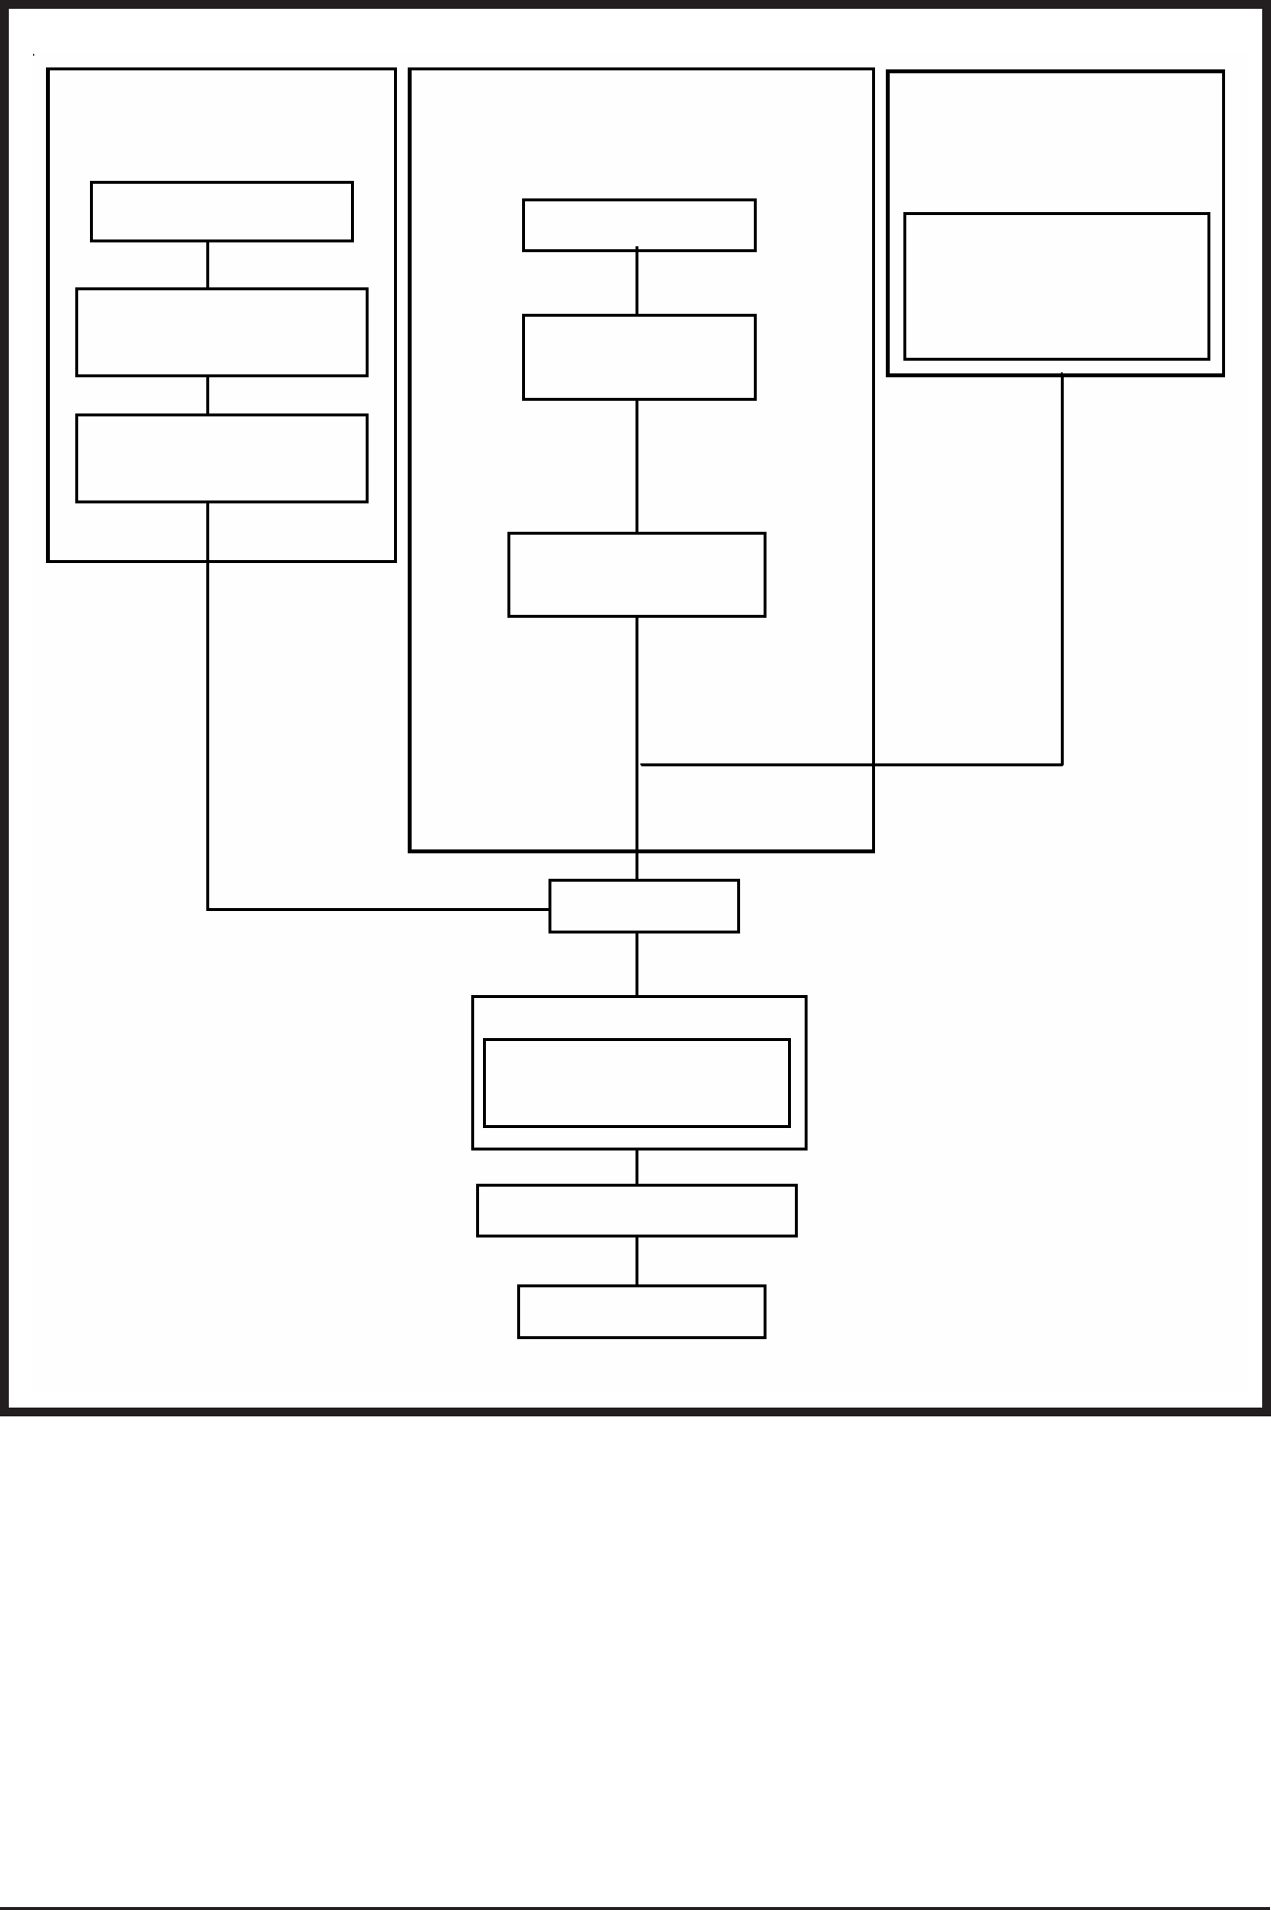
Manual on Mangrove Nursery Raising Techniques
7.1 Avicennia marina (Forsk.) Vierh.
Local Name: Tella Mada (Telugu), Singal Bani (Oriya),
Venkandal (Tamil), Peyara-ban, bain, bani (Bengali)
Avicennia officinalis L.
Local Name: Nalla Mada (Telugu), Bani (Oriya),
Karukandal (Tamil), Jat-ban, bain, bani (Bengali)
Collection and treatment of Avicennia seeds
Healthy and mature seeds of Avicennia marina and A. officinalis should be collected separately. The mature seeds can be easily distinguished by observing the light yellowish colour of the seed coat with cracks on it. The seeds can be collected from October to December.

fruit
pedicel
culyx
culyx
pedicel
fruit

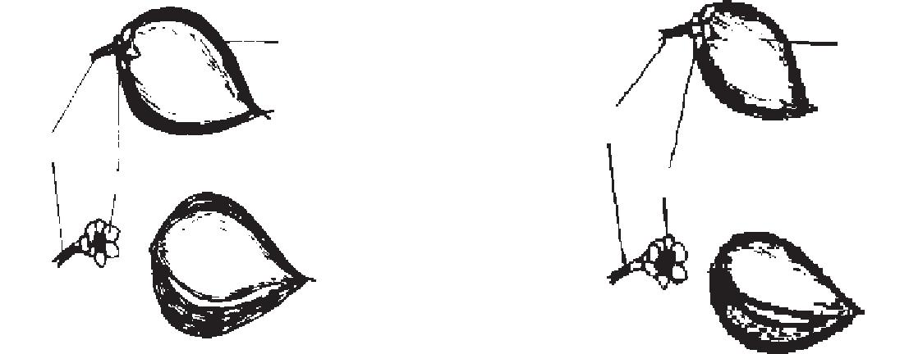

Avicennia officinalis Avicennia marina
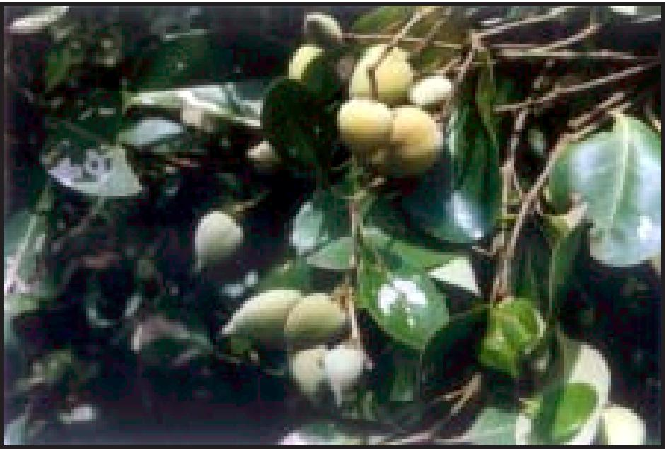
Avicennia officinalis
27

M. S. Swaminathan Research Foundation
28
Selection and processing of the seeds
Mature fruits should be selected and checked for insect borers. Seeds should be soaked in brackish water overnight to remove the seed coats. This treatment reduces the establishment time by two to three days. Only seeds without seed coats should be used for planting in the polythene bags. Normally the seeds must be planted in the polythene bags immediately. In case of storing, the seeds should be kept in the shade for one or two days.
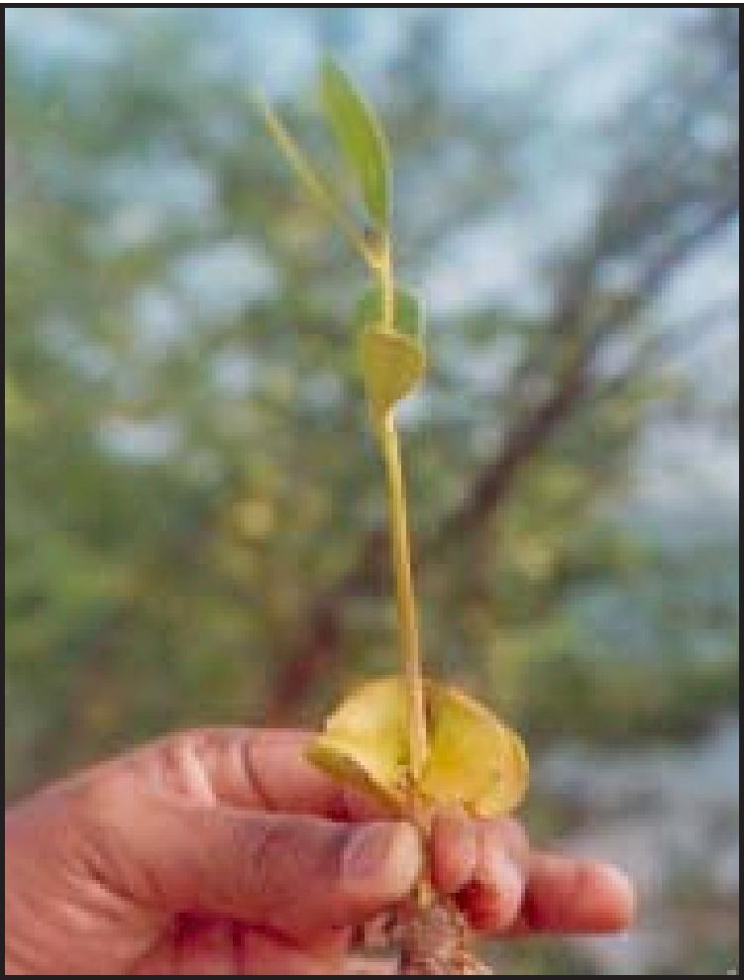
Young seedling of Avicennia marina Sowing into nursery bags
The polythene bags with soil must be allowed to harden by placing them outside the beds. After hardening, the polythene bags containing mud should be watered, using sprinklers. The radicle part of the seeds must be gently pushed (1/3 of the seed) inside the soft mud. Deeply buried seeds will not germinate and will rot.
Manual on Mangrove Nursery Raising Techniques
29
Watering
During the initial stages, water should be sprinkled twice, using rose-water cans. After germination, the polythene bags should be transported to the beds and watered through canals.
Pest control
During the sprouting stages, crabs damage young seedlings. These damaged seedlings should be replaced with fresh seed / seedlings. Caterpillars are the major pests for Avicennia and when the attack is severe, pesticides like Monochrotophos and Ekalux may be used. Water from the beds should be drained before pesticide application.
Grading
For the purpose of grading and to ensure raising healthy seedlings, casualties should be replaced with seeds / seedlings. The seedlings from the beds must be shifted periodically for three months after sowing.
Selection of seedlings from the nursery beds
The recommended specifications of the seedlings are as follows:
Height : 50 cm
No. of leaves : at least 12
Period : 8 months
M. S. Swaminathan Research Foundation
7.2 Excoecaria agallocha L.
Local Name: Thilla (Telugu), Guan (Oriya), Tillai (Tamil), Gneoa (Bengali)
Collection of young seedlings
Juvenile seedlings collected from the mangrove forest can be used as planting material. The seedlings should be collected in the morning and planted on the same day, as early as possible.
Sowing into nursery bags
The young seedlings collected from the forests should be transplanted into the bags. Polythene bags filled with mud should be kept ready.
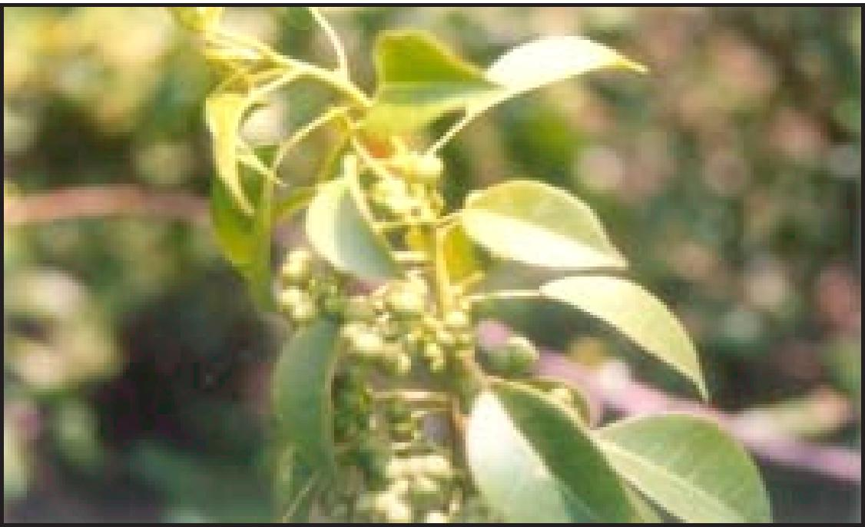

pedicel
fruit culyx
seeds

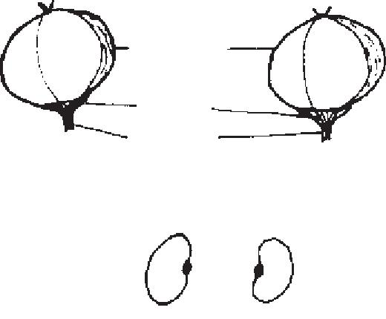

Excoecaria agallocha
30

Manual on Mangrove Nursery Raising Techniques
31
Watering
Watering is to be done daily through the canals. Grading
The casualties need to be replaced with young seedlings that are collected from the forests. The seedlings from the beds should be shifted periodically for three months after sowing.
Selection of seedlings
The recommended specifications of the seedlings are as follows:
Height : 40 cm
No. of leaves : at least 12 to 14
Period : 8 months
Vegetative propagation of Excoecaria through stem cuttings
Healthy plants should be chosen as mother plants. Branches of 1 cm diameter, should be cut to a size of 20 cm length and planted in the nursery. Polythene bags filled with mangrove soil should be kept ready and the cuttings planted in them. Watering should be done regularly for six months if the nursery is maintained in the houses of fishermen as a livelihood alternative. If maintained in regular nursery with tidal inundation facility, the watering is to be done for the first fifteen days.
Juvenile leaves start appearing from the nodes after 10 to 15 days, from which time manual watering can be stopped in the nurseries. However watering should be continued in the homestead nurseries. Roots will develop after 40 days. Polythene bags with rooted saplings need to be rotated within the beds after two months, at an interval of 30 days,until planting in the degraded areas.
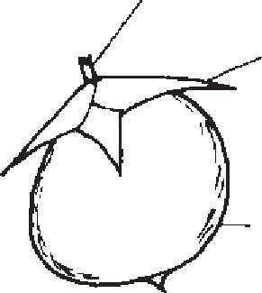

M. S. Swaminathan Research Foundation
fruit seeds
Sonneratia apetala
32
pedicel
culyx

7.3 Sonneratia apetala Buch. - Ham
Local Name: Kalinga (Telugu), Keruan (Oriya),
Marama maram (Tamil), Keora (Bengali)
Collection of fruits
Healthy and mature fruits should be collected from the trees. The characteristic indicators of mature fruits are deep green colour and souro taste of the mesocarp.
Collection of seeds from fruits and sowing
Mature fruits of Sonneratia apetala can be easily identified by the change in their colour from pale green to deep green. The taste of the fruit becomes sour as it matures. The mature, healthy
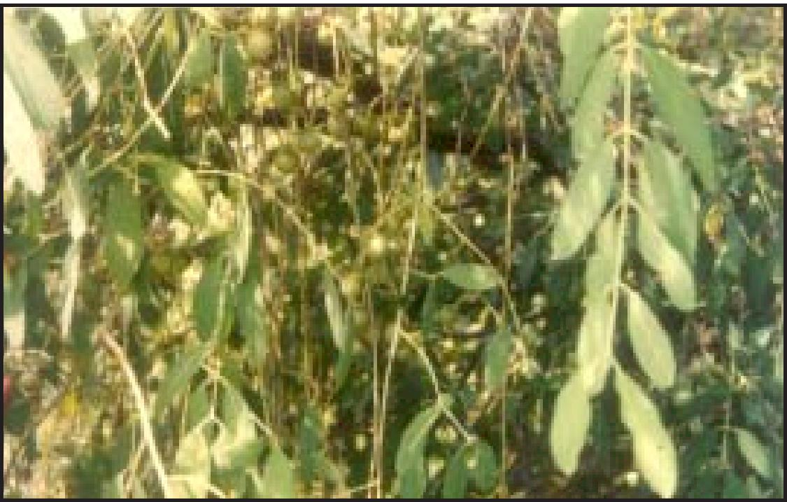
Manual on Mangrove Nursery Raising Techniques
33
fruits can be collected during September and October from the forest near the creeks and river mouth. The fruits should be kept in polythene bags for 15 days, to allow the fleshy mesocarp of the fruits to rot in order to collect the seeds. The fruits should then be gently crushed and the seeds, along with debris, sown in a primary bed. Periodical watering through canals is necessary. After 20 to 30 days, the seeds will start sprouting. The young seedlings of about 30 days old should then be transplanted into the polythene bags.
Transplanting of young seedlings
Young seedlings of 30 days old should be transplanted from the primary bed to the polythene bags and kept in beds. Polythene bags filled with mud should be kept ready.
Watering
Watering is to done daily through the canals. Grading
The casualties need to be replaced with young seedlings that are collected from the mangrove forests, in order to raise healthy seedlings. The seedlings from the beds should be shifted periodically for three months after sowing.
Selection of seedlings
The recommended specifications of the seedlings are as follows:
Height : 50 cm
No. of leaves : at least 6
Period : 8 months
M. S. Swaminathan Research Foundation
34
7.4 Xylocarpus moluccensis (Lamk.) M. Roem.
Local Name: Senuga (Telugu), Pitamari (Oriya), Komandry (Tamil), Pasur (Bengali)
Collection of fruits
Healthy and mature fruits should be collected from the creeks using fishing nets;they can also be collected from the trees. The characteristic indicators of mature fruits are yellow colour and a cracked pericarp.
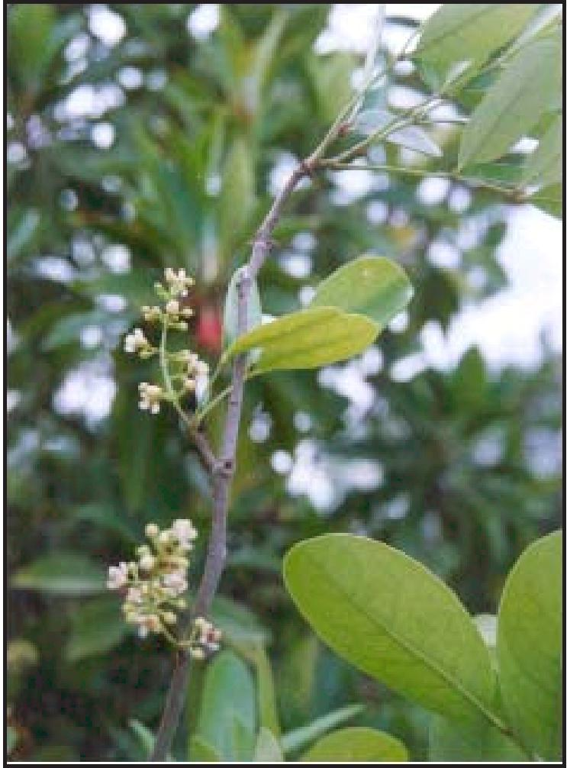
Collection of seeds
The seeds should be removed from the fruits. The seeds available in the creeks can be harvested with fishing nets. The seeds should be checked for insect / pest attack before planting.
Manual on Mangrove Nursery Raising Techniques
35
Sowing into nursery bags
Polythene bags containing hardened mud should be sprinkled with water. The radicle side of the seeds should be placed gently in the polythene bags, ensuring that the mud is soft. Polythene bags filled with mud should be kept ready.
Transporting of young seedlings to beds
Young seedlings of about ten days old should then be transferred to the nursery beds.
Watering
Watering is to be done daily through the canals. Grading
The casualties need to be replaced with seeds. The seedlings from the beds should be shifted periodically for three months after sowing.
Selection of seedlings
The recommended specifications of the seedlings are as follows:
Height : 50 cm
No. of leaves : at least 12 to 14
Period : 8 months
M. S. Swaminathan Research Foundation
36
7.5 Aegiceras corniculatum (L.) Blanto
Local Name: Guggilam (Telugu), Khrasi (Oriya),
Narikandal (Tamil), Khalsi (Bengali)
Collection of seeds
Healthy and mature seeds should be collected from the trees. The mature seeds can be easily identified by the yellow or greenishyellow colour of the seed coat.
Propagule selection and processing
The selected seeds should be checked for insect borers.As in the case of Avicennia, the seeds should be planted in polythene
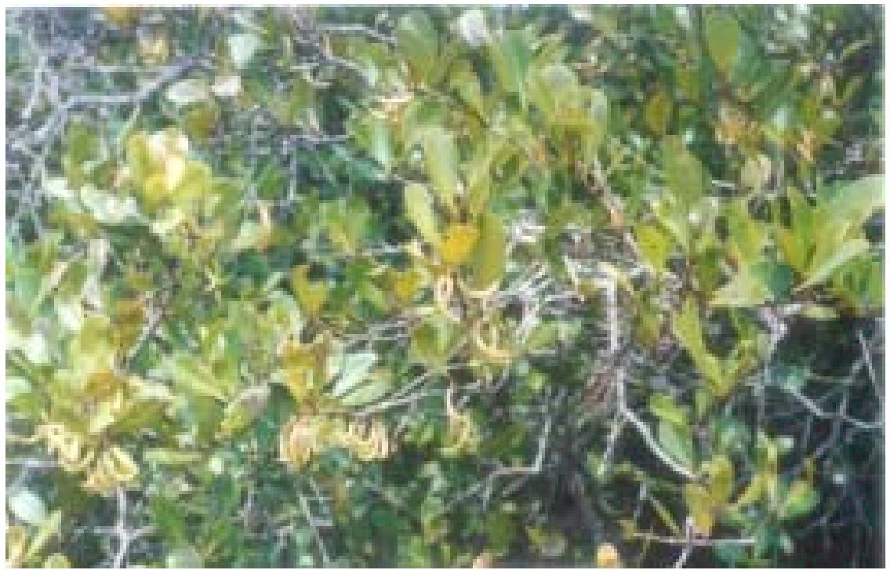
bags directly. While storing the seeds, they should be kept in the shade for two to five days.
Sowing into nursery bags
The calyx region of the fruit should be inserted to a depth of about two to three cm. After the germination of the seedlings, they should be transported to the beds and watered. Polythene bags filled with mud should be kept ready.
Manual on Mangrove Nursery Raising Techniques
37
Watering
Watering is to be done daily through the canals. Pest control
Caterpillars are the major pests and in case of a severe attack, pesticides like Monochrotophos and Ekalux may be applied. However, as a precaution, water from the beds should be drained before applying the pesticide.
Grading
Initially the casualties should be replaced with seeds / seedlings. The seedlings from the beds should be shifted periodically for three months after sowing.
Selection of seedlings
The recommended specifications of the seedlings are as follows:
Height : 50 cm
No. of leaves : at least 10
Period : 8 months
M. S. Swaminathan Research Foundation
pedicel
colyx
plumuloe
hypocotyl
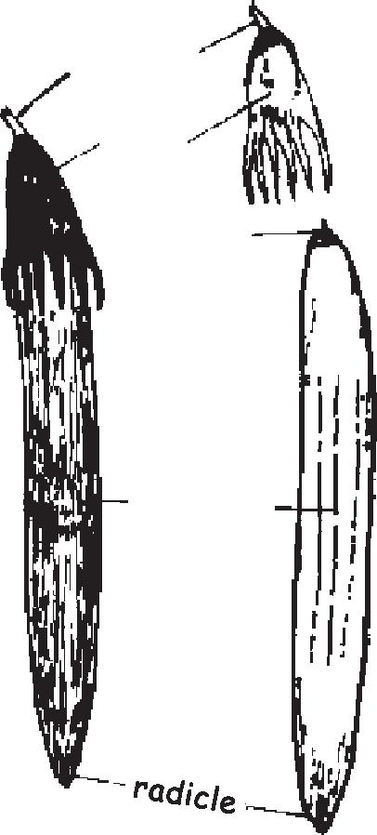
7.6 Bruguiera gymnorrhiza (L.) Savigny
Local Name: Kandriga (Telugu), Bandari (Oriya),
Kakra (Bengali)
Collection of propagules
Healthy and mature propagules should be collected in the creeks with the help of fishing nets. The characteristic and visible indicator of mature propagules of Bruguiera gymnorrhiza is the reddish brown or greenish red colour of the hypocotyle.

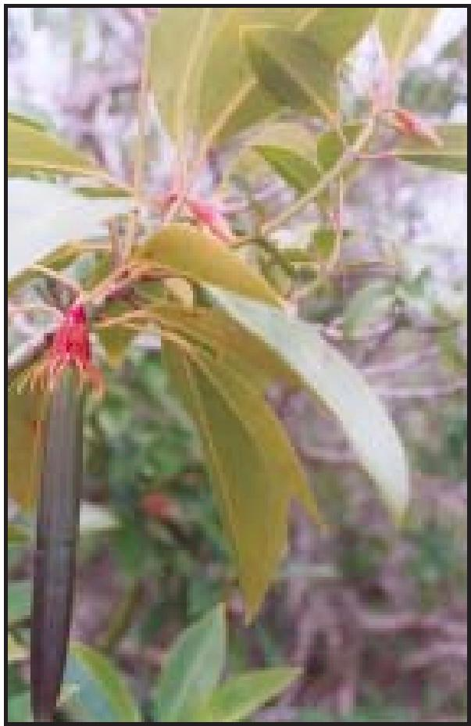

Bruguiera gymnorrhiza propagule
38
Selection and processing of propagules
Mature propagules should be selected and checked for insect borers. The propagules should then be planted in the polythene bags placed in the beds. In case the propagules have to be stored, they should be kept in the shade for one or two days, without exposing them to direct sunlight.

Manual on Mangrove Nursery Raising Techniques
39
Sowing into nursery bags
The hypocotyl of the propagules should be inserted to a depth of about 4 to 5 cm. Polythene bags filled with mud should be kept ready.
Watering
Watering is to be done daily through the canals. Grading
Initially the casualties should be replaced with propagules. The seedlings from the beds should be shifted periodically for three months after sowing.
Selection of seedlings
The recommended specifications of the seedlings are as follows:
Height : 50 cm
No. of leaves : at least 6
Period : 8 months
M. S. Swaminathan Research Foundation
7.7 Rhizophora apiculata Bl. and Rhizophora mucronata LaméLocal Name: Ponna (Telugu), Raai (Oriya), Surapunnai (Tamil),
Garjan (Bengali)
Collection of propagules
Healthy and mature propagules should be collected from the tidal creeks, using fishing nets. Characteristic indicators of mature propagules of Rhizophora mucronata are pale green or yellow
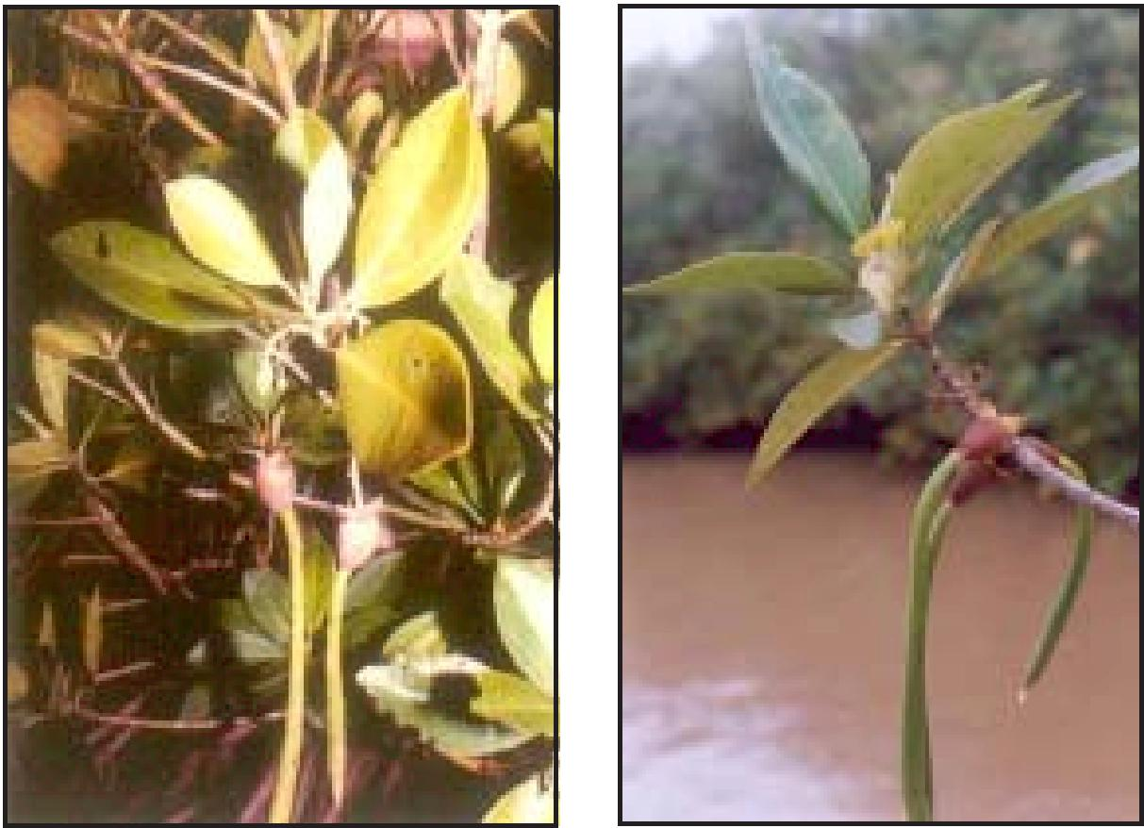
Rhizophora mucronata propagule | Rhizophora apiculata propagule

hypocotyl
cotyledon
radicle
pedicel
calyx fruit
plumulae
pedicel
hypocotyl
radicle
cotyledon
calyx
fruit
plumulae

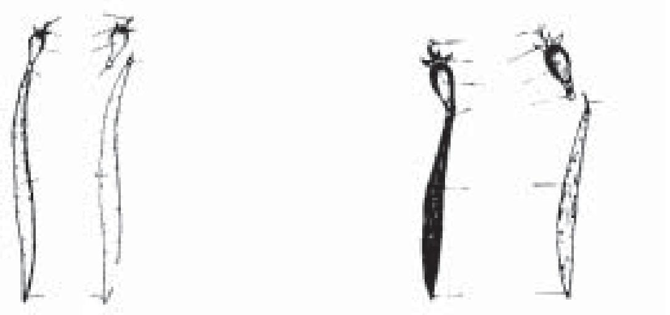

Rhizophora mucronata Rhizophora apiculata
40

Manual on Mangrove Nursery Raising Techniques
41
cotyledon and green hypocotyle. Propagules of Rhizophora apiculata have red or yellow cotyledons. Propagules of Rhizophora mucronata are bigger than R. apiculata.
Selection and processing of propagules
Healthy propagules should be selected and checked for insect borers. The propagules should then be planted immediately in the polythene bags placed in the beds. In case of storing, the seeds should be kept in the shade for one or two days, without being exposed to direct sunlight.
Sowing into nursery bags
The hypocotyl of the propagule should be inserted to a depth of about 7 to 8 cm. Small sticks are to be tied to the hypocotyl for providing support. Polythene bags filled with mud should be kept ready .
Watering
Watering is to be done daily through the canals. Grading
Initially, the casualties should be replaced with propagules. The seedlings from the beds should be shifted periodically for three months after sowing.
Selection of seedlings
The recommended specifications of the seedlings are as follows:
Height : 60 cm.
No. of leaves : at least 8
Period : 8 months
M. S. Swaminathan Research Foundation
42
8. Seed Germination and growth of seedling
The germination period, percentage of germination and average height of mangrove saplings raised in the mangrove nursery are given in Table 4. Avicennia officinalis and Avicennia marina germinate within 6 days when compared to other mangrove species, which take nearly 20 days. The percentage of germination of these two species is also high. As these species have a wide range of tolerance to salinity, they were raised in large numbers compared to other species for planting in the degraded areas for the restoration of mangroves. Some mangrove species, namely Excoecaria agallocha, Rhizophora apiculata, R. mucronata, Bruguiera gymnorrhiza, Xylocarpus moluccensis and Sonneratia apetala, take more than 20 days to germinate. The nursery saplings should be fed with saline water (5 to 30 ppt) collected from the mangrove creeks. The salinity levels will be 5 ppt during October (germination period) and will be 30 ppt after March. The initial growth of Xylocarpus moluccensis was found to be rapid and the colour of the shoot was brown. The germination percentage of the propagules of Rhizophora apiculata, R. mucronata and Bruguiera gymnorrhiza was observed to be high - above 90%. Nevertheless, their establishment time is longer.
8.1. Viability of seed material
The viability of the seeds depends on the age of the tree. For eg. Rhizophora spp. is able to produce fruits between the third and fourth years, but the propagules should be collected from trees at least 5 years old (Wirjodarmodjo and Hamzah, 1984). In the present study, the age of the tree was determined with the help of elderly local villagers and by measuring the girth at breast height (GBH). The mangrove seeds / propagules were collected from mature stands (10-15 years old). The viability period of the mangrove seeds is very short and hence they are to be planted immediately after collection (within 24 h). Siddiqui and Islam (1988) observed that Sonneratia apetala seeds loose their viability after
Manual on Mangrove Nursery Raising Techniques
43
Table 4. Details of Mangrove species to be followed
for better survival
Plant species | Seed material | Ge rm i-  natio n  period | Germ in ation  percentag e | Averag e heig ht after 8 mo nths (c m.)
Avicennia officinalis | Fruit | 6 days | 95 | 75
Avicennia marina | Frui t | 6 d ays | 95 | 75
Excoecaria agallocha | Young seedlings | - | 60 | 60
Aegiceras corniculatum | Fruit | 35 days | 80 | 70
Sonneratia apetala | Seed | 30 days | 20 | 80
Xylocarpus molluccensis | Seed | 20 days | 90 | 80
Bruguiera gymnorrhiza | Propag ule | 35 days | 100 | 60
Rhizophora apiculata | Propag ule | 40 days | 100 | 70
Rhizophora mucronata | Propag ule | 40 days | 100 | 80

60 days of collection of fruits. The salinity levels of the water that is used also plays an important role in the germination and survival of mangrove saplings. The saplings were raised in low salinity initially (10 ppt during October); the salinity was increased gradually and saline water with 30 ppt was used in the later stages. Siddiqi et al. (1989) found that 10 ppt salinity is optimum for Sonneratia apetala and no germination of seeds was observed over 40 ppt. Mortality of the propagules can be avoided by selecting healthy propagules.
M. S. Swaminathan Research Foundation
44
9. Role of nurseries in participatory management
In participatory management, the local community should be sufficiently involved and made to own the resources, in the management of which, they are involved as partners for sustainable management. In this regard, the community mangrove nurseries helped in the movement of mangrove forest restoration and management in Godavari and Krishna mangrove wetlands. At present, fisherwomen and men living in Godavari and Krishna mangroves are trained in nursery raising techniques. Seedlings of Avicennia marina, A. officinalis and Excoecaria agallocha were raised by the members of women self-help groups. The saplings thus grown by the women were purchased and planted in the degraded areas thus helping the women in providing alternative employment and income generation.
Similarly, if the FD and NGOs involved in mangrove restoration and conservation include the community in raising the mangrove nursery in their backyards and buy the saplings from the community, it will help them to earn additional income and also increase the responsibility of owning the mangrove resources and paving the way for sustainable mangrove forest management.
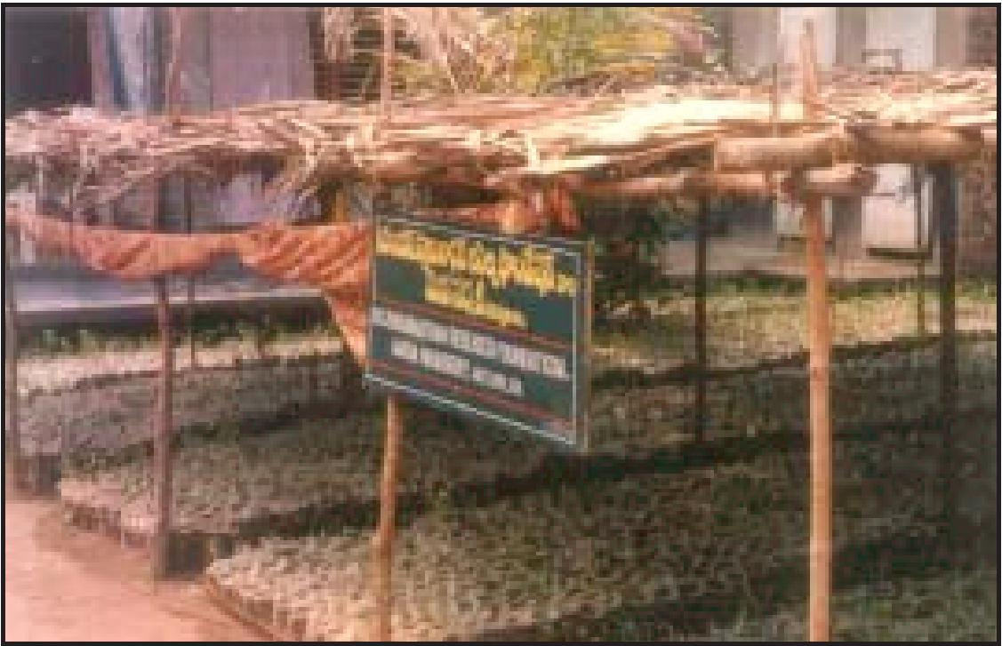
Manual on Mangrove Nursery Raising Techniques
45
10. Mangrove nurseries as livelihood alternative for women
Community mangrove nurseries were started in the villages of Matlapalem and Bhairavalanka. The nursery techniques were discussed with the villagers. Necessary materials like polythene bags, seeds / propagules were provided to the community. The community members were involved in the collection of seeds and propagules, using nets in the creeks. The saplings were raised in the backyard of the houses in Bhairavalanka and Matlapalem. In Dheenadayalapuram, the mangrove nursery established by the project was used to raise the mangrove saplings. Mostly women were involved in raising the saplings and in maintaining the nursery by periodical removal of algae and other materials. The mangrove saplings were bought from the community @ Rs.1/- after 6-8 months. By raising mangrove saplings in their respective villages the fisherwomen earned an income of Rs. 2,15,000/-. The women have to work for four to five days in the initial stages. Later on they have to spend an hour a day for watering the nursery saplings in their backyards. Table 5 provides the details of saplings raised by the village level institutions and Table 6 provides details of the wages and the labour absorption for raising 30,000 mangrove saplings.
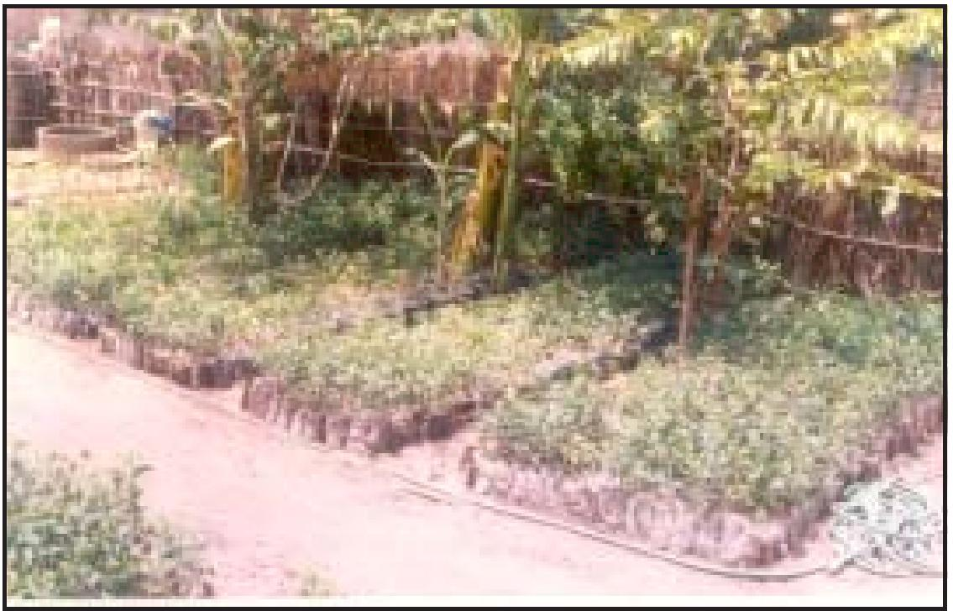
M. S. Swaminathan Research Foundation
46
Table - 5. Details of mangrove saplings raised by VLIs
Name of the VLI and  Village | Species raised | No. of  saplings | Income for  community
Sri Vigneswara EDC, Matlapalem | Excoecaria agallocha | 12,000 | Rs. 12,000
Dr. B.R. Ambedkar VSS, | Avicennia officinalis | 1,000 | Rs. 3,000
Bhairavalanka | Avicennia marina | 2,000
Dheenadayaljee EDC, | Avicennia officinalis | 60,000 | Rs. 2,00,000
Dheenadayalapuram | Avicennia marina | 1,40,000
Total |  | 2,15,000 | Rs. 2,15,000

Table 6. Labour absorption for nursery for raising 30,000 mangrove salings
Task | Persons |  | Hours of work | Wages |  | Amount
Task | Men | Women | Hours of work | Men | Women | Amount
Clearing the area & Clearing Bushes | 7 |  | 6 | 60 |  | 420
Bed preparation | 70 |  | 6 | 60 |  | 4200
Fencing | 40 |  | 6 | 60 |  | 2400
Filling bags | 28 | 98 | 6 | 60 | 40 | 5600
Seed collection |  | 42 | 6 |  | 40 | 1680
Bag transfer to beds |  | 16 | 6 |  | 40 | 640
Planting seeds in bags |  | 108 | 6 |  | 40 | 4320
Maintenance |  | 96 | 6 |  | 40 | 3840
Total | 145 | 360 |  |  |  | 23100

Manual on Mangrove Nursery Raising Techniques
47
References
Banerjee, L.K., A.R.K . Sastry and M.P. Nayar, 1989. Mangroves in India, Identification Manual, Botanical Survey of India Publications, Calcutta. 113.
FAO Forestry Paper, 1994. Mangrove forest management guidelines, Food and Agricultural Organization of the United Nations, Rome. 319.
Forest Survey of India (FSI) 1999. Status of Forest Report, Ministry of Environment and Forests, Government of India, New Delhi.
Gamble, J.S. 1915-1938. Flora of the Presidency of Madras Vol. 1 3. (Vol. 3 by C.E.C. Fischer). Adlard & Sons Ltd., London.
Qureshi, M.T. 1990. Experimental plantation of rehabilitation of mangrove forests in Pakistan, Mangrove ecosystems Occasional Papers No. 4. UNDP/UNESCO Regional Project for Research and Application to the Management of Mangroves.
Ramasubramanian, R. T. Ravishankar and D. Sridhar 2003. Mangroves of Andhra Pradesh- Identification and Conservation Manual, M.S. Swaminathan Reserach Foundation, Chennai. pp - 67.
Siddiqi, N.A. and M.R. Islam, 1988. Studies on fruit size, seed production and viability of seeds of keora (Sonneratia apetala) Bano Biggyam Patrika 17:15 – 19.
Siddiqi, N.A., M.R. Islam and M.A.S.Khan, 1989. Effect of salinity on germination success in keora (Sonneratia apetala Buch. – Ham) Bano Biggyam Patrika 18: 57 – 62.
Siddiqi, N.A., M.R. Islam, M.A.S.Khan and M. Shahidullah, 1993. Mangrove nurseries in Bangladesh. Mangrove Ecosystem Occassional papers No. 1. International Society for Mangrove Ecosystems, Japan. 1-14.
M. S. Swaminathan Research Foundation
48
Sidhu, S.S. 1963. Studies on the mangroves of India: East Godavari region. Indian Forester 89: 337-351.
Soemodihardjo, S., P. Wiroatmodjo, F. Mulia and M.K. Harahap, 1996. Mangroves in Indonesia. In: Restoration of Mangrove Ecosystems. Field, C.D. (Ed.,) International Society for Mangrove Ecosystems, Okinawa, Japan. 97-100.
Untawale, A.G. 1993. Development of an intertidal mangrove nursery and afforestation techniques along the Indian Coast. In: H. Lieth and A. Al Masoom (eds.): Towards the Rational Use of High Salinity Plants, Kluwer Academic Publications, London. 1:371-378.
Wirjodarmodjo, H. and Z. Hamzah, 1984. Beberapa pengalaman Permum Perhutani dalam pengelolaan hutan mangrove. Prosidings Seminar II Ekosistem Mangrove. Baturraden Agustus 1982; MABLIPI, Jakarta: 29-40.

