This Action Sheet illustrates some of the amazing multipurpose trees used by agroforesters in Africa. You will find more by talking to knowledgeable people. Do a survey of the trees that grow in your area. Ask which trees grow well and find out what they do for people and soil. Action Sheets 35: Agroforestry and 49: Tree-planting, contain further tips about how to grow trees and where to get seeds.
multipurpose trees
Action Sheet 50
Goods  Acacia albida is indigenous (occurs naturally) in 19 African countries. Other acacias such as Acacia scorpionides, and Acacia tortellis are also useful multipurpose trees, indigenous to many African countries!  ACACIA ALBIDA  (FAIDHERBIA ALBIDA) – WHITETHORN  SWAHILI: mgunga,mkababu |  | Services |  | Growing Guide
  1 Forests | 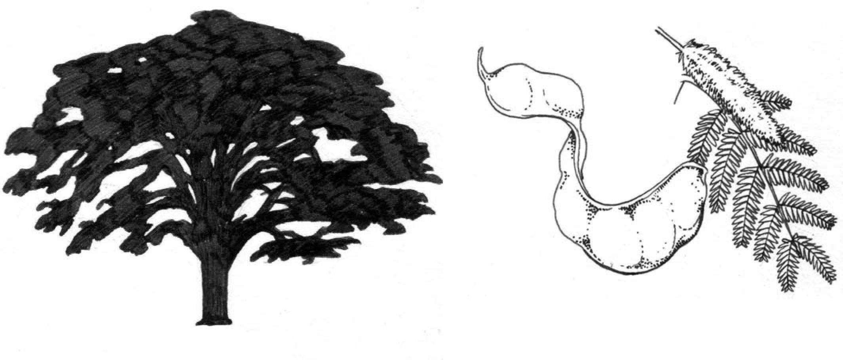 | 
● | Fodder (shoots, leaves, pods) | ● | Shade | WHERE WILL IT GROW
● | Good for bees | ● | Shelter | Altitude: -270-2700 m
● | Timber | ● | Mulching
● | Poles | ● | Nitrogen fixing | Mean annual temperature: 18-30°
● | Tools | ● | Windbreak | Mean annual rainfall: 250-1200 mm
● | Fuelwood | ● | Living fence – very thorny! | Soil: Coarse-textured well-drained alluvial
● | Tannin |  |  | soils; tolerates seasonal water-logging and
● | Medicine |  |  | salinity but cannot withstand heavy clayey soils.
 |  |  |  | PROPAGATION AND MANAGEMENT
 |  |  |  | See ACTION SHEET 37: Planting fodder banks for livestock

Neem is originally from India, where it is known as the ‘village pharmacy’. It has been grown in Africa since the 19th century.
Image: Robert Zwahlen (WAC)
AZADIRACHTA INDICA – NEEM
SWAHILI: mkilifi, mwarubaini, mwarubaini, kamili

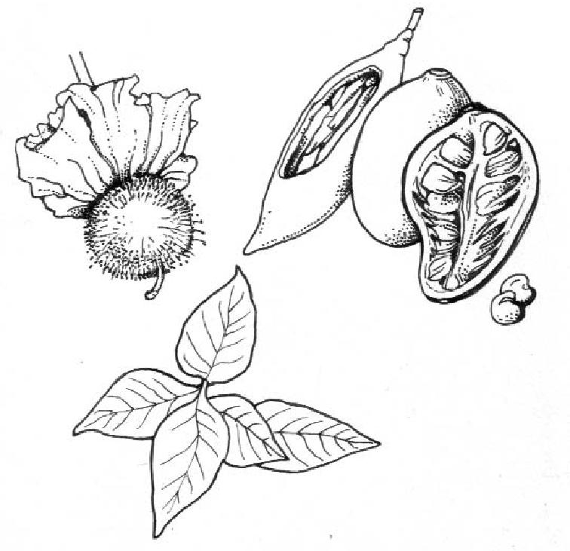
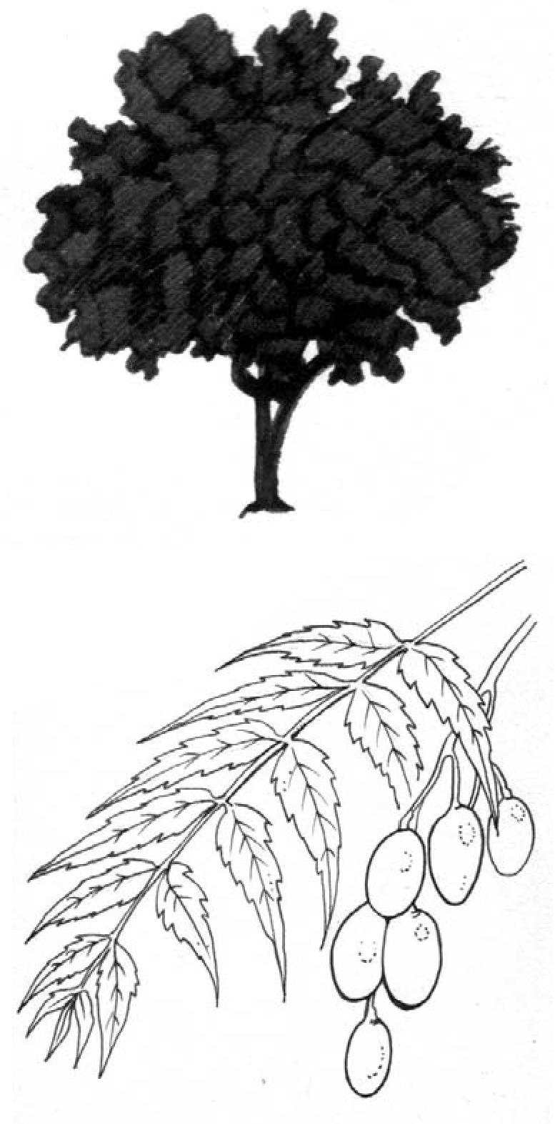
2 Forests
Goods
- Fodder
- Fuelwood
- Timber (termite resistant)
- Carving
- Glue
- Toothbrushes
- Fruits
- Oil (not edible)
- Medicine
Services
- Erosion control
- Shade
- Shelter
- Natural pesticide
- Soil improver
- Mulch
- Green manure
- Windbreak
Growing Guide
WHERE WILL IT GROW
Altitude: 0-1500m
Mean annual temperature: Up to 40°C Mean annual rainfall: 400-1200mm Soil: grows on a wide variety of neutral to alkaline soils but performs better than most species on shallow, stony, sandy soils, or in places where there is a hard calcareous or clay pan not far below the surface. It grows best on soils with a pH of 6.2-7.
PROPAGATION AND MANAGEMENT See ACTION SHEET 51 – NEEM
ADANSONIA DIGITATA BAOBAB
SWAHILI: mbuyu
ZULU: isiMuhu,isiMuku,umShimulu TSWANA: mowana
Indigenous to 24 African countries. Can live for more than a 1000 years!

Goods
- Fodder (Young leaves, fruit, pods and seeds, sap in drought)
- Honey: Good for wild bees and bee-keeping
- Fuelwood
- Strong fibre
- Light timber
- Glue
- Tannin or
- Red dye (roots)
- Seed oil - edible
- Brewing beer
- Natural insecticide
- Fruit and young leaves – rich in vitamin C
- Seeds and young roots also edible
- Medicines
Services
- Soil improver – decaying wood of a tree that has died of old age or from lightning can be spread on fields as a fertilizer. Ashes from the fruit shells, bark and seed are useful as a fertilizer.
- Water storage in hollowed trunks
Growing Guide
WHERE WILL IT GROW
Altitude: 0-1500m,
Mean annual rainfall: 250-1000mm.
Temperature: arid and semi-arid, with not more than a day of frost per year
Soil: Prefers well-drained acidic soils (pH <6.5), preferably with sandy top soils overlaying loamy substrates; prefers a high watertable.
PROPAGATION AND MANAGEMENT
Sow directly into soil. Germinates more quickly if scarified or covered in boiling water and left to soak for 24 hours.

CAJANUS CAJUN – PIGEON PEA
SWAHILI: mbaazi
Originally from India, this tree was introduced to Africa at least 4000 years ago.
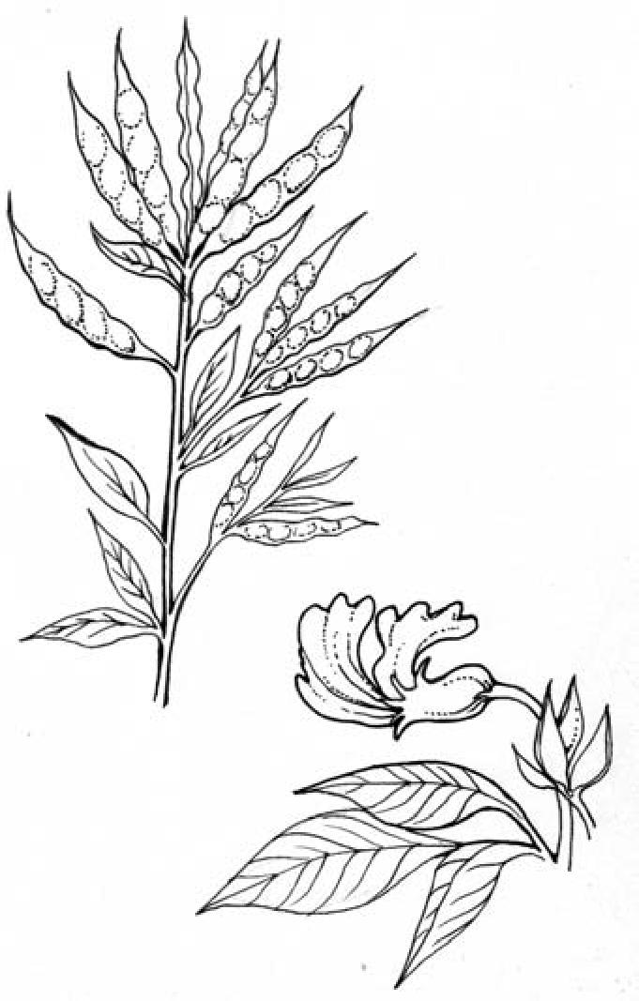
3 Forests
Goods
- Fodder: (not very rich in energy or protein)
- Chicken feed (grain)
- Honey: Good for bees
- Fuelwood: (fast-growing)
- Fibre: (baskets, paper)
- Timber
- Edible seeds
- Medicine
Services
- Erosion control
- Shade
- Shelter:
- Cover crop
- Windbreak
- Nitrogen fixing
- Leaves add nitrogen and organic matter to the soil
- Roots improve soil structure
- Intercropping
Growing Guide
WHERE WILL IT GROW Altitude: 0-2000m
Mean annual temperature: 18-38°C Mean annual rainfall: 400-2500mm
Soil: grows on a wide range of soils, except saline or waterlogged soils
PROPAGATION AND MANAGEMENT
Pick pods when they lose bright colour. Seeds need no treatment. Sew directly in a wellprepared field. Weed to help growth.
CALLIANDRA CALOTHYRSUS – CALLIANDRA
SWAHILI: mkaliandra
Calliandra is a South American tree, now being tested for agroforestry in Africa. It now grows in Cameroon, Ethiopia, Kenya, Rwanda, Tanzania and Uganda
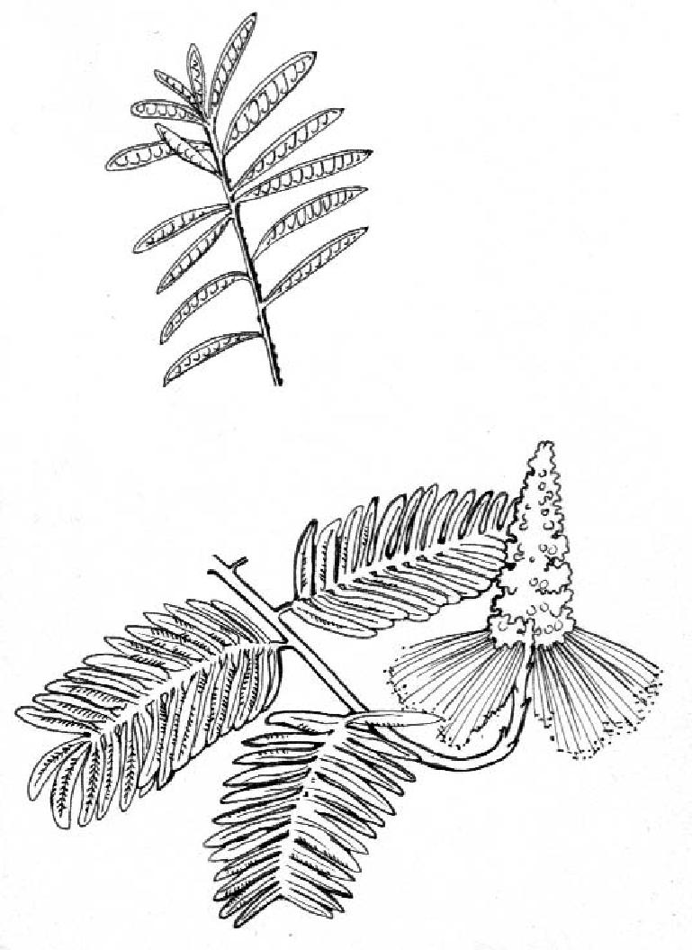
Goods
- Fodder (Protein rich leaves and pods)
- Honey: Good for bees
- Fuelwood, charcoal (fast-growing, good coppice)
- Fibre (Paper)
Services
- Erosion control
- Shade
- Shelter
- Nitrogen fixing
- Soil improver (Green manure, alley-cropping)
- Intercropping
Growing Guide
WHERE WILL IT GROW
Altitude: 250-1800m
Mean annual temperature: 20-28°C,
Mean annual rainfall: 700-4000mm
Soil: Grows well on a wide range of soil types; prefers light textured, slightly acidic soils; can tolerate infertile and compacted or poorly aerated soils but does not tolerate waterlogged and alkaline soils
PROPAGATION AND MANAGEMENT
Cover seed with hot water, allow to cool and soak for 12-24 hours. Sow direct, grow from stem cuttings, or plant nursery seedlings out.. Prune roots to keep tap-root checked and encourage side roots. Weeding needed in first year. In alley-cropping systems, pruned in cycles to limit shade on associated crops. Coppicing – cut at one metre height for highest yields.

The smell of crushed C. abbreviata leaves is said to drive snakes from their holes.
CASSIA ABBREVIATA SJAMBOK POD
Indigenous to 12 African countries

4 Forests
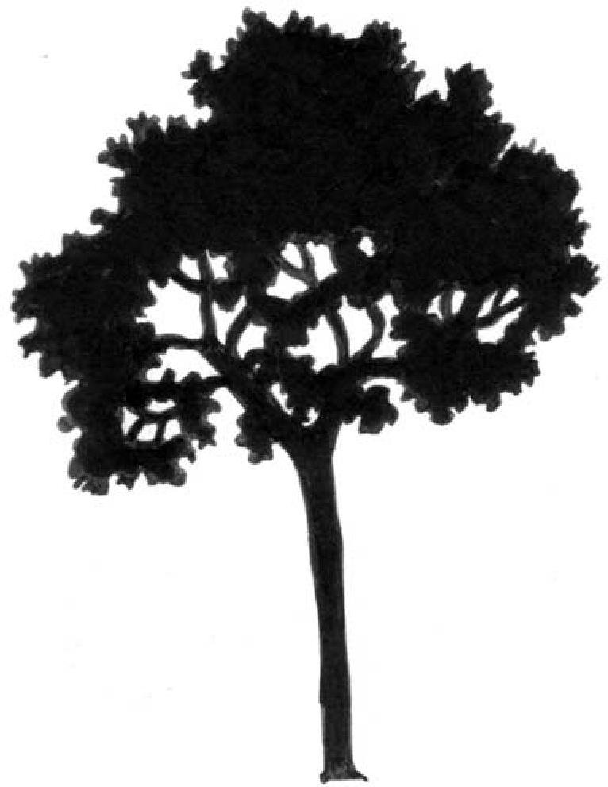
Goods
- Fodder: Good for birds and wildlife
- Fuelwood/charcoal
- Timber
- Dye
- Medicine
Services
- Erosion control (deep roots)
- Shade
- Soil improver: Mulch
- Intercropping: deeply rooting, therefore unlikely to compete with crops for mineral nutrients and water.
Growing Guide
WHERE WILL IT GROW
Altitude: 350-1000m
Mean annual temperature: 27°C
Mean annual rainfall: 1400mm
Soil: deep light/sandy and well drained soils PROPAGATION AND MANAGEMENT
Grow from seed or collect wild seedlings. Sow seeds in a sand:compost mixture (1:1) and keep warm and moist. Soak in hot water to improve germination. Sow directly into polythene bags or into the ground. Plant out seedlings in 1-2 weeks. Trim roots because the plants develop a long taproot early.
Pollard, coppice, trim and prune to manage. Over-watering results in poor flower display.
ANNONA SENEGALENSIS – CUSTARD APPLE
SWAHILI: mchekwa, mkonokono, mtomoko mtomoko-mwitu, mutopetope, mwitu
Indigenous to 19 African countries
Leaves picked on a Thursday morning and thrown over the right shoulder bring good luck!
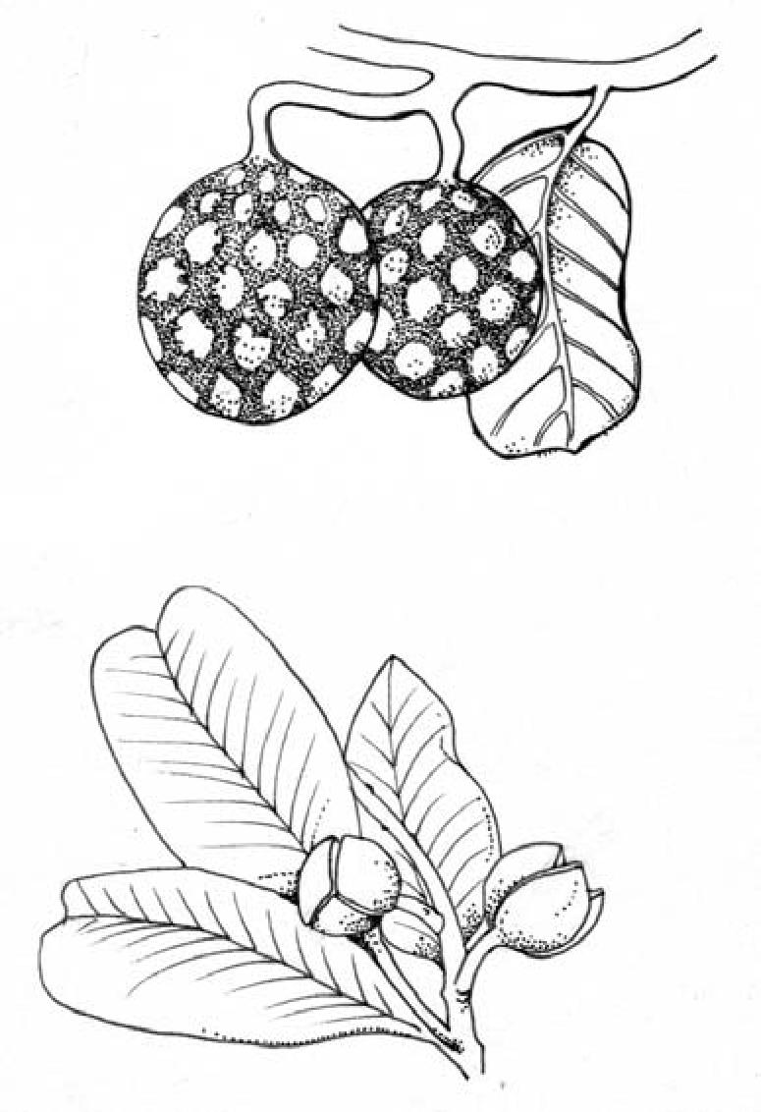
Goods
- Fruit
- Leaves used as vegetable
- Timber: Poles, tool handles
- Fibre
- Medicines
- Poisons
- Dyes
Services
- Shade
- Shelter
- Windbreak
Growing Guide
WHERE WILL IT GROW
Altitude: 0-2400m
Mean annual temperature: 17-30°C
Mean annual rainfall: 700-2500mm
Soil: Grows on various soil types; does well on coral rocks dominated by sandy loam soils
PROPAGATION AND MANAGEMENT
Grows well from seed especially if scarified first. Coppices well and grows from root suckers. Weed planting site well and provide light shade. Protect from fire and browsing by livestock and wildlife.

DIOSPYROS MESPILIFORMIS – AFRICAN EBONY, JACKAL BERRY
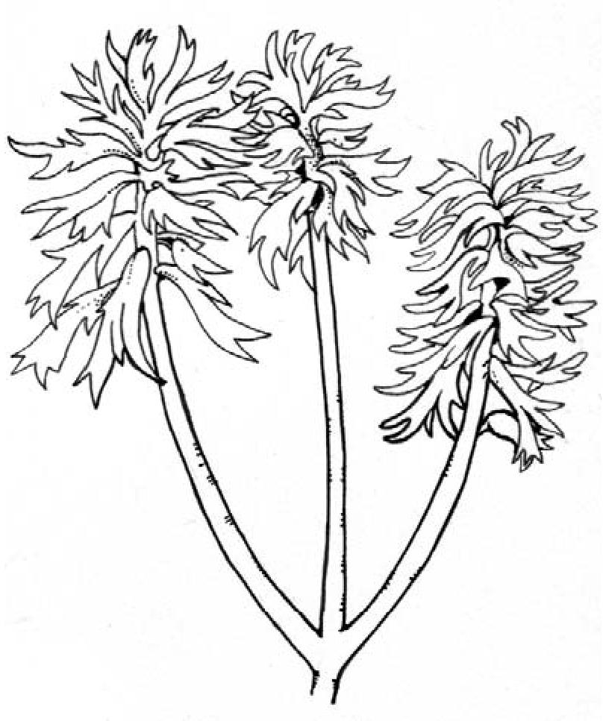
SWAHILI: mgiriti,mjoho mpweke
Indigenous to 15 African countries from Ethiopia to Swaziland. A definite asset to any farm!
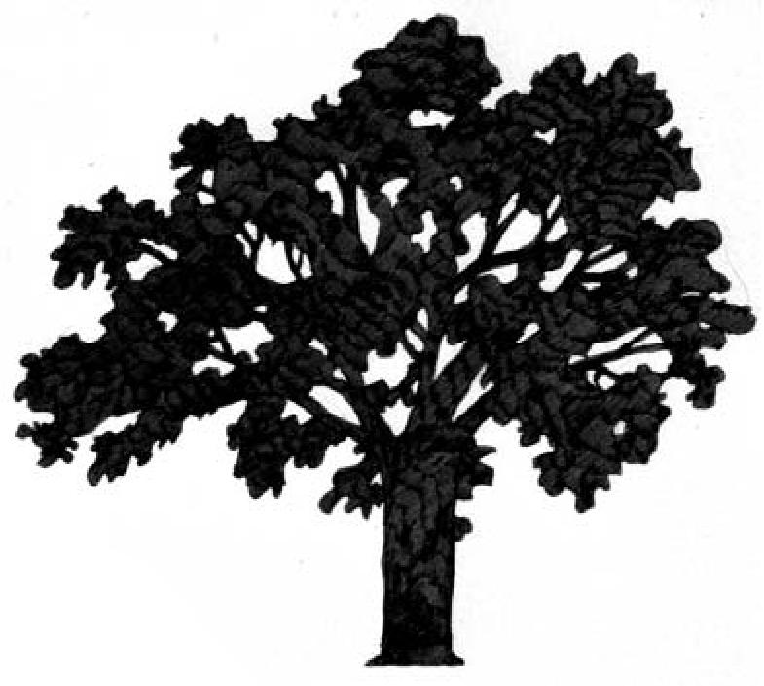
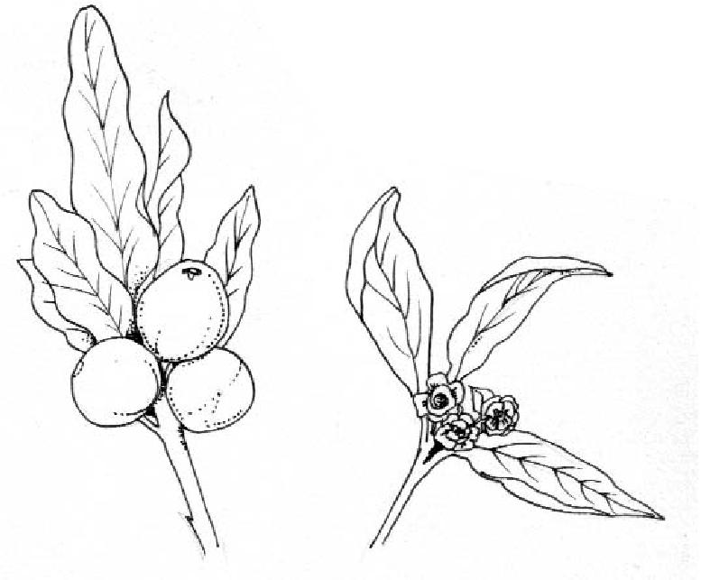
5 Forests
Goods
- Fodder (Leaves, shoots)
- Good for bees
- Fuelwood (coppices well)
- Strong timber
- Carvings
- Poles
- Cartbooms
- Yoke pins
- Pestles
- Beer
- Edible fruit
- Home to Mopane caterpillar Toothbrushes
- Medicines
Growing Guide
Leaves are eaten by elephant, giraffe, black rhino, eland and kudu. Fruits are eaten by kudu, klipspringer, warthog, baboons, vervet monkeys, yellow spotted rock dassies, pigeons, parrots, hornbills, louries and bulbuls!
Services
- Shade
- Shelter
- Mulching
WHERE WILL IT GROW
Altitude: 350-1250m
Mean annual temperature: 16-27°C Mean annual rainfall: 500-1270mm.
Soil: prefers rocky soils along seasonal water courses and swamps. It grows well in moist, red loams, volcanic and loamy sands. Drought resistant.
PROPAGATION AND MANAGEMENT Grows from seed, coppice and root suckers. Soak seed overnight in hot water. Sow in flat seed trays filled with river sand. To avoid damage to tap-root, plant out when seedlings have 3 leaves. Slash and weed around young trees until the trees are well established. Can be coppiced.
Termite resistant. Often found growing wild on termite mounds.
ERYTHRINA ABYSSINICA LUCKY BEAN TREE, RED HOT POKER TREE
SWAHILI: mbamba ngoma, mjafari, muhuti, mwamba ngoma
Found in savannahs throughout eastern and southern Africa
Goods
- Fodder (leaves)
- Good for bees
- Fuelwood
- Carvings
- Drums
- Fishing float (bark)
- Jewellery (from poisonous seed!)
- Medicines
- Insecticides/Poison
Services
- Erosion control – contour planting and stream banks
- Shade
- Shelter
- Mulch
- Living fence (plant truncheons)
- Nitrogen Fixing
- Windbreaks
- Intercropping with coffee and cocoa
Growing Guide
WHERE WILL IT GROW
Altitude: 1250-2400m
Mean annual temperature: 10-26°C
Mean annual rainfall: 800-2000mm Soil: Grows best in well-drained soils of pH 3.5-5.4
PROPAGATION AND MANAGEMENT
Grows from seeds or truncheons (large cuttings stripped of leaves).
See ACTION SHEET 36: Planting Nitrogen Fixing Trees for further details.

A South American tree, introduced throughout the tropics as a nitrogen fixing fodder plant.
GLIRICIDIA SEPIUM – MOTHER OF COCOA
JATROPHA CURCUS – THE PHYSIC NUT TREE
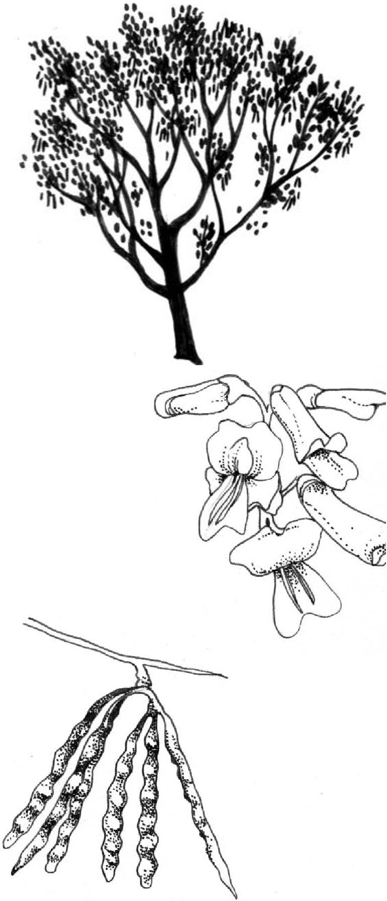
6 Forests
Goods
- Fodder for goats and cows: Rich in protein
- Good for bees
- Fuelwood/charcoal
- Flowers – fried and eaten
- Timber: used for railway sleepers, farm implements, furniture, house construction and fence posts
- Poison: Rodenticide/pesticide
- Medicine
Services
- Shade for tea, coffee, cocoa
- Nitrogen fixing
- Green manure
- Alley-cropping
- Living fence
- Support for pepper, vanilla, yam
Growing Guide
WHERE WILL IT GROW
Altitude: 0-1200 (1600) m
Mean annual temperature: 15-30°C
Mean annual rainfall: 600-3500mm
Soil: From pure sand to deep alluvial lake-bed deposits. Can grow on slightly saline soil, but will not grow on very acidic soils
PROPAGATION AND MANAGEMENT See ACTION SHEET 54: Gliricidia sepium
SWAHILI: Mbono
Exotic to Africa – probably from Mexico, introduced to Africa centuries ago by portugese seafarers
Physic nut oil was used in engines in Segou, Mali, during the Second World II
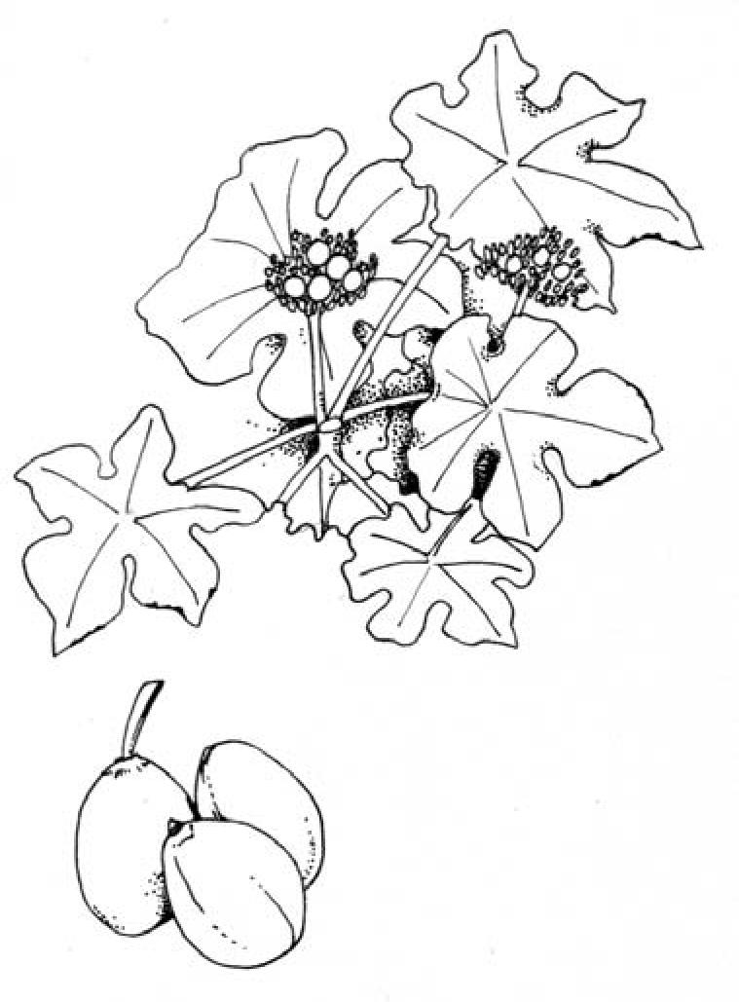
Goods
- House lighting
- Fuelwood
- Oil (used to make candles, soap and varnish, can be sold commercially in some countries, could be substitute for diesel and kerosene)
- Dye – red, black and blue
- Poison: rodenticide/pesticide from poisonous seeds Medicine
Services
- Living fence (from cuttings; leaves and stem are toxic to animals)
- Erosion control
- Nitrogen fixing
- Green manure
- Natural fertilizer (Use residue after crushing seed to take out oil)
Growing Guide
WHERE WILL IT GROW
Altitude: 0-500 m
Mean annual temperature: 20-28°C
Mean annual rainfall: 300-1000mm or more
Soil: Grows on well-drained soils with good aeration; well adapted to dry areas and poor soils with low nutrient content.
PROPAGATION AND MANAGEMENT
Easy to propagate from fresh seeds, wild and cultivated seedlings and branch cuttings. Collect the seeds when the capsules have split. Soak and dry repeatedly before planting. Weed around young trees. On plantations, plant between 2 and 3 metres apart. Nursery plants fruit after first rainy season. Direct seeded plants fruit after second rainy season.

SWAHILI: mlonge, mronge, mrongo, mzunze
MORINGA OLEIFERA DRUMSTICK TREE
PARINARI CURATELLIFOLIA – MOBOLA PLUM
This Asian tree has been introduced to Africa for its healthy leaves and pods
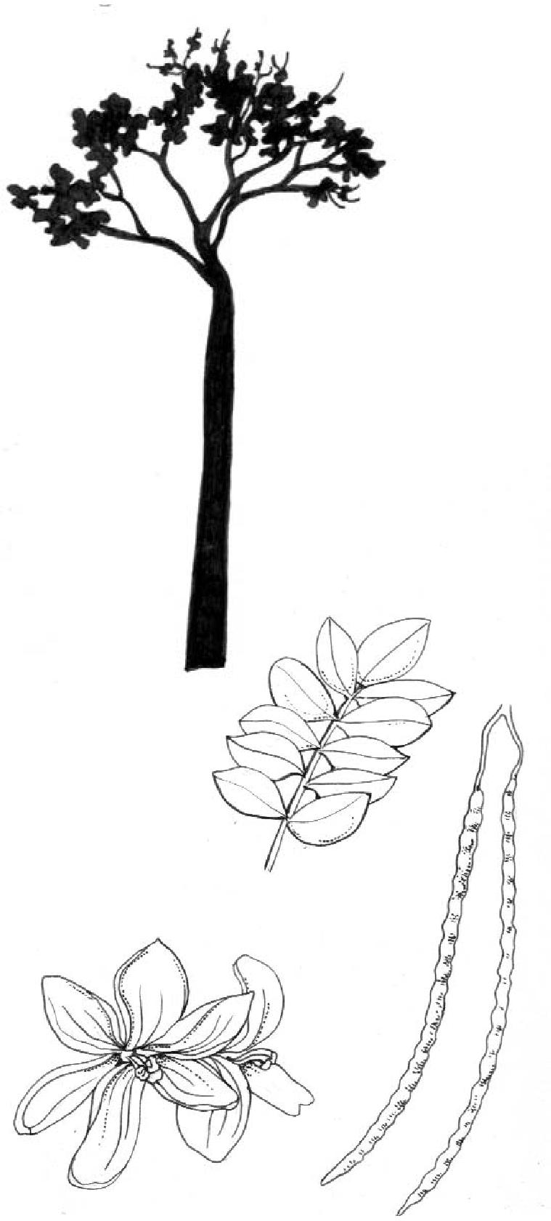
7 Forests
Goods
- Good food: Vitamin-rich leaves, pods, young roots and oil.
- Good for bees: Flowers on and off year round if managed with cutting and coppicing
- Fuelwood
- Fibre: Beat the bark to make fibre for ropes and mats
- Timber for light construction work
- Dyes and tannin
- Water treatment for muddy water (See Action Sheet 23)
Services
- Erosion control: can be grown in dry areas with strong winds
- Soil improver: Use leaves as a mulch
- Natural fertilizer from the left-over residue seed cake from oil extraction
- Living fence
- Shade
- Shelter
- Windbreak
- Intercropping
Growing Guide
WHERE WILL IT GROW
Altitude: 0-1 000m
Mean annual temperature: 12.6 to 40°C
Mean annual rainfall: At least 500mm
Soil: Grows in a wide range of soil types; does well in well-drained clay or clay loam without long water-logging.
PROPAGATION AND MANAGEMENT Grows well from cuttings.
See ACTION SHEET 52: Moringa oleifera
SWAHILI: mbura
SHONA: muchacha,muhacha NDEBELE: umkhuna
Indigenous to Sub Saharan Africa
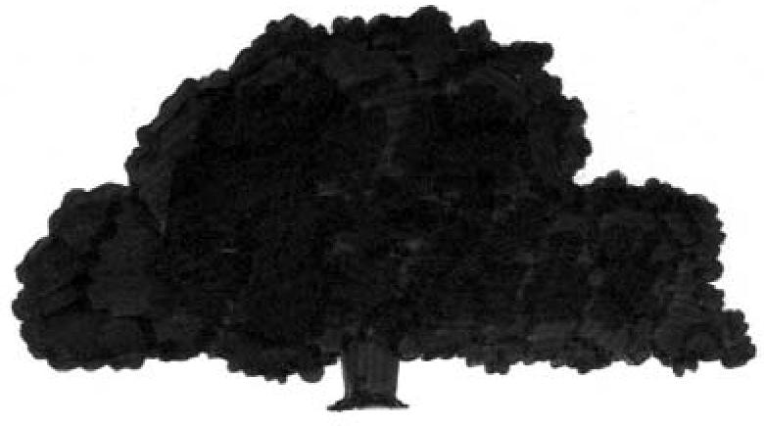
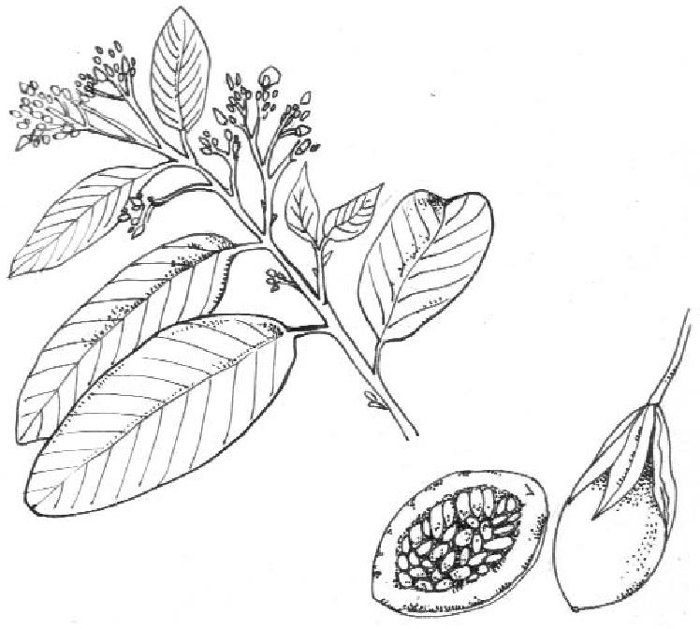
Goods
- Fodder: Leaves and fruit eaten by wildlife and cattle
- Good for bees: lots of nectar-rich flowers
- Fuelwood and charcoal
- Timber
- Edible fruit rich in vitamin C, makes a delicious drink
- Edible seeds
- Medicines
- Dyes
- Tannin
- Toothbrushes
- Medicines
Services
- Shade
- Shelter
- Improves soil
Growing Guide
WHERE WILL IT GROW
Altitude: 0-1900m
Mean annual temperature: 10-30°C
Mean annual rainfall: 0-2700mm
Soil: Light yellowish-brown to reddish-yellow, gritty, sandy clay loams and red to dark red clays
PROPAGATION AND MANAGEMENT
Germination difficult. Best grown from root cuttings. Root suckers, produced when the root is wounded, can be transplanted to a nursery and grown. After 2 years, transplant to the field or garden. Take care to avoid damage to tap-root when re-planting. Plant in groups of 10 or more, and water until trees become established. Can be coppiced.

NDEBELE: ihabahaba SHONA: mutukutu
PILIOSTIGMA THONNINGI MONKEY BREAD
SWAHILI: mchekeche, mchikichi
An indigenous tree which grows throughout tropical Africa, except Somalia.
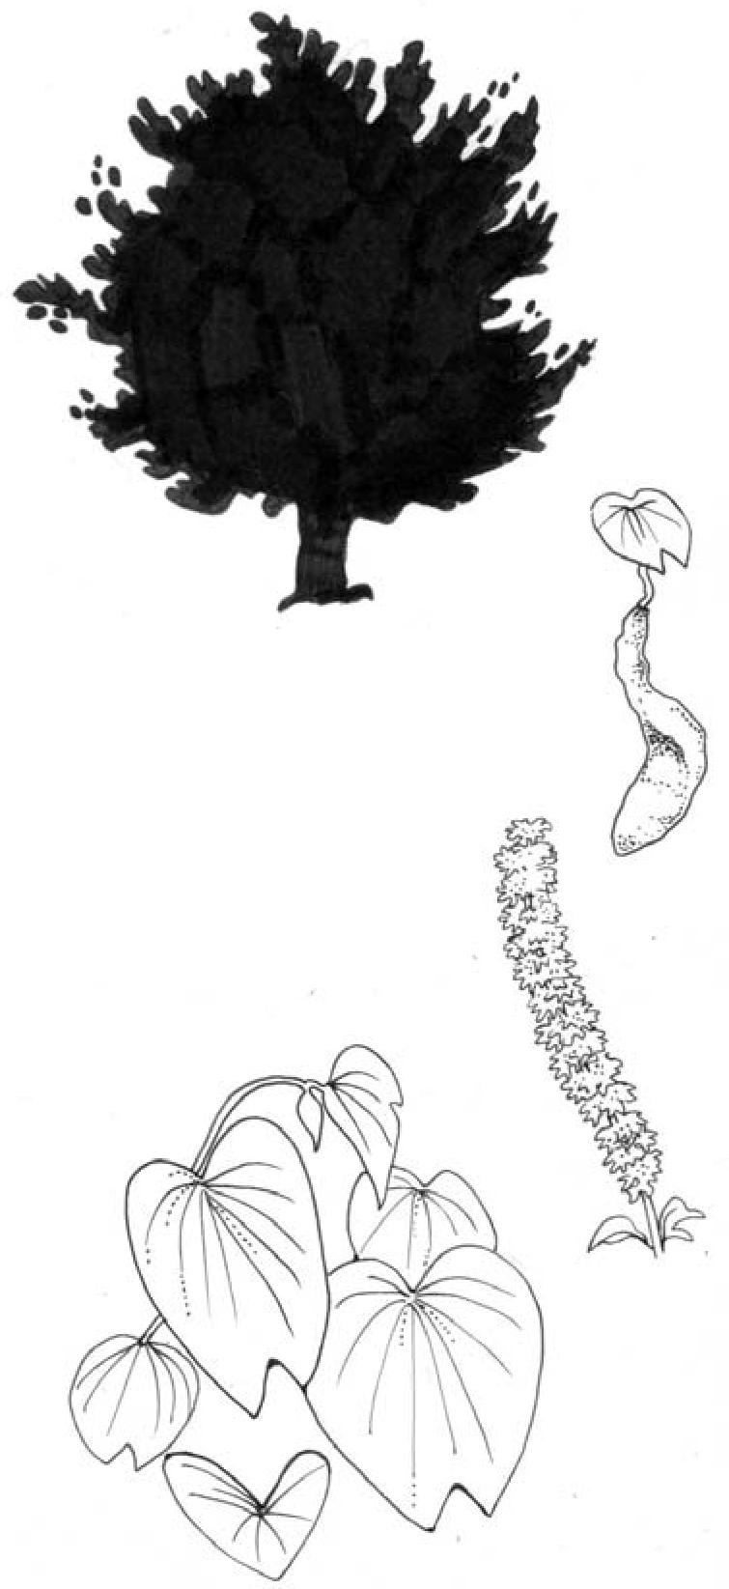
8 Forests
Goods
- Fodder: leaves, pods, seeds, eaten by cattle, antelopes and elephants
SCLEROCARYA BIRREA MARULA
SWAHILI: (mgongo, mng’ ongo, mng’ong’o, morula
A fruit tree indigenous to Africa. Elephants get drunk when the fruit ferments in their stomachs.
This is a protected species in South Africa!
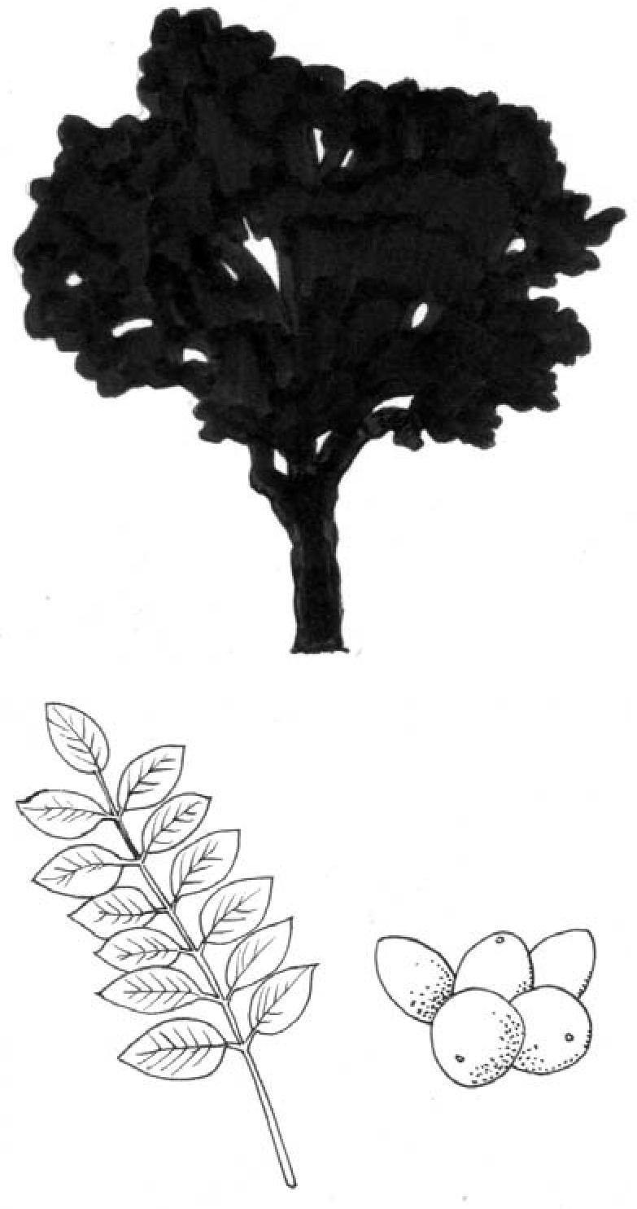

Goods
- Fodder (Leaves, Fruit)
- Fuelwood (Coppices well)
- Carving stools
- Mortars
- Plates
- Poles
- Timber
- Fibre
- Fruits high in vitamin C (can be preserved)
- Nuts (high in Vitamin C - can be made into nut butter or oil)
- Medicine
- Dyes
- Ornamental tree
- Mopane caterpillar lives on the marula tree
Services
- Shade
- Shelter
- Windbreak
- Living fence (grow from truncheons)
Growing Guide
WHERE WILL IT GROW
Altitude: 0-1500m
Mean annual rainfall: 0-1370mm
Mean annual temperature: 19-35°C
Soil: Few specific requirements; grows on sandy or stony soils and on lateritic crusts
PROPAGATION AND MANAGEMENT
If growing from seed, soak seeds overnight before sowing. Seed germination is good but survival rate of seedlings is poor. Probably best grown from truncheons (cuttings with a diameter of 100-150mm, and a length of 2m).
- Fuelwood (coppices well)
- Tool handles
- Fibre from bark
- Food: Leaves, fruit, seeds. Mealie-meal substitute made from ground dried pods
- Soap-substitute: pods
- Dye
- Medicine
Services
- Shade
- Shelter
- Windbreak
- Erosion control: deep-rooted
- Nitrogen fixing
- Mulching with leaf litter
Growing Guide
WHERE WILL IT GROW
Altitude: 0-1850m
Mean annual temperature: 20°C Mean annual rainfall: 700-1400mm
Soil type: Heavy clayey soils or medium loamy soils preferred.
PROPAGATION AND MANAGEMENT
Can be grown from root cuttings or direct seeding. To prevent insect attack, collect seeds immediately after pods turn brown. Seeds grow and germinate quickly. Soak or scarify the seeds before planting. Can be coppiced and pollarded.

ZULU: (umQambuqweqwe,umsokosoko)
SESBANIA SESBAN – SESBANIA
STRYCHNOS COCCULOIDES WILD ORANGE
Indigenous to Chad, Egypt, Kenya, Uganda; now grows widely throughout Africa
9 Forests
Famously fastgrowing!

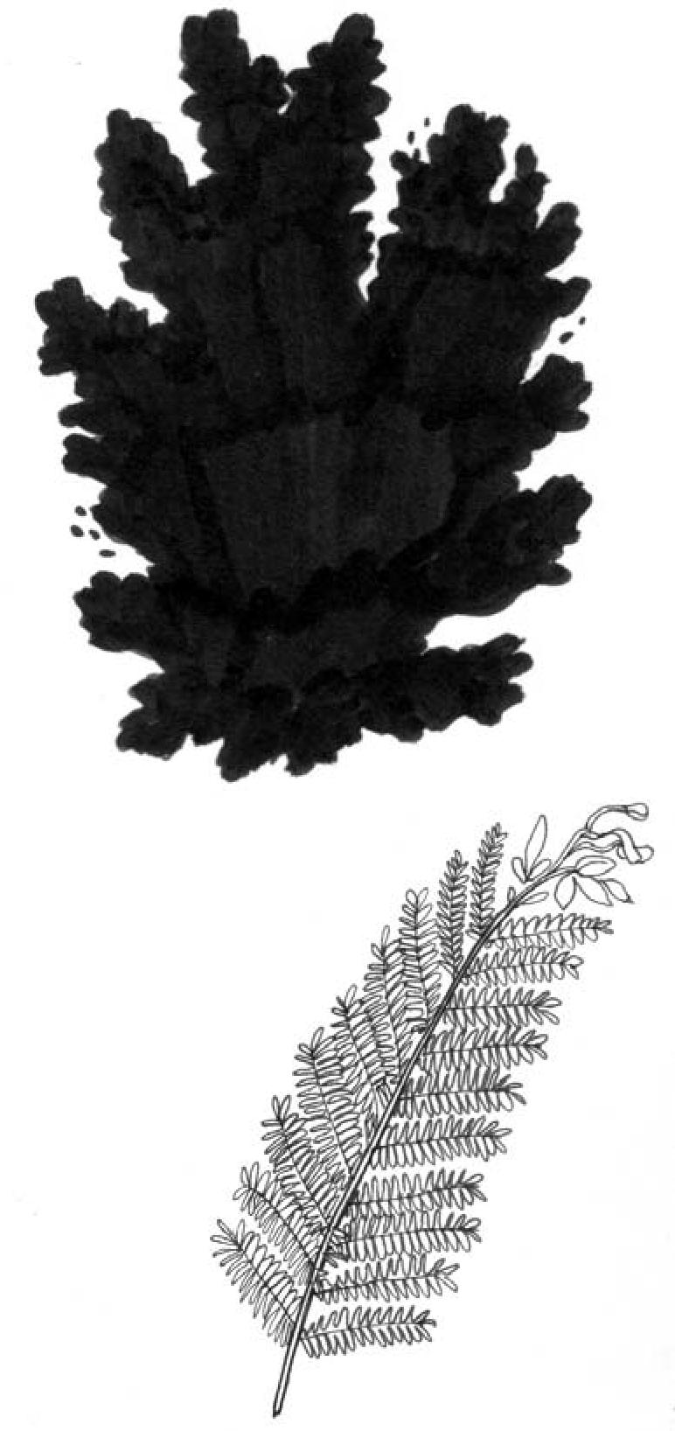
Goods
- Fuelwood/charcoal: (good coppice)
- Fodder: nutritious leaves, high quality fodder for livestock
- Fibre
- Medicines
- Flowers can be eaten
Services
- Shade
- Windbreak
- Nitrogen fixing
- Mulch
- Green manure
- Improved fallows – One year’s S. sesban fallows can double maize yields without mineral fertilizer
- Live trellis support for pepper
Growing Guide
WHERE WILL IT GROW Altitude: 100-2300m
Mean annual temperature: (10 min.) 18-23 (45 max.)°C
Mean annual rainfall: 500-2000mm
Soil: Tolerates seasonal or permanently waterlogged soils as well as saline, acidic and alkaline soils.
PROPAGATION AND MANAGEMENT
See ACTION SHEET 55: Sesbania sesban
SWAHILI: mpera-mwitu,mtonga
Indigenous to Botswana, Kenya, Namibia, South Africa, Tanzania, Uganda, Zambia, Zimbabwe
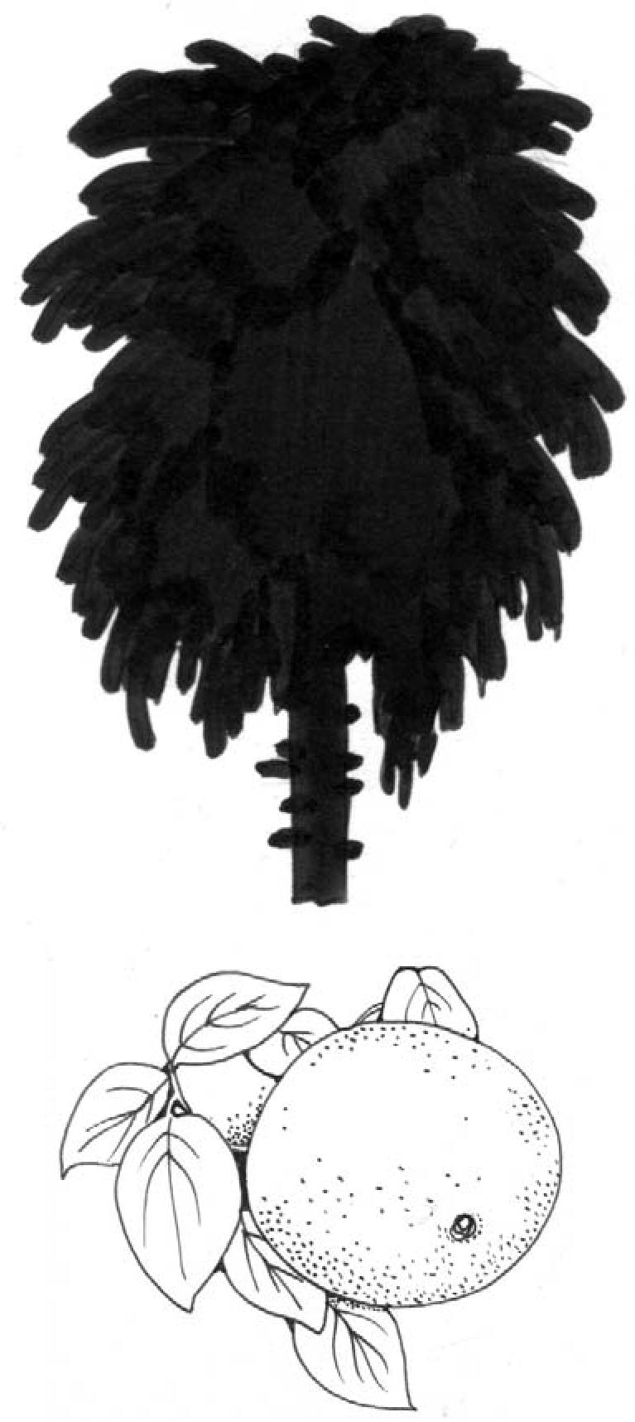
Goods
- Fuelwood (Coppices well)
- Building
- Poles
- Carving
- Edible fruit (can be dried and preserved, or used to make a refreshing drink)
- Medicine
Services
- Shade
- Shelter
- Living fence
Growing Guide
WHERE WILL IT GROW
Altitude: 400-2000m
Mean annual temperature: 14-25°C
Mean annual rainfall: 600-1200mm
Soil: Prefers deep sandy soil on rocky slopes, and grows on acidic dark-grey clays and red or yellow-red loams. Grows wild in woodlands, mixed forests, deciduous woodlands and lowlands.
PROPAGATION AND MANAGEMENT
Seeds germinate easily. Soak for 24-48 hours in hot water before planting. Can be grown through root cuttings, produced by wounding the root. Raise seedlings in the nursery, and then plant out on a cleared site. Weed well until trees are established.

SYZYGIUM GUINEENSE – WATER BERRY
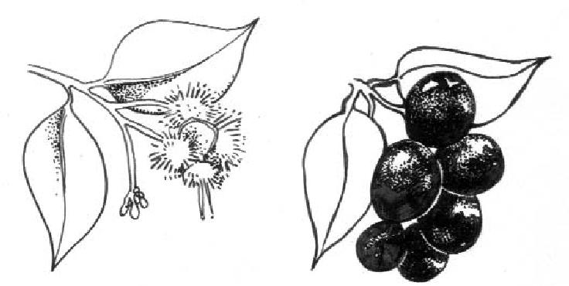
10 Forests
SWAHILI: (msambaran,
mzambarai,mzambarani, mzambarau, mzambarau mwitu, mzuari SHONA: (mukute) NDEBELE: (umdoni)
Indigenous to Botswana, Eritrea, Ethiopia, Kenya, Lesotho, Mozambique, Namibia, Senegal, Somalia, South Africa, Swaziland, Tanzania, Uganda, Zambia, Zimbabwe
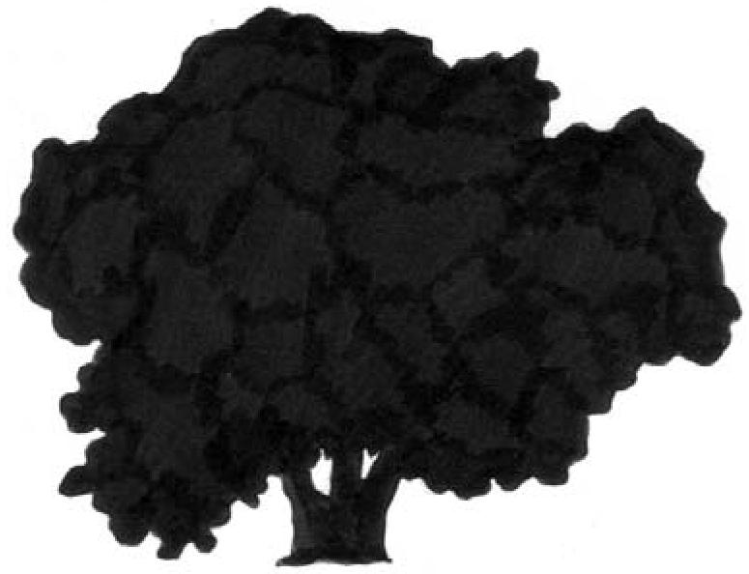
Goods
- Fodder (Leaves, Shoots)
- Good for bees
- Carving
- Implements
- Building
- Edible fruit
Services
- Good leaf humus (mulch)
- Shade
- Shelter
Growing Guide
WHERE WILL IT GROW Altitude: 0-2100m
Mean annual temperature: 10-30°C, Mean annual rainfall: 1000-2300mm
Soil: prefers fresh, moist, well-drained soils with high water table. Grows wild in lowland rain forests, mountain rain forests, swampy forests and open woodland
PROPAGATION AND MANAGEMENT
Germinates easily from fresh fruit seed. Can be sown directly or raised in a nursery from seed or collection of wild seedlings. Plant out on cleared site. Needs a lot of light, so overhead shade may need to be cleared too. Can be coppiced and pollarded.
TEPHROSIA VOGELII – FISH POISON TREE
SWAHILI: kibaazi, kibazi, mibaazi, mtupa, utupa wa kibaazi, utupa wa kingindo, utupa wa mrima
Indigenous to tropical Africa
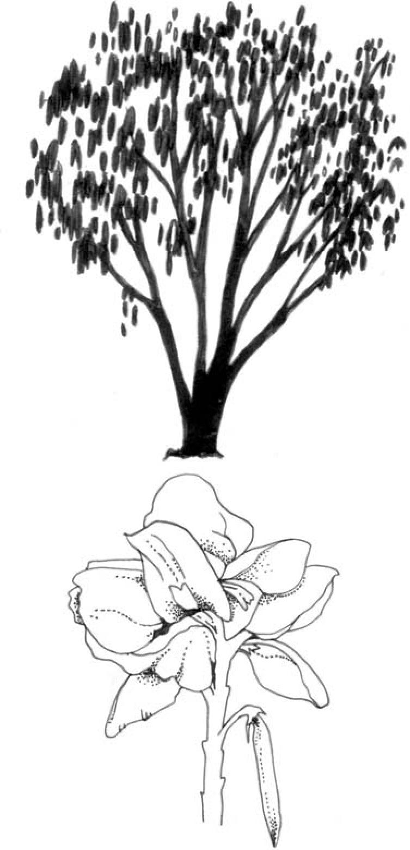
Goods
- Poisonous leaves: used to make natural pesticide to kill lice, fleas, ticks, snails and mites; used to make a fish poison (illegal in some countries) and arrow poison for hunting
- Medicine
Services
- Nitrogen fixing
- Green manure
- Living fence (makes a good barrier)
- Shade and shelter in plantations
Growing Guide
WHERE WILL IT GROW Altitude: 2100m
Mean annual temperature: 12-27°C Mean annual rainfall: 850-2650mm
Soil: can tolerate acidic soils. Grows well on volcanic ash soils that are not flooded, and also on well-drained loam with pH 5-6.5.
PROPAGATION AND MANAGEMENT See ACTION SHEET 53: Tephrosia vogelli

ZIZIPHUS MUCRONATA – BUFFALO THORN
Ndebele: umphafa Shona: muchecheni Swahili:mkunazi Tswana:mokgalo Xhosa: umPhafa Zulu: isiLahla, umKhobonga, umLahlankosi, umPhafa
Indigenous to Sub Saharan Africa
Goods
- Fodder for wildlife and livestock (leaves)
- Good for bees
- Fuelwood
- Timber
- Boma/kraals
- Tools
- Edible fruit (high in Vitamin C and essential nutrients)
- Medicine
Leaves are eaten by giraffe, eland, kudu, sable, black wildebeest, nyala, impala, klipspringer, springbok, Sharpe’s greysbok, steenbok, Damara dik-dik and warthog

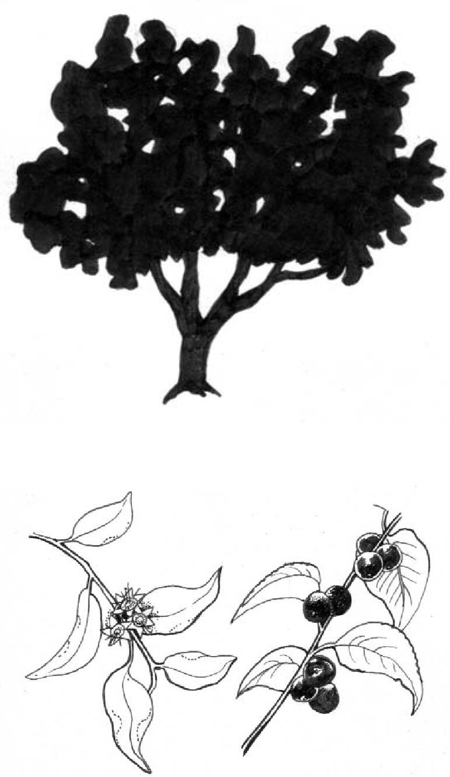
11 Forests
Services
- Living fence – makes a very good barrier
- Shade
Growing Guide
WHERE WILL IT GROW
Altitude: Up to 2000m
Mean annual temperature: 12-30°C
Mean annual rainfall: 446-1200mm
Soil: Grows on a variety of fine texture soils. Can grow in shallow soils and cope with seasonal waterlogging, salt spray and soil salinity. A very hardy species, most common in dry areas.
PROPAGATION AND MANAGEMENT
Remove the flesh of the fruit and soak the seeds in cold water for 6 hours. Plant in a seedling tray with a thin layer of river sand and keep moist. Take care not to damage the long tap root when planting the seedlings out. Alternatively, sow seeds or root suckers directly where you want your plants to grow. Can be coppiced and pollarded. Young trees must be protected from browsing cattle.
SOURCES: World Agroforestry Centre Agroforestree Database, Action Environmental Health Magazine. Illustrations by Alexi Francis

