

Agroforestry systems of timber species and cacao: survival and
growth during the early stages
Journal of Agriculture and Rural Development in the Tropics and Subtropics Vol. 114 No. 1 (2013) 1–11
urn:nbn:de:hebis:34-2012112642171 ISSN: 1612-9830 – journal online: www.jarts.info
Ramón E. Jaimez ^{a,∗}, Osmary Araque ^{a,b}, Danni Guzman^{b}, Argenis Mora^{c},
Wilmer Espinoza ª, Wilmer Tezara d
ªLaboratorio Ecofisiología de cultivos. Instituto de Investigaciones Agropecuarias. Facultad de Ciencias Forestales y Ambientales. Universidad
de Los Andes. Mérida Venezuela
^{b}Escuela de Ingeniería Forestal. Facultad de Ciencias Forestales y Ambientales. Universidad de Los Andes. Mérida Venezuela
^{c}Instituto de Desarrollo Forestal. Facultad de Ciencias Forestales y Ambientales. Universidad de Los Andes. Mérida Venezuela
^{d}Instituto de Biología Experimental. Universidad Central de Venezuela. Caracas Venezuela
Abstract
In recent times, increased emphasis has been placed on diversifying the types of trees to shade cacao (Theobroma cacao L.) and to achieve additional services. Agroforestry systems that include profitable and native timber trees are a viable alternative but it is necessary to understand the growth characteristics of these species under different environmental conditions. Thus, timber tree species selection should be based on plant responses to biotic and abiotic factors. The aims of this study were (1) to evaluate growth rates and leaf area index of the four commercial timber species: Cordia thaisiana, Cedrela odorata, Swietenia macrophylla and Tabebuia rosea in conjunction with incidence of insect attacks and (2) to compare growth rates of four Venezuelan Criollo cacao cultivars planted under the shade of these four timber species during the first 36 months after establishment. Parameters monitored in timber trees were: survival rates, growth rates expressed as height and diameter at breast height and leaf area index. In the four cacao cultivars: height and basal diameter. C. thaisiana and C. odorata had the fastest growth and the highest survival rates. Growth rates of timber trees will depend on their susceptibility to insect attacks as well as to total leaf area. All cacao cultivars showed higher growth rates under the shade of C. odorata. Growth rates of timber trees and cacao cultivars suggest that combinations of cacao and timber trees are a feasible agroforestry strategy in Venezuela.
Keywords: tree growth and survival, insect attack, intercropping, criollo cacao, timber tree

1 Introduction
In order to increase the profits obtained in cacao plantations, agroforestry systems are focusing on diversifying the species used to shade the cacao, incorporating other species that will provide additional benefits such as wood, nitrogen fixation and edible products. The traditional employment of legume trees to provide shade in agroforestry systems has proved to be a good strategy, given that they improve soil fertility, reducing de-
∗ Corresponding author Email: rjaimez@ula.ve Phone: +58-274 2401575
pendence on chemical fertilizers (Dechert et al., 2005; Daudin & Sierra, 2008). Nevertheless, agroforestry systems must provide various shade levels, which can only be obtained by introducing a greater variety of life forms and species in order to gain greater functional diversity. Despite the recommendations of incorporating commercially valuable native forest species in the cacao agroforestry systems to increase final profits, very little is known about their management (Tscharntke et al., 2011).
Over time, cacao agroforestry systems have incorporated timber species of high commercial value, and successful examples of this practice are reported in several

tropical countries of Central and South America (Somarriba & Beer, 1987; Heuveldop et al., 1988; Musaack & Laarman, 1989; Jardim et al., 2004; Orozco et al., 2008). Nevertheless, despite all the benefits derived from these agroforestry systems, selection criteria for native timber species and their management are lacking. Without appropriate selection criteria, it is not advisable to establish these systems at a larger scale (Dagang & Nair, 2003). Timber trees constitute a potential capital saving over time, which could eventually reduce financial losses caused by sudden drops in marketing prices (Tscharntke et al., 2011).
2 R. E. Jaimez et al. _{I} J. Agr. Rural Develop. Trop. Subtrop. 114- 1 (2013) 1–11
In tropical countries, tree species selection is crucial in order to guarantee success during the establishment phase, given that juvenile plants are particularly vulnerable to limiting field conditions, such as precipitation dynamics and high temperature which affect negatively plant survival and optimal growth. Other limiting factors in seedling and juvenile plant survival are soil texture and fertility, insect attacks (Plath et al., 2011), leaf area and phenology (Pallardy, 2008). It is likely that slow growth rate of timber species are associated with lower foliage areas. Thus, it is important when designing any agroforestry system to be aware of the species response to local environmental stresses, prior to their selection.
In cacao agroforestry systems, timber species selection should strongly depend on the amount of shade they provide to cacao plants during their development and once they reach their productive age. Excessive shade increases the incidence of fungal and bacterial diseases and reduces flower and fruit production. On the other hand, excessive radiation increases physiological stresses, enhancing crop vulnerability to insect damages. Tscharntke et al. (2011) provide an extensive review of the benefits of shade trees in cacao agroforestry systems, with recommendations related to shade tree management in order to maintain a source of biodiversity in the system and a stable production over a longer period of time.
In Latin America, cacao farmers traditionally include legume trees, mainly Erythrina fusca to shade cacao plants. Nevertheless, studies involving combinations of woody legumes and timber species are still scarce. Different agroforestry systems have combined various non timber species such as plantains to modify incoming radiation (Cubillo, 1993), whereas other strategies involve exclusively timber species (Somarriba & Beer, 2011).
The aims of this study were (1) to evaluate tree survival and the impact of insect attacks on growth rates and leaf area index in four commercial timber tree species during their first 36 months of establishment, and (2) to compare growth rates of four Venezue
lan criollo cacao cultivars: Porcelana, Guasare, Lobatera and Criollo Merideño planted under these four commercial timber trees in combination with Erythrina fusca.
2 Materials and methods 2.1 Study site
The study was conducted at "La Judibana" farm, Universidad de Los Andes, in the Municipality Alberto Adriani, Mérida state, Venezuela (8° 37’26”N, 71° 42’22”W) at an altitude of 73 m.a.s.l. The climate in the Maracaibo Lake Basin corresponds to a tropical rain forest. During this study, air temperature, relative humidity and annual average precipitation were 28.6°C, 77.7 % and 1,834 mm, respectively (data provided by the Venezuelan National Air Forces Station, located at El Vigia Airport). The soils ranged between sandy loam and sandy, with a pH of 5.2–6.3, a N content between 0.03 and 0.1 %, P between 2–8 mg/kg and K between 25–118 mg/kg.
2.2 Planting design combinations
Before the agroforestry trial was established, all of the vegetation was eliminated with a tractor and the soil of the first 30 cm layer was mixed. A random block design with three repetitions was established. Three blocks were established in the same area, maintaining a distance of 6 m between blocks. Each block consisted of 16 plots (24 m × 9 m) with a 6 m distance between individual plots (Figure 1). Each plot consisted of one of the four timber species assayed, in combination with one of the four Venezuelan cacao cultivars. All plots included the legume tree Erythrina fusca (Fabaceae). The four timber species assayed were: Cordia thaisiana Agostini (Boraginaceae), Cedrela odorata L. (Meliaceae), Swietenia macrophylla King (Meliaceae) and Tabebuia rosea (Bertol) A.D.C. (Bignoniaceae). The four cacao cultivars were: Porcelana, Guasare, Lobatera and Criollo Merideño. Four month-old plants of the timber species and E. fusca were planted between January and March 2007, keeping a distance of 6 m between plants, alternating lines of timber trees and E. fusca (Figure 2). With the purpose of providing provisional shading to the cacao cultivars during initial establishment juvenile plantains (Musa sp.) were planted in January 2008 at a
3 × 3 m distance between the juvenile timber trees. Between December 2008 and July 2009 the four cultivars of three month-old Venezuelan cacao were introduced, planted in rows alternating with the timber trees at a distance of 3 × 3 m. Thus, each plot consisted of 15 trees (nine timber trees and six E. fusca), 26 cacao trees and 30 Musa sp. plants (Figure 2).

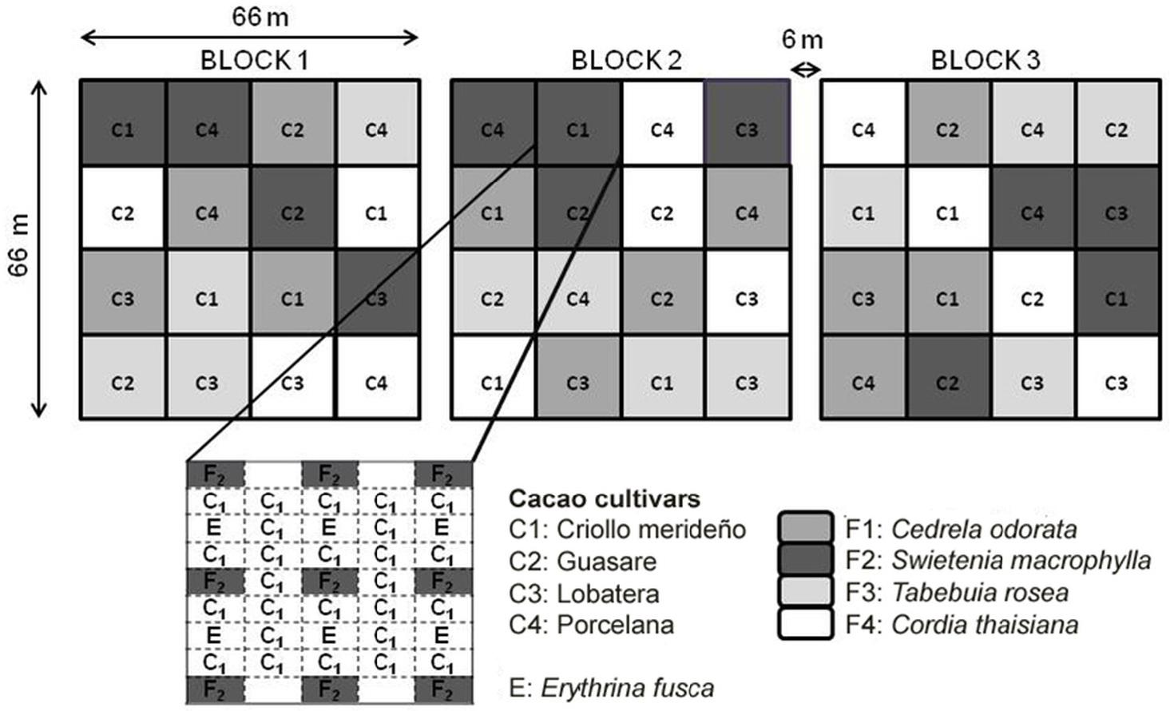

Fig. 1: Random block planting design with three repetitions. Each block consists of 16 plots and each plot consists of a specific combination of timber tree (F1–F4) and a cacao cultivar (C1–C4).
R. E. Jaimez et al. _{I} J. Agr. Rural Develop. Trop. Subtrop. 114-1 (2013) 1–11 3

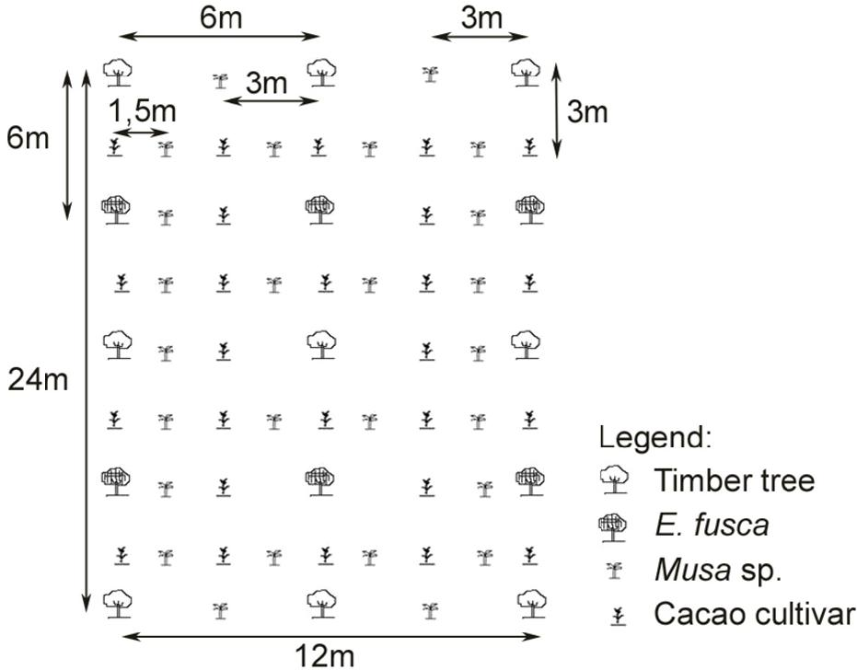
Fig. 2: Spatial arrangement of the tree, plantain and cacao plants in each plot. Each plot contains a total of nine timber trees, six E. fusca, 30 plantain (Musa sp.) and 26 cacao plants.
2.3 Agroforestry management activities
Weeding was carried out regularly every 4 months. Lower branches were eliminated in all of the trees at a distance of 1 m above ground level and pruning wounds were covered with a copper-oxychloride fungicide. All woody species were fertilized 4 times. The first fertilization was carried out in May 2007, with a commercial formula 15-15-15 (N, P, K), applying 30 g/plant; the second in November 2007, 18-18-18 (N, P, K), at a dosage of 85 g/plant, the third one was applied in July 2008, consisting 200 g of urea per plant and the fourth one was carried out in June 2009 (100 g/plant 18-18-18 N,P, K).
Cacao plants were fertilized a month after planting with 40 g per plant of 15-15-15 (N, P, K) and 9 months later, with 50 g/plant of 15-15-15-3 Ca-3 S. The latter also received a preventive treatment with acaricides; the first treatment was applied one month after planting and the second three months later.
Both C. odorata and S. macrophylla trees suffered attacks of the mahogany shootborer Hypsipyla grandella Zeller, which were controlled applying a bio-insecticide of Baccillus thuringiensis. Applications were made at the beginning of the rainy season and repeated at monthly intervals between 5–18 months after planting. All damaged apical shoots were removed and lateral branches were eliminated after each attack, in order to regain apical dominance leaving only two or three main shoots. Ant herbivory was controlled with a Fenthionbased insecticide applied at the base of the trees, and a sulfluramide insecticide was applied to the ant nests entrance holes.
2.4 Tree measurements
Total survival of all timber species was assessed at 12, 18 and 24 months after planting. Damages caused by insect attacks were evaluated every 15 days in each plot. In each case, insects were identified, and affected trees marked. During the first 18 months, basal stem diameter (bd, diameter at 10 cm above soil surface) and total height (TH) were measured every six months in the central timber trees of each plot, which represented a total of 36 timber trees per species. Between the second and third year, TH, diameter at breast height at a distance of 1.5 m above the ground (DBH) and trunk

height (ht, distance from the ground to the branch bifurcation) were measured at the same central timber trees every six months. TH and DBH were also measured in three E. fusca trees of each plot, at 36 months after establishment. Leaf area index (LAI) of timber trees was estimated with a Canopy analyzer (LAI-2000, LI-COR, inc., Nebraska USES) at 18 and 24 months on 12 trees per species (1 tree per plot). LAI of each tree was calculated from two measurements outside of the plot and four readings below the canopy. TH and bd were measured at six different cacao plants per plot (24 plants per cultivar in each block) at 3, 7 and 10 months after planting.
4 R. E. Jaimez et al. / J. Agr. Rural Develop. Trop. Subtrop. 114- 1 (2013) 1–11
2.5 Plot measurements
Total intercepted radiation was measured for each agroforestry system using a quantum sensor 24 months after establishing the trial. Photosynthetically photon flux density (PPFD) values were measured outside and inside the plantation, taking six different measurements inside of each plot.
The percentages of seedling survival of the four timber species were arcsine transformed (Sokal & Rohlf, 2012). Results of growth related variables were analyzed using ANOVA and differences between cultivars were evaluated using the Tukey or Duncan tests (p<0.05).
3 Results
3.1 Damages caused by insects
With exception of C. thaisiana, timber species suffered significant damages due to insect attacks during the first year. C. odorata and S. macrophylla (Meliaceae) were highly susceptible to the shoot borer H. grandella, which attacked 100% of the individuals of C. odorata and 61.7 % of S. macrophylla. But foliage damages were also caused by tree dwelling leafcutter ants (Atta sp., Myrmicinae) that attacked 52 % of the individuals of T. rosea, which suffered 50 % loss of their total leaf area, and 38 % of the individuals of S. macrophylla, although in the latter, only the lower foliage area was defoliated. T. rosea trees defoliated by ants showed significantly lower bd and TH after 12 and 18 months (Figure 3A and 3B). However, after 25 months of plant establishment no significant differences were found between attacked and non-attacked Tabebuia trees. In contrast, attacked plants of S. macrophylla by ants and the shoot borer H. grandella had still a significantly lower bd after 25 months while tree height was similar to that of un-attacked plants (Figure 3C and 3D).

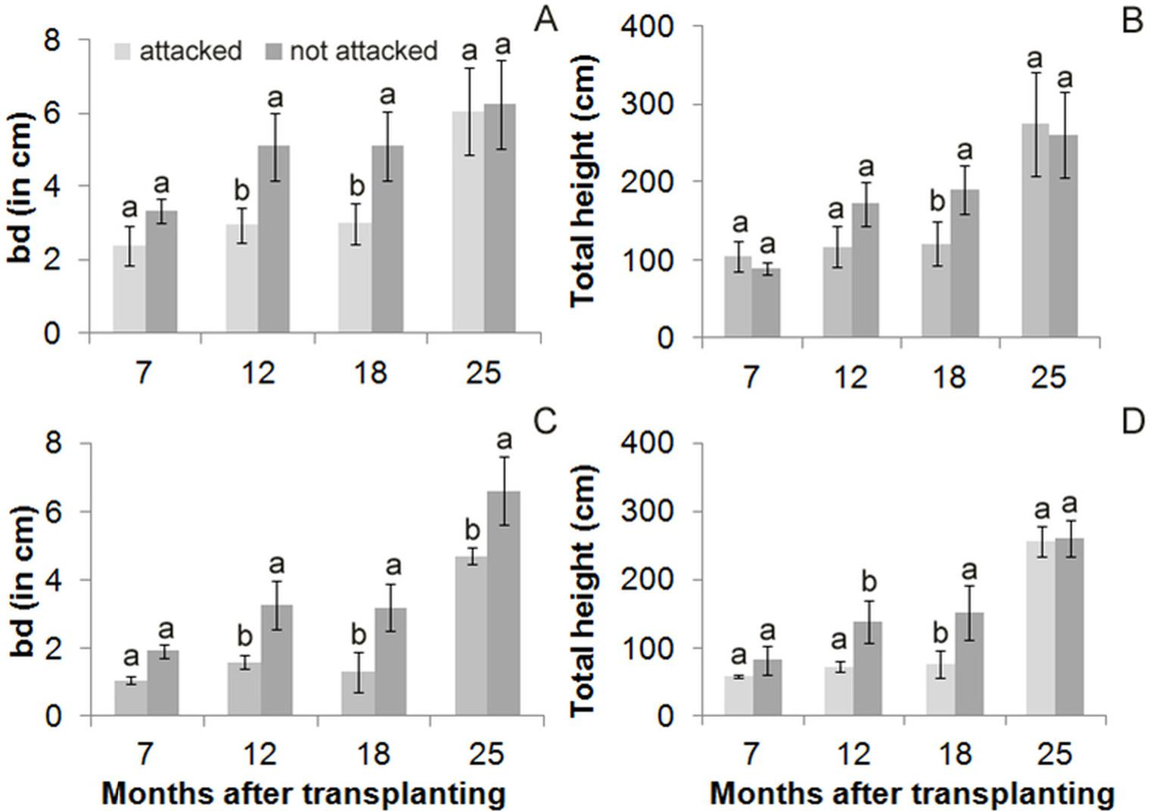
Fig. 3: Basal diameter (bd) and total height for attacked and non-attacked plants of T. rosea (A and B) and S. macrophylla (C and D) after 7, 12, 18 and 25 months afterplanting. Bars correspond to standard errors. Values with the same letter in the same month were not significantly different according to T test (p<0.05).

3.2 Tree survival and growth
R. E. Jaimez et al. / J. Agr. Rural Develop. Trop. Subtrop. 114-1 (2013) 1–11 5
Survival rates differed between tree species during the first 24 months after transplanting. Survival rates of C. thaisiana and C. odorata were 81 and 74 %, respectively; whereas T. rosea and S. macrophylla had a survival rate of 56 % after 18 months. After 24 months, survival rates were very similar in these four species and no changes were observed after this period (Figure 4). From the 24th until the 36th month, C. thaisiana maintained the highest TH, DBH and ht (p<0.05) (Figure 5), whereas T. rosea and S. macrophylla presented the lowest TH and DBH. After 36 months, DBH values clearly segregated these four timber species into three groups: C. thaisiana with DBH values above 15 cm, C. odorata between 8 and 9 cm, and S. macrophylla and T. rosea below 6 cm. The height of tree trunks of C. odorata, T. rosea and S. macrophylla remained similar during the entire measurement period. On the other hand, E. fusca maintained uniform DBH (14.3 t 1.4 cm) and TH (6.4 t 0.3 m) values when growing in combination with any of these timber trees-cacao criollo associations during the 36 month assay.
Highest positive correlations between DBH and TH corresponded to C. odorata and T. rosea (r² = 0.77 and 0.64, respectively), and the lowest to C. thaisiana (r² = 0.45) (Figure 6). Positive correlations were also observed between LAI, TH and DBH in C. thaisiana and C. odorata after 18 months (r² = 0.96). The same tendency was observed in all species with a positive relationship between LAI and TH (r²= 0.76) after 24 months but with no correlation between LAI and DBH (Figure 7). After 24 months, the total leaf area of these timber trees that grew in combination with E. fusca reduced the incoming radiation to 45 % in C. odorata plots, 40 % in C. thaisiana plots, 30 % in S. macrophylla plots and up to 28 % in T. rosea stands.
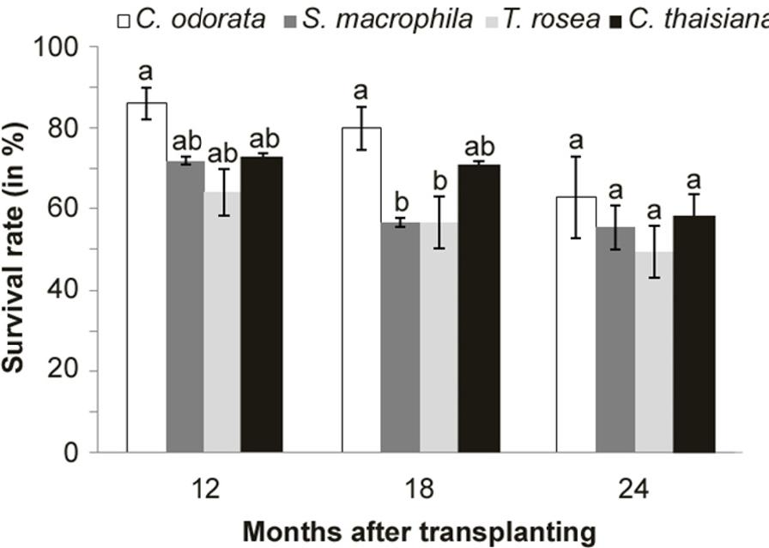
Fig. 4: Timber tree survival rates during the first 24 months after establishment. Values with the same letter for the same month were not significantly different according to Tukey s test (p<0.05). Bars correspond to standard errors.
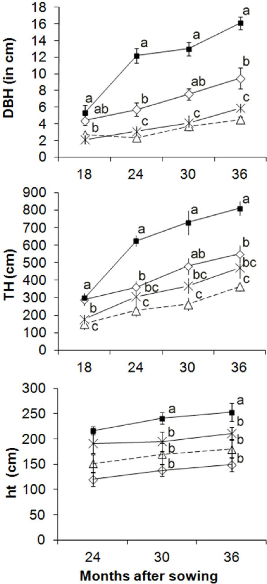
Fig. 5: Diameter at breast height (DBH), total height (TH) and trunk height (ht) for C. thaisiana, (a), C. odorata (), S. macrophylla (4) and T. rosea (x) during the first 36 months of growth. Values with the same letter for the same month were not significantly different according to Tukey s test (p< 0.05). Bars correspond to standard errors.
3.3 Growth of cacao cultivars
None of the four cacao cultivars suffered insect attacks or diseases. The cacao cultivar Lobatera presented the highest bd, TH and survival rates (94.8 %) after 10 months (p<0.05) (Table 1). The highest growth rates were observed in the individuals growing under the shade of C. odorata. However, Lobatera plants also presented high bd and TH in the individuals growing under T. rosea (Figure 8).

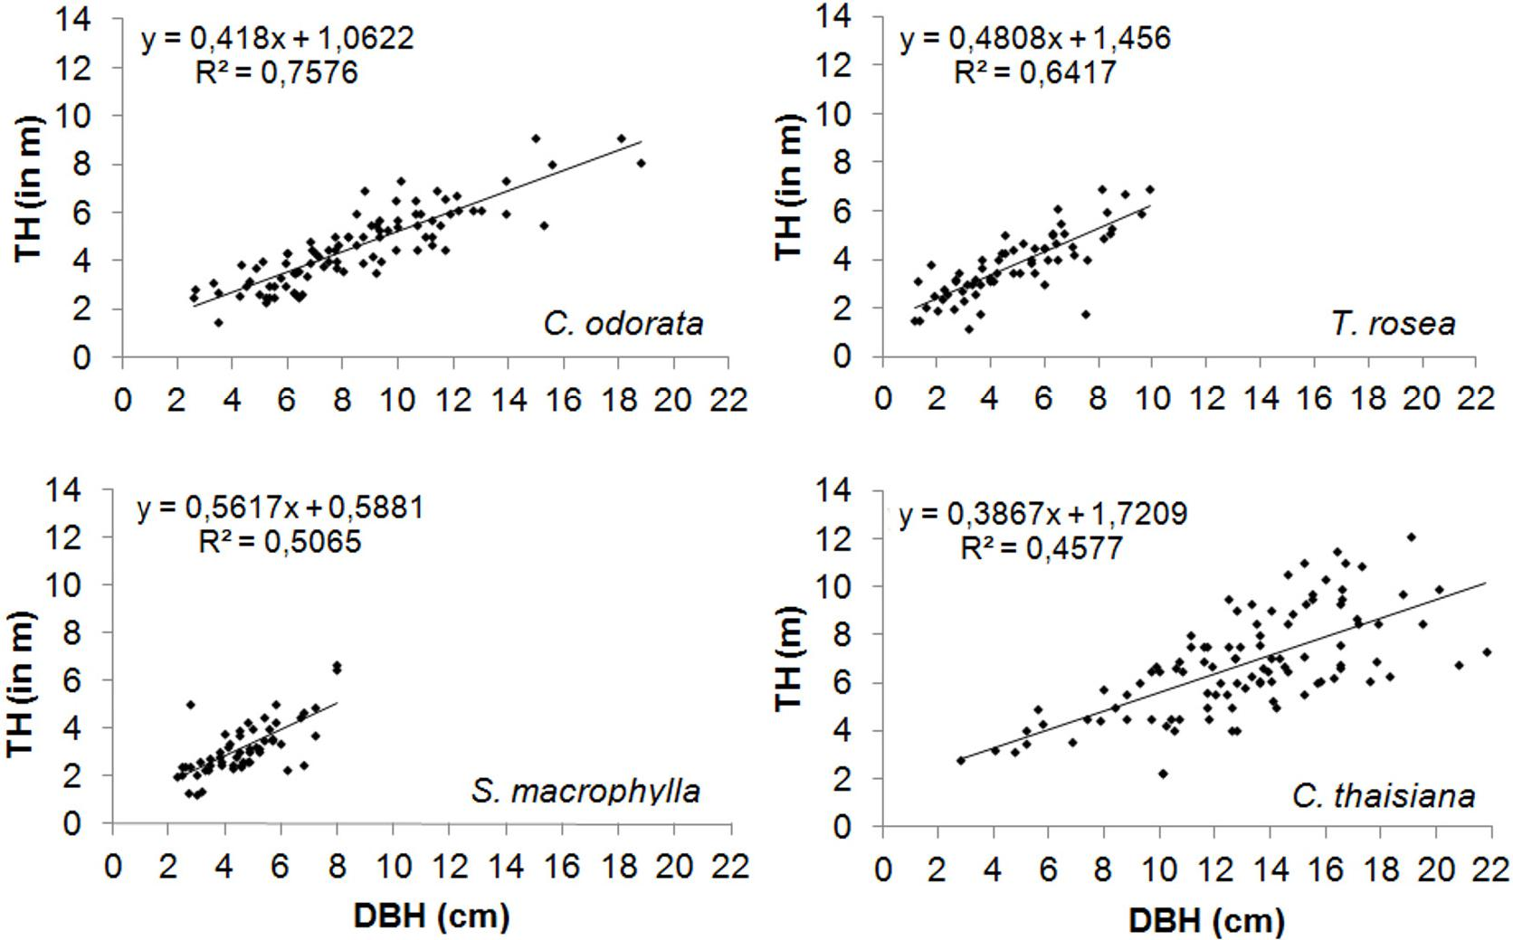
Fig. 6: Allometric relation between diameter at breast height (DBH) and total height (TH) measured for the four timberspecies (C. odorata, T. rosea, S. macrophylla, and C. thaisiana) during thefirst36 months ofgrowth.
6 R. E. Jaimez et al. / J. Agr. Rural Develop. Trop. Subtrop. 114- 1 (2013) 1–11

Fig. 7: Relation between leafarea index (LAI), total tree height (TH) and diameter at breast height (DBH) after 18 months (black) and after 24 months (white) for the four timber species C. thaisiana (,), C. odorata (@, El), T. rosea (•, ◦) and S. macrophylla (A, 4). Vertical and horizontal bars correspond to standard errors.
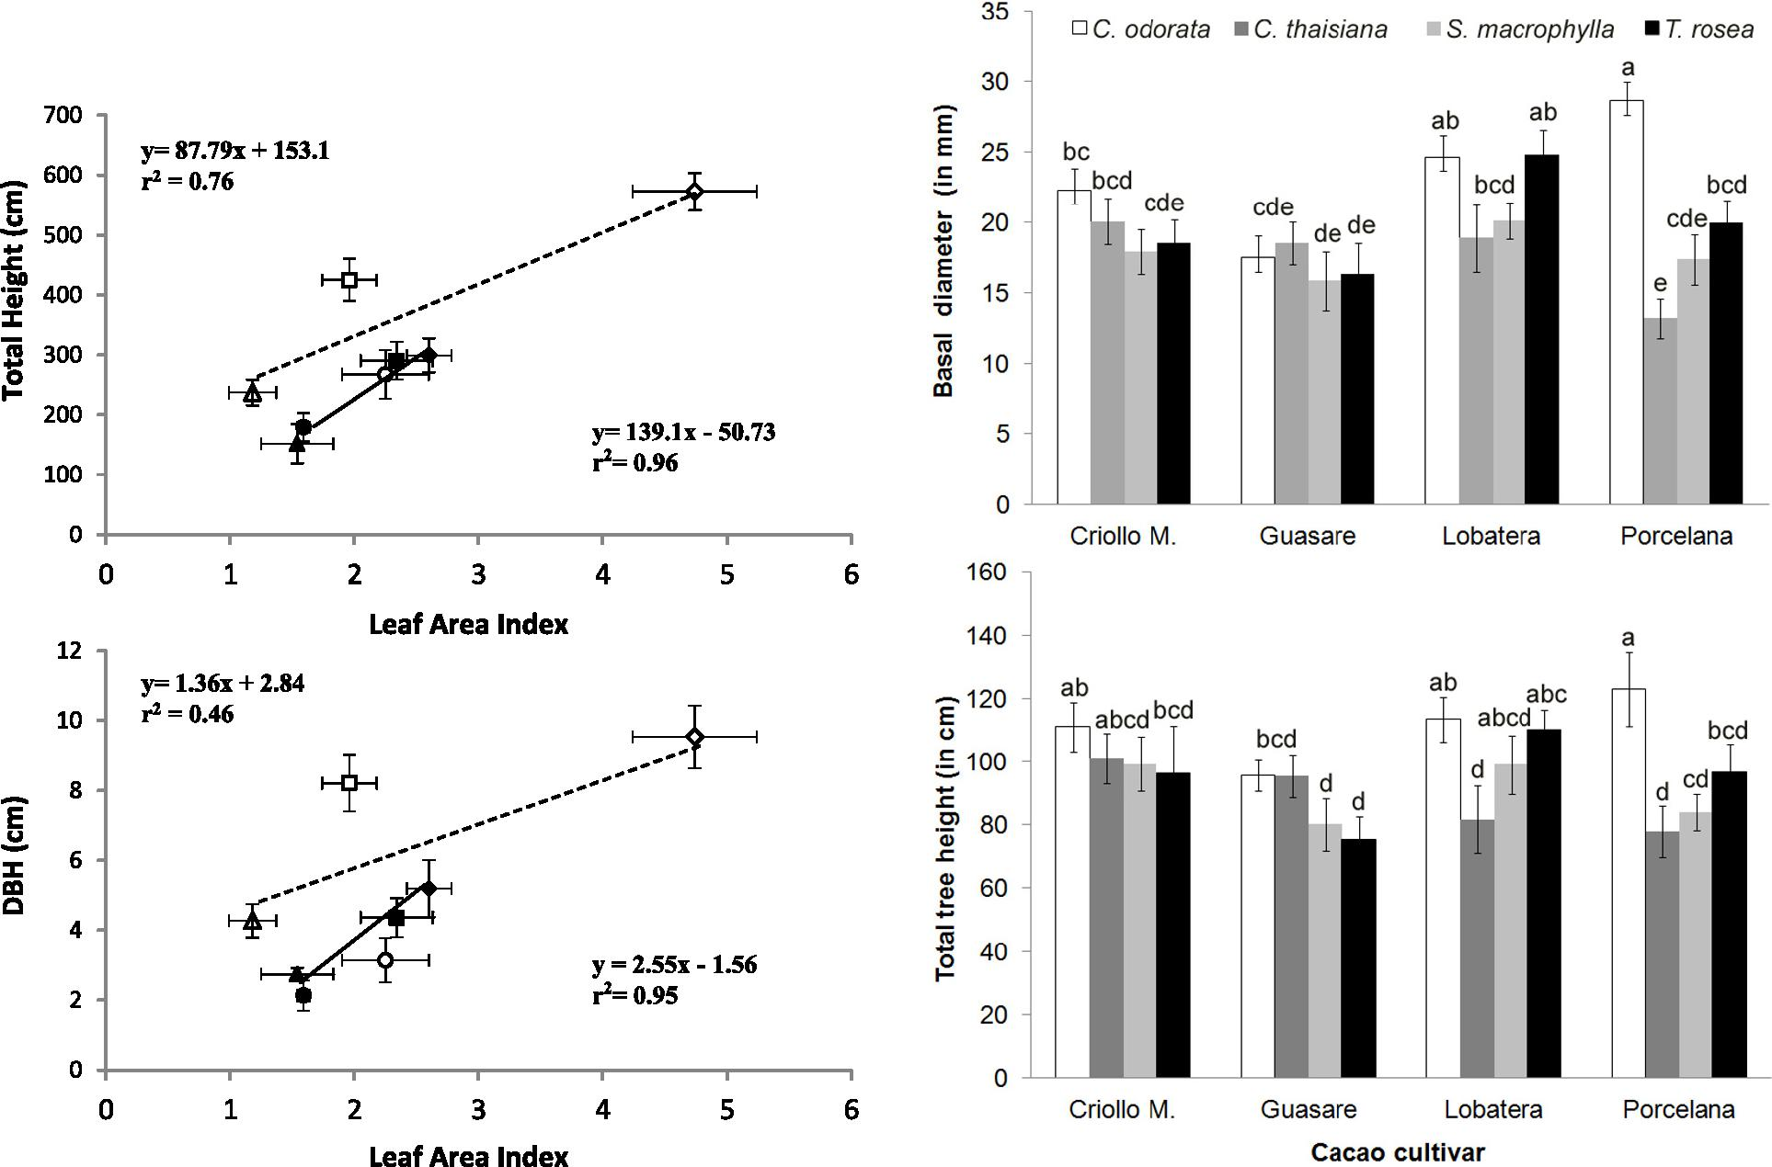
Fig. 8: Basal stem diameter and total tree heightfor the cacao cultivars: Lobatera, Guasare, Porcelana and Criollo Merideño under the shade of timber trees in combination with E. glauca. Each point represents the mean of 10 to 14 individuals un-der the shade of the timber species C.odorata, T. rosea, C. thaisiana, S. macrophylla. Bars correspond to standard errors.

Table 1: Basal stem diameter (bd), total plant height (TH) and plant survival rate of cacao cultivars after 10 months of establishment. Values are means ± SE (n=48).
R. E. Jaimez et al. / J. Agr. Rural Develop. Trop. Subtrop. 114-1 (2013) 1–11 7
Cacao Cultivar | bd (in mm) | TH (in cm) | Survival  rate (in %)
C. Meridefio | 19.6 ± 1.34 ^{ab} | 101.3 ±5.0ª | 84.6 b
Guasare | 17.5 ± 1.3 b | 86.8 ± 4.4 b | 88.2 b
Lobatera | 22.6 ± 1.3 a | 101.2 ± 6.0 a | 94.8 a
Porcelana | 17.6 ± 1.2 b | 95.6 ± 4.3 ab | 75.3 b

Values with the same letter in each column were not significantly different (p<0.05) according to Tukey´s test.
4 Discussion
4.1 Damages caused by Hypsipyla grandella and leafcutter ants
According to previous reports in monoculture plantations and in agroforestry systems established in Venezuela (Lozada & Graterol, 2003), Brazil (Jardim et al., 2004), and Costa Rica (Cornelius & Watt, 2003; Navarro et al., 2004), H. grandella limits growth of both C. odorata and S. macrophylla. In the case of S. macrophylla, our results support these studies in the initial growth stages (12 to 24 months). Unfortunately, we were unable to compare the negative impact of H. grandella on the growth of C. odorata, since the entire group suffered attacks. Cole & Ewel (2006) mentioned that C. odorata’s main branches regain growth with a greater accumulation of biomass as soon as the attacks by H. grandella cease. It is possible that C. odorata plants are more affected by H. grandella when growing under full sun exposure as proved in this study. Navarro et al. (2004) found that the attack by H. grandella was lower in C. odorata under the shade of mature coffee shrubs, than in open field conditions. However, more research related with growth conditions on C. odorata juvenile plants and the impacts of H. grandella on its development are needed.
Young T. rosea plants were highly susceptible to ant attacks. In several cases, individual plants were completely defoliated (Personal observation). Consequently, the growth of new leaves was delayed between the 12th and the 18th month resulting in a reduction in mean growth. Once the ants nested were eliminated in all of the plots, a complete recovery was observed in all of the affected individuals after 25 months, since bd and TH did not differ significantly between individuals that suffered defoliation and those which did not. Hall et al. (2011), reported high leaf losses due to the attack of
insects in various regions in Panama. Defoliation by leafcutter ants in T. rosea occurs not only in plantations, but also in natural forests (Rockwood & Hubbell, 1987; Benítez et al., 2002). Alike T. rosea, S. macrophylla was also affected by ants and the shoot borer H. grandella, resulting in lower growth rates during the second year. In general, insect herbivory had a negative effect on the growth of these two species during their first two years; thus, adequate pest control measures must be regarded in order to obtain higher growth rates. Insecticide treatment and adequate management practice during tree establishment must be considered with regard to local environmental conditions (Plath et al., 2011).
Cordia thaisiana was the only timber species that did not suffer insect attacks. However, the high density of ants observed on tree trunks suggests that a different type of interaction is predominant. Mutualism between Cordia alliodora and ants has been reported as a defense strategy against herbivory (Pringle et al., 2012). It is possible that the presence of cystoliths (deposits of calcium carbonate crystals) in young foliage tissues of C. thaisiana could prevent damage by pest insects. Cor-dia thaisiana is also the only one of these four timber species in which this anatomical trait has been reported (Araque et al., 2009).
4.2 Survival and growth of timber trees
High mortality rates were registered for S. macrophylla in the brief dry periods that occurred during the first three months after planting. This species appears to be sensitive to conditions of soil water deficit, more intensified under sandy soils. Under different conditions, Villarreal et al. (2006) have reported survival rates of 72 % for S. macrophylla, whereas Lozada et al. (2003) reported survival rates of only 24 %. In contrast, Espinoza et al. (2000) reported survival rates for S. macrophylla above 96 %.
Espinoza et al. (2000) also reported survival rates of over 67 % for T. rosea a year after establishing the trial. Recently, Somarriba & Beer (2011) combining systems of cacao and T. rosea and C. alliodora reported survival rates of 90 and 60 %, respectively. Plath et al. (2011) reported high survival rates (>95 %) in T. rosea after two years of growth, while C. odorata only reached 50% survival. Survival rates of 51 and 43 % for C. odorata were reported by Villarreal et al. (2006) and Lozada et al. (2003). Hence, the differences in the survival rates observed in these four timber species appear to be related with local edaphoclimatic conditions as well as insect attacks during the first years of establishment. The first 24 months revealed to be crucial for the survival of juvenile plants in the field. Therefore, it is very important to guarantee optimal management practices, involving the application of chemical products to control

insect attacks, adequate pruning and fertilization techniques, according to the specific requirements of each timber species during this period.
8 R. E. Jaimez et al. _{I} J. Agr. Rural Develop. Trop. Subtrop. 114- 1 (2013) 1–11
Trunk diameter growth rates of C. thaisiana and C. odorata allow us to consider them as rapid-growth
species. In the Panama humid forests, rapid growth species reach a DBH of 10 cm after 5 years (Condit et al., 1993). Information regarding growth rates of C.
thaisiana is notably scarce; therefore its growth rates can only be compared with the rates of C. alliodora
growing under similar climatic conditions. For exam-
ple, TH and DBH of C. alliodora were higher (8.9 m and 17.1 cm, respectively) during the first two years in
similar agroforestry systems established in Costa Rica
(Heuveldop et al., 1988). On the other hand, Menalled et al. in Costa Rica (1998) reported similar height and
lower DBH (8 cm) in C. alliodora after 30 months in a plantation with C. odorata and Hyeronima alchorneoides, whereas Somarriba & Beer (2011) reported similar growth rates after 36 months in plantations of C.alliodora combined with cacao.
Stem diameters measured in C. odorata during this study were significantly higher than those reported for
the same species in 30 month old monocultures, in
which reported values ranged between 6.6 cm (Menalled et al., 1998) and 7.6 cm (Cornelius & Watt, 2003), as
well as in similar agroforestry systems established in
Venezuela (12.7 cm) (Villarreal et al., 2006). Despite the fact that C. odorata had the second highest DBH
and TH values in our study, ht values did not differ sig-
nificantly from those measured in S. macrophylla and T. rosea, due to the attacks of H. grandella on the terminal
shoots, which affected its commercial value, as well as
maintenance costs. S. macrophylla was also negatively affected by the attacks of H. grandella, which limited
growth rates, resulting in lower average DBH and TH after 24 months, compared to the values reported by Villarreal et al. (2006).
T. rosea showed lower DBH and heights during the first two years related to ant induced defoliation, but
recovered rapidly after control measurements were applied. The latter presented considerably greater growth rates compared with growth rates obtained in other studies (Plath et al., 2011; Hall et al., 2011; Somarriba & Beer, 2011).
The maintenance of a larger leaf area results in a higher light harvesting area (Kings et al. 2005) and
higher total CO2 assimilation rates (Araque et al., 2009),
which in turn will promote higher plant growths (height and diameter). Apparently, during the first 18 months
those species that had high leaf areas also showed higher growth rates, as is the case of C. thaisiana. Tabebuia rosea and S. macrophylla that had smaller leaf areas which affected DBH and height negatively. Similar
tendencies were observed in young trees in temperate forests (Bartelink, 1997; Lusk, 2004).
Two trends of assimilate allocation seem to be associated with foliage losses during the first 36 months. The first, exhibited by C. thaisiana with lower slopes in the allometric relationship between TH and DBH, suggests a greater proportion of assimilates allocated to trunk diameter. The second one, exhibited by the other three species corresponds to a low proportion of assimilates distributed to DBH. Cole & Ewel (2006) obtained similar slopes in the TH and DBH relations in Cordia alliodora and C. odorata.
Different distribution patterns of assimilates between species have a marked influence on the plant’s crown architecture as well as the competitive interactions occurring between neighboring plants. However, allometric relations can change with tree stature; therefore stable allometric equation predictions may not necessarily reflect realistic biomass estimations (Cole & Ewel, 2006). Hence it is very important, not only to have reliable data relative to early growth stages, but also during all other phases of development in order to make accurate predictions of growth and biomass production.
4.3 Cacao growth
Partial shade is important for the establishment of cacao by creating a less stressful environment and favouring the growth of cacao seedlings (de Almeida & Valle, 2007; Jaimez et al., 2008). In a tropical environment such as the South of Maracaibo Lake, air temperatures can surpass 35°C at midday at full sunlight (Jaimez et al., 2005). Additionally, the decrease in air humidity in conjunction with an increase in leaf to air water vapor pressure deficits (VPD) induces partial stomatal clousure, which in turn will limit photosynthesis. Such environmental conditions are extremely stressful for unshaded T. cacao seedlings.
All cacao cultivars presented greater growth under the shade of C. odorata. It seems that microenvironmental conditions generated by the combination of E. fusca with C. odorata (5 % incoming light) were the most adequate for cacao plants during the first year of growth. We have to evaluate if the strict deciduous condition of C. odorata that occur during the period March to May in this region, independently of the availability of soil water, affects cacao flowering and/or pod yield. If leaf fall of C. odorata coincides with leaf fall of E. fusca during dry periods, greater decreases in flowering and pod production will probably occur. Under high light conditions and lower water availability, drastic decreases in photosynthesis rates have been reported (Araque et al., 2012; de Almeida & Valle, 2007).
With the exception of the combination of the Porcelana cultivar with C. odorata, the Lobatera cultivar

shows highest growth rates independent of the shade of the timber species. The cultivar Guasare showed the lowest growth rates under any of the timber species assayed. Nevertheless, the tree heights obtained for the four cacao cultivars tested in this trial were 30 % higher than those reported for other cacao cultivars during the same growth stage (Raja Harum & Kamariah, 1983).
R. E. Jaimez et al. _{I} J. Agr. Rural Develop. Trop. Subtrop. 114-1 (2013) 1–11 9
It is also worth mentioning that the four week dry period that occurred during the sixth month after transplant caused high seedling mortality in some of the cultivars. By the seventh month, Lobatera and Guasare cultivars had the highest survival percentages (94 and 88 %), whereas the remaining cultivars displayed values below 84 %. Although the Lobatera and Criollo Merideiïo cultivars showed similar growth rates, they differed in their drought tolerance capacity. Despite the fact that the Venezuelan Porcelana cultivar is the most widely grown in the South of Lake Maracaibo, its survival rates were extremely low due to low tolerance to water stress during the establishment phase (Araque et al., 2012). Few evaluations, however, have been carried out in Criollo cultivars in open field conditions in order to understand the possible mechanisms involved in water deficit tolerance. Variations in these characteristics may be incorporated into criollo cultivars, like the strategies of osmotic adjustments exhibited by four year-old Guasare trees (Rada et al., 2005; Araque et al., 2012) and stomatal closure in Amazon cultivars (de Almeida et al., 2002) and differences in root growth.
The strategy of using trees in combination with E. fusca to provide an adequate light and temperature environment for cacao seedlings is a feasible alternative that may be extended in the region. These agroforestry systems can be a successful model that provides adequate shade for cacao.
The results of our study indicate that C. thaisiana is the most successful timber species in this agroforestry system; due to its crown architecture, higher growth rates and lower incidence of insect attacks. However, cacao cultivars presented higher growth rates under the shade of C. odorata. Therefore, the combination of both species with other timber species with less susceptibility to insect attacks can also represent a viable option. Evaluations in the next four years will give us more precise information regarding the most adequate timber tree and cacao combination, regarding cacao yield.
In conclusion, the implementation of agroforestry systems that combine cacao with timber trees are feasible; nevertheless, insect attacks are also an important factor to consider in the establishment of timber trees, as they decrease growth by reducing total leaf area. Apparently, timber species that maintain higher leaf areas also coincide with higher trunk heights and DBH during their first 30 months of development. In cacao agroforestry
systems, cultivars with a rapid initial growth during the first ten months will show significantly higher survival rates.
Acknowledgements
This study was financed by the MCT, sub-project 5 of the Project Chocolate Route N° 200500898, Convertidora PAPELEX, CDCHT-Universidad de Los Andes project PIC CVI FO-04-09-01 and FONACIT-LOCTI N° 2012001369. We are grateful to the MSc. Carmen Azôcar and personnel of "La Judibana" farm of the Universidad de Los Andes for logistic support during this research. We also appreciate the contribution of Francisca, Ely, Fermin Rada and Miguel Costa for editing as well as to the anonymous reviewer for the important suggestions which substantially improved the final version.
References
de Almeida, A.-A. F., Brito, R. C. T., Aguilar, M. A. G. & Valle, R. R. (2002). Water relations’ aspect of Theobroma cacao L. clones. Agrotrôpica, 14 (2),35– 44.
de Almeida, A.-A. F. & Valle, R. R. (2007). Ecophysiology of the cacao tree. Brazilian Journal of Plant Physiology, 19 (4),425–448.
Araque, O., Jaimez, R. E., Azocar, C., Espinoza, W. & Tezara, W. (2009). Relaciones entre anatomía foliar, intercambio de gases y crecimiento en juveniles de cuatro especies forestales. Interciencia, 34 (10), 725– 729.
Araque, O., Jaimez, R. E., Tezara, W., Coronel, I., Urich, R. & Espinosa, W. (2012). Comparative photosynthesis, water relations, growth and survival rates in juvenile Criollo cacao cultivars (Theobroma cacao) during dry and wet seasons. Experimental agriculture, 48,513–522.
Bartelink, H. H. (1997). Allometric relationship for biomass and leaf area of beech (Fagus sylvatica L.). Annals ofForest Science, 54,39–50.
Benítez, G., Equihua, M. & Pulido-Salas, M. (2002). Diagnostico de la situaciôn de los viveros oficiales de Veracruz y su papel para apoyar programas de reforestaciôn y restauraciôn. Revista Chapingo Serie Ciencias Forestales y del Ambiente, 8 (1),5–12.
Cole, T. G. & Ewel, J. J. (2006). Allometric equations for four valuable tropical tree species. Forest Ecology and Managament, 229,351–360.
Condit, R., S., H. & Foster, R. (1993). Indentifying fastgrowing native tree from Neotropics using data from a large permanent census plot. Forest Ecology and Managament, 62,143–163.

Cornelius, J. P. & Watt, A. D. (2003). Genetic variation in a Hypsipyla-attacked clonal trial of Cedrela odorata under two pruning regimes. Forest Ecology and Managament, 183,341–349.
10 R. E. Jaimez et al. _{I} J. Agr. Rural Develop. Trop. Subtrop. 114- 1 (2013) 1–11
Cubillo, O. (1993). Desarrollo de un sistema sostenible cacao-plâtano-maderables en la regiôn central de Costa Rica. In P.-M. W. (Ed.), Seminario Regional ”Sombras y cultivos asociados con cacao” (pp. 175– 178). Turrialba, CATIE, Costa Rica.
Dagang, A. B. K. & Nair, P. K. R. (2003). Silvopastoral research and adoption in Central America: recent findings and recommendations for future directions. Agroforestry Systems, 59,149–155.
Daudin, D. & Sierra, J. (2008). Spatial and temporal variation of below ground N transfer from a leguminous tree to an associated grass in an agroforestry system. Agriculture ecosystem and environ-ment, 126,275–280.
Dechert, G., Veldkamp, E. & Brumme, R. (2005). Are partial nutrient balances suitable to evaluate nutrient sutainability of land use systems? Results from a case study in Central Sulawesi, Indonesia. Nutrient Cycling in Agroecosystems, 72 (3),201–212.
Espinoza, R., Gutiérrez, A. & Reina, J. (2000). Evaluaciôn del Componente arbôreo dentro del Sistema agroforestal de la Fundaciôn DANAC, San Felipe, estado Yaracuy. Tesis de grado. Universidad de Los Andes. Facultad de Ciencias Forestales y Ambientales. Escuela Técnica Superior Forestal. Mérida, Venezuela. 65 p.
Hall, J. S., Love, B. E., Garen, E. J., Slusser, J. L., Saltonstall, K., Mathias, S., van Breugel, M., Ibarra, D., Bork, E. W., Spaner, D., Wishnie, M. H. & Ashton, M. S. (2011). Tree plantations on farms: Evaluating growth and potential for success. Forest Ecology and Managament, 261(10),1675–1683.
Heuveldop, J., Fassbender, H., Alpizar, L., Enriquez, G. & Fölster, H. (1988). Modelling Agroforestry Systems of Cacao (Theobroma cacao) with Laurel (Cor-dia alliodora) and Poro (Erythrina poeppigiana) in Costa Rica. II. Cacao and Wood production, litter production and decomposition. Agroforestry Systems, 6,37–48.
Jaimez, R. E., Rada, F., García-Núiez, C. & Azôcar, A. (2005). Seasonal variations in leaf gas exchange of plantain cv. Hartôn (Musa AAB) under different soil water conditions in a humid tropical region. Scientia Horticulturae, 104,79–89.
Jaimez, R. E., Tezara, W., Coronel, I. & Urich, R. (2008). Ecofisiología del cacao (Theobroma cacao): su manejo en el sistema agroforestal. Sugerencias para su mejoramiento en Venezuela. Revista Forestal Venezolana, 52 (8),253–258.
Jardim, F., Ribeiro, J. & Rosa, L. (2004). Avaliação preliminar de sistema agroflorestal no Projeto Agua Verde, Albrâs, Barcarena, Parâ-I. Revista de Ciências Agrârias, 41,25–46.
Llany, T., Ashton, M., Montagnini, F. & Martinez, C. (2010). Using agroforestry to improve soil fertility: effects of intercropping on Ilex paraguariensis (yerba mate) plantations with Araucaria angustifolia. Agroforestry Systems, 80,399–409.
Lozada, J. & Graterol, D. (2003). Prâcticas agroforestales en el municipio Rosario de Perijâ, estado Zulia. Revista Forestal Latinoamerica, 33,21–36.
Lozada, J., Moreno, J. & Suescun, R. (2003). Plantaciones en Fajas de Enriquecimiento: experiencias en 4 unidades de Manejo Forestal de la Guayana Venezolana. Interciencia, 28 (10),568–575.
Lusk, C. H. (2004). Leaf area and growth of juvenile temperate evergreens in low light: species of contrasting shade tolerance change rank during ontogeny. Functional Ecology, 28 (6),820–828.
Menalled, F., Kelty, M. & Ewel, J. (1998). Canopy development in tropical tree plantations: a comparison of species mixtures and monocultures. Forest Ecology and Management, 104,249–263.
Musaack, M. F. & Laarman, J. G. (1989). Farmers’ productions of timber tree in the coffe-cacao region of coastal Ecuador. Agroforestry systems, 9,155–170.
Navarro, C., Montagnini, F. & Hernândez, G. (2004). Genetic variability of Cedrela odorata Linnaeus: result of early performance of provenances and families from Mesoamerica grown in association with coffee. Forest Ecology and Managament, 192,217–227.
Orozco, L., Lôpez, A. & Somarriba, E. (2008). Enriquecimiento de fincas cacaoteras con frutales y maderables en el Alto Benni Bolivia. Agroforestería en las Américas, 46,65–72.
Pallardy, S. (2008). Physiology of woody plants Third edition. Academic Express Elsevier. 441 p.
Plath, M., Mody, K., Potvin, C. & Dorn, S. (2011). Establishment of native tropical timber trees in monoculture and mixed-species plantations: small-scale effects on tree performance and insect herbivory. Forest Ecology and Management, 261,741–750.
Pringle, E., Dirzo, R. & Gordon, D. (2012). Plant defense, herbivory, and the growth of Cordia alliodora trees and their symbiotic Azteca ant colonies. Oecologia, 170,677–685.
Rada, F., Jaimez, R. E., Garcia-Nuiez, C., Azocar, A. & Ramírez, M. (2005). Water relations in Theobroma cacao var. Guasare under periods of water deficits. Revista de la Facultad de Agronomia de la Universidad del Zulia, 22 (2),112–120.

Raja Harum, R. M. & Kamariah, H. J. (1983). The effects of shading regimes on the growth of cocoa seedlings (Theobroma cacao L.). Pertanika, 6 (3),1– 5.
R. E. Jaimez et al. _{I} J. Agr. Rural Develop. Trop. Subtrop. 114-1 (2013) 1–11 11
Rockwood, L. & Hubbell, S. (1987). Host-Plant selection, Diet Diversity and Optimal foraging in a Tropical Leaf cutting ant. Oecologia, 74 (1), 55–61.
Sokal, R. R. & Rohlf, F. J. (2012). Biometry: the principles and practice of statistics in biological research. 4th edition. W. H. Freeman and Co.: New York. 937 pp.
Somarriba, E. & Beer, J. (1987). Dimensions, Volumes and growth of Cordia alliodora in Agroforestry Systems. Forest Ecology and Managament, 18,113–126.
Somarriba, E. & Beer, J. (2011). Productuvity of Teobroma cacao agroforestry systems with timber and
legume service shade tree. Agroforestry systems, 81,109–121.
Tscharntke, T., Shonil, Y., Bhagwat, S., Buchori, D., Faust, H., Hertel, D., Hölscher, D., Juhrbandt, J., Kessler, M., Perfecto, I., Scherber, C., Schroth, G., Veldkamp, E. & Wanger, T. C. (2011). Multifunctional shade-tree management in tropical agroforestry landscapes – a review. Journal of Applied Ecology, 48 (3),619–629.
Villarreal, A., Carrero, O., Arends, E., Sánchez, D. & Escalante, E. (2006). Evaluaciôn de Rendimientos y Rentabilidad de los Componentes asociados a Swietenia macrophylla (Caoba), Cedrela odorata (Cedro) y Carica papaya (Lechosa), establecidos en Ensayos Agroforestales en la Finca ULA, Estaciôn Experimental Caparo, Edo. Barinas, Venezuela. Revista Forestal Latinoamericana, 21(39), 85–104.

