A Call to Plant Trees
Dr. Akira Miyawaki
The Rise and Fall of the Forest and Human Civilization
Today, we live in an era marked by the greatest scientific and technological advances ever seen in the 6,000-year history of human civilization. Differences remain between the North and the South. Nonetheless, every industry has progressed, and we enjoy more material wealth than our ancestors could have ever imagined. To satisfy mounting desires, however, we fell forests and mountains, overwhelm oceans and rivers with landfill, create new industrial sites, and scramble to build more cities.
Before long, more and more greenery began disappearing from our environment. In particular, the “native forests by native trees,” the indigenous forests with 30 times the greenery in surface area of single-layered lawns, are disappearing without a trace. Living greenery is the only producer in the ecosystem, and is fundamental to the existence of all life forms on Earth including humankind. With the destruction of nature and the spread of environmental contamination, however, people—from scientists, corporations, and politicians to housewives and children—have finally begun to contemplate the gravity of environmental problems.
Environmental problems are occurring not only within large-scale natural development and the realm of physics and chemistry, but also within new industries that contend with life forms, such as agroforestry. They also accompany urbanization and the development of transportation infrastructure.
Environmental problems encompass an extremely wide range of issues. Some, like typhoons, earthquakes, fires, floods, and tsunami, seem like nature’s retribution, triggered by her fury. Other problems include the environmental destruction wrought by natural development, water and atmospheric pollution caused by factory emissions of chemical substances, and global warming caused by increased carbon dioxide emissions. Various measures are being put into place to contend with each of the problems, incorporating the latest science and technology; nevertheless, these solutions are implemented on a case-by-case basis. Although conferences do take place to deal with such issues, as environmental problems range so widely, the essence of environmental concerns gets lost in political and other agendas.
To protect the environment is to protect life. Human beings today behave as though they own the universe. The fact is they only appeared in the last interlude of the history of life on earth spanning some three billion years. Human beings have barely achieved a life span of less than 100 years. Primitive forms of life were created on Earth three billion years ago. Since then, our DNA, the thin thread of our genes, has somehow continued until the present in an unbroken chain, bringing us to our existence today.
What is it that those of us who live today can leave for the future? It cannot merely be material luxuries or money. What we can pass down is the thin but irreplaceable thread of our genes, the genes that have been passed down from three billion years ago until the present day. These are the genes that belong to you, your loved ones, and your neighbors, which is the one thing we can carry into the future. We live today as milestones for the future.
The most fundamental factor in protecting those genes is living greenery. In particular, the “native forest by native trees,” the concentration of three-dimensional native greenery, is the basis that guarantees the passage of our life, intelligence, sensibility, and, most importantly, our genes into the future. In reality, however, much of the three largest rain forests, long regarded as natural forests, have also been felled and devastated. Forests in most areas where people have built civilizations, beginning in ancient times, from the Mediterranean to India to China, have been completely destroyed from practices such as the overgrazing of livestock. Environmental destruction has also advanced in North and South America, as well as in Australia, known as the new world. Indigenous forests are without a doubt vanishing on a global scale.
Global Warming and the Forest
There have been voluminous research and assessment across the world into global warming caused by increased carbon dioxide emissions, with projections made into the future.
Fossil fuels, like petroleum, coal, and natural gas, contain carbon, the principal culprit for global warming. Fossil fuels were produced as a result of the underground carbonization of organisms, largely plants, from approximately 300 million years ago. Life forms were in the midst of evolution. There were no broad-leaved plants like there are today; plants had only evolved to ferns. In a climate likely to have been favorable with high temperatures and humidity, however, tree ferns grew dense, forming large forests. Through photosynthesis, these forests absorbed the carbon in the atmosphere and solidified. Subsequently, shifts in the climate and in the Earth’s crust buried them underground. Underwater mechanisms have yet to be fully elucidated, but conventional thinking states that until recently the balance of material circulation on Earth had been maintained in the space between the atmosphere, the geosphere, including the hydrosphere, and the biosphere, the thin layer on Earth where all life forms exist.
With the onset of the Industrial Revolution at the end of the 18th century, the development of new industries like heavy manufacturing, fossil fuels that had been buried and locked underground were drawn above ground and burned. Burning fossil fuels creates a chemical reaction whereby the carbon combines with the oxygen in the atmosphere, producing carbon dioxide. The amount of atmospheric carbon dioxide became unquestionably greater the more fossil fuels people burned, which advanced global warming.
Energy conservation has been advocated as a countermeasure to global warming. People around the world are raising their voices to advocate specific measures like curbing manufacturing or excess consumption, decreasing electricity consumption, and driving as little as possible. Such vital measures have been put into place throughout the world; unfortunately, however, no matter how much they conserve, people of today will be unable to completely stop using electricity or eliminate the use of machines, cars, and air conditioners. Even if countries fully exert their efforts to curb carbon dioxide emissions as determined at the Kyoto Conference, as long as they continue to maintain their current economies, industries, and urban lifestyles, energy conservation measures will remain insufficient. Further, there is an end to the availability of fossil fuels, which can be said is the current basis for modern civilization. Estimates project fossil fuel reserves to run out in several decades; no matter how much people conserve, the reserves will not last another 100 years. In addition to hydraulic and nuclear power, and the use of natural sources of power such as solar energy, research in nuclear fission, has been advanced and its results are highly anticipated. However, these sources of power are still insufficient for immediate use. So what options are available?
The alternative I will describe may seem unspectacular and rather unrefined at first, and some may think it will not have an immediate effect. Having said that, I believe that creating indigenous and real forests, and covering as much of the land as possible with forests, is the most certain and effective measure to reduce carbon dioxide. Real forests form multilayered communities, of tall trees, semi-tall trees, short trees, and bottom weeds. Thus, they have 30 times the surface area of greenery for photosynthesis compared to such single-layered communities as moors and lawns. As such, real forests should also have 30 times the ability to preserve the local environment and to mitigate impact, in terms of noise insulation, dust filtration, air purification, and maintaining water quality. Moreover, the primary trees of real forests have deep and axial roots, making them more resistant to falling, and contributing towards disaster prevention.
Plants absorb the carbon in the atmosphere through photosynthesis, turning into hydrocarbon and lignin and forming trunks, branches, and leaves. By following such methods to create a forest—in which small potted seedlings of the primary trees of the area’s potential natural vegetation are planted—increasing amounts of carbon are absorbed and solidified as the seedling grows into a mature tree. For example, if a seedling with a dry weight of 300–500 grams grows into a tree, 10–20 meters in height or even taller, with a dry weight of one ton, then 50 percent, or at least 40 percent of its weight is carbon. This suggests that the tree absorbed and solidified that much carbon from the air. Further, the semi-tall trees, short trees and the bottom weeds would also grow as the forest develops, increasing the amount of car-bon that is absorbed.
Theorists ridicule such efforts. They say that for a small number of people to plant trees for carbon dioxide reduction represents only a drop in the bucket. But in 30 years, we have created forests alongside residential communities in more than 1,300 locations in Japan, with the number rising to 1,500 when we include overseas locations like Borneo, the Amazon, China, and Inner Mongolia _ planting more than 30 million seedlings. Environmentalist Wangari Maathai of Kenya, winner of the 2004 Nobel Peace Prize, has also planted 30 million trees.
When I first met Ms. Maathai, I promised her I would cooperate with her in creating real, indigenous forests in Kenya. After conducting two rounds of field surveys of the local vegetation, we had our first tree-planting ceremony in November 2006 and planted seedlings of indigenous primary trees, with the support of organizations like Mitsubishi Corporation. At the time, Ms. Maathai spoke about her proposal to the United Nations to plant one billion trees around the world in 2007. It may not have an enormous impact for one or two people to plant trees, but what would happen if people around the world planted 10 trees wherever they could? What would happen if they planted another 30 trees?
People often ask if we would run out of places to live if we continued to plant so many trees. But that concern is unwarranted. For example, 98% of the 120 million people in Japan live in the evergreen broadleaf region of the country, which stays green throughout the winter. That landmass is the equivalent to the area from the shoreline to 800 meters above sea level west of the Kanto region. Many say that Japan has an abundance of greenery. Our recent research, however, shows that only 0.06% of indigenous forests with multilayered communities remains compared to the original potential of the evergreen broadleaf forest region. Even if the amount was increased a hundred-fold, it would only comprise 6%.
It may be the case that certain situations require the isolated planting of coniferous trees for economic purposes, or to plant fast-growing trees to accelerate the greening of an area. But the fundamental principle behind creating forests with high disaster prevention and environ-mental preservation capacities is to conduct mixed and dense planting of as many different types of trees, in accordance with the potential natural vegetation of the area. The planting should center on the primary trees of the location, and following the laws of the natural forest.
Fast-growing trees like the poplar and eucalyptus grow extremely rapidly in the early stages, leading many to think that they have a high capability for absorbing and solidifying car-bon. But the effect is not lasting. Seedlings of potential natural vegetation indigenous to the area, with well-developed roots, planted densely and with different species mixed together, will not require maintenance after three years. They may bloom slightly later, but they will unfailingly grow through a process of competition, and will continue to live for hundreds of years. If plants cost money to maintain after five years, it is because they are secondary vegetation or substitute tree species; in other words, they are counterfeit.
Real forests consisting of potential natural vegetation are formed from tall trees, which are the primary trees, and beneath them, semi-tall trees, short trees, and bottom weeds, with the entire forest functioning as a whole system. They are resistant to natural disasters like typhoons, earthquakes, and fires, and do not collapse easily. They also serve as levees against tsunami, and can be a shelter or an escape route in case of an emergency. In addition to such local functions, globally, they absorb carbon and can be expected to curb global warming by solidifying the carbon and maintaining it within the forest for countless years.
Naturally, live trees die after several hundred years. But the semi-tall trees and short trees underneath them have successor trees in waiting. When one tree dies, these successor trees quickly dominate the space it left behind. As a result, forest systems sustain themselves semi permanently.
Plant Trees—From under Your Feet to the World
Creating indigenous forests is possible around the world. On continents with vast amounts of land, forests should be created on the largest possible scale. Places, where even if desertification has progressed, plant trees. Approximately two-thirds of the deserts and semi-deserts on Earth today are man-made. In other words, these are regions where forests have been devastated, annihilated, and turned into semi-deserts as a result of human activity over the long term. It follows that pursuing an ecological response—although challenging—will enable forests to recover, and that is what must be done. In addition, in places like Japan where land-mass is limited and the population is concentrated, forests should be created not only in mountain areas but also in the metropolitan areas as urban forests. They should also be planted in residential areas.
In the Japanese written language, the pictograph for “forest” is symbolized by three trees, while the pictograph for “dense forest” is represented by five trees. As this implies, the first step is to plant a tree. If a problem arises, then a solution should be considered. Debates and conferences are also necessary, but actions should first be implemented. Even if it is a small number, plant indigenous forests—those that absorb and solidify carbon; have the capabilities to prevent disasters and preserve the environment; enhance the knowledge and awareness of all citizens; and function as reservoirs of potential energy for new activity. It is essential to implement measures to counter the source of environmental contamination on the one hand, and, at the same time, aggressively plant trees to create a green environment brimming with life.
Recently, there has been a trend toward planting trees as a societal contribution, perhaps as a result of society gaining some breathing room. They say it is to bring back the insects and the wild birds, and to restore our natural habitat. There is no question that this is important. But regardless of the scientific and technological advancements that we achieve, I would like for people to recognize the cold, harsh reality that we only sustain our lives by being parasites to green plants. Restoring and regenerating real forests, the native forests by native trees with the greatest concentration of greenery—our hosts—is of utmost importance. Recreating forests is not merely for wild birds, or for other people. It is for you yourself to survive into the future in good health, and to ensure the future of the blue planet that is rich in biodiversity, where all types of life forms can coexist.
Real forests created based on the research of potential natural vegetation should, as a forest system, last more than 10,000 years even if individual trees replace one another. They should continue to exist provided there are no catastrophic circumstances or human-inflicted destruction. The next ice age is predicted to arrive in 10,000 years. Let each one of us take an active step to plant trees to create this forest of life, starting with the ground we stand on—for ourselves, for our loved ones, for our many neighbors, and to protect this beautiful blue planet.
In the last 60 years, I have conducted field surveys in 38 countries around the world, and planted 30 million trees in the last 30 or so years. The main participants of forest creation are citizens. It is the local citizens of all ages who plant trees, with sweat on their brow and hands in the earth. The trees are planted densely with different species mixed together. The citizens’ efforts are overseen by governments, corporations, and all types of organizations, and are based on the results of local field surveys of vegetation science, in accordance with the laws of the natural forest. It is not necessary to plant large trees but to plant potted seedlings with well developed roots of many different species of trees. Focus the planting on primary trees indigenous to the location; they will have the strength to grow into large trees. Anybody who is serious about this endeavor can start anywhere, at any time.
I am only 78 years old. From a biological standpoint, humankind should live for around 110 years. My dream, as the first Japanese recipient of the Blue Planet Prize, an award acclaimed highly both domestically and abroad, is to continue planting trees for another 30 years. I would like nothing more than to create the forest of life, the foundation for the survival for all of Earth’s life forms and the key to human development, with the citizens of Japan, the rest of Asia, and the entire world. I would like to make this dream come true. Let us plant trees together—from under our feet, and into the world.
Lecture
Aiming for the Restoration of a Green Global Environment
Restoration of the Green Environment on the Basis of Field Studies and Research into the Ecology of Vegetation
Dr. Akira Miyawaki
Introduction
I am deeply honored to receive the Asahi Glass Foundation’s 15th international global environmental award, the Blue Planet Prize. In accepting this honor, I would like to express both my debt and my heartfelt thanks to all the people who have given their support, cooperation, guidance, and assistance, both in and away from the spotlight, for the humble research and environmental restoration activities with which I have had the good fortune to be involved.
Protecting the Environment Means Protecting Life
Science and technology have made astonishing advances, and we are now enjoying lifestyles somewhat rich in material in the midst of an artificial environment that our ancestors could never have imagined. The necessities for life and our other desires can mostly be fulfilled in an instant, and in the virtual world of information technology in particular we can gain access to information around the world with just a finger. Yet why is it that while we are blessed with such an environment, there exists a great many people who feel a vague unease about the future? Perhaps it may come from some basic, animal instinct within us human beings who have been made to dwell in an unliving, uniform urban environment from which the greenery and the indigenous forests that once covered the land have almost all been lost.
If we are to live in good health into the future, we must protect the environment, which is the very basis of living and health. Environmental problems are the most pressing issues facing us, which everyone from elementary schoolchildren to politicians in the world must address. However, the area covered by the environment is extremely wide, comprising both hands-on and more intangible aspects. Hands-on measures taken in such areas as energy conservation, waste disposal, or pollution source control are all important, but it is not sufficient just to take partial measures that only focus on one side of the issue; the fact is that at best such measures merely prevent the environment from deteriorating further than it already has. Rather than just thinking in terms of returning the environment that has been lost to its original state, for the sake of the future we need to proactively regenerate and create a rich environment for survival. Protecting the environment means protecting life from an ecological standpoint. Our DNA and our genes stretch back for over three billion years in an unbroken chain; biologically speaking, whole purpose of our short lifespan in this modern day, which measures less than one hundred years, is to continue this chain of genes into the future.
The Role of Forests in Protecting Life
There are many types of greenery. Whether it be man-made, monoculture forests of conifers grown for lumber, undeveloped woodland surrounding rural settlements, or the purely cosmetic greenery grown to make our cities more pleasant, all greenery is important. Living greenery is the only producer in the ecosystem. We human beings are consumers within the social order of living things, and we only live by being merely parasites on green plants. Green plants are thus our hosts. Among the different types of greenery, real forests made up of trees native to the area are three-dimensional, multi-layered communities with 30 times the surface area of greenery of single-layered lawns, and have more than 30 times the ability to protect against natural disasters and to conserve the environment. These forests are completely unyielding to natural disasters such as fires, earthquakes, typhoons, or tsunamis. So the greenery that is most important to us now is the greenery of native forests made up of trees native to the area, as symbolized by the groves of village shrines. Native forests protect life and protect the environment.
I have been working on creating forests of indigenous trees in their native habitat for over 30 years, together with people of foresight from the government, private companies and the general public. Rather than simply restoring forests that were there before, this work involves creating genuine native forests through rigorous field surveys and research into the ecology of the vegetation in order to ensure a future without the mistakes that have been made so far. Forests that have been regenerated on the basis of potential natural vegetation cost nothing to maintain, are long lasting, and carry out a diverse range of functions. Native forests protect the lives of all the people born and raised in the area, and the people who go to school or work there. They sharpen the senses for the creation of culture; they give rise to intellect for new developments. I became wholly engrossed in regenerating this three-dimensional green environment almost without realizing it. The conviction and the activities with which I devote myself to creating forests for life are not something that came about overnight; I hope you will look at them as the way I have lived for 78 years.
Specialty in the Ecology of Weeds
I was born the fourth son of a farming family in a mountainous area some 400 meters above sea level in Kibi Kogen, Okayama Prefecture. I grew up watching the people around me carry out the hard task of clearing weeds and undergrowth by hand, and in my young mind I wondered if there could be a way to make life a bit easier for farmers by keeping the weeds at bay without resorting to herbicides. I left elementary school at the end of the 1930s, in the midst of a disastrous war. My brothers went off to war, and my father decided that I, the youngest of the four, should take over the family’s farm. However, perhaps because he thought I wouldn’t be up to straightforward agricultural work as I was a rather weak and lazy fellow, he sent me to Niimi High School of Agriculture and Forestry, one of three agriculture high schools in Okayama Prefecture at the time.
Academic study became more interesting for me when I entered agricultural high school, and as I felt I wanted to continue my studies a little further, I took the examination to enter Tokyo College of Agriculture and Forestry, which is now Tokyo University of Agriculture and Technology, in Fuchu City. The examination was in February 1945, the final year of the war. I couldn’t make it to the examination hall because of the fierce air raids on Tokyo, but I was given another chance to sit the examination a month later. The Tokaido Line had sustained damage in the bombing and was out of use, so I had to make my way along the coastline of the Japan Sea. It took me three days and three nights to reach my brother’s house in Saitama. My brother had avoided being conscripted due to his weak constitution and was aiming to become a writer of stories for children. The night I arrived, the sky to the south was bright red. It was March 9, the night of the firebombing of Tokyo. The following day I walked to Fuchu, and after all I had been through I was finally able to sit the examination. I entered Tokyo College of Agriculture and Forestry on the biology course, which had been specially set up because there were not enough biology teachers in the junior high schools, girls’ high schools and normal schools at the time.
At that time I didn’t have any special liking for green plants; in fact, I was rather indifferent to them. Right by my parents’ house there were plantations of cedar and cypress trees, as well as groves of undeveloped woodland _ called satoyama in Japanese _ with deciduous trees such as sawtooth oak, konara oak and Japanese snowbell. There were also meadows of cut grass, rice paddies and crop fields. All around was a mass of greenery, yet I longed for the big cities standing shrouded in black smoke that I had seen in my text books in elementary and junior school. As a youth, my dream was to live somewhere where I could hear the deafening roar of airplanes every day.
When I actually moved to Tokyo, the year the war ended, there was a grave shortage of food and I felt the pangs of hunger in my belly. Nonetheless, I threw myself into my studies with Ichiro Oga and my fellow students. Going out to Mt. Takao to carry out surveys and looking at the grass and trees of the fields, I was amazed by the variety of plant species which I had never even noticed before. When I went back home to Okayama for the summer vacation, I was surprised again to discover that the wild plants growing in the fields were more or less the same as I had seen in Tokyo.
After graduating I worked for a year as a teacher of biology and English at Niimi Agricultural High School in Okayama, but I very much wanted to study some more. However, I did not want to return to the hunger of Tokyo, and instead I went to Hiroshima University of Literature and Science (now Hiroshima University), which was then the nearest national university to Okayama. It was normal for students from agricultural school to go into the biology department, and I opted to specialize in plants, as I couldn’t stand the sight of blood. It was four years since the atom bomb had devastated Hiroshima; the ceiling of the science department building, which had escaped being burned down, was pitch black and the electric lines still hung down. There were just nine other students beside me, and we studied as hard as we could, at night cooking rice in a camping pot together. I enjoyed it immensely.
I was fortunate to be taught by Dr. Yoshio Horikawa, who took a fieldwork-oriented approach and had walked throughout Japan studying plant distribution. When I was asked what I wanted to study for my graduation thesis, I replied straight away that I wanted to study weed ecology. I had grown up watching farmers struggle with weeds, and so one way or another I wanted to become an expert on them. Dr. Horikawa looked me steadily in the eye. “Weeds are on the border of science and agriculture _ there is almost no one working in that area,” he said. “If you study weeds, Miyawaki, your work will probably never see the light of day and no one will have anything to do with you. But if you are determined to risk everything on this, then you should certainly go ahead and do it.” I am an extremely earthy individual, and I have spent nearly 60 years since then single-mindedly tramping the field.
Weeds grow quickly, and so surveys of weeds need to be carried out in each of the four seasons. Four times a year I would spend 60 days _ a total of 240 days _ surveying groups of weeds from Kagoshima in the south to Otoineppu on the island of Hokkaido in the north, sleeping on night trains as I traveled the country. Otoineppu was then the most northerly region of Japan where rice was cultivated. When I graduated from Hiroshima University of Literature and Science, plant physiologist Prof. Yasona Fukuda told me that I needed to study some more and he took me to Tokyo. There I entered the morphology laboratory of Prof. Ken Ogura, part of the graduate school of the old University of Tokyo. I was never very keen on using a microscope, but when I was given a task I put everything into coming to grips with it. I entered the University of Tokyo laboratory in April, and in May I was appointed to the position of assistant at Yokohama National University. For the next six years I spent three days a week at the morphology laboratory of the University of Tokyo, and the other three days teaching at Yokohama National University as an assistant under Prof. Masao Kitagawa, devoting myself to research into weeds. I also wrote two theses in English and one in German, which brought together the research I carried out under Prof. Ogura into morphological and ecological variations in the roots of weeds in relation to differences in the amount of moisture.
Just as Prof. Horikawa had predicted, Japanese scholars did not want anything to do with me. However, one day an airmail letter arrived. Apparently, my work had caught the eye of Prof. Dr. Drs. mult. Reinhold Tüxen, who was then director of the Federal Institute for Vegetation Mapping in Germany. “Weeds are at the point where human activity meets natural vegetation, and are extremely important,” he wrote. “I am also working in this area; by all means come and join me.” This was in the days when an air ticket to Germany cost 450,000 yen. The salary for an assistant at Yokohama National University was then 9,000 yen a month, while a professor made 20,000 yen a month; going to Germany seemed almost impossible. I was fortunate, though, to receive assistance from the German government and the Humboldt Foundation, and it was arranged for me to study in Germany for nearly two years from the end of September 1958. Professor Tüxen turned out to be the most important teacher I have had.
Vegetation Science and Phytosociology Learned in the Field
I was to study at a vegetation-mapping laboratory in Stolzenau, a small town in Germany where the laboratory was evacuated with a population of 5,000 people. I remember that in late September the bitter winter winds were already blowing in northwest Germany, and it was unpleasantly cold. Right from the day after I arrived, I was taken out every day to carry out field surveys, and I spent the nights drawing up a comparative study of the data the laboratory had on weeds from around the world and the data I had collected in Japan.
I began to wonder if it was really worth spending every day out in the harsh conditions of freezing wind mixed with drizzle just making field surveys of plants and soil profiles, and so after about a month I rather timidly asked Professor Tüxen if I could perhaps do some slightly more scientific research. Professor Tüxen was a grave, imposing figure, like the last of the great Teutonic warriors. He fixed me with a steely blue eye; “What is scientific?” he asked. I answered, “I want to listen to some professor’s lectures in Berlin Technical University and want to read books in Bonn University” Then he said “It’s too early for you to listen to people talking or to read books. Get out there into the field _ there are three billion years of the history of life out there, there is a real life drama unfolding under our great sun that the German government could never achieve, no matter how many million marks they threw into research. Your own body should be the instrument to measure it _ study it by looking at it with your eyes, touching it with your hands, smell it, taste it, feel it!” He drove into me the art of thoroughly scrutinizing plants in the field. Together with Professor Tüxen and the other researchers working there, I carried out exhaustive field studies of every group of plants _ from the weeds growing in fields and grasslands to secondary forest, the heaths (heide in German) formed as a result of degradation of the vegetation through long years of human activity, and the homestead woodland and forests of native trees. Fieldwork was the most important thing _ always, it was fieldwork.
Around the time I published my first thesis on plant communities, Professor Tüxen said to me, “Weeds are important, but they are just like my beard _ they grow because you cut them. The important thing is the concept of ‘potential natural vegetation,’ in other words what sort of vegetation a given area has the ability to support.” Professor Tüxen had published his idea of potential natural vegetation, the unadorned, indigenous vegetation of an area, in 1956, and it was thoroughly instilled into me out in the field. In both Europe and Japan, most of the vegetation has changed under the influence of various different human activities, and most of the real forests made up of native vegetation have been lost. Distinguishing the potential natural vegetation of an area is just like trying to see a body through the clothes it is wearing _ you can’t really make it out. It is so difficult that I first thought you needed some special, ninja-type skills.
One day, when it was getting near the time to return to Japan, I woke up in the middle of the night and for some reason the image of a festival I attended as a child entered my head. It was the festival of Onzaki Shrine in my hometown, which was held at the beginning of every November and at the time was the sole amusement in my remote village. The traditional Bitchu kagura music and dancing, which started from midnight, was performed at the shrine all through the night. I remembered walking out into the small precinct yard at half past four in the morning when the music and dancing ended and seeing the branches of the trees stretching upwards, jet black against the dawn sky. I had trembled with emotion when I saw those trees all those years ago, and in a flash it struck me _ surely they were the primary trees for potential natural vegetation!
My Interest Moves from Weeds to Trees
As soon as I returned to Japan, I visited Onzaki Shrine. The surroundings of the shrine were occupied by secondary forests of broad-leaved trees and plantations of cedar and cypress, but on either side of the steps to the shrine were huge specimens of Quercus acuta and Q. salicina (see photo). These trees were the primary trees for the potential natural vegetation of areas of the Chugoku region at an altitude of around 400 meters. Whereas I had only been interested in weeds up until then, after returning to Japan I carried out exhaustive surveys of
all types of vegetation. My surveys covered everything from the plants growing in cities and industrial areas, secondary forests such as the mixed woodland around rural settlements, and plantations of cedar, to the groves remaining in village shrines up and down the country. My first thesis in which I freed myself from weeds was a research investigation into the evergreen forest that remains on the island of Amami Oshima. | 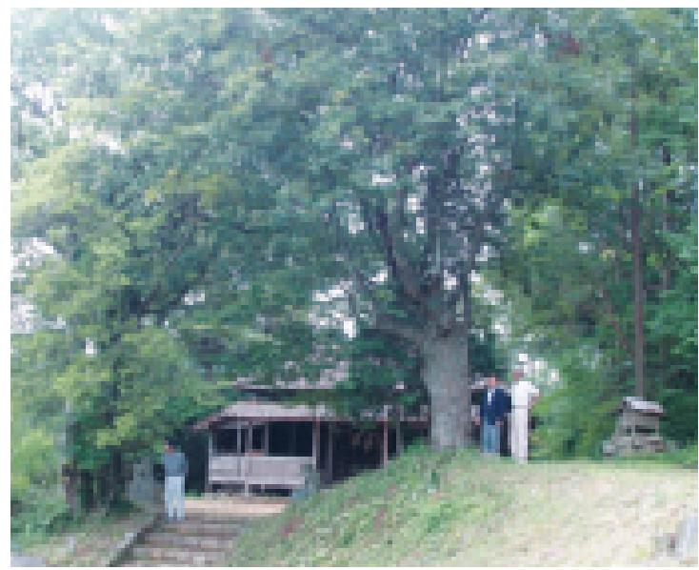  Big trees of Quercus acuta and Q. saliciva at Onzaki Shrine
Around that time in Germany, vegetation maps, and in particular, potential natural vegetation maps, were being used for urban planning, regional planning, planning of industrial areas, and even national land conservation. In Japan, however, there was no one who would recognize the value of using vegetation mapping, and there were no requests at all for vegetation surveys. During the roughly 10 years following my return to Japan at the end of 1960, I devoted myself to just going around Japan, carrying out field surveys of vegetation. It was around this time that young people from around the country who were interested in studying under me gathered at Yokohama National University’s education department, which at the time did not have the right of awarding degrees. No one who came was turned away, and no one who left was chased after; we were simply absorbed in our work. During the day we went out into the field, surveying every different type of plant community in places ranging from forests to grasslands, even the communities of weeds growing in cities, and at night we compiled and collated our data. This decade was perhaps the most fulfilling period of my life, and I think it was decisive in shaping my later fieldwork-oriented stance on research. We accumulated a mass of data on the vegetation around Japan, which came from the results of surveys carried out by crawling around on the ground, and these data were so important they were practically a census of the nation’s greenery.
Fortunately, we started to receive requests from different companies for cooperation over research surveys in the 1970s. Researchers are egoistic people _ I politely refused any requests or any assistance that did not benefit my own research. My method was to survey all the vegetation on-site. In other words, using the vegetation science methods that were widely used internationally, I would judge the degree of cover and the degree of community formation of each plant present there, and draw up a census of the greenery. From regional data I made comparisons on a global scale and compiled plant community units and clusters made up of combinations of species; these are termed “associations.” By further comparing similar communities to each other, I compiled them into alliances, orders, and classes. My aim was always to make a phytosociological organization of plant communities like this. Furthermore, whenever I received an external request to cooperate over a survey, I would without fail append a text in an European language to the survey or research report _ we were studying the world, for the world. I asked them to print over 500 additional reprints, and, gladly or grudgingly, they cooperated. As far as I was concerned, a vegetation survey did not end with simply putting out the report; it didn’t become a real research survey until it had been subjected to the unforgiving, critical eyes of a great many specialists at international academic gatherings. And if the results were not the scientific research results of real vegetation surveys, they would be of no use in creating real forests for protection against natural disasters and environmental conservation.
The Completion of Vegetation of Japan
So we were completely engrossed in carrying out vegetation surveys up and down the country with the cooperation of companies, municipal governments, central government ministries, and other organizations that all had the necessary foresight. We drew the actual distribution of vegetation communities into diagnostic maps of the current status of greenery, and existing vegetation maps that could be of use to related sciences. The existing vegetation is completely different from the original vegetation, which has been changed by human intervention, and so at the same time I also gained a grasp of the sort of natural vegetation that the sum total of the natural environment could support if all human influence were stopped. This is not necessarily the same as the original vegetation; it is today’s potential natural vegetation, and we mapped its spread in the form of potential natural vegetation maps. While comparing existing vegetation maps with potential natural vegetation maps, I made a diagnosis of the natural environment of the area, and made full use of this as a scientific scenario for using potential natural vegetation in the creation of forests where the original forests of the area had been lost. I did not limit the work of drawing up these vegetation data, greenery censuses and vegetation maps just to any given region—my real desire was to draw them up on a nationwide scale that would cover every region of Japan.
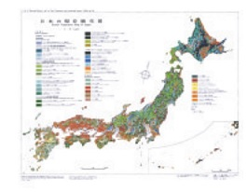  Existing vegetation of Japan | 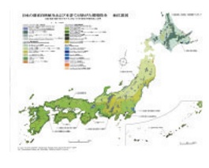  Potential natural vegetation of Japan
I was fortunate enough to receive promotional expenses for publicizing the findings of my research from the then Ministry of Education, and I was able to compile and publish them as 10 volumes of Vegetation of Japan, (Vol. 1, Yakushima; Vol. 2, Kyushu; Vol. 3, Shikoku; Vol. 4, Chugoku; Vol. 5, Kinki; Vol. 6, Chubu; Vol. 7, Kanto; Vol. 8, Tohoku; Vol. 9, Hokkaido; Vol. 10, Ogasawara, Okinawa). | 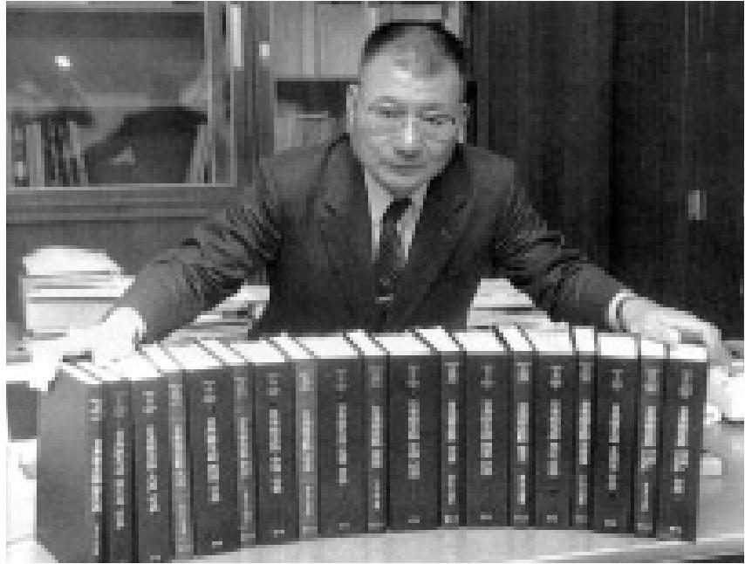  Completed 10 volume Vegetation of Japan
I sweated blood over this huge task. Vegetation of Japan was published at the rate of one volume a year starting in 1980. My approach was to compile and collate the vegetation survey data and vegetation maps from the areas of Japan that had been surveyed so far, while at the same time carrying out a thorough field survey of the vegetation of the area to be published the following year. My aim was for a near-perfect collection of vegetation survey data; during the day I worked hard at the fieldwork and at night I sorted through the data. I put a great deal of effort into determining individual plant community units, and organizing and systemizing plant communities that could be compared on a global scale. While I was working on compiling Vol. 1, Yakushima, I was concurrently working on the vegetations surveys for Vol. 2, Kyushu, which was to be published the following year; while I compiled the Kyushu data, I was also carrying out surveys in Shikoku. Working in this way, I completed 10 volumes of Vegetation of Japan over the course of 10 years. The compositional charts of plant communities that are a census of the nation’s greenery, the existing vegetation maps that serve as diagnostic maps for the present status of greenery, and the potential natural vegetation maps that serve as a scientific scenario for the regeneration of a new green environment were printed in 12 colors, and an index was appended. The text ran to 6,000 pages, and the whole thing weighed 36 kilograms.
Working under such relentless conditions, I would never have completed the Vegetation of Japan if it were not for the 116 people from universities and research organizations around the country who so generously cooperated on the project. At the very core, though, it was just five or six researchers from the vegetation laboratory of Yokohama National University who carried out the work of determining the plant community units, organizing them on a global scale, and producing vegetation maps. Just as we were approaching the third volume, Assistant Professor Shigetoshi Okuda said to me on behalf of the research team that they wanted me to take a break for a year. If they carried on like that they were all going to die, he said, and did I really want to kill them? It was just at the time that an Southeast Asian plant community survey project was being carried out with overseas survey funds from the then Ministry of Education. I had set my heart on this project, which involved spending three months of the year, from November to January, carrying out overseas surveys in parallel in Borneo, Thailand, Malaysia, and Indonesia. I thought long and hard about it, but I realized that if I broke off the Japanese vegetation project for a year, despite all the effort that had gone into getting it started it would probably just end there. So I told them that I was going to give everything I had, and I wanted them to do the same. We came to a mutual understanding, and in that way we brought all 10 volume of the Vegetation of Japan to completion. I really am enormously grateful to all the members of the research laboratories from that time, to all the researchers around Japan who supported them, and to my senior researchers for their cooperation and for the results of their splendid efforts.
The distinctive feature of Vegetation of Japan is that not only does it contain the results of vegetation surveys and vegetation maps compiled from a global perspective, it also has a large section on the vegetation ecology approach to the conservation and regeneration of the green environment at the end of each volume. These sections contain specific proposals compiled by region for the preservation of natural vegetation that is close to the original vegetation of the region, and for the creation of disaster prevention and nature conservation forests native to the area, forests that nurture river sources, urban forests, forests in industrial areas, and forests to protect the environment of roads and traffic facilities. From the tall trees that will form the main species of future forests, to the semi-tall trees, the bushes and flowering shrubs, and the species that make up the mantle communities at the forest edge, every tree species is listed by its potential natural vegetation regions. I believe Vegetation of Japan is now being used as the fundamental ecological work for conservation and regeneration of the green environment. Additionally, as Japan stretches for 3,000 kilometers across the central region of the Northern Hemisphere, the completion of the 10 volumes of Vegetation of Japan has received acclaim overseas. All the data is also appended in European languages, so Vegetation of Japan should have a place as a basic text in many universities and libraries across America and Europe.
Research into Non-flowering Vegetation Begins to Attract Attention: Creating Forests Based on Potential Natural Vegetation
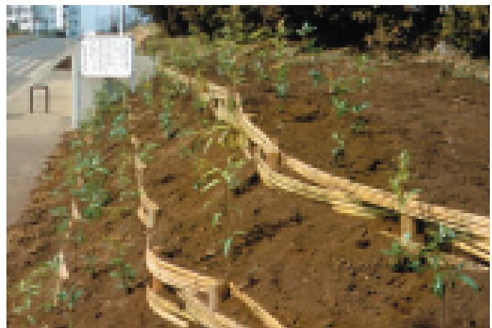  Planted area in front of the main gate of Yokohama National University | 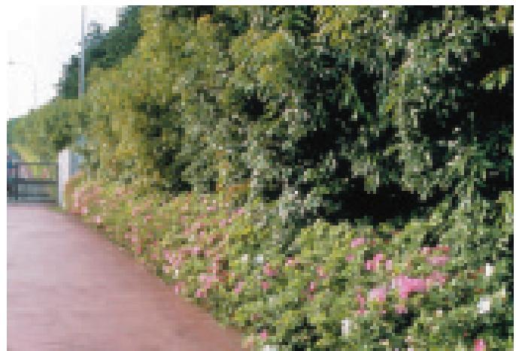  The main gate of Yokohama National University (five years after planting)
From around the end of the 1960s onward that there was a rapid growth in industry, and there was exploitation of nature on a massive scale. Atmospheric and water pollution became more and more serious, and such hazards came to be addressed as grave social problems. There was an unexpected backlash of public opinion, and civil campaigns opposed to pollution and the destruction of nature spread from the regions. The small laboratory where we weed people worked, which had previously had no connection to society, suddenly had visitors coming one after another. I thought their only real interest in coming was probably just to ask us to plant some greenery to atone for the pollution they had caused. I always answered that I would not help by planting greenery just as a temporary coverup. I would, though, be very happy to cooperate in creating a real, native forest based on the potential natural vegetation of the area. Most of the people who came to the laboratory said no way, that’s just pure cheek, and went home in a huff. But there were some people who thought that this Miyawaki person’s ideas might just have something to them, and so to find out more they asked me to give lectures at their company headquarters or came back with their company executives in tow to hear again what I had to say. These people seriously looked into creating forests.
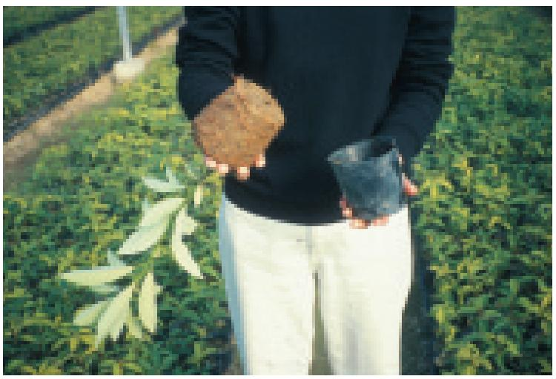  Potted seedlings with well-established root systems (Machilus) | 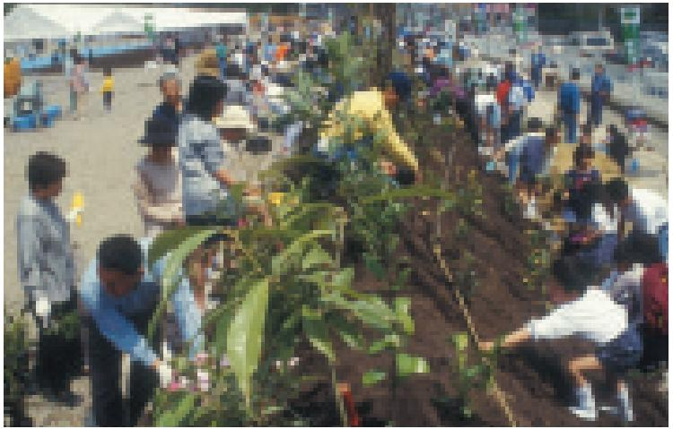  Planted area in a shopping center
The first forest I created was at the request of Nippon Steel Corporation. In 1971, there was a telephone call to the laboratory at seven o’clock one morning from Ken Shikimura, head of the newly-formed environmental division of Nippon Steel Corporation. He had attended one of my lectures at the Japan Association of Corporate Executives in Tokyo, and he wanted my cooperation in creating a forest. This was a period when the big companies were considered the main culprits for the pollution and Yokohama National University was seen as a hotbed of left-wing activity. It was unthinkable for a major company and a university to put together a joint project, but I told him, rather audaciously, “The lives of the trees I plant are at stake. If you are prepared to put your job on the line as well, I will help you.” These were the words of a greenhorn assistant professor at a new university, but Mr. Shikimura replied, “Of course I’ll do it for real.” And so began the creation of a forest at the Oita Steelworks, which was then still under construction.
When I visited the site, I found it was reclaimed land with seawater rising up. The prefectural and municipal authorities had planted various trees, but only the stakes to support them remained. I carried out a vegetation survey of the surrounding area, and found the primary trees for potential natural vegetation such as Machilus tunbergii, Castanopsis cuspidate, blue Japanese oak, and Quercus myrsinaefolia, growing at nearby Usa Shrine to heights of over 20 meters and with trunk diameters at breast height of over 80 centimeters. I proposed that the seeds of these tree _ their acorn _ be gathered and used for planting.
Japan has heavy rainfall, and if the soil is too wet it is difficult for deep-rooted trees or trees with axial roots to grow. I realized that for the trees to grow well, it would be best to create a mound to improve the drainage and plant the trees on top of the mound. I had all the waste left lying around the vast site, such as waste wood and anything else that was neither poisonous nor difficult to break down, used as a natural resource; it was mixed into soil, and I had this built up into a rounded mound between 30 and 50 meters in width, 10 meters at the narrowest, and about five meters high.
Conifers such as cedar, Japanese cypress, or pine have shallow roots, and if planted as bare seedlings they soon take. However, the trees I wanted to plant were species with deep roots or axial root systems, which are difficult to transplant _ so difficult, that gardeners tend to dislike them. I couldn’t create a real forest without full use of these species, and through trial and error I found that planting potted trees worked well. I planted acorns in pots, and after a year and a half or two years there would be 30-centimeter seedlings with well-established root systems.

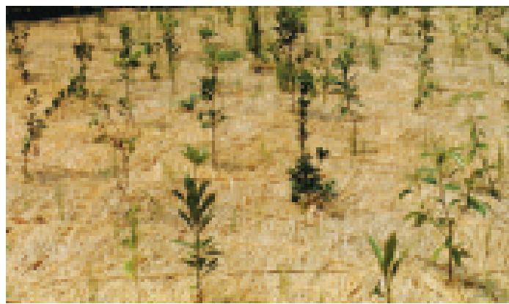  Trees planted on the premises of Tokyo Electric Power's Higashi Ohgishima thermal power station immediately after planting | 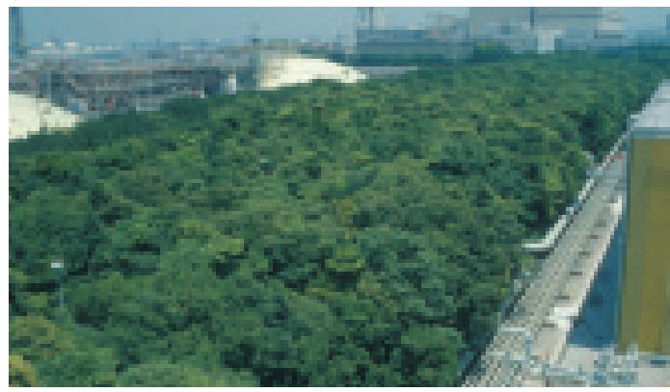  Nature conservation forest grown on the premises of Tokyo Electric Power's Higashi Ohgishima thermal power station
I planted these on the mound, where the topsoil had been restored, together with all the other people working on the project. The style of planting whereby trees that have already grown big are planted here and there on a lawn, supported by stakes, is used for creating the scenery of parks or gardens and it means creating what is basically a heath-like, wilderness landscape. For a natural plant community (society), the best situation is where the plants compete with each other and have to put up with each other. Our method of planting trees followed the law of the forest, and seedlings whose roots had filled the pot were planted densely, different species mixed together. In a natural forest, between 30 and 50 seedlings sprout per square meter. There are some places in Borneo where there are between 500 and nearly 1,000 seedlings per square meter. We densely planted different species together in the proportion of about three seedlings per square meter.
In a natural forest, seedlings emerge from a covering of fallen leaves, and when creating the forest we spread a thick layer of rice straw on the ground. Three or four kilos of straw per square meter is about right, and we spread it as gently as if we were putting a blanket over a sleeping baby. The straw gradually forms a mulch, which is extremely important; even if there is no rain the seedlings do not have to be watered for 40 days or so, and even if there is a sudden, 150-millimeter deluge one night the soil will not be washed away. The mulch also serves to protect against cold, and makes it difficult for weeds to grow. As the straw rots, it fertilizes the soil.
These days I am rather more timid, but then it was a case of fools rush in where angels fear to tread; I brazenly announced to the Nippon Steel Corporation, said to be the world’s number one company, “The primary trees for potential natural vegetation like these species of chinquapin, Machilus, and oak have grown together with the residents of this region over hundreds of years. I want a guarantee that if the trees of these species that we planted at the steelworks all suddenly die off one day, you will turn off your blast furnaces.” Nippon Steel Corporation asked for three days to think about it. Mr. Shikimura and Hideaki Nakagawa, the manager of the Administrative Department, got back to me: “OK. We will do everything we can for pollution source control,” they said. After that, I worked on the creation of forests not just in Oita but also for all of Nippon Steel’s other steelworks in Nagoya, Sakai, Kamaishi, Futtu, Hikari, Muroran, and Yawata.
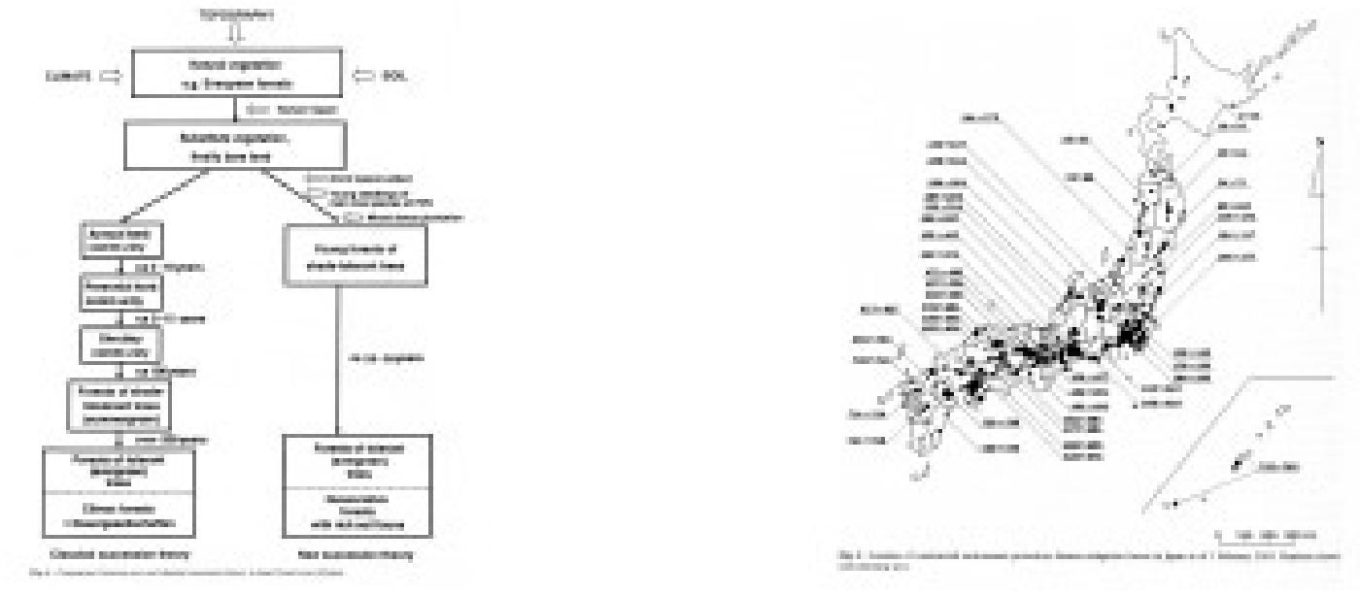
Comparison of classical and new succession theories | Location of disaster-prevention and nature conservation forests created in Japan (1,400 as of September 30, 2006)

When the then Ministry of Trade and Industry established the Factory Location Law, which stipulated that 20% of the area of the land on which a new factory was built must be covered with vegetation, many young officials came to us and I gave various different proposals. However, because the law made no reference to the type of trees to be planted, in the end there were many cases in which the greening just took the form of a few fully-grown, non-native trees with insufficient roots planted here and there on a lawn. As a consequence, greening around factories had a bad reputation for costing too much in maintenance fees. However, our way of creating forests using seedlings of trees indigenous to the area with well-developed roots, planted densely and with different species mixed together, gradually became better understood. Electricity companies such as Tokyo Electric Power, Kansai Electric Power, Kyushu Electric Power, and Okinawa Electric Power, and companies such as Toray, Honda Motors, and Mitsui Fudosan—thinking about it now, these were international corporations all put our ideas for forest creation into practice. Of course, there were a great many small and medium-sized companies, as well as local authorities with foresight, who also started to work to create real forests in different regions. In this way, disaster-prevention and nature conservation forests of trees indigenous to the area took shape around the country.
In the retail industry, Takuya Okada, honorary president of Jusco, part of the Aeon Group, gave his understanding and consent and from 1990 it was decided that all new premises were to carry out forest creation work. Under this plan, the space around new premises, even if only one meter in width, is covered in a three-dimensional forest, centered around the primary trees for potential natural vegetation. Trees with seasonal flowers are good as a sort of cosmetic touch for the marginal trees facing a road, a bit like the patterned hem of a kimono. Along the coastline trees that are resistant to salt water, such as Japanese pittosporum, Indian hawthorn, and Eurya emarginata, are planted; inland, it is trees that flower in winter such as snow camellia and sasanqua camellia, or spring-flowering trees such as gardenia or daphne.
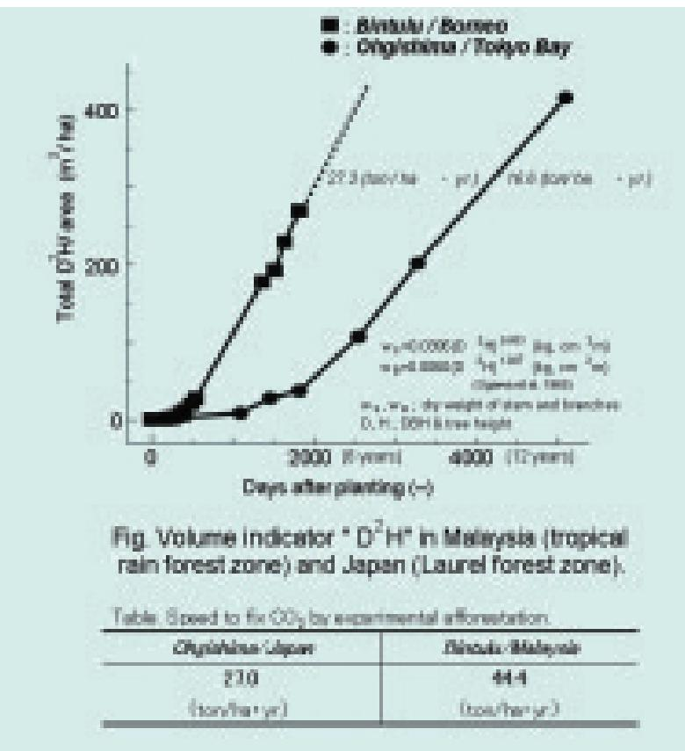  Comparison of CO2 absorption and fixation between subtropical rainforest in Malaysia and evergreen forest in Japan (from D²H) | Satsuki azalea or azalea are planted on south facing slopes. The trees are mixed together and densely planted, in line with the laws of a natural forest, and mantle communities form. People going to do their shopping always pass through a park with flowers, and dead leaves do not fall outside the group of trees _ they decompose with time, and help in the reproduction of the forest. As of August 2006, the Aeon Group has created forest like this at 550 sites, which include places in Malaysia, Thailand, Hong Kong, and China. Over six million seedlings have been planted by local citizens. Magnificent forests have developed where the primary trees for potential natural vegetation were planted, and these are some of the few places in the world where shopping centers surrounded by green forests can be seen standing out in the midst of urban desert.
Regenerating Forests Overseas
(1) Southeast Asia
The established opinion up until the 1970s was that the world’s great tropical forests of Southeast Asia, the South American Amazon, and Central Africa could not be regenerated once they had been destroyed, and so they should be preserved without any logging. However, as I carried out field surveys in Southeast Asia, my assessment was that it was difficult but not impossible to regenerate the ecosystems of the tropical forests, which are a treasure house of every biotic resource. To do this, rather than planting non-native species such as Australian eucalyptus or American pine, it is necessary to densely plant the area with a mix of the primary tree species indigenous to the area. The primary trees could be ascertained by carrying out the necessary field studies.
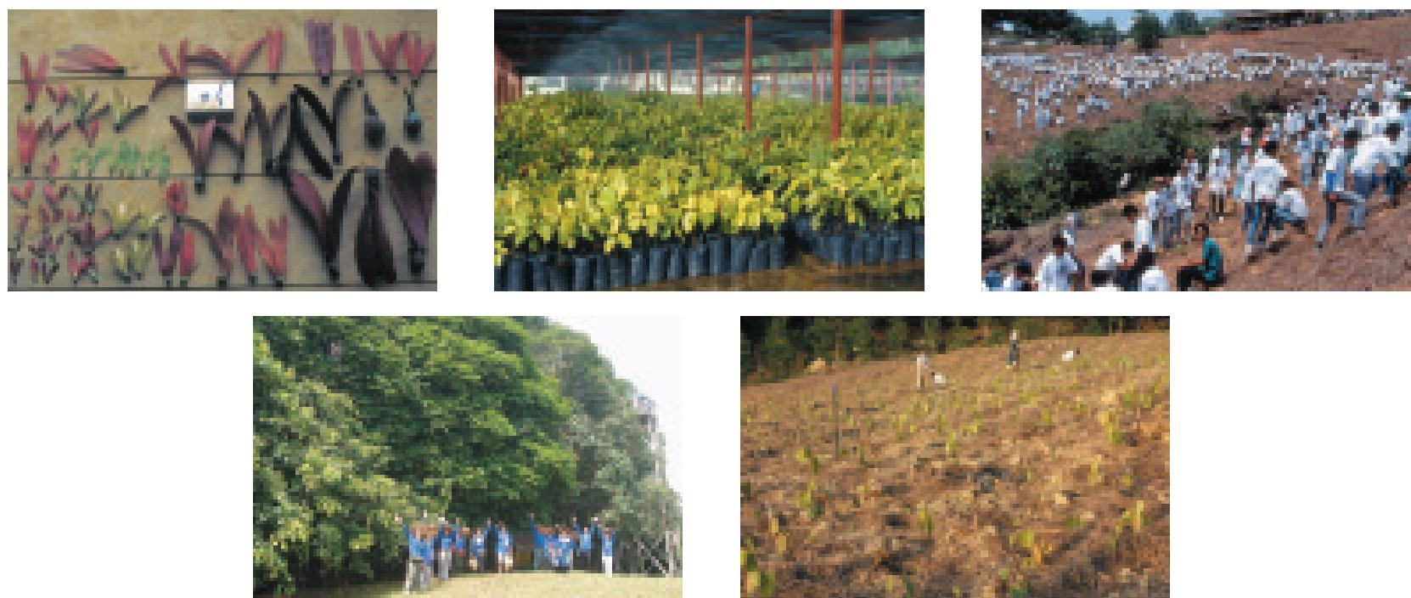
Clockwise from top left; Seeds of lauan tree botanized in Malaysia, A seed bed in Brunei Forestry Center (June 3, 1991), 2000 people planting 6,000 trees at eight hundred hectares of burnt fields on the Bintulu campus of the Universiti Putra Malaysia in Bintulu, Sarawak State, Malaysia, (July 1991), Planted area on the Bintulu campus of the Universiti Putra Malaysia (July 15, 1991), Planted area at Universiti Putra Malaysia (August 20, 2006)
As luck would have it, Mitsubishi Corporation put forward a proposal and in 1990 I set up the world’s first project aiming to regenerate native tropical rainforest. The site for the project was an 800-hectare area of burnt fields on the Bintulu campus of the Universiti Putra Malaysia (UPM) in the Malaysian state of Sarawak. I collected the seeds of indigenous tree species, the primary tree communities for potential natural vegetation, and grew them in pots. Some 2,000 people took part in the first tree-planting festival on July 15, 1991, including students at the UPM and members of the local Iban tribe. We had to dig the holes for planting the trees by hand, so that time we only managed to plant 6,000 trees, but those 30-centimeter seedlings with their sturdy roots that filled the pots have now reached a height of nearly 20 meters and are growing unhindered into a forest that is close to the ecosystem of a natural rainforest (see photo).
Since then, tree-planting festivals have been held every year right up until the present, and starting 13 years ago around 30 Japanese volunteers have taken part every year; together with local people, they are working on creating forests.
This project to regenerate the rainforest was extremely well received in Malaysia because it was carried out in the form of a joint research project with the UPM, which is the country’s oldest university. On July 30, 2006, I was awarded an honorary doctorate in forestry _ I was the first foreigner to receive such a degree, and I was deeply honored to receive it from the Sultan in person at a magnificent degree ceremony to mark the university’s 75th anniversary. I pledged once again my desire to work even more energetically for the regeneration of natural tropical rainforest in Malaysia and other parts of Southeast Asia together with local people as well as volunteers from Japan and other countries.
I am now working on regenerating water conservation forest and dry tropical forest in Thailand and Cambodia together with local people and volunteers from Japan by planting seedlings mainly of the primary trees for potential natural vegetation.
(2) The Brazilian Amazon, Kenya in Africa, and China
After the tropical rainforest regeneration project in Borneo, we started a field survey of the vegetation in the Brazilian Amazon on the South American continent in December 1990, with the aim of regenerating lowland tropical forest. We decided to hold the first tree-planting festival ten days before the Earth Summit, which was held in Brazil in 1992. In Southeast Asia we had carried out field surveys over a period of more than 10 years, but we only spent just over a year on the field survey in the Brazilian Amazon. We determined that the primary trees for potential natural vegetation as virola and other trees in the outskirts of Belem, the capital of the State of Para, but it was by no means certain that we had determined all the primary trees in the indigenous forest. We therefore grew seedlings in pots of over 20 species of the tall trees found in the area. We invited then Ambassador Extraordinary and Plenipotentiary Yasushi Murazumi and his wife to the festival, and altogether 1,000 people, including students of University of Agrarian Sciences of Pará (Faculade de Ciencias Agrarias do Para) and local people, planted a total of 10,000 seedlings.
Among the trees we planted, fast-growing species such as balsa at first grew at a tremendous rate. After three years they were six meters high, after five years, 10 meters. From the tenth year onward, however, these trees started to topple over and die, even though there were no strong winds. On the other hand, trees such as the virola, which had been considered one of the primary trees, grew steadily and are now forming a forest that closely resembles a lowland tropical forest ecosystem. This project was carried out in the form of a joint research project with University of Agrarian Sciences of Pará (Faculade de Ciencias Agrarias do Para), with the cooperation of the then Eidai Brazil and the Mitsubishi Corporation.
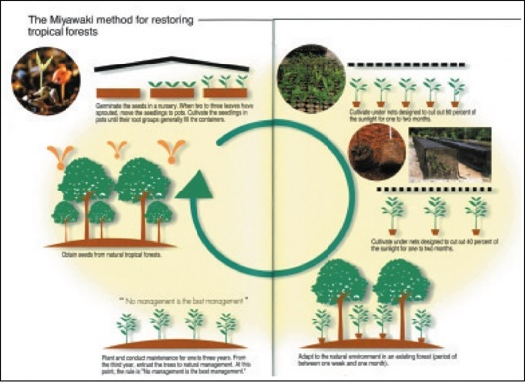
The Miyawaki method for regenerating tropical forest
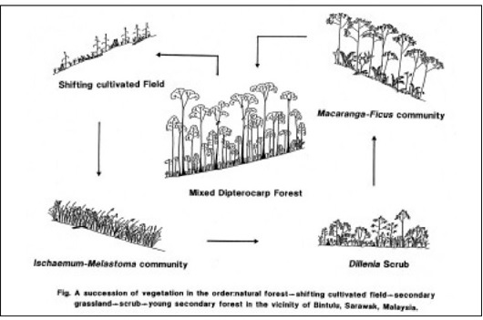
Pattern diagram of secondary succession at a burnt natural rainforest, Malaysia
After successfully regenerating tropical forest in Malaysia and the Amazon, I am currently working on regenerating the tropical forest of Africa, the last of the world’s three great tropical forests. I am carrying out the regeneration work in Kenya which lies along the equator. I became involved in this area after Wangari Maathai, the Nobel prizewinner from Kenya who has planted 30 million trees in Africa, asked for advice. She told me that foreign tree species such as eucalyptus, which were planted during the colonial era, were destroying the hills. I went to Kenya twice, in December 2005 and March 2006, to carry out field surveys of the vegetation. I plan to do all I can for the regeneration of the African tropical forests, and I will hold tree-planting festivals in November of this year (2006) and March 2007, together with members of Kenya’s Green Belt Movement as well as companies and volunteers from Japan.I have also been working to create forests in continental China, which is Japan’s neigh-bor and also the womb that nurtured Japan’s vegetation. This work is based on the results of surveys I carried out with grants for overseas surveys from the former Ministry of Education. I met with Takuya Okada, honorary chairman of the Aeon Environment Foundation, and the Beijing Municipal People’s Government, and the decision was made to regenerate the indigenous forests along the Great Wall on the outskirts of Beijing over a three-year period starting in 1998. At the time I was the first Asian to have been elected President of the International Association for Ecology, and with the recommendation of both Japan and China I was appointed to lead the project. From previous surveys I knew that the primary tree around the Great Wall in the province of Yanqing was Quercus mongolica, and we proposed to the mayor that we should create forests using mainly this species. However, the head of the city’s Forestry Division and others told us, “Those sort of trees disappeared ages ago, we don’t have them now. The only ones we do have are poplar, false acacia, willow, and alder.” Fast-growing trees like that develop quickly but they do not last a long time. I insisted that if we were going to create a forest it had to be a real forest with indigenous tree species that could withstand disasters and would last a long time.
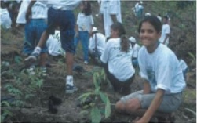 | 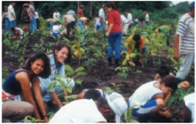
People planting trees in the Brazilian Amazon(above and above right). Planted area in the Brazilian Amazon(right) | 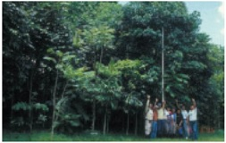

On three separate occasions between 1998 and 2000 we planted a total of 400,000 seedlings, mainly of the primary tree Quercus mongolica and also Chinese arborvitae, Chinese pine, acer and other species, together with 3,200 Chinese people from Beijing and elsewhere, as well as 3,980 volunteers from Japan. Because the trees were planted in very rocky areas with harsh conditions their initial development was rather slow, but a field survey carried out in June of this year (2006), the sixth year since the final planting, showed that with some exceptions the Quercus mongolica and other trees have grown over three meters high. Their roots have
eaten their way firmly into the rock, binding the slopes like living rope. I was able to confirm that a native forest based on potential natural vegetation is steadily being regenerated.
The same sort of forest creation is being carried out using species indigenous to the area in the Pudong district of Shanghai, which is currently undergoing development, as well as along the Qingdao Expressway, around the Maanshan Steelworks, and other areas. All of these projects have been commissioned by local city authorities or companies, who plant the seedlings together with local residents. Forests are also being created around the Aeon shopping centers at Huhehaote in Inner Mongolia, Linxi, and Guangzhou.
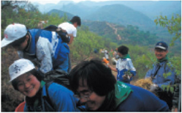  Planted area along the Great Wall of China | 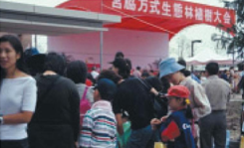  Tree-planting festival in China
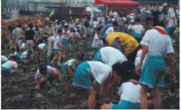  Tree planting in China | 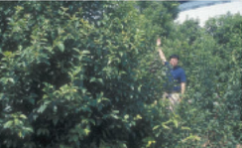  Planted area in the Pudong district of Shanghai, China

Indigenous Forests and Biodiversity
Tree-planting festivals based on the concept of potential natural vegetation and on ecological field surveys of vegetation have so far been held over 1,500 times in Japan and overseas. I have planted trees with a huge number of people; together we have worked up a sweat on our brows and felt the solid earth with our hands. I believe that there is so much more to planting a tree than just a scientific investigation to take stock of the present conditions—it is the act of planting a tree in the hearts of every individual. The forest is the root of all life; it is the womb that revives our biological instincts, that deepens our intelligence and increases our sensitivity as human beings.
Local forests that have been regenerated or created using trees indigenous to the area on the basis of the concept of potential natural vegetation do not just carry out diverse functions of disaster prevention and environmental protection; at the same time they have an ecological connection to the conservation and maintenance of biodiversity. E.O. Wilson advocated the importance of biodiversity at the 1992 United Nations Earth Summit in Rio de Janeiro, after which the preservation of biodiversity became a worldwide environmental theme. There is now an ever-growing body of thought that we should preserve native and endemic species, preserve all their particular characteristics from their genes to their ecosystems, and ensure their continuity in every region of the world.
We have successfully regenerated forests of multi-layered plant communities that are extremely close to their natural state using the method of densely planting mixed species indigenous to the area. We have worked to regenerate and maintain the diverse forest ecosystems, from the layers of tall trees and semi-tall trees to the short trees, the bottom weeds and even the bacteria in the soil. For us, the protection of biodiversity is a fundamental principle that guides our actions. We started putting our method of forest creation into practice in the 1970s, which means that we pre-empted Wilson’s thinking on the preservation of biodiversity by nearly 20 years.
Protecting the environment of indigenous forests is protecting life, protecting genes, and protecting the mind. At the same time, it makes a definite contribution to the regeneration and maintenance of ecosystems and biodiversity native to particular areas. Everyone has a leading role to play in creating forests. Let us go out and create real forests based on potential natural vegetation—not waiting for tomorrow, but starting now from where we are standing and spreading outward to the whole world. I myself am resolved to continue to plant trees based on potential natural vegetation together with you all, starting from where I stand and spreading to the whole world, so long as I have life left in my body. Receiving the Blue Planet Prize has made this resolve stronger still.

Major Publications Dr. Akira Miyawaki
Books
- Miyawaki,A. (1970) Plants and Humans — Balance of Biocoenosis — 230pp. NHK Books 109. Japan Broadcast Publishing, Tokyo. (Japanese).
- Miyawaki,A. (1983) Testimony by Green Plants. 241pp. Tokyo-Shoseki, Tokyo. (Japanese).
- Miyawaki,A.(1987) Forest is Life — Ecology and the right to live— . 268pp. Yuhikaku, Tokyo. (Japanese).
- Miyawaki,A.(1991) Prescription for Restoration of Green Environments. 289pp Asahi-Shinbun-sha, Tokyo. (Japanese).
- Miyawaki,A. et al.(1994) Vegetation in Eastern North America — Vegetation System and Dynamics under Human Activity in the Eastern North American Cultural Region in Comparison with Japan —. 515pp. Univ. of Tokyo Press, Tokyo.
- Miyawaki,A.(1997) Green Environments and Vegetation Science — Chinjuno-mori to the global forest. — 244pp. NTT Publishing, Tokyo. (Japanese).
- Miyawaki,A.(1999): Bring Forests to Life. 178pp. Dainippon-tosho, Tokyo. (Japanese).
- Miyawaki,A.& Itabashi,K.(2000) Chinju-no-mori(Native forests of native trees) 159pp. Shincho-sha, Tokyo. (Japanese).
- Miyawaki,A. et al.(2004) Planting Tomorrow. 287pp. Mainichi-Shinbun-sha, Tokyo. (Japanese).
- Miyawaki,A.(2005) Forests of acorns save our lives. 192pp. Shuei-sha, Tokyo. (Japanese).
- Miyawaki,A.(2005) A man who planted the most trees in Japan. Textbook for NHK TV Program. 161pp. Japan Broadcast Publishing, Tokyo. (Japanese).
- Miyawaki,A.(2006) 30,000,000 seedlings bear native forests. 205pp. Japan Broad-cast Publishing, Tokyo. (Japanese).
- Miyawaki,A.(2006) Plant Trees!. 220pp. Shincho-sha, Tokyo. (Japanese).
- Miyawaki,A. & Box, E.O. (2006) The Healing Power of Forests. The Philosophy behind Restoring Earth’s Balance with Native Trees. 286pp. Kosei Publishing Co., Tokyo.
Articles
- Miyawaki,A. & Itow,S.(1966) Phytosociological Approach to the Conservation of Nature and Natural Resources in Japan. Presented at Divisional Meeting of Conservation, the 11th Pacific Science Congress. 5pp. Tokyo.
- Miyawaki,A.(1975) Entwicklung der Umweltschutz-Pflanzungen und -Ansaaten.
In: Tüxen,R.(ed.) Sukzessionforschung. Berichte der Internationalen Symposien der Internationalen Vereinigung für Vegetationskunde 237-254.
Gramer, Vaduz.
- Miyawaki,A.(1981a) Das System der Lorbeerwälder (Camellietea japonicae) Japans. In: Dierschke,H.(ed.) Syntaxonomie. Berichte der Internationalen Symposien der Internationalen Vereinigung für Vegetationskunde 589-597. Gramer, Vaduz.
- Miyawaki,A.(1981b) Energy policy and green environment on the base of ecology. In: Fazzolage,R.A.& Smith,C.B.(eds.) Beyond the energy crisis opportunity and challenge. 581-587. Oxford & New York.
- Miyawaki,A.(1982a) Umweltschutz in Japan auf Vegetations-ökologischer Grundlage. Bull. Inst. Environ. Sci. Technl. Yokohama Natl. Univ. 8: 107-120. (German with Engl. synopsis).
- Miyawaki,A.(1982b) Anthropogene Veränderungen der Struktur und Dynamik Immer- und Sommergrüne Laubwälder auf den Japanischen Inseln. In: Dierschke, H.(ed.) Struktur und Dynamik von Wäldern. Ber. Intl. Symp. der Internationalen Vereinigung für Vegetationskunde 659-679. Gramer, Vaduz.
- Miyawaki,A.(1982c) Phytosociological study of East Kalimantan, Indonesia. Bull. Inst. Environ. Sci. Technl. Yokohama Natl. Univ. 8: 219-232.(Germany with English synopsis).
- Miyawaki,A.(1985) Vegetationsökologische Betrachtung Mittel-Japans unter dem Aspekt der Geomorphologie. Colloques Phytosociologiques 8: 28-40. Bailleul.
- 9. Miyawaki,A.,Fujiwara,K. & Box,E.O.(1987) Toward harmonious green urban environments in Japan and other countries. Bull. Inst. Environ. Sci. Technl. Yokohama Natl. Univ. 14: 67-82. Yokohama.
- Miyawaki,A.(1988) Die Veränderung innerhalb der japanischen anthropogenen Vegetation. Flora 180: 191¬ 201. Jena.
- Miyawaki,A.(1990) A Vegetation-Ecological View of the Japanese Archipelago. Ecology International. INTECOL Bull. 18: 13-28. Athens, GA.
- Miyawaki,A.(1992a) Restoration of Evergreen Broad-leaved Forests in the Pacific Region. In: Wali,M.K.(ed.) Ecosystem Rehabilitation. 2. Ecosystem analysis and synthesis 233-245. SPB Academic Publishing, The Hague.
- Miyawaki,A.(1992b) Ecological Studies on Human Activities and Vegetation Dynamics in the Eastern North American Cultural Region in Comparison with Japan Archipelago. Gakujutsu-Geppo 45(5): 424-434. (Japanese).
- Miyawaki,A.(1993) Restoration of native forests from Japan to Malaysia.
- In: Lieth,H. & Lohmann,M.(eds.) Restoration of Tropical Forest Ecosystems. 5-24. Kluwer Academic Publishers, the Netherlands.
- Miyawaki,A.,Fujiwara,K. & Ozawa,M.(1993) Native forest by native trees — Restoration of indigenous for-est ecosystem — (Reconstruction of environmental protection forest by Prof.Miyawaki's Method) Bull. Inst. Environ. Sci. Technl. Yokohama Natl. Univ. 19: 73-107. Yokohama. (English and Japanese).
- Miyawaki,A. & Golley,F.B.(1993) Forest reconstruction as ecological engineering. Ecological Engineering 2: 333-345. Elsevier, Amsterdam.
- Meguro, S. & Miyawaki,A.(1997) A study of initial growth behavior of planted Dipterocarpaceae trees for restoration of tropical rain forests in Borneo/Malaysia. Tropical Ecology 38(2): 237-245.
- Miyawaki,A.(1998) Restoration of urban green environments based on the theories of vegetation ecology. Ecological Engineering 11: 157-165. Elsevier, Amsterdam.
- Miyawaki,A.(1999) Creative Ecology: Restoration of native forests by native trees. Plant Biotechnology 16(1): 15-25.
- Miyawaki,A.(1999) Potential Natural Vegetation and Reforestation. JCCA for Tomorrow 203: 30-33. Tokyo. (Japanese).
- Miyawaki,A.(2000) Recreation of Ecological Environment Protection Forests. Forestry Economy 617: 9-19. Tokyo. (Japanese).
- Miyawaki,A. & Meguro,S. (2000) Planting experiments for the restoration of tropical rainforest in Southeast Asia and a comparison with laurel forest at Tokyo Bay. Proceedings of IAVS Symposium, 249-250. Opulus Press, Uppsala, Sweden.
- Miyawaki,A. & Abe,S. (2003) A Reforestation Project of Lowland Tropical Forests in Brazilian Amazon – Growth behavior in ten years. Proceedings of IAVS Symposium
- Miyawaki,A. (2004) Restoration of living environment based on vegetation ecology: Theory and practice. Ecological Research 19: 83-90. Blackwell Publishing Asia, Australia.
- Miyawaki,A. & Abe,S. (2004) Public awareness generation for the reforestation in Amazon tropical lowland region. Tropical Ecology 45(1): 59-65.
- Editorial Work, Miyawaki,A. & Tüxen,R.(eds.1977) Vegetation Science and Environmental Protection. Proceedings of the International Symposium in Tokyo on Protection of the Environment and Excursion on Vegetation Science through Japan. 578pp. Maruzen Co., Tokyo.
- Miyawaki,A.(ed.1980-1989) Vegetation of Japan. vol. 1-10.
- Yakushima 376pp. 2.Kyushu 484pp. 3.Shikoku 604pp. 4.Chugoku 540pp.
- Kinki 596pp. 6.Chubu 604pp. 7.Kanto 641pp. 8.Tohoku 563pp.
- Hokkaido 563pp. 10.Okinawa and Ogasawara 676pp. each vol. with colored vegetation maps and tables.
- (Japanese with German and/or English summary). Shibundo, Tokyo.
- Miyawaki,A. et al.(eds.1983) Handbook of Japanese Vegetation. 872pp. (Japanese with Latin). with Distribution Maps of Japanese Plant Communities 168pp. Shibundo, Tokyo.
- Miyawaki,A.(ed.1985) Vegetation Ecological Studies on Mangrove Forests in Thailand. 152pp. Inst. Environ. Sci. Technl. Yokohama Natl. Univ. Yokohama.5. Miyawaki,A., Bogenrider,A., Okuda,S. & White,I.(eds.1987) Vegetation Ecology and Creation of New Environments. Proceedings of International Symposium in Tokyo and Phytogeographical Excursion through Central Japan. 473pp. Tokai Univ. Press, Tokyo.
- Miyawaki,A.& Okuda,S. (eds.1991) Vegetation of Japan Illustrated. 800pp. Shibundo, Tokyo. (Japanese).
- Miyawaki,A. (ed.1996) Indices to Vegetation of Japan. — Community names and subjects —. 330pp. Shibundo, Tokyo. (Japanese with German and Latin).

