From Around The World

The tree guru
Nirmal Ghosh meets a Japanese man helping Toyota reduce CO2 emissions.
By Nirmal Ghosh
Thailand Correspondent
nirmal@sph.com.sg

In Bangkok
IT WAS an early start on a hot morning, but well worth the trip to meet Dr Akira Miyawaki.
''I am only 80, I hope to keep working for another 30 years'' he said, eyes twinkling as he looked at the 100,000 seedlings that 10,000 volunteers planted in a single day at Toyota's Ban Pho plant in Chachoengsao, a short drive out of Bangkok.
Japanese tree guru Dr Akira Miyawaki has recreated ''natural'' forests from degraded greenfield sites all over the world including Malaysia, Brazil, China and Chile – and has been given a host of awards including the Blue Planet Prize in 2006 – putting him in the same league as Dr James E. Lovelock, Dr Norman Myers and Gro Harlem Brundtland among others.
Dr Miyawaki is now helping Japanese car maker Toyota plant hundreds of thousands of trees and shrubs to help offset its CO2 emissions at Ban Pho, which churns out 100,000 Hilux pickups a year for export.

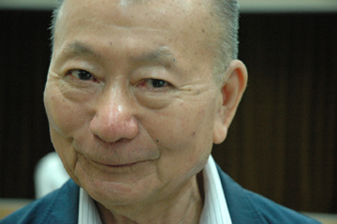
Meet Toyota's tree guru.
ST PHOTO: Nirmal Ghosh
But he does not blindly plant any old tree.
His method is inherently simple, but also a great challenge. He researches the local native vegetation and determines what would have been on an empty spot years – and sometimes generations – ago before the land was converted from forest to agriculture, and then from agriculture to industry.
When I met him at Ban Pho, he fished out a creased list from his back pocket, which was a veritable blueprint of species in a natural, bio diverse forest in that particular area.
Dr Miyawaki then sets about obtaining the right combination of seeds and saplings, prepares the soil without any chemical inputs, and has thousands of people – in this case Toyota employees and local people – plant them.
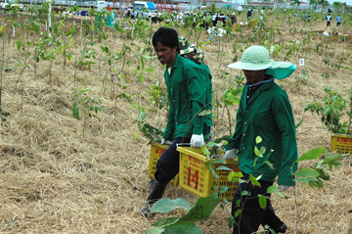
Planting at the Toyota plant.
ST Photo: Nirmal Ghosh
They are planted in high density, which creates competition – simulating conditions in a natural forest and recreating a ''food chain'' of herbs at ground level, medium level shrubs, and a canopy. In a few years, insects will begin cross-pollination. Growth is actually faster than in a natural forest thanks partly to his method of soil preparation.
At Ban Pho, he has planted 34 species on 12 acres. In about 10-20 years, the forest will absorb up to 800 tons of CO2 a year.
It's all part of Toyota's drive to ultimately create a zero-emission situation at its plants. At Ban Pho, which is one of five plants worldwide designated to demonstrate how this can be done, 80 per cent of energy is from natural gas.
It is an uphill task in many respects. Solar panels on the roof of the plant, for example, contribute only 16 per cent of the energy needs of just one of the buildings. But the approach is integrated; all paint is water-based, and water and waste is recycled.
Toyota which employs 14,000 people in Thailand, wants to eventually plant 1 million trees in five years at its production sites.
''Humans are like parasites on the Earth'' says Dr Miyawaki. ''If every plant in the world could do this, we could change the situation.''
Tree by tree.
Source : http://blogs.straitstimes.com/2008/8/21/the-tree-guru/

