Reforestation centre Mandrosoa

1. What is reforestation?
To re-plant trees in some spots where forests do not exist or in forests where too much logging has occurred in an effort to rehabilitate the forest.
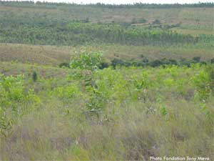

2. Why reforestation?
Tree planting is necessary to preserve the environment and improve people's standards of living:
- For firewood and charcoal, to build houses and make furniture;
- To generate income for those managing the re-planted forests;
- To allow for the regeneration of the soil;
- To preserve water sources from drying up;
- To clean the air;
- To help mitigate climate change;
- To increase exports;
- Manampy amin'ny fiadiana amin'ny fikorontanan'ny toetr'andro ;
- Mitombo ny isan'ny hazo varotana any ivelany ;

3. Who can help?

Technical assistance
- GTZ (provides training for technicians to produce seedlings as well as for reforestation)
PGME office in Antsiranana : Tel. 032 05 667 67
PGME office in Mahajanga : Tel. 032 07 294 44
PGME office in Toliara : Tel. 94 411 89 - 032 05 425 30
- WWF (provides nursery gardening technicians to produce seedlings)
WWF office in Antananarivo
Tel. 22 348 85 - 22 304 20
E-mail: wwfrep@moov.mg
- SNGF (produces and sells seeds as well as seedlings)
SNGF office: Ambatobe Antananarivo - BP. 5091
Tel. 22 412 30 - 22 402 85 - 24 382 03
E-mail: silonagf@moov.mg
- DREF (provides technical advice)
 | Region | email
1 | Atsimo andrefana | dreeft.aand@meeft.go.mg
2 | Atsimo Atsinanana | dreeft.aats@meeft.go.mg
3 | Amoron'i Mania | dreft.aim@meeft.go.mg
4 | Alaotra Mangoro | dreeft.alm@meeft.go.mg
5 | Analamanga | dreeft.anlg@meeft.go.mg
6 | Androy | dreeft.andr@meeft.go.mg
7 | Analanjirofo | dreeft.anlj@meeft.go.mg
8 | Anosy | dreeft.ans@meeft.go.mg
9 | Atsinanana | dreeft.ats@meeft.go.mg
10 | Boeny | dreeft.boe@meeft.go.mg
11 | Bongolava | dreeft.bong@meeft.go.mg
12 | Betsiboka | dreeft.bts@meeft.go.mg
13 | Diana | dreeft.diana@meeft.go.mg
14 | Haute Matsiatra | dreeft.hm@meeft.go.mg
15 | Ihorombe | dreeft.ih@meeft.go.mg
16 | Itasy | dreeft.its@meeft.go.mg
17 | Menabe | dreeft.mnb@meeft.go.mg
18 | Melaky | dreeft.mlk@meeft.go.mg
19 | Sava | dreeft.sava@meeft.go.mg
20 | Sofia | dreeft.sofia@meeft.go.mg
21 | Vakinakaratra | dreeft.vak@meeft.go.mg
22 | Vatovavy Fitovinany | dreeft.v7v@meeft.go.mg

- CI (provides advice and funding)
- TANY MEVA (provides training for technicians to produce seedlings as well as for reforestation)
Office in Antananarivo
Lot IAI 1 bis, Ambatobe, Antananarivo 103
Tél : 22 403 99
E-mail: contact@tanymeva.org.mg
Siteweb: www.tanymeva.org.mg
Office in Toliara
GEF-SGP Office in Toliara - Rue Leda Albert Facing «Lycée Botokeky», the storeyed building Close to "C Accumul" - Toliara 601
Tél : 0331157985
E-mail : h.rakotoarison@tanymeva.org.mg

Assistance in equipment
- GTZ (seeds, wheelbarrows, watering cans, pesticides, wrapping plastics for seedlings, tractors)
- WWF (seeds, wheelbarrows, watering cans, pesticides, wrapping plastics for seedlings, tractors)
- SNGF (seeds)

Financial assistance
- Tany Meva (funding for farmers associations)
- Conservation International (funding for farmers to rehabilitate forests)
- SNGF (funding for Communes)

4. What are the local officials' roles?

The communes and neighborhoods
- To raise the local populations' awareness ;
- To be a facilitator between the local planters and all partners ;
- To ensure the coordination of activities with the tree planters ;
- To be a mediator in case of dispute regarding land ownership or social problems.
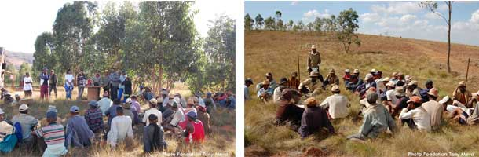

The tree planters
- To choose the location of tree nurseries with the technicians;
- To establish nurseries;
- To produce and upkeep seedlings with the technicians;
- To plant trees;
- To ensure and undertake the upkeep of planted trees.
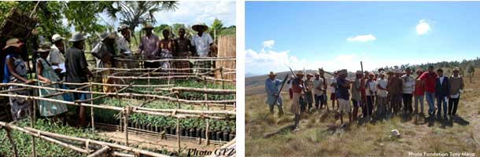

5. What are the different reforestation techniques?

Preparation
- Collect information about the expanse of the land to be reforested;
- Select the types of trees and seeds to be planted;
- Prepare pesticides to protect the plants;
- Collect information about the necessary equipment (spades, watering cans, wrapping plastics, etc);
- Choose seeds of good quality (dry, clean, intact);
- Keep the seeds in a dry and clean location, far from parasites.

To design the nurseries
- Use the following criteria to choose the location for the nurseries:
  - Well lit
  - Near clean water
  - Flat, even area
  - Protected from the wind

- Required improvements for the chosen location
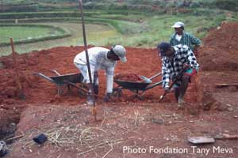
  - Clean the area;
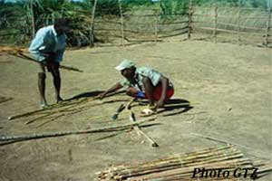
  - Level the soil;
  - Enclose the area with a fence;
  - former des plates-bandes;
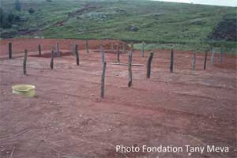
  - Build a shelter to protect against the sun: height = 80-100cm - width = 1,4m;
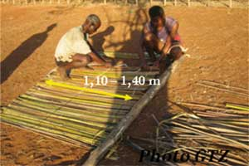
  - Find a place to store fertilizers or other necessary materials
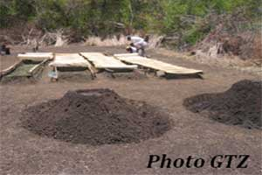
Note that the size of the nursery depends on the number of seedlings to be produced.

- To construct the nurseries
  - Size
    - Length: 6-110 meters
    - Width: 1 meter
  - Size of the shelter
    - Height: 80cm-1 meter
    - The space between the rows = 50-80 cm (to have a clear path for the wheelbarrows)
  - Orient the nursery east-west
  - Edge the rows with some bricks or mud clods to protect them.
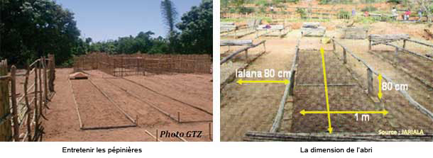

To produce seedlings
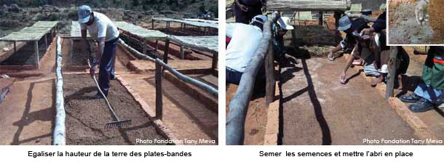
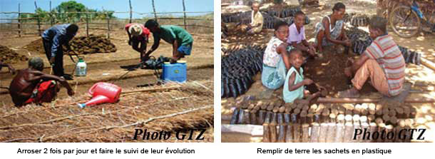
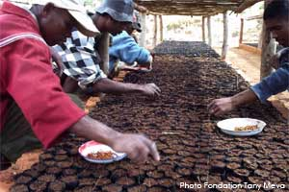
Some types of tree seeds can be sown directly in a wrapping plastic that is filled with mud; add fertilizer if necessary.
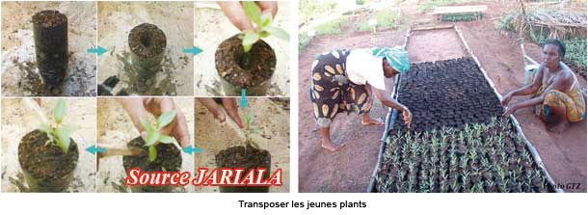
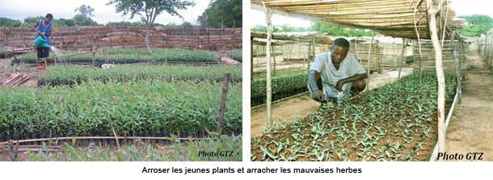
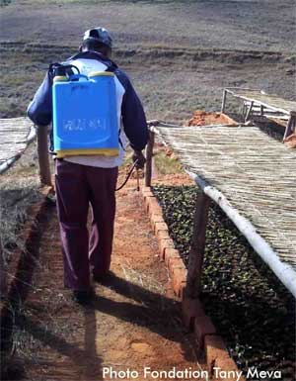
Utiliser des pesticides si nécessaire

The plantation
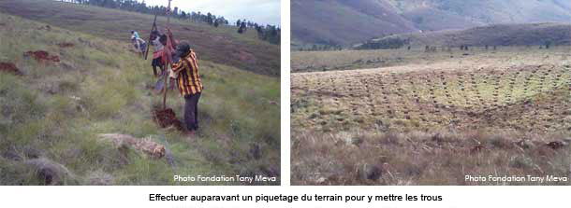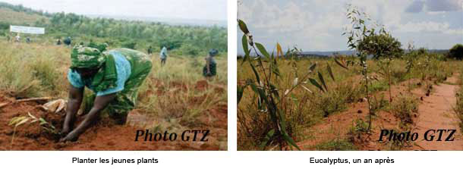

To care for the planted trees
- Weed frequently;
- Remove dead seedlings;
- Establish fire barriers.
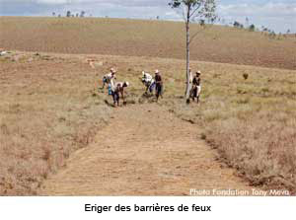

What are the types of trees to be planted?
Types of trees |  | Use | The regions where  they can be planted
« Ditimena » | Abrahamia sericea | To make furniture  To build houses | Toamasina
Mûrier, Acacia | Acacia auriculiformis | Windbreak  Firewood  To build houses  Raw material to make papers | Toliara
Mulberry tree, Acacia | Acacia mangium | Windbreak  To preserve the soil  Charcoal  Raw material to make papers  To build houses | Toamasina
Pink cedar | Acrocarpus fraxinifolius | To make furniture  To preserve the soil | Toamasina  Majunga
Gum tree | Albizia gummifera | Charcoal and firewood  To make furniture  To build houses  Food for livestock  To shelter from the sun  Medicine (malaria)  To preserve the soil | Antananarivo
« Bonara » | Albizzia lebbeck | To make furniture  To preserve the soil | Toliara
« Fantsilotra » | Alluaudia procera | To make furniture | Toalagnaro  Betioky Sud
« Neem » | Azadirachta indica | To make furniture  Electricity pylon  Charcoal and firewood  Windbreak  Medicine  To kill harmful insects | Toliara
« Sohihy » | Brenadia salicina | To make furniture  Pirogue and coffin  Firewood  Medicine | Antananarivo  Toamasina  Majunga  Antsiranana  Toliara
« Vory » | Broussonetia greveana | To make furniture  Pirogue | Toliara
« Honko » | Brugeria gymnorhiza | Charcoal and firewood | Toliara
« Ramy » | Canarium madagascariensis | To make furniture  Pirogue
Casurina | Casurina equisetifolia | Firewood  To preserve the soil | Betioky Sud
« Katrafay » | Cedrelopsis grevei | To make furniture  Medicine  Essential oil | Toliara
« Arofy » | Commiphora guillaumini | To make furniture  Medicine
« Trandramborondreo » | Colubrina decipiens | To make furniture  Raw material to make papers | Toalagnaro
« Sarongaza » | Colvillea racemosa | To make furniture | Toalagnaro
« Molanga » | Croton mongue | To make furniture
Palissandre, «Manary» | Dalbergia baronii | To make furniture | Antananarivo  Toamasina
«Hazovola» | Dalbergia monticola | To make furniture
« Volobe mavo » | Dendrocalamus giganteus | To build houses  Raw material to make papers  Food (the internal part) | Antananarivo  Toamasina
Eucalyptus | Eucalyptus camaldulensis | To build houses  To make furniture  Charcoal and firewood | Antananarivo  Toamasina  Majunga  Toliara
Eucalyptus | Eucalyptus maculata | To make furniture  Charcoal and firewood | Antananarivo  Toamasina  Majunga
« Kininimanitra » | Eucalyptus citriodora | For infusion  Essential oil | Antananarivo  Fianarantsoa  Antsiranana  Toamasina
Grevillea | Grevillea robusta | To make furniture  Raw material to make papers  To shelter from the sun  Charcoal and firewood  Ornamental tree | Majunga  Antsiranana
«Harongana» | Harungana madagascariensis | Medicine | Antananarivo  Toamasina  Majunga  Antsiranana  Toliara  Toalagnaro  Betioky Sud
«Hazolamanga» | Hazomalania voyroni | To make furniture  To make coffins | Toliara
«Mandrorofy» | Hymenaea verrucosa | To make furniture and build houses | Antananarivo  Toamasina
«Hintsy» | Intsia bijuga | To make furniture | Antananarivo  Toamasina
«Hazomena» | Khaya madagascariensis | To make furniture | Antananarivo
«Handy» | Neobequea mahafaliensis | To make furniture | Toalagnaro
«Varongy» | Ocotea cymosa | To make furniture  To build houses | Toamasina
«Antavaratra» | Potomeia obovata | To make furniture | Toamasina
«Kotofihy» | Prunus africana | To make furniture  To build houses  Windbreak  Medicine | Toamasina
Tamarinier, «Madirokarana» | Tamarindus indica | Charcoal and firewood  To make furniture  Comestible fruit | Toliara  Toalagnaro
Teck | Tectonia grandis | To make furniture  To build houses | Toliara
«Mantaly» | Terminalia mantaly | To make furniture | Majunga
«Voapaka» | Uapaca thouarsii | To make furniture | Antananarivo
«Ravintsara» | Cinnamomum camphora | Essential oil | Madagasikara
«Hetatra» | Podocarpus madagascariensis | To build houses  Ornamental tree | Antananarivo
«Tapia» | Uapaca bojerii | Comestible fruit  For wild silkworm breeding | Arivonimamo, Ambositra, Antsirabe, Toliara
Homepage The Mandrosoa Project News Contact us Website plan Partners

Source : http://www.mandrosoa.org/dossier.php?id=49&lang=en

